WHO SEARO Daily Flood Early Warning Brief — 2026-10-28
Generated 2026-10-28 06:05 IST

Verdict (triage)
ALERT: India
WATCH: Sri Lanka, Thailand
STABLE: Bangladesh, Myanmar, Nepal

Flood Hub — country gauge summary
country | tier | total_gauges | Warning | Danger | Extreme | new_danger | new_extreme | cleared_hot
Bangladesh | STABLE | 894 | 0 | 0 | 0 | 0 | 0 | 0
India | ALERT | 16,340 | 147 | 60 | 2 | 29 | 2 | 0
Myanmar | STABLE | 3,177 | 0 | 0 | 0 | 0 | 0 | 0
Nepal | STABLE | 765 | 0 | 0 | 0 | 0 | 0 | 0
Sri Lanka | WATCH | 310 | 41 | 1 | 0 | 0 | 0 | 14
Thailand | WATCH | 2,143 | 0 | 0 | 0 | 0 | 0 | 0
ALERT: ≥1 Extreme gauge; or Danger gauges plus a GDACS orange/red flood/cyclone for that country; or newly elevated hot gauges with ≥3 Danger gauges.
WATCH: ≥1 Danger gauge, a GDACS orange/red hit, urban flash-flood signal (next ~24h), and/or newly elevated hot gauges — without meeting ALERT criteria.
STABLE: No Danger/Extreme gauges, no GDACS orange/red, and no urban flash-flood signal for that country.

Urban flash floods — next ~24 hours (SEARO)
country | iso2 | events | highly_likely_events | likely_events | period_hours | latest_issue
Thailand | TH | 11 | 1 | 11 | 24 | 2026-10-27T18:34:34.278239Z
India | IN | 5 | 1 | 5 | 24 | 2026-10-27T18:34:34.278239Z
Sri Lanka | LK | 5 | 1 | 5 | 24 | 2026-10-27T18:34:34.278239Z
Urban flash floods: Flood Hub model of flash-flood likelihood in urban areas over the next ~24 hours (~20 km). Highly likely = stronger polygon signal. Decision support only — verify with national met/hydro.

GDACS — SEARO floods & cyclones (last 7 days)
alert_level | event_type | country | name | from_date | url
red | TC | India | Tropical Cyclone ARNAB-26 | 2026-10-26T00:00:00 | https://www.gdacs.org/report.aspx?eventid=1001345&episodeid=8&eventtype=TC

Flood Hub significant events (SEARO filter)
None touching SEARO right now.

Admin-1 screen (Danger/Extreme gauges only)
country | region_code | ADM1 | Danger | Extreme | hot_gauges
India | IN | Odisha | 29 | 2 | 31
India | IN | Andhra Pradesh | 26 | 0 | 26
India | IN | Rajasthan | 1 | 0 | 1
Sri Lanka | LK | Puttalama | 1 | 0 | 1
Hot gauges: Flood Hub stations currently at Danger (severe) or Extreme severity. Admin-1 units are listed only if they contain ≥1 hot gauge; use as a geographic filter and verify with gauges + national met/hydro before acting.

OpenMeteo Forecasting
Forecast data collected for 229 locations from 28 October 2026 to 03 November 2026. Across this forecast period, 16 Warning and 186 Watch alerts were identified (counts represent location–date forecasts).

Warning reasons: Daily rainfall above 100 mm; Thunderstorm with hail.
Watch reasons: Heavy rain; Heavy rain showers; Strong wind; Thunderstorm; Very heavy rainfall.

Daily forecast alerts by location
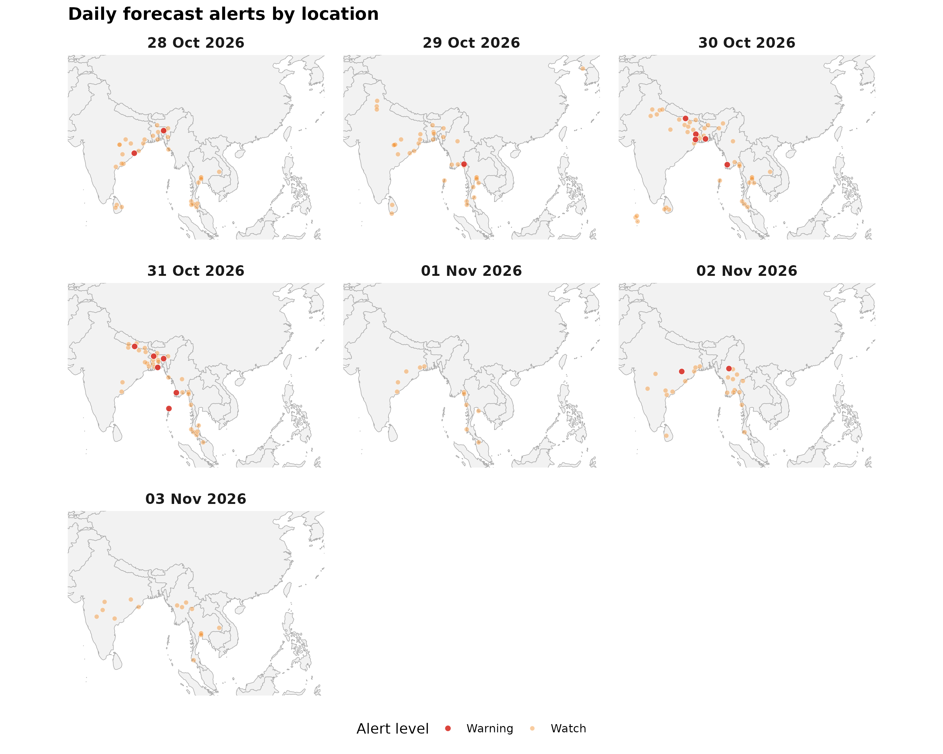

Forecast alerts by country
Country | Warning | Watch | Alert_Reasons
Bangladesh | 5 | 14 | Thunderstorm with hail; Thunderstorm
India | 5 | 81 | Thunderstorm with hail; Thunderstorm; Heavy rain showers; Thunderstorm; Strong wind
Myanmar | 4 | 30 | Thunderstorm; Thunderstorm with hail
Nepal | 2 | 4 | Daily rainfall above 100 mm; Thunderstorm; Very heavy rainfall; Heavy rain showers
Bhutan | 0 | 0 | —
DPR Korea | 0 | 1 | Heavy rain
Maldives | 0 | 3 | Thunderstorm
Sri Lanka | 0 | 9 | Thunderstorm
Thailand | 0 | 44 | Thunderstorm; Very heavy rainfall; Very heavy rainfall; Thunderstorm
Timor-Leste | 0 | 0 | —

Forecast alerts by state/province
Country | State | Warning | Watch | Total
Myanmar | Ayeyarwady Region | 2 | 2 | 4
Bangladesh | Sylhet Division | 2 | 0 | 2
Nepal | Madhesh Province | 2 | 0 | 2
Bangladesh | Khulna Division | 1 | 4 | 5
India | Paschim Medinipur | 1 | 4 | 5
Myanmar | Kayin State | 1 | 4 | 5
India | Sambalpur | 1 | 3 | 4
Bangladesh | Barisal Division | 1 | 2 | 3
Bangladesh | Rajshahi Division | 1 | 2 | 3
India | Ganjam | 1 | 2 | 3
India | North and Middle Andaman | 1 | 2 | 3
India | Paschim Bardhaman | 1 | 2 | 3
Myanmar | Sagaing Region | 1 | 0 | 1
Bangladesh | Dhaka Division | 0 | 5 | 5
Thailand | Krabi | 0 | 5 | 5
Thailand | Phang Nga | 0 | 5 | 5
India | Baleswar | 0 | 4 | 4
India | Bastar | 0 | 4 | 4
India | Cachar | 0 | 4 | 4
India | Durg | 0 | 4 | 4
India | East Godavari | 0 | 4 | 4
India | Howrah | 0 | 4 | 4
India | West Garo Hills | 0 | 4 | 4
Myanmar | Mon State | 0 | 4 | 4
Thailand | Nonthaburi | 0 | 4 | 4
Thailand | Pathum Thani | 0 | 4 | 4
Thailand | Samut Prakan | 0 | 4 | 4
India | Puri | 0 | 3 | 3
Myanmar | Mandalay Region | 0 | 3 | 3
Myanmar | Naypyidaw Union Territory | 0 | 3 | 3
Myanmar | Tanintharyi Region | 0 | 3 | 3
Myanmar | Yangon Region | 0 | 3 | 3
Sri Lanka | Sabaragamuwa Province | 0 | 3 | 3
Thailand | Rayong | 0 | 3 | 3
Thailand | Trang | 0 | 3 | 3
Thailand | Ubon Ratchathani | 0 | 3 | 3
India | Amravati | 0 | 2 | 2
India | Darbhanga | 0 | 2 | 2
India | Gorakhpur | 0 | 2 | 2
India | Guntur | 0 | 2 | 2
India | Khammam | 0 | 2 | 2
India | Korba | 0 | 2 | 2
India | Lunglei | 0 | 2 | 2
India | Purba Bardhaman | 0 | 2 | 2
India | Solapur | 0 | 2 | 2
India | Sonipat | 0 | 2 | 2
Myanmar | Bago Region | 0 | 2 | 2
Myanmar | Magway Region | 0 | 2 | 2
Myanmar | Rakhine State | 0 | 2 | 2
Myanmar | Shan State | 0 | 2 | 2
Nepal | Koshi Province | 0 | 2 | 2
Sri Lanka | Central Province | 0 | 2 | 2
Thailand | Mae Hong Son | 0 | 2 | 2
Thailand | Nakhon Si Thammarat | 0 | 2 | 2
Thailand | Phetchaburi | 0 | 2 | 2
Thailand | Phuket | 0 | 2 | 2
Thailand | Surat Thani | 0 | 2 | 2
Thailand | Yala | 0 | 2 | 2
Bangladesh | Mymensingh Division | 0 | 1 | 1
DPR Korea | South Hwanghae Province | 0 | 1 | 1
India | Aligarh | 0 | 1 | 1
India | Alwar | 0 | 1 | 1
India | Bhojpur | 0 | 1 | 1
India | Deoghar | 0 | 1 | 1
India | Dimapur | 0 | 1 | 1
India | Hazaribagh | 0 | 1 | 1
India | Kakinada | 0 | 1 | 1
India | Karnal | 0 | 1 | 1
India | Moradabad | 0 | 1 | 1
India | Nalanda | 0 | 1 | 1
India | Nanded | 0 | 1 | 1
India | North Tripura | 0 | 1 | 1
India | Purnia | 0 | 1 | 1
India | Rajnandgaon | 0 | 1 | 1
India | Rewa | 0 | 1 | 1
India | Solan | 0 | 1 | 1
India | Udham Singh Nagar | 0 | 1 | 1
Maldives | Baa Atoll | 0 | 1 | 1
Maldives | Kaafu Atoll | 0 | 1 | 1
Maldives | Lhaviyani Atoll | 0 | 1 | 1
Nepal | Bagmati Province | 0 | 1 | 1
Nepal | Lumbini Province | 0 | 1 | 1
Sri Lanka | Eastern Province | 0 | 1 | 1
Sri Lanka | Southern Province | 0 | 1 | 1
Sri Lanka | Uva Province | 0 | 1 | 1
Sri Lanka | Western Province | 0 | 1 | 1
Thailand | Prachuap Khiri Khan | 0 | 1 | 1
Source: Open-Meteo. Alert counts represent location–date forecast rows across all forecast dates. Forecast alerts use WMO weather codes and country-specific thresholds for Bangladesh, Bhutan, India, Thailand, Nepal, and Sri Lanka, informed by national meteorological and disaster-management agencies. Custom rules apply where unavailable. The highest triggered severity determines the forecast alert level: Normal, Advisory, Watch, or Warning. These indicators are not official agency warnings.

Met / hydro verification checklist
[ ] India — https://mausam.imd.gov.in/ / https://ffs.india-water.gov.in/
[ ] Sri Lanka — https://www.meteo.gov.lk/ / https://www.irrigation.gov.lk/
[ ] Thailand — https://www.tmd.go.th/ / https://www.thaiwater.net/

Sources: Google Flood Forecasting API / Flood Hub (gauges, significant events, urban flash floods); GDACS; national NMHS/hydro. Decision support only — not an official WHO warning.

