Noisy Neighbors — The Load Scenario Kit: Realistic Workload Contention with Load Forecasting on a Shared Kubernetes Cluster
Course D0020E — project description for the student groups

Background
In shared cloud infrastructure, many applications run on the same machines. When batch jobs (reports, backups, model training) and data streams (sensor data, logs) peak at the same time as user traffic, the machines run out of CPU and unrelated applications slow down.
Existing load tools either send web traffic to one app or simply burn CPU; none creates a realistic, repeatable mix of workloads with a record of what really happened. For this course, such an environment — the Load Scenario Kit — is already built and handed to the groups in a running state: it drives real pods on a real machine, scripts repeatable storms, measures the machine and every workload every 15 seconds, and writes a diary of every real event with its cause. Each scenario is one settings file, and the same settings and seed always produce the same pattern of jobs and bursts.
The groups build the intelligence layer an on-call engineer actually wants — an autoscaler, a load forecaster, an early-warning detector and a cause-finder — and they prove it against the recorded ground truth: nobody's work is judged by opinion, and the diary decides.
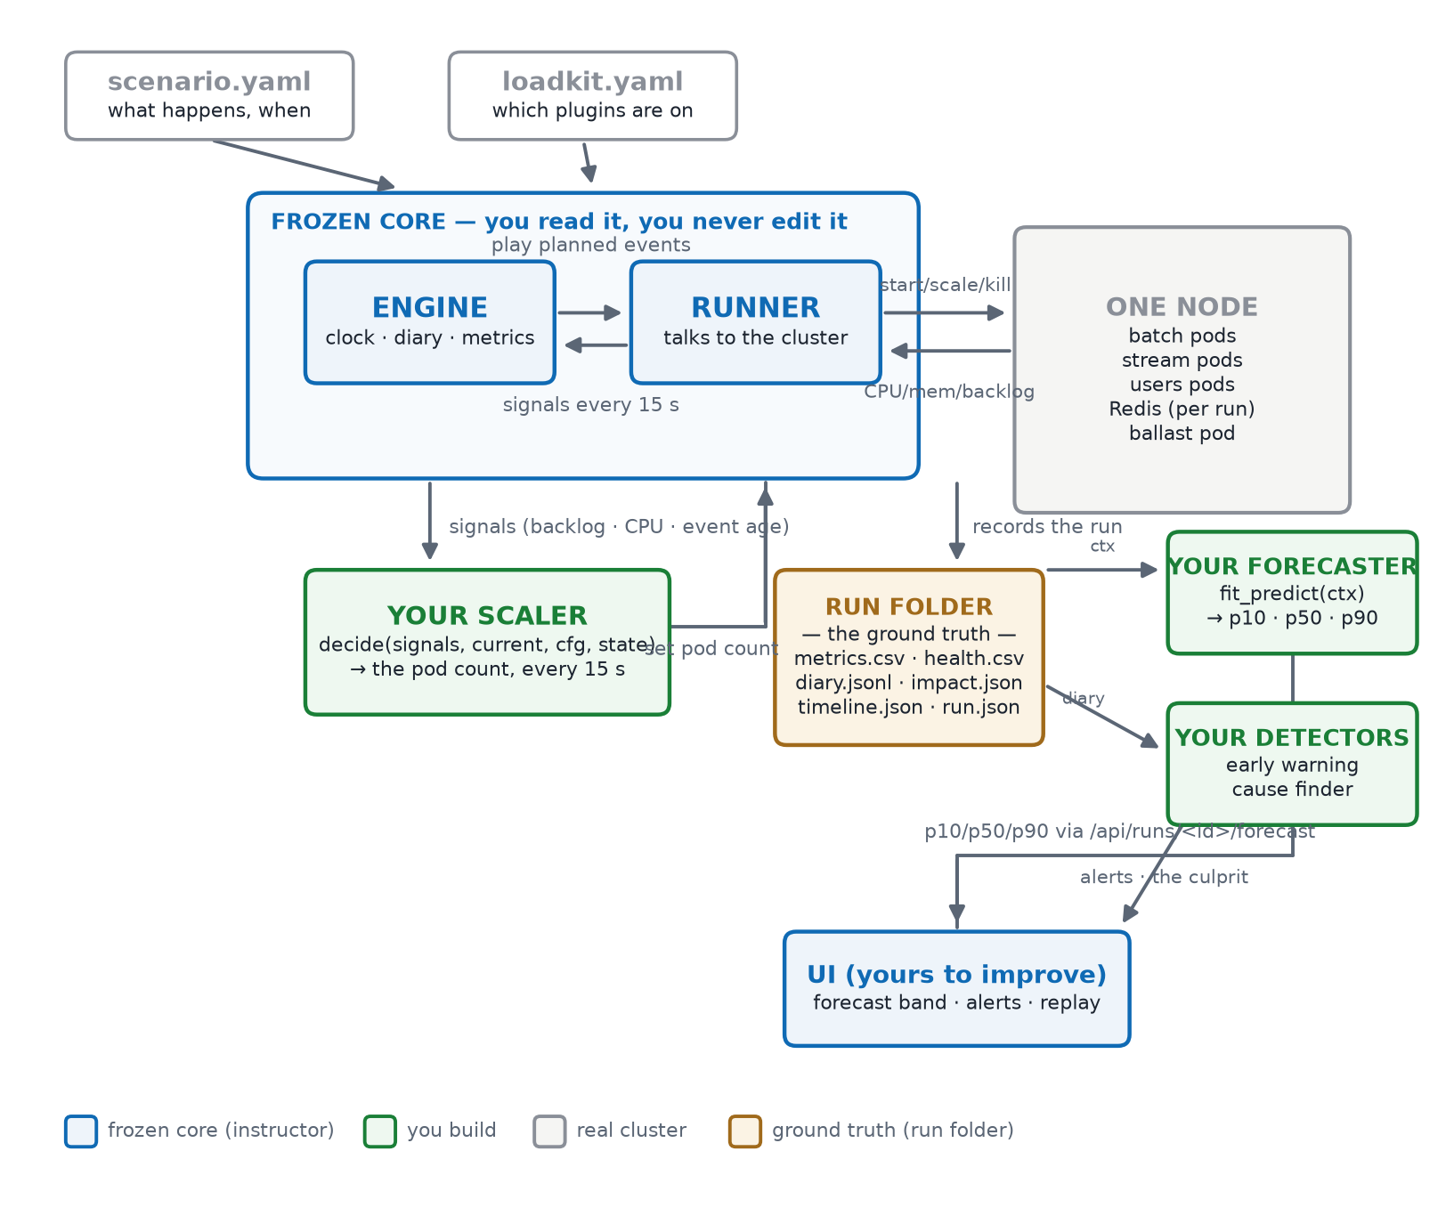
Figure 1 — The kit's architecture: the frozen core (engine + runner) plays the scenario on one node; the group's scaler plugs into the live control loop, and the group's forecaster and detectors plug in after the run, fed by the run folder — the ground truth everything is judged against.

What the group builds
- Their own scaler plugin: reads live signals (backlog, CPU, event age) every 15 seconds and decides the pod count — judged by fewer degraded minutes in the run's health record than the no-scaling baseline.
- A forecaster built around Timestral: calls Mistral's pre-trained Timestral model (probabilistic, multivariate, CPU only, no training) through the kit's adapter, returns p10/p50/p90 forecast bands, and must beat the built-in reference forecaster. The scenario's planned events are used as known future covariates.
- An early-warning detector: fires before a workload's health degrades, with few false alarms — judged by lead time against the diary.
- A cause-finder: when a run degrades, names the workload that caused it — judged by precision and recall against the kit's own impact analysis.
- The forecast-bands panel in the web UI (shipped and enabled): shades p10–p90 around the real metric line; the group extends it (more metrics, detector alerts).
- Working in a CI/CD pipeline (GitHub Actions): lint and unit tests on every push and pull request, a deterministic simulation of all short scenarios compared against main (posted as a pull-request comment), a nightly real-cluster check, a protected main branch with code review, and a rule that the kit's core changes only with the instructor's approval.
Development happens entirely on the laptop — tests and scenario simulations run in-process, no cluster, Docker or GPU required. Final validation runs on one shared, instructor-managed cluster: each group gets its own labelled node and its own scoped access key, so all groups run in parallel without touching each other.

Technologies
Python 3.12, Kubernetes (shared cluster for finals), Redis, Docker (worker image), GitHub Actions, Mistral Timestral (CPU inference) and a simple web front end. No prior Kubernetes or machine-learning experience is needed.

Sprint plan
Sprint | When | What gets delivered
Sprint 0 | LP2 | Laptop set up (Python, Git); first plugin — a scaler that beats the no-scaling baseline on one short scenario, with a passing test that needs no cluster. Repository with a protected main branch, code review through pull requests, and CI (lint + tests) green on every change.
Sprint 1 | first half of LP3 | Forecaster: the Timestral call working through the kit's adapter, beating the reference baseline on the short scenarios; the forecast-bands panel showing the group's band; the simulated comparison on pull requests reviewed and defended.
Sprint 2 | second half of LP3 | Early-warning detector and cause-finder with reported numbers (lead time, false alarms, precision/recall); user documentation; final validation of all builds on one full scenario on the shared cluster; a versioned release of the group's plugin set.

Hardware requirements
Item | Requirement
Each student's laptop (development) | any modern CPU with 2+ cores; 8 GiB RAM; ~10 GiB disk; Python 3.12 and Git; network access to GitHub. No Kubernetes, Docker or GPU needed — development and simulation run in-process.
Shared class cluster (final validation) | 5 worker nodes — one per group — each 4 cores / 8 GiB RAM (up to 32 GiB for the full 2-hour scenarios); plus a control plane and metrics-server. Total ≈ 20 cores / 40 GiB.
Access | student laptops need only network access to the cluster's API server, with one scoped key per group (no kubectl, no node access).

