Noisy Neighbors: A Realistic Workload Generator with Load Forecasting for Shared Kubernetes Clusters
Course D0020E — project description for the student groups

Background
In shared cloud infrastructure, many applications run on the same machines. When batch jobs (reports, backups, model training) and data streams (sensor data, logs) peak at the same time as user traffic, the machines run out of CPU and unrelated applications slow down.
Existing load tools either send web traffic to one app or simply burn CPU; none creates a realistic, repeatable mix of batch jobs and data streams with a record of what really happened. This project builds such a test environment for evaluating monitoring tools, autoscalers and AI operations agents.
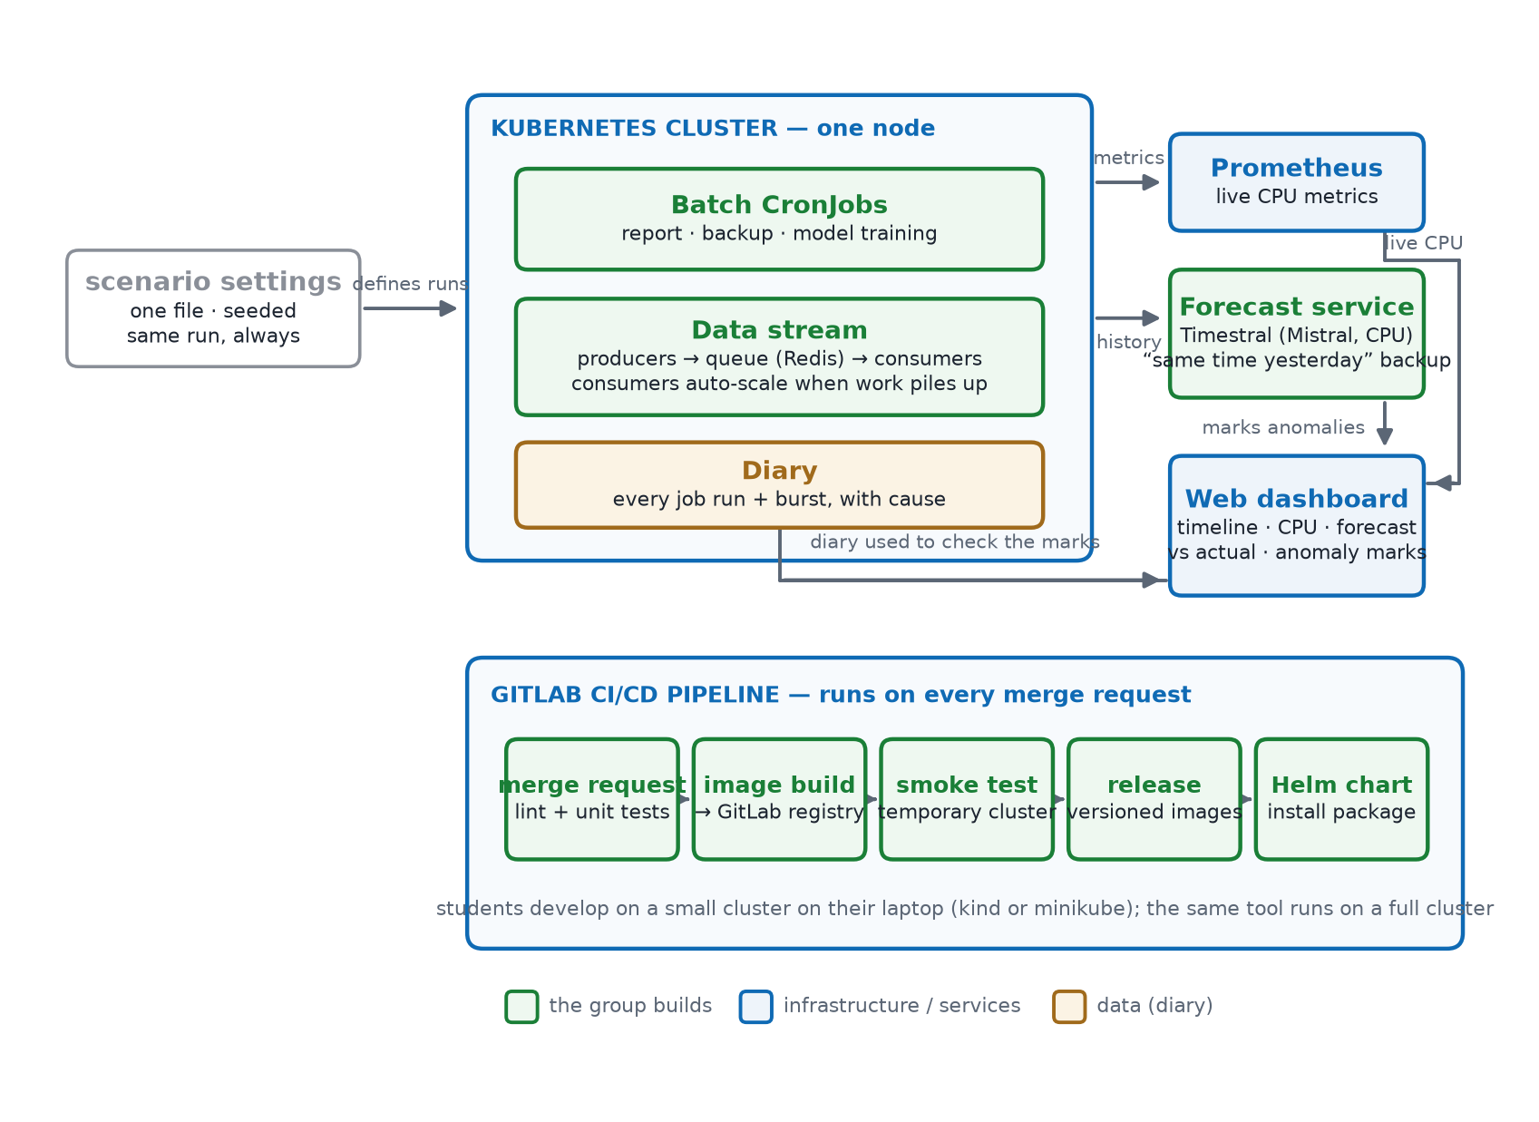
Figure 1 — The system: one settings file drives the workloads on one node; Prometheus, the diary and the Timestral-based forecast service feed the dashboard; GitLab CI runs the tests and builds on every merge request.

What the group builds
- Batch jobs: several Kubernetes CronJobs doing real CPU work (report, backup, model training), on schedules with random start delays so they sometimes overlap.
- A data stream: producer, queue and consumers, with a daily pattern and random bursts. Consumers scale up automatically when work piles up.
- A diary: records when each job ran and when each burst happened.
- A web dashboard: shows each workload on a timeline, next to live CPU metrics from Prometheus.
- A forecast service: predicts each workload’s normal load with Mistral’s pre-trained Timestral model (CPU only, no training), plus a simple method such as “same time yesterday” as backup and comparison. The dashboard marks moments where the real load is far from the forecast, and the diary is used to check those marks.
- A CI/CD pipeline (GitLab CI): automatic tests on every merge request, container image builds, a short test run on a temporary Kubernetes cluster, and versioned releases.
Each scenario is described in one settings file; the same settings always produce the same pattern of jobs and bursts. Students develop a small Kubernetes cluster on their own laptops (kind or minikube); the tool also works on a full cluster.

Technologies
Python, Docker, Kubernetes, Redis, Prometheus, GitLab CI and a simple web front end. No prior Kubernetes or machine-learning experience is needed.

Sprint plan
Sprint | When | What gets delivered
Sprint 0 | LP2 | Laptop cluster set up; two or three batch jobs and a first data stream running, with a diary. Git repository with a protected main branch, code review through merge requests, and a CI pipeline that runs lint and unit tests on every change.
Sprint 1 | first half of LP3 | All workloads described in one settings file, with repeatable runs; any number of jobs and streams; automatic consumer scaling; first timeline page. CI builds container images into the GitLab registry and runs a short smoke test on a temporary Kubernetes cluster.
Sprint 2 | second half of LP3 | Live CPU metrics on the dashboard; forecast service (Timestral + simple backup) marking unusual load; user documentation. A release pipeline publishes versioned images and an install package (Helm chart) when a version tag is created.

Hardware requirements
Item | Requirement
Each student's laptop (development) | modern CPU with 4 cores; 8 GiB RAM (local cluster + IDE); ~30 GiB disk for Docker images; Docker, kubectl and Python installed; network access to GitLab
Local cluster | kind or minikube cluster on the laptop (one or two nodes) for development
Full cluster (optional) | for final validation: a few worker nodes of 4 cores / 8 GiB each; the tool runs unchanged on any standard cluster

