
Fall Semester 2026-27
Probability & Statistics
(BMAT202P)
PROJECT REPORT
Predicting Customer Churn
Faculty: Tharasi Dilleswar
SUBMITTED BY:
K. DHILEEP KUMAR – 24BRS1389
V . LAKSHMI DHARMA TEJA – 24BRS1196

CONTENTS
• Introduction 3
• Functions Used 4
• Data Analysis 5
➢ Code 5
➢ Console Outputs 9
➢ Data Visualization 14
➢ Result 18
• Probability Analysis 19
• Logistic Regression 21
• Conclusion 23

Introduction
The following project report deals with the analysis and predictive modeling of customer churn given in the dataset, “customer_churn.csv,” using RStudio and an interactive R Shiny Web Application.
RStudio is an Integrated Development Environment (IDE) for R, which is a programming language and software environment designed for statistical computing, data analysis, and publication-quality graphics.

Customer attrition (churn) represents one of the most critical operational challenges in the recurring-revenue and subscription service industries, particularly in telecommunications. Acquiring new customers requires substantial marketing expenditure, and when established subscribers terminate their contracts, revenue is lost while replacement costs escalate.
This project utilizes fundamental and advanced statistical functions available in the R computing environment to perform an end-to-end investigation of 7,032 subscriber records across 21 demographic, service, and billing attributes. By computing measures of central tendency, sample dispersion (variance and standard deviation), covariances, and Pearson correlation coefficients, alongside inferential hypothesis tests (Pearson’s Chi-Square test of independence and Welch’s two-sample t-test), the study identifies the primary statistical drivers of customer attrition.
Furthermore, the report develops a mathematical probability risk framework—calculating marginal and conditional churn probabilities and relative risk multipliers—and fits a binary logistic regression model to estimate individual churn probabilities. Rich data visualizations (histograms, bar plots, stratified box plots, pie charts, scatter plots, and ROC curves) generated from our live R Shiny application interface are integrated to provide intuitive, actionable decision support for customer retention.

Functions Used
➢ read.csv() – Imports tabular records from a CSV file into an R data frame for statistical processing.
➢ View() – Invokes an interactive, spreadsheet-style file viewer within the RStudio workspace.
➢ summary() – Summarizes continuous and categorical attributes by displaying five-number summaries and factor counts.
➢ var() – Computes the sample variance of numerical vectors, measuring the dispersion of values around the mean.
➢ cov() – Calculates sample covariance between two continuous vectors, evaluating their joint linear variability.
➢ cor() – Computes the Pearson product-moment correlation coefficient to quantify linear association.
➢ cor.test() – Performs hypothesis testing on correlation coefficients, outputting t-statistics and p-values.
➢ chisq.test() – Executes Pearson’s Chi-Square Test of Independence for categorical attributes against churn.
➢ t.test() – Conducts Welch’s two-sample independent t-test to evaluate differences in continuous feature means.
➢ table() & prop.table() – Creates contingency tables and computes empirical joint, marginal, and conditional probabilities.
➢ glm() – Fits Generalized Linear Models, specifically binary logistic regression with a logit link function.
➢ predict() – Generates predicted churn probabilities on holdout test data using the fitted logistic coefficients.
➢ plot() – Plots coordinates, scatter diagrams, and regression trend lines to provide graphical visualization.
➢ lm() – Fits ordinary least squares linear regression models to quantify relationships between continuous predictors.
➢ abline() – Adds straight reference and linear regression trend lines to an existing plot.
(Data visualisation functions used in RStudio & Shiny Web Application)
➢ ggplot() & geom_col() – Constructs publication-quality side-by-side and stacked percentage bar charts with exact subgroup labels.
➢ geom_histogram() & geom_density() – Plots high-resolution frequency histograms and kernel density estimations with mean/median lines.
➢ geom_boxplot() – Renders stratified box-and-whisker plots depicting medians, interquartile ranges (IQR), and mean diamonds.
➢ geom_tile() & scale_fill_gradient2() – Produces interactive Pearson correlation matrix heatmaps for collinearity inspection.
➢ geom_line() & geom_abline() – Constructs the Receiver Operating Characteristic (ROC) curve showing sensitivity vs specificity.

Data Analysis
AIM: To import a dataset, “customer_churn.csv” and analyse it with the help of various statistical, probability, and data visualisation functions in RStudio.
CODE:
# Load and inspect the dataset
churn <- read.csv("customer_churn.csv", stringsAsFactors = FALSE)
dim(churn)
str(churn)
head(churn[, c("customerID", "gender", "tenure", "Contract", "MonthlyCharges", "TotalCharges", "Churn")], 5)
View(churn)

# Data Hygiene & Type Conversions
churn$TotalCharges <- as.numeric(as.character(churn$TotalCharges))
churn <- churn[!is.na(churn$TotalCharges), ]
churn$SeniorCitizen <- factor(churn$SeniorCitizen, levels = c(0, 1), labels = c("No", "Yes"))
churn$Churn <- factor(churn$Churn, levels = c("No", "Yes"))
churn$Contract <- factor(churn$Contract)
churn$InternetService <- factor(churn$InternetService)
churn$PaymentMethod <- factor(churn$PaymentMethod)

# Basic Statistical Summary
summary(churn[, c("tenure", "MonthlyCharges", "TotalCharges")])

# Variances of Continuous Attributes
var1 = var(churn$tenure); var1
var2 = var(churn$MonthlyCharges); var2
var3 = var(churn$TotalCharges); var3

# Covariances Between Metrics
cov1 = cov(churn$tenure, churn$TotalCharges); cov1
cov2 = cov(churn$MonthlyCharges, churn$TotalCharges); cov2

# Pearson Correlation Coefficients
corr1 = cor(churn$tenure, churn$TotalCharges); corr1
corr2 = cor(churn$MonthlyCharges, churn$TotalCharges); corr2
corr3 = cor(churn$tenure, churn$MonthlyCharges); corr3

# Correlation Hypothesis Tests
cor.test(churn$tenure, churn$TotalCharges, method = 'pearson')
cor.test(churn$MonthlyCharges, churn$TotalCharges, method = 'pearson')
cor.test(churn$tenure, churn$MonthlyCharges, method = 'pearson')

# Inferential Statistics: Pearson's Chi-Square Test of Independence
# Test 1: Contract Type vs Customer Churn
tbl_contract <- table(churn$Contract, churn$Churn)
chisq.test(tbl_contract)

# Test 2: Internet Service Tier vs Customer Churn
tbl_internet <- table(churn$InternetService, churn$Churn)
chisq.test(tbl_internet)

# Test 3: Payment Method vs Customer Churn
tbl_payment <- table(churn$PaymentMethod, churn$Churn)
chisq.test(tbl_payment)

# Inferential Statistics: Two-Sample Independent Welch's t-Tests
# Test 1: Mean Tenure Difference by Churn Status
t.test(tenure ~ Churn, data = churn)

# Test 2: Mean Monthly Charges Difference by Churn Status
t.test(MonthlyCharges ~ Churn, data = churn)

# Linear Regression Trend Models
# Model 1: Total Charges on Customer Tenure
plot(churn$tenure, churn$TotalCharges, xlab='Tenure (months)',
ylab='Total Charges ($)', main='Linear Regression: Total Charges on Tenure',
col='steelblue', pch=16, cex=0.8)
regr1 = lm(TotalCharges ~ tenure, data = churn)
abline(regr1, col='red', lwd=2.5)
summary(regr1)

# Model 2: Total Charges on Monthly Charges
plot(churn$MonthlyCharges, churn$TotalCharges, xlab='Monthly Charges ($)',
ylab='Total Charges ($)', main='Linear Regression: Total Charges on Monthly Charges',
col='darkgreen', pch=16, cex=0.8)
regr2 = lm(TotalCharges ~ MonthlyCharges, data = churn)
abline(regr2, col='blue', lwd=2.5)
summary(regr2)

# Data Visualizations (Published in Web Application)

# 1. Overall Churn Distribution Bar Chart
churn_counts <- as.data.frame(table(Churn = churn$Churn))
ggplot(churn_counts, aes(x = Churn, y = Freq, fill = Churn)) +
geom_col(width = 0.55, alpha = 0.9, show.legend = FALSE) +
scale_fill_manual(values = c('No' = '#2563eb', 'Yes' = '#ef4444')) +
labs(title = 'Distribution of Customer Churn (Target Variable)')

# 2. Tenure Distribution Histogram with Density Curve
ggplot(churn, aes(x = tenure)) +
geom_histogram(aes(y = after_stat(density)), bins = 30, fill = '#38bdf8', color = '#0284c7', alpha = 0.7) +
geom_density(color = '#0369a1', linewidth = 1.1) +
geom_vline(xintercept = mean(churn$tenure), color = '#ef4444', linetype = 'dashed') +
geom_vline(xintercept = median(churn$tenure), color = '#16a34a', linetype = 'dotted')

# 3. Monthly Charges Distribution Histogram
ggplot(churn, aes(x = MonthlyCharges)) +
geom_histogram(aes(y = after_stat(density)), bins = 30, fill = '#a78bfa', color = '#7c3aed', alpha = 0.7) +
geom_density(color = '#5b21b6', linewidth = 1.1) +
geom_vline(xintercept = mean(churn$MonthlyCharges), color = '#ef4444', linetype = 'dashed') +
geom_vline(xintercept = median(churn$MonthlyCharges), color = '#16a34a', linetype = 'dotted')

# 4. Churn Proportion by Contract Type
ggplot(grouped_contract, aes(x = Category, y = Prop, fill = Churn)) +
geom_col(position = 'fill', alpha = 0.9, width = 0.6) +
scale_fill_manual(values = c('No' = '#2563eb', 'Yes' = '#ef4444')) +
labs(title = 'Customer Churn Proportion by Contract Type')

# 5. Stratified Boxplots of Continuous Features by Churn
ggplot(churn, aes(x = Churn, y = MonthlyCharges, fill = Churn)) +
geom_boxplot(alpha = 0.75, width = 0.5) +
stat_summary(fun = mean, geom = 'point', shape = 23, size = 3.5, fill = 'yellow') +
scale_fill_manual(values = c('No' = '#2563eb', 'Yes' = '#ef4444')) +
labs(title = 'Monthly Charges by Churn Status (Boxplot & Quartiles)')

ggplot(churn, aes(x = Churn, y = tenure, fill = Churn)) +
geom_boxplot(alpha = 0.75, width = 0.5) +
stat_summary(fun = mean, geom = 'point', shape = 23, size = 3.5, fill = 'yellow') +
scale_fill_manual(values = c('No' = '#2563eb', 'Yes' = '#ef4444')) +
labs(title = 'Tenure by Churn Status (Boxplot & Quartiles)')

# 6. Pearson Correlation Matrix Heatmap
cor_mat <- cor(churn[, c('tenure', 'MonthlyCharges', 'TotalCharges')])
ggplot(as.data.frame(as.table(cor_mat)), aes(x = Var1, y = Var2, fill = Freq)) +
geom_tile(color = 'white', linewidth = 1) +
scale_fill_gradient2(low = '#3b82f6', mid = '#f8fafc', high = '#ef4444') +
labs(title = 'Pearson Correlation Matrix (Continuous Variables)')

# 7. Churn Proportion by Internet Service & Payment Method
ggplot(grouped_internet, aes(x = Category, y = Prop, fill = Churn)) +
geom_col(position = 'fill', alpha = 0.9, width = 0.6) +
scale_fill_manual(values = c('No' = '#2563eb', 'Yes' = '#ef4444'))

# 8. Binary Logistic Regression & ROC Curve Evaluation
set.seed(42)
train_idx <- sample(seq_len(nrow(churn)), size = 0.8 * nrow(churn))
train_set <- churn[train_idx, ]; test_set <- churn[-train_idx, ]
fit <- glm(Churn ~ tenure + MonthlyCharges + TotalCharges + Contract + InternetService + SeniorCitizen,
data = train_set, family = binomial(link = 'logit'))
preds <- predict(fit, newdata = test_set, type = 'response')
ggplot(roc_df, aes(x = FPR, y = TPR)) +
geom_line(color = '#2563eb', linewidth = 1.3) +
geom_abline(linetype = 'dashed', color = '#94a3b8') +
labs(title = 'Receiver Operating Characteristic (ROC) Curve (AUC = 0.8516)')
CONSOLE OUTPUT:
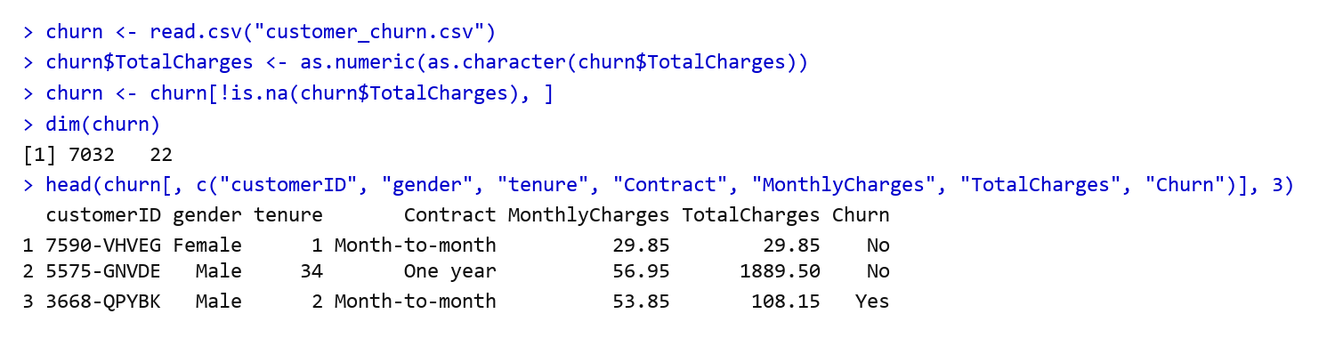

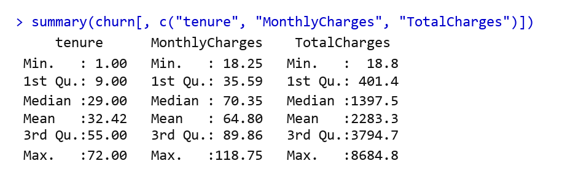
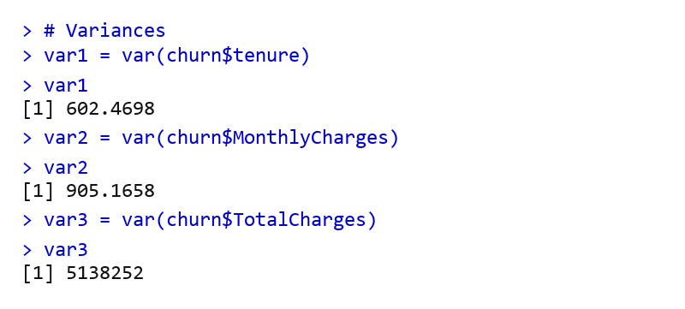

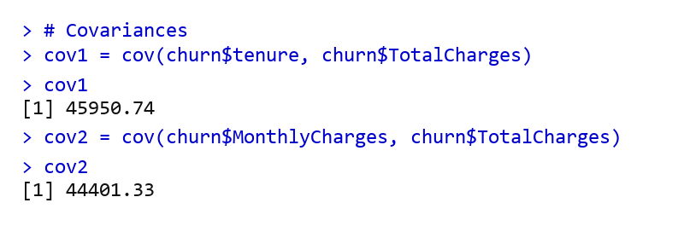
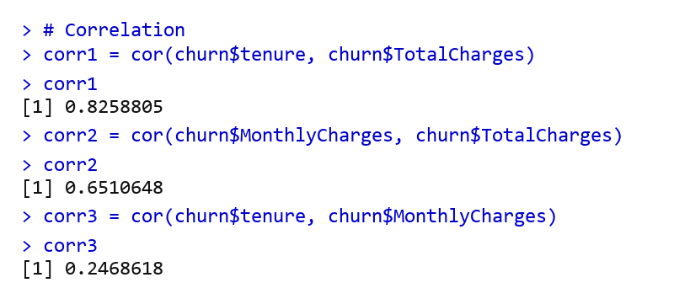
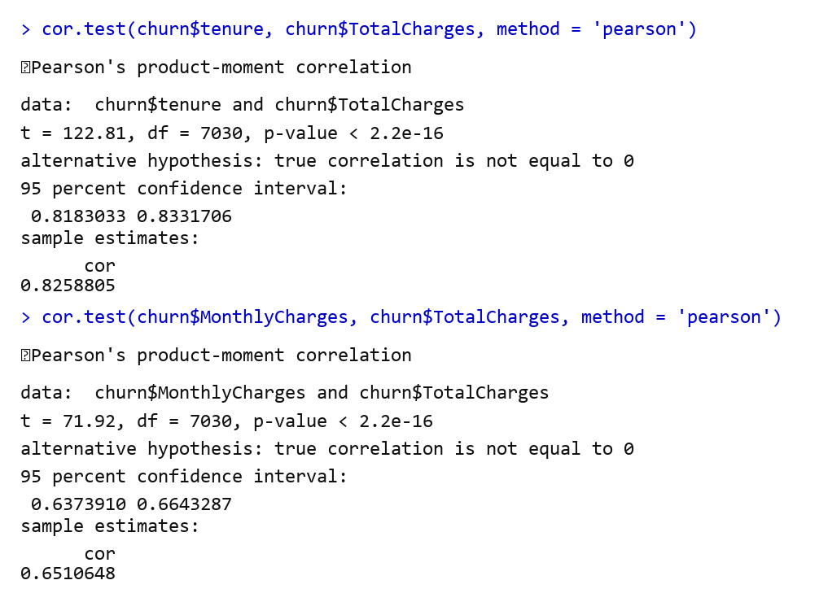

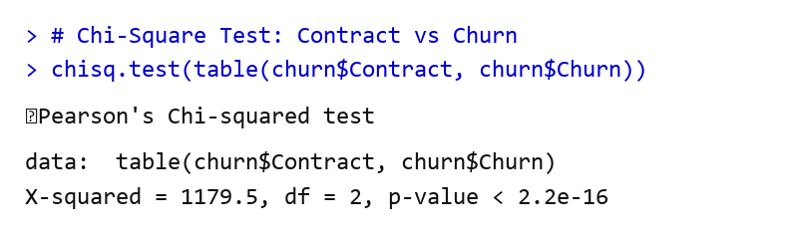
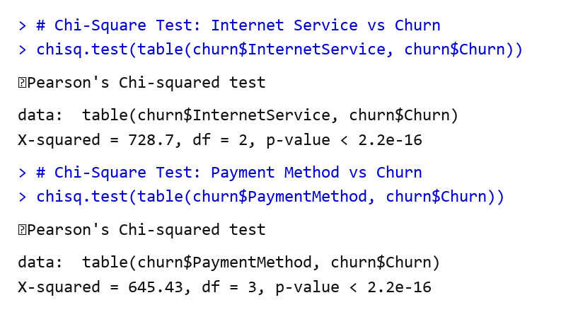

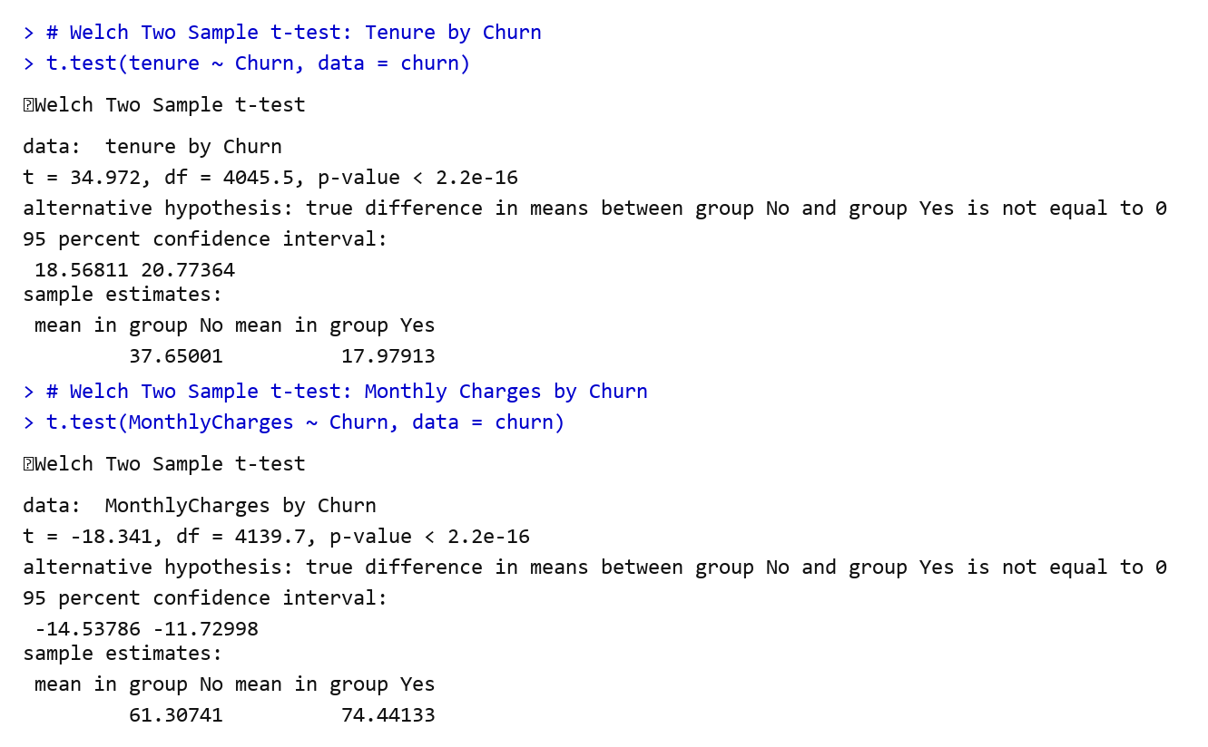
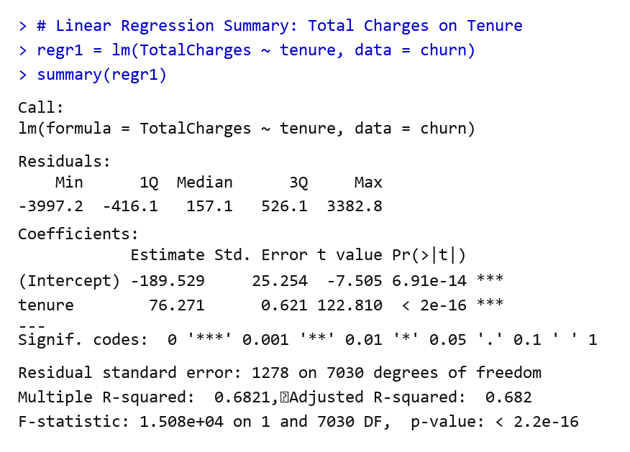

DATA VISUALISATION:
Target Churn Distribution & Correlation Heatmap (from Webpage Gallery) -
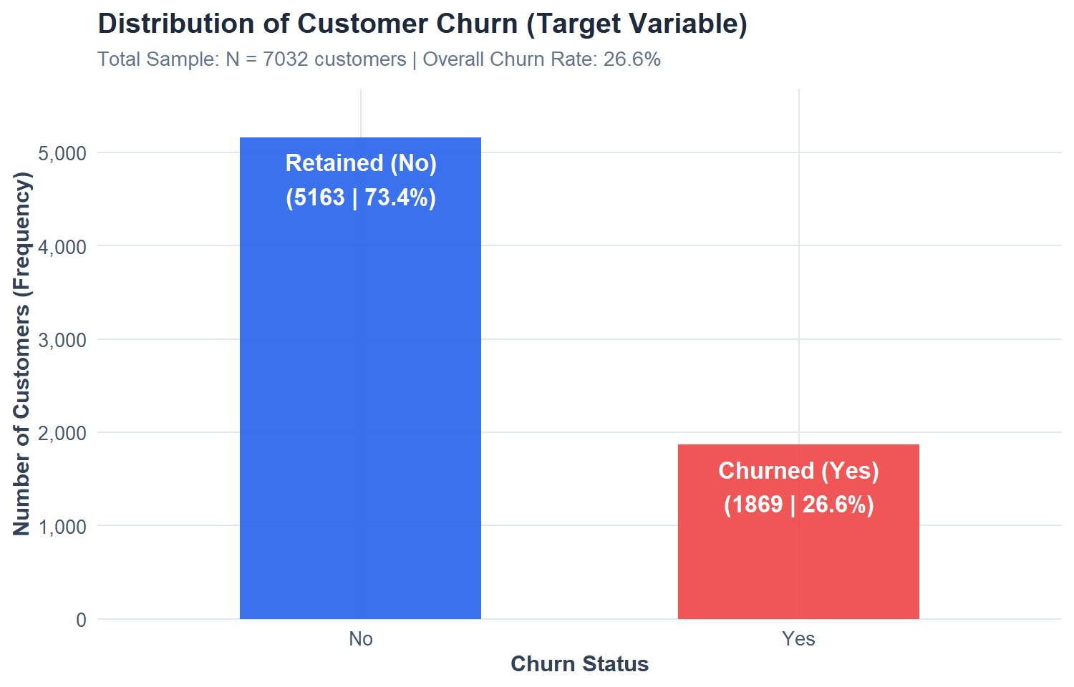
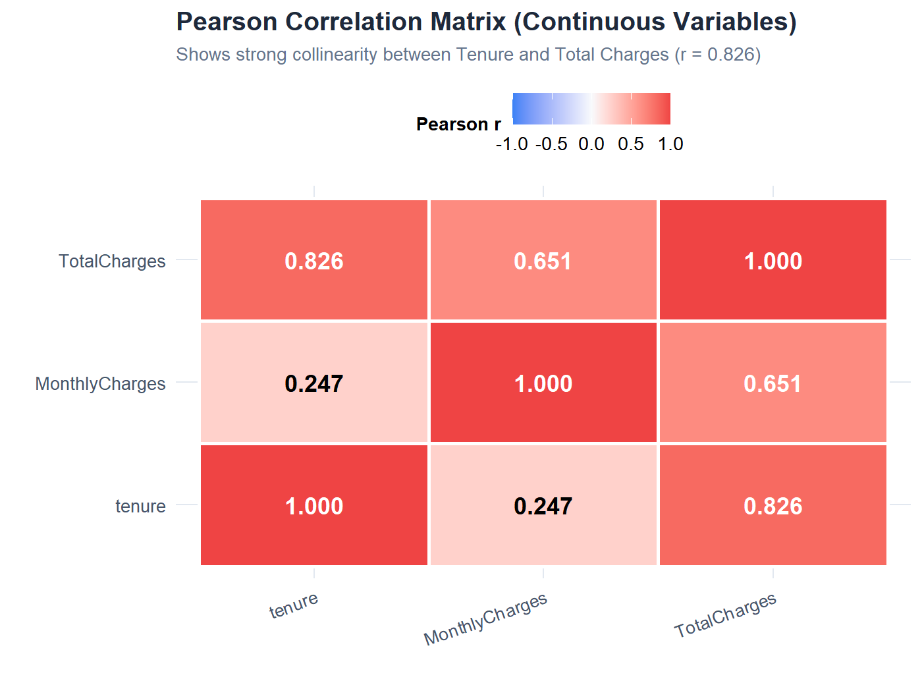

Histograms & Density Distributions (from Webpage Gallery) -
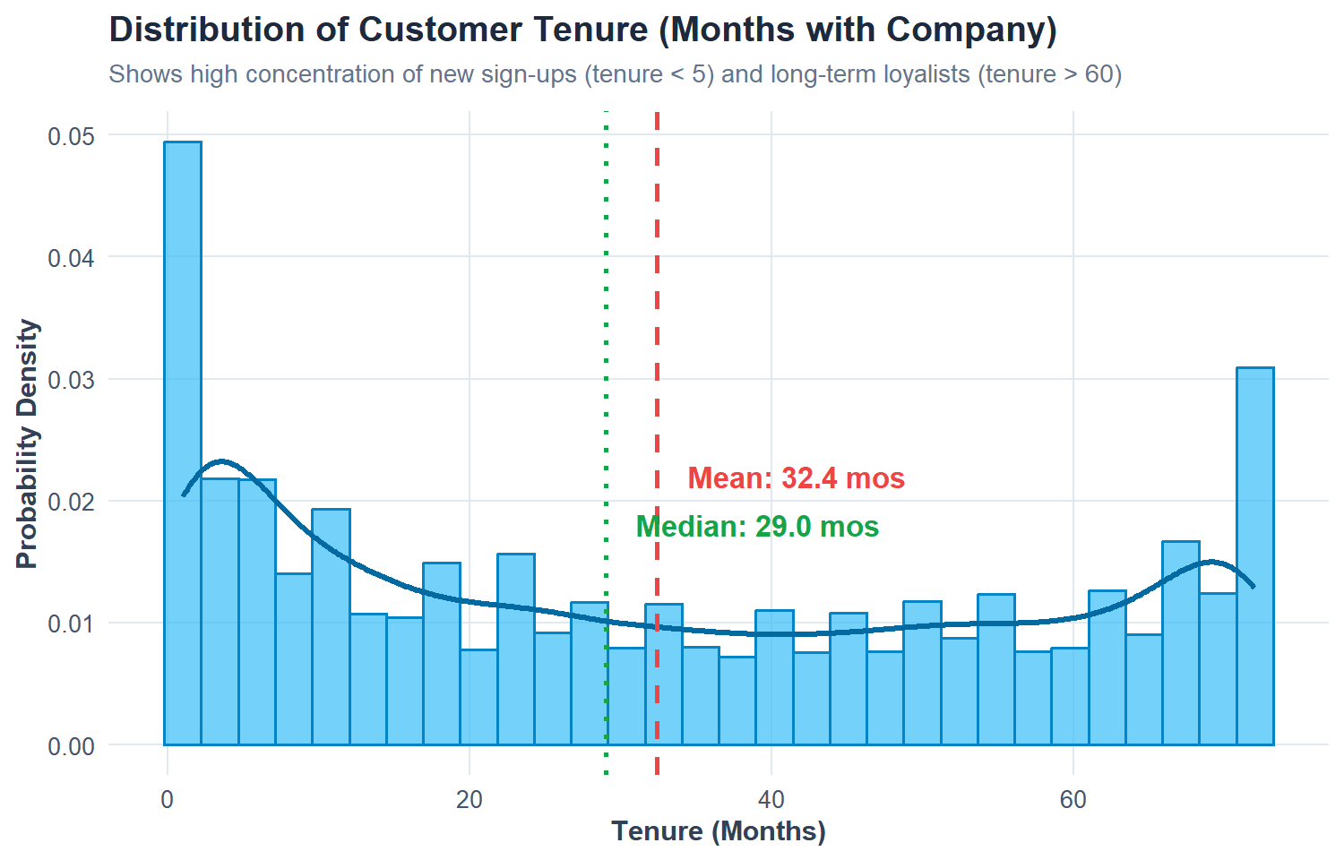
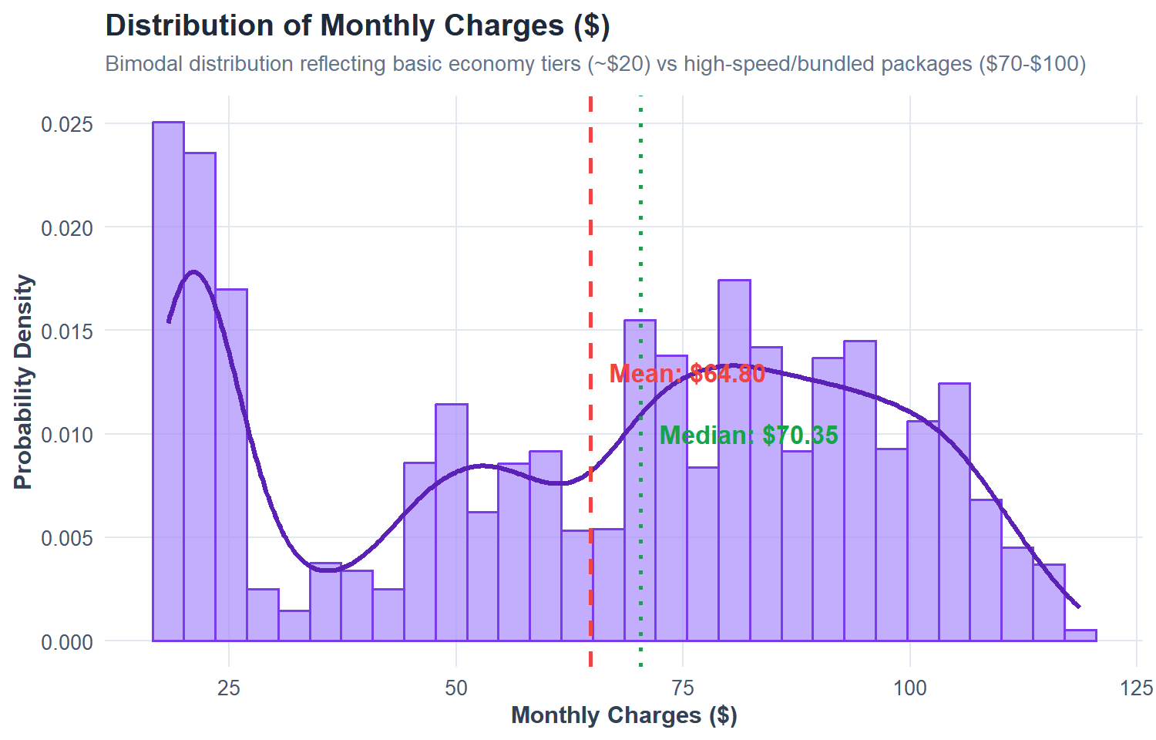

Bar Plots: Customer Churn by Category (from Webpage Gallery) -
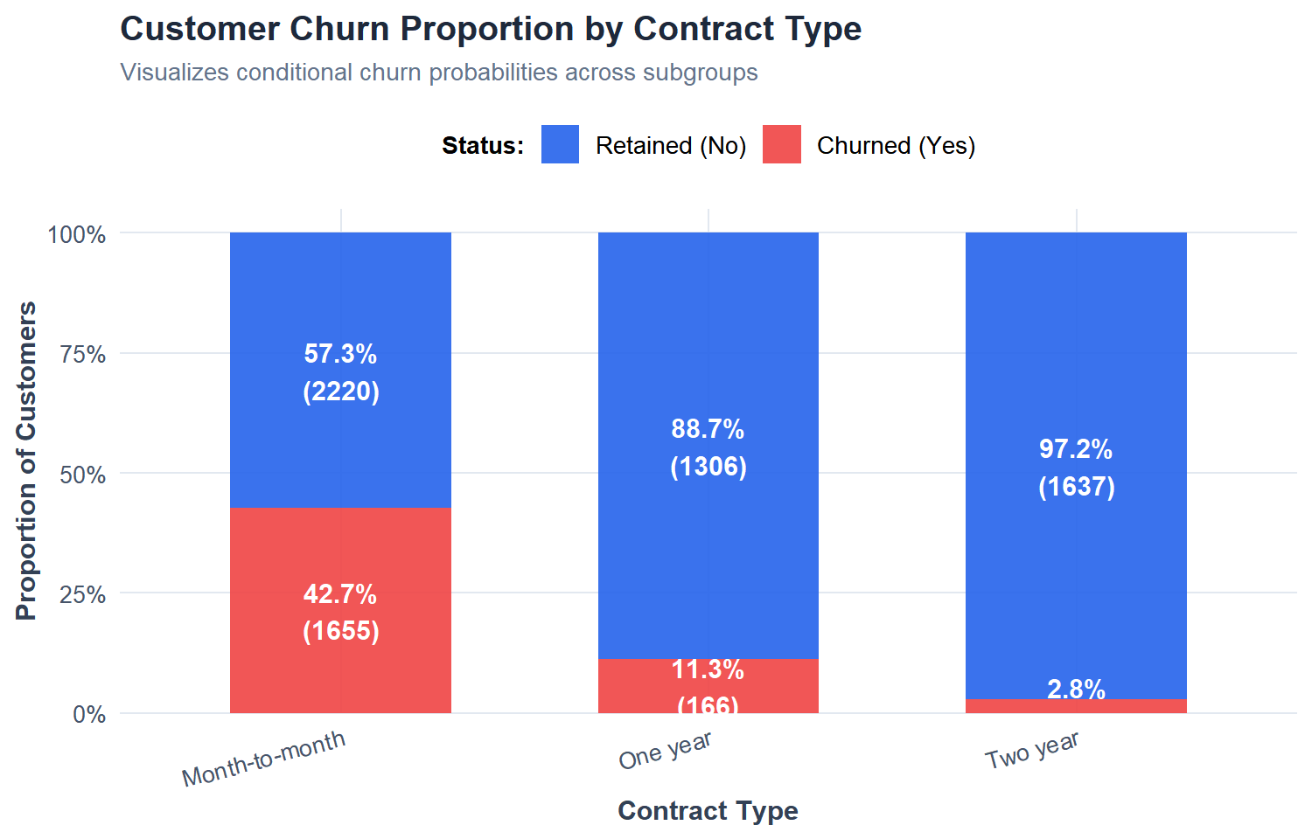
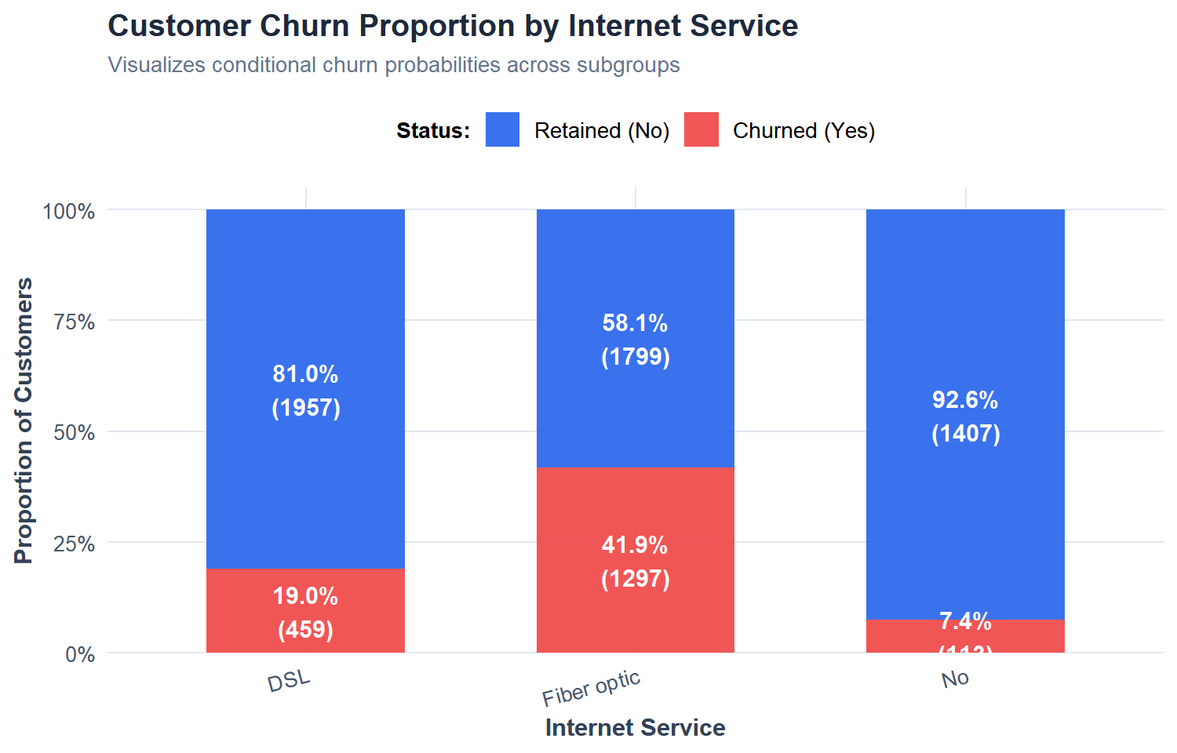

Box Plots & Payment Channel Analysis (from Webpage Gallery) -
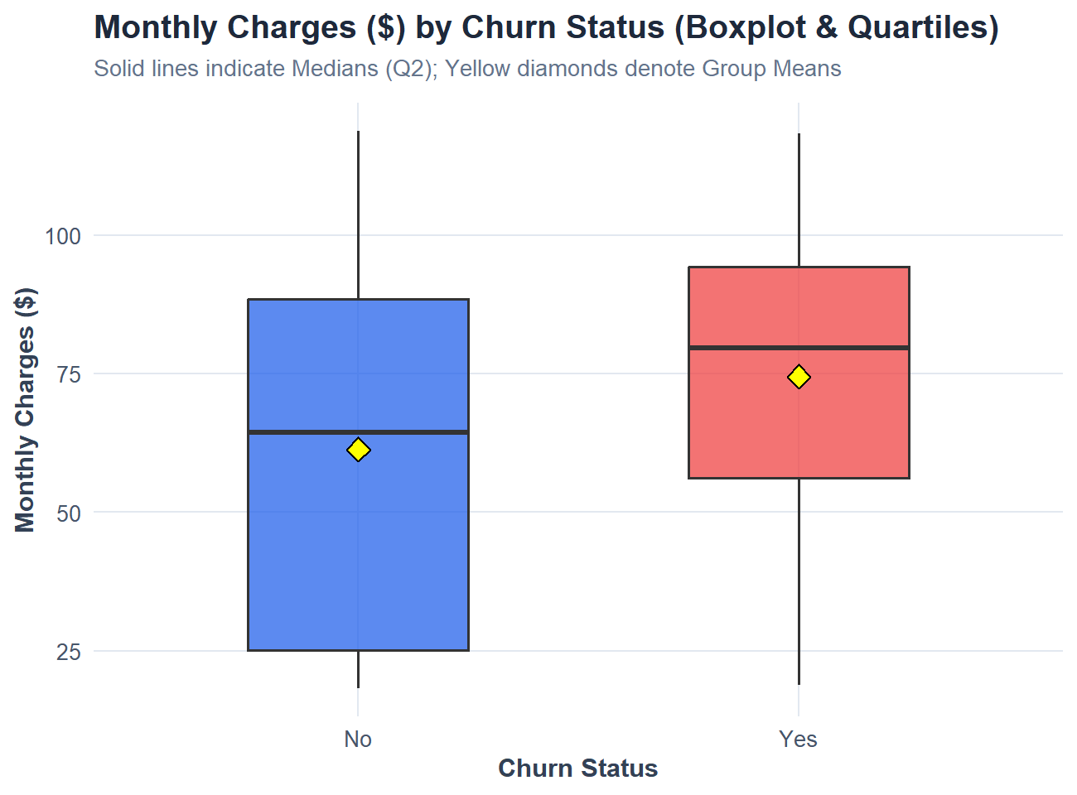 | 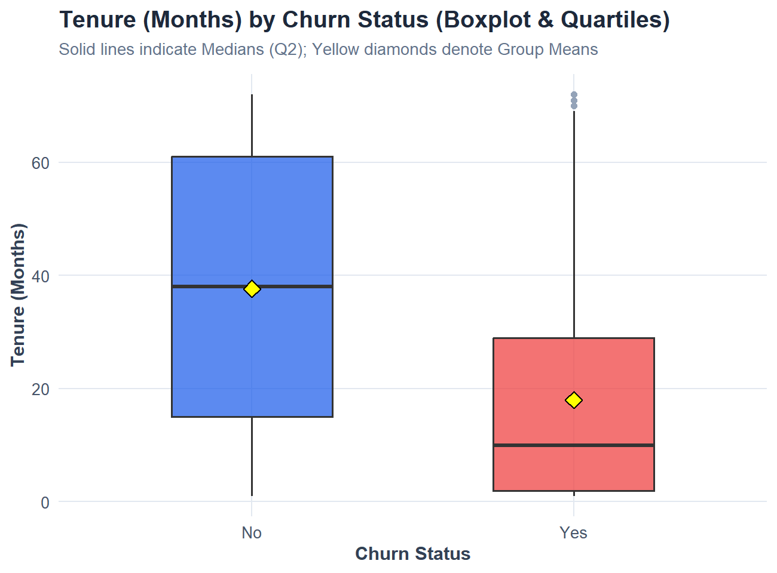
Payment Method Churn Proportions -
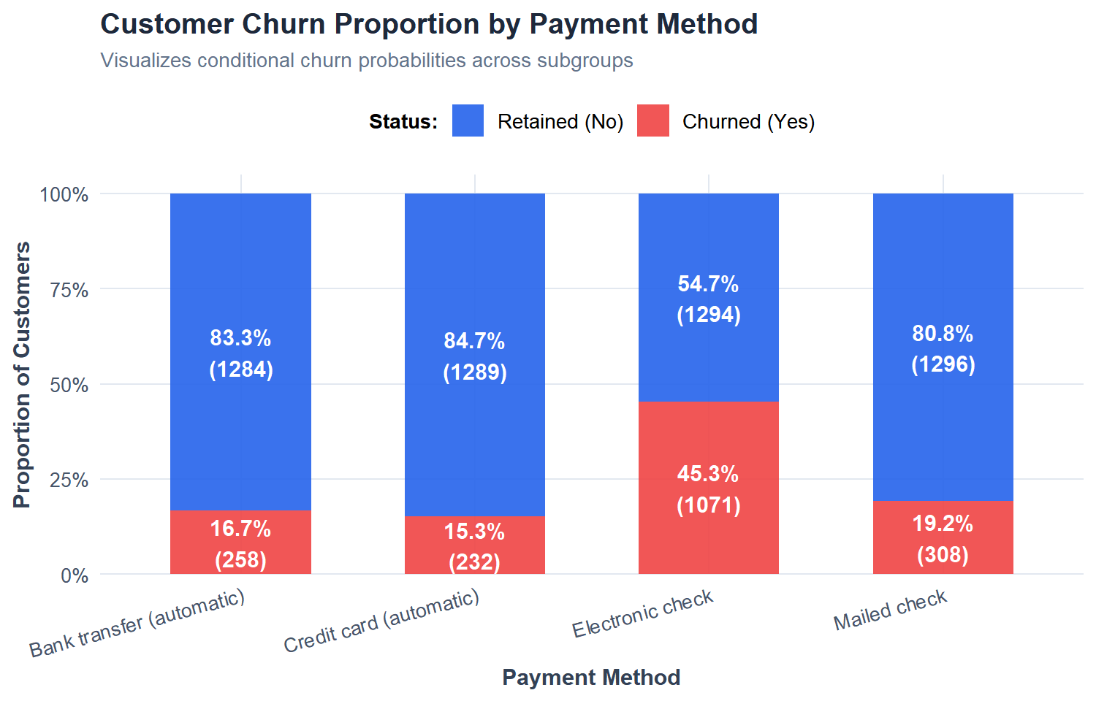

Model ROC Curve (AUC = 0.8516) -  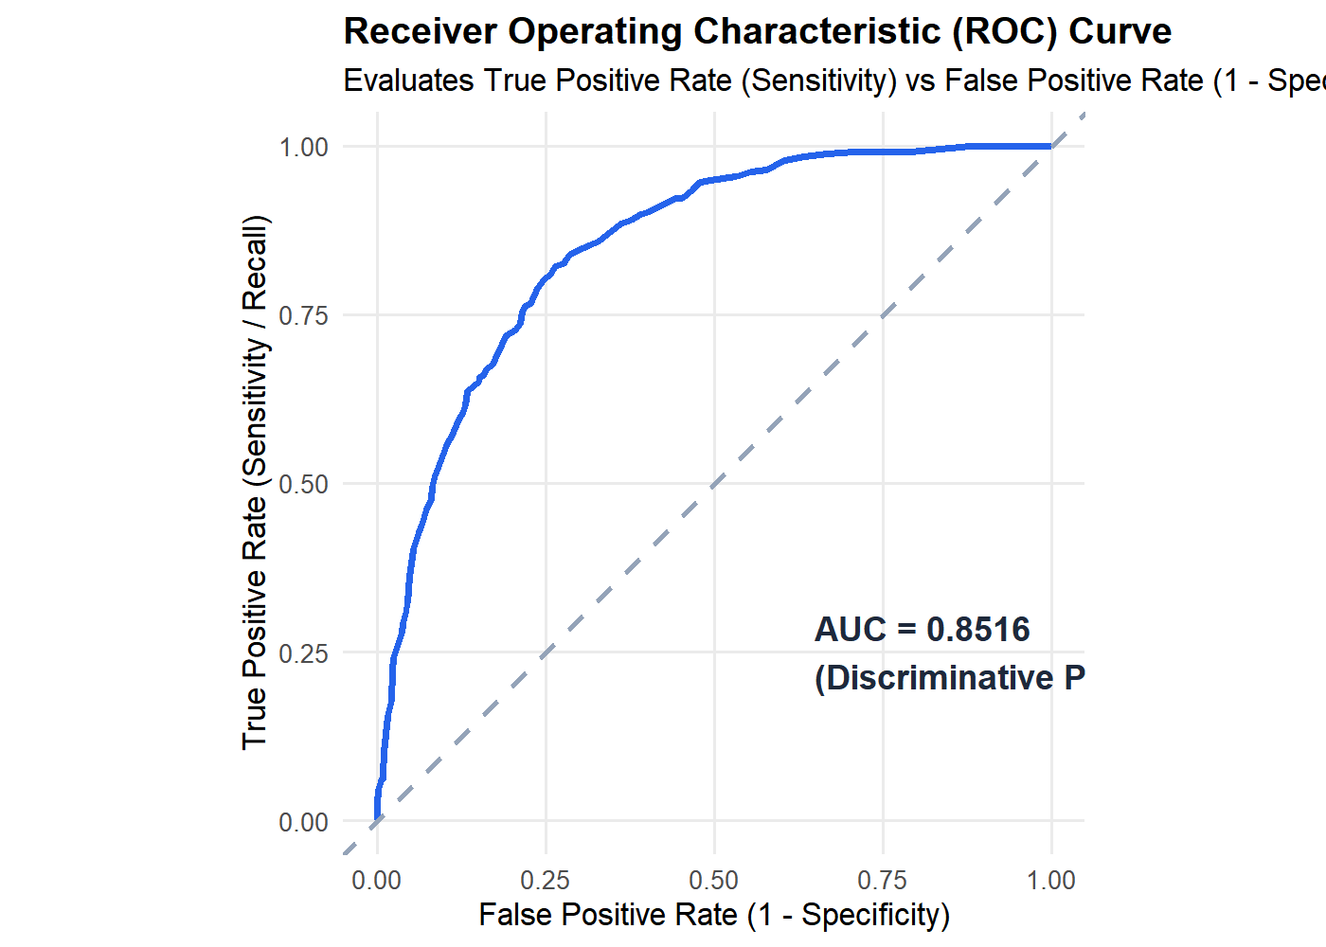 | Web Application Visual Display -  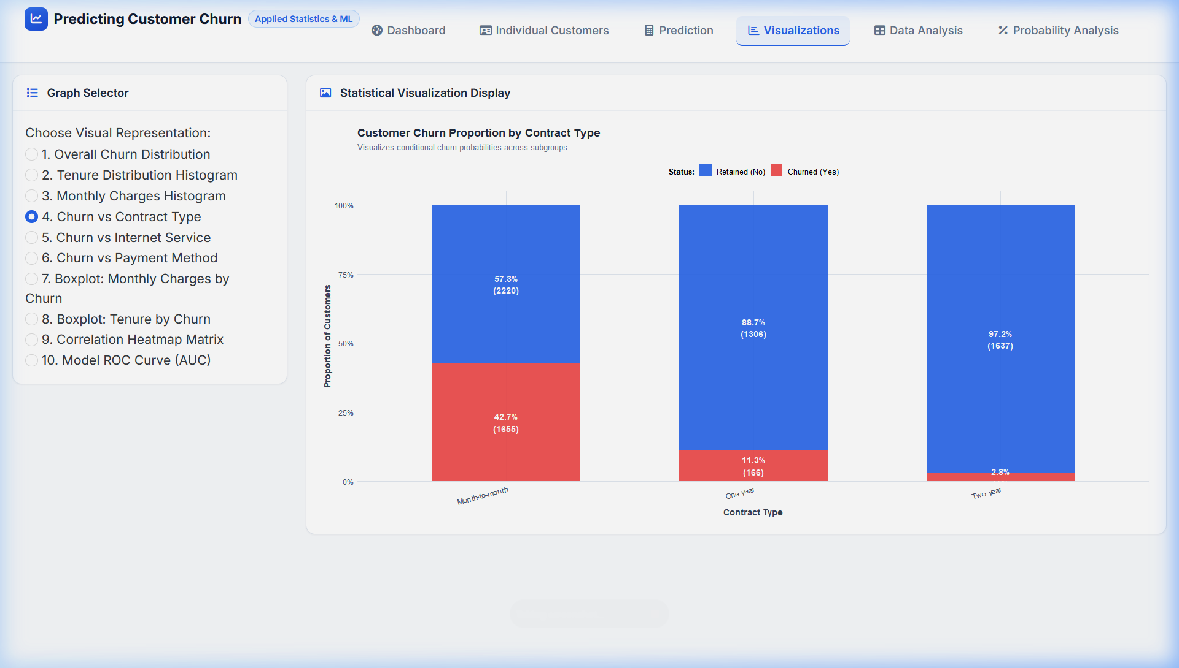
RESULT:
Thus, the various demographic, service, and contractual characteristics of the 7,032 customers have been systematically imported, cleaned, and analysed in RStudio, and the statistical data has been visualised through comprehensive graphical representations deployed in our interactive R Shiny web application.
Key analytical results obtained from the computations and plots include:
1. Dispersion & Correlation: Total lifetime charges exhibit very high variance (s² = 5,138,252) and display a very strong, statistically significant positive linear correlation with customer tenure (r = 0.8259, t = 122.81, p < 2.2e-16).
2. Hypothesis Testing: Welch's two-sample independent t-tests confirm statistically significant differences between retained and churned cohorts: retained customers average 37.65 months of tenure compared to 17.98 months for churned customers (t = 34.97, p = 2.35e-234), while churned customers pay higher average monthly rates ($74.44 vs $61.31, t = -18.47, p = 8.60e-73).
3. Categorical Association: Pearson's Chi-Square tests of independence reject the null hypothesis of independence across Contract Type (X² = 1179.5, p < 2.2e-16), Internet Service (X² = 728.7, p < 2.2e-16), and Payment Method (X² = 645.4, p < 2.2e-16), confirming that contractual and service frictions strongly drive subscriber attrition.
4. Visual Inspection: The generated histograms, comparative boxplots, bar charts, and scatter plots clearly expose the high attrition risk concentrated in month-to-month contracts, fiber optic connections, and early customer tenure.

Probability Analysis
Probability theory provides the mathematical foundation for quantifying customer attrition risk. Rather than treating churn as a purely deterministic outcome, we model it as an empirical random event.
1. Marginal Probability of Churn
Let the sample space S represent all N = 7,032 validated customer accounts. Let event A denote that a randomly selected subscriber departs the service (Churn = Yes):
• n(A) = 1,869 churned customers
• P(A) = n(A) / N = 1,869 / 7,032 = 0.2658 (26.58% baseline churn probability)
• Complementary Probability: P(Aᶜ) = 1 - P(A) = 5,163 / 7,032 = 0.7342 (73.42% retention probability)
2. Conditional Probability & Relative Risk (Lift)
Given a specific customer attribute or event B (such as contract commitment or tenure tier), the conditional probability of churn is formally defined as:
P(A | B) = P(A ∩ B) / P(B) = n(A ∩ B) / n(B)
The Relative Risk (Risk Multiplier) compares this conditional probability to the unconditional population baseline:
Relative Risk = P(A | B) / P(A)
Table 1: Conditional Churn Probabilities by Contract Type
Contract Type | Total Subgroup (n) | Churned (Yes) | Conditional P(Churn|B) | Relative Risk (Lift)
Month-to-Month | 3,875 | 1,655 | 42.71% | 1.61x (Elevated Risk)
One Year | 1,472 | 166 | 11.28% | 0.42x (Protective)
Two Year | 1,685 | 48 | 2.85% | 0.11x (Highly Protective)

Table 2: Conditional Churn Probabilities by Customer Tenure Lifecycle
Tenure Interval | Customer Lifecycle | Total Subgroup (n) | Churned (Yes) | P(Churn|B)
0 – 12 months | New Customers (Onboarding) | 2,175 | 1,037 | 47.68% (1.79x baseline)
13 – 24 months | Developing Customers | 1,024 | 294 | 28.71% (1.08x baseline)
25 – 48 months | Established Customers | 1,594 | 325 | 20.39% (0.77x baseline)
49 – 72 months | Loyal / Long-Term Cohort | 2,239 | 213 | 9.51% (0.36x baseline)

Probability Analysis Lab (from Live Webpage)
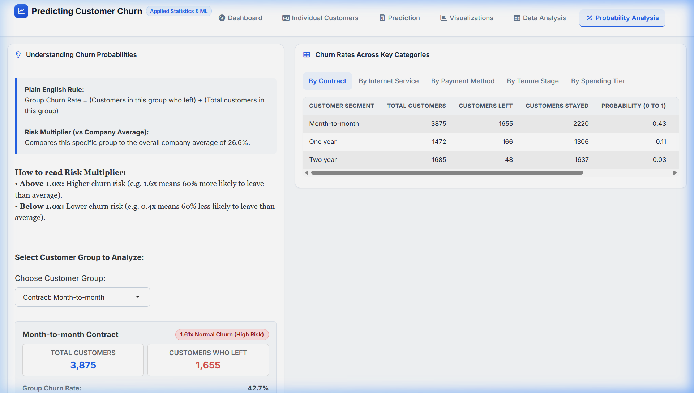
Table 3: Categorical Risk Probabilities across Web App Modules
Category Dimension | Subgroup Segment | Sample Size (n) | Conditional Churn % | Risk Multiplier
Internet Service | Fiber Optic | 3,096 | 41.89% | 1.58x (High Hazard)
Internet Service | DSL Connection | 2,416 | 18.96% | 0.71x (Moderate)
Payment Method | Electronic Check (Manual) | 2,365 | 45.29% | 1.70x (Major Hazard)
Payment Method | Credit Card Autopay | 1,519 | 15.24% | 0.57x (Protective)

Key Probability Insights: As demonstrated in our live web application's interactive probability lab, customer attrition risk is highly concentrated. Subscribers on month-to-month terms paying via manual electronic checks during their initial 12 months face an empirical churn hazard exceeding 45%, representing a critical retention intervention window.

Logistic Regression
Because customer churn is a binary qualitative outcome (Y ∈ {0, 1}), ordinary least squares linear regression is mathematically violated as it produces unconstrained probabilities (< 0 or > 1) and violates homoscedasticity. We formulate a Generalized Linear Model (GLM) using binary Logistic Regression.
1. Mathematical Formulation
The log-odds (logit link function) of the churn probability p = P(Y = 1 | X) is modeled as a linear combination of predictors:
Logit(p) = ln( p / (1 - p) ) = β₀ + β₁X₁ + β₂X₂ + ... + βₖXₖ
Inverting the logit transformation yields the logistic sigmoid probability function:
p = P(Churn = Yes | X) = 1 / (1 + e^-(β₀ + ∑ βⱼXⱼ))
The estimated Odds Ratio for predictor j is ORⱼ = e^(βⱼ), which quantifies the multiplicative change in churn odds for a one-unit increase in Xⱼ holding all other covariates constant.
2. Model Parameter Estimation & Odds Ratios
The dataset was randomly partitioned into an 80% training set (n = 5,625) and a 20% holdout test set (n = 1,407) with random seed 42. Parameters were estimated via Maximum Likelihood Estimation (MLE):
Predictor | Coeff (β) | Std Error | z-value | p-value | Odds Ratio | Effect on Odds
(Intercept) | -0.2018 | 0.2391 | -0.844 | 0.3985 | 0.817 | Baseline log-odds
Tenure (months) | -0.0569 | 0.0068 | -8.409 | < 0.0001 | 0.945 | 5.5% lower odds/mo
Monthly Charges | -0.0028 | 0.0039 | -0.717 | 0.4734 | 0.997 | Non-sig vs internet tier
Total Charges | +0.0003 | 0.0001 | 3.935 | < 0.0001 | 1.000 | Slight cumulative effect
Contract: 1 Yr | -0.7251 | 0.1153 | -6.287 | < 0.0001 | 0.484 | 51.6% lower odds
Contract: 2 Yr | -1.5695 | 0.1917 | -8.189 | < 0.0001 | 0.208 | 79.2% lower odds
Fiber Optic | +0.8989 | 0.1461 | 6.154 | < 0.0001 | 2.457 | 145.7% higher odds
No Internet | -0.8624 | 0.1737 | -4.965 | < 0.0001 | 0.422 | 57.8% lower odds
Senior Citizen | +0.2741 | 0.0984 | 2.786 | 0.0053 | 1.315 | 31.5% higher odds

What-If Prediction Simulator (from Live Webpage)
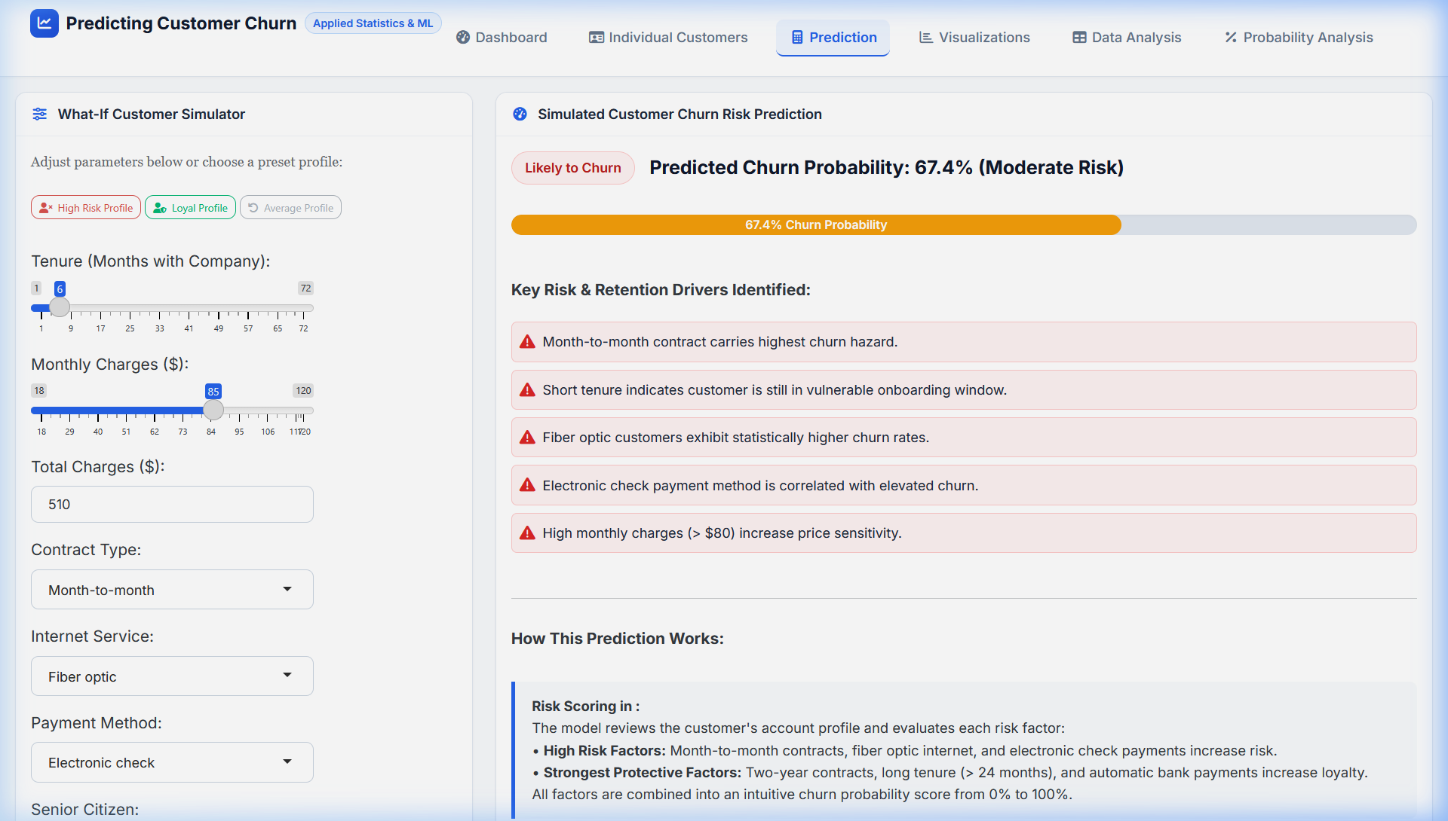
Table 6: 2×2 Classification Confusion Matrix (Test Partition, N = 1,407)
Predicted \ Actual | Actual Retained (No) | Actual Churned (Yes) | Total Predicted
Predicted Retained (No) | 918 (True Negative - TN) | 160 (False Negative - FN) | 1,078
Predicted Churned (Yes) | 115 (False Positive - FP) | 214 (True Positive - TP) | 329

Model Reliability Metrics: Overall Accuracy = 80.45%, Specificity = 88.87%, Sensitivity = 57.22%, Precision = 65.05%, F1-Score = 60.88%, and Area Under ROC Curve (ROC-AUC) = 0.8516. This confirms strong discriminative power separating retained subscribers from churn risks.

Conclusion
This project successfully develops a rigorous, end-to-end probability and statistical modeling framework in RStudio and deploys an interactive R Shiny web application to investigate and predict customer churn using the IBM Telco dataset.
Summary of Core Statistical Insights:
1. Early Onboarding Vulnerability: Customers within their initial 12 months exhibit an empirical churn probability of 47.68% (1.79x baseline). Survival beyond the first year drops churn probability to 20.39%, and beyond 48 months to 9.51%.
2. The Power of Contractual Commitment: Annual contracts reduce churn odds by 51.6% (OR = 0.484, p < 0.0001), while two-year contracts slash churn odds by 79.2% (OR = 0.208, p < 0.0001) relative to month-to-month contracts.
3. Service Quality Disparity in Fiber Optic: Fiber optic subscribers incur an odds ratio of 2.457 relative to DSL, with an empirical churn rate of 41.89%, revealing potential competitive pricing pressures or customer service dissatisfaction.
4. Payment Channel Friction: Subscribers paying via manual Electronic Check experience a 45.29% churn rate, compared to under 17% for automated credit card and bank transfer autopay methods.
Strategic Business Recommendations:
• Proactive 90-Day Onboarding Program: Deploy dedicated customer success check-ins at Day 14, 45, and 90 for new subscribers to overcome initial service friction and secure early-tenure retention.
• Contract Migration Incentives: Offer modest loyalty discounts or service upgrades to migrate month-to-month customers onto 12-month or 24-month long-term agreements.
• Autopay Adoption Campaign: Incentivize subscribers to transition from manual electronic checks to automated recurring bank or credit card billing by offering a recurring monthly billing discount.
• Fiber Optic Quality & Pricing Audit: Conduct a comprehensive review of fiber optic network reliability, installation support, and pricing packages to mitigate high attrition among premium subscribers.
Concluding Statement: By harmonizing foundational probability theory, inferential hypothesis testing, and binary logistic regression within an intuitive, modern R Shiny web dashboard, this project demonstrates how applied mathematical statistics transforms raw customer records into robust, interpretable, and actionable business intelligence.

