**13.Bank Transaction**

**i.)**

**CREATE TABLE BANK(acc_id INT PRIMARY KEY,acc_name VARCHAR(123),bank_location VARCHAR(123),balance INT)**

**INSERT INTO BANK VALUES(1001,'John justin','Trichy',5023);**

**INSERT INTO BANK VALUES(1002,'LOGAN','Chennai',10000);**

**INSERT INTO BANK VALUES(1003,'Vector','Coimbatore',8123);**

**INSERT INTO BANK VALUES(1004,'Wade','Kodaikonal',15000);**

**INSERT INTO BANK VALUES(1005,'Kira','Kanchipuram',75004);**

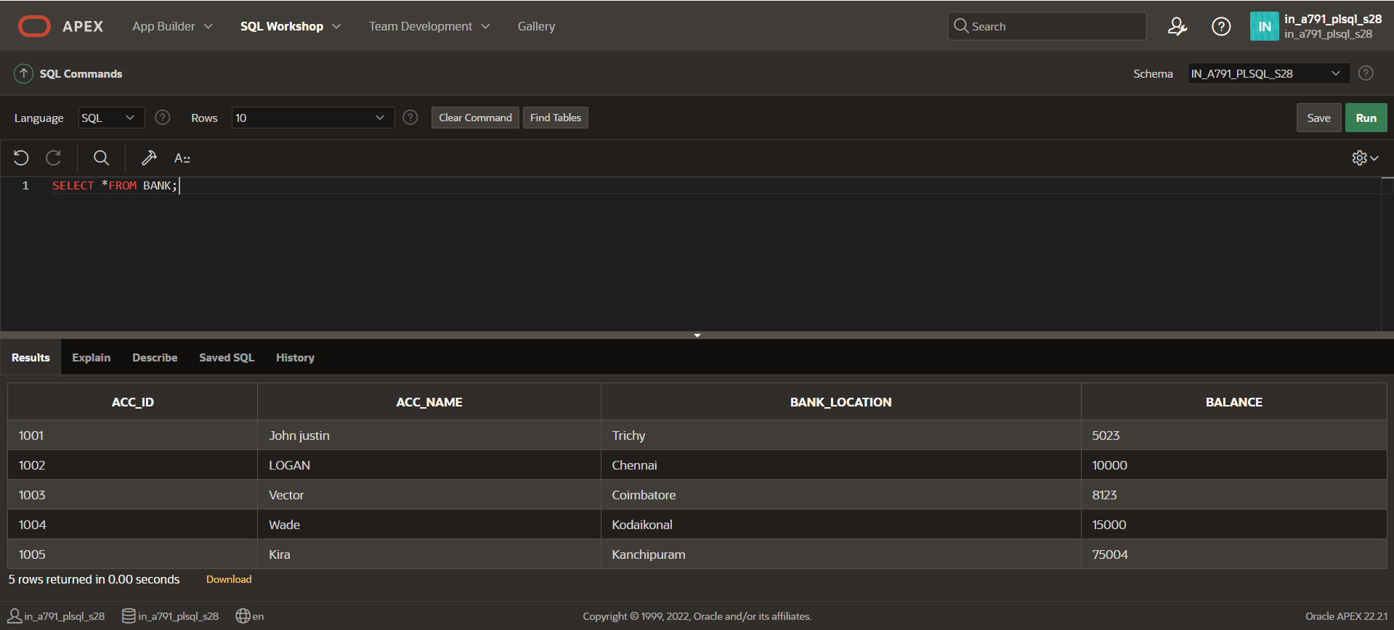

**MERGE INTO BANK b USING(**

**SELECT 2 AS acc_id FROM DUAL**

**)t**

**ON(b.acc_id=t.acc_id)**

**WHEN MATCHED THEN**

**UPDATE SET b.balance=b.balance-200;**

**SELECT *FROM BANK;**

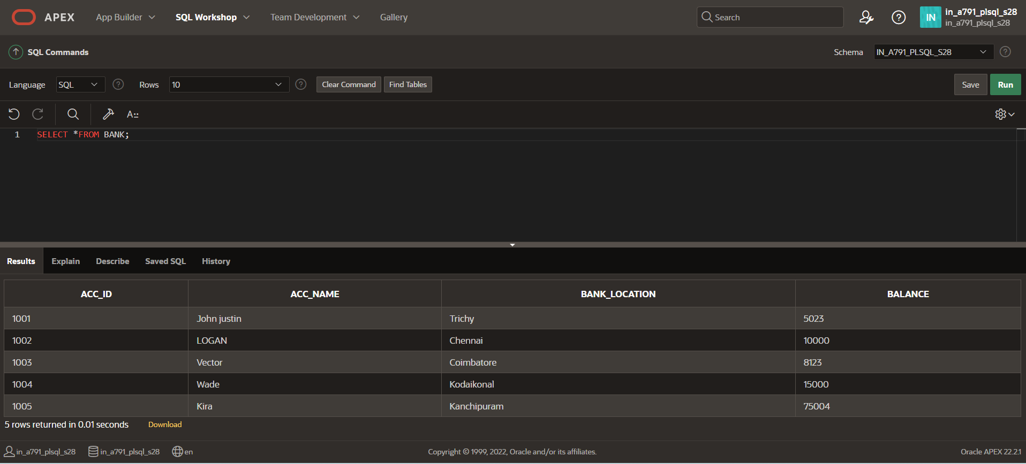

**BEGIN**

**UPDATE BANK SET balance=balance-100.0 WHERE acc_id=1001;**

**SAVEPOINT S1;**

**UPDATE BANK SET balance=balance-200.0 WHERE acc_id=1002;**

**SAVEPOINT S2;**

**UPDATE BANK SET balance=balance-300.0 WHERE acc_id=1003;**

**SAVEPOINT S3;**

**UPDATE BANK SET balance=balance-400.0 WHERE acc_id=1004;**

**ROLLBACK TO S1;**

**COMMIT;**

**END;**

**/**

**SELECT *FROM BANK;**

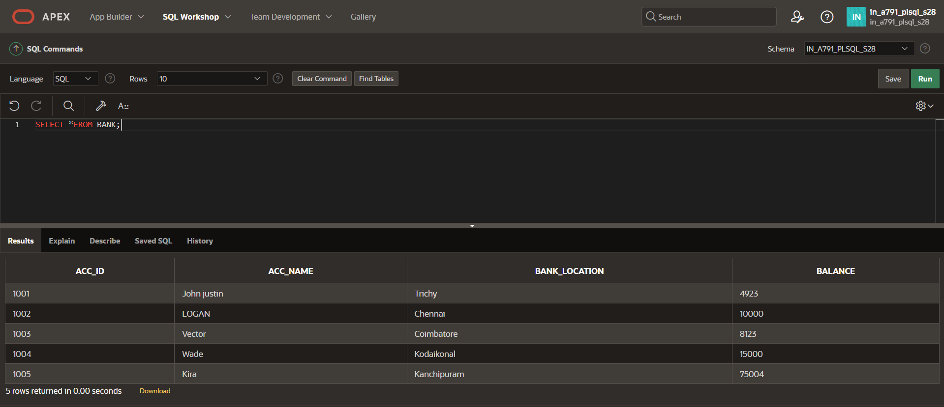

**ii.)**

**CREATE TABLE BANK(acc_id INT PRIMARY KEY,acc_name VARCHAR(123),bank_location VARCHAR(123),balance INT)**

**INSERT INTO BANK VALUES(1001,'John justin','Trichy',5023);**

**INSERT INTO BANK VALUES(1002,'LOGAN','Chennai',10000);**

**INSERT INTO BANK VALUES(1003,'Vector','Coimbatore',8123);**

**INSERT INTO BANK VALUES(1004,'Wade','Kodaikonal',15000);**

**INSERT INTO BANK VALUES(1005,'Kira','Kanchipuram',75004);**



**CREATE TABLE TRANSACTIONS(Tran_id INT PRIMARY KEY,acc_id INT,type_trans VARCHAR(123),amount INT,FOREIGN KEY(acc_id) REFERENCES BANK(acc_id));**

**INSERT INTO TRANSACTIONS(100,1004,'Deposit',100);**

**INSERT INTO TRANSACTIONS VALUES(101,1002,'Deposit',1000);**

**INSERT INTO TRANSACTIONS VALUES(102,1001,'Withdraw',2000);**

**INSERT INTO TRANSACTIONS VALUES(103,1003,'Withdraw',200);**

**INSERT INTO TRANSACTIONS VALUES(104,1005,'Deposit',15000);**

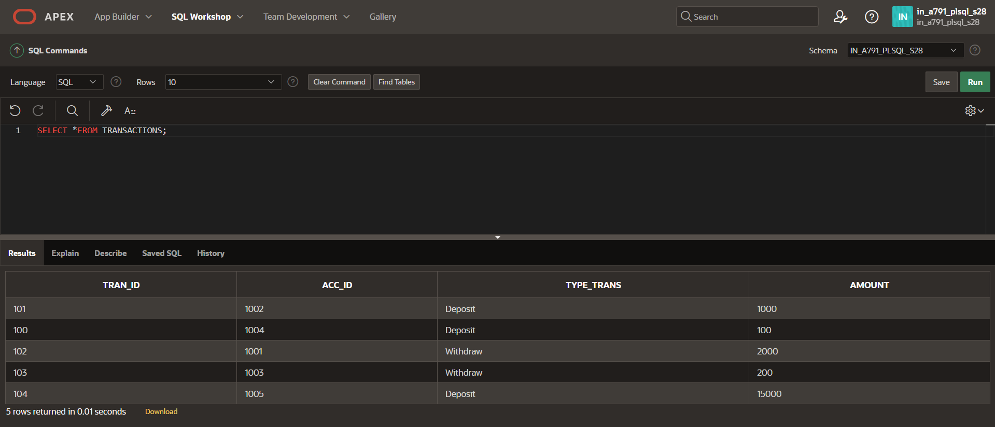

**MERGE INTO BANK b USING(**

**SELECT acc_id,amount**

**FROM TRANSACTIONS**

**WHERE TYPE_TRANS ='Withdrawal'**

**)t**

**ON(b.acc_id=t.acc_id)**

**WHEN MATCHED THEN**

**UPDATE SET b.balance=b.balance-t.amount;**

**SELECT *FROM BANK;**

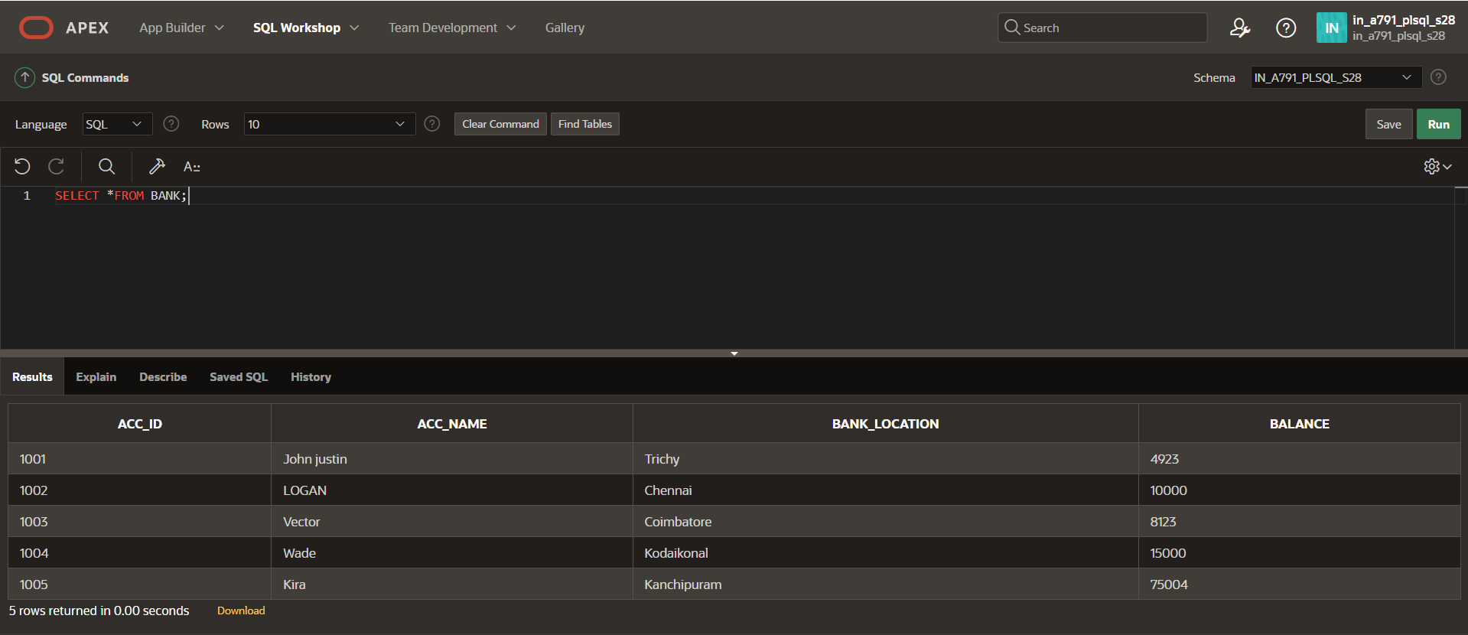

**BEGIN**

**UPDATE BANK SET balance = balance - 100 WHERE acc_id = 1001;**

**INSERT INTO TRANSACTIONS VALUES (106, 1001, 'Withdraw', 100);**

**SAVEPOINT S1;**

**UPDATE BANK SET balance = balance - 200 WHERE acc_id = 1002;**

**INSERT INTO TRANSACTIONS VALUES (107, 1002, 'Withdraw', 200);**

**SAVEPOINT S2;**

**UPDATE BANK SET balance = balance - 300 WHERE acc_id = 1003;**

**INSERT INTO TRANSACTIONS VALUES (108, 1003, 'Withdraw', 300);**

**SAVEPOINT S3;**

**UPDATE BANK SET balance = balance - 400 WHERE acc_id = 1004; -- Changed 500 to 400 for consistency**

**INSERT INTO TRANSACTIONS VALUES (109, 1004, 'Withdraw', 400);**

**ROLLBACK TO S2;**

**COMMIT;**

**END;**

**/**

**SELECT *FROM TRANSACTIONS;**

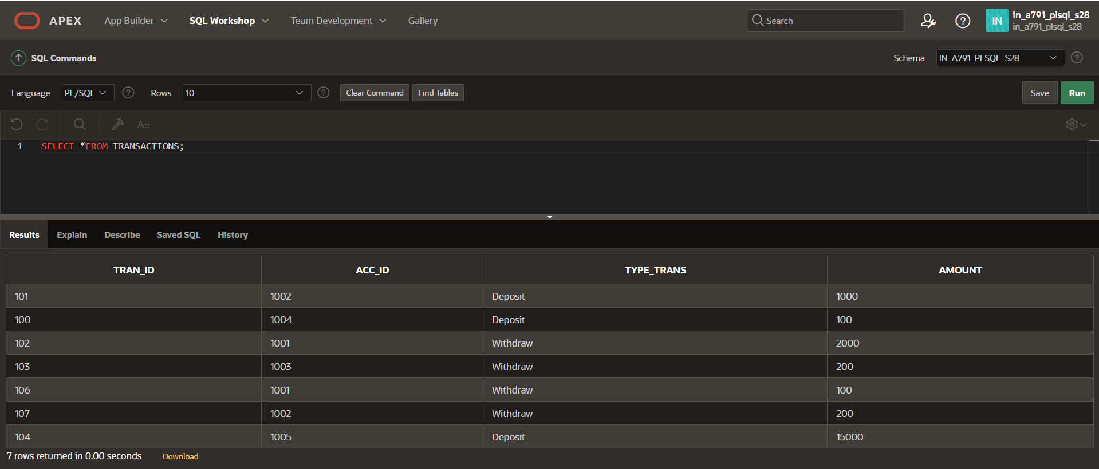

**SELECT *FROM BANK;**

