**14.STUDENT REPORT**

**WITHOUT TABLE:**

**CREATE OR REPLACE PROCEDURE STUDENT123(**

**n VARCHAR2,**

**n_id number,**

**m1 number,**

**m2 number,**

**m3 number,**

**m4 number,**

**m5 number**

**) IS**

**z number;**

**BEGIN**

**z:=(m1+m2+m3+m4+m5)/5;**

**IF z>90 THEN**

**DBMS_OUTPUT.PUT_LINE('Out standing');**

**ELSIF z>=80 AND z<=90 THEN**

**DBMS_OUTPUT.PUT_LINE('Distinction');**

**ELSIF z>=70 AND z<=79 THEN**

**DBMS_OUTPUT.PUT_LINE('Good');**

**ELSIF z>=60 AND z<=69 THEN**

**DBMS_OUTPUT.PUT_LINE('First class');**

**ELSIF z>=50 AND z<=59 THEN**

**DBMS_OUTPUT.PUT_LINE('Second class');**

**ELSE**

**DBMS_OUTPUT.PUT_LINE('FAIL');**

**END IF;**

**END;**

**/**

**BEGIN STUDENT123('Dhilip',5013,87,89,91,79,78);**

**END;**

**/**

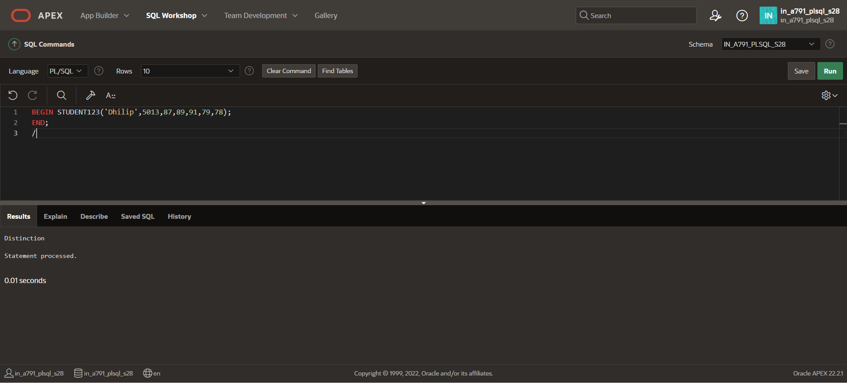

**WITH TABLE:**

**CREATE TABLE STUDENT_GRADE(stu_name VARCHAR(123),stu_id NUMBER PRIMARY KEY,m1 INT,m2 INT,m3 INT,m4 INT,m5 INT);**

**INSERT INTO STUDENT_GRADE VALUES('Dhilip',5013,87,80,92,81,98);**

**SELECT *FROM STUDENT_GRADE;**

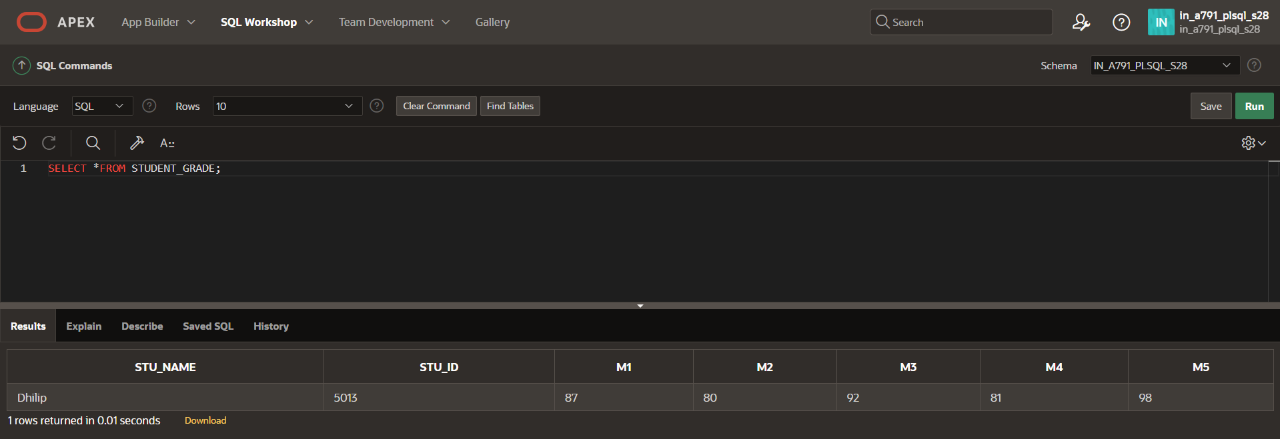

**CREATE OR REPLACE PROCEDURE STU_GRADE(**

**b NUMBER**

**) IS**

**nname VARCHAR(123);**

**nm1 INT;**

**nm2 INT;**

**nm3 INT;**

**nm4 INT;**

**nm5 INT;**

**navg NUMBER;**

**BEGIN**

**SELECT STU_NAME, M1, M2, M3, M4, M5**

**INTO nname, nm1, nm2, nm3, nm4, nm5**

**FROM STUDENT_GRADE**

**WHERE STU_ID = b;**

**navg := (nm1 + nm2 + nm3 + nm4 + nm5) / 5;**

**dbms_output.put_line('Student Name: ' || nname);**

**dbms_output.put_line('Student ID: ' || b);**

**IF navg >= 90 THEN**

**dbms_output.put_line('OUTSTANDING');**

**ELSIF navg >= 80 THEN**

**dbms_output.put_line('DISTINCTION');**

**ELSIF navg >= 70 THEN**

**dbms_output.put_line('GOOD');**

**ELSIF navg >= 60 THEN**

**dbms_output.put_line('FIRST CLASS');**

**ELSIF navg >= 50 THEN**

**dbms_output.put_line('SECOND CLASS');**

**ELSE**

**dbms_output.put_line('FAIL');**

**END IF;**

**END;**

**/**

**BEGIN**

**STU_GRADE(5013);**

**END;**

**/**

