**22.TRAPPING USER DEFINED RECORDS**

**CREATE TABLE EMPLOYEE4(EMP_ID INT PRIMARY KEY,EMP_NAME VARCHAR(20),DEPT_ID INT,SALARY INT);**

**INSERT INTO EMPLOYEE4 VALUES(1,'Peter',100,10000);**

**INSERT INTO EMPLOYEE4 VALUES(2,'Ben',101,20000);**

**INSERT INTO EMPLOYEE4 VALUES(3,'Kiran',102,30000);**

**INSERT INTO EMPLOYEE4 VALUES(4,'Shaam',103,40000);**

**INSERT INTO EMPLOYEE4 VALUES(5,'Logesh',101,40500);**

**INSERT INTO EMPLOYEE4 VALUES(6,'Kishore',103,50500);**

**INSERT INTO EMPLOYEE4 VALUES(7,'Wajith',105,60100);**

**SELECT *FROM EMPLOYEE4 ORDER BY EMP_ID;**

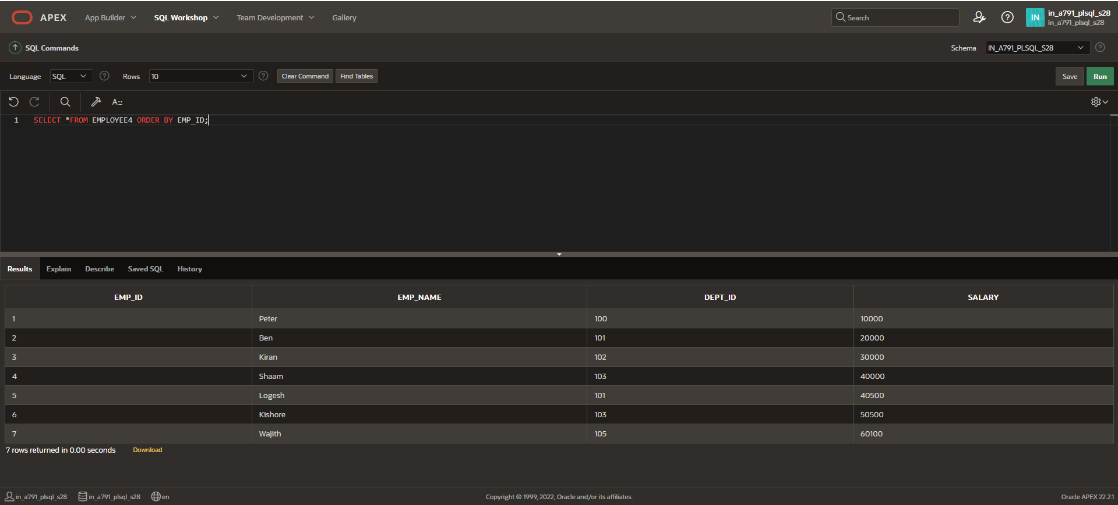

**DECLARE**

**e_name EXCEPTION;**

**PRAGMA EXCEPTION_INIT(e_name, -20999);**

**v_last_name employee4.emp_name%TYPE := 'Wajith';**

**BEGIN**

**DELETE FROM employee4**

**WHERE emp_name = v_last_name;**

**IF SQL%ROWCOUNT = 0 THEN**

**RAISE_APPLICATION_ERROR(-20999, 'Invalid last name');**

**ELSE**

**DBMS_OUTPUT.PUT_LINE(v_last_name ||' deleted');**

**END IF;**

**EXCEPTION**

**WHEN e_name THEN**

**DBMS_OUTPUT.PUT_LINE('Valid last names are: ');**

**FOR c1 IN (SELECT DISTINCT emp_name FROM employee4)**

**LOOP**

**DBMS_OUTPUT.PUT_LINE(c1.emp_name);**

**END LOOP;**

**WHEN OTHERS THEN**

**DBMS_OUTPUT.PUT_LINE('Error deleting from employees');**

**END;**

