**24.RAISE SALARY USING PROCEDURE**

**CREATE TABLE EMPLOYEE_DETAIL (EMP_ID INT PRIMARY KEY,EMP_NAME VARCHAR(20),SALARY INT);**

**INSERT INTO EMPLOYEE_DETAIL VALUES(1,'Ajith',30000);**

**INSERT INTO EMPLOYEE_DETAIL VALUES(2,'Ben',30500);**

**INSERT INTO EMPLOYEE_DETAIL VALUES(3,'Devin',15000);**

**INSERT INTO EMPLOYEE_DETAIL VALUES(4,'Giri',40000);**

**INSERT INTO EMPLOYEE_DETAIL VALUES(5,'Kiran',50000);**

**INSERT INTO EMPLOYEE_DETAIL VALUES(6,'Mohan',47000);**

**SELECT *FROM EMPLOYEE_DETAIL ORDER BY EMP_ID;**

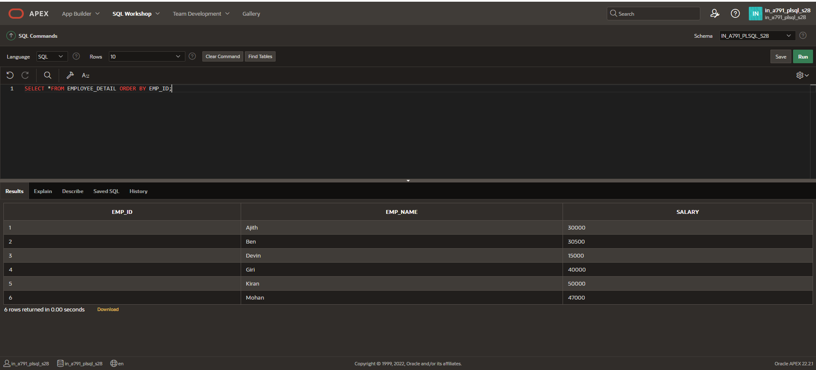

**INCREASE THE SALARY FOR PARTICULAR EMPLOYEE USING PROCEDURE:**

**CREATE OR REPLACE PROCEDURE r_salary**

**(v_emp_id IN EMPLOYEE_DETAIL.EMP_ID%TYPE,**

**v_raise_salary IN INT)**

**IS**

**BEGIN**

**UPDATE EMPLOYEE_DETAIL**

**SET SALARY=SALARY*(1+v_raise_salary/100)**

**WHERE EMP_ID=v_emp_id;**

**END r_salary;**

**BEGIN r_salary(3,10);**

**END;**

**/**

**SELECT *FROM EMPLOYEE_DETAIL ORDER BY EMP_ID;**

