**TAX CALCULATION FOR EMPLOYEE**

**DECLARE**

**CURSOR cemp IS SELECT *FROM EMPLOYEE1;**

**BEGIN**

**FOR c1 in cemp**

**LOOP**

**IF c1.BASIC_SALARY<20000 THEN**

**UPDATE EMPLOYEE1**

**SET TAX=0.1*c1.BASIC_SALARY**

**WHERE EMP_ID=c1.EMP_ID;**

**ELSE IF c1.BASIC_SALARY>=20000 AND c1.BASIC_SALARY<=40000 THEN**

**UPDATE EMPLOYEE1**

**SET TAX=0.2*BASIC_SALARY**

**WHERE EMP_ID=c1.EMP_ID;**

**ELSE**

**UPDATE EMPLOYEE1**

**SET TAX=0.4*BASIC_SALARY**

**WHERE EMP_ID=c1.EMP_ID;**

**END IF;**

**END IF;**

**END LOOP;**

**END;**

**/**

**SELECT *FROM EMPLOYEE1;**

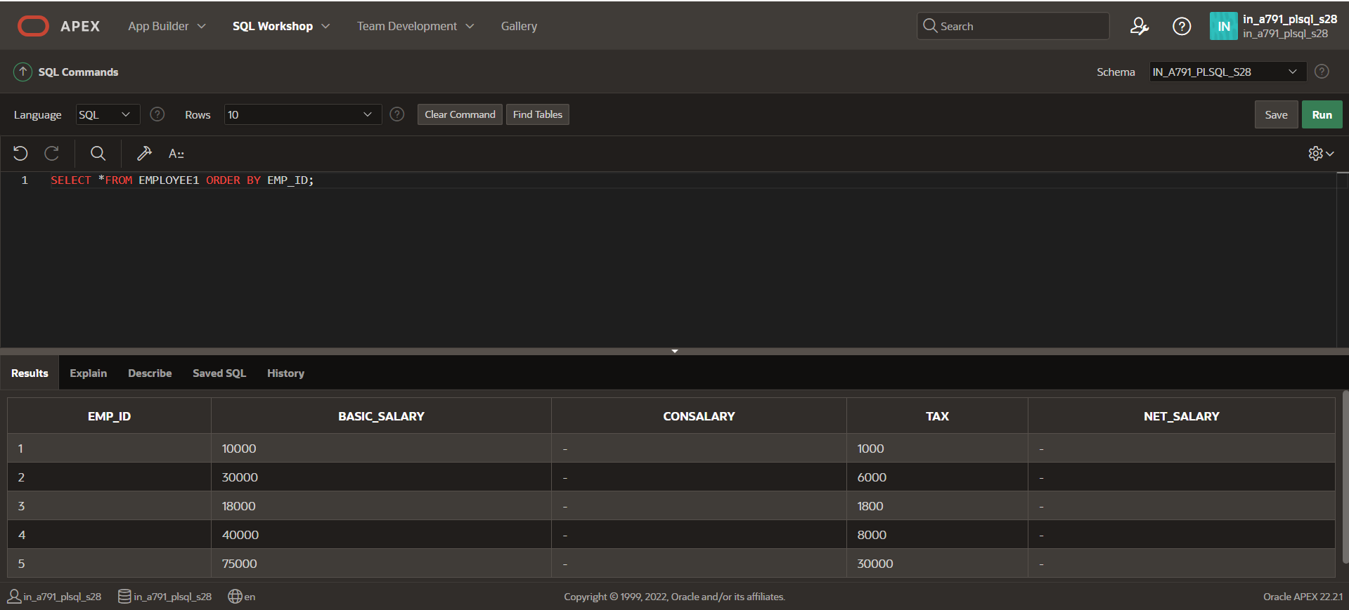

**CANVINANCE SALARY CALCULATION FOR EMPLOYEE**

**DECLARE**

**CURSOR cemp IS SELECT *FROM EMPLOYEE1;**

**BEGIN**

**FOR c1 in cemp**

**LOOP**

**IF c1.BASIC_SALARY<20000 THEN**

**UPDATE EMPLOYEE1**

**SET CONSALARY=0.02*c1.BASIC_SALARY**

**WHERE EMP_ID=c1.EMP_ID;**

**ELSE IF c1.BASIC_SALARY>=20000 AND c1.BASIC_SALARY<=40000 THEN**

**UPDATE EMPLOYEE1**

**SET CONSALARY=0.03*BASIC_SALARY**

**WHERE EMP_ID=c1.EMP_ID;**

**ELSE**

**UPDATE EMPLOYEE1**

**SET CONSALARY=0.05*BASIC_SALARY**

**WHERE EMP_ID=c1.EMP_ID;**

**END IF;**

**END IF;**

**END LOOP;**

**END;**

**/**

**SELECT *FROM EMPLOYEE1;**

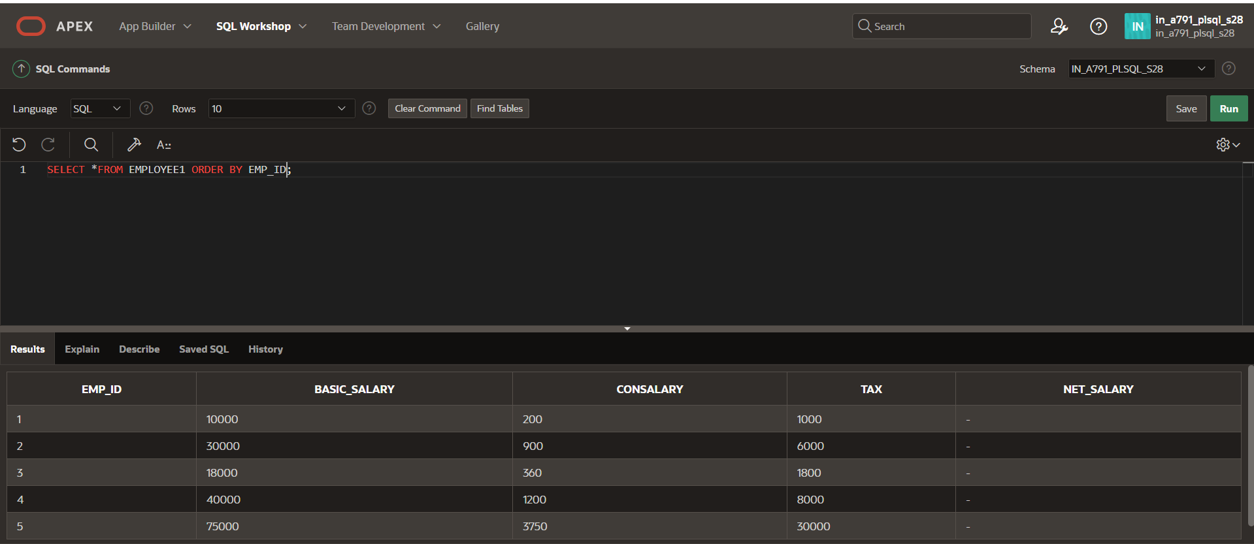

**NET_SALARY CALCULATION FOR EMPLOYEE**

**DECLARE**

**CURSOR cemp IS SELECT *FROM EMPLOYEE1;**

**BEGIN**

**FOR c1 in cemp**

**LOOP**

**IF c1.BASIC_SALARY<20000 THEN**

**UPDATE EMPLOYEE1**

**SET NET_SALARY=c1.BASIC_SALARY+c1.CONSALARY-c1.TAX**

**WHERE EMP_ID=c1.EMP_ID;**

**ELSE IF c1.BASIC_SALARY>=20000 AND c1.BASIC_SALARY<=40000 THEN**

**UPDATE EMPLOYEE1**

**SET NET_SALARY=c1.BASIC_SALARY+c1.CONSALARY-c1.TAX**

**WHERE EMP_ID=c1.EMP_ID;**

**ELSE**

**UPDATE EMPLOYEE1**

**SET NET_SALARY=c1.BASIC_SALARY+c1.CONSALARY-c1.TAX**

**WHERE EMP_ID=c1.EMP_ID;**

**END IF;**

**END IF;**

**END LOOP;**

**END;**

**/**

**SELECT *FROM EMPLOYEE1 ORDER BY EMP_ID;**

