35. Dynamic SQL with a DML Statement

CREATE TABLE DEPARTMENTS (DEPARTMENT_ID INT PRIARY KEY,DEPARTMENT_NAME VARCHAR(20),LOCATION_ID INT);
INSERT INTO DEPARTMENTS VALUES(1,’HR’,1700);
INSERT INTO DEPARTMENTS VALUES(2,’Finance’,1800);
INSERT INTO DEPARTMENTS VALUES(10,’CSE’,100);
INSERT INTO DEPARTMENTS VALUES(12,’Sales_Departmet’,120);
INSERT INTO DEPARTMENTS VALUES(13,’IT_Department’,130);

SELECT *FROM DEPARTMENTS ORDER BY DEPARTMENT_ID;
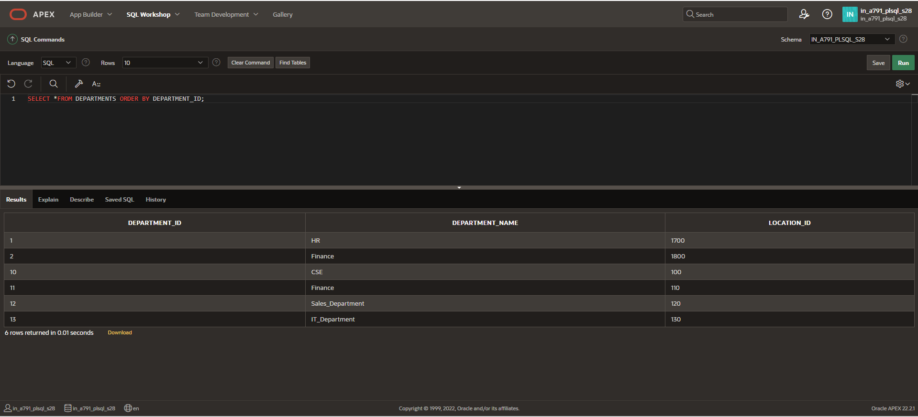

FUNCTION CREATION
CREATE FUNCTION d_rows(p_table_name VARCHAR2)
RETURN NUMBER IS
BEGIN
EXECUTE IMMEDIATE 'DELETE FROM ' || p_table_name;
RETURN SQL%ROWCOUNT;
END;

DECLARE
LOCATION_ID NUMBER;
BEGIN
LOCATION_ID:= del_rows('DEPARTMENTS');
DBMS_OUTPUT.PUT_LINE(LOCATION_ID || ' rows deleted.');
END;
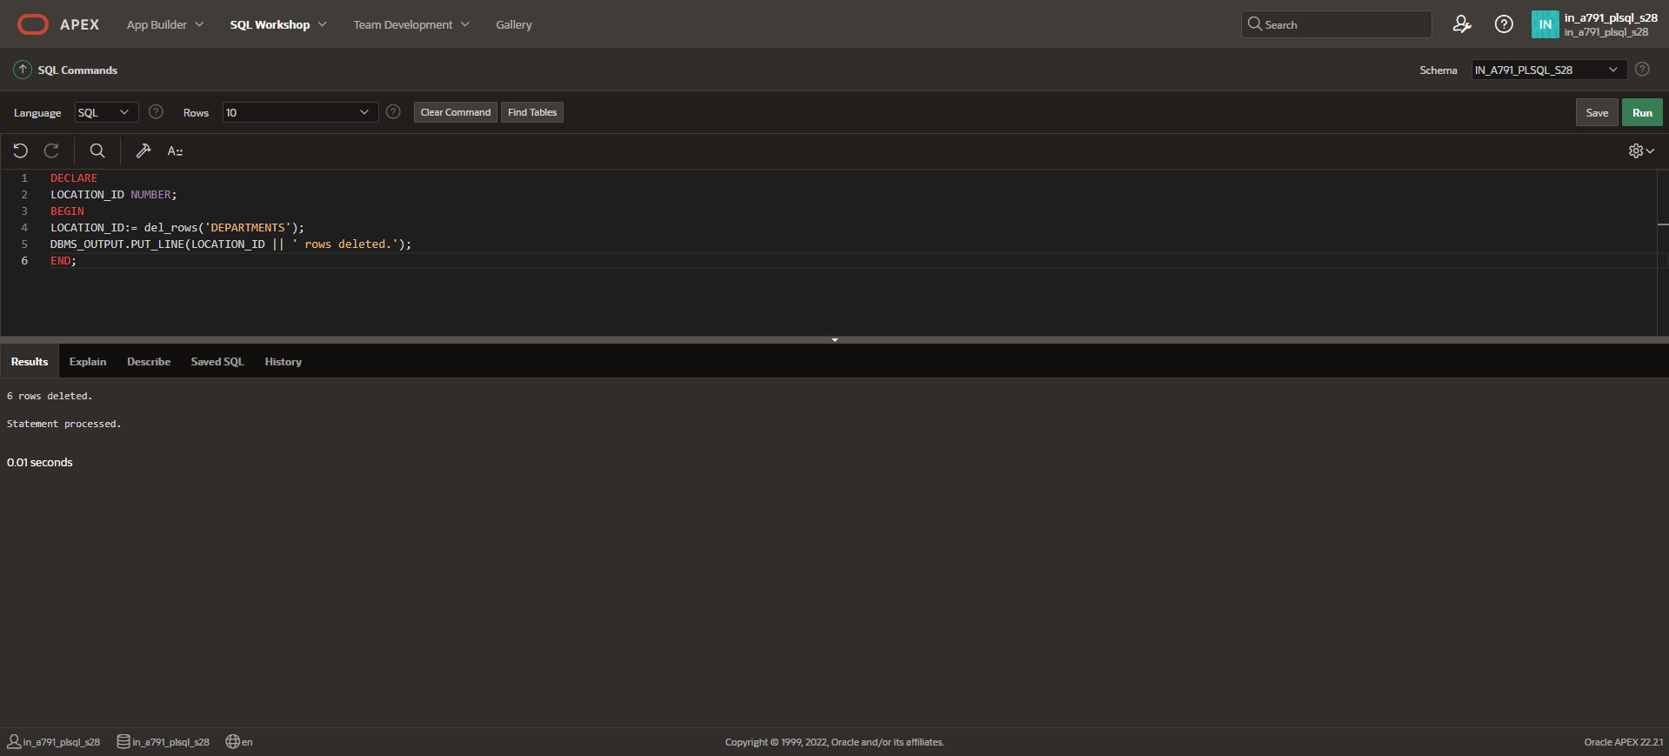

DESC DEPARTMENTS;
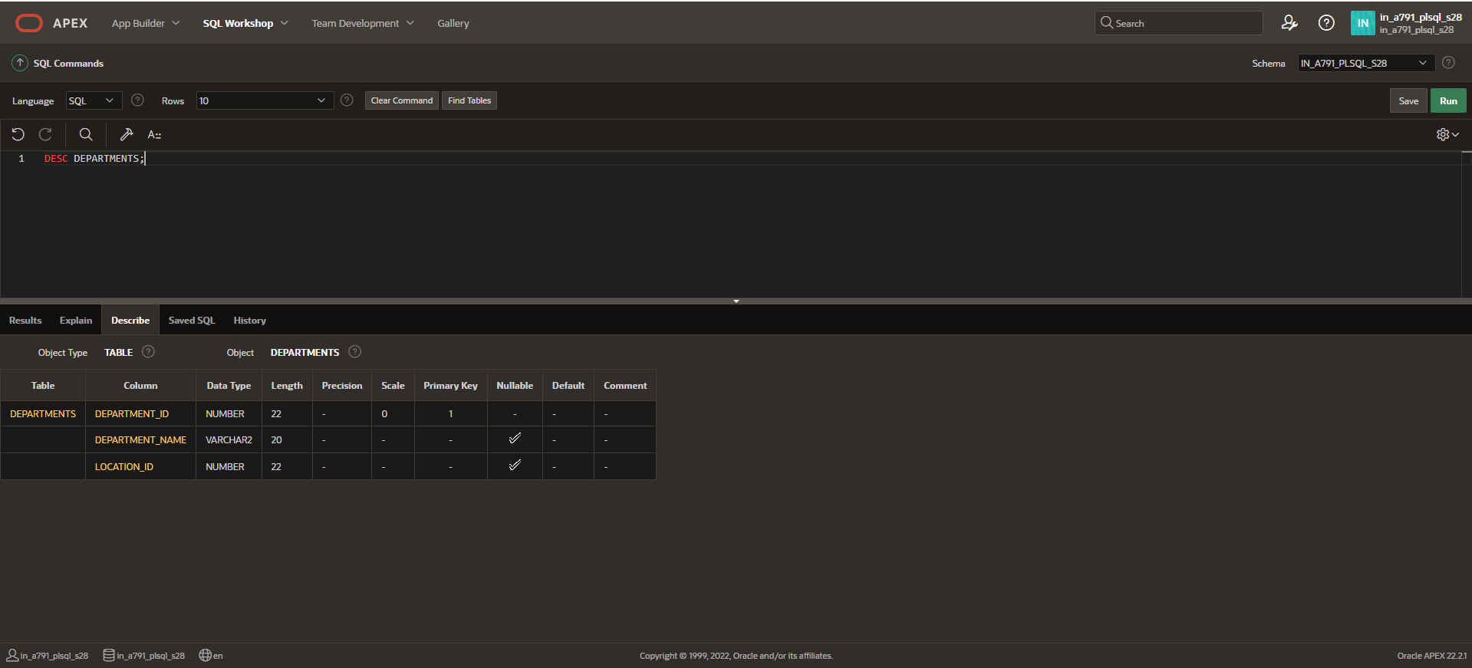

SELECT *FROM DEPARTMENTS;
