39. Automated ticket generator for calculating profit or loss by date
(i) Create a conceptual model
(ii) implement database using SQL
(iii) use PL/SQL

i)
LOGICAL MODEL
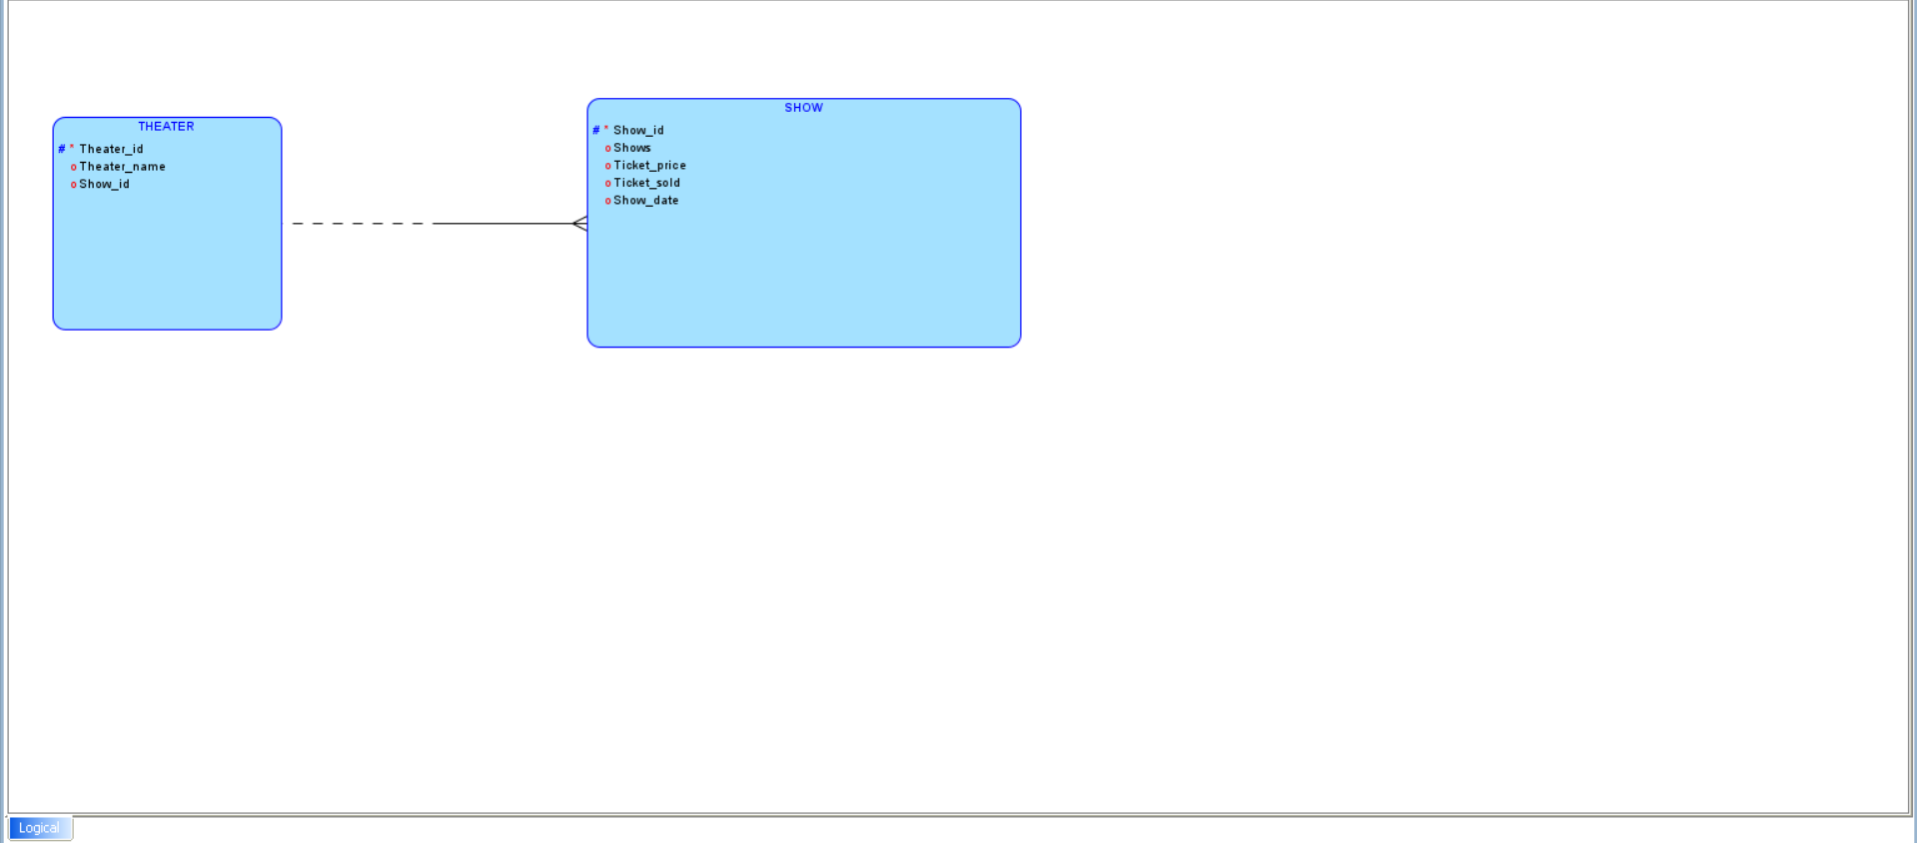

RELATIONAL MODEL
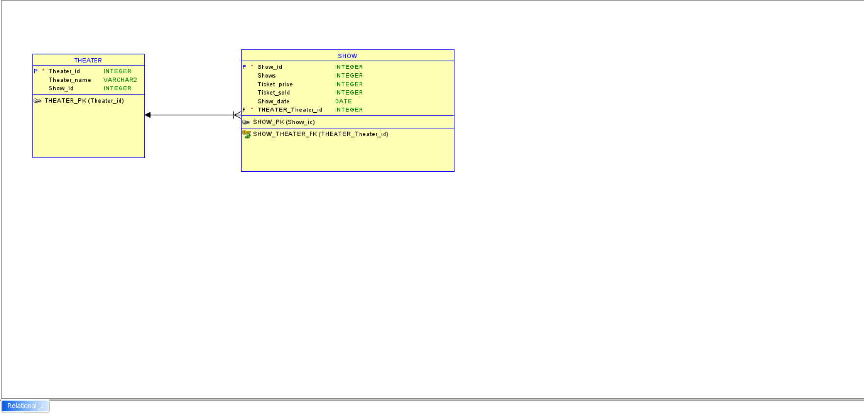

ii)
CREATE TABLE Theater (
theater_id INT PRIMARY KEY,
name VARCHAR(255) NOT NULL,
show_id INT
);
INSERT INTO Theater VALUES (1, 'Jazz Cinemas',101);
INSERT INTO Theater VALUES (2, 'SB Cinemas',102);
INSERT INTO Theater VALUES (3, 'AGS Cinemas',103);
INSERT INTO Theater VALUES (4, 'Rohini Cinemas',104);

SELECT *FROM THEATER ORDER BY theater_id;
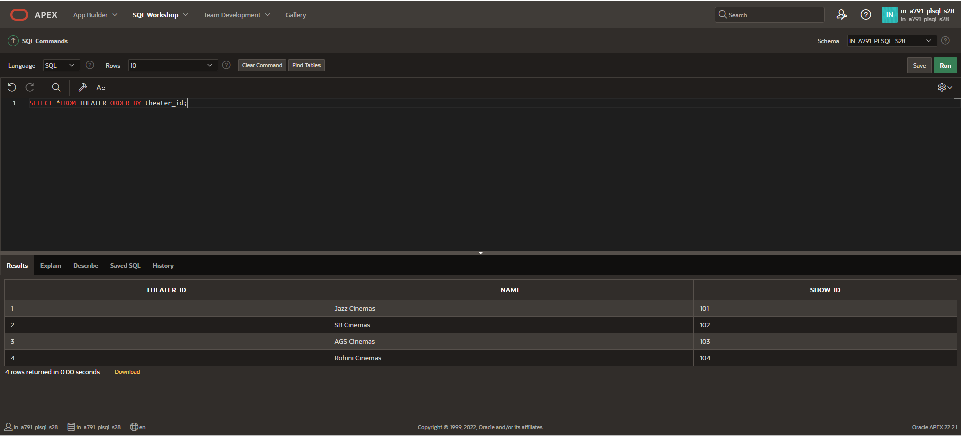

CREATE TABLE show(show_id NUMBER PRIMARY KEY,shows NUMBER,ticket_price NUMBER,ticket_sold NUMBER,show_date DATE,theater_id NUMBER,FOREIGN KEY (theater_id) REFERENCES Theater(theater_id));
INSERT INTO show VALUES(101,3,120,300,TO_DATE('2024-08-15', 'YYYY-MM-DD'),1);
INSERT INTO show VALUES(102,3,120,270,TO_DATE('2024-08-17', 'YYYY-MM-DD'),2);
INSERT INTO show VALUES(103,3,120,160,TO_DATE('2024-08-14', 'YYYY-MM-DD'),3);
INSERT INTO show VALUES(104,3,120,255,TO_DATE('2024-08-18', 'YYYY-MM-DD'),4);

SELECT *FROM SHOW ORDER BY SHOW_ID;
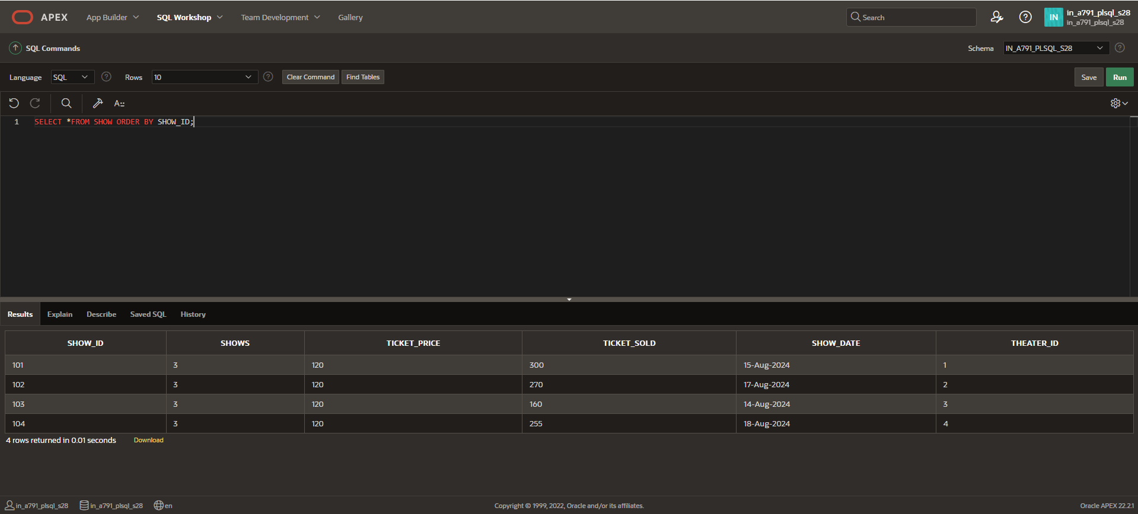

CREATE OR REPLACE PROCEDURE Calculate_Profit_Loss IS
income NUMBER;
expenses NUMBER := 90000;
r NUMBER;
profit_loss VARCHAR2(20);
CURSOR c1 IS
SELECT s.shows,s.ticket_sold,s.ticket_price,s.show_date,t.name,t.show_id FROM Show s JOIN Theater t ON s.theater_id = t.theater_id;
BEGIN
FOR s IN c1 LOOP
income := s.ticket_sold * s.ticket_price * s.shows;
r:= income - expenses;
IF r>0 THEN
profit_loss := 'Profit';
ELSE
profit_loss := 'Loss';
END IF;
DBMS_OUTPUT.PUT_LINE('Show Date: '||TO_CHAR(s.show_date, 'YYYY-MM-DD')||' | Theater: '||s.name||' | Net Profit/Loss: '||profit_loss);
END LOOP;
END;
/

BEGIN
Calculate_Profit_Loss;
END;
/
