32.TO IMPLEMENT FUNCTIONS,RECORDS AND USER-DEFINED IN PACKAGE.

CREATE TABLE EMPLOYEES(EMP_ID INT PRIMARY KEY,FIRST_NAME VARCHAR(20),LAST_NAME VARCHAR(20),DEP_ID INT,Salary INT);
INSERT INTO EMPLOYEES VALUES(1,'Peter','Parker','Finance',100,30000);
INSERT INTO EMPLOYEES VALUES(2,'Tony','Stark','Sales',101,40000);
INSERT INTO EMPLOYEES VALUES(3,'Adarsh','Vishal','IT',103,50000);
INSERT INTO EMPLOYEES VALUES(4,'Harsha','Kyle','Finance',100,30000);

SELECT *FROM EMPLOYEES ORDER BY EMP_ID;
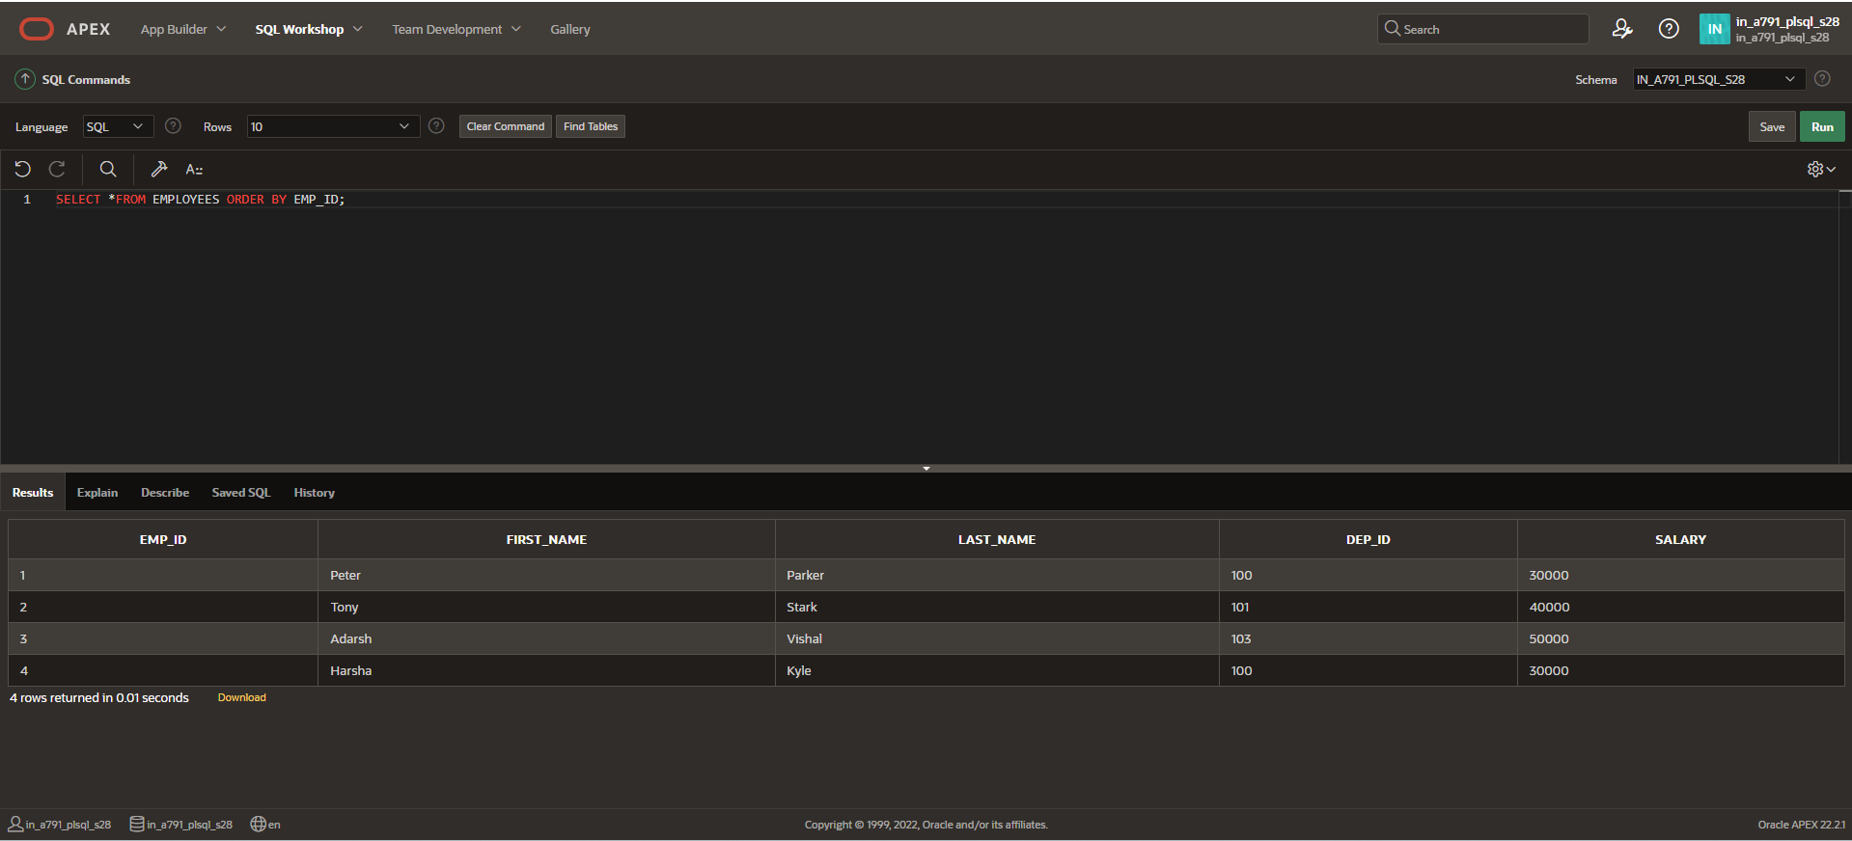

FUNCTION PACKAGE
CREATE OR REPLACE PACKAGE taxes_pkg IS
FUNCTION tax (p_value IN NUMBER) RETURN NUMBER;
END taxes_pkg;
/
CREATE OR REPLACE PACKAGE BODY taxes_pkg IS
FUNCTION tax (p_value IN NUMBER) RETURN NUMBER IS
v_rate NUMBER := 0.06;
BEGIN
RETURN (p_value * v_rate);
END tax;
END taxes_pkg;
/

SELECT taxes_pkg.tax(salary), salary, last_name FROM employees;
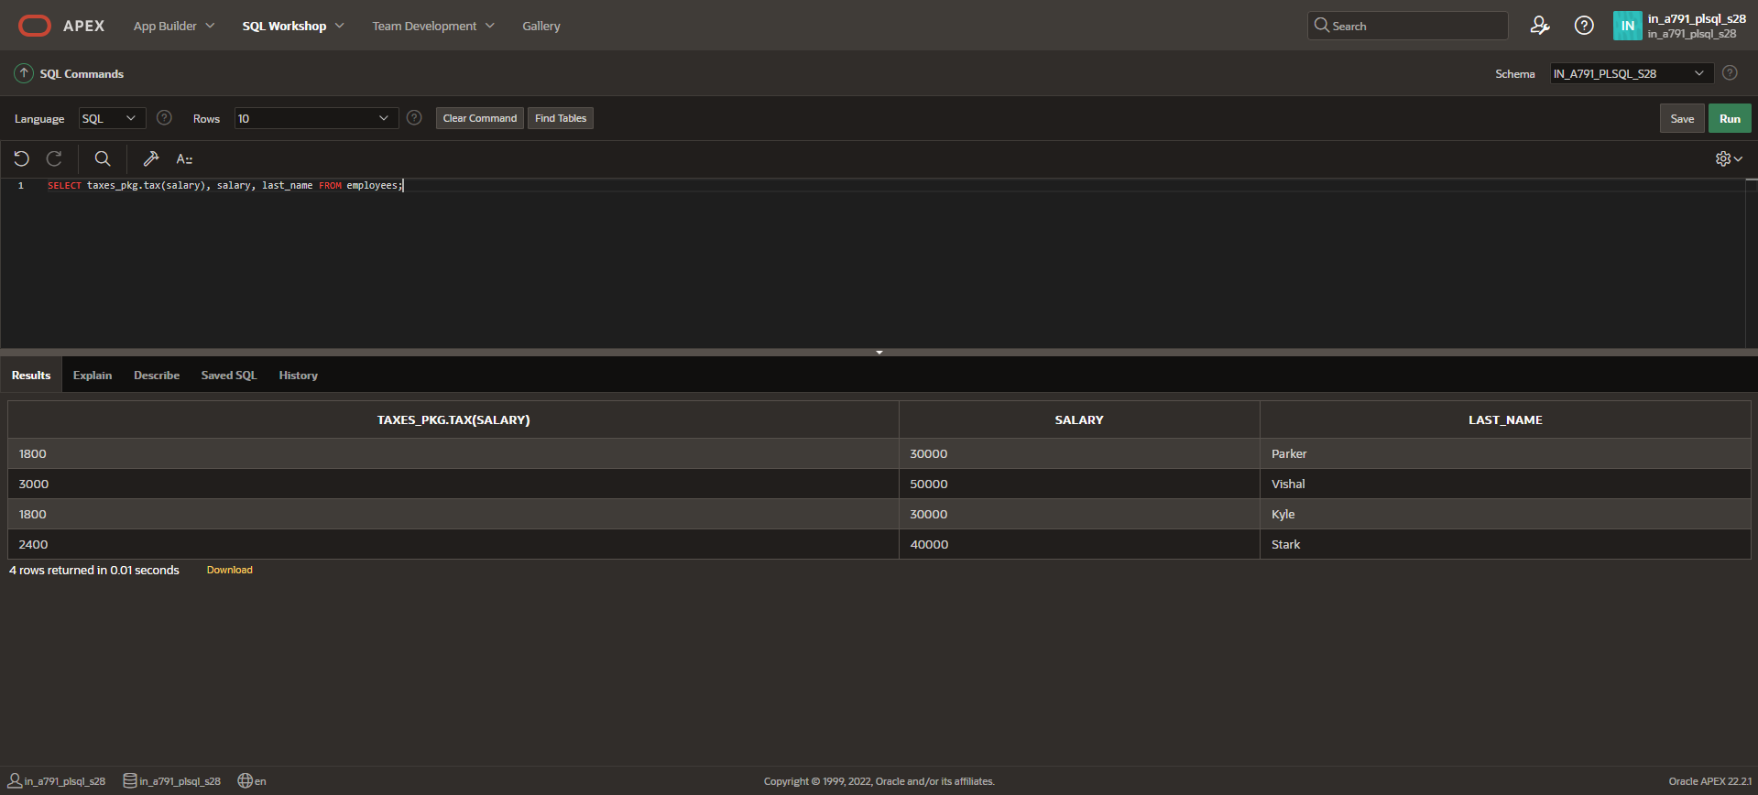

RECORDS PACKAGE
CREATE OR REPLACE PROCEDURE sel_one_emp (
p_emp_id IN employees.emp_id%TYPE,
p_emprec OUT employees%ROWTYPE
)
IS
BEGIN
SELECT *
INTO p_emprec
FROM employees
WHERE emp_id = p_emp_id;

EXCEPTION
WHEN NO_DATA_FOUND THEN
RAISE_APPLICATION_ERROR(-20002, 'No employee found with the provided EMP_ID.');
WHEN OTHERS THEN
RAISE_APPLICATION_ERROR(-20001, 'Unexpected error occurred: ' || SQLERRM);
END sel_one_emp;
/

DECLARE
v_emprec employees%ROWTYPE;
BEGIN
sel_one_emp(1, v_emprec);
IF v_emprec.emp_id IS NOT NULL THEN
dbms_output.put_line('Last Name: ' || v_emprec.last_name);
ELSE
dbms_output.put_line('No data found for the given employee ID.');
END IF;
EXCEPTION
WHEN OTHERS THEN
dbms_output.put_line('An unexpected error occurred: ' || SQLERRM);
END;
/

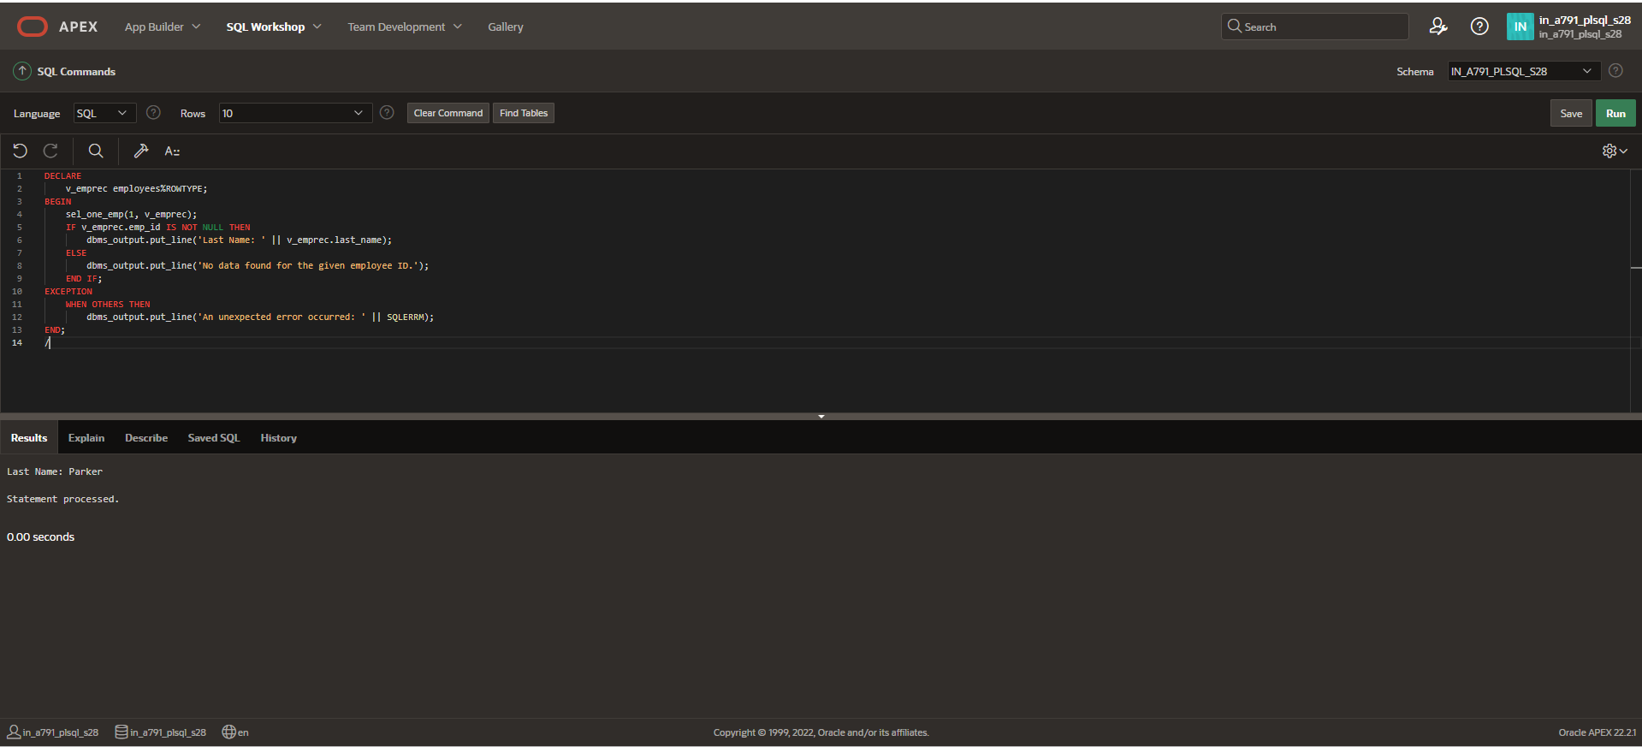

USER-DEFINED PACKAGE

CREATE OR REPLACE PACKAGE emp_dept_pkg
IS
TYPE ed_type IS RECORD (
f_name employees.first_name%TYPE,
l_name employees.last_name%TYPE,
d_name departments5.department_name%TYPE
);
PROCEDURE sel_emp_dept (
p_emp_id IN employees.emp_id%TYPE,
p_emp_dept_rec OUT ed_type
);
END emp_dept_pkg;
/
CREATE OR REPLACE PACKAGE BODY emp_dept_pkg
IS
PROCEDURE sel_emp_dept (
p_emp_id IN employees.emp_id%TYPE,
p_emp_dept_rec OUT ed_type
)
IS
BEGIN
SELECT e.first_name, e.last_name, d.department_name
INTO p_emp_dept_rec.f_name, p_emp_dept_rec.l_name, p_emp_dept_rec.d_name
FROM employees e
JOIN departments5 d ON e.dep_id = d.department_id
WHERE e.emp_id = p_emp_id;
EXCEPTION
WHEN NO_DATA_FOUND THEN
p_emp_dept_rec.f_name := NULL;
p_emp_dept_rec.l_name := NULL;
p_emp_dept_rec.d_name := NULL;
WHEN OTHERS THEN
RAISE_APPLICATION_ERROR(-20001, 'Unexpected error occurred: ' || SQLERRM);
END sel_emp_dept;
END emp_dept_pkg;
/

DECLARE
v_emp_dept_rec emp_dept_pkg.ed_type;
BEGIN
emp_dept_pkg.sel_emp_dept(1, v_emp_dept_rec);
dbms_output.put_line('First Name: ' || v_emp_dept_rec.f_name);
dbms_output.put_line('Last Name: ' || v_emp_dept_rec.l_name);
dbms_output.put_line('Department Name: ' || v_emp_dept_rec.d_name);

EXCEPTION
WHEN NO_DATA_FOUND THEN
dbms_output.put_line('No data found for the given employee ID.');
WHEN OTHERS THEN
dbms_output.put_line('An unexpected error occurred: ' || SQLERRM);
END;
/

