30.BODY WITH PACKAGE

CREATE OR REPLACE PACKAGE salary_pkg
IS
g_max_sal_raise CONSTANT NUMBER := 0.20;
PROCEDURE update_sal
(p_employee_id employees.employee_id%TYPE,
p_new_salary employees.salary%TYPE);
END salary_pkg;

CREATE OR REPLACE PACKAGE BODY salary_pkg IS
FUNCTION validate_raise
(p_old_salary employees.salary%TYPE,
p_new_salary employees.salary%TYPE)
RETURN BOOLEAN IS
BEGIN
IF p_new_salary >
(p_old_salary * (1 + g_max_sal_raise)) THEN
RETURN FALSE;
ELSE
RETURN TRUE;
END IF;
END validate_raise;
PROCEDURE update_sal
(p_employee_id employees.employee_id%TYPE,
p_new_salary employees.salary%TYPE)
IS v_old_salary employees.salary%TYPE;
BEGIN
SELECT salary INTO v_old_salary FROM employees
WHERE employee_id = p_employee_id;
IF validate_raise(v_old_salary, p_new_salary) THEN
UPDATE employees
SET salary = p_new_salary
WHERE employee_id = p_employee_id;
ELSE
RAISE_APPLICATION_ERROR(-20210, 'Raise too high');
END IF;
END update_sal;
END salary_pkg;

SELECT *FROM EMPLOYEES;
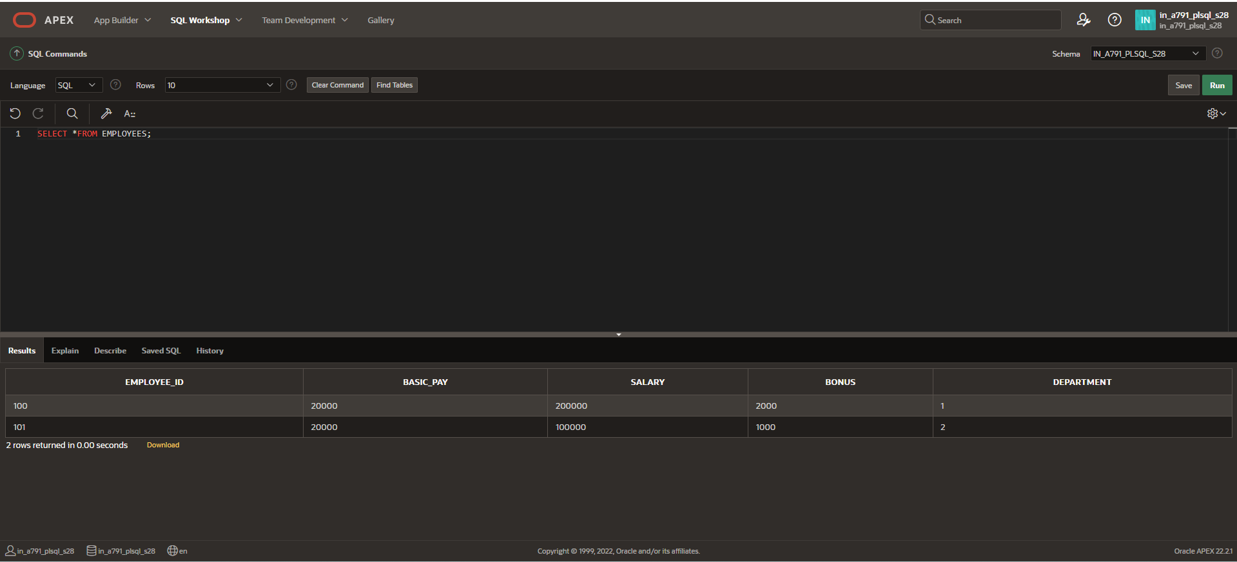

BEGIN
salary_pkg.update_sal(101,50000);
END;
/

SELECT *FROM EMPLOYEES;
