**Feedback fixes**

**Desktop:**

1.Same line alignment to header logo -**fixed**

2.width and space reduced in login box-**fixed**

**3.**Email box has been set 100%

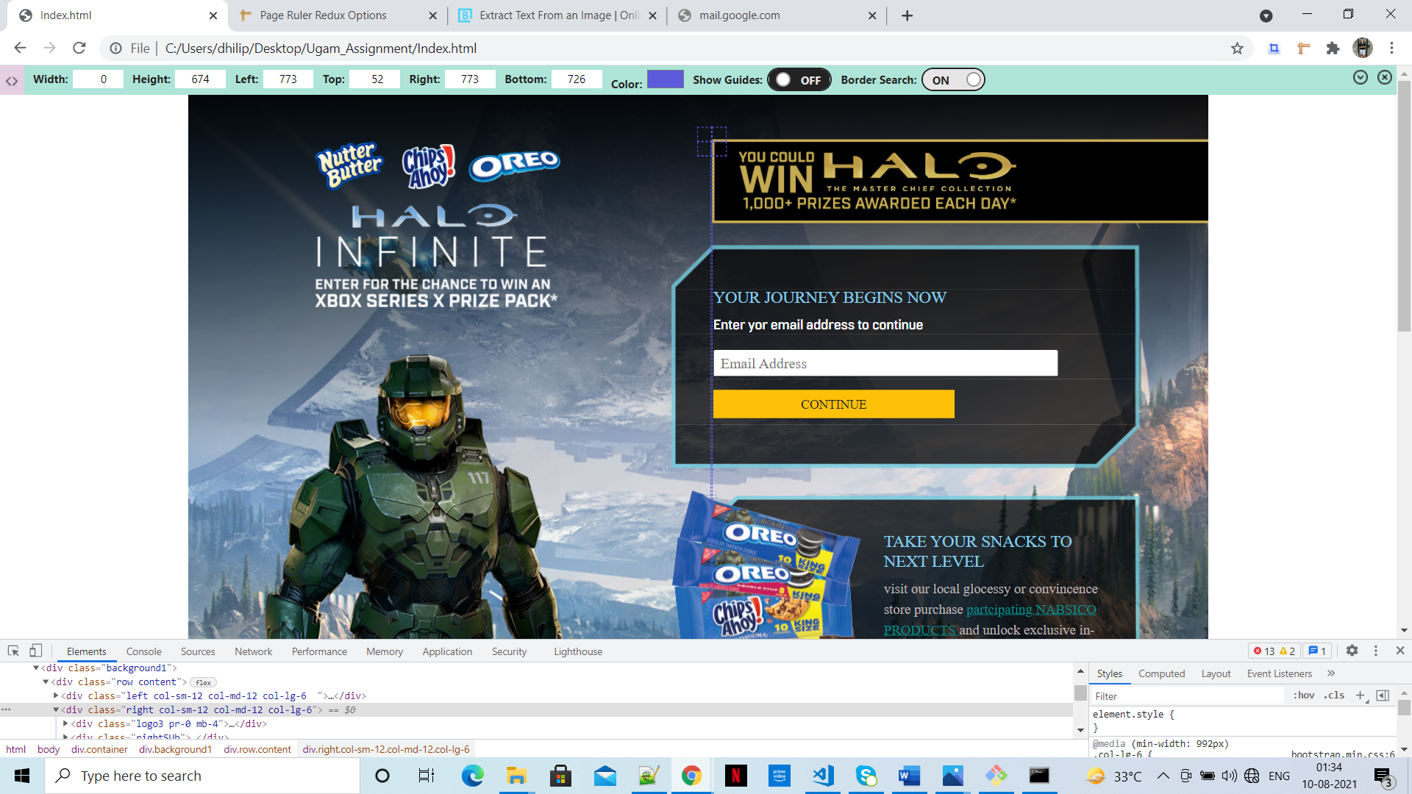

Mobile

1.padding for login and snack box-**fixed**

2.Halo banner on bottom for mobile-**fixed**

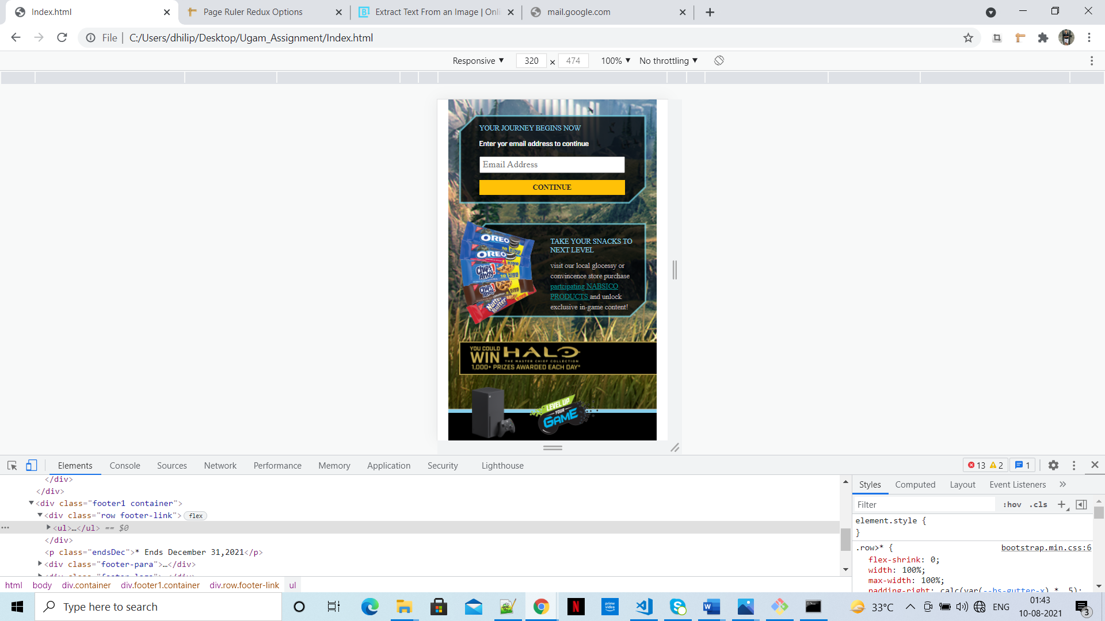

3.footer link has been bolded

4.footer link has been center aligned

5.footer para has been replaced with the original text and center aligned

6.font family”normative” has been used

