HealthMate – Personal Health & Wellness Tracker
Mobile Application Development – Coursework 1
Student ID: [ID]
Student Name: Dhilshan
Module: [Code / Name]
Module Leader: [Name]
Date submitted: [Date]

Table of Contents
[TODO: Insert > Table of Contents in Word after filling the report]

1. Project Overview
[TODO: Purpose of HealthMate, target user, scope, tech stack (Flutter, Dart, sqflite, Provider) in your own words]

2. Application Features
[TODO: List core features: add/view/update/delete records, date search, dashboard; extra features: goal progress bars, 7-day steps chart, delete confirmation, dark theme]

3. Application Architecture

3.1 Explanation of project architecture
The app follows MVVM with a feature-based folder structure (lib/features/records) and a small core layer for shared code. State is managed with Provider (ChangeNotifier).
[TODO: Explain why MVVM and why Provider, in your own words]

3.2 Architecture diagram
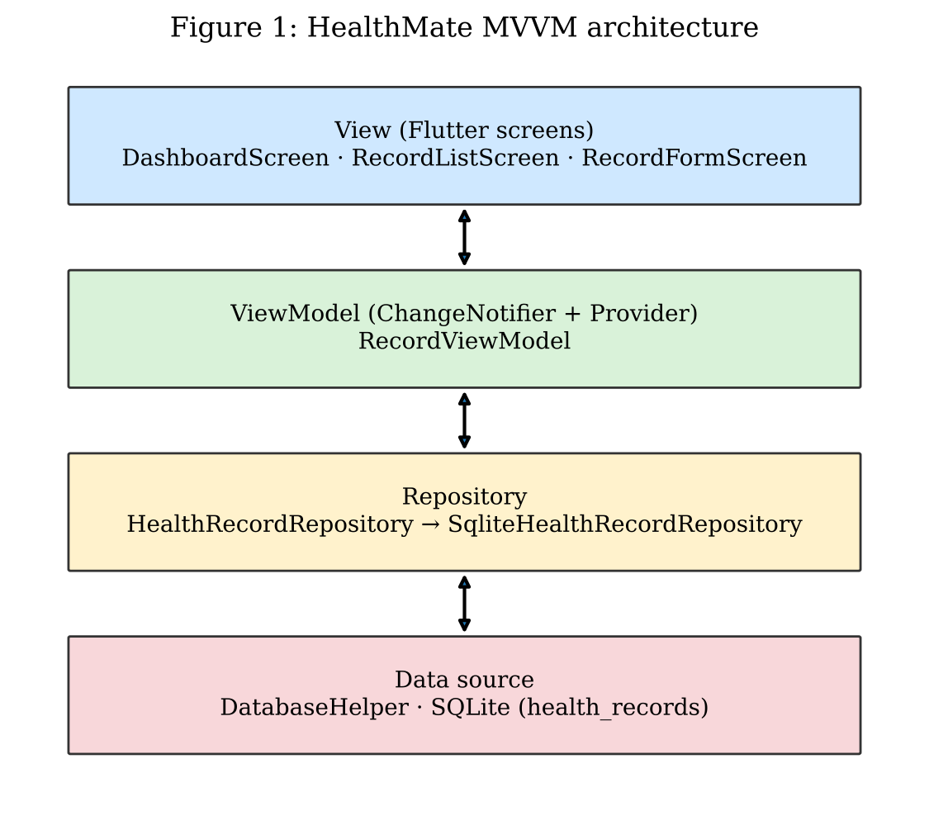

3.3 Layers and folders
Folder / file | Responsibility
core/database/database_helper.dart | Opens SQLite, creates table, seeds dummy data
core/validators.dart | Pure input-validation functions
core/app_theme.dart | Material 3 theme and semantic colours
features/records/model | HealthRecord data class, toMap/fromMap
features/records/repository | Repository interface + sqflite implementation (CRUD)
features/records/viewmodel | RecordViewModel: state, totals, filter
features/records/view | Dashboard, History list, Add/Edit form, navigation shell
features/records/widgets | Reusable MetricCard
Table 1: Project folders and responsibilities

3.4 State-management approach
[TODO: How ChangeNotifier + context.watch/read rebuild the UI; data-flow description]

4. Database Design

4.1 Database structure and table diagram
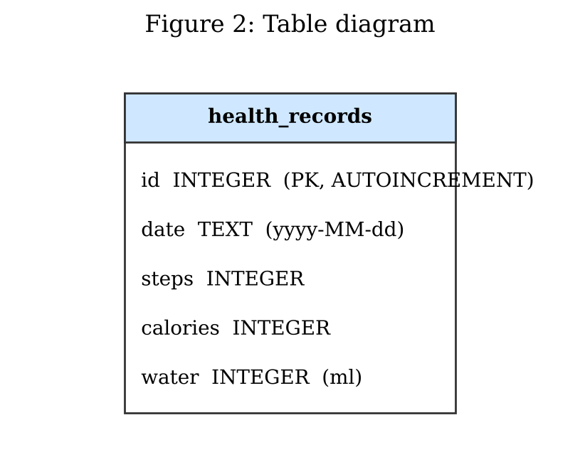

4.2 Field descriptions
Field | Type | Description
id | INTEGER PK | Auto-incremented identifier
date | TEXT | Record date, yyyy-MM-dd
steps | INTEGER | Steps walked
calories | INTEGER | Calories burned (kcal)
water | INTEGER | Water intake (ml)
Table 2: health_records fields

4.3 Sample database code and SQLite communication
[TODO: Paste the CREATE TABLE snippet from database_helper.dart; explain how the repository calls sqflite and how the ViewModel uses the repository]

5. CRUD Implementation

5. Create
[TODO: Short code snippet from sqlite_health_record_repository.dart / viewmodel + explanation]

5. Read
[TODO: Short code snippet from sqlite_health_record_repository.dart / viewmodel + explanation]

5. Update
[TODO: Short code snippet from sqlite_health_record_repository.dart / viewmodel + explanation]

5. Delete
[TODO: Short code snippet from sqlite_health_record_repository.dart / viewmodel + explanation]

6. Third-Party Libraries
Package | Why it was selected
provider | TODO: your reasoning
sqflite | TODO
path | TODO
intl | TODO
Table 3: Packages used

7. UI / UX Design

7.1 Wireframes
[TODO: Add large, clear images / explain WHY decisions were made (water = blue, calories = red, steps = green, bottom navigation, FAB for add)]

7.2 Final screenshots
[TODO: Add large, clear images / explain WHY decisions were made (water = blue, calories = red, steps = green, bottom navigation, FAB for add)]

7.3 Design decisions (colours, navigation flow, icons, components)
[TODO: Add large, clear images / explain WHY decisions were made (water = blue, calories = red, steps = green, bottom navigation, FAB for add)]

8. Test Cases
Test ID | Test Scenario | Input | Expected Result | Actual Result | Status
TC01 | Add valid record | Steps 7850, Cal 420, Water 2000 | Record saved; appears in History and Dashboard | TODO | TODO
TC02 | Empty field validation | Steps left empty | Error 'Steps is required'; nothing saved | TODO | TODO
TC03 | Non-numeric input | Water = 'abc' | Error 'Water must be a whole number' | TODO | TODO
TC04 | Negative value | Calories = -5 | Error 'Calories cannot be negative' | TODO | TODO
TC05 | Update record | Edit steps 7850 -> 9000 | List shows 9000 after save | TODO | TODO
TC06 | Delete record | Tap delete, confirm | Record removed from list | TODO | TODO
TC07 | Cancel delete | Tap delete, Cancel | Record remains | TODO | TODO
TC08 | Search by date | Pick a date with a record | Only that date's records shown | TODO | TODO
TC09 | Search date with no records | Pick an empty date | 'No records found' shown | TODO | TODO
TC10 | Dummy data on first launch | Fresh install | 10 seeded records present | TODO | TODO
Table 4: Test cases (fill Actual Result / Status after running the app; attach screenshots)

9. Issues / Errors and Fixes
[TODO: Real problems you hit (e.g. build errors, sqflite setup, date format) and how you fixed them. Do not invent these.]

10. Version Control
[TODO: Repository link, branches, screenshot of git log, explanation of progressive commits]

11. Conclusion
[TODO: Summary, limitations, future work]

12. References
[TODO: Harvard-style: Flutter docs, Provider, sqflite, Material Design 3, etc.]

Acknowledgement of AI Contribution
Generative AI (Claude, by Anthropic) was used to generate an initial version of the application source code, the architecture/table diagrams and this report outline. [TODO: describe in your own words what you reviewed, changed, and tested yourself.]

Appendix

Appendix A – Demonstration Video
Google Drive Video Link: [Insert link]

Appendix B – Release APK
Google Drive APK Link: [Insert link]

Appendix C – Source Code
GitHub Repository: [Insert link]

Appendix D – Additional Evidence
[Screenshots, test evidence, git log]

