**ANVI DHIMAN**

**LAB FILE OF FOCP -2 JAVA**

**BY JYOTI YADAV**

**PROGRAM - 01**

//write a program to print the name, branch and college name.

public class Main

{

public static void main(String[] args) {

System.out.print("Anvi Dhiman \t");

System.out.println("BCA Section B \t");

System.out.print("The Northcap \t University");

}

}

**OUTPUT-**

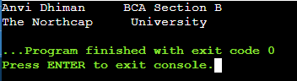

**public -** public is a java keyword which declares a member’s access as public. Public member’s are visible to all other classes. This means that any other class can access a public field or method. Further, other classes can modify public fields unless the field is declared as final.

**static –** The static keyword is non-access modifier used for methods and attributes. Static methods/attributes can be accessed without creating an object of a class. The static keyword in java is used for memory management mainly. We can apply static keyword with variables, methods, blocks, and nested classes.

**main() –** The main() is the starting point for JVM to start execution of java program. Without the main() method, JVM will not execute the program.

**string args[] –** String args[] in java is an array of type java lang. string class that stores java command line arguments. Variable argument or varargs in java allows us to write more flexible methods which can accept as many arguments as we need.

Access Specifier Return type Array of string type

**public static void main(String args[])**

Keyword Method name

1st Feb 2023

**PROGRAM – 02**

//Datatype in JAVA

public class Main

{

public static void main(String[] args) {

//integar whole Number

int myNum = 5;

//floating point number

float myFloatNum = 5.99f;

//character

char myletter = 'D';

//boolean

boolean myBool = true;

//string

String mytext = "hello";

System.out.println(myNum);

System.out.println(myFloatNum);

System.out.println(myletter);

System.out.println(myBool);

System.out.println(mytext);

}

}

**OUTPUT-**

5

5.99

D

true

hello

**PROGRAM – 03**

//NUMBER DATATYPE

public class Main

{

public static void main(String[] args) {

System.out.println("Number DATATYPE");

byte myNum1 = 100;

System.out.println("byte " +myNum1);

short myNum2 = 5000;

System.out.println("short " +myNum2);

int myNum3 = 100000;

System.out.println("int " +myNum3);

long myNum4 = 15000000000L;

System.out.println("long " +myNum4);

float myNum5 = 5.75f;

System.out.println("float " +myNum5);

double myNum6 = 19.99d;

System.out.println("double " +myNum6);

}

}

**OUTPUT-**

Number DATATYPE

byte 100

short 5000

int 100000

long 15000000000

float 5.75

double 19.99

**PROGRAM – 04**

// BYTE DATATYPE

/*The byte data type can store whole numbers from -128 to 127. This xan be used instead of int or other integar

type to save memeory when you are certain that the value will be within -128and 127*/

public class Main {

public static void main(String[]args){

byte myNum = 127;

System.out.println(myNum);

byte myNum1 = -129;

System.out.println(myNum1);

byte myNum2 = 200;

System.out.println(myNum2);

}

}

**OUTPUT-**

Main.java:8: error: incompatible types: possible lossy conversion from int to byte

byte myNum1 = -129;

^

Main.java:10: error: incompatible types: possible lossy conversion from int to byte

byte myNum2 = 200;

^

2 errors

**PROGRAM – 05**

//BOOLEAN DATATYPE

public class Main

{

public static void main(String[] args) {

boolean isJavaFun = true;

//case sensitive, True and true are different

boolean isFishTasty = false;

System.out.println(isJavaFun);

System.out.println(isFishTasty);

}

}

**OUTPUT-**

true

false

**PROGRAM – 05**

// CHAR DATATYPE

public class Main{

public static void main(String[] args){

char myGrade = 'B';

System.out.println("SINGLE CHAR "+myGrade);

char myVar1 = 65, myVar2 = 66, myVar3 = 67;

System.out.println("CHAR USING ASCII VALUE "+myVar1);

System.out.println(myVar2);

System.out.println(myVar3);

String greeting = "Hello World";

System.out.println("STRING "+greeting);

}

}

**OUTPUT-**

CHAR USING ASCII VALUE A

B

C

STRING Hello World

**PROGRAM – 06**

// Take value of lenght and breadth of a rectangle from user and check if it is square or not

import java.util.Scanner;

public class Main

{

public static void main(String[] args) {

Scanner sc = new Scanner(System.in);

System.out.print("Enter the length: ");

double l=sc.nextDouble();

System.out.println("Enter the breadth: ");

double b=sc.nextDouble();

if(l==b)

System.out.println("Square...");

else

System.out.println("Not a Square...");

}

}

**OUTPUT-**

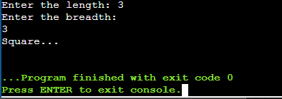

**OR –**

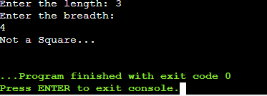

**PROGRAM – 07**

import java.util.Scanner;

public class Main

{

public static void main(String[] args) {

int num1, num2, largest;

Scanner sc = new Scanner(System.in);

System.out.print("enter the first number :");

num1 = sc.nextInt();

System.out.print("enter the second number :");

num2 = sc.nextInt();

if(num1>num2)

largest = num1;

else

largest = num2;

System.out.print("\n Largest" + largest);

}

}

**OUTPUT-**

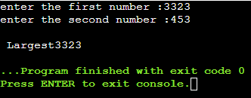

**PROGRAM – 08**

//Enter the marks by the user and print the grade corresponding the student marks

import java.util.Scanner;

public class Main

{

public static void main(String[] args) {

Scanner s = new Scanner(System.in);

System.out.println("Enter your marks");

int x = s.nextInt();

if(x<25){

System.out.println("F");

}

else if((x>=25)&&(x<45)){

System.out.println("E");

}

else if((x>=45)&&(x<50)){

System.out.println("D");

}

else if((x>=50)&&(x<60)){

System.out.println("C");

}

else if((x>=60)&&(x<80)){

System.out.println("B");

}

else if((x>=80)&&(x<=100)){

System.out.println("A");

}

else{

System.out.println("Not correct marks");

}

}

}

**OUTPUT-**

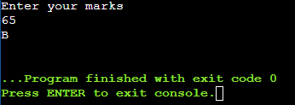

**PROGRAM – 09**

//taking input from user

// show use of arithmetic operators

import java.util.Scanner;

public class Main

{

public static void main(String[] args) {

int n1,n2, add, subtract, multiply, mod;

float divide;

Scanner scanner = new Scanner(System.in);

System.out.print("enter two number : ");

n1 = scanner.nextInt();

n2 = scanner.nextInt();

add = n1+n2;

subtract = n1-n2;

multiply = n1*n2;

divide = n1/n2;

mod = n1%n2;

System.out.println("sum ="+add);

System.out.println("Differenca ="+subtract);

System.out.println("Multiplication ="+multiply);

System.out.println("Division ="+divide);

System.out.println("Modulus ="+mod);

}

}

**OUTPUT-**

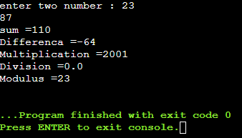

**PROGRAM – 11**

// Convert minutes entered by user into years , months, and days

import java.util.Scanner;

class Main{

public static void main(String args[]){

int mins;

long yr, month, day, remmyr, remmon;

Scanner sc = new Scanner(System.in);

System.out.print("Enter minute");

mins = sc.nextInt();

yr = mins/(365*24*60);

remmyr = mins%(365*24*60);

month = remmyr/43800;

remmon = remmyr%43800;

day = remmon/1440;

System.out.print(yr+"years" +month+"months"+day+"days");

}

}

**OUTPUT-**

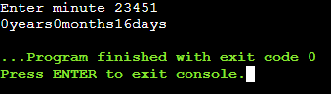

**PROGRAM – 12**

// A shop will give discount of 10% if the cost of purchased quantity is more than 1000.

//Ask user for quantity

import java.util.Scanner;

public class Main{

public static void main(String args[]){

Scanner sc = new Scanner(System.in);

System.out.println("enter quantity");

int x = sc.nextInt();

if((x*100)>1000)

{

System.out.println("You get a discount of "+(.1*x*100)+"and your total cost is "+(x*100-(.1*x*100)));

}

else{

System.out.println("no discunt");

}

}

}

**OUTPUT-**

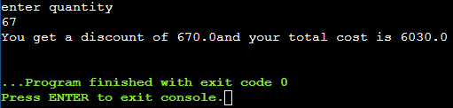

**PROGRAM – 13**

//A company decided to give bonus of 5% to employee if his/her year of service is more than 5 years.

//Ask user for their salary and year of service and print the net bonus amount.

import java.util.Scanner;

public class Main

{

public static void main (String[]args)

{

int year;

int sal;

double d;

System.out.println ("Enter total Years of services :");

Scanner t = new Scanner (System.in);

year = t.nextInt ();

if (year > 5)

{

System.out.

println

("Congrats..YES..! your total year of services more than 5 years\n Please Enter your salary : ");

sal = t.nextInt ();

System.out.println ("YOUR SALARY IS " + sal);

System.out.println ("YOUR 5% BONUS IS " + sal * 0.05);

System.out.println ("YOUR NET BONUS WITH SALARY IS " +

(sal + (sal * 0.05)));

}

else

{

System.out.println ("NO BONUS..");

}

}

}

**OUTPUT-**

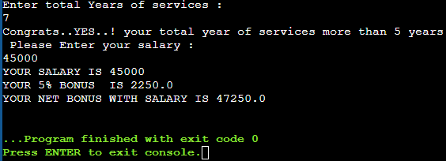

**PROGRAM – 14**

import java.util.Scanner;

public class Main

{

public static void main(String[] args)

{

int n, sum = 0;

float average;

int even = 0;

int odd = 0;

int max=0;

int min=0;

int pos = 0, neg = 0, zero = 0;

Scanner sc = new Scanner(System.in);

//enter the size of array by the user input

System.out.print("Enter size of the array:");

n = sc.nextInt();

int a[] = new int[n];

//enter the array elements by the user input

System.out.println("Enter array elements:");

for(int i = 0; i < n; i++)

{

a[i] = sc.nextInt();

//sum of the elements

sum = sum + a[i];

}

System.out.println("Sum of the array is:"+sum);

//average of the elements

average = (float)sum/n;

System.out.println("Average of the array is :"+average);

//print th elemnts id even

System.out.println("the even elements");

for(int i=0; i<n; i++)

{

if(a[i]%2==0) //check the whether is even or not

{

even++;

}

}

System.out.println("even"+even);

System.out.println(" ");

//Print the element of odd

System.out.println("The odd elements ");

for(int i=0;i<n;i++)

{

if(a[i]%2!=0) //check the whether is odd or not

{

odd++;

}

}

System.out.println("odd"+odd);

//print the maximun number

for(int num:a)

{

if(num>max)

max = num;

}

System.out.println("max :"+max);

//print the minimun number

for(int num:a)

{

if(num<min)

min=num;

}

System.out.println("min"+min);

//print the positive, negetive and zero number

for(int i=0; i<n; i++)

{

if(a[i]<0)

neg++;

else if(a[i]>0)

pos++;

else

zero++;

}

System.out.println("\nTotal Positive Number: " +pos);

System.out.println("Total Negative Number: " +neg);

System.out.println("Total Zero: " +zero);

}

}

**OUTPUT**

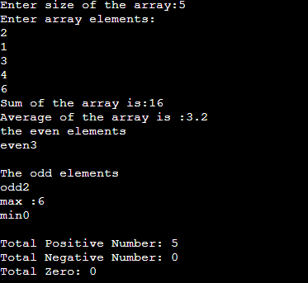

**PROGRAM – 15**

// Print the pattren of number, alphabets, star, etc.

public class Main

{

public static void main(String[] args) {

//i for the row and j for the columns

// row denote the number of rows you want to print

int i, j ,row=3;

for(i=0;i<row;i++)

{

for(j=0;j<=i;j++)

{

//print the number '1'

System.out.print("1");

}

System.out.println();

}

System.out.println("------------------------------------------------");

for(i=0;i<row;i++)

{

for(j=0;j<=i;j++)

{

//print the number '*'

System.out.print("*");

}

System.out.println();

}

System.out.println("------------------------------------------------");

for (i = 0; i < row; i++) {

for (j = row; j > i; j--) {

System.out.print("*");

}

System.out.println();

}

System.out.println("------------------------------------------------");

for (i = 1; i <= 3; i++) {

for (j = 1; j <= i; j++) {

System.out.print(j);

}

//print the number by the seris

System.out.println(" ");

}

System.out.println("------------------------------------------------");

for (i = 1; i <= 3; ++i) {

for (j = 1; j <= i; ++j) {

System.out.print(i);

}

System.out.println(" ");

}

System.out.println("------------------------------------------------");

for(i = 1; i <= 3; ++i) {

for(j = 0; j < i; ++j){

System.out.print((char)('a' + j));

}

System.out.println(" ");

}

System.out.println("------------------------------------------------");

for (i = 1; i <= 3; i++) {

for (j = 1; j< i + 1; j++) {

System.out.print(k++);

}

System.out.println(" ");

}

System.out.println("------------------------------------------------");

for (i = 0; i <= 3; i++) {

for (j = 0; j<=1; j++) {

System.out.print((char) z);

z++;

}

System.out.println(" ");

}

System.out.println("------------------------------------------------");

}

}

**OUTPUT**

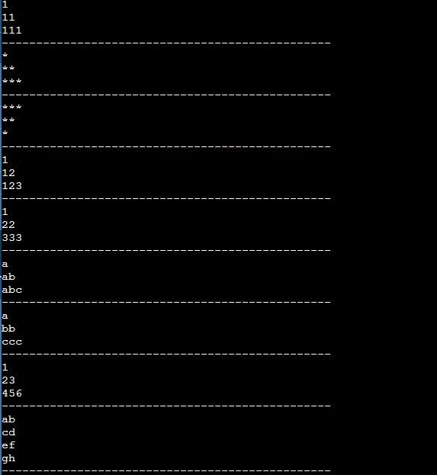

**PROGRAM – 16**

//Print the jagged array

import java.util.Scanner;

public class Main

{

public static void main(String[] args) {

Scanner sc = new Scanner(System.in);

int R, C, a=0;

int Arr[][] = new int[3][];

Arr[0] = new int[3];

Arr[1] = new int[2];

Arr[2] = new int[4];

for(R=0;R<Arr.length;R++)

{

for(C=0;C<Arr[R].length;C++)

Arr[R][C]=a++;

}

for(R=0;R<Arr.length;R++)

{

for(C=0;C<Arr[R].length;C++)

{

System.out.print(Arr[R][C]);

}

System.out.println();

}

}

}

**PROGRAM – 17**

//Program to create class and display the volume of box

class Box

{

//data mamber of box

//variable

double width;

double height;

double depth;

double findVolume(){

double V = height*width*depth;

return(V);

}

void displayVolume(){

System.out.println(findVolume());

}

Box()

{

width=height=depth=10;

}

}

class Main

{

public static void main(String[] args) {

//create and object to display the result

Box b = new Box();

b.displayVolume();

}

}

**OUTPUT –**

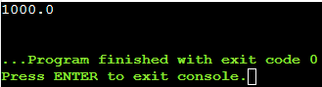

**PROGRAM – 18**

//Program to create class and display the volume of box

//Constructor overloading

import java.util.Scanner;

class Box

{

//data mamber of box

//variable

double width;

double height;

double depth;

double findVolume(){

double V = height*width*depth;

return(V);

}

void displayVolume(){

System.out.println(findVolume());

}

//Constructor overloading

Box()

{

width=height=depth=0;

}

Box(double dt, double wt, double hgt)

{

height=hgt;

width=wt;

depth=dt;

}

}

class Main

{

public static void main(String[] args) {

double w,d,h;

Scanner sc = new Scanner(System.in);

System.out.println("Enter the values of box : ");

w = sc.nextDouble();

h = sc.nextDouble();

d = sc.nextDouble();

//create and object to display the result

Box b = new Box(w,h,d);

b.displayVolume();

}

}

**OUTPUT –**

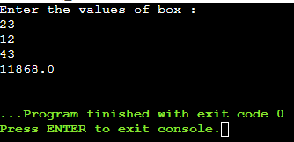

**PROGRAM – 19**

//Returning object

class Test{

int a;

Test(int i) {

a = i;

}

Test incrByTen () {

Test temp = new

Test(a+10) ;

return temp;

}

}

class Retob {

public static void main (String args []) {

Test ob1 = new Test(2);

Test ob2;

ob2 = ob1.incrByTen();

System.out.println("ob1.a: " + ob1.a);

System.out.println("ob2.a: " + ob2.a);

ob2 = ob2.incrByTen();

System.out.println("ob2.a after second increase : " + ob2.a);

}

}

**OUTPUT –**



**PROGRAM – 20**

//passing object as a parameters

class Test {

int a, b;

Test(int i, int j) {

a= i;

b=j;

}

void meth(Test o) {

o.a *= 2;

o.a /= 2;

}

}

class CallByRefDemo {

public static void main(String args []) {

Test ob = new Test(15, 20);

System.out.println("ob.a and ob.b before call :"+ob.a+" "+ob.b);

System.out.println("ob.a and ob.b after call :"+ob.a+" "+ob.b);

}

}

**OUTPUT –**



**PROGRAM – 20**

//Static members and member function

class UseStatic {

static int a = 3;

static int b;

static void meth(int x) {

System.out.println("x = " +x);

System.out.println("a = " +a);

System.out.println("b = " +b);

}

static {

System.out.println("Static block initialized.");

b = a*4;

}

public static void main(String args[]) {

meth(42);

}

}

**OUTPUT –**

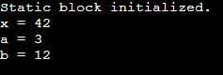

**PROGRAM – 21**

//Interitance of class

class A {

public void methodA()

{

System.out.println("Base class method");

}

}

class B extends A {

public void methodB()

{

System.out.println("Child class method");

}

public static void main(String args[])

{

B obj = new B();

obj.methodA();

obj.methodB();

}

}

**OUTPUT –**

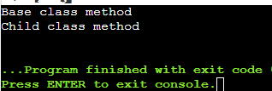

**PROGRAM – 22**

class X {

public void methodX()

{

System.out.println("class X method");

}

}

class Y extends X {

public void methodY()

{

System.out.println("class Y method");

}

}

class Z extends Y{

public void methodZ()

{

System.out.println("class Z method");

}

public static void main(String args[])

{

Z obj = new Z();

//CALLING GRAND PARENT CLASS METHOD

obj.methodX();

//CALLING PARENT C;ASS METHOD

obj.methodY();

//CALLING LOCAL METHOD

obj.methodZ();

}

}

**OUTPUT –**

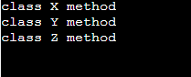

**PROGRAM – 23**

class Animal {

void eat()

{

System.out.println("eating...");

}

}

class Dog extends Animal {

void bark()

{

System.out.println("braking...");

}

}

class Cat extends Animal{

void meow()

{

System.out.println("meowing...");

}

}

class TestInheritance3{

public static void main(String args[])

{

Cat c = new Cat();

c.meow();

c.eat();

//c.bark();

}

}

**OUTPUT –**

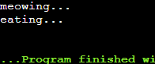

**PROGRAM – 24**

import java.util.Scanner;

class Box {

float width, height, depth;

public Box(float w, float h, float d) {

width = w;

height = h;

depth = d;

}

public void setWidth(float w) {

width = w;

}

public void setHeight(float h) {

height = h;

}

public void setDepth(float d) {

depth = d;

}

public float getWidth() {

return width;

}

public float getHeight() {

return height;

}

public float getDepth() {

return depth;

}

public void displayVolume() {

System.out.println("Volume of Box: " + width * height * depth);

}

}

class BoxWeight extends Box {

private float weight;

public BoxWeight(float w, float h, float d, float wt) {

super(w, h, d);

weight = wt;

}

public void setWeight(float wt) {

weight = wt;

}

public float getWeight() {

return weight;

}

public void displayWeight() {

System.out.println("Weight of Box: " + weight);

}

}

public class BoxWeightDemo{

public static void main(String[] args) {

Scanner sc = new Scanner(System.in);

System.out.print("Enter width: ");

float width = sc.nextFloat();

System.out.print("Enter height: ");

float height = sc.nextFloat();

System.out.print("Enter depth: ");

float depth = sc.nextFloat();

System.out.print("Enter weight: ");

float weight = sc.nextFloat();

BoxWeight bw = new BoxWeight(width, height, depth, weight);

bw.displayVolume();

bw.displayWeight();

sc.close();

}

}

**DATE – 12-04-2023**

**PROGRAM – 25**

interface printable{

void print();

}

class A6 implements printable{

public void print(){System.out.println("Hello");}

public static void main(String args[]){

A6 obj = new A6();

obj.print();

}

}

**OUTPUT -**



**PROGRAM – 26**

//Interface declaration: by first user

interface Drawable{

void draw();

}

//Implementation: by second user

class Rectangle implements Drawable{

public void draw(){System.out.println("drawing rectangle");

}

}

class Circle implements Drawable{

public void draw(){System.out.println("drawing circle");

}

}

//Using interface: by third user

class TestInterface1{

public static void main(String args[]){

Drawable d=new Circle();//In real scenario, object is provided by method e.g. getDrawable()

d.draw();

}

}

**OUTPUT -**



**PROGRAM – 27**

interface FirstInterface{

public void myMethod();

}

interface SecondInterface{

public int myMethod();

}

class Democlass implements FirstInterface, SecondInterface{

public void myMethod(){

System.out.println("Some text..");

}

public int myMethod(){

System.out.println("Some other text..");

return(1);

}

}

class Main{

public static void main(String args[]){

Democlass myobj = new Democlass();

myobj.myMethod();

System.out.println(myobj.myMethod());

}

}

