

VITYARTHI - PROGRAMMING IN JAVA PROJECT REPORT

TOPIC - Student Budget & Expense Tracker

Course: Programming in Java Course code: CSE2006

Name: Dhimant Bhardwaj
Registration Number: 24BAI10746
Faculty: Dr. Kamlesh Chandravanshi
Academic Year: 2026

Introduction

Human energy levels change every day depending on sleep quality, mood, caffeine intake, workload and personal habits. Most people are unable to notice patterns in their daily energy because they do not track these factors consistently. As a result, they experience sudden productivity drops, tiredness or burnout without understanding the reason behind it.
This project aims to create a simple console based Java program that helps users record minimal daily data and receive meaningful insights. The system stores daily entries, performs statistical calculations, identifies trends and predicts energy for the next day. The goal is not medical accuracy, but to provide the user with useful, easily understandable observations about their lifestyle patterns.

Problem Statement

People often feel energetic on some days and then extremely tired on other days, but they do not know what causes these changes. Without tracking daily inputs such as sleep hours, mood and productivity, it becomes difficult to understand patterns and fix problems. Symptoms of burnout also go unnoticed because there is no structured monitoring.
This project solves the problem by allowing users to enter simple data once a day and automatically generating insights such as:
- Energy score trends

- High-energy and low-energy days

- Sleep energy relationship

- Productivity level classification

- Potential crash indicators

- Best time of day for deep work

- Predicting next day’s energy

Objectives
- To record and store daily lifestyle inputs.

- To calculate a meaningful energy score.

- To analyse weekly and monthly behaviour patterns.

- To detect energy crashes and irregularities.

- To recommend the ideal deep-work time based on real data.

- To show data visually using ASCII graphs.

- To predict tomorrow’s mood and energy using simple logic.

Functional Requirements-

Daily Data Entry User inputs:
- Sleep hours

- Mood (1–5)

- Productivity (1–5)

- Caffeine intake

- Work type (Study / Creative / Physical / Mixed)

- Peak energy time (Morning / Afternoon / Night)

2. Energy Score Calculation
- The system calculates a simple energy score using a fixed formula.
Energy Score = (Sleep × 2) + (Mood × 3) + (Productivity × 3) – (Caffeine × 1)

3. Persistent Storage
- All entries are saved to `energy_data.csv`, which loads automatically at startup.

4. Analytics and Reporting
- Show highest energy day
- Show lowest energy day
- Show weekly/overall average
- Detect possible “energy crash”
- Recommend ideal deep-work timing
- Productivity tier (High/Moderate/Low)

5. Prediction Module
- Predict tomorrow’s energy using a 3 day moving average.

6. ASCII Energy Graph
Displays the last 7 days using bars:
2025-01-10 | |||||||||| (35)

7. Summary Output
- Provide a complete summary of the user's energy trends on demand.

Non-Functional Requirements

1. Usability
- Simple menu-driven console interface.

2. Performance
- Must load and analyse stored CSV data within 1 second.

3. Reliability
- Data must not be lost between program runs.

4. Maintainability
- Code structured into three clear classes for easy updates.

5. Error Handling
- Handle invalid input (non-numerical values, missing fields).

System Architecture

Architecture follows a 3-layer modular approach:

1. User Interface Layer (Main.java)
- Handles user inputs and menu operations.

2. Application Logic Layer (EnergyTracker.java)
- Performs analytics, predictions, crash detection, and summary.

3. Data Layer (EnergyEntry.java + CSV file)
- Stores, models, and loads individual daily records.

Architecture Diagram (Text Format)

+---------------------+
| Main UI |
| (Main.java) |
+----------+----------+
| v
+---------------------------+
| Energy Tracker |
| (EnergyTracker.java) |
+----------+----------------+
| v
+---------------------+
| Data Storage | | energy_data.csv |
| EnergyEntry.java |
+---------------------+

Design Diagrams
Use Case Diagram

User → Add Daily Entry
User → View Dashboard
User → Predict Energy
User → Show Graph
User → View All Entries
User → Export Data

Workflow Diagram
Start
|
v
Show Menu ---------------+
| |
|1 Add Entry |2 Summary
v v
Collect data Calculate analytics
Save to file Display summary
| |
+--------> Back to Menu <-------+
|
|3 Predict v
Display prediction
| v Exit

Sequence Diagram

User → Main: Select "Add Entry"
Main → User: Ask for input
User → Main: Provide input
Main → EnergyEntry: Create object
Main → EnergyTracker: addEntry()
EnergyTracker → CSV: Save entry
Main → User: Display "Entry saved"

Class Diagram
EnergyEntry
-----------------
Attributes: date, sleepHours, mood, productivity, caffeine, workType, peakTime, energyScore
Methods: calculateScore(), toCSV(), fromCSV()

EnergyTracker
--------------
Attributes: entries, csvFile
Methods:
- addEntry()
- loadFromFile()
- saveToFile()
- highestEnergy()
- lowestEnergy()
- weeklyInsights()
- asciiGraph()
- predictTomorrow()
- predictMood()
- productivityTier()
- sleepEnergyCorrelation()
- summaryDashboard()

Main
----
Methods: main(), addEntryFlow(), exportCopy()

ER Diagram (CSV Based Storage)
+-------------+
| User |
+-------------+
| user_id (PK)|
| name |
+------+------+
|
| 1 : M
+------v--------+
| EnergyEntry |
+---------------+
| entry_id (PK) |
| date |
| sleep Hours |
| mood |
| productivity |
| caffeine |
| workType |
| peakTime |
| energyScore |
+---------------+

Design Decisions & Rationale

1. Choice of Programming Language (Java)
Java was chosen because it supports object-oriented design, and has strong file handling libraries. It is widely used in academic and industry projects. Its structured approach makes it suitable for modelling real world data like daily energy patterns.

2. Use of CSV for Storage
A database was avoided to keep the project lightweight. CSV files are easy to create, portable, human readable, and work great for small datasets. This also reduces setup time, making the project simple for beginners.

3. Separation into Three Classes
The project uses five classes Main, EnergyEntry, FileManager, StatisticsUtil and EnergyTracker to maintain readability and modularity.

4. Menu-Driven Console Interface
A console based UI was chosen because it is easier to implement and demonstrates the core Java concepts clearly. It avoids GUI complexity and keeps the focus on logic and data analysis.

5. Energy Score Formula Selection
The scoring formula is intentionally simple and explainable. The aim is not medical accuracy but to offer clear and easily interpretable results to the user.

6. ASCII Graph Instead of External Libraries
ASCII graphs allow visualization without adding graphics libraries. It keeps the project fully console-based and simple while still making insights visually attractive.

Screenshots / Results
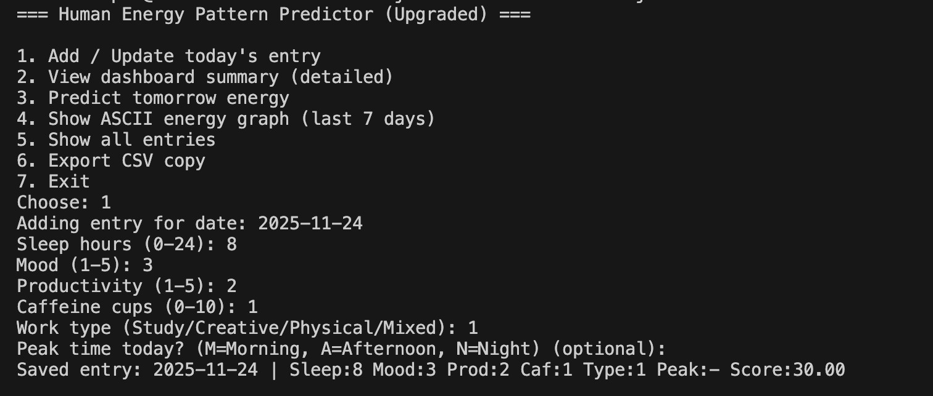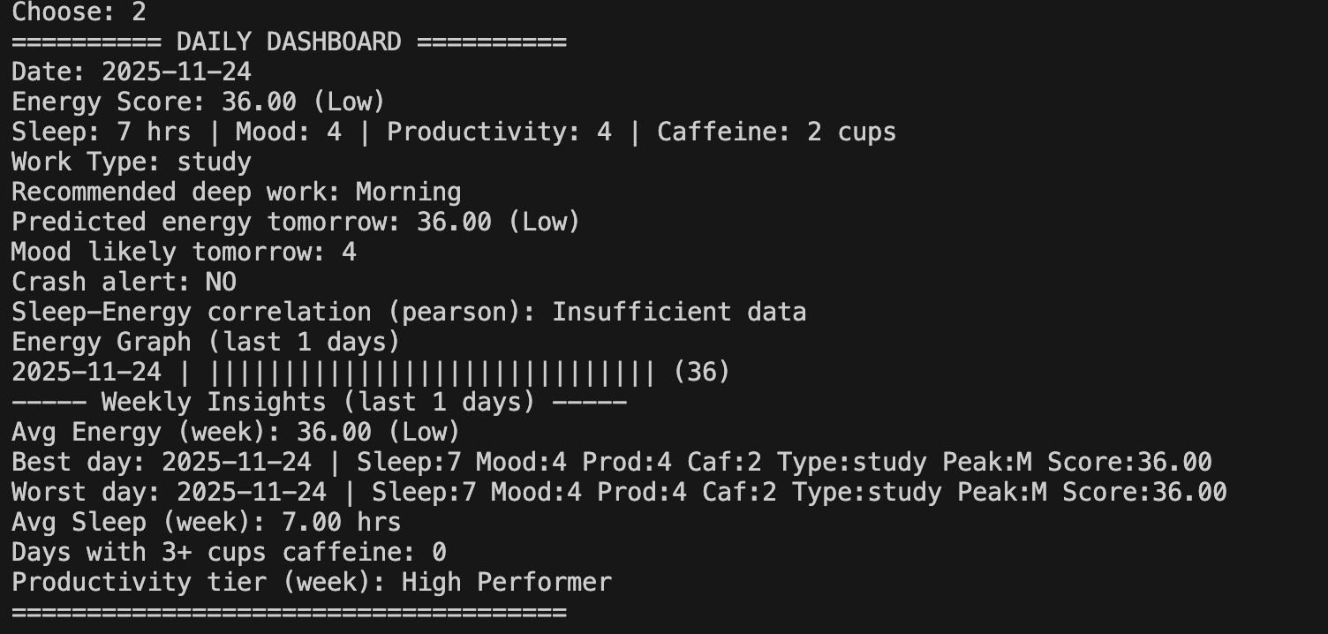
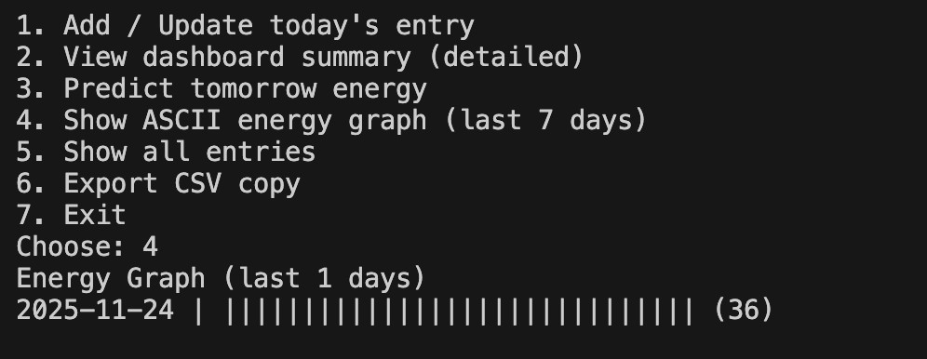

Testing Approach
Manual Test Cases:
- Insert valid daily record → stored correctly
- Insert invalid value (letters instead of numbers) → handled
- No existing data file → program creates new CSV
- Multiple entries → summary updates correctly

Boundary Tests:
- Sleep hours = 0 or 24
- Mood/productivity = 1 or 5
- Caffeine = 0 or 10

Challenges Faced
- Ensuring CSV reading/writing worked correctly across systems.
- Choosing an energy formula that is simple but meaningful.
- Designing a prediction method without using any ML libraries.
- Making the UI clear enough for new users.

Learnings & Key Takeaways
This project helped me understand how simple daily habits can be measured and analysed using a structured programming approach. I learned how to design classes, interact with files, and apply basic analytical techniques. Implementing the ASCII graph improved my understanding of loops and formatting. I also learned how data patterns reveal trends such as high-energy days and productivity peaks.
Overall, the project strengthened my Java concepts, logical thinking, and problem-solving skills.

Future Enhancements
- Add charts for visual energy trends
- Mobile app version
- Weekly reminders
- Import/export data
- Sleep cycle tracking using more variables

References
- Java Documentation: https://docs.oracle.com/javase
- Class notes and flipped-classroom videos

