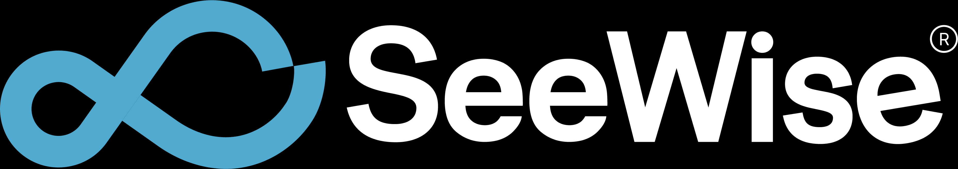
ENGINEERING PROJECT REPORT
AI-Powered Water Bottle Quality Inspection System
Internal company review and performance evaluation
Field | Details
Organization | SEEWISE.ai
Prepared for | Engineering Managers, Technical Leads, CTO / Leadership, Product Team, Future Developers
Prepared by | Internship Project Contributor
Report date | May 30, 2026
Status | Functional full-stack prototype with live AI inspection, video processing, analytics, and reporting

Evaluation Focus
This report emphasizes individual technical ownership, production-style debugging, real-time AI system design, and the business impact of automating visual quality inspection.

Table of Contents
1. Executive Summary
2. Problem Statement
3. Project Objectives
4. Solution Architecture
5. Technology Stack
6. Features Implemented
7. Engineering Challenges
8. Solutions Implemented
9. Performance Results
10. Business Impact
11. Key Learnings
12. Future Roadmap
13. Conclusion
14. Appendix
Document Use
This document is written for internal review. It is intentionally business-readable while preserving the engineering details needed for maintainability and future development.

1. Executive Summary

Project overview
The AI-Powered Water Bottle Quality Inspection System is a full-stack industrial computer vision platform built for SEEWISE.ai to automate visual quality inspection of water bottles. The system combines a React web application, a Python FastAPI backend, OpenCV-based frame handling, and YOLOv8 inference to classify bottles, fill-level conditions, and label defects across uploaded videos and live camera streams.
The project progressed from a core YOLO inference workflow into an operator-facing inspection platform with authentication, live inspection, camera source selection, video upload inspection, analytics, inspection history, CSV reporting, and usability features such as screenshots and fullscreen inspection views.

Key achievements
- Delivered an end-to-end inspection workflow covering webcam, RTSP camera, mobile IP camera, and uploaded video sources.
- Integrated YOLOv8 inference with class-level outputs for bottle, fill-level, and label-quality categories.
- Implemented live streaming through an MJPEG video feed with backend status endpoints for FPS, GPU state, capture timing, inference timing, and defect counts.
- Built management-facing dashboards for pass/fail statistics, defect trends, historical records, and CSV report export.
- Improved operational reliability through low-latency OpenCV capture settings, RTSP reconnect handling, asynchronous stream processing, and production-style error handling.

Business impact
The system reduces dependence on manual visual inspection, improves consistency of quality decisions, and gives production stakeholders real-time visibility into defects. It also creates a historical evidence trail through structured records and CSV exports, helping engineering and operations teams investigate line issues faster.
Individual Contribution Summary
The intern contributor owned full-stack implementation across UI workflows, backend APIs, live stream integration, AI inference orchestration, analytics, debugging, and reportable system outputs. The work demonstrates technical ownership across both product surface and infrastructure behavior.

2. Problem Statement

Existing inspection challenges
Water bottle quality inspection requires identifying multiple visual conditions quickly and consistently: whether a bottle is present, whether the fill level is proper, underfilled, or overfilled, and whether the label is acceptable, torn, or missing. Manual inspection is repetitive and sensitive to fatigue, lighting variance, operator availability, and line speed.

Production bottlenecks
- Manual inspection creates a throughput ceiling when production volume increases.
- Operators can miss short-lived defects when bottles move quickly through the line.
- Inspection results are often not structured enough for analytics, trend review, or root-cause analysis.
- Live camera feeds from different sources require different connection approaches and failure handling.
- Quality teams need fast reporting without manually compiling evidence after each inspection cycle.

Need for AI-driven automation
An AI-driven inspection system can monitor every frame, apply consistent classification logic, and surface actionable metrics immediately. The business need is not only object detection; it is an integrated inspection workflow that turns detections into operational decisions, evidence, and management visibility.
Manual inspection limitation | AI-enabled response
Fatigue and subjectivity | Consistent model-driven detections and pass/fail logic
Limited reporting | Stored inspection history and CSV exports
Delayed issue discovery | Real-time dashboards and live stream monitoring
Camera-source complexity | Unified webcam, RTSP, mobile camera, and upload workflows

3. Project Objectives

Accuracy goals
- Detect bottle presence and relevant quality classes using trained YOLOv8 weights.
- Differentiate proper_fill, under_fill, over_fill, label_ok, label_torn, and label_missing outcomes.
- Apply pass/fail logic where a bottle passes only when proper fill and label OK are detected.
- Preserve model confidence, bounding boxes, and class labels for review and future tuning.

Real-time performance goals
- Support live camera inspection with responsive visual feedback.
- Target 640 x 480 inference frames and a 30 FPS operational target when hardware allows.
- Expose real-time FPS, capture timing, inference timing, stream timing, and GPU status to the frontend.
- Use CUDA acceleration and FP16 inference when available to reduce latency.

Scalability goals
- Separate frontend, API, inference, stream, and persistence responsibilities.
- Support additional camera sources through the same start/stop/status interface.
- Store inspection results in a structure that can be migrated from SQLite to a production database.
- Design future extensibility for multi-camera support, cloud deployment, and edge AI deployment.
Objective area | Definition of success | Implemented evidence
Functional coverage | All core workflows available from the web app | Dashboard, live, upload, analytics, history, settings
Source flexibility | Multiple video inputs accepted | Webcam, RTSP, mobile IP camera, uploaded files
Operational insight | KPIs visible during and after inspection | Stats cards, charts, logs, CSV exports
Maintainability | Clear route and service boundaries | FastAPI routers, React pages, service helpers

4. Solution Architecture
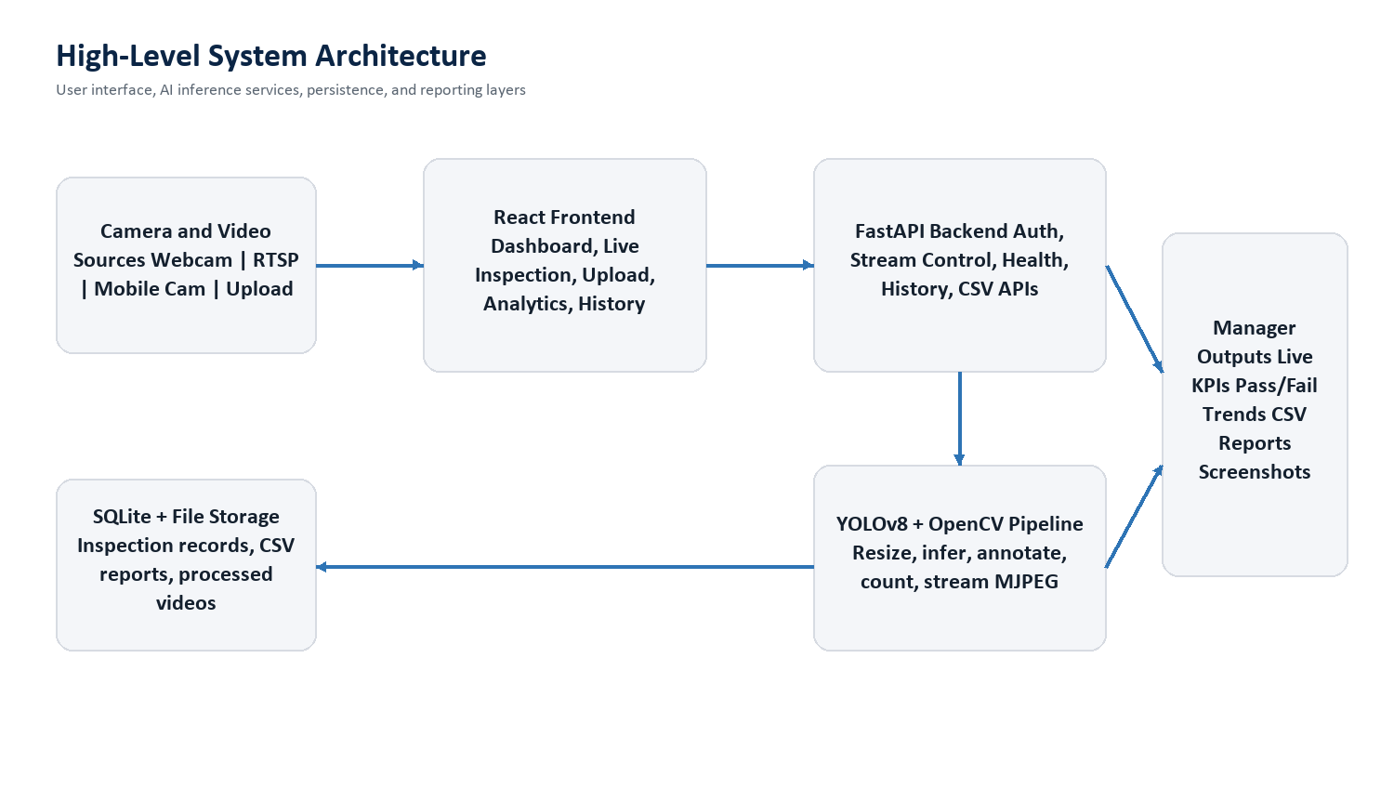
Figure 1. High-level architecture of the inspection platform.
The system follows a modular web architecture. The React frontend owns navigation, operator workflows, dashboards, and visualization. The FastAPI backend owns model health, camera stream control, uploaded video processing, analytics aggregation, inspection history, authentication endpoints, and report exports. The inference layer uses YOLOv8 and OpenCV to process frames and produce annotated outputs.

Frontend architecture
- React single-page application with protected `/app` routes for operational pages.
- Feature pages for Dashboard, Live Inspection, Video Upload, Analytics, History, Settings, Profile, Account Settings, and Activity Logs.
- Reusable service layer for backend API calls, analytics, inference, and history.
- Responsive UI components for live stream display, stats cards, charts, tables, toasts, and navigation.

Backend architecture
- FastAPI application with routers for analytics, history, inference, streams, users, and legacy inspection endpoints.
- SQLite persistence for inspection records, historical analytics, reports, and uploaded video references.
- Stream state manager tracking capture FPS, inference FPS, stream FPS, GPU state, frame drops, and latest annotated frames.
- CSV report endpoints for per-inspection and global export workflows.

AI inference pipeline
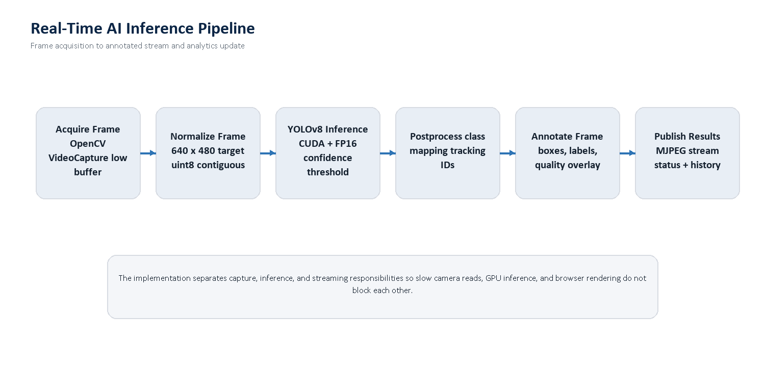
Figure 2. Real-time inference pipeline from frame acquisition to published results.
The inference pipeline normalizes frames, runs YOLOv8 on the configured device, extracts class-level detections, assigns bottle IDs where possible, draws bounding boxes and labels, and publishes annotated frames for browser consumption. The upload path writes processed video output while live inspection publishes the most recent annotated frame through an MJPEG feed.

Core pipeline responsibilities
- Acquire frames from webcam, RTSP, mobile IP camera, or uploaded video.
- Resize frames to the configured target size and ensure contiguous uint8 format.
- Run YOLO inference with confidence thresholding and CUDA/FP16 acceleration when available.
- Map model class names into canonical business classes.
- Calculate pass/fail and defect counts.
- Publish annotated frames, live status, analytics updates, and persisted results.
Architecture Decision
The implementation separates camera capture, inference, and browser streaming so a slow camera read, GPU inference spike, or frontend reconnect does not collapse the entire live inspection workflow.

5. Technology Stack
Layer | Technology | Role in system
Frontend | React, React Router, Vite | Operator UI, protected routes, dashboards, live inspection controls
Visualization | Recharts, custom CSS, lucide-react | Analytics charts, KPI cards, icons, responsive UI
Backend | Python, FastAPI, Uvicorn | REST APIs, stream control, health checks, history, reports
Computer Vision | YOLOv8, OpenCV, NumPy | Object detection, frame capture, resizing, annotation, encoding
Acceleration | PyTorch CUDA, FP16 | GPU inference and reduced latency on CUDA hardware
Persistence | SQLite, SQLAlchemy | Inspection records, analytics history, user data
Exports | CSV, processed video, screenshot download | Evidence and reporting outputs for quality teams

Stack rationale
React was selected for a responsive dashboard-oriented interface. FastAPI was selected for clear Python-native API development around model inference and stream controls. YOLOv8 and OpenCV provide a mature, practical computer vision stack for real-time object detection, annotation, and video handling. CUDA/FP16 support allows the system to take advantage of available NVIDIA hardware while retaining CPU fallback behavior for upload workflows where configured.

Verified runtime status
Runtime item | Observed value
Model readiness | Health endpoint reports model_ready = true
Live model device | cuda
Analysis model device | cuda
Precision mode | FP16 active for live and analysis models
Local GPU | NVIDIA GeForce RTX 3050 6GB Laptop GPU
Live metrics endpoint | Exposes inference_fps, stream_fps, capture_fps, average_fps, GPU state, and frame drops

6. Features Implemented
Feature | Implementation summary | Business value
Authentication | Register, login, protected app routes, profile/activity support | Controls access to inspection tools and user workflows
Dashboard | KPI cards, recent inspections, charts, model status | Gives leadership and operators quick operational visibility
Live Inspection | Start/stop stream, source selection, MJPEG output, live stats | Supports real-time quality monitoring
Webcam Integration | OpenCV webcam capture using device ID 0 | Fast local camera validation and live inspection
RTSP Integration | RTSP URL support with TCP/UDP retry candidates | Connects to production-style network cameras
Mobile Camera | IP webcam URL builder for phone-based camera streams | Enables low-cost flexible camera testing
Video Upload | Upload video, start inference, stream annotated output | Supports offline validation and recorded production reviews

Feature | Implementation summary | Business value
Analytics Dashboard | Pass/fail charts, defect bars, trend lines, clear analytics | Turns detections into management insight
Inspection History | Search, filters, pagination, per-inspection detail | Creates traceability for quality events
CSV Export | Per-inspection and global CSV report endpoints | Automates reporting and evidence sharing
Admin Features | Settings, account pages, activity logs, analytics clearing | Supports maintainability and operational control
Screenshot Capture | Canvas-based capture of current visible live frame | Provides quick visual evidence during live review
Fullscreen View | Dedicated fullscreen control for inspection output | Improves operator focus during live monitoring
Toasts and Error Handling | User-facing messages for startup, stop, upload, failures | Improves usability and debuggability

Individual ownership
The project required ownership across frontend behavior, API integration, stream handling, inference orchestration, debugging, reporting, and UI polish. The implemented surface is not a narrow model demo; it is a functioning inspection platform with multiple operator workflows and evidence outputs.

7. Engineering Challenges

Stream stability
Live streams are inherently unstable because camera devices, RTSP endpoints, Wi-Fi mobile cameras, browser image decoding, and backend inference all operate on different timing models. A production inspection system must keep serving current frames even when one component slows down.

FPS optimization
YOLO inference can become the bottleneck if frames are too large, if the model is repeatedly reloaded, or if CPU/GPU memory handling is inefficient. The system needed target frame sizing, rolling FPS measurements, adaptive delay behavior for uploads, and GPU acceleration.

RTSP handling
RTSP streams can fail due to transport configuration, buffering, authentication, network latency, or camera firmware behavior. The backend needed low-buffer capture settings, timeout detection, and retry candidates using TCP and UDP transport options.

Mobile camera support
Mobile IP camera apps expose streams through URLs that may include hostnames, IP addresses, ports, and path differences. The UI had to normalize user input while preserving flexibility for different mobile camera apps.

Real-time inference bottlenecks
The system needed to avoid blocking live capture while inference was running. It also needed to prevent frontend stream rendering from depending on every captured frame being processed, because live inspection should prioritize the latest frame over stale frame backlog.

UI responsiveness
The frontend had to communicate state clearly: whether the system is connected, whether frames are available, which source is selected, current FPS, pass/fail counts, and whether an action succeeded or failed.

8. Solutions Implemented
Challenge | Solution | Engineering result
Frame backlog | Latest-frame queue with max size 1 and annotated frame publisher | Live output prioritizes current state over stale frames
RTSP instability | Reconnect loop, low-delay capture settings, TCP/UDP candidates | Improved tolerance for camera/network variance
GPU efficiency | Model loaded once, pinned to CUDA, optional FP16, torch.no_grad | Reduced per-frame inference overhead
Browser streaming | MJPEG endpoint serving latest annotated JPEG frame | Simple browser-compatible live view
Source diversity | Unified start-stream API with source_type and URL | One frontend flow supports webcam, RTSP, and mobile camera
Reporting | Inspection persistence plus CSV endpoints | Quality evidence is structured and exportable

Technical decisions
- Used FastAPI for API clarity and Python-native integration with OpenCV, PyTorch, and YOLO.
- Used MJPEG for live browser rendering because it is simple, broadly compatible, and works well for annotated JPEG frames.
- Used SQLite during prototype development for low operational overhead and easy local evaluation.
- Maintained separate upload and live inspectors to support different inference behavior and operational constraints.
- Exposed detailed stream status so performance debugging can be done from both backend logs and frontend dashboards.

Debugging approach
The project relied on end-to-end tracing rather than isolated assumptions. For example, screenshot capture was traced from button click to canvas drawing to blob creation to file download, revealing that the original implementation linked to the MJPEG endpoint instead of capturing rendered pixels. This same debugging style was applied across stream startup, camera source handling, API failures, and UI state transitions.
Problem-Solving Signal
A recurring pattern in the project was converting vague symptoms into observable stages: user action, frontend state, API request, backend capture, inference output, stream publication, browser rendering, persistence, and export.

9. Performance Results

Functional validation
- YOLO predictions were validated as accurate for the implemented bottle, fill, and label classes during project testing.
- Webcam, RTSP, mobile camera, video upload, and live inspection flows were confirmed functional.
- Navigation, UI layout, analytics, history, screenshot capture, and fullscreen behaviors were verified after fixes.
- The backend health endpoint reports the model is ready and GPU acceleration is available.

Runtime performance indicators
Metric | Implemented measurement | Observed / target status
Detection accuracy | Model-level validation using YOLO detections and class mapping | Functionally validated; formal dataset mAP should be added in future evaluation
Average FPS | average_inference_fps exposed by stream status endpoint | Endpoint implemented; target is near 30 FPS when source and GPU permit
Live inference FPS | inference_fps exposed by stream status endpoint | Endpoint implemented; frontend displays FPS during live operation
Capture latency | capture_time_ms tracked by backend | Endpoint implemented for camera read diagnostics
Inference latency | inference_time_ms tracked by backend | Endpoint implemented for model bottleneck analysis
GPU utilization readiness | CUDA, GPU active, model device, FP16 flags | Observed CUDA active, model_device cuda, FP16 active
Stability | frames_dropped, last_error, is_running, reconnect status | Implemented for live stream monitoring and recovery

Validated environment
A local runtime health check reported `model_ready=true`, `live_model_device=cuda`, `analysis_model_device=cuda`, `live_fp16=true`, and `analysis_fp16=true` on an NVIDIA GeForce RTX 3050 6GB Laptop GPU. This confirms that the deployed local system can use GPU acceleration for both live and upload analysis paths.
Evaluation Note
Formal benchmark reporting should add a fixed validation dataset, labeled ground truth, mAP/precision/recall, per-source FPS, and latency percentiles. The current implementation already exposes the telemetry needed to run that evaluation cleanly.

10. Business Impact

Reduced manual inspection effort
The system shifts repetitive visual checks from manual observation to automated detection and monitoring. Operators can focus on exceptions, process adjustments, and quality escalation rather than watching every bottle frame-by-frame.

Improved quality control
Real-time class detection helps identify fill and label defects while the line is active. Structured pass/fail metrics create a repeatable quality signal that can be compared over time.

Real-time monitoring capability
Live inspection pages make current stream health, FPS, and defect metrics visible in the browser. This supports quicker decision-making for engineering managers, technical leads, and production supervisors.

Reporting automation
CSV exports and inspection history reduce manual report preparation. The same data can be used for management summaries, defect trend reviews, and future model evaluation.
Business outcome | System capability enabling it
Faster defect visibility | Live camera inspection and real-time KPI display
Consistent inspection criteria | YOLO class detection and pass/fail logic
Traceable quality events | Inspection history and CSV reports
Lower review overhead | Dashboard summaries and analytics charts
Scalable roadmap | Modular API and camera-source abstractions

11. Key Learnings

Computer vision
The project deepened practical understanding of YOLO model loading, class mapping, confidence handling, bounding-box annotation, frame resizing, and detection statistics. It also highlighted that model accuracy is only one part of a usable inspection system.

Real-time AI systems
Real-time behavior depends on the interaction between camera capture, network transport, GPU inference, frame encoding, browser rendering, and user expectations. The system must be designed around current frames, clear status reporting, and graceful degradation.

Full-stack development
The work required building and connecting React pages, service APIs, FastAPI routes, persistence models, stream endpoints, and visual reporting. This created experience across frontend, backend, and AI integration boundaries.

Production debugging
Several issues required tracing behavior end to end, including camera-source handling, stream readiness, canvas screenshot capture, and API health. The key learning was to add observable checkpoints before assuming a UI event, backend route, or model call was the source of failure.

Performance optimization
The project reinforced the importance of target input resolution, GPU device pinning, FP16 inference, frame queue design, low-delay capture settings, and telemetry-driven performance review.
Growth Signal
The project demonstrates movement from feature implementation toward engineering ownership: diagnosing systems, making tradeoffs, instrumenting runtime behavior, and building outputs that can be reviewed by both technical and business stakeholders.

12. Future Roadmap
Roadmap item | Description | Expected value
Multi-camera support | Support multiple simultaneous production camera feeds with per-line dashboards | Scales system from prototype to factory monitoring
Cloud deployment | Containerized deployment with managed database, object storage, and observability | Improves availability and remote access
Advanced analytics | Defect heatmaps, time-series drilldowns, shift reports, alert thresholds | Turns inspection data into process intelligence
Edge AI deployment | Run inference near production cameras on edge GPU devices | Reduces network latency and improves resilience
Model evaluation suite | Automated mAP, precision, recall, latency, and regression reports | Creates repeatable model-quality governance
Role-based access | Operator, manager, admin permission layers | Improves enterprise readiness

Recommended next milestones
- Create a fixed labeled validation dataset and benchmark current weights.
- Run controlled FPS and latency tests for webcam, RTSP, mobile camera, and upload workflows.
- Add multi-camera stream orchestration and per-camera health monitoring.
- Move inspection storage from SQLite to a production database when deployment scope expands.
- Package the backend and frontend into a reproducible deployment pipeline.

13. Conclusion
The AI-Powered Water Bottle Quality Inspection System successfully demonstrates a practical, full-stack AI inspection platform for SEEWISE.ai. It moves beyond a standalone YOLO model by delivering user authentication, operational dashboards, live camera integration, uploaded video analysis, analytics, history, reports, and evidence capture.
The project required solving real engineering problems around stream stability, real-time performance, camera-source variability, UI responsiveness, and debugging across frontend/backend boundaries. The final system is suitable for internal evaluation and provides a strong foundation for production hardening, multi-camera expansion, cloud deployment, and edge AI adoption.
Final Evaluation Summary
The individual contribution demonstrates strong technical ownership, problem-solving maturity, and the ability to translate AI capability into a usable engineering product with measurable operational value.

14. Appendix

Appendix A: User Workflow Diagram
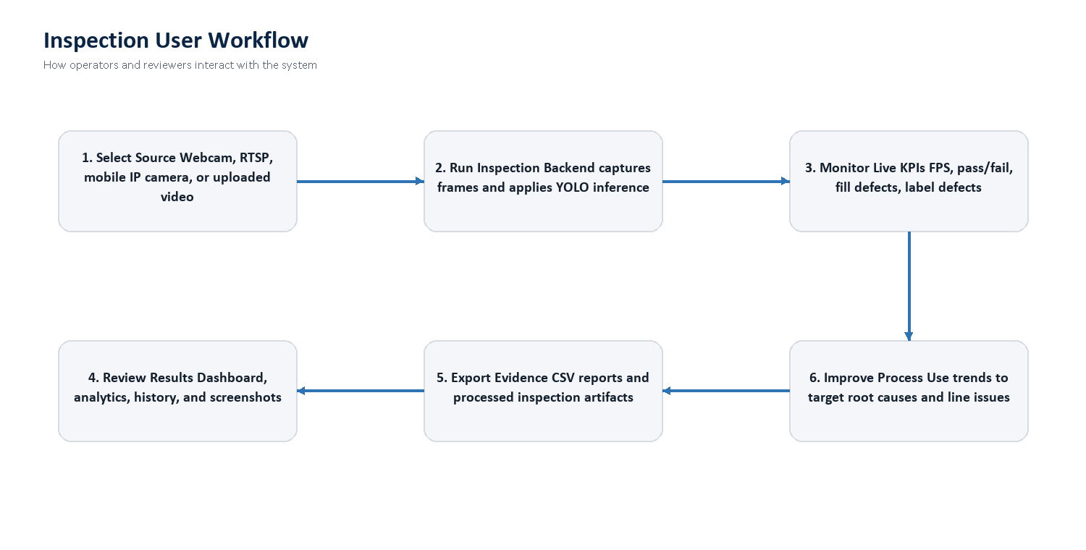
Figure 3. End-to-end user workflow for inspection setup, monitoring, reporting, and improvement.

Appendix B: System Screenshots and Visual Evidence
The application includes the following system views for review and demonstration. In a formal leadership walkthrough, these views should be shown live from the running application so evaluators can inspect current data and camera behavior.
View | Purpose
Homepage | Introduces SEEWISE.ai inspection platform and routes users into the app
Dashboard | Shows model readiness, KPI totals, charts, and recent inspections
Live Inspection | Controls webcam, RTSP, and mobile camera streams with live detection output
Video Upload | Uploads recorded footage and streams processed YOLO output
Analytics | Summarizes pass/fail, defect categories, and trends
Inspection History | Searches historical inspections and exports CSV reports

Appendix C: API Surface Summary
API area | Representative endpoints
Health and model readiness | GET /health
Video upload inspection | POST /upload-video, POST /start-inference, POST /stop-inference
Live stream control | POST /start-stream, GET /stop-stream, GET /stream-status
Streaming output | GET /video-feed, GET /video-feed-stats
Analytics | GET /api/analytics/dashboard, DELETE /api/analytics/clear
History and reports | GET /api/history/, GET /api/history/{id}/report, GET /export-csv
Users | POST /api/users/register, POST /api/users/login, GET /api/users/me

Appendix D: Detection Classes
Class | Meaning
bottle | Bottle object detected
proper_fill | Correct fill level detected
under_fill | Bottle fill level below acceptable threshold
over_fill | Bottle fill level above acceptable threshold
label_ok | Acceptable label detected
label_torn | Torn or damaged label detected
label_missing | Missing label condition detected

Appendix E: Maintenance Notes
- Keep trained weights under backend/weights or configure YOLO_WEIGHTS and YOLO_LIVE_WEIGHTS.
- Use /health to verify model readiness and GPU state before a demo.
- Use /stream-status and /video-feed-stats to diagnose live stream performance.
- For future benchmarking, record source type, resolution, FPS, latency, GPU status, and defect counts in a fixed test protocol.

