STUDENT MANAGEMENT SYSTEM (SIMS) USING PHP
Velumani J¹, Aditya Pareek V², Dhina S³, Gobiprasath N⁴
¹Assistan Professor, Dept. of Computer Science and Engineering & Paavai Engineering College, TN, India
^{2,3,4}UG Scholar, Dept. of Computer Science and Engineering & Paavai Engineering College, TN India

---------------------------------------------------------------------***---------------------------------------------------------------------

Abstract - The aim of this project is to create a web application software for college and the purpose is to maintain the “STUDENT INFORMATION MANAGEMENT SYSTEM (SIMS) USING PHP” for both the students and staff members. This webpage can be used by colleges to maintain the records of students easily for placement purpose. This project also contains faculty details, student’s details, various academic and placement notifications to the staff and students updated by the administration. This project mainly explains the various actions related to student details. This project shows an ease in adding, editing and deleting the student details and it consume less time. This system is focused on recording and updating the student details. It can also facilitate to explore the placement updates for the students with several core companies.
Key Words: Student, management, MySQL, registration, CGPA.

1. INTRODUCTION

The design and implementation of a comprehensive student information system and user interface to replace the current paper records is proposed in this project can be able to access all aspects of a student’s academic progress through a secure, online interface embedded in the website. The system utilizes user authentication, displaying only information necessary for an individual’s duties.
Additionally, each sub-system has authentication allowing authorized users to create or update information in that subsystem. All data is thoroughly reviewed and validated on the server before actual record alteration occurs. All data is stored securely on SQL servers managed by the administrator and ensures highest possible level of security. The system features a complex logging system to track all user access and ensure conforming by the giving username and password.
Previously, faculty worked heavily on paper records for this initiative on collecting the details of students regarding placement purpose. Paper records are difficult to manage and track. The physical exertion required to retrieve, alter, and re-file the paper records are all non-value added activities. This system provides a simple interface for the maintenance of student information. It can be used by educational institutes or colleges to maintain the records of students easily.
Achieving this objective is difficult using a manual system as the information is scattered, can be redundant and collecting relevant information may be very time consuming. All these problems are solved using online Student Information Management System(SIMS). It facilitates online registration and profile creation of student’s automating the record generation process in an educational institution.
This form seeks to find out details of the student.

1.1 Objective

The main objective of this project is to maintain the details of students and the purpose of Student Information Management System is to get an understanding of how the student’s record is maintained. This Student Information Management System is based on identification of some key qualities in the document and their relations. With the understanding of the structure and content of key quality documents, it will help to reduce the duplication and save more time.
The objectives are
- Giving online interface for students and faculty members.
- Expanding the effectiveness of college record administration.
- Abatement time needed to access and convey students’ records.

2. EXISTING SYSTEM

System Analysis is a detailed study of the various operations performed by a system and their relationships within and outside of the system. Here the key question is- what all problems exist in the present system? What must be done to solve the problem? Analysis begins when a user or manager begins a study of the program using existing system.
During analysis, data collected on the various files, decision points and transactions handled by the present system. The commonly used tools in the system are Data Flow Diagram, interviews, etc. Training, experience and common sense are required for collection of relevant information needed to develop the system. The success of the system depends largely on how clearly the problem is defined, thoroughly investigated and properly carried out through the choice of solution. A good analysis model should provide not only the mechanisms of problem understanding but also the frame work of the solution. Thus it should be studied thoroughly by collecting data about the system. Then the proposed system should be analysed thoroughly in accordance with the needs.
System analysis can be categorized into four parts.
- System planning and initial investigation
- Information Gathering
In the current system we need to keep a number of records related to the student and want to enter the details of the student and the marks manually. In this system only the teacher or the school authority views, verifies the mark of the students and they enter the details of the students. This is time consuming and has much cost.

2.1 DISADVANTAGE OF EXISTING SYSTEM
- The data can be easily leaked.
- There is no efficient technique to safe guard the users of phishing websites.
3. PROPOSED SYSTEM
The proposed system will have the provision for adding the details of the students by staff. Another advantage of the system is that it is very easy to edit the details of the student and delete a student when it found unnecessary. The marks of the student are added in the database. The proposed system has several advantages
- User friendly interface
- Fast access to database
- Less error
- More Storage Capacity(250GB)
- Search facility
- Look and Feel Environment
All the manual difficulties in managing the student details in a school or college have been rectified by implementing computerization.
In this case, using a local server called XAMPP. For, Frontend HTML, CSS, JavaScript and backend will be PHP and MySQL.
3. SOFTWARE ENVIRONMENT
3.1 PHP TECHNOLOGY
PHP is a server-side scripting language designed for web development but also used as a general-purpose programming language. PHP is now installed on more than 244 million websites and 2.1 million web servers. Originally created by RasmusLerdorf in 1995, the reference implementation of PHP is now produced by The PHP Group. While PHP originally stood for Personal Home Page, it now stands for PHP: Hypertext Preprocessor, a recursive backronym.PHP code is interpreted by a web server with a PHP processor module, which generates the resulting web page: PHP commands can be embedded directly into an HTML source document rather than calling an external file to process data. It has also evolved to include a command-line interface capability and can be used in standalone graphical applications.
PHP is free software released under the PHP License. PHP can be deployed on most web servers and also as a standalone shell on almost every operating system and platform, free of charge.

3.2 MySQL
MySQL ("My S-Q-L", officially, but also called "My Sequel") is (as of July 2013) the world's second most widely used open-source relational database management system(RDBMS). It is named after co-founder Michael Widenius daughter, My SQL phrase stands for Structured Query Language. The MySQL development project has made its source code available under the terms of the GNU General Public License, as well as under a variety of proprietary agreements. MySQL was owned and sponsored by a single for-profit firm, the Swedish company MySQL AB, now owned by Oracle Corporation .MySQL is a popular choice of database for use in web applications, and is a central component of the widely used LAMP opens source web application software stack (and other 'AMP' stacks). LAMP is an acronym for "Linux, Apache, MySQL, Perl/PHP/Python." Free-software-open source projects that require a full-featured database management system often use MySQL. For commercial use, several paid editions are available, and offer additional functionality.

3.3 HTML and CSS
Hyper Text Markup Language is the main language for creating web pages and other information that can be displayed in a web browser.HTML is written in the form of HTML elements consisting of tags enclosed in angle brackets like<html>, within the web page content.
HTML tags most commonly come in pairs like <h1> and </h1>, although some tags represent empty elements and so are unpaired, for example <img>. The first tag in a pair is the start tag, and the second tag is the end tag (they are also called opening tags and closing tags). In between these tags web designers can add text, further tags, comments and other types of text-based content.
Cascading Style Sheets (CSS) is a style sheet language used for describing the look and formatting of a document written in a markup language, to style web pages and interfaces written in HTML and XHTML. The language can be applied to any kind of XML document, including plain XML, SVG.
3.4 JavaScript
JavaScript is a dynamic computer programming language. It is most commonly used as part of web browsers, whose implementations allow client-side scripts to interact with the user, control the browser, communicate asynchronously, and alter the document content that is displayed. It is also being used in server-side programming, game development and the creation of desktop and mobile applications.
JavaScript is a prototype-based scripting language with dynamic typing and has first-class functions. Its syntax was influenced by C. JavaScript copies many names and naming conventions from Java, but the two languages are otherwise unrelated and have very different semantics.
4 UML Diagrams
4.1 Introduction
Design is the first step in the development phase for an engineered product or system. Design is the place where quality is fostered in software development. Design is the only way that can accurately translate a user's requirements into a finished software product or system.
4.2 UML Diagrams
Use Case Diagram
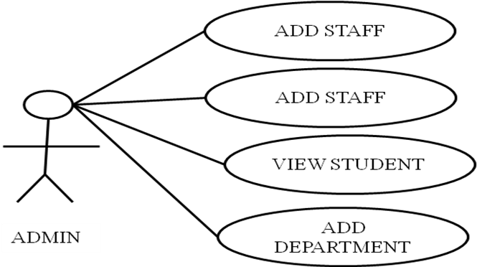
Figure 1: Use Case Diagram for Admin.
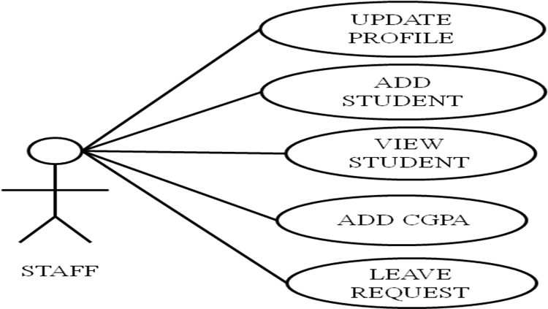
Figure 2: Use Case Diagram for Staff

Figure 1 and 2 shows the representation of a user's interaction with the system that shows the relationship between the user and the different use cases in which the user is involved and displays the relationship between actors and use cases.

State Diagram
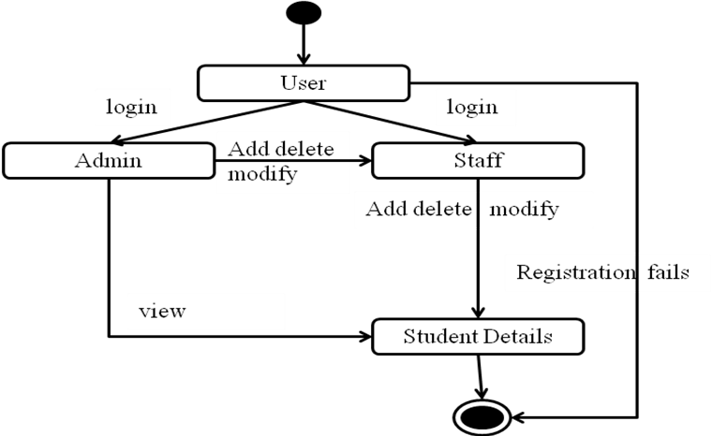
Figure 3: State diagram
Figure 3 shows the sequence of states that an object of an interaction goes through during its life in response to received stimuli, together with its responses and actions.
Deployment Diagram

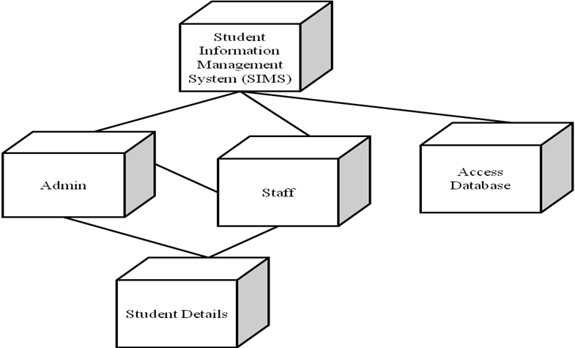
Figure 4: Deployment diagram
Figure 4 shows architecture of Student Information Management System to deployment targets of Administrator, staff, Student details and Accessing Database.

4.3 DATABASE DESIGN

The general theme behind a database is to handle information as an integrated whole. A database is a collection of interrelated data stored with minimum redundancy to serve many users quickly and efficiently. The general objective is to make information access easy quick and flexible for user. In database design several objectives are considered.

4.3.1 TABLE STRUCTURES

Student Table
Field Name | Data Type | Constraint
Id | int | Primary Key
reg_no | int
Name | varchar
father_name | varchar
Dob | date
gender | varchar
Contact | number
Email | varchar
address | text
department | varchar
sec | varchar
Image | longblob
Table 1: Database design for Student
UAD Table
Field Name | Data Type | Constraint
Username | varchar
Password | varchar
Table 2: Database design for UAD
Academic Table
Field Name | Data Type | Constraint
Id | int | Primary Key
reg_no | int
Name | varchar
departmet | varchar
percentage_sslc | float
percentage_hsc | float
percentage_sem 1 | float
percentage_sem 2 | float
percentage_sem 3 | float
percentage_sem 4 | float
percentage_sem 5 | float
percentage_sem 6 | float
percentage_sem 7 | float
percentage_sem 8 | float
percentage_cgpa | float
current_arrear | varchar
history_arrear | varchar
Table 3: Database design for Academic
4.3.2 DATA FLOW DIAGRAM
The Data Flow Diagram (DFD) is also called as bubble chart. It is a simple graphical formalism that can be used to represent a system in terms of the input data to the system, various processing carried out on these data, and the output data is generated by the system.
- A DFD is a graphical representation of the "flow" of data through an information system, modeling its process aspects. Often they are a preliminary step used to create an overview of the system which can later be elaborated.
- A DFD shows, what kind of data will be input to and output from the system, where the data will come from and go to, and where the data will be stored.

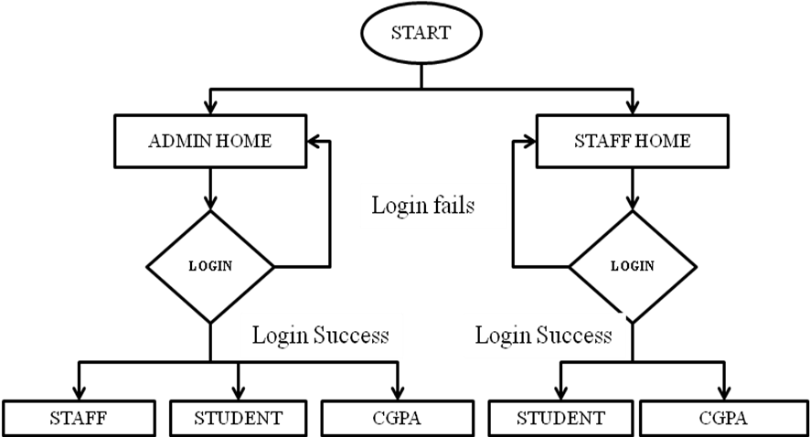
Figure 5: Data Flow Diagram

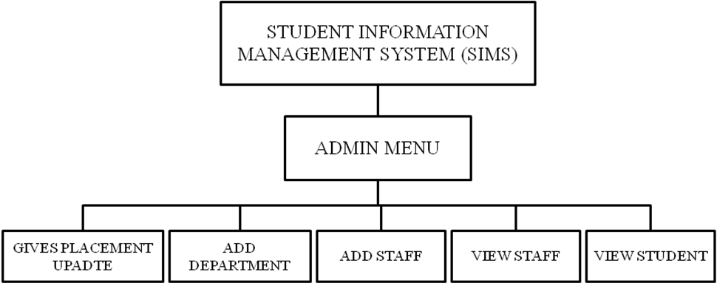
Figure 6: Admin Menu

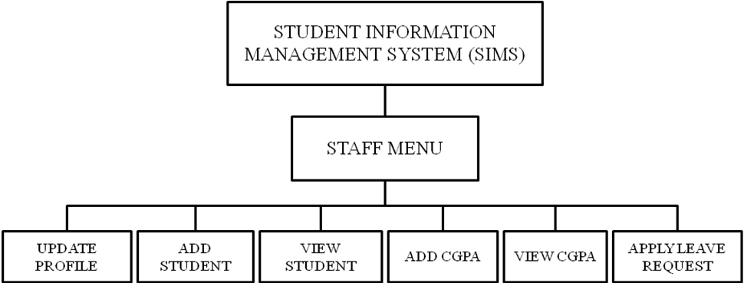
Figure 7: Staff Menu

Admin Login Page
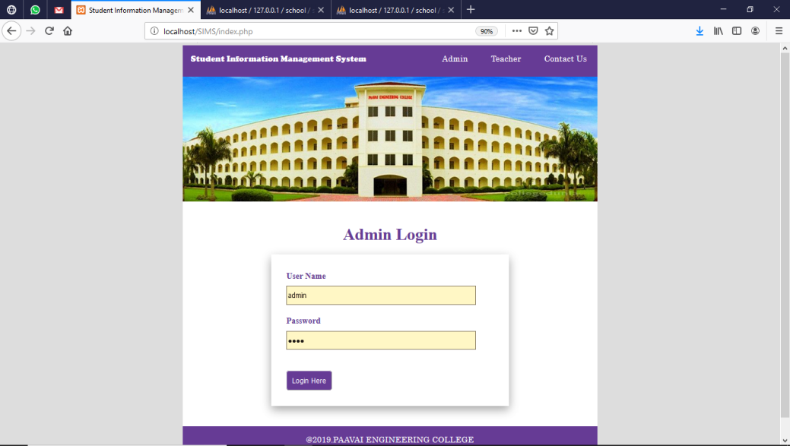
Description:
Here user gives their username and password to login in to the Adminstrator Screen.
Admin home page
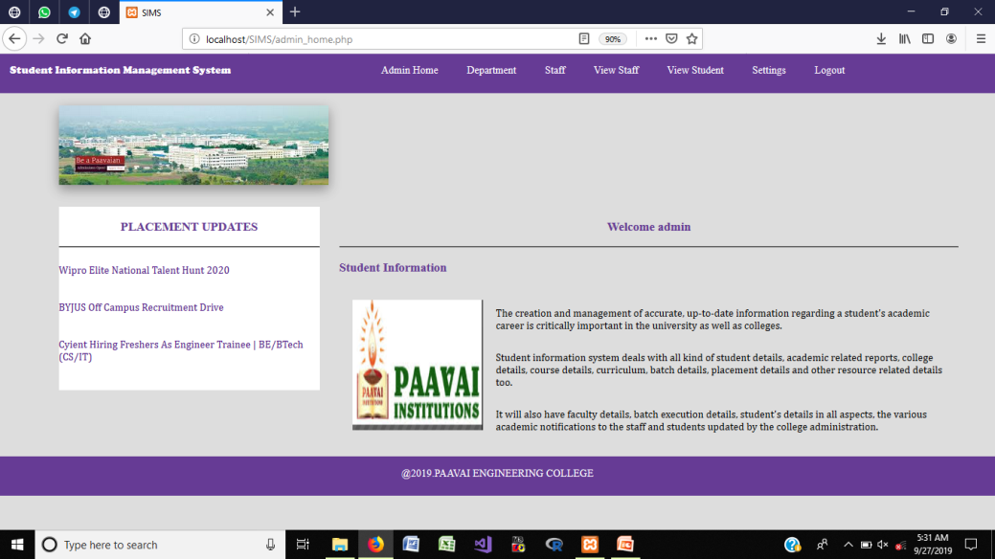
Description:
Here admin can give the placement updates for the students day by day.
Add Department

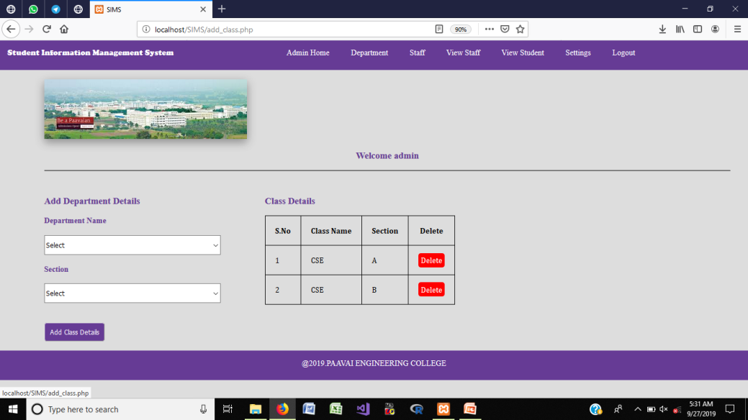
Description:
Here admin can add new department details and can delete if it is unnecessary.
View Student
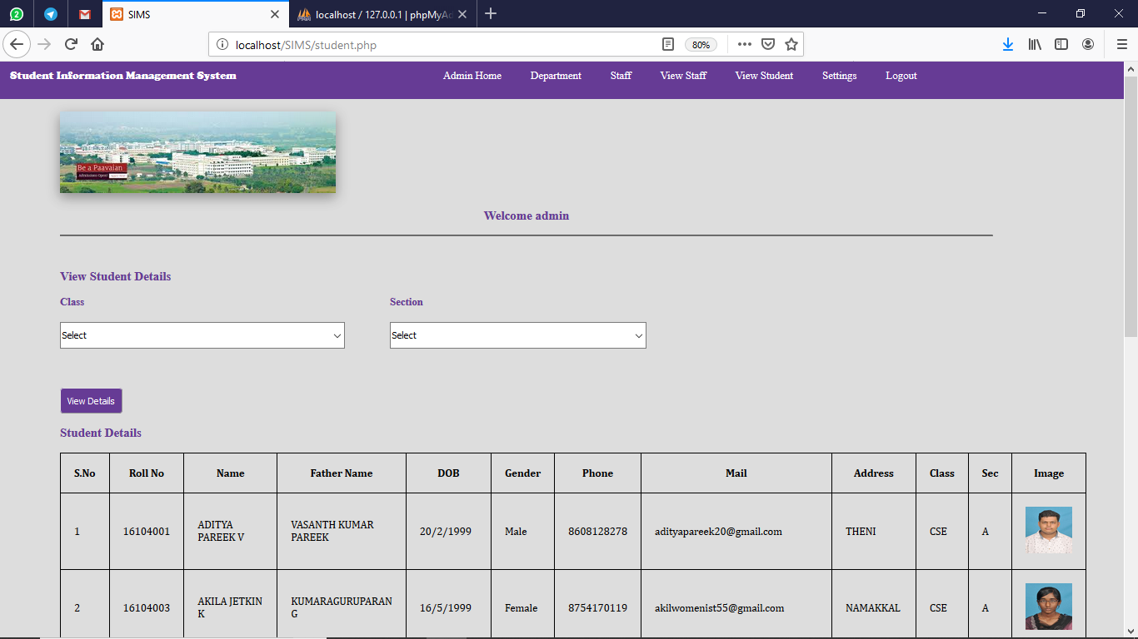
Description:
Here admin can see the student’s details by selecting the required department
5. CONCLUSION AND FUTURE ENHANCEMENT
5.1 CONCLUSION
A web application for Students Information Management is developed. This application offers reliability and it is easy to monitor. It can be implemented in all educational institutions to maintain the student’s data. It gathers the data of the student and easy to sort list the members at the time of placement time. In proposed system it will be easier to process the student’s data to current update. Its works systematically and will make ease the user in order to manage all the student data in the system. This system will give a better performance in arranging the lecturer and student information without having to do it manually. This system will help faculty to arrange student data and schedule faster and easier.
5.2 FUTURE ENHANCEMENT
In future it can be implemented with additional student data with the strength of whole institution. Since it is a web based application anyone can use the system anywhere at any time and it is very easy to get the necessary information without latency. It can be enhanced to get their report on attendance and internal assessments. Information about student’s academic performance to their parents via SMS and mail can be added in future. Since this application is handled by the college, any upgradation of the system will be with only the addition of module cost without the upfront investment, and the system will be more secure when it is handled by granted users who have the privilege.

REFERENCES
[1] N.M.Z.Hashim, S.N.K.S.Mohamed, ”Development of Student Information System” International Journal of Science and Research (IJSR), Vol. 2, Issue 8, August 2013.
[2] S.R.Bharamagoudar, Geeta R.B., S.G.Totad, “Web Based Student Information Management System” International Journal of Advanced Research in Computer and Communication Engineering, Vol. 2, Issue 6, June 2013.
[3] Saurabh Walia1, SatinderjitKaur Gill, “A Framework for Web Based Student Record Management System using PHP” International Journal of Computer Science and Mobile Computing (IJCSMC), Vol. 3, Issue. 8, August 2014.
[4] Manisha K, Alekhya K, T Manikanta, B Ramya, S. Sai Kumar, “Student Information Management System” International Journal of Advanced Research in Computer Science and Software Engineering,Volume 6, Issue 3, March 2016.
[5] Krithi P, Dr M Ramakrishna, “Student Management System – A Survey” International Research Journal of Computer Science (IRJCS) Issue 05, Volume 4 (May 2017).

