1. Create a file via touch and update that file and also verify the timestamp and output will be redirected to another file.

->First we create a file using “touch” and to know the time stamp use “ls-l”

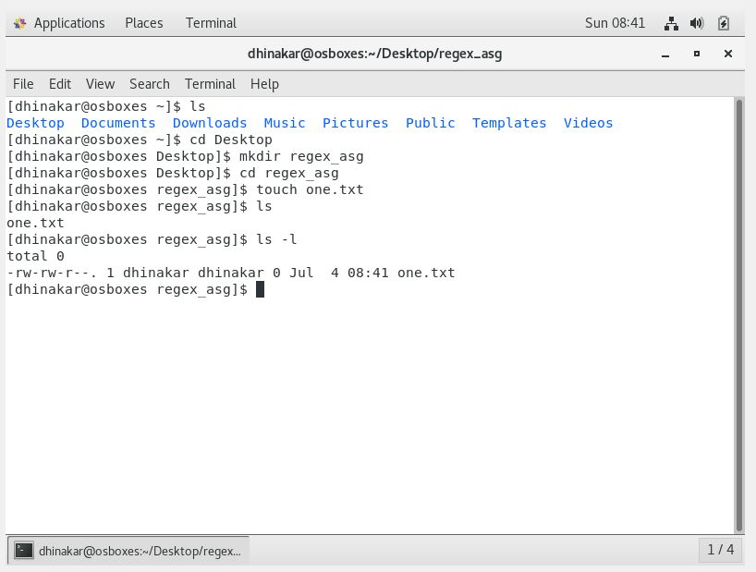

->To update the file use “vim” to open file in an editor

->after that use “cat” to view the content in the file

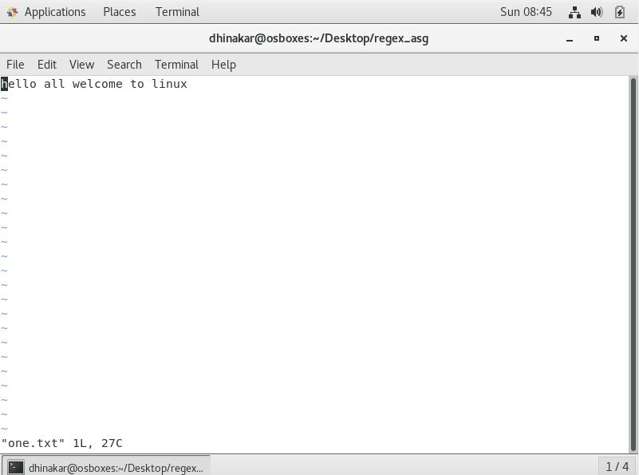

->To redirect data to another file as follows

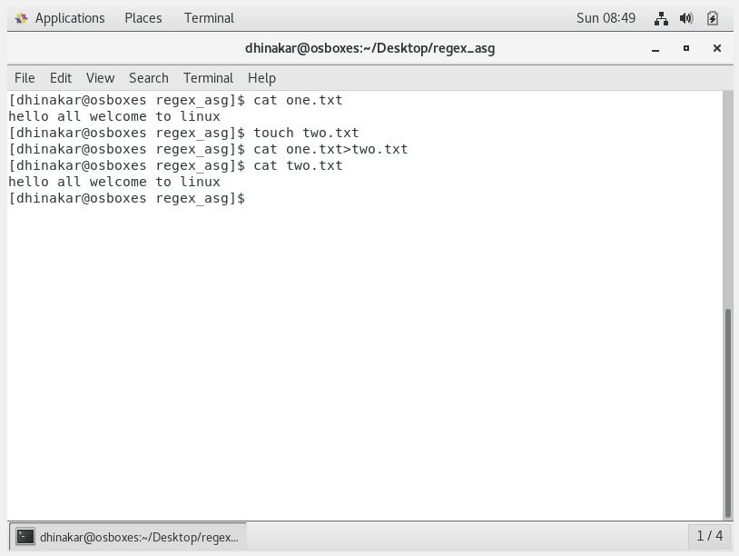

2.Add some of the data as per your choice and append that data via echo command in the same file.

->using “echo” append the data to file

->to check if it is appended or not use “cat”

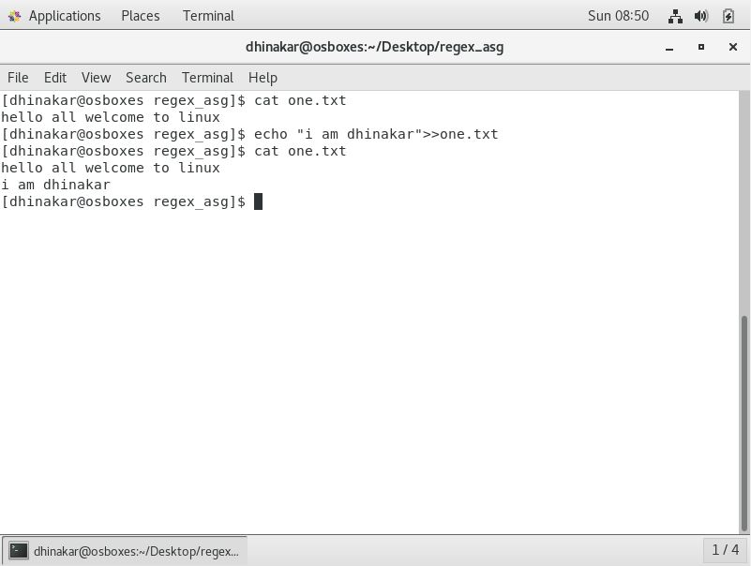

1. Install httpd and set up your own web server.

->to install htppd use “yum install htppd -y> /dev/null”

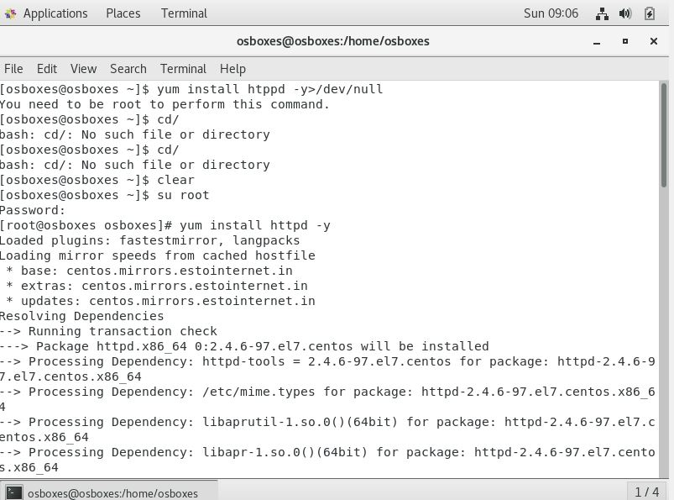

->to start httpd use “systemctl start httpd”

->to enable httpd use “systemctl enable httpd”

->to check status of httpd use “systemctl status httpd”

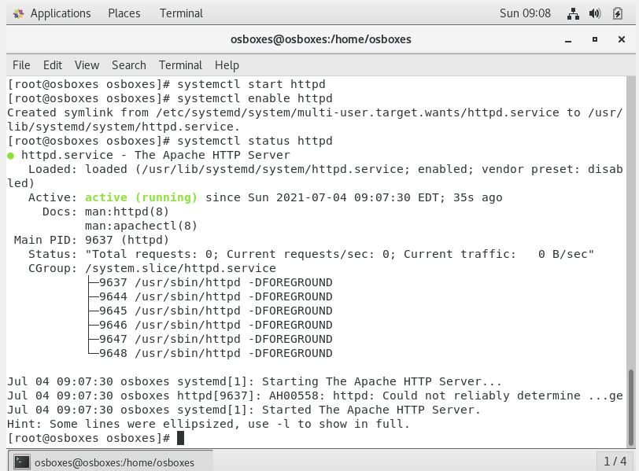

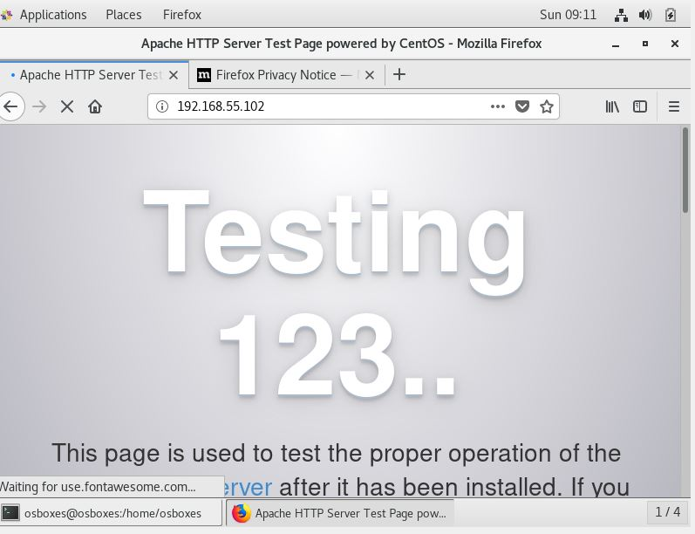

1. Copy some files from one Linux host to another Linux host via SCP

-> first I changed the names of two hosts with the use of “hostnamectl”

-> now check the ip address of both using “ifconfig”

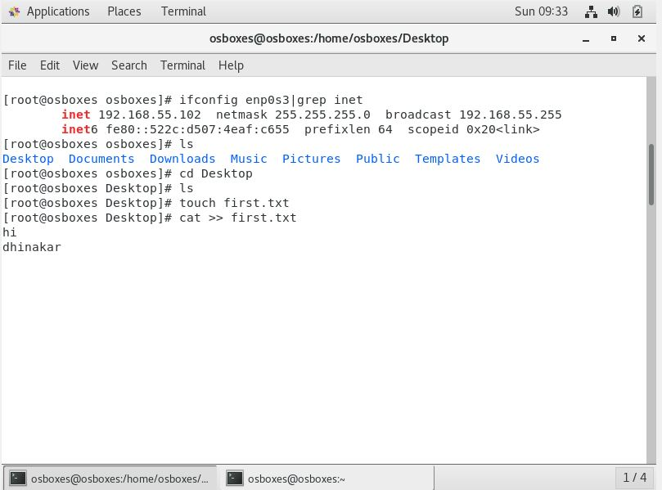

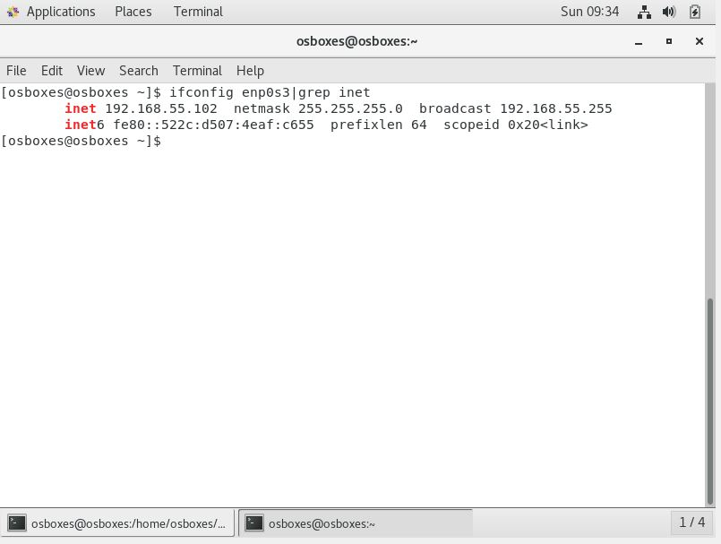

* + Transfer file from host1 to host2 using “scp filename root@(ip address of host2):/tmp”,password of host2 will asked at that time

scp first.txtosboxes@192.168.55.102:/tmp after that check the file in host2

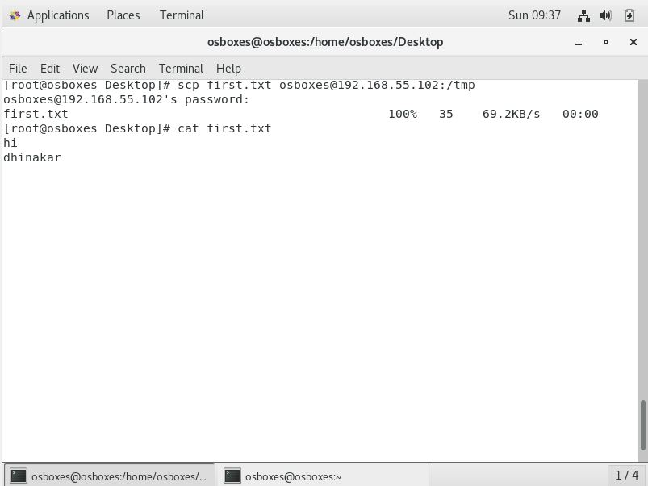

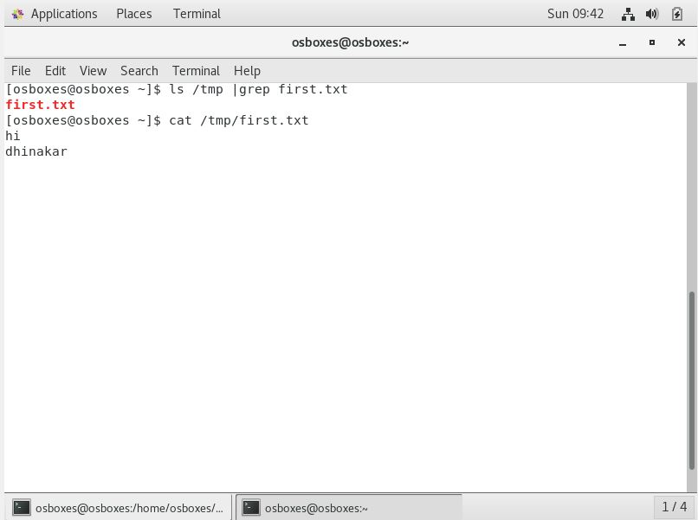

1. Create another VM and setup password less authentication

->First create a clone .

Following are main commands for this

* + ssh-keygen
  + ssh-copy-id root@192.168.55.102
  + Ssh root@192.168.55.102
  + exit #to logout

