IoT Based Smart Parking System

A Project report submitted in partial fulfilment of the requirements for the degree of B.E in Electronics and Communication Engineering

By

k.Dhinakaran(513221106307)

Under the supervision of

Professor & Mentor

Department of Electronics and

Communication Engineering

Smart Parking system

PHASE-1 : PROBLEM DEFFINITION AND DESIGN THINKING

* Problem Definition
* Design Thinking

Problem Statement

* **Ultrasonic:** The precision of the smart parking sensor is improved by using ultrasonic wave. The disadvantage of this type of sensor is that it can get clogged with dirt.
* **Electromagnetic Field Detection:** The sensor can detect small changes in the magnetic field when a metal object is near it.
* **Infrared:** This type of sensor measures changes in ambient temperature and detects movement.
* The screen displays the available and occupied parking Spaces. Iot platforms, ideally cloud-based, should aggregate sensor data and turn it into a clear and concise view of the facility’s parking space occupancy.
* Monitor parking occupancy in real time from any PC or smartphone. Drivers should be able to see how many free parking Spaces are available near all parking facilities in real time.

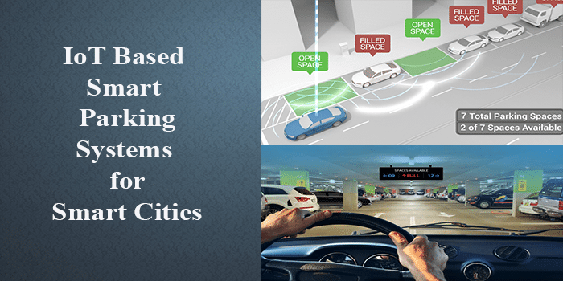

**Project Definition:**

* Project Objectives: Real-time parking space monitoring
* A sensor that can detect the presence of the vehicle.
* A micro control that can help you processing the data.
* A cloud platform will restore the data.
* A mobile application enables you to control the smart parking process.
* Each parking space is equipped with a battery-powered occupancy sensor that detects the absence, arrival, presence and departure of vehicles. Due to their low-power design, these sensors can be self-configured to assign each unit a unique MAC address associated with a serial number and bar code.

Mobile app integration:

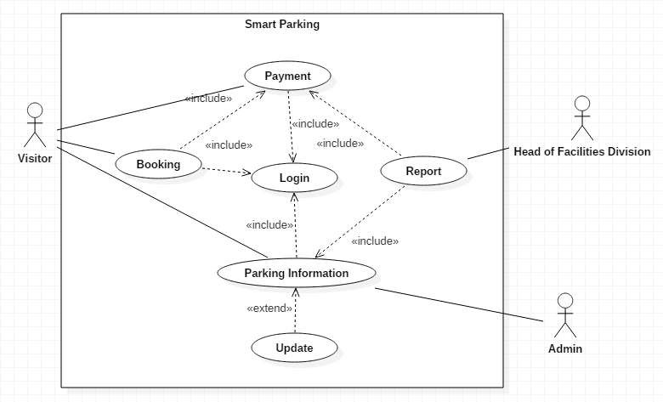

1. In the class diagram above each actor who will enter each process is required to enter the login process
2. Visitor actors can view parking information, place orders, and make payments
3. Division head actors can view parking information and manage reports from parking payments
4. Actor admin can only manage parking information

**Efficient Parking guidance:**

* Inquiry on availability of parking space and reservation of parking lot
* Real-time parking navigation and route guidance
* Vehicle occupancy detection and management of parking lots
* The E-parking system proposed in this paper also provides city-wide smart parking management solution via providing parking facility availability information and parking lot reservation system and it is named as parking meter (PM) based E-parking (PM-EP).

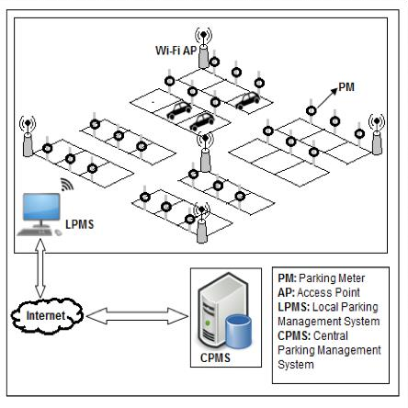

**Design Thinking:**

**1. Tracking vehecles with sensor systems**

Internet of Things is the core technology of vehicle tracking platform. Tools such as GPS or OBD sensors can help collect location data from cars or fleets and monitor parking space occupancy. The information is transmitted to the CSA, processed, and then sent to the network server. This data will be shown to drivers and car company managers in an understandable and clear way.

At present, vehicle trackers based on the Internet of Things are mainly used for fleet management of large enterprise organizations. In the future, when the rollout of 5G makes the Internet of Things more accessible, parking technology will spread among car drivers and will be used to manage daily commutes and ease parking challenges.

**2. Smart meter systems**

The connected metering system detects when a car enters and leaves the parking lot. In this way, an iot platform will be able to provide drivers with a real-time meter of available spaces.

Facility managers can use the meter system to improve the efficiency of parking facilities, identify trends and patterns about the ridership, and be able to predict the surges of future vehicle.

**3**. **Automatic parking systems**

Automatic parking systems help reduce parking lots and maximize space efficiency. An automated system is used to move the car up and down to the upper level of the facility. Since the APS facility is fully automated and has access restrictions, it is safer to park there.

Automatic parking systems help reduce search time and engine emissions that accumulate due to increased driving time. In such a facility, the use of resources is minimized because there is little light and ventilation required to maintain the automatic parking system.

**4. Control systems**

The Internet of Things, as a powerful traffic law enforcer, contributes to urban security and order. Using a network of sensors and fast data-processing algorithms, the parking control system can detect, register, collect and store required evidence, issue tickets, and notify parking violations in seconds.