

K.Dhinakaran

# REG NO:(513221106307)



Iot based smart parking system

A project report submitted in partial fulfilment of the requirements for the degree of B.E in

Electronics and communication Engineering

Under the supervision of Hod & Professor Department of Electronics and communication Engineering

Smart parking system

Phase 3 : DEVELOPMENT OF PART-1

INTRODUTION OF PYTHON:

*python is vary simple and best language.

*python language is future industry in worldwide.

Problem statement:

* Define the problem of smart parking system that your project aims to address.
* Provide relevant statistics and data to emphasize the significance of the issue.
* Explain the current challenges and shortcomings in existing smart parking systems.
* By using ultrasonic sensors be able to keep a record of the number of cars parked inside of a parking garage.
* Consequently, once a car enters a parking garage followed by a parking space, a ping ultrasonic sensor will then be able to determine if a car is parked in the space or not.

**PROBLEM:**

* Finding a parking space in most metropolitan areas, especially during the rush hours, is difficult for drivers.
* Difficulty arises from not knowing where the available spaces may be at that time traffic congestion may occur.
* Shortage of parking space, high parking tariffs, and traffic congestion due to visitors in search for a parking place are only a few examples of everyday parking problems.

**SOLVING STATEMENT:**

* once a car enters a parking garage followed by a parking space, a ping ultrasonic sensor will then be able to determine if a car is parked in the space or not.
* This information would then be relayed to update the network**.**
* Using the smart parking system based on IOT devices(Arduino UNO) easy to find space slot and reduce the time of the users.

* Building new parking facilities.
* Encouraging the use of alternative modes of transportation.
* Implementing car-sharing programs.
* Offering incentives for carpooling.
* Encouraging the use of park and ride options.

**Difficulty finding parking spots in public places:**

* Takes time to find a parking spot. **Existing solution:** 
  + - Hire people to direct drivers to vacant spots.
    - Using security camera and parking attendant.

**Our solution:**

* A low cost device to locate the vacant spots in a parking lot.

* + Several cameras.
  + Personal computers.
  + Microcontrollers.
  + Image processing software.

**REAL PARKING SLOT:**

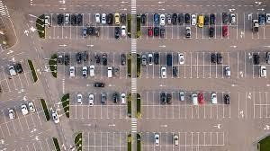

DESIGn Thinking approach:

* The parking lot system should be able to park cars, bikes, and handicapped vehicles.
* The system should be able to calculate the cost of parking for each type of vehicle.
* The system should be able to keep track of the time a vehicle is parked**.**

**BEST DESIGN:**

* Ideally, parking lots should be rectangular with parking on both sides of access aisles. For two-way traffic flow, parking spaces perpendicular (90 degrees) to the aisles provide the most efficient design.
* The efficiency decreases as the parking angle decreases.

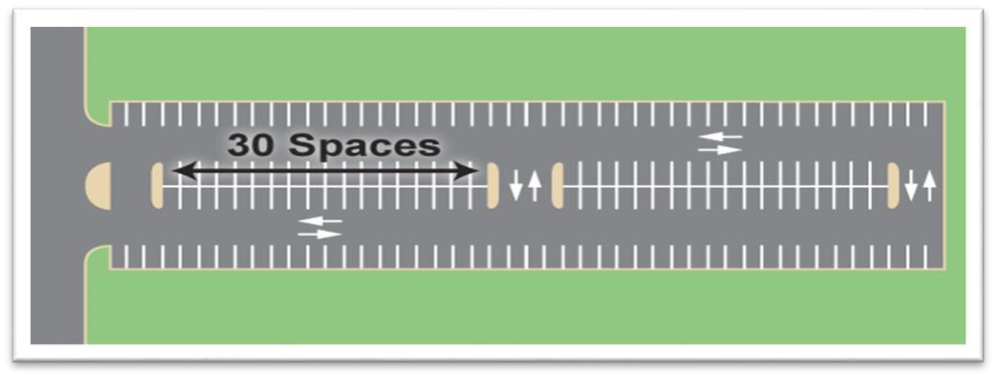

**Design Architecture:**

* Large and rectangular shaped sites are ideal for parking structures. Although flat sites are generally more economical to develop, sloped sites can provide design opportunities such as access on different levels and/or no ramping between levels.

* The parking facility or lot must foremost deal with the

Functional/Operational as in providing for safe and efficient passage of the automobile and driver.

* This is a very complex challenge as automotive, engineering and traffic issues relative to site locations must be integrated to create the appropriate solution.

**FUTURE DESIGN:**

* Tracking cars with sensor systems
* Smart counter systems
* Automated parking systems
* Control systems

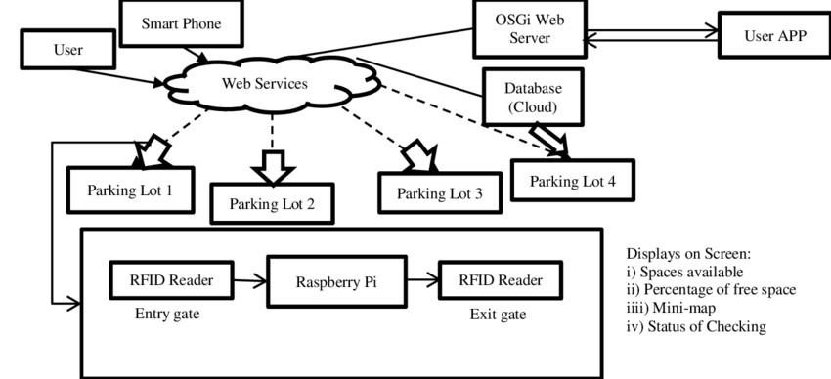

* Most of the people used to the smart parking system today and the result will be increased for future.
* This process implement and based on the IOT (Arduino UNO).