**IOT BASED SMART PARKING SYSTEM**

A project report submitted in partial fulfilment

Of the requirements for the degree ofB.E in Electronics and Communication Engineering

By

k.Dhinakaran(513221106307)

## 

Under the supervision of Proffessor & HOD Department of Electronics and Communication Engineering

# SMART PARKING SYSTEM

**Phase 2: Innovation to solve the problem**

## Innovations in smart parking solutions

As per the survey by the Smart Parking Institute, 42 percent of respondents voted in favor of the need for Parking systems. The good news is that thanks to parking [lot sensor](https://www.mokosmart.com/iot-sensors/) systems, connectivity platforms and other iot applications, drivers can know where the nearest parking space is if it’s occupied. Real-time parking maps will be common in the future.

As for innovations already in the field, here are the top smart parking apps that have been released or will be released soon.

### 1. Tracking vehicles with sensor systems

Internet of Things is the core technology of vehicle tracking platform. Tools such as GPS or OBD sensors can help collect location data from cars or fleets and monitor parking space occupancy. The information is transmitted to the CSA, processed, and then sent to the network server. This data will be shown to drivers and car company managers in an understandable and clear way.

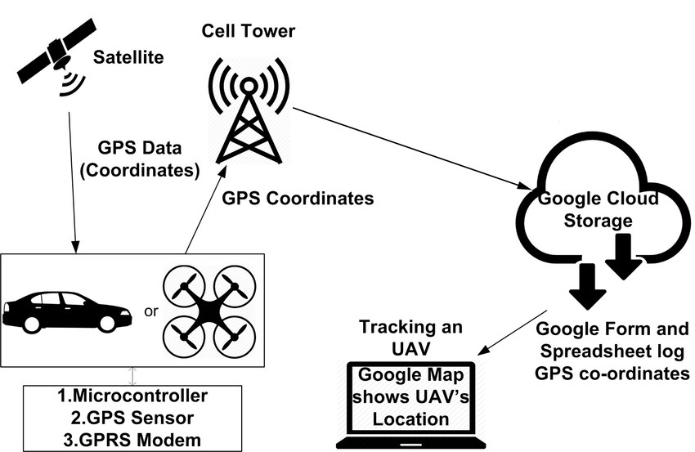

### 2. Smart meter systems

The connected metering system detects when a car enters and leaves the parking lot. In this way, an iot platform will be able to provide drivers with a real-time meter of available spaces.

Facility managers can use the meter system to improve the efficiency of parking facilities, identify trends and patterns about the ridership, and be able to predict the surges of future vehicle.

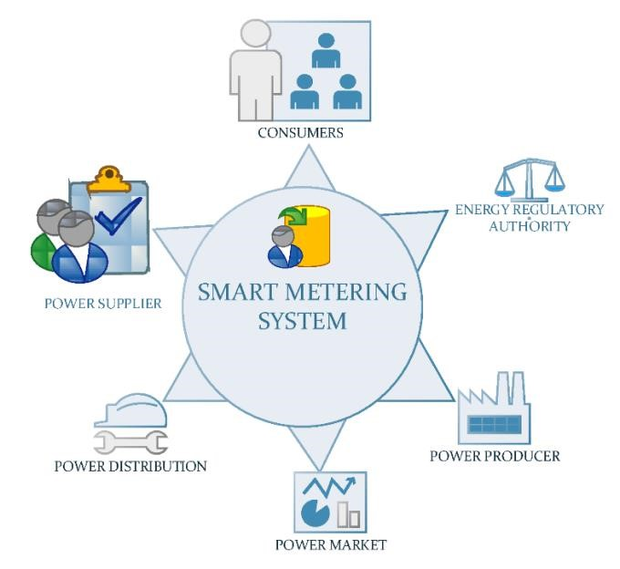

### 3. Automatic parking systems

Automatic parking systems help reduce parking lots and maximize space efficiency. An automated system is used to move the car up and down to the upper level of the facility. Since the APS facility is fully automated and has access restrictions, it is safer to park there.

Automatic parking systems help reduce search time and engine emissions that accumulate due to increased driving time. In such a facility, the use of resources is minimized because there is little light and ventilation required to maintain the automatic parking system.

### 4. Control systems

The Internet of Things, as a powerful traffic law enforcer, contributes to urban security and order. Using a network of sensors and fast data-processing algorithms, the parking control system can detect, register, collect and store required evidence, issue tickets, and notify parking violations in seconds.

The role of Internet of Things in parking technology Smart parking will have a significant impact on all stakeholders throughout the process. Drivers can book parking Spaces in advance, plan trips and commutes, and take parking lot occupancy into account. The reinforcement mechanism will be able to detect and assess the severity of illegal parking in a split second.

Parking managers will be able to optimize the use of space and resources within their parking lots, effectively formulating future developments. Community leaders will improve the comfort of city residents by applying iot parking solutions.

### ➢ Meter time extended

When the parking meter is about to expire, the connected platform will notify the driver. Such a tool will help extend parking time at a click once the driver pays for the extension. The automatic parking meter extension system will reduce traffic violations and increase revenue for the facility.

### ➢ Innovative parking solutions that identify the safety of parking Spaces

the Red areas such as bus stops, pick-up and drop-off areas for passengers, and parking Spaces for disabled people will be identified by the platform and notified to drivers. In this way, the number of negligent parking violations will be reduced. If a driver still parks in an area where parking is prohibited, a connected platform will immediately notify the strengthening department violator, increasing the chances of a successful penalty for violator.

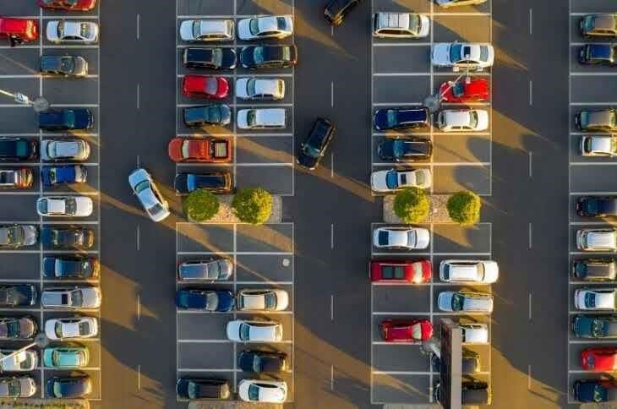

### ➢ Efficient use of parking Spaces in cities

With a network of sensors, automated parking planners can collect occupancy data for all parking lots. In order to evenly distribute the number of parking Spaces in a city, municipal communities can use the data provided by the iot platform to adjust fees and allowed parking hours in the decision-making process.