**PLACEMENT CELL AUTOMATION WITH DYNAMIC**

**STUDENT PROFILE**

Mr.T.Manoj Praphakar

[tmanojpraphakarcse@siet.ac.in](mailto:tmanojpraphakarcse@siet.ac.in)

C. Dhinakaran  
[dhinakaranc23cse@srishakthi.ac.in](mailto:dhinakaranc23cse@srishakthi.ac.inm)

S. Dineshkumar

dineshkumars23cse@srishakthi.ac.in

R. Dshanthini

[dshanthinir23cse@srishakthi.ac.in](mailto:dshanthinir23cse@srishakthi.ac.inm)

K. Anunithi

[anunithik23cse@srishakthi.ac.in](mailto:anunithik23cse@srishakthi.ac.in)

Sri Shakthi Institute of Engineering and Technology, Coimbatore. Department of Computer Science and Engineering, Sri Shakthi Institute of Engineering and Technology, Coimbatore.

**ABSTRACT:**

The **Placement Cell Automation with Dynamic Student Profile (PCADSP)** is a web-based application designed to streamline the process of managing student profiles for placement activities in educational institutions. The system leverages Node.js for backend development and MySQL as the database management system to ensure efficient data handling, scalability, and real-time processing. With a user-friendly interface, the PCADSP enables students to update personal, academic, and professional information, upload documents, and link their LinkedIn profiles, ensuring their profiles remain comprehensive and up-to-date. The system also allows students to categorize themselves by batch and department, facilitating easy filtering of data for recruiters. The dynamic certificate management feature ensures flexibility in handling multiple achievements, while the responsive design ensures accessibility across various devices. The integration of Node.js and MySQL provides a robust and scalable backend infrastructure, ensuring the system can handle large volumes of user data and deliver a smooth experience for both students and recruiters. Ultimately, the Placement Profile System aims to enhance the placement process by providing educational institutions with a reliable and efficient tool for managing student data and offering students an intuitive platform to showcase their qualifications to potential employers.

# **INTRODUCTION:**

The Placement Cell Automation with Dynamic Student Profile (PCADSP) has been developed as a web-based platform designed to streamline the management of student profiles for placement activities. The system aims to simplify the process of maintaining accurate, up-to-date student information while also providing a centralized platform for students to showcase their academic and professional achievements.

The Placement Cell Automation with Dynamic Student Profile (PCADSP) addresses these challenges by offering a centralized digital platform that facilitates seamless interaction among students, placement coordinators, and recruiters. This system allows students to maintain detailed, up-to-date profiles highlighting their academic achievements, skills, projects, and certifications. Placement coordinators can efficiently manage and organize batch-specific data, monitor placement progress, and communicate directly with recruiters. Recruiters, in turn, can access and filter student data based on their hiring requirements, ensuring targeted and efficient recruitment processes.

By integrating modern web technologies, database management systems, and secure data-sharing capabilities, the Placement Cell Automation with Dynamic Student Profile offers a user-friendly and scalable solution to meet the dynamic needs of educational institutions. The system not only enhances transparency and operational efficiency but also empowers students by connecting them with a broader range of opportunities, ultimately improving placement outcomes and fostering stronger academia-industry relationships.

This Placement Cell Automation with Dynamic Student Profile is designed as a comprehensive platform to address these challenges by offering a centralized digital hub for managing student profiles, placement records, and recruiter interactions. Students can create and maintain detailed profiles that include their academic credentials, technical skills, certifications, extracurricular achievements, and project experiences. This helps recruiters access well-organized and structured data, enabling them to identify and shortlist potential candidates based on specific hiring criteria.

**LITERARURE SURVEY:**

**Introduction to Placement Systems**

Placement systems have been a cornerstone in educational institutions to connect students with potential employers. Traditional placement practices relied heavily on manual processes, leading to inefficiencies in data management and communication. With the rise of digital technologies, several automated systems have been developed to address these challenges, enhancing the placement experience for all stakeholders.

**Student Profile Optimization**

One of the key components of placement profile systems is the ability to create and optimize student profiles. These profiles offer recruiters a comprehensive view of a candidate’s qualifications, skills, and achievements.

**Evolution of Placement Systems**

Initial placement systems were primarily offline and required significant manual intervention. Early advancements introduced spreadsheet-based tracking, which improved data organization but still lacked automation. The emergence of web-based solutions marked a turning point, offering centralized platforms that streamlined the management of student profiles, recruiter data, and placement events.

**Role of Technology in Modern Placement Systems**

Technologies like database management systems, cloud computing, and real-time data analytics have significantly impacted the design of modern placement systems. These technologies enable efficient data storage, secure access, and the ability to retrieve information instantaneously, making the placement process smoother and faster.

**Student-Centric Placement Platforms**

Modern placement systems focus on empowering students by enabling them to create dynamic profiles. These profiles highlight their academic achievements, certifications, and skills, making it easier for recruiters to identify suitable candidates. Tools like resume builders and skill-matching algorithms are increasingly integrated into these platforms to further support student needs.

**Recruiter Perspective on Placement Systems**

From a recruiter’s standpoint, placement systems provide access to a diverse pool of candidates, organized and searchable through advanced filtering options. Automated shortlisting features based on predefined criteria, such as CGPA, skills, or certifications, save time and ensure targeted hiring.

**Administrator Tools and Automation**

Placement coordinators and administrators benefit from tools that automate repetitive tasks like scheduling interviews, tracking placement progress, and generating reports. Systems that integrate batch-wise data management and dynamic dashboards provide real-time insights into placement activities, enabling better planning and decision-making.

**Challenges in Traditional Placement Processes**

Traditional placement processes often suffer from issues like data duplication, lack of standardization, and miscommunication between students, recruiters, and administrators. These challenges hinder the effectiveness of the placement process and necessitate the development of more robust systems.

**Security Concerns in Placement Systems**

As placement systems manage sensitive data, including student personal information and recruiter details, security becomes a critical concern. Modern systems employ encryption, authentication protocols, and role-based access to ensure data integrity and confidentiality.

**Future Trends in Placement Systems**

The future of placement systems lies in greater personalization, enhanced data integration, and improved interoperability. Trends such as blockchain-based credential verification, gamified learning modules, and industry-specific skill assessments are expected to redefine the placement ecosystem.

**Real-Time Notifications in Placement Systems**

Real-time notifications and alerts ensure timely updates about placement activities such as job postings, deadlines, and interview schedules. This feature enhances communication and ensures stakeholders remain informed throughout the process.

**Customizable Reporting and Dashboards**

Modern placement systems provide customizable dashboards for administrators and recruiters. These dashboards help visualize key metrics, such as placement rates, recruiter engagement, and student performance, in an intuitive manner.

**Placement Systems for Global Opportunities**

With globalization, placement systems now include features to support international recruitment. These systems enable currency conversion, time zone synchronization, and visa documentation support.

**Future Scope of Placement Systems**

The future of placement systems lies in the integration of virtual reality for interview simulations, AI-driven career counseling, and personalized learning paths. These advancements will further enhance the capabilities of such systems and their impact on employability.

**Role of Blockchain in Placements**

Blockchain technology offers a secure way to verify student credentials and prevent fraud. By integrating blockchain, placement systems can provide recruiters with tamper-proof certifications and records.

**SYSTEM IMPLEMENTATION:**

**System Architecture and Design**

This section outlines the overall structure of the PPMS, providing an overview of how different components of the system interact with each other. It describes the core architecture, including the backend (Node.js), frontend (web interface), and database (MySQL), and how these components are integrated to provide a seamless experience for students, placement coordinators, and recruiters. This section also touches on the choice of technologies used for building the system and the reasons behind these decisions.

**Frontend and Backend Integration**

Here, you can detail the specific technologies chosen for the system and why they were selected. This includes the use of Node.js for backend development, MySQL for database management, and front-end technologies such as HTML5, CSS3, and JavaScript (possibly React or Angular for dynamic UI). This section also discusses the decision-making process behind choosing technologies such as RESTful APIs, AJAX, and responsive web design principles.

**Database Design and Schema**

This section delves into the database design and schema of the Placement Profile Management System. It covers the structure of the MySQL database, detailing tables, relationships, and data flow between various entities such as students, documents, certificates, departments, and batches. It also explains the normalization process to ensure data integrity and optimization for queries, as well as how the system manages large data sets for real-time processing.

**User Authentication and Authorization**

This section discusses how the system ensures secure access control for different types of users, such as students, placement coordinators, and recruiters. It covers the login and registration process, user roles, password encryption, and session management. This section also explains how the system handles authorization using token-based authentication (e.g., JWT - JSON Web Token) and the security measures put in place to protect sensitive user data.

**Profile Management Module**

This module is the core of the PPS and allows students to update, maintain, and showcase their profiles. This section covers the design and functionality of the profile management module, including the input of personal details (e.g., name, email, registration number, department), uploading resumes, and linking social media profiles such as LinkedIn. It also addresses features like real-time validation and user notifications to ensure a smooth experience.

**Document Upload and Management**

This section explains the document management feature of the system, where students can upload important documents such as resumes, project demo videos, and certificates. It covers how these files are uploaded to the system, stored securely in the database, and organized. It also addresses file type validation, size restrictions, and how the system dynamically handles multiple uploads for certificates and other documents.

**Batch and Department Categorization**

In this section, the system's approach to organizing students by their respective batches and departments is discussed. It details how students can select their department and batch when updating their profiles. This categorization is key to filtering and organizing data for both administrative purposes and recruiter searches. The section may also touch upon how the system ensures that batch and department data are accurate and up-to-date for effective filtering and querying.

**Notifications and Alerts System**

This section focuses on the notification system within the PCADSP. It explains how the system generates real-time alerts and notifications for students, placement coordinators, and recruiters. Examples include notifications about profile updates, upcoming interviews, document upload reminders, and placement announcements.

**Responsive Web Design and Mobile Accessibility**

This section elaborates on the responsive web design principles used to ensure that the PPMS is fully accessible across multiple devices, including smartphones, tablets, and desktops. It discusses how the design adapts to different screen sizes, ensuring       students and recruiters can interact with the platform effectively regardless of the device they are using. It may also cover specific front-end frameworks like   Bootstrap, CSS Grid, or Media Queries used to achieve this responsiveness.

**Testing and Quality Assurance**

This section outlines the testing procedures followed during the development of the Placement Profile System. It explains the different types of testing conducted, such as unit testing, integration testing, user acceptance testing (UAT), and security testing. The section discusses how automated testing tools and manual testing were used to ensure the system’s functionality, usability, and security. It may also cover performance testing and load testing to ensure the system can handle a large number of users and data efficiently.

**Deployment and Hosting**

This section details the process of deploying the PPMS on a server and making it accessible to users. It covers the hosting environment, whether on a cloud service (e.g., AWS, Azure, or Google Cloud) or on a dedicated server. It discusses the steps taken to ensure that the system is scalable, secure, and performs well under load. Additionally, this section may include information about continuous integration/continuous deployment (CI/CD) pipelines used for automated deployment.

**PROPOSED SYSTEM**

**Overview of the System**

The Proposed Methodology for the Placement Cell Automation with Dynamic Student Profile involves developing a dynamic student profile system that allows students to create, manage, and update their profiles with key academic and extra-curricular data, including project information, certifications, and scores. The methodology is divided into several stages to ensure a structured approach to building and maintaining the system:

**Student Profile Creation and Management**

**Profile Data Entry:** Admin create an account for the student on the system and fill in essential details such as their name, contact information, department, batch year, and academic qualifications. They also enter details about their skills, certifications, projects, and scores of the student.

**Linking Projects and Certifications:** Admin can link the students academic projects and any external certifications to their profiles through update forms. Projects include project name, domain, description, technologies used, and the role they played in the project. Certifications include the certificate name, issuing organization, and date of issue.

**Academic Scores:** Admin enter their academic scores such as CGPA, marks in individual subjects, and any other relevant academic performance data. These scores will be displayed in a structured and clear manner within their profile.

**Dynamic Profile Updates**

**Real-Time Updates:** Students can update their profiles at any time, ensuring that their information remains current. This includes adding new projects, certifications, and updated academic scores.

**Profile Sections:** The student profile will be divided into different sections, such as:

**Personal Information:** Name, contact, department, etc.

**Academic Details:** Marks, CGPA, etc.

**Projects and Certifications:** Linked to external platforms like GitHub or LinkedIn.

**Skills and Experience:** Skills gained during the course or from other extra-curricular activities.

**Profile Verification and Linkage**

**Project Linkage:** For each project added, students can provide links to repositories (e.g., GitHub) or presentations (e.g., YouTube, Google Drive). These links are displayed in the profile, allowing recruiters to access project details directly.

**Certificate Verification:** The system allows students to upload certificates in digital format (e.g., PDFs or images). These documents can be verified by administrators or recruiters to ensure authenticity. Verification could be automatic if the issuing organization has an API or a manual process could be used by administrators.

**Linkedin Integration:** The system can integrate with platforms like LinkedIn to automatically fetch professional skills, certifications, and endorsements.

**Adding New Information via Update Form**

**Update Form for Profile Changes:** If students need to update their profile with new projects, certifications, or academic information, an update form is provided. The form allows the students to:

* Select the type of update (e.g., new project, new certificate, updated score).
* Upload relevant documents (e.g., project links, certificate copies).
* Add details and descriptions for the new entries.

**Approval Process:** The updates submitted by students can be sent to administrators for review and approval before being made public, ensuring accuracy and maintaining the integrity of the data.

**Automation of Profile Update Notifications**

Profile Update Confirmation: Once a student updates their profile (e.g., updating their resume, adding new certifications, or modifying personal information), the system triggers an automated notification to the student. This notification confirms that the update was received and is being reviewed.

**Approval or Additional Information Required:** After the student's profile is reviewed by the placement coordinator or admin, the system sends an automated notification to the student, informing them of the status. If the profile update is approved, the student receives a confirmation message. If additional information or clarification is needed, the student is notified with details on what is required to complete the update. This ensures the student is always aware of the next steps.

**Data Validation and Security**

**Input Validation:** To ensure the quality of data, input fields in the profile update form will have validation mechanisms to check for errors, such as invalid email formats, incorrect date formats, or incomplete information.

**Security:** The system will ensure that all personal data, project details, certificates, and scores are securely stored using encryption techniques. Additionally, user authentication (login credentials) will be implemented to protect sensitive data from unauthorized access.

**Profile Display and Access by Recruiters**

**Searchable Profiles:** Recruiters will have access to a structured, searchable database of student profiles. Recruiters can filter profiles based on specific criteria, such as skills, academic scores, project experience, or certification details.

**Access Controls:** While students have full access to edit their profiles, recruiters can view only the information relevant to their hiring needs. Admins manage the permissions and access to various features within the system.

**Continuous Improvement**

**Continuous Updates:** As the education system and recruitment processes evolve, the profile system will undergo continuous updates to add new features, improve user experience, and ensure the platform stays relevant.

**RESULT AND ANALYSIS:**

The implementation of the **Placement Cell Automation with Dynamic Student Profile (PCADSP)** has significantly streamlined the process of collecting, managing, and sharing student data for placement purposes. After Admin update the student profiles, the system ensures the seamless upload and storage of their data, including personal details, batch, department, and uploaded documents such as resumes, certificates, and project demo videos. As a crucial enhancement, the system automatically sends a confirmation email to students upon successful submission of their data, ensuring transparency and allowing students to verify their updates.

Students can conveniently update their profiles by submitting the Update Profile Form, where they provide their personal details, batch, department, and project-related information, along with uploading important documents like resumes, certificates, and project demo videos. This ensures that their profiles remain accurate and up-to-date, catering to dynamic placement requirements. Upon submitting the update form, the system verifies the input and stores the data efficiently in a centralized database.

This system has improved efficiency by reducing manual errors and enabling real-time updates. The automated email notifications have fostered better communication, keeping students informed and engaged. Furthermore, the centralized data repository simplifies profile retrieval for placement coordinators, enabling targeted searches based on specific criteria such as department or batch. Overall, the system provides a robust, user-friendly, and efficient solution that enhances the placement preparation process for both students and administrators.

**FRONT WEBPAGE:**



**PLACEMENT LIST :**

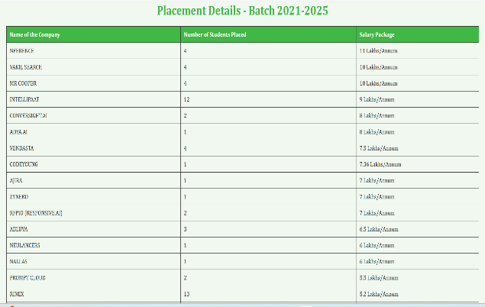

**LOGIN FOR PROFILE PAGE:**

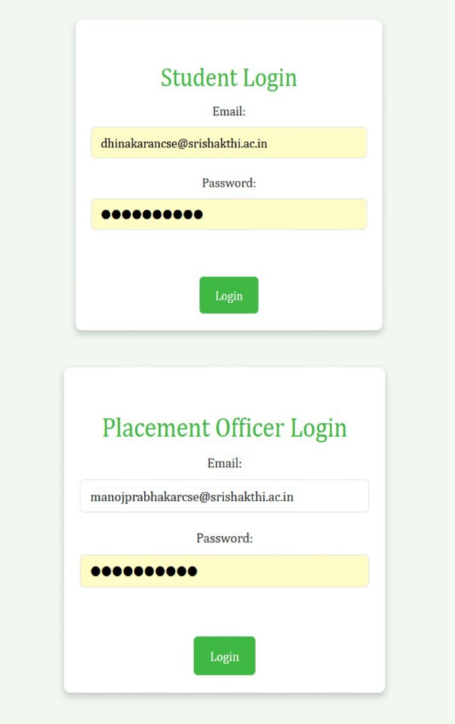

**WELCOME STUDENTS PROFILE:**

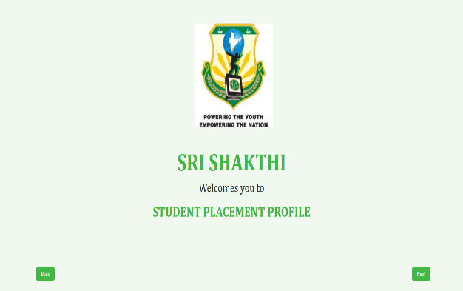

**BATCH AND DEPARTMENT SELECTION:**

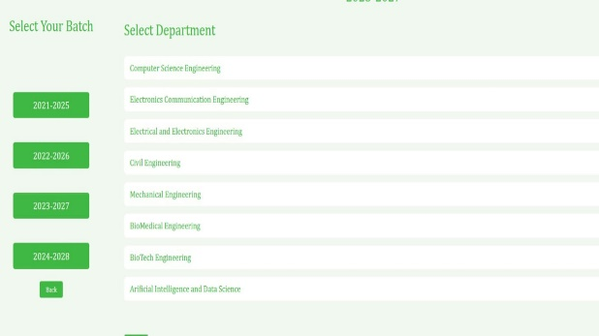

**REGISTER NUMBER SELECTION:**

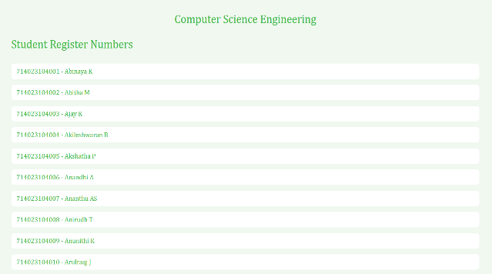

**STUDENT PROFILE PAGE:**

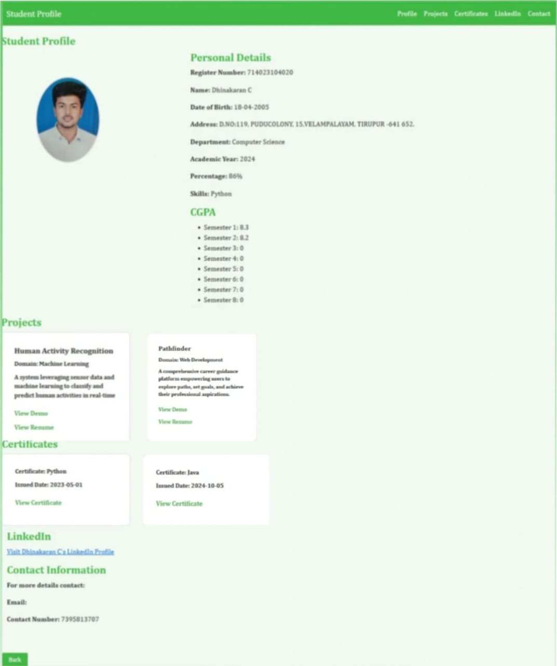

**UPDATE FORM:**

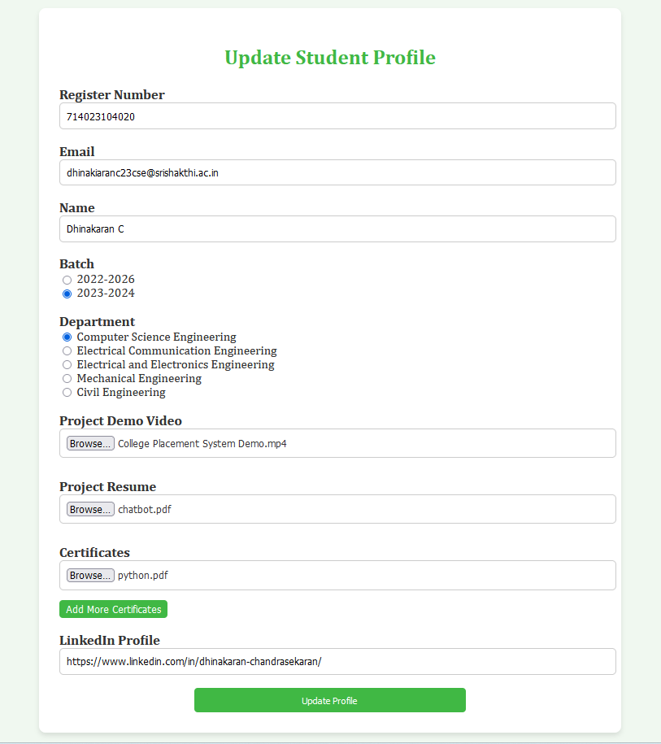

**CONCLUSION:**

The **Placement Cell Automation with Dynamic Student Profile (PCADSP)** provides an effective and streamlined approach to managing student data for placement-related activities. By allowing students to update their profiles dynamically through an intuitive and user-friendly form, the system ensures that all relevant information, such as personal details, academic achievements, certifications, and project documentation, remains current and accessible. This feature empowers students to take ownership of their placement preparation by enabling them to showcase their most recent qualifications and skills, which are critical for prospective employers.

Moreover, the ability to upload multiple certificates and documents through a dynamic interface adds significant flexibility to the system. Students can seamlessly include their latest achievements without any technical complexities. This ensures a holistic representation of their academic and extracurricular accomplishments, enhancing their profiles' overall appeal for recruitment processes.

From an administrative perspective, the centralized data repository created by the system simplifies profile management and retrieval for placement coordinators. They can easily filter and analyze student data based on various parameters, such as batch, department, or specific qualifications, which streamlines shortlisting and reporting tasks. The system also minimizes errors associated with manual data handling, ensuring the accuracy and reliability of stored information.

The Placement Cell Automation with Dynamic Student Profile (PCADSP)serves as a robust tool that bridges the gap between students and placement coordinators. By integrating features like profile updating,

document uploads, and automated notifications, the system not only enhances the user experience but also improves operational efficiency. This modernized approach to managing placement-related data significantly contributes to preparing students for successful placement outcomes, ultimately benefiting both educational institutions and recruiters in achieving their goals.

**FUTURESCOPE:**

The Placement Cell Automation with Dynamic Student Profile (PCADSP) can be further enhanced to provide more dynamic and tailored functionalities, ensuring optimal benefits for students and institutions alike. One significant area of improvement is categorizing students based on their project domains. By analyzing the projects and skills listed in their profiles, students can be grouped into domain-specific categories such as artificial intelligence, cybersecurity, data science, or embedded systems. This categorization would allow companies to efficiently target candidates suited to their job requirements, streamlining the recruitment process.

Another future enhancement is the regular update of placement opportunities in the system. By maintaining a constantly updated database of job postings and internships, students will have access to the latest opportunities in alignment with their qualifications and interests. Additionally, offering customized job recommendations and company listings based on individual student profiles can help them identify opportunities that match their career goals.

The standout functionalities of the system in future is automated email notification feature. Upon submitting the update form, students receive a confirmation email, which acts as an acknowledgment of their submission. This not only fosters transparency but also reduces the communication gap between the placement coordinators and students. By automating this process, the system eliminates the need for manual verification and notification, thereby saving time and effort for all stakeholders involved.

To further improve the system's efficiency, it could implement a salary optimization feature. This would prevent students who have secured high-paying positions from being recommended or offered roles with significantly lower packages, ensuring equitable distribution of opportunities among all candidates. Such a feature would also encourage companies to offer competitive salaries to attract top talent.

Other potential enhancements include developing a real-time notification system for students to receive updates on new job opportunities, application deadlines, and placement results. Introducing a feedback loop for companies and students to review the placement process and outcomes would allow continuous improvement of the system.

These advancements, combined with existing features, will make the Placement Cell Automation with Dynamic Student Profile an all-encompassing tool for fostering better student-employer engagement, improving career outcomes, and optimizing placement processes.

**REFERENCES**

[1].     Alfiya Banu, Dr. Manju Bargavi S. K.,2022 “A Research on Placement Management System” in International Journal for Research in Applied Science and Engineering Technology (IJRASET).

[2].     Ajeena Sunny, Aneena Felix, Angeli Saji, Christina Sebastian, Praseetha V.M "Placement Management System for Campus Recruitment" Volume 5, Issue 5, May – 2020 International Journal of Innovative Science and Research Technology.

[3].  Nguyen Thai-Nghe, Tomas Horvath, Lars Schmidt-Thieme 2011, "Factorization models for forecasting student performance", Proceedings of the 4th International Conference on Educational Data Mining, Eindhoven, The Netherlands, July 6-8, 2011.

[4].       Rajnish Tripathii, Raghvendra Singh, Ms. Jaweria Usmani,” Campus Recruitment and Placement System”, In International Conference on Recent Innovations in Science and Engineering (ICRISE-18), April, 2018.

 [5]. Mythili M, Aishwarya R, Shenbagam P, Sandhiya C,” E Placement Management”, International Journal of Pure and Applied Mathematics (IJPAM), Volume 119 No. 10 2018,1823-1834.

[6].     Molina, M. M., Luna, J. M., Romero, C., & Ventura, S., 2012, "Meta-learning approach for automatic parameter tuning: A case study with educational datasets" In Proceedings of the 5th International Conference on Educational Data Mining, of EDM 2012, pages 180-183, Chania, Greece, 2012.

[7]. Santhosh Kumar H,” Online Training and Placement Management system” ,International Journal of Engineering Research Technology (IJERT),ICACT - 2016 Conference Proceedings.

[8]. Mythili M, Aishwarya R, Shenbagam P, Sandhiya C,” E Placement Management”, International Jour- nal of Pure and Applied Mathematics(IJPAM), Volume 119 No. 10 2018, 1823-1834.

[9].  Anjali v, Jeyalakshmi PR, Anbubala R,Sri Mathura devi, Ranjini.V, ”Web Based Placement Management System”, International Journal of Computer Science and Information Technologies(IJCSIT), Vol. 7 (2) , 2016, 760-763.

[10].  Rajnesh Tripathi, Raghvendra Singh, Jaweria Usmani, ”Campus Recruitment and Placement Sys- tem”, International Conference on Recent Innovations in Science and Engineering(Icrise-18), April, 2018.

[11]. Design Paper on Online Training and Placement System (OTaP) By Mr. Nilesh T. Rathod And Prof. Seema Shah Vidyalankar Institute of Technology Wadala, Mumbai, India.

[12].  Talaba D., University-Industry cooperation in the Knowledge based society. Proceedings of the 2nd International EUI-Net Conference on: Teaching and Research Synergy”, 4-6 May, Tallinn, pp.-13. (2006).

[13].  Online Training and Placement System MullaKajal1,MahadikAwanti2,Pandharpatte Sonali3,Kalantre Rashmi4,BansodeSwapnali 5 Prof. Inamdar S. Y.,Dept. of Computer Science & Engineering, DACOE Karad, Maharashtra, India