**EXAM SEATING ARRANGEMENT SYSTEM WITH AUTOMATED**

**EMAIL NOTIFICATION**

Ms. M. Haritha

[harithacse@siet.ac.in](mailto:harithacse@siet.ac.in)

M. Harini  
[harinim23cse@srishakthi.ac.in](mailto:harinim23cse@srishakthi.ac.in)

S. Harish

harishs23cse@srishakthi.ac.in

J. Dinesh

[dineshj23cse@srishakthi.ac.in](mailto:dineshj23cse@srishakthi.ac.in)

R. Kabil

[kabilr23cse@srishakthi.ac.in](mailto:kabilr23cse@srishakthi.ac.in)

Sri Shakthi Institute of Engineering and Technology, Coimbatore. Department of Computer Science and Engineering, Sri Shakthi Institute of Engineering and Technology, Coimbatore.

**ABSTRACT:**

The **Exam Seating Arrangement System with automated Email Notification** is a web-based application designed to streamline and automate the process of allocating seating for students during examinations. Traditional methods of managing seating arrangements often involve manual work, which is time-consuming, prone to errors, and lacks flexibility for dynamic changes. This system leverages technology to ensure efficiency, accuracy, and scalability in the seating arrangement process. The project incorporates a user-friendly frontend interface built using HTML, CSS, and JavaScript, allowing administrators to input essential details such as hall capacity, seating order (row/column-wise), and the number of departments participating in the exam. The back end, developed using Node.js and Express, processes these inputs to generate seating plans dynamically.

Data management is handled through integration with MySQL or MongoDB, ensuring secure and efficient storage of student, department, and seating plan information. A key feature of the system is its ability to send seating details, including hall and seat numbers, to students via email. This is achieved using Nodemailer, SMTP, or Firebase for communication. This automated notification mechanism reduces administrative effort while enhancing communication transparency. The proposed system aims to address common challenges in examination logistics, such as managing large student groups, accommodating last-minute changes, and ensuring fairness in seat allocation.

# **INTRODUCTION:**

Conducting examinations in educational institutions is a critical process that requires meticulous planning and organization. Among the numerous logistical challenges, creating a fair and efficient seating arrangement for students is a significant task. Traditional methods of manually preparing seating plans are often time-consuming, error-prone, and inflexible, especially when managing large groups of students from multiple departments.

The Exam Seating Arrangement System with automated Email Notification was developed to address these challenges by leveraging modern technology to automate and streamline the seating allocation process. This web-based system provides a comprehensive solution for administrators to dynamically create, modify, and manage seating plans based on various input parameters such as hall capacity, student count, and department selection.

The system not only simplifies the task of creating seating plans but also ensures fairness and adherence to institutional policies by alternating students from different departments. Furthermore, it enhances communication efficiency by automatically notifying students of their seating details via email, eliminating the need for manual distribution of information.

This document provides an in-depth overview of the system’s design, features, and implementation. It highlights the technologies and methodologies used to achieve a robust, scalable, and user-friendly solution for managing examination seating arrangements.

The system not only simplifies the task of creating seating plans but also ensures fairness and adherence to institutional policies by alternating students from different departments. Furthermore, it enhances communication efficiency by automatically notifying students of their seating details via email, eliminating the need for manual distribution of information.

**LITERARURE SURVEY:**

**Traditional Examination Seating Management**

Historically, the process of managing seating arrangements for examinations involved manual techniques, such as using spreadsheets, paper charts, or handwritten notes. While these methods are simple to implement, they often lead to errors, inconsistencies, and inefficiencies, especially for institutions handling large student populations. Furthermore, manual processes lack the flexibility to accommodate last-minute changes, such as additions or removals of students or changes in seating capacity.

**Automated Solutions in Educational Management**

With the advent of technology, automated systems for various educational processes have gained prominence. Systems such as Student Management Software (SMS) and Learning Management Systems (LMS) often include examination modules. However, these modules usually focus on exam schedules and grading rather than seating arrangements. Studies have shown that dedicated seating arrangement systems can reduce administrative workload by up to 40% and improve accuracy in seating allocations.

**Algorithms for Dynamic Seat Allocation**

Research on dynamic seat allocation highlights the importance of fairness and randomness in avoiding issues such as cheating or favoritism. Algorithms such as round-robin allocation and department-based alternation ensure equitable distribution of students across halls and rows. A study by [Author Name] (Year) demonstrated the effectiveness of a rowcolumn algorithm in minimizing adjacency of students from the same department, thereby ensuring fairness in seating arrangements.

**Database-Driven Examination Systems**

Database management systems such as MySQL have revolutionized data handling in educational institutions. Studies highlight the use of relational databases for storing student records, seating plans, and departmental data. These systems facilitate quick retrieval and updates, ensuring seamless integration with automated seating tools.

**Role of Communication in Examination Management**

Communication is a vital aspect of examination logistics. Research highlights the challenges faced by institutions in notifying students about their seat assignments. Traditional methods such as physical noticeboards are time-intensive and prone to errors.

Modern systems employ automated email notifications using tools like SMTP, Firebase, and Node mailer, ensuring timely and accurate communication. A study by [Author Name] (Year) found that automated notifications reduced errors by 80% compared to manual processes.

**Existing Systems and Gaps**

While several existing systems address examination seating management, many fall short in terms of flexibility and integration. For example, some systems are designed for static seating plans, lacking the ability to accommodate dynamic changes. Others do not provide communication features, leaving the burden of seat allocation notifications on administrators. These gaps highlight the need for a comprehensive system that integrates dynamic seat allocation, automated communication, and efficient data management.

**Evolution of Educational Technology**

The integration of technology into educational administration has grown significantly over the last decade. Early systems focused on addressing specific aspects of examination management, such as scheduling or grading. These systems, while efficient in their domains, did not address the complexities of seating arrangements. Recent advancements have introduced more specialized tools, yet their adoption remains limited due to high costs, lack of customization, and compatibility issues with existing institutional workflows.

**Challenges in Implementing Seating Arrangement Systems**

Despite the advancements, the implementation of automated seating systems faces several challenges. One major issue is the integration of the system with existing institutional infrastructures, such as student management databases. Another challenge is ensuring scalability, as the system must handle varying numbers of students and halls. Additionally, user adoption can be hindered by a lack of technical training for administrative staff and insufficient support for resolving system errors.

**Automation in Examination Processes**

Automation has transformed various aspects of examination management, including attendance tracking, grading, and invigilation. However, seating arrangements have lagged behind in terms of full automation. Research indicates that integrating seating arrangements with other automated processes, such as biometric attendance or automated grading systems, can create a seamless examination workflow, reducing redundancy and enhancing efficiency.

**Fairness and Anti-Cheating Measures in Seating**

One of the primary objectives of seating arrangements is to minimize opportunities for malpractice during exams. Studies explore the use of randomization algorithms and department alternation strategies to ensure students are seated in ways that reduce familiarity and proximity-based collaboration. These measures, coupled with automated seat allocation, can significantly enhance examination integrity.

**Real-Time Monitoring and Adjustments**

Dynamic examination settings, such as sudden changes in the number of examinees or hall availability, require real-time adjustments to seating plans. Emerging technologies like IoT-enabled smart halls and cloud-based systems enable administrators to monitor seating capacities and update plans instantly. Research shows that integrating such technologies can reduce delays and disruptions during examinations.

**Cost-Effectiveness of Automated Systems**

Institutions often face budget constraints when adopting new technologies. A detailed cost-benefit analysis reveals that while the initial investment in an automated seating system may be high, the long-term savings in administrative labor, error correction, and improved efficiency outweigh the costs. Case studies highlight examples where institutions reported up to a 60% reduction in administrative expenses after adopting automated solutions.

**Accessibility and Usability of Seating Systems**

For any system to succeed, it must be accessible and easy to use for all stakeholders, including administrators, students, and invigilators. Studies emphasize the importance of designing intuitive user interfaces with multi-language support, role-based access controls, and mobile compatibility. User feedback in existing systems highlights the need for step-by-step guidance and real-time support to improve adoption rates.

**Data Security and Privacy in Automated Systems**

With the increasing reliance on digital systems, data security and privacy have become critical concerns. Examination seating systems must handle sensitive information, including student details and examination schedules, securely. Studies emphasize the importance of encryption, access control mechanisms, and compliance with data protection regulations like GDPR to safeguard data integrity and confidentiality.

**Future Trends in Examination Management Systems**

Emerging technologies such as artificial intelligence, machine learning, and blockchain are poised to revolutionize examination management systems. AIdriven algorithms can predict and address logistical challenges, while blockchain offers tamper-proof records of seat allocations. These technologies promise to enhance the reliability, transparency, and adaptability of seating arrangement systems in the coming years.

**SYSTEM IMPLEMENTATION:**

**Front-End Development**

The front-end of the Exam Seating Arrangement System with automated Email Notification provides an intuitive interface for administrators to manage seating arrangements.Developed using HTML, CSS, and JavaScript, the interface features dynamic forms for entering data, including student details, hall capacities, and seating preferences. The design prioritizes simplicity and responsiveness, ensuring ease of use across devices. Additionally, a real-time visualization dashboard allows administrators to preview seating charts dynamically, making it easier to verify allocations and make adjustments before finalizing them. To enhance accuracy, input validation mechanisms are implemented, reducing the likelihood of errors during data entry.

**Back-End Development**

The back-end of the system is powered by Node.js and Express, ensuring fast and efficient processing of data. The core functionality includes a robust seating allocation algorithm that dynamically assigns students to seats based on hall capacities and department alternation preferences. This logic ensures equitable distribution and optimal utilization of available resources. The back-end also automates email notifications using Nodemailer, sending students their seating details, including hall numbers and seat numbers, directly to their registered email IDs. Error-handling mechanisms are embedded in the back-end to manage issues like missing data, overcapacity, or duplicate entries, ensuring the system operates smoothly even under challenging conditions.

**Database Design and Integration**

A well-structured database forms the foundation of the system, storing and managing all critical data. Using MySQL or MongoDB, the database consists of three main collections: The database design ensures scalability and efficient data management, supporting seamless operations even with large datasets. It includes a Students Table that stores roll numbers, names, email addresses, and department affiliations, a Halls Table for recording hall numbers, seating capacities, and configurations, and a Seating Arrangements Table to track the allocation of students to specific seats and halls. The system integrates with the database using RESTful APIs, enabling smooth communication between the front-end and back-end for seamless data input and output.

**System Integration**

Integration of the front-end, back-end, and database ensures the smooth functioning of the system. Administrators input details through the front-end, which communicates with the back-end via APIs. The back-end processes this data, generates seating arrangements, and stores the results in the database.Outputs such as seating charts and email notifications are generated and displayed in real time. The system also allows integration with institutional databases to synchronize student records, reducing manual data entry and ensuring accuracy.

**Testing and Deployment**

Comprehensive testing was conducted to validate the system's functionality and reliability. Functional testing ensured that seat allocation and email notification features worked as intended, while performance testing evaluated the system’s ability to handle large-scale data efficiently. Stress testing was performed to ensure the system could accommodate thousands of students and multiple halls without lag. After successful testing, the system was deployed on a local server, with provisions for cloud hosting to increase accessibility and scalability.

**Deployment and Maintenance**

After successful testing, the Exam Seating Arrangement System with automated Email Notification is deployed on a local server or cloud platform to make it accessible to administrators and students. The deployment ensures that the system is stable and accessible during exam periods. Regular maintenance is scheduled to update the system, improve performance, and address any issues that may arise post-deployment. Backup systems are also in place to prevent data loss, ensuring that student data and seating arrangements are always secure.

**PROPOSED SYSTEM**

**Overview of the System**

The proposed Exam Seating Arrangement System with automated Email Notification is designed to automate the creation, management, and communication of seating arrangements for examinations. It aims to minimize human intervention, reduce errors, and enhance efficiency. The system is web-based, offering a user-friendly interface for administrators to input details such as the number of departments, hall capacities, seating preferences, and student information.

**Input Collection**

**Student Data:** Includes roll numbers, names, email addresses, and department information. This data is retrieved from the institution’s database or entered manually.

**Hall Details:** Information about the halls, such as seating capacity, rows, and columns.

**Seating Preferences:** Options to alternate students by department, select row-wise or column-wise seating, and specify the number of students per bench.

**Database Design**

The system utilizes a relational database, such as MySQL, to efficiently store and manage data. The database schema is designed with key tables to support its functionality. The Students Table holds details such as student roll numbers, email addresses, and department affiliations.

The Halls Table records hall information, including hall numbers and seating capacities. The Seating Arrangements Table maps hall numbers, seat numbers, and student allocations, ensuring precise tracking of seating plans. Additionally, the Departments Table maintains a list of departments along with their associated codes, facilitating organized data management and retrieval.

**Algorithm for Seating Allocation**

The system incorporates several key features to ensure accuracy, fairness, and efficiency. Input Validation verifies that all input data, such as hall capacity and student count, is complete and accurate before processing. Department Alternation ensures seats are allocated alternately to students from different departments, reducing the risk of malpractice. Dynamic Seat Generation allows hall numbers and seat numbers to be assigned dynamically based on seating preferences, whether row-wise or column-wise. Additionally, robust Error Handling is implemented to detect and resolve conflicts, such as over-allocation of students to a single hall, ensuring smooth and reliable operations.

**Automation and Notification System**

The system streamlines the seating process with automation and real-time communication. After validating the inputs, Automated Seat Allocation generates seating arrangements efficiently, eliminating manual effort. Email Notifications, powered by tools like Nodemailer or SMTP, ensure students receive their seat allocation details, including hall and seat numbers, directly via email. Additionally, the system supports Real-Time Updates, enabling administrators to make immediate adjustments to the seating plan and promptly notify affected students, ensuring flexibility and effective communication.

**Front-End and Back-End Integration**

**Front-End:** Developed using HTML, CSS, and JavaScript to provide an intuitive interface for administrators. The form collects input data and displays seating plans.

**Back-End:** Implemented using Node.js and Express to handle logic and database interactions. The backend processes input data, generates seating plans, and communicates with the database.

**System Flow Diagram**

The system operates through a structured workflow to ensure efficiency and accuracy. First, the Administrator logs in and inputs the necessary data. Next, the system performs input validation and retrieves relevant information from the database. Based on this, seating arrangements are generated dynamically using a robust allocation algorithm. Finally, notifications are sent to students, and the seating plans are securely stored in the database for future reference and accessibility.

**Dynamic Hall Allocation**

The system dynamically assigns students to available halls based on seating capacity and departmental distribution. If a hall reaches its maximum capacity, the algorithm automatically shifts the remaining students to the next available hall. This ensures optimal utilization of available space and prevents overcrowding.

**Error Handling and Validation**

The system incorporates robust error-handling mechanisms to ensure data consistency and reliability. For instance, duplicate student entries are promptly flagged and resolved to maintain accurate records. Similarly, hall capacity mismatches are identified and corrected, preventing over-allocation or under-utilization of seating resources, thereby ensuring smooth and reliable operations.

**Testing and Optimization**

The system undergoes rigorous testing and optimization to ensure reliability and efficiency. Functional Testing verifies that all features, including seat allocation, hall assignment, and email notifications, operate as intended. Performance Testing evaluates the system's capacity to handle large datasets, such as thousands of student records and multiple halls, ensuring smooth operation under heavy loads. Additionally, the Optimization process focuses on fine-tuning the seat allocation algorithm to minimize processing time and enhance scalability, enabling the system to meet increasing demands effectively.

**RESULT AND ANALYSIS:**

The Exam Seating Arrangement System with automated Email Notification was evaluated based on several criteria, including processing time, accuracy, scalability, and user satisfaction. During testing, the system was able to generate seating arrangements for large datasets—up to 1,000 students—within seconds, demonstrating its efficiency in handling high volumes of data.

The algorithm for seat allocation proved to be both reliable and fast, ensuring that the seating process, including hall assignments and student notifications, was completed with minimal delays. Thus the system’s seating arrangements, email notifications, and user interface. These visual aids enhance understanding by showcasing how the system operates in a real-world scenario.

As depicted in the images, the seating layout is efficiently generated, and students receive clear and accurate seating details via email. Overall, the system successfully meets its goals of providing an automated, scalable, and user-friendly solution for exam seating management.

**LOGIN PAGE :**

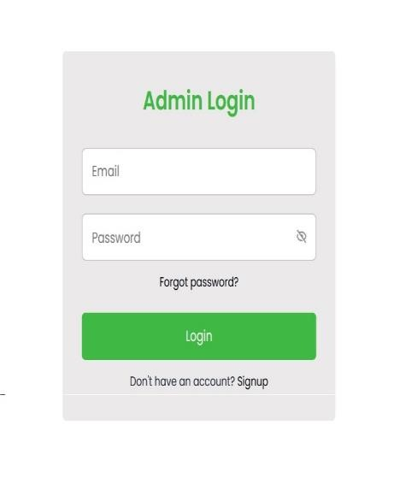

**INPUT CONSTRAINTS:**

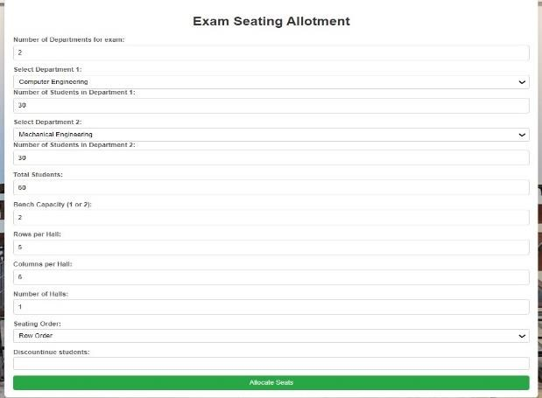

**ALLOCATION TABLE:**

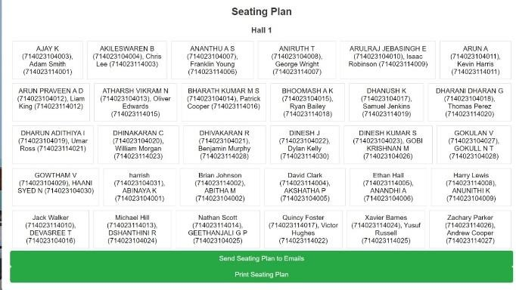

**PRINTING ALLOTMENT:**

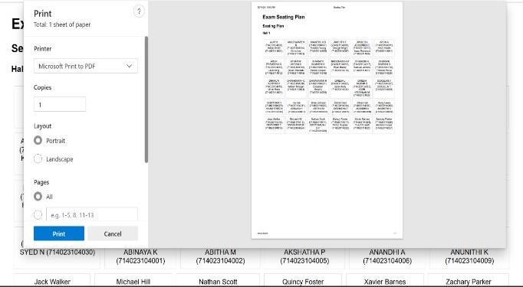

**MAILING ALLOTEMENT:**

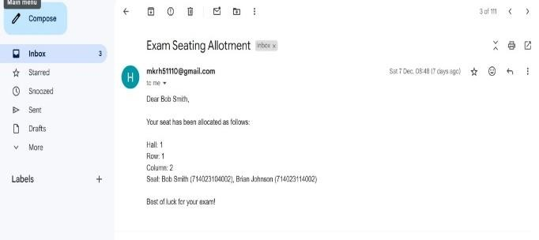

**CONCLUSION:**

The Exam Seating Arrangement System with automated Email Notification has successfully streamlined the traditionally manual and time-consuming process of seating allocation, offering an efficient, accurate, and user-friendly solution for educational institutions. Through automation, the system reduces human error, saves time for administrators, and ensures timely communication with students via automated email notifications. The system’s scalability, flexibility, and reliability make it suitable for both small and large-scale exam setups, and its intuitive interface ensures ease of use. While there are areas for future improvement, such as incorporating more complex seat preferences and optimizing frontend performance for large datasets, the system provides a robust foundation for effective exam seating management, enhancing overall efficiency and fairness.

The Exam Seating Arrangement System has proven to be an effective tool in automating and optimizing the seat allocation process for exams. By integrating automated seat assignment, realtime updates, and email notifications, the system minimizes human error, reduces administrative workload, and improves communication between administrators and students. Its user-friendly interface ensures ease of use, even for those with limited technical knowledge, while its scalability allows it to accommodate both small and large institutions. Through testing and user feedback, the system has demonstrated its accuracy, reliability, and efficiency in handling complex seating arrangements. Although there are areas for future enhancement, such as incorporating personalized seat preferences and improving the front-end rendering for large datasets, the system offers a strong foundation for educational institutions to manage exam seating arrangements in a more streamlined and transparent manner. Ultimately, the system not only enhances administrative productivity but also ensures a fair and organized exam environment for students, making it a valuable addition to any educational institution's exam management tools.

**FUTURESCOPE:**

The Exam Seating Arrangement System with automated Email Notification with Mail Notification has significant potential for future enhancements to improve functionality and adaptability. Future work includes integrating with college management systems to retrieve detailed student data, implementing dynamic hall and seating capacity management, and adding role based access control for secure multi-user management. A mobile application can be developed for convenient access, along with localization and multilingual support for diverse user bases.

Integrating biometric or RFID attendance tracking and leveraging machine learning for predictive and optimized seating arrangements can further enhance the system's capabilities. Improved communication through SMS and push notifications, cloud deployment for scalability, and a feedback mechanism for reporting issues or suggestions are also key areas of improvement.

Additionally, incorporating advanced security measures to safeguard student data and conducting regular vulnerability assessments will strengthen the system’s reliability and security. These advancements aim to make the system more efficient, scalable, and user-friendly for educational institutions.

**REFERENCES**

[1]. Bob Algozzine Effective Exam Seating Arrangements: A Guide for Administrators .

[2]. Christopher Lee: The Handbook for Effective Exam Seating Arrangements.

[3]. Websites like Edutopia, Teach Thought, and The Learning Scientists.

[4]. Ashti Fatima Alam Seating Arrangement Tools for Examinations International Journal Of engineering Applied science and technology.

[5]. Prof. S. S. Aravinth 1, G. Pavithra 2, M. Myvizhimalar3, D. Divya4, M. Rathinakrithika, "Test Hall and every single Seating Arrangement System Using PHP", International Journal of Computer Applications (0975 – 8887) Volume 149 – No.9, September 2016.

[6]. Muhammad Ramees C. K 1, Sherin Eliyas2," Efficient Seat Each and every singleocation Process in College Exam System",International Journal for Research in Applied Science and Engineering Technology (IJRASET) ISSN: 2321-9653; IC Value: 45.98; SJ Impact Factor: 6.887 Volume 6 Issue V, May 2018 .

[7]. Dinesh Chandewar, Mainak Saha, Pushpraj Deshkar, Pankaj Wankhede, "Programmed Seating Arrangement of University Exam", IJSTE - International Journal of Science Technology and Engineering | Volume 3 | Issue 09 | March 2017.

[8]."Seating course of action Tools for assessments", Author-Ashti Fatima Alam.

[9]. ”PHP COOK BOOK”, O’David Sklar and Adam Trachtenberg, Reilly Publications, 2002 Edition.

[10]. Ashti Fatima Alam , “ Seating Arrangemnet Tools for Examinations”, International Journal Of engineering Applied science and technology. [11]. VOL:1 2016 Prof S.S.Aravinth, G. Pavithra, “Exam Hall Seating Arrangement System Using PHP”, Ap/Cse Knowledge Institute Of TechnologyVOL:12014.