**Task Objective:**

Main objective of this task is to develop a theme based personal website with distinct pages provided with a common informative theme.

**SDLC DOCUMENTATION**

The Software Development Lifecycle (SDLC) is a systematic process for building software that ensures the quality and correctness of the software built. SDLC consists of a detailed plan which explains how to plan, build, and maintain specific software. Every phase of the SDLC lifecycle has its own process and deliverables that feed into the next phase of the project.

Totally there are 6 different types of SDLC models are available. The main purpose of our task is to develop a personal website. For this website development task “Waterfall model” is chosen.

**Waterfall model:**

The waterfall is a widely accepted SDLC model. In this approach, the whole process of the software development is divided into various phases. In waterfall model, the outcome of one phase acts as the input for the next phase. The following diagram describes the flow of various stages in waterfall model.

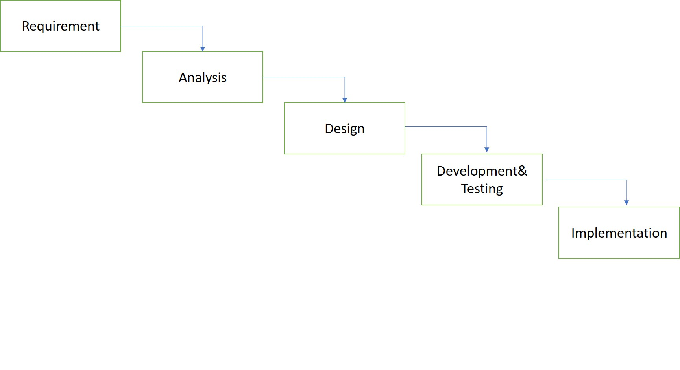

Problem Side – Requirements, Analysis.

Solution Side – Design, Development & Testing, Implementation.

**Phase-1**

**Requirements:**

Requirement Gathering is the most important and fundamental stage in SDLC. During this phase all the requirements need to gathered for developing the website. The most important task at this point is to get a clear understanding of purpose of the website, the main goals and the target audience you want to attract to your site. Key requirements like purpose/goal of the website, how it need to be hosted and what content/ information will be put on the web site and where it has to be put. All these information needs to be collected and documented to support the analysis phase. The developed document is called as Business Requirement Specification(BRS).

***Website-Theme:*** Save Trees.

***Distinct Pages:***

* Home.
* About Me.
* Academics.
* Gallery.
* Achievements.
* Contact.

***Web-server:*** This website needs to be hosted by local workstation using IIS web-server rather than public hosting.

***Repository:*** Also, Git hub repository setup is required for this project to keep track of changes made over time.

**Phase-2**

**Analysis:**

Once the requirement phase is completed the next step is to analyze the requirements from BRS to define and document software needs for developing the website. At the end of this phase “Software Requirement Specification” document also known as (SRS) document will be formed. The software requirements specification document lists sufficient and necessary requirements for the project development.

***Software Requirements Specification for website development task:***

* Visual Studio.
* HTML5.
* Cascading Style Sheets (CSS).
* jQuery (For Slideshow).
* Wireframe Tool (i.e. Draw.io)
* IIS Web-server.
* Git Repository.

**Phase-3**

**Design:**

* It involves preparing the blue print of the web site. In this stage, a **wireframe model** or**mock-up** will be created for the website. A wireframe is a visual representation of the user interface that you’re going to create.
* Wire-frames provide a detailed view of the content that will appear on each page.
* Also, a site-map will be developed to show key pages in the site, showing their relationship to each other and defining how the sties overall navigation should be structured.
* Documentation of various details like operations and functions such as screen layouts, process diagrams and other documentation are done here.

***Site-map:***

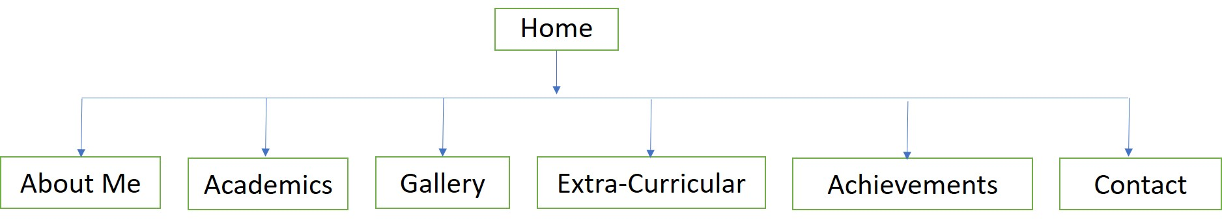

***Wire-frame:***

***Home Page:***

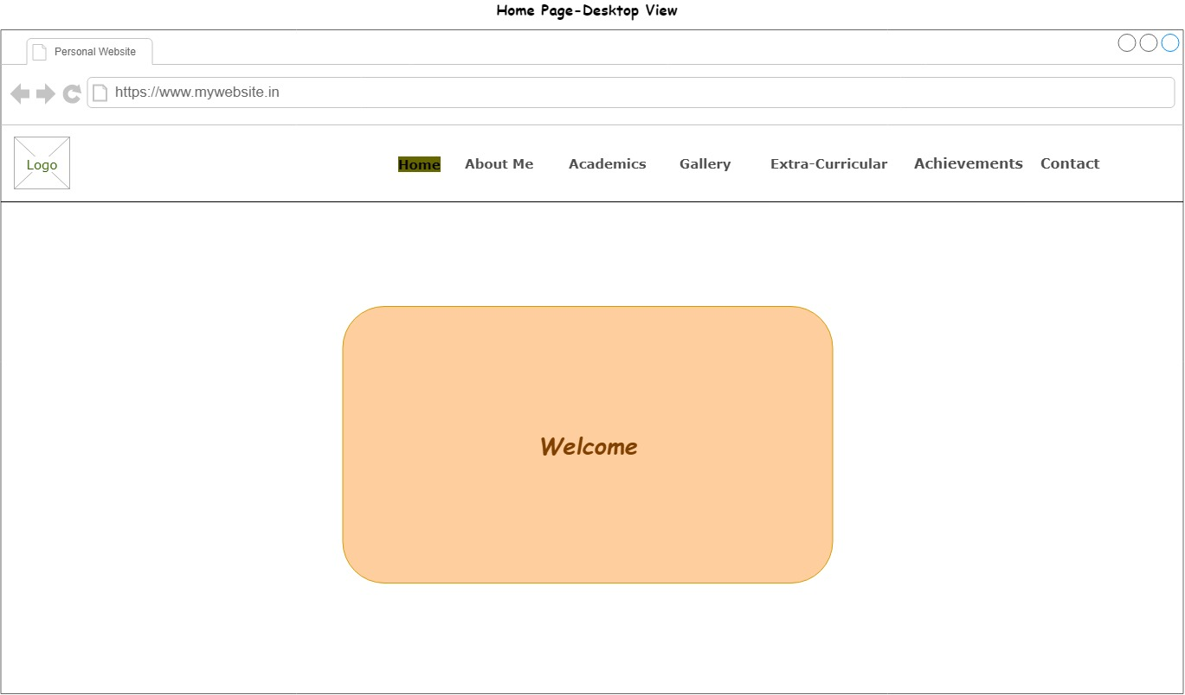

***About Page:***

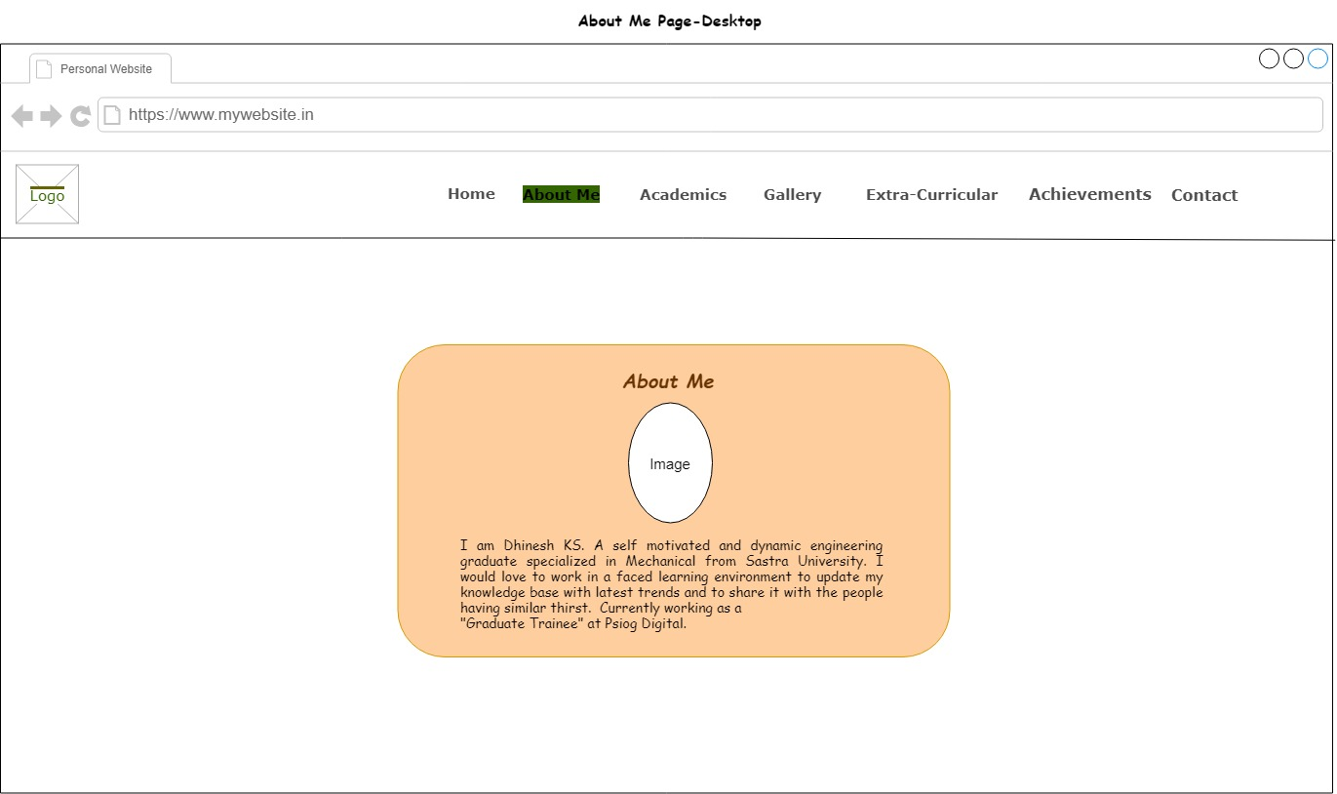

***Academics:***

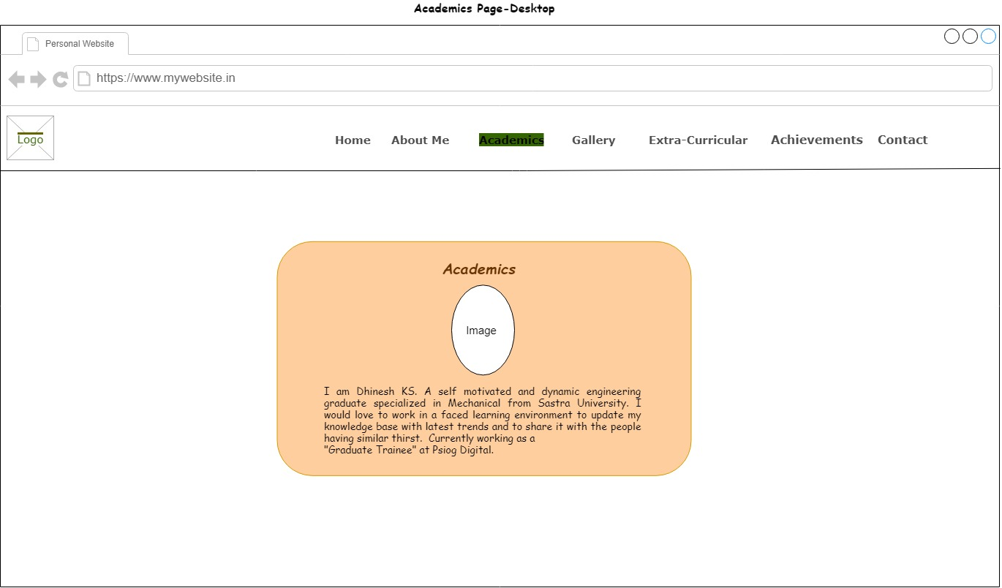

***Gallery:***

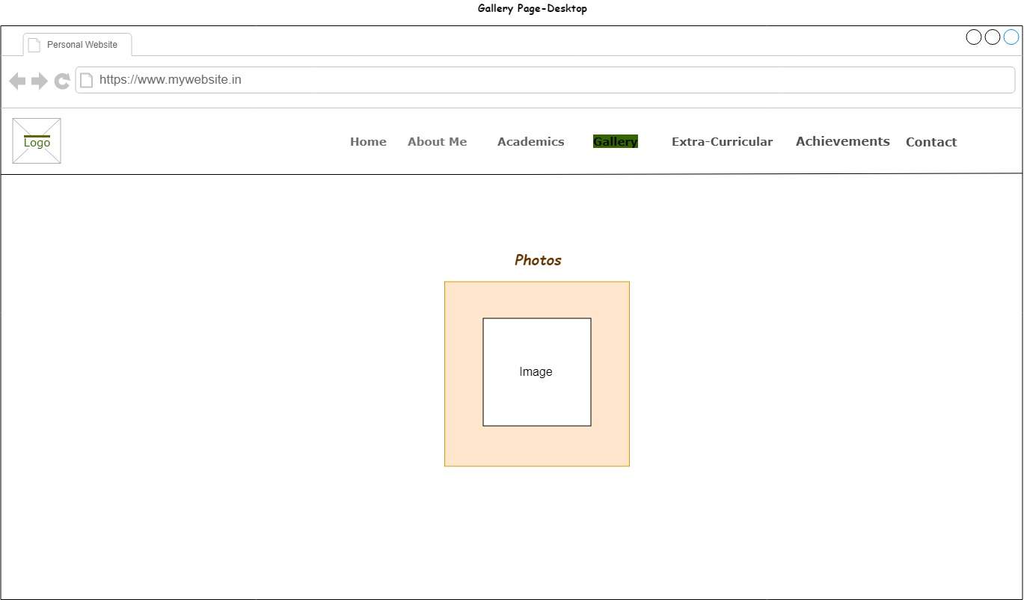

***Extra-Curricular:***

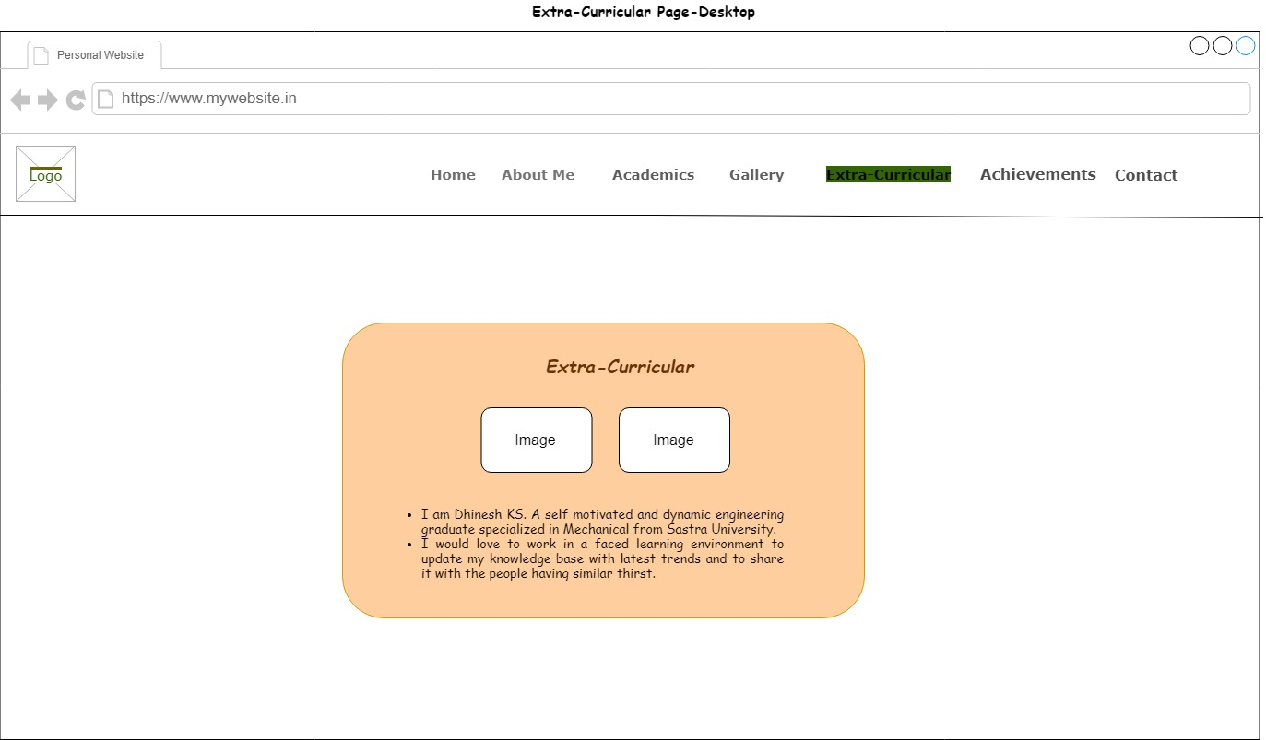

***Achievements:***



***Contact:***

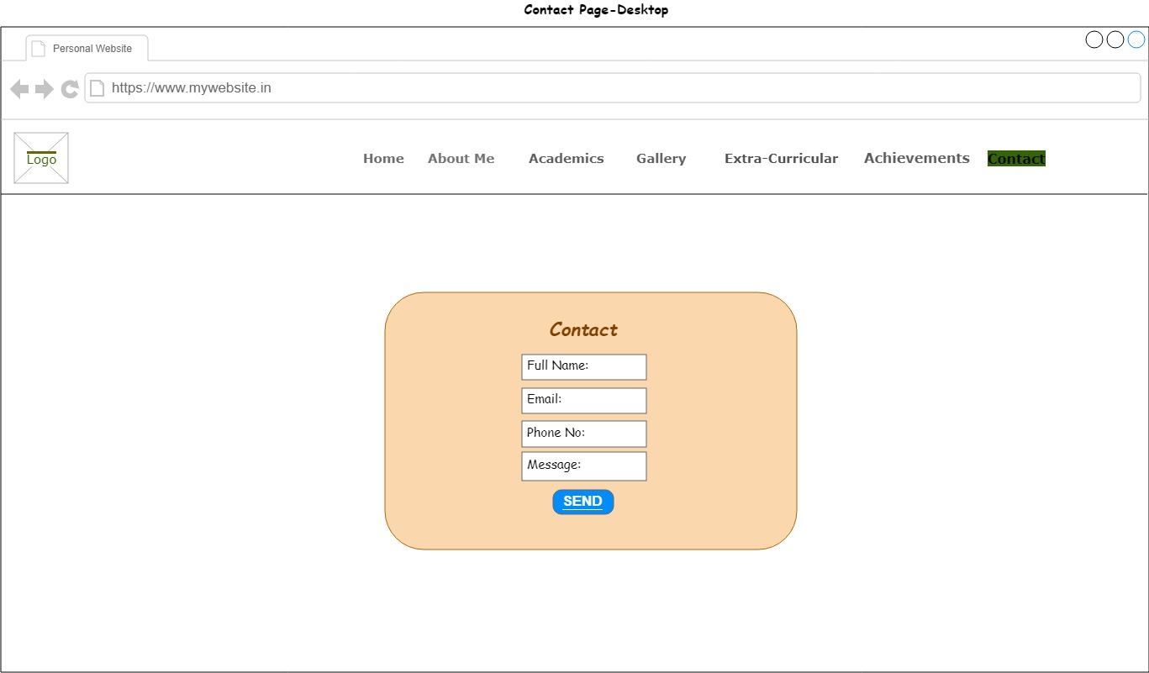

**Phase-4**

**Development & Testing:**

1. ) Development:

The actual source code will be developed in this phase based on the design document. The process of entire code creation may be subdivided into small units, and each unit is developed and tested for its functionality.This is the only phase where the conceptual web site is first translated into a useful and attractive web site.

* HTML5 is used for creating web-pages.
* Cascading Style Sheets (CSS) is used to style the website (i.e. Coloring, Positioning, Fonts, Size etc.) **CSS** describes how elements should be rendered on screen
* Jquery plugins are used for slideshow.

While developing the code the following best practices need to be followed.

***HTML:***

* Proper Document Structure.
* No inline styles.
* Use of alt attribute with images.
* Meaningful tags usage.
* Try to maintain minimum no.of.elements.
* Semantic Divisions.

***CSS:***

* Avoid absolute position and sizing.
* External CSS usage.
* Use generic classes.
* Combine elements.
* Top down structure.
* Make use of “em” units for fonts.
* Use multiple style sheets.
* Use shorthand.
* Appropriate naming.

(b.) Testing:

In this phase the product is put through various testing environments and tools designed and used by web development services to make the product to remove its bugs and errors. Websites should be tested at following stages

**Functionality Testing**

* Verify there is no dead page or invalid redirects.
* Verify the work flow of the system.
* Test the outgoing links from all the pages to the specific domain under test.

**Usability testing -** To verify how the application is easy to use with.

* Test the navigation and controls.
* Content checking.
* Ease of use.

**Compatibility testing-** Compatibility testing is performed based on the context of the application.

* Browser compatibility
* Operating system compatibility
* Compatible to various devices like notebook, mobile, etc.

**Phase-5:**

**Implementation:**

* Once the software testing phase is over and no bugs or errors left in the system then the final implementation process starts.
* Next step is to upload the website to the web-server either public hosted or local hosted. Here the developed web-site will be local hosted by IIS web-server.
* Also the site need to be maintained properly after implementation for bug fixing, upgrade and enhancement.