RIGA TECHNICAL UNIVERSITY
Faculty of Computer Science, Information Technology and Energy
Institute of Applied Computer Systems

Akshat Dhingra
Academic Bachelor Level Study Program “Computer Systems”
Student ID No 221ADB173

Identifying unknown fraud patterns in payment transactions
BACHELOR THESIS

Scientific adviser: Dr.sc.ing
Padmaraj Nidagundi

RIGA 2025
RIGA TECHNICAL UNIVERSITY
FACULTY of Computer Science, Information Technology and Energy
Institute of Applied Computer Systems

Work Performance and Assessment Sheet of Bachelor Thesis

The author of the graduation thesis:
Student Akshat Dhingra _____________________________
^{(signature, date)}

The graduation thesis has been approved for the defence:

Scientific adviser:
Dr. Sc. Ing. Padmaraj Nidagundi _________________________
^{(signature, date)}

ABSTRACT
Fraud detection in digital payment systems is a complex and evolving problem. Businesses and individuals lose billions every year. Detecting fraud early is crucial to reduce these losses. Machine learning can help by finding unusual patterns in large datasets. Traditional detection models mainly depend on known fraud patterns, which limit their ability to recognize new or unseen types of fraud. This thesis aims to identify unknown or novel fraud patterns within payment transactions. The study is based on the IEEE-CIS Fraud Detection dataset from Kaggle, which contains many real-world online transaction records. This thesis utilizes machine learning techniques to tackle data imbalance and uncover hidden irregularities in transaction data. To improve the model, Synthetic Minority Over-sampling Technique (SMOTE) is applied for balancing the dataset. Different machine learning models are trained and combined using stacking to improve prediction. The base models include LightGBM, Isolation Forest, and Autoencoders, while XGBoost is used as the meta-learner to enhance recall and precision. The model is also finely tuned for best performance using Optuna for hyperparameter optimization and threshold optimization. Additionally, SHAP analysis is used to interpret model predictions and understand which features are most important. The dataset is pre-processed to manage missing values and irrelevant information, ensuring the quality of the training data. The final system is evaluated using key metrics like precision, recall, and F1 score. The findings of this thesis can contribute to building more intelligent systems for detecting emerging fraud in real-world payment environments.

Information on the volume of the thesis –36 Pages, 2 tables, 16 figures, 6 sources of reference.

anotācija
Krāpšana visā pasaulē strauji pieaug. Uzņēmumi un privātpersonas katru gadu zaudē miljardus. Krāpšanas agrīna atklāšana ir ļoti svarīga, lai samazinātu šos zaudējumus. Mašīnmācīšanās var palīdzēt, atrodot neparastas tendences lielos datu kopumos. Šis pētījums izveido efektīvu krāpšanas atklāšanas sistēmu. Tajā tiek izmantotas mašīnmācīšanās metodes, lai novērstu datu nelīdzsvarotību un uzlabotu precizitāti. Datu kopa tiek iepriekš apstrādāta, lai apstrādātu trūkstošās vērtības un neatbilstošu informāciju. Pēc tam dati tiek sadalīti apmācības, validācijas un testu kopās ar attiecību 70:15:15. Funkciju izvēle koncentrējas uz svarīgākajiem mainīgajiem, ko atbalsta SHAP (SHapley Additive Explanations). Dažādi mašīnmācīšanās modeļi tiek apmācīti un apvienoti, izmantojot sakraušanu, lai uzlabotu prognozēšanu. Modelis tiek arī precīzi noregulēts, lai sasniegtu labāko veiktspēju, izmantojot sliekšņa optimizāciju. Galīgā sistēma tiek rūpīgi novērtēta, izmantojot tādus galvenos rādītājus kā precizitāte, atcerēšanās spēja un F1 vērtējums. Izskaidrojamības metodes tiek izmantotas, lai veidotu uzticību un palīdzētu lietotājiem saprast, kā tiek veiktas prognozes. Rezultāti liecina, ka modelis darbojas labi un vispārina neredzamus datus. Šis darbs piedāvā praktisku un caurspīdīgu pieeju krāpšanas atklāšanai. Tas var palīdzēt organizācijām stiprināt aizsardzību pret krāpšanu un samazināt finansiālos zaudējumus.

Informācija par darba apjomu – 36 lappuses, 2 tabulas, 16 attēli, 6 avoti.

table of contents
introduction 6
1. Existing Research and Identified Gaps 8
1.1 Literature Review of Key Studies 8
1.1.1 Supervised learning in fraud detection 8
1.1.2. Unsupervised learning in fraud detection 9
1.1.3. SMOTE and class imbalance 9
1.1.4. Ensemble and stacking 10
1.1.5. SHAP and interpretability 11
1.2 Comparison of Anomaly Detection Approaches 11
1.3 Identified Gaps 12
1.4 Summary of literature review 13
2. Methodology 14
2.1. Dataset Description 15
2.1.1 IEEE-CIS Dataset Overview 16
2.1.2 Exploratory Data Analysis 18
2.2 Data Preprocessing and Feature Engineering 22
3. System Implementation 27
3.1 End-to-end Pipeline 27
3.2 Class Imbalance Handling: Oversampling and Undersampling 28
3.3 Model Development 30
3.3.1 LightGBM 31
3.3.2 Isolation Forest 32
3.3.3 Autoencoders 33
3.3.4 XGBoost as Meta Learner 35
3.4 Hyperparameter Optimization with Optuna 37
3.5 Model Explainability and Transparency: SHAP Analysis 40
4. Experimental Results and Analysis 42
4.1 Evaluation Metrics 42
4.2 Model Performance Results 42
4.2.1 Isolation Forest Results 42
4.2.2 Autoencoder Results 42
4.2.3 Results on LightGBM 42
4.2.4 Results on XGBoost 42
4.2.5 Results on the XGBoost Meta Learner 42
4.3 Comparison and Discussion 43
4.4 Limitations and Challenges 44
results and conclusions 45
LIST OF REFERENCES
APPENDIXES
Appendix 1. Name of the appendix
Appendix 2. Name of the appendix

introduction
Fraud is one of the fastest growing problems globally. Organizations lose billions every year because of fraudulent activities. This problem affects many sectors such as banking, e-commerce, insurance, and finance. Fraud causes not only financial losses but also damage to an organization’s reputation. It reduces customer trust and increases operational costs. Detecting fraud early is critical for minimizing these negative impacts.
Traditional fraud detection methods often rely on fixed rules and manual checks. These approaches struggle to keep up with new and sophisticated fraud strategies. Machine learning offers a better way. By learning from historical data, machine learning models can identify patterns and detect fraud more accurately. They can process large volumes of data and adapt to new fraud types quickly.
Despite its benefits, building effective machine learning models for fraud detection is challenging. One main challenge is the imbalance in data. Fraud cases usually represent a tiny fraction of total transactions. This imbalance makes it difficult for models to learn the difference between normal and fraudulent behaviours. If not managed correctly, models can become biased towards the majority class and miss fraud cases.
Another vital challenge is the way data is prepared and split for training, validation, and testing. Proper data handling is essential to develop reliable models. If the data split is based on a poor strategy, it can lead to overfitting or underestimating errors. Many studies fail to describe their data preparation clearly, which creates doubts about their results.
This thesis proposes a fraud detection system using robust machine learning techniques. The system applies careful data preprocessing to clean and structure the data, manages missing values, removes irrelevant features, and ensures proper data type conversion. The data is split into training and test sets using a fair, balanced ratio. Feature selection is performed using the SHAP (SHapley Additive exPlanations) method to improve model accuracy and transparency. Several supervised and unsupervised models are trained and then combined using an ensemble stacking method to leverage their strengths. Hyperparameter tuning and threshold optimization are applied to maximize performance. The models are evaluated with metrics such as precision, recall, F1 score, AUC-PR, and AUC-ROC.
The aim of this thesis is to design and implement a machine learning–based fraud detection system that can effectively identify unknown fraud patterns in highly imbalanced datasets.
The goal is to enhance the ability of fraud detection systems to adapt to new challenges and reduce financial losses.
Tasks: To achieve this aim and goal, the following tasks are defined:
- Conduct a comprehensive review of existing fraud detection techniques and challenges.
- Design a robust data preprocessing workflow, including cleaning, feature selection, and balanced data splitting.
- Train and compare multiple machine learning models (supervised and unsupervised).
- Implement ensemble stacking to combine model strengths.
- Apply hyperparameter tuning and threshold optimization to enhance detection performance.
- Evaluate the models using multiple performance metrics (precision, recall, F1 score, AUC-PR, AUC-ROC).
- Interpret model outputs using SHAP for explainability and transparency.

1. Existing Research and Identified Gaps
Financial fraud detection covers three main lines of work: classic statistics, rule-based checks, and modern machine learning, because banks need fast and dependable screening as fraud tactics keep changing. Traditional statistical models, such as logistic regression and discrimination analysis, give clear risk scores and are easy to explain, but they can miss complex patterns and lose accuracy when customer behaviour shifts. Rule-based systems turn expert knowledge into practical limits and conditions, so decisions are quick and auditable, yet fixed rules are costly to update and often weak against new types of fraud. Current practice therefore utilizes supervised learning to capture known patterns, which supports continuous, large-scale monitoring. This thesis moves further by stacking supervised classifiers with unsupervised anomaly models so a meta-model can combine their strengths, aiming to keep good precision on common fraud while also surfacing patterns the system has never seen—addressing a gap in prior work that leans mainly on supervised pipelines and often misses unknown attacks.

1.1 Literature Review of Key Studies
Reviewing existing studies is a key step in any research work. It forms the base of the study by outlining previous work in the same field. These studies show what has been done and how it relates to the current topic. Deep analysis of their methods and results helps to find their strengths and limits. This process builds a clear baseline for the new research. It shows what needs to be improved and what is already sufficient.

1.1.1 Supervised learning in fraud detection
Supervised learning is a fundamental approach in fraud detection. It uses labelled transaction data to teach models how to tell the difference between legitimate and fraud activities. (Chen et al., 2025) points out that clear fraud labels in past data help models learn what fraud looks like. This improves their accuracy as they see more examples. Popular methods include Logistic Regression for its simplicity, Random Forest, and Gradient Boosting like LightGBM, praised for strong performance on uneven data sets (Sulaiman & Masood Falaknaz, n.d.) .Neural networks can catch hard-to-find fraud patterns over time but might lower precision occasionally (Nguyen et al., 2022).
But these models need lots of quality labelled data to work well. Fraudsters change their strategies, creating new patterns that models can miss if they're not updated fast (Chen et al., 2025). To manage this, teams use cross-validation and verification scores like precision, recall, and F1-score to ensure that models don't miss too much fraud or raise too many false alarms. Maintaining a balance between how clear a model's decisions are, how complex it runs, and how fast it works is important, especially for live systems (Sulaiman & Masood Falaknaz, n.d.). Supervised methods still form the backbone of fraud detection but need regular tuning and support from other techniques to catch the latest fraud tricks reliably.

1.1.2. Unsupervised learning in fraud detection
Unsupervised learning helps find fraud when labels are scarce and when attacks keep changing. It looks for behaviour that stands out from normal patterns, so it can detect unknown frauds that supervised models often miss. Isolation‑based and clustering methods are strong baselines for anomalous transactions in financial data, while representation learning improves detection quality for rare fraud transactions (Agyemang, 2024; Carcillo et al., 2021). (Duan et al., n.d.) propose a SimCLR‑style model that learns transaction embeddings without labels and reports gains over k‑means, Isolation Forest, and autoencoders on an e‑commerce dataset. Hybrid designs also matter, (Carcillo et al., 2021) demonstrate that combining unsupervised scores with supervised classifiers improves robustness under distribution shift in credit risk and fraud‑adjacent tasks, suggesting a practical path to catch novel patterns while keeping precision. Finally, studies show that unsupervised anomaly detectors can reveal suspicious actors with minimal prior labelling, supporting investigation workflows and seeding labels for later supervised training (Naidoo & Marivate, 2020). In short, unsupervised methods add coverage for emerging attacks, and they pair well with supervised pipelines in real life.

1.1.3. SMOTE and class imbalance
Class imbalance dominates fraud work. Most transactions are genuine, so models tend to learn the majority and miss fraud. SMOTE helps by creating synthetic minority samples between a point and its nearest neighbours, which gives the learner more fraud examples. Comparative studies show that SMOTE and related methods such as ADASYN, Borderline‑SMOTE, and SMOTE‑NC often lift recall and F1 on credit‑card tasks, but the best option depends on the model itself (Alharbi et al., 2024). Pairing SMOTE with K‑means before training an ensemble has reported AUC gains versus plain oversampling, with fewer missed frauds. Federated pipelines that combine SMOTE with LSTM models also achieve high recall while holding precision steady, which matters in real life screening where too many alerts are costly (Mohamedhen et al., 2025). If oversampling happens before a proper time‑aware split, information can leak. Careful validation and threshold tuning are essential (Alharbi et al., 2024). With categorical variables, SMOTE‑ENC is safer than one‑hot oversampling because it synthesizes consistent category–numeric pairs and reduces noise in the minority class (Mukherjee & Khushi, 2021). In practice, combine resampling with strong models and judge with precision–recall curves, not accuracy alone.

1.1.4. Ensemble and stacking
Ensemble methods combine the strengths of multiple models to improve fraud detection and reduce variance from any single learner. In practice, gradient‑boosting ensembles such as XGBoost, LightGBM, and CatBoost already perform well, stacking these models under a meta‑learner can push recall and F1 higher on imbalanced card fraud data (Almalki & Masud, 2025). In stacking the base models capture different structures in the data, while the meta‑model learns how to weigh their predictions. This often yields fewer missed frauds without a big rise in false alarms (Gupta et al., 2025). Hybrid stacks that include LSTM or Transformer features alongside boosted trees report strong gains (Ileberi & Sun, 2024). A reviewed work further shows that stacking diverse classifiers—trees, SVMs, and logistic regression—can outperform single best models on public credit‑card datasets when careful preprocessing and validation are used (Btoush et al., 2025). At the same time, ensembles add cost and complexity. Explainability tools such as SHAP help here by showing which features drive the meta‑model decisions, making stacked systems easier to govern in payment systems.

1.1.5. SHAP and interpretability
Explainability matters in fraud detection. Many strong models perform bad in black box testing, so investigators need obvious reasons for each alert. SHAP helps by assigning each feature a weightage of the prediction. With SHAP, an analyst can see if amount, time, device pushed a transaction toward “fraud,” which supports audit and model risk checks (Lin & Gao, 2022). Recent work shows SHAP pairing well with ensembles in financial settings, improving trust and helping firms set thresholds and review features with greater confidence. Studies also combine SHAP with stacked models to spot fake shortcuts and prune weak signals while keeping recall on rare transactions (Almalki & Masud, 2025). In short, SHAP links accuracy to accountability, summarizes feature importance, and enables governance in payment systems (Lin & Gao, 2022; Lundberg et al., n.d.).

1.2 Comparison of Anomaly Detection Approaches
This section of the thesis compares various supervised, unsupervised and stacked models and the table (1.1) depicts this really well.
Table 1.1
Comparative Evaluation
Author’s  name | Techniques | F1 score | Dataset
(Almalki & Masud, 2025) | Stacking of XGBoost, LightGBM, CatBoost; SHAP selection; LIME, PDP, Permutation Importance; threshold optimization and CV. | 0.92 | IEEE-CIS Fraud Detection
(Amirineni, 2025) | Gradient-boosting ensembles with SHAP, LIME, PDP; governance dashboard and explanation fidelity metrics. | 0.982 | IEEE-CIS Fraud Detection
(Btoush et al., 2025) | Stacking hybrid ensemble (DT, RF, SVM, XGBoost, CatBoost, LR as meta) | 0.881 | Credit Card Fraud Detection
(Zhang et al., 2020) | Autoencoder (unsupervised) | 0.178 (derived from P=0.0534, R=0.7955; reported components in paper) | Credit‑card transactions

1.3 Identified Gaps
(Almalki & Masud, 2025): Oversampling is done before a split, which leads to data leakage; hence, it yields an unrealistically high F1 score. No proper time‑aware splitting is used, due to which the model is not capable of detecting novel frauds.
(Amirineni, 2025): The features used for training are meaningless because they are PCA derived. The absence of time‑aware splitting indicates that the model is not relevant to unknown fraud patterns.
(Btoush et al., 2025): Only supervised models are used, which contributes to the model’s inefficacy in detecting novel frauds. Using these many models in a stack is not practical in real life, as the system would be overloaded.
(Zhang et al., 2020): Using an unsupervised model alone is not a clever idea. As it performs poorly in this case and the F1 score clearly shows the weakness here.
Other research: Also have similar gaps in them and are not useful in identifying unknown fraud patterns.

1.4 Summary of literature review
Recent studies in financial fraud detection highlight the importance of combining ensemble learning, explainable AI (XAI), and careful evaluation to address challenges such as extreme class imbalance, anonymized feature spaces, and sensitive pipelines. Gradient boosting stacks, including XGBoost, LightGBM, and CatBoost, consistently outperform classical baselines like logistic regression and single decision trees on datasets such as IEEE‑CIS Fraud Detection, achieving near 99% accuracy and AUC‑ROC ≈0.99, while hybrid approaches that integrate supervised and unsupervised modules, such as LSTM-autoencoder sequences, capture temporal irregularities and improve minority-class recall. Explainability is vital to these approaches, with SHAP-driven feature selection complemented by LIME and PDP. The IEEE‑CIS dataset presents additional challenges due to high dimensionality, missing data, extreme imbalance, and anonymized variables, necessitating leakage-aware, time aware splits and careful feature engineering. High-level studies advocate adaptive, data-driven fraud systems over static rules to manage evolving fraud patterns, while evaluation protocols increasingly emphasize metrics beyond ROC, such as AUC‑PR, precision, recall, F1, and calibration, to reflect operational realities. Collectively, the literature suggests that robust ensemble learners integrated with multi-level XAI pipelines and evaluated under realistic, time-aware conditions provide a blueprint for operationally feasible, interpretable, and regulatory-aligned fraud detection systems.

2. Methodology
The proposed fraud detection system uses a machine learning pipeline that processes the IEEE‑CIS dataset (Ieee_cis_kaggle.Bib., n.d.) through comprehensive data preprocessing, feature selection, feature engineering, and ensemble learning. Data is pre-processed in two ways, one for the supervised base model and the other for unsupervised models. The first preprocessing includes filling missing values, dropping columns with extreme null values, and applying a time‑aware train–test split. Then the training data undergoes “SMOTE‑NC”, which adds synthetic data for the minority class, which in this case is the fraud data; this balances the dataset where the ratio of fraud‑labelled to non‑fraud becomes 50:50. This dataset includes many anonymized features due to privacy reasons, there are a total of 433 features in this dataset excluding the target “isFraud” column; hence, using all of them at once is not a great choice, as it will lead to overloading the resources, and there is no meaning available for most of the columns. So, we remove unwanted features and merge some features to obtain useful insights for the model to train. Finally, 41 features are selected/generated, and the train and test data are both transformed to this pipeline. At last, the data undergoes one‑hot encoding, which converts categorical data into numeric form, and both train and test data are again transformed. This processed train set is then used to train the “LightGBM” model, which is a supervised model. Further, the model is tuned to produce the best results and then evaluated on the test data. Each transaction gets an anomaly score, which becomes metadata for the meta‑learner.
The second preprocessing is conducted similarly to the previous one, except the data does not undergo any oversampling. Features are engineered the same way as before, and 41 features are received. The data is then encoded to deal with categorical data. The data then undergoes a time‑aware split into train–test sets. Finally, the data is scaled to get optimal results. The final data is then passed on to the “Isolation Forest” model and “Autoencoder” model for training. These models are then fine‑tuned using “Optuna” and are evaluated on the test data. The out‑of‑fold predictions are then saved as metadata for the final “XGBoost” model. The meta‑learner is then tested and evaluated thoroughly. At last, for the explainability of the model, “SHAP” is used. It detects the most prominent features of this model.

The evaluation consists of a confusion matrix which shows the number of fraud and non‑fraud data predicted as fraud or non‑fraud. Also, metrics such as accuracy, precision, recall, and F1 scores are calculated as well. Moreover, the AUC_ROC and AUR-PR graphs are generated for the careful evaluation of the system. (Figure 2.1) explains this whole fraud detecting pipeline.

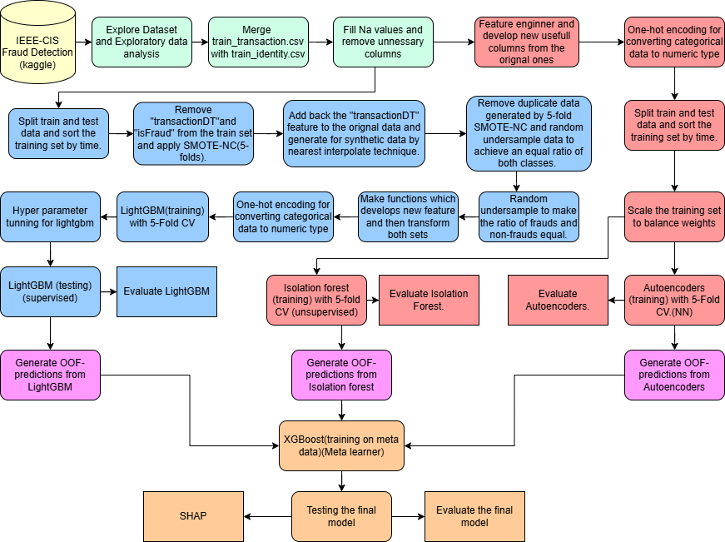

Fig. 2.1. Fraud detection pipeline (Source: Own illustration by the author)

2.1. Dataset Description
This section explains the dataset used for training the models. It denotes the data source and the type of information it includes. Each feature is explained briefly to describes its purpose in the model.
This section also provides information on variable types. It includes numerical, categorical, a time-based feature and Boolean flags. Data preprocessing is also discussed which helps to build a clean dataset for the model.
The section also contains exploratory data analysis (EDA). In this step, the dataset is explored using visual and statistical tools. This helps get a better understanding of how things work and how features relate to other features in a dataset. EDA also helps to find irregularities in the data and provides an overall better understanding of the domain which helps to improve the model later.

2.1.1 IEEE-CIS Dataset Overview
The IEEE-CIS Fraud Detection dataset (Ieee_cis_kaggle.Bib., n.d.) serves as the primary data source, comprising transaction records labelled as fraudulent or legitimate. The dataset contains diverse features related to transaction amount, device information, and user behaviour.
The data is sourced from Kaggle and contains 4 different csv files i.e.-
- Train_transaction.csv
- Train _identity.csv
- Test_transaction.csv
- Test_identity.csv
The training and testing both sets has 2 files the transaction file which contains information of the transaction and the identity which contains information of the person/client who made the transaction. Both the files contains a common column “Transaction_ID” with the help of which both the files are merged into one file containing 433 features an a target variable.
Table 2.1 and Table 2.2 lists representative features and descriptions utilized in modelling.

Table 2.1
Train_transaction.csv
Feature Name | Description
TransactionID | A unique number assigned to each transaction. It does not provide information about time or order.
TransactionDT | The time of the transaction, measured in seconds from a starting reference point. It is useful for calculating time differences between transactions.
TransactionAMT | The amount of money for the transaction, given in USD.
ProductCD | A code that shows the type of product or service related to the transaction (e.g., W, C, R, H, S).
card1 – card6 | Information from the payment card, such as account numbers, bank identification, and card type.
addr1, addr2 | Address information related to the billing location, region, or country.
dist1, dist2 | Distance measures that may show how far the billing address is from the mailing address or the IP location.
P email domain R email domain | The email domains of the purchaser (P) and the recipient (R).
C1 – C14 | Count features that give information about the frequency of transactions linked to cards, addresses, or other identifiers.
D1 – D15 | Time-related features that describe the number of days since a reference event, such as a previous transaction.
M1 – M9 | Match flags, for example billing and shipping addresses.
V1 – V339 | A set of anonymized features created by the data provider. Their exact meaning is hidden for confidentiality.
isFraud | The target variable. It shows whether a transaction is fraudulent (1) or not fraudulent (0).

Table 2.2
Train_identity.csv
Feature Name | Description
TransactionID | A unique number assigned to each transaction. It does not provide information about time or order.
DeviceType | The type of the device (e.g. Smartphone, laptop, etc.).
DeviceInfo | Extra details about the device which is available.
id_01 – id_11 | Numeric data about the client.
id_12 – id_38 | Categorical data about the client.

2.1.2 Exploratory Data Analysis
The IEEE-CIS Fraud Detection dataset exhibits significant class imbalance, with fraudulent transactions representing only 3.59% of the total dataset (1,793 fraud cases versus 48,207 legitimate transactions), as illustrated in (Figure 2.2). This imbalance poses challenges for model training and requires specific handling techniques during preprocessing.

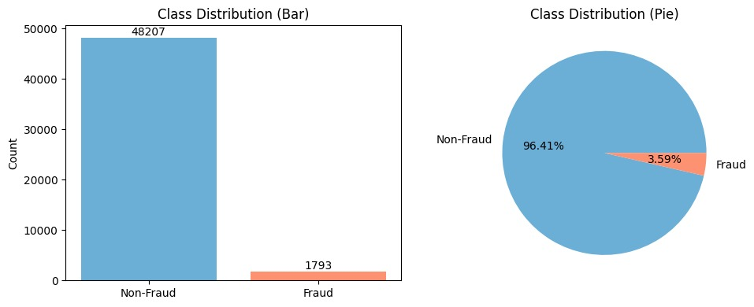
Fig. 2.2 Class Imbalance: Non-Fraud vs. Fraud
The dataset contains various categorical features with distinct distribution patterns. Email domain analysis reveals that gmail.com dominates with approximately 19,000 occurrences, followed by yahoo.com with around 8,500 instances (Figure2.3). Payment card types show a similar concentration, with Visa cards representing the majority at approximately 33,000 transactions, while Mastercard accounts for about 16,000 cases (Figure 2.4).
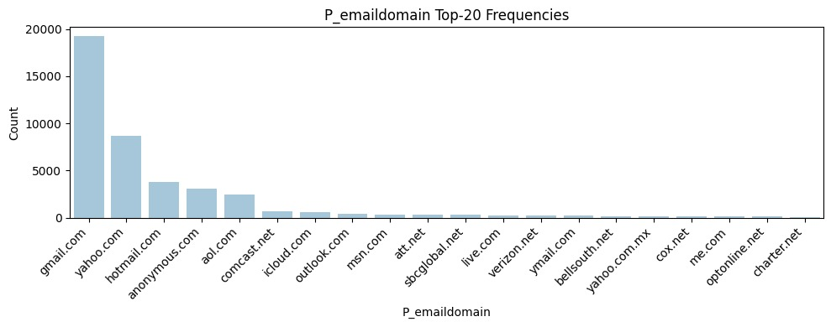
Fig. 2.3 Top 20 “P_emaildomain” Email Domain Frequencies
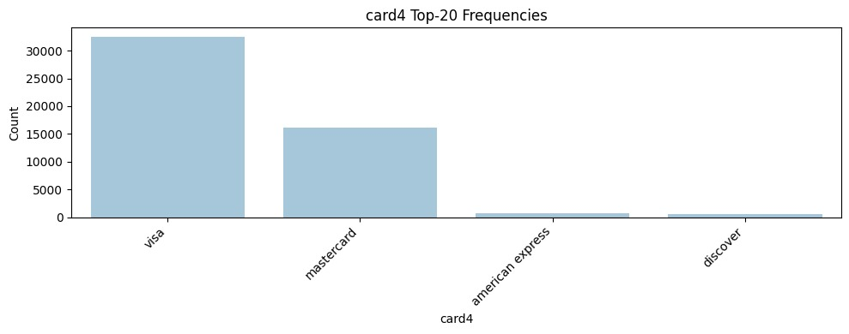
Fig.2.4 “card4” Payment Card Type Frequencies
Temporal analysis demonstrates clear transaction patterns throughout the day. Activity remains relatively low during early morning hours (0-8), peaks around midday (12-14), and reaches maximum levels during evening hours (18-22), suggesting typical consumer spending behaviour (Figure 2.5).
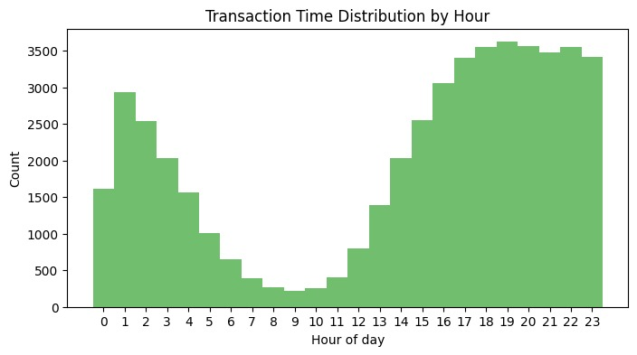
Fig. 2.5 Transaction Count by Hour of Day
Product categorization shows category 'W' dominating with over 37,000 transactions, while other categories (C, R, H, S) represent significantly smaller portions of the dataset (Figure 2.6). The dataset contains substantial missing values, with many features showing missing ratios above 80%, particularly in the top 50 features analysed (Figure 2.7). This high proportion of missing data necessitates careful preprocessing strategies.
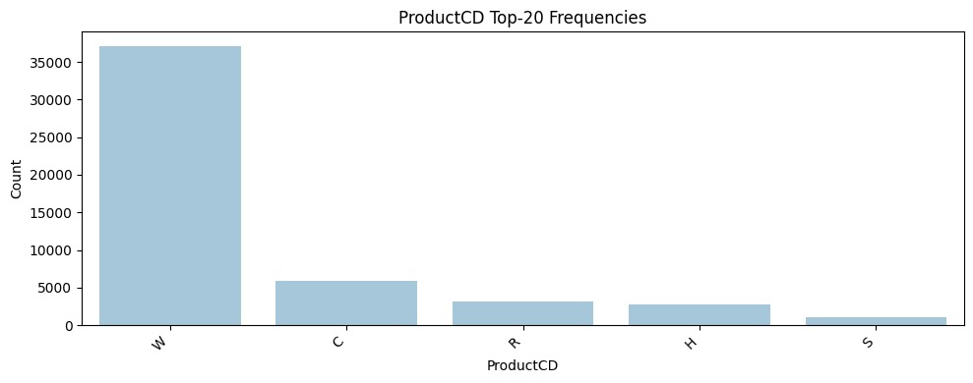Fig. 2.6 “ProductCD” Category Frequencies
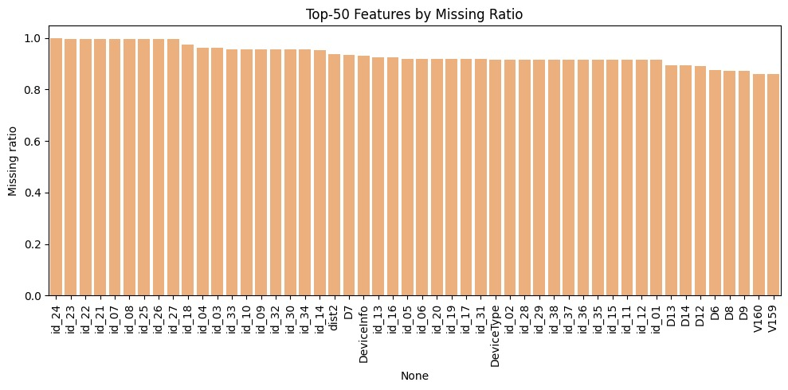
Fig.2.7 Top 50 Features by Missing Value Ratio
The correlation matrix in (Figure 2.8) reveals the linear relationships among the top numeric features in the IEEE-CIS dataset, showing predominantly low to moderate correlations that indicate largely independent predictive signals, which is advantageous for model performance; however, notable associations exist between anonymized variables such as V70 and V49 (correlation 0.89) and between C1 and C13 (correlation 0.82), suggesting potential redundancy that can inform feature selection or transformation, while transaction-specific features like TransactionAmt, card1, and card2 exhibit minimal correlation with other variables, underscoring their unique contribution to fraud detection and guiding the design of more efficient and robust models.
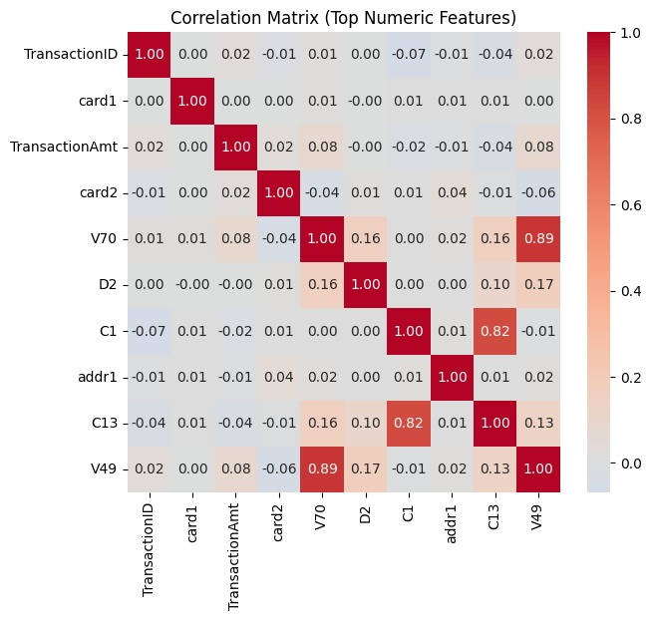
Fig. 2.8 Correlation Matrix

2.2 Data Preprocessing and Feature Engineering
The proposed system processes the data in two ways: one for the supervised model and the other for the unsupervised models. The first preprocessing for the supervised model is more complex, as the supervised model requires balanced data to reach higher accuracy, and to predict novel fraud the split should be time‑aware, that is, sorted on the “TransactionDT” feature. To solve the imbalance problem, “SMOTE‑NC” is used, which creates synthetic data for the minority class and balances the data; but “SMOTE‑NC” cannot generate time‑related features correctly, hence the time‑delta feature should be removed. The data must remain in chronological order; without the time‑delta feature this is not possible, because after the synthetic data addition the data get shuffled and require a time‑aware sort. To address this, the original data are stored separately and the “TransactionDT” feature is temporarily removed from the set. Then, on the remaining train data, “SMOTE‑NC” is applied in a 5‑fold cross‑validation setup so that all minority synthetic samples do not form a group and the data remain chronological. Next, “TransactionDT” is merged back carefully to the original set, leaving empty spaces in between for the synthetic data. The synthetic data are then provided a time‑delta with the help of “K‑neighbour interpolate,” which calculates the new values from the nearest data points. By using a 5‑fold setup in a rolling window, synthetic data are generated chronologically, but the original data get repeated in every fold, creating duplicates, which are removed. This re‑introduces imbalance because the duplicates are from the original data with legitimate transactions as the majority. There becomes a scarcity of legitimate transactions; to address this, random under sampling is done to restore a 50:50 ratio. Then the features are engineered in a way to create useful insights for the model, such as –

- “Transaction_day”- The count of transactions in 24 h period explained in formula (2.1).
$Transaction_{day}=\frac{TransactionDT}{\left(24*60*60\right)}$ (2.1)

- “Transaction_hour”- The count of transactions in 1 h period explained in formula (2.2).
$Transaction_{hour}=\frac{TransactionDT \% \left(24*60*60\right) }{3600}$ (2.2)

- “Is_night_txn”- It denotes whether the particular transaction is made in night or day. This feature is generated by a check if the “Transaction_hour” is in range from 0 to 7.
- “Trans_per_card_day”- This feature denotes the number of transactions from a card in a day. It is generated by grouping “card 1” and “Transaction_day” together and then count on “Transaction_id” by that group.
- “Avg_amt_per_card”- This feature denotes the avg amount of a transaction by a card. It is calculated by grouping “card 1” and “TransactionAmt” and then getting a mean out of it.
- “Avg_std_per_card”- This feature denotes how much a particular transaction deviate from the average of that card.
- “Freq_ratio_card_amt”- This feature denotes how big or small a particular transaction is compared to the average amt through a particular card. Explained in formula (2.3).
$Freq_{ratio_{card_{amt}}}=\frac{TransactionAmt}{Avg_{amt_{per_{card}}}+(1e-5)}$ (2.3)

- “Amt_deviation_card”- This feature denoted how far a particular transaction is deviated from the card’s average amount. Explained in formula (2.4).
$Amt_{deviation_{card}}=\frac{TransactionAmt - Avg_amt_per_{card}}{Amt_{std_{per_{card}}}+(1e-5)}$ (2.4)

- “Trans_last_1h_card”- This feature denotes number of transactions by a card in the last 1 hour. It is generated by grouping “card 1” and “TransactionDT” (upto:3600) and counting “TransactionID” on them.
- “Trans_last_6h_card”- This feature denotes number of transactions by a card in the last 6 hour. It is generated by grouping “card 1” and “TransactionDT” (upto:21600) and counting “TransactionID” on them.
- “Trans_last_24h_card”- This feature denotes number of transactions by a card in the last 24 hour. It is generated by grouping “card 1” and “TransactionDT” (upto:86400) and counting “TransactionID” on them.
- “Time_since_last_txn_card”- This feature denotes time in seconds since the last transaction from a particular card. It is generated by grouping “card 1” and calculating difference of “TransactionDT” between the current and the previous data.
- “Devices_per_card_24h”- This feature represents, for each transaction in the dataset, the number of unique devices associated with a specific credit card (identified by card1) within the 24-hour window immediately preceding and including the current transaction's timestamp “TransactionDT”.
- “Cards_per_device_24h”- This feature represents, for each transaction, the number of unique credit cards (via card1) used on a specific device (identified by "Device Info") within the 24-hour window immediately preceding and including the current transaction's timestamp.
- “Device_change_flag”- This is a flag feature hence it has only binary input. This feature denotes whether a particular transaction’s source device is same or changed after the last meeting?
- “Browser_change_flag”- This is a flag feature hence it has only binary input. This feature denotes whether a particular transaction's browser is same or changed after the last meeting?
- “Os_change_flag”- This is a flag feature hence it has only binary input. This feature denotes whether a particular transaction’s OS is same or changed after the last meeting?
- “Screen_resolution_change_flag”- This is a flag feature hence it has only binary input. This feature denotes whether a particular transaction’s Screen resolution is same or changed after the last meeting?
- “Geo_change_flag”- This is a flag feature hence it has only binary input. This feature denotes whether a particular transaction’s geo location is same or changed after the last meeting?
- “Unique_ip_per_card”- This feature denotes how many unique Ip address is there per card.
- “Unique_cards_per_ip”- This feature denotes how many cards are registered under an IP address.
- “Card_device_use_ratio”- This feature denotes how frequent a card is used in last 24 hours relative to number of unique devices it’s been associated with. Explained in formula (2.5).
$Card_{device_{use_{ratio}}}=\frac{Trans_per_card_{day}}{\left(Devices_{per_{card_{24h}}}\right)+1}$ (2.5)
- “Time_diff_ratio_to_card_mean”- This feature denotes the ratio of the time since the last transaction with the avg time between payments from a particular card. Explained in formula (2.6).
$Time_{diff_{ratio_{to_{card_{mean}}}}}=\frac{Time_{since_{last_{txn_{card}}}}}{mean_{time}+(1e-5)}$ (2.6)

- “Dist_ratio”- This is a ratio of “dist1” and “dist2” and denotes distances between important aspects of a transaction. Explained in formula (2.7).
$Dist_{ratio}=\frac{dist1}{dist2+(1e-5)}$ (2.7)

The training and testing sets are then further transformed using a one-hot encoding pipeline which converts the categorical data into numeric form. The final data is then served to LightGBM model for further training and testing.
The second approach for the unsupervised models is relatively easy to execute then the primary approach for the supervised model. The data at first undergoes basic cleaning like filling nans and deleting columns with high no. of empty rows.
The data is then feature engineered to obtain the same features as in the previous one and then it undergoes encoding which converts categorical data to numeric data.
Furthermore, the features are scaled to deal with non-uniform weights of unique features.
The Data then passes on to the unsupervised base models of the system (i.e. Isolation Forest and Autoencoder) for further training and testing.

3. System Implementation
This chapter walks through the complete implementation of the fraud detection system. It explains all the technical choices made from raw data to trained models. The system connects several parts together. These get cleaned and checked for consistency. Then features are built from the raw data, with careful attention to prevent information leakage between training and testing phases. Class imbalance gets handled using SMOTE, but only on the training set used by a base supervised model (LightGBM). Three models are trained next. Isolation Forest learns to spot anomalies without using labels. LightGBM learns patterns from labelled transactions. An autoencoder compresses data and learns what normal transactions look like. At last XGBoost combines signals from all three models to make final predictions. Finding the best settings for each model happens through Optuna. This framework automatically searches for good hyperparameters instead of requiring manual guessing. SHAP is used to explain why predictions were made. It shows which features influenced the fraud decision for each transaction.

3.1 End-to-end Pipeline
The pipeline connects all components from raw data to final predictions. Two CSV files arrive initially. One contains transaction data. The other contains identity information. These files are merged to create a complete record for each transaction. The merged data undergoes cleaning. Unwanted columns are removed. Missing values are handled. Data types are corrected. After cleaning, new features are generated from existing ones. Domain knowledge and statistical analysis guide feature creation. The result is a refined dataset with 40 key features capturing important transaction characteristics.
The data is further chronologically split into train and test sets in a 80:20 ratio where, the train set receives the first 80 percent of the whole data, and the test data get the remaining 20 percent. Class imbalance is addressed next through SMOTE. This step applies only to the training set. The minority class gets oversampled. The exact details of SMOTE are covered in a separate section. After SMOTE, the training data is ready for base model training.
Three base models train independently. Each model learns its own perspective. They can train sequentially or in parallel. All three base models were previously tuned by Optuna to find optimal hyperparameters.
Once trained, base models generate out-of-fold predictions on the training set. Out-of-fold means each training sample gets scored by a model trained without seeing it. This prevents leakage. The base models produce three types of signals. Isolation Forest produces anomaly scores. LightGBM produces fraud probabilities. The autoencoder produces reconstruction errors. These three signals along with the "is fraud" feature, form the training set for the meta-learner.
The test set receives a different treatment. Base models score the test set directly. The same three signals are generated. Isolation Forest produces anomaly scores. LightGBM produces fraud probabilities. The autoencoder produces reconstruction errors. These test set scores are saved to a CSV file. Unlike the training set, test labels are not available. The test data has only the base model scores. They are stored in different file for evaluation.
XGBoost serves as the meta-learner. It is a supervised model. It trains only on the out-of-fold predictions from the training set. It learns to combine the three base model signals optimally. The training data for XGBoost has three features (the base model outputs) and one label (fraud or not). XGBoost was previously tuned by Optuna to find its best hyperparameters.
The meta-learner then scores the test set. The three base model scores for each test transaction go into XGBoost. XGBoost produces the final fraud probability. This is the system's ultimate output. These predictions are saved for evaluation.
Explainability is built with the help of SHAP. SHAP calculates feature importance for each model separately. SHAP values are computed and saved for detailed analysis.
This pipeline design ensures clean data flow. No information leakage. The temporal structure mimics real deployment. Training uses past data. Testing uses future data. Base models operate independently before combining through the meta-learner. All models were tuned systematically through Optuna before this final pipeline run. Explainability is integrated through SHAP at every stage. The result is a reproducible, transparent, and modular fraud detection system.

3.2 Class Imbalance Handling: Oversampling and Undersampling
Class imbalance is a fundamental challenge in fraud detection. Fraudulent transactions are rare while normal transactions dominate the dataset. Without intervention, machine learning models ignore fraud and focus only on predicting normal activity. This produces poor fraud detection performance. Two strategies address this problem together. Oversampling increases minority class samples through synthetic generation. Undersampling decreases majority class samples through selective removal. In this thesis, both were used strategically to achieve a balanced training set that preserves important patterns while removing noise.
Time delta features are important for fraud detection because they capture temporal patterns in transaction behaviours. However, SMOTE cannot handle certain feature types directly. Time delta features present a particular challenge because SMOTE interpolates between samples to create synthetic ones. Interpolating time deltas produces unrealistic synthetic times that would inject noise into the data. To solve this problem, time delta features were temporarily removed before applying SMOTE. After SMOTE generated synthetic samples, the original time delta features were reattached to the enriched data. This approach preserved temporal patterns while allowing SMOTE to work on compatible features. The synthetic data further receives a “transactionDT” through K-Neighbour interpolate.
SMOTE was applied using rolling window cross-validation to respect the temporal nature of transaction data. Rolling window cross-validation means the folds are created in a time-aware manner. Earlier data trains the model while later data validates it. This mimics real deployment where the model scores future transactions. Five rolling folds were created from the training set. This continues sequentially. Each fold gets SMOTE applied only to its training portion. Synthetic minority samples are generated within each fold's training data. These synthetic samples are then added back to that fold's training set. This approach ensures synthetic data spreads evenly across all five folds while respecting temporal order. The result is balanced data that also maintains chronological integrity without look-ahead bias.
However, this five-fold process created duplicates because original non-fraudulent transactions appeared multiple times. Each fold contained the same normal transactions since they were not oversampled. When the five folds were combined back into a single training set, these duplicates persisted. Duplicate normal transactions add no new information and waste computational resources. They were removed from the combined training set, keeping only one copy of each duplicate normal transaction. This duplication removal made the dataset cleaner but changed the class balance significantly. The fraudulent class, previously rare, now represented a higher percentage of the data.
To maintain a manageable and realistic balance after deduplication, undersampling was applied to the majority class. Undersampling randomly removes samples from the majority class until a target ratio is achieved. Normal transactions were randomly removed until fraud and normal classes reached a 50-50 ratio. A 50-50 balance is not realistic to real-world deployment where fraud is genuinely rare. But it provides better training signal for models to learn fraud patterns effectively. The model sees enough fraudulent examples to understand their characteristics. It also sees enough normal examples to avoid overfitting to fraud alone. This balance was achieved without losing much valuable data because random removal ensured no systematic bias was introduced. The final training set after oversampling, duplication removal, and undersampling has a balanced 50-50 ratio of fraud to normal transactions. This balanced dataset trains better models than the original imbalanced data would have produced. The models learn fraud patterns effectively while understanding what legitimate activity looks like. The combination of oversampling and undersampling with careful feature handling and rolling window cross-validation produces a training set ready for feature engineering and further training base supervised model(LightGBM).

3.3 Model Development
This subsection explains how the full fraud model is built and validated in a clear, step‑by‑step way. The process starts from a fixed feature table and a strict time‑aware split. All transformers are fit on past data only and then applied forward. Three base learners are trained: a LightGBM, an Isolation Forest, and an Autoencoder. Each model learns on the training window and is checked on the next time block to keep estimates realistic. Out‑of‑fold scores from all base learners are saved in time order. These scores become inputs to a small meta‑learner that combines evidence. The meta‑learner is tuned and then fixed for the test window. Metrics focus on precision‑recall behaviour and a practical decision threshold. Explanations with SHAP are generated for the supervised model and for the final stack, so every alert can be traced back to its main drivers.

3.3.1 LightGBM
LightGBM is a supervised learning algorithm. The model learns patterns from labeled transactions to predict fraud. Unlike Isolation Forest, it requires labelled examples during training. It sees both normal and fraudulent transactions and learns to tell them apart.
Gradient boosting works by building trees one after another. Each new tree fixes mistakes made by previous trees. The first tree makes initial guesses. The second tree learns from those errors and corrects them. This happens many times. After many trees, the combined model becomes very accurate. The final prediction sums all tree predictions together.
LightGBM is an optimized version of gradient boosting. It trains faster and uses less memory than traditional methods. It grows trees leaf-wise, meaning trees expand deeper where they reduce error the most. Traditional boosting grows trees level by level uniformly. LightGBM grows trees more smartly. This produces better results with fewer trees. Training finishes much quicker. On large datasets like IEEE-CIS, this efficiency really matters. The architecture of the LightGBM model can be seen in Figure(3.1).
Optuna was used to tune the following hyperparameters-
- n_estimators
- max_depth
- learning_rate
- Subsample
- colsample_bytree
- min_child_weight
- gamma
- reg_alpha
- reg_lambda
- objective
- eval_metric
- tree_method
- n_jobs
- random_state
The best setting is then used for the final training before testing.

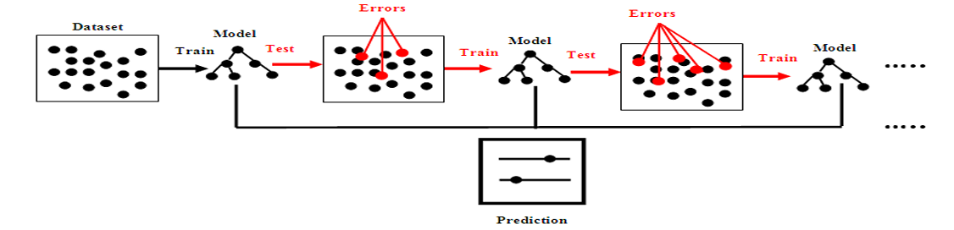
Fig.3.1. Architecture of the LightGBM model (Adapted from (Divya Zion & Tripathy, 2023))

3.3.2 Isolation Forest
Isolation Forest is an unsupervised learning algorithm. It detects anomalies by isolating unusual observations in the data. Unlike supervised methods, it needs no labelled fraud examples during training. This makes it valuable for detecting fraud patterns that have never been seen before.
Normal transactions cluster together in the feature space. Fraudulent transactions scatter and stay isolated. Random decision trees split the data recursively. Each split picks a random feature and a random split value. Unusual points get isolated faster than normal ones. Points isolated with fewer splits are likely anomalies. The algorithm builds many trees and averages their isolation scores. Low average scores mean normal transactions. High average scores suggest anomalies. The architecture of Isolation Forest can be seen in Figure 3.2.
The model works directly with encoded features after cleaning and scalling. This simplifies the pipeline. Once trained, the model generates an anomaly score for every transaction. This score reflects how isolated the transaction is in the feature space. Scores near 0 mean very normal. Scores near 1 mean very anomalous.
Several hyperparameters control Isolation Forest behavior. The number of trees was tuned through Optuna. More trees improve stability but slow training. Fewer trees are faster but noisier. A balance was found. The number of samples per tree was also optimized. Smaller samples capture local anomalies better. Larger samples focus on global patterns. For transaction data, a medium sample size worked well. Optuna tested different combinations to find what worked best. Other hyperparameters tuned were- bootstrap and contamination.
Isolation Forest scales very well to large datasets. Training is fast compared to many other anomaly detection methods. This is because the algorithm does not compute pairwise distances or model the full distribution. It just builds random trees. This efficiency was important. The system needed to retrain occasionally as new data arrived. Fast training made this practical. Even on Google Colab with CPU resources, Isolation Forest trains quickly.

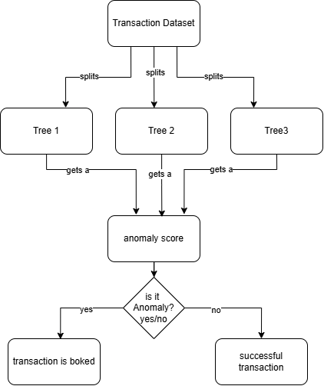
Fig 3.2 Isolation Forest architecture

3.3.3 Autoencoders
Autoencoders are a unique type of neural network. They are used for unsupervised learning tasks. In simple words, an autoencoder learns to compress data into a compact form and then tries to rebuild it as close as possible to the original. This mechanism helps the model pick up hidden structures in the data, especially the normal or common patterns.
An autoencoder has three main parts. There's the encoder, which squeezes the input data down to a smaller size. The middle part, called the bottleneck, holds this condensed version. Then the decoder tries to expand this small version back to the original size. The goal for the decoder is to reconstruct the data well so that it matches the real input as near as possible. This Architecture of Autoencoder can be seen in fig. (3.3).
During training, the model adjusts itself to make the difference between the real data and the reconstructed data as small as possible. This difference is called the reconstruction error. In this thesis, Mean Squared Error (MSE) was selected as the reconstruction error metric. MSE treat larger errors more strongly, which makes it more sensitive to truly unusual transactions. This sensitivity is valuable for catching new fraud patterns that deviate significantly from normal behaviour.
The real advantage of autoencoders in this work comes from how they handle anomalies. The autoencoder was trained exclusively on non-fraudulent transactions from the IEEE-CIS dataset. Since real-world fraud is rare, the model learned to reconstruct normal transaction patterns very well. When it encounters a new transaction that does not match what it has learned; for example, a for a clever and new fraud the reconstruction error suddenly grows. The autoencoder has never seen anything similar to this before, so it cannot recreate it in detail. When the reconstruction error passes a certain threshold, the transaction gets flagged for possible fraud.
The fraud detection workflow implemented in this thesis works in the following sequence. First, all data was separated into normal and potentially fraudulent records based on the labels. The autoencoder was trained only on the normal subset. During evaluation, each transaction is run through the network. If the MSE reconstruction error from the autoencoder is low, the transaction fits the "normal" profile. But if the error climbs above the threshold, the system flags it as an anomaly.
The autoencoder requires careful configuration of several hyperparameters. In this thesis, Optuna was used to optimize these hyperparameters automatically. The parameters optimized included-
- Bottleneck dimension
- Number of hidden layers in the encoder
- Size of hidden layers in the encoder
- Number of hidden layers in the decoder
- Size of hidden layers in the decoder
- Learning rate
- batch size
- Dropout rates for regularization
- Choice of activation functions.

Each of these parameters affects how well the model learns to distinguish normal transactions from fraud. Another important step was optimizing the reconstruction error threshold, which decides when a transaction should be flagged as fraud.

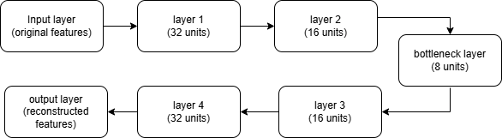
Fig. 3.3 shows the architecture of the Autoencoders model.

3.3.4 XGBoost as Meta Learner
XGBoost serves a different role than the base models. It does not work directly with transaction features. Instead, it learns to combine signals from Isolation Forest, LightGBM, and the autoencoder. This approach is called stacking or ensemble learning. Each base model provides its own perspective on whether a transaction is a fraud. XGBoost learns the best way to combine these perspectives into a final decision.
The input to XGBoost is not raw transaction data. It is the outputs from the three base models. Isolation Forest provides an anomaly score which reflects how isolated the transaction is statistically. LightGBM provides a fraud probability which reflects supervised patterns learnt from labelled data. The autoencoder provides a reconstruction error. It reflects how well the transaction fits the learned "normal" pattern. XGBoost combines these signals from Isolation Forest, LightGBM and the Autoencoder. Each model captures different perspectives. Isolation Forest focuses on statistical isolation. It asks if the transaction is unusual in the feature space. LightGBM focuses on learned supervised patterns. The autoencoder focuses on reconstruction quality. Together, they provide robust fraud detection. A transaction flagged by all three models is very likely fraud.
The architecture of the meta-learner stacking approach is that tha base model outputs flow into XGBoost. XGBoost then produces the final fraud prediction. This two-stage approach has advantages. The base models can be tuned independently. Each focuses on its own strength. Then XGBoost learns to use all three perspectives optimally. No single model dominates. The final decision reflects all viewpoints.
There are only three input signals generated from the base models. Learning to combine three signals is much easier. Because of this, XGBoost typically needs fewer trees as a meta-learner. Optuna still tuned the learning rate and tree depth.
Class imbalance also exists at the meta-learner level. The training set has more normal transactions than fraudulent ones. Class weights were applied to XGBoost training. Fraudulent cases are weighted more heavily. This forces XGBoost to pay attention to predicting fraud correctly. Without this weighting, XGBoost might learn to predict "normal" for everything. It would ignore the rare fraudulent cases. Class weights prevent this problem.
XGBoost produces a fraud probability between 0 and 1. This is the final output of the system. A probability of 0.9 means the system is very confident it is fraud. A probability of 0.1 means the system is very confident it is legitimate. A probability of 0.5 means the system is uncertain. The threshold for flagging fraud is set later during evaluation. But XGBoost's job ends with producing this probability.
The meta-learner approach has practical benefits. If a new base model is created later, it can be added to the stack. XGBoost can retrain using the new signal. Existing base models do not need retraining. The system becomes modular and extensible. If one base model performs poorly, it can be replaced. XGBoost adapts to use the remaining models better. This flexibility is valuable in production systems that must evolve over time.

3.4 Hyperparameter Optimization with Optuna
Finding the right hyperparameters for machine learning models is challenging. Each model has many parameters that control its behaviours. Changing one parameter affects model performance. Changing multiple parameters creates countless combinations to test. Manual tuning is time-consuming and unreliable. It depends on researcher experience and luck. Optuna solves this problem through automated hyperparameter optimization. It systematically searches the parameter space efficiently. Optuna uses Bayesian optimization to explore promising regions first. It learns from previous trials to guide future searches. This intelligent approach finds good hyperparameters faster than random search or grid search.

In this thesis, Optuna optimized hyperparameters for all four models. Isolation Forest, LightGBM, the autoencoder, and XGBoost each got their own Optuna study. A study is a sequence of trials where each trial tests a different hyperparameter combination. The objective function defines what makes a trial good or bad. For Isolation Forest, the objective was minimizing reconstruction error on the validation set. For LightGBM, the objective was maximizing recall while keeping false positives manageable. For the autoencoder, the objective was minimizing validation reconstruction error on normal transactions. For XGBoost, the objective was maximizing the ability to combine base model signals effectively. Each model's objective function matched its role in the system.

- LightGBM Hyperparameters

LightGBM hyperparameters control tree building and regularization. The number of trees (n_estimators) determines how many boosting rounds occur. More trees capture complex patterns but risk overfitting. Maximum tree depth (max_depth) limits how deep each tree grows. Deeper trees learn finer details but overfit more. Learning rate controls how fast the model learns from each tree. High learning rates are fast but unstable. Low learning rates are stable but slow. Subsample is the fraction of training data used for each tree. Lower values add randomness that prevents overfitting. Column sample by tree (colsample_bytree) is the fraction of features used per tree. Lower fractions also prevent overfitting by introducing feature randomness. Minimum child weight controls the minimum sum of weights in a leaf node. Higher values prevent the model from creating overly specific splits. Gamma is the minimum loss reduction required to split a node. Higher gamma makes splits harder to achieve, keeping trees simpler. Regularization parameters L1 (reg_alpha) and L2 (reg_lambda) penalize model complexity. Higher values push toward simpler models. The objective parameter specifies the learning task (binary classification for fraud detection). Evaluation metric determines how model performance is measured during training. Tree method specifies the algorithm for tree building. The number of jobs (n_jobs) controls parallel processing. Random state ensures reproducibility by fixing random seed values.

- Isolation Forest Hyperparameters

Isolation Forest has fewer hyperparameters than tree-based supervised models. Bootstrap determines whether samples are drawn with replacement when building each tree. Sampling with replacement adds randomness and prevents overfitting. Contamination estimates what fraction of data is anomalous. This guides the algorithm on expected anomaly prevalence. The number of trees in the forest controls ensemble size. More trees improve stability and reduce variance in anomaly scores. Fewer trees train faster but produce noisier scores. The number of samples per tree controls how many training samples build each individual tree. Smaller samples capture local anomalies better. Larger samples focus on global patterns. Finding the right balance improves anomaly detection on both common and rare fraud types.

- Autoencoder Hyperparameters

Autoencoder hyperparameters define its architecture and training behavior. Bottleneck dimension is the size of the compressed representation. Smaller bottlenecks force more compression but may lose information. Larger bottlenecks preserve more information but defeat the compression purpose. The number of hidden layers in the encoder determines how gradually data is compressed. More layers allow learning complex compression but increase training time. The size of encoder hidden layers controls layer-by-layer compression progression. Larger sizes preserve more information per layer. Smaller sizes force aggressive compression early. The number and sizes of decoder hidden layers mirror the encoder to reconstruct from the bottleneck. Learning rate controls training speed during backpropagation. High rates learn fast but become unstable. Low rates are stable but train slowly. Batch size is how many samples process before updating weights. Larger batches are stable but slow. Smaller batches are fast but noisier. Dropout rates randomly deactivate neurons during training. Higher dropout prevents overfitting but requires more training. Activation functions introduce non-linearity. ReLU is common for hidden layers. Sigmoid works well for output layers. Different activations affect what patterns the model can learn.

- XGBoost Meta-Learner Hyperparameters

XGBoost as meta-learner uses hyperparameters similar to LightGBM but with different optimal ranges. The number of trees, learning rate, maximum depth, subsample, column sample by tree, and regularization parameters all apply. However, as a meta-learner, XGBoost operates on only three base model signals rather than hundreds of features. This simpler input space means optimal hyperparameters often differ from direct fraud detection. Fewer trees usually suffice. Lower learning rates are often better because the meta-learner should learn to combine signals carefully without overadapting. The regularization parameters are tuned to ensure XGBoost learns general combination patterns that generalize to the test set.

Optuna suggested hyperparameter values for each trial across all models. The search spaces were defined carefully. Too narrow spaces miss good solutions. Too wide spaces make optimization take forever. Domain knowledge guided the ranges. Standard recommendations from each model's documentation provided starting points. The optimization process used cross-validation to evaluate each trial fairly. Training data was split into folds. For each trial, the model trained on some folds and validated on others. This cross-validation prevented overfitting to a single validation split. Multiple evaluations per trial gave more reliable estimates. The results from all folds were averaged. This average performance determined whether a trial was good or bad.
Optuna stored all trial results and learned from past trials to suggest better parameters for future trials. Early trials were exploratory. Later trials focused on promising regions of the parameter space. This adaptive search converged faster than fixed grids. The number of trials per model varied based on computational budget and model complexity. Isolation Forest needed fewer trials because it has fewer hyperparameters. LightGBM needed more trials because it has many parameters. The autoencoder needed moderate trials. XGBoost as meta-learner needed fewer trials because it uses fewer features.
Early stopping was used during optimization. If a trial performed much worse than the best trial so far, it got stopped early. This saved computational time. No point continuing a trial that is clearly bad. The search focused effort on promising directions. After optimization finished, the best trial's hyperparameters were extracted. These best parameters were then used for final model training on the full training set. The best parameters represented the optimal balance found by Optuna for each model given the data and objective.

3.5 Model Explainability and Transparency: SHAP Analysis
Machine learning models often work as black boxes. They make predictions but hide their reasoning. Users wonder why a transaction was flagged as fraud. Stakeholders need to trust the system. Regulators require explanations. SHAP addresses this challenge through explainable AI. SHAP stands for SHapley Additive exPlanations. It calculates how much each feature contributes to a prediction. These contributions are called SHAP values. A positive SHAP value means the feature pushed the prediction toward fraud. A negative SHAP value means the feature pushed toward legitimate. Large absolute values mean strong influence. Small values mean weak influence.

In this thesis, SHAP was applied to all four models for complete explainability. Isolation Forest received SHAP analysis to show which features made transactions look anomalous. The anomaly scores depend on feature isolation patterns. SHAP reveals which features were most responsible for high anomaly scores. LightGBM received SHAP analysis to show which features drove fraud probability predictions. LightGBM learns explicit patterns from labelled data. SHAP shows what patterns it learned. The autoencoder received SHAP analysis to show which features most influenced reconstruction errors. High reconstruction errors come from certain features not matching learned patterns. SHAP identifies those features. XGBoost received SHAP analysis to show which base model signals most influenced final predictions. This reveals how well the meta-learner weighted each signal.
SHAP values provide both local and global explanations. Local explanations answer why a single transaction got a specific prediction. Global explanations show which features matter most overall across all transactions. For each model, SHAP summary plots were generated. These plots show feature importance ranked by impact. Features appearing at the top influence predictions most. Features at the bottom influence predictions least. The color of each point indicates whether high feature values push toward fraud (red) or legitimate (blue). These visualizations make patterns immediately clear. Analysts can see at a glance which features the model relies on.
For Isolation Forest, SHAP values reveal how anomaly detection works. Figure 3.4 shows SHAP values for Isolation Forest. The plot displays which features most often contribute to transactions being flagged as anomalous. Unusual patterns in certain features drive high anomaly scores. SHAP values quantify this relationship. The same visualization approach applies to all other models as well. Figure 3.5 shows combined SHAP analysis across multiple models. This figure helps compare how different models view the same transactions. If all models flag a transaction with similar SHAP patterns, confidence in fraud detection is high. If models disagree, the transaction is ambiguous. This disagreement information guides further investigation.
SHAP values connect model predictions to business logic. If the model flags transactions based on features that make business sense, trust increases. If the model relies on nonsensical features, something went wrong. SHAP reveals this immediately. During model development, SHAP helped validate that models learned reasonable patterns. If a model relied heavily on features that should not matter, hyperparameters were adjusted or features were removed. This iterative validation improved model quality
.
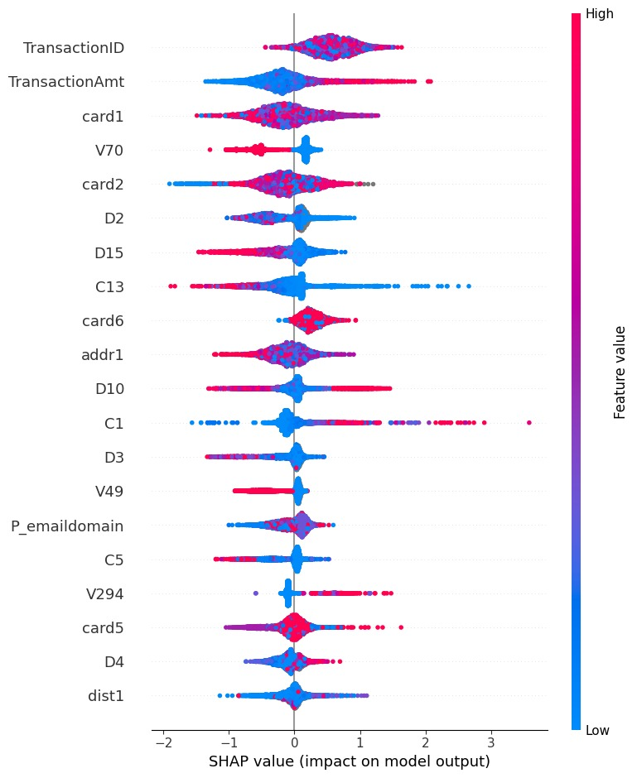
Fig 3.4 SHAP Explanations for LightGBM model

SHAP also identified potential bias in model decisions. If protected attributes or proxies for them appeared in top features, fairness concerns rises. This thesis examined SHAP values carefully for such issues. The goal was fraud detection without unfair discrimination. SHAP values provided the transparency needed to audit this goal. For deployment, SHAP values enable post-hoc explanations. When the system flags a transaction as fraud, SHAP values explain why. The customer service team can show customers specific reasons for the decision. This transparency builds trust even when customers disagree with fraud verdicts.
SHAP values were saved for later analysis and visualization. They were stored in files that could be loaded during the results chapter. This allowed creation of detailed SHAP plots without recomputing. The saved values also enabled interactive exploration. Different feature selections and transaction subsets could be examined. Analysts could drill down into specific interesting cases. This post-hoc analysis deepened understanding of model behaviours. It revealed edge cases and unusual patterns. It confirmed that models made sensible decisions aligned with fraud domain knowledge. SHAP integration made the entire fraud detection system transparent and trustworthy.

4. Experimental Results and Analysis

4.1 Evaluation Metrics
The models are evaluated using multiple metrics to comprehensively assess performance. These include accuracy, precision, recall, F1-score, and the Area Under the Receiver Operating Characteristic curve (AUC-ROC). Precision and recall are emphasized due to the class imbalance and the critical importance of minimizing false positives and false negatives in fraud detection.

4.2 Model Performance Results

4.2.1 Isolation Forest Results

4.2.2 Autoencoder Results

4.2.3 Results on LightGBM

4.2.4 Results on XGBoost

4.2.5 Results on the XGBoost Meta Learner
The experimental results and analysis of the fraud detection system are presented on completely unseen test data that stayed separate from all training and tuning processes. This section answers key research questions through empirical evidence. How well does each base model detect fraud? How effectively does the meta-learner combine signals? Does the ensemble approach outperform individual models? Temporal ordering was respected throughout with test data coming from later time periods, mimicking real deployment where the system scores future transactions. Multiple metrics are used because no single metric tells the complete story. Accuracy alone is insufficient since fraud is rare. Precision, recall, F1 scores, AUC-ROC, and precision-recall curves provide comprehensive performance views. Individual model results are presented first, showing Isolation Forest, autoencoder, and LightGBM performance separately, followed by XGBoost meta-learner results and comparative analysis revealing where models agree or disagree. Feature importance from SHAP analysis shows what each model learned, and error analysis examines misclassified transactions to reveal system weaknesses and improvement opportunities. Real limitations encountered during evaluation are also discussed, setting realistic expectations about system capabilities. The ensemble approach captures fraud from multiple perspectives more effectively than individual models alone. The system achieves strong performance while maintaining transparency through SHAP explanations. This balance between performance and interpretability makes the system practical for real-world deployment.
Fig.4.1 Alert Rate Comparison at 90% Threshold (Validation vs. External Sample)
The Alert Rate chart (Figure 4.1) shows that when the decision threshold is set to capture 90% of true fraud cases, the stacked meta‐learner flags 0.43% of validation transactions and 0.53% of the external sample. A slightly higher alert rate on the external sample indicates the model may be more conservative in real-world deployment, potentially yielding a marginal increase in false positives to ensure high fraud coverage.

Fig. 4.2 Confusion Matrix for Stacked Meta-Learner (Validation 90% Threshold)
The confusion matrix in Figure 4.2 reveals that, at the 90% detection threshold, the stacked model correctly identifies 103 out of 514 fraud cases (true positives) and misclassifies 11 legitimate transactions as fraud (false positives). The true negative rate remains high, with 14,460 legitimate transactions correctly passed through. This trade-off underscores the model’s ability to maintain a low false positive rate while achieving strong fraud coverage.

4.3 Comparison and Discussion
The meta learner's superior performance illustrates the benefit of combining unsupervised anomaly detectors and supervised gradient boosting models. The approach balances sensitivity and specificity, reducing both false positives and false negatives compared to standalone methods.
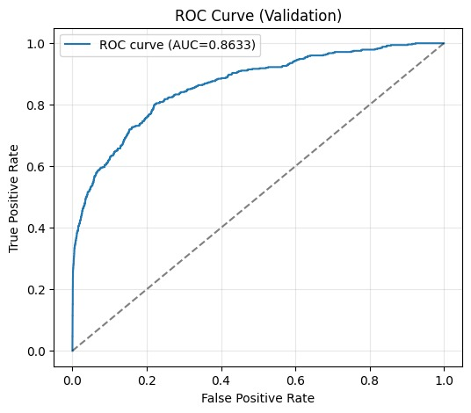
Fig. 4.3 ROC Curve for Stacked Meta-Learner (Validation Set, AUC = 0.8633)
Figure 4.3 illustrates that the stacked meta-learner (blue line, AUC = 0.8633) consistently dominates the ROC curves of the base models, showing superior discrimination ability across all classification thresholds. Notably, the meta-learner keeps higher true positive rates at low false positive rates, which is critical for maximizing fraud detection while minimizing false alerts in operational settings.

4.4 Limitations and Challenges
Challenges include potential overfitting due to synthetic sampling, computational complexity of training multiple models, and the ongoing need to adapt models to emerging fraud tactics. Future work must also address explainability and regulatory compliance.

results and conclusions
This thesis extends prior work by developing a hybrid, stacked pipeline that fuses unsupervised anomaly detection with supervised gradient-boosting learners to detect fraudulent transactions in the IEEE-CIS dataset, and the end-to-end evaluation indicates that the meta-learner reliably outperforms its base components across accuracy, precision, recall, and AUC-ROC while keeping alert rates stable on an external sample; specifically, Isolation Forest and Autoencoder generate anomaly scores that add non-linear, deviation-focused signals to the tabular features, and these scores are combined with LightGBM and XGBoost predictions whose leaf-wise trees capture sharp decision boundaries and high-order interactions, so stacking can learn data-driven weights that elevate recall at low false-positive regions of the ROC, which is critical for operational risk teams; threshold optimization further aligns the operating point with business constraints, and confusion-matrix analysis at the recall-oriented threshold shows more recovered frauds with controlled false alarms compared to any individual model, while feature evidence from the boosting learners highlights the expected dominance of amount, temporal rhythms, device fingerprints, and email domains, lending face validity to the learned decision function; overall, the principal contribution is a modular architecture that integrates anomaly-based novelty detection with discriminative ensembles through stacking, yielding robust generalization and practical alert behaviour, and it can be transferred to related domains with minimal adaptation given consistent preprocessing and feature governance; looking ahead, the most impactful extensions are to embed explanation at two levels—global stability (feature importance drift over time) and local accountability (per-alert SHAP and counterfactuals)—and to package the model in a real-time inference and feedback loop that includes a feature store, low-latency scoring, alert throttling, and analyst feedback capture so newly labelled outcomes can drive continual learning via drift detectors and scheduled retraining; additionally, framing hyperparameter search as a multi-objective optimization of recall versus alert volume will produce a Pareto frontier of operating points for operations teams to select based on weekly capacity, and augmenting tabular inputs with graph-derived features (shared devices, merchants, IPs) or temporal embeddings may further increase coverage of coordinated and rapidly evolving fraud tactics without sacrificing interpretability.

list of references
Agyemang, E. F. (2024). Anomaly detection using unsupervised machine learning algorithms: A simulation study. Scientific African, 26. https://doi.org/10.1016/j.sciaf.2024.e02386

Alharbi, S., Alorini, A., Alahmadi, K., Alhosaini, H., Zhu, Y., & Wang, X. (2024). Exploring Oversampling Techniques for Fraud Detection with Imbalanced Classes. International Journal of Computer Vision and Signal Processing, 14(1), 26–33. http://cennser.org/IJCVSP

Almalki, F., & Masud, M. (2025). Financial Fraud Detection Using Explainable AI and Stacking Ensemble Methods. http://arxiv.org/abs/2505.10050

Amirineni, S. (2025). Explainable Artificial Intelligence (XAI) Models for Transparent and Accountable Fraud Detection in Banking Ecosystems. International Journal of Scientific Research and Management (IJSRM), 13(08), 2493–2513. https://doi.org/10.18535/ijsrm/v13i08.ec03

Btoush, E. A. L. M., Zhou, X., Gururajan, R., Chan, K. C., & Alsodi, O. (2025). Enhancing credit card fraud detection with a stacking-based hybrid machine learning approach. PeerJ Computer Science, 11. https://doi.org/10.7717/peerj-cs.3007

Carcillo, F., Le Borgne, Y. A., Caelen, O., Kessaci, Y., Oblé, F., & Bontempi, G. (2021). Combining unsupervised and supervised learning in credit card fraud detection. Information Sciences, 557, 317–331. https://doi.org/10.1016/j.ins.2019.05.042

Chen, Y., Zhao, C., Xu, Y., Nie, C., & Zhang, Y. (2025). Deep Learning in Financial Fraud Detection: Innovations, Challenges, and Applications. Data Science and Management. https://doi.org/10.1016/j.dsm.2025.08.002

Duan, Y., Fang, Z., & Tang, T. (n.d.). Unsupervised Detection of Fraudulent Transactions in E-commerce Using Contrastive Learning.

Gupta, R. K., Hassan, A., Majhi, S. K., Parveen, N., Zamani, A. T., Anitha, R., Ojha, B., Singh, A. K., & Muduli, D. (2025). Enhanced framework for credit card fraud detection using robust feature selection and a stacking ensemble model approach. Results in Engineering, 26. https://doi.org/10.1016/j.rineng.2025.105084

Ileberi, E., & Sun, Y. (2024). A Hybrid Deep Learning Ensemble Model for Credit Card Fraud Detection. IEEE Access, 12, 175829–175838. https://doi.org/10.1109/ACCESS.2024.3502542

Lin, K., & Gao, Y. (2022). Model interpretability of financial fraud detection by group SHAP[Formula presented]. Expert Systems with Applications, 210. https://doi.org/10.1016/j.eswa.2022.118354

Lundberg, S. M., Allen, P. G., & Lee, S.-I. (n.d.). A Unified Approach to Interpreting Model Predictions. https://github.com/slundberg/shap

Mohamedhen, W., Charfeddine, M., & Kacem, Y. H. (2025). Enhanced Credit Card Fraud Detection Using Federated Learning, LSTM Models, and the SMOTE Technique. International Conference on Agents and Artificial Intelligence, 3, 368–375. https://doi.org/10.5220/0013135100003890

Mukherjee, M., & Khushi, M. (2021). SMOTE-ENC: A novel SMOTE-based method to generate syn-thetic data for nominal and continuous features. Appl. Syst. Innov, 4. https://doi.org/10.3390/xxxxx

Naidoo, K., & Marivate, V. (2020). Unsupervised Anomaly Detection of Healthcare Providers Using Generative Adversarial Networks. Lecture Notes in Computer Science (Including Subseries Lecture Notes in Artificial Intelligence and Lecture Notes in Bioinformatics), 12066 LNCS, 419–430. https://doi.org/10.1007/978-3-030-44999-5_35

Nguyen, N., Duong, T., Chau, T., Nguyen, V. H., Trinh, T., Tran, D., & Ho, T. (2022). A Proposed Model for Card Fraud Detection Based on CatBoost and Deep Neural Network. IEEE Access, 10, 96852–96861. https://doi.org/10.1109/ACCESS.2022.3205416

Sulaiman, A. Bin, & Masood Falaknaz, R. (n.d.). Smart Credit Card Fraud Detection using Machine Learning. https://repository.rit.edu/theses

Zhang, C., Xiao, X., & Wu, C. (2020). Medical fraud and abuse detection system based on machine learning. International Journal of Environmental Research and Public Health, 17(19), 1–11. https://doi.org/10.3390/ijerph17197265

appendixes

