**ASSIGNMENT - HARDWARE TASK**

**TASK OVERVIEW:**

The purpose of this task is to identify and select the most suitable hardware components that meet the given technical requirements for a DC Motor Driver IC and a Linear DC Voltage Regulator IC. The selection process involves researching available options from various industrial component vendors and manufacturers, carefully reviewing datasheets, and justifying the choice based on performance, reliability, and compatibility with the project specifications. Additionally, the task requires listing alternative components in case the primary choice is unavailable, along with providing purchase links and datasheets. Special attention will be given to any additional components (such as diodes, capacitors, resistors, or heatsinks) needed to ensure the proper functioning of the selected ICs.

**1. HARDWARE COMPONENTS FOR THE MOTOR DRIVE IC FOR DC MOTOR**

**1.1 Hardware Requirements Summary**

* **Motor Driver IC for DC Motor**
  + Operating Voltage: 5 V – 12 V
  + Stall Current: 6 A
  + Start/Stop Current Spikes: Up to 8 A
  + Control Method: PWM signal for speed control
  + Rotation Direction: Both clockwise and anti-clockwise

**1.2 Requirements**

* **Operating Voltage Range:** 5 V – 12 V
* **Stall Current Handling Capacity:** Minimum 6 A
* **Start/Stop Current Spike Tolerance:** Up to 8 A
* **Speed Control Method:** Compatible with PWM signal input
* **Direction Control:** Support for both clockwise and anti-clockwise rotation
* **Type:** Dedicated Motor Driver IC (no readymade development boards)
* **Additional Considerations:**
  + Thermal protection and overcurrent protection preferred
  + Low on-resistance for reduced heat dissipation
  + Support for external heatsink if required
  + Supporting components such as flyback diodes, capacitors, and resistors to ensure safe operation

**1.3 Motor Driver IC – Main Choice**

* **IC Model:** Texas Instruments DRV8262
* **Product page (TI):** [**https://www.ti.com/product/DRV8262**](https://www.ti.com/product/DRV8262)
* **Datasheet:** [**https://www.ti.com/lit/ds/symlink/drv8262.pdf**](https://www.ti.com/lit/ds/symlink/drv8262.pdf) **(drv8262.pdf)**
* **Main Features:** Works with 4.5–40 V, can handle 10 A continuously and up to 16 A in short peaks, full H-Bridge for both directions, supports PWM speed control.
* **Reason for Choosing:** High current handling, wide voltage range, built-in protection, and easy control for forward/reverse motion.

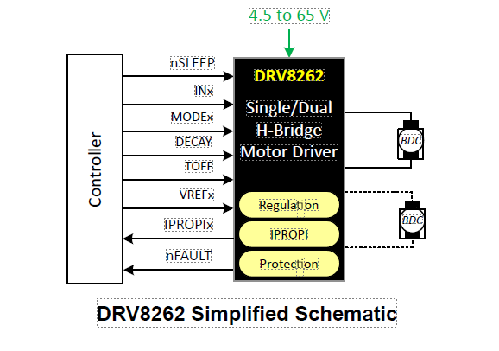**1.4 DRV8262 Simplified Schematic**

**1.5 Pin Configuration And Functions**

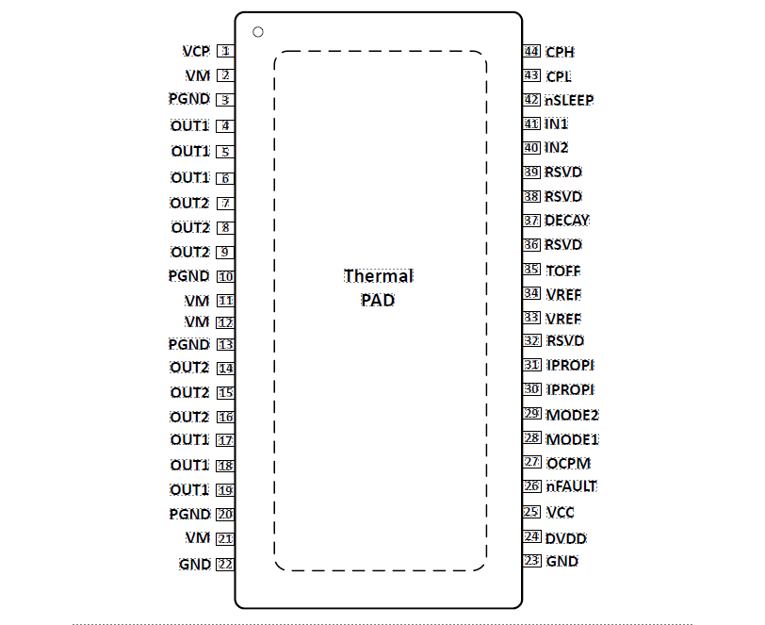

**1.6 Why DRV8262?**

* Current rating (up to 16A peak): comfortably exceeds the requirement.
* Voltage rating (8V–60V): fits the 5–12V range.
* Integrated H-bridge: supports directional change and PWM—ideal for speed and direction control.
* Advanced protections: overtemp, overcurrent, undervoltage, etc.

**1.7 FEATURE**

* Can work as a **single or dual H-bridge motor driver**.
* Can drive:
  + One or two brushed DC motors
  + One stepper motor
  + One or two thermoelectric coolers (TEC)
* Works with **4.5 V to 60 V** power supply.
* Low heat loss in switches (low RDS(on)):
  + 100 mΩ in dual H-bridge mode
  + 50 mΩ in single H-bridge mode
* Supports different control methods:
  + Phase/Enable (PH/EN)
  + PWM input (IN/IN)
* Built-in current sensing and control:
  + Measures current in high-side switches
  + Gives current sense output (IPROPI) for each H-bridge
  + ±4% accuracy at max current
* Separate voltage supply for control logic (VCC).
* Adjustable PWM chopping off-time: 7, 16, 24, or 32 µs.
* Programmable fault recovery.
* Works with 1.8 V, 3.3 V, and 5.0 V control signals.
* Very low sleep mode current (3 µA).
* Built-in safety protections:
  + Low voltage lockout
  + Charge pump undervoltage
  + Overcurrent protection
  + Over-temperature shutdown
  + Fault output pin (nFAULT)

**1.8 APPLICATIONS OF DRV8262**

* Brushed DC motor control
* Factory automation, stepper motors, and robots
* Medical machines and diagnostic equipment
* ATMs, currency counters, and point-of-sale machines
* Thermoelectric cooler (TEC) drivers

**1.9 Alternatives If Drv8262 Is Unavailable**

* Infineon MOTIX™-family H-bridge drivers, e.g. BTN8982TA ([Infineon brushed DC motor solutions page](https://www.infineon.com/products/power/motor-control-ics/brushed-dc)). Some models support >10A (datasheet on the Infineon site).
* Monolithic Power Systems MP8937 or similar high-current brushed DC motor drivers.

**2. HARDWARE COMPONENT FOR THE LINEAR DC VOLTAGE REGULATOR IC**

**2.1 Hardware Requirements Summary**

Linear DC Voltage Regulator IC

* Input Voltage: 5 V – 12 V
* Output Voltage: Fixed 3.3 V
* Max Output Current: 2 A
* Line Regulation: Less than 0.6%
* Load Regulation: Less than 0.6%
* Type: Bare IC only, no ready-made modules
* Extra Needs: Input and output capacitors, protection diode (if needed), heatsink or copper PCB area for cooling

**2.2 Linear DC Voltage Regulator IC** **Requirements:**

Linear DC Voltage Regulator IC

* **Input Voltage:** 5 V – 12 V
* **Output Voltage:** Fixed 3.3 V
* **Max Output Current:** 2 A
* **Line Regulation:** Less than 0.6%
* **Load Regulation:** Less than 0.6%
* **Type:** Bare IC only, no ready-made modules
* **Extra Needs:** Input and output capacitors, protection diode (if needed), heatsink or copper PCB area for cooling

**2.3 Linear DC Voltage Regulator IC – Main Choice**

* **IC Model:** Texas Instruments TPS7A47 (3.3 V version)
* **Main Features:**
  + Input voltage range: 3 V to 36 V
  + Fixed 3.3 V output voltage
  + Can supply up to 2 A output current
  + Very low noise output, suitable for sensitive electronics
  + Excellent line and load regulation (<0.6%)
  + Built-in thermal shutdown and short-circuit protection
* **Reason for Choosing:** Wide input range, high current capacity, low noise, and high stability make it reliable for industrial and precision applications.
* **Extra Parts Needed:** Input and output capacitors (as per datasheet), heatsink or copper PCB area for cooling when operating near full load.
* **Product page:** [**https://www.ti.com/product/TPS7A47**](https://www.ti.com/product/TPS7A47)
* **Datasheet:** [**https://www.ti.com/lit/ds/symlink/tps7a47.pdf**](https://www.ti.com/lit/ds/symlink/tps7a47.pdf) (TPS7A47.PDF)

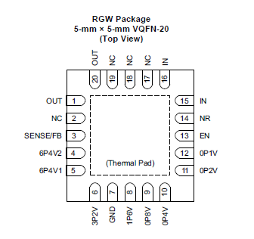**2.4 Pin Configuration and Functions**

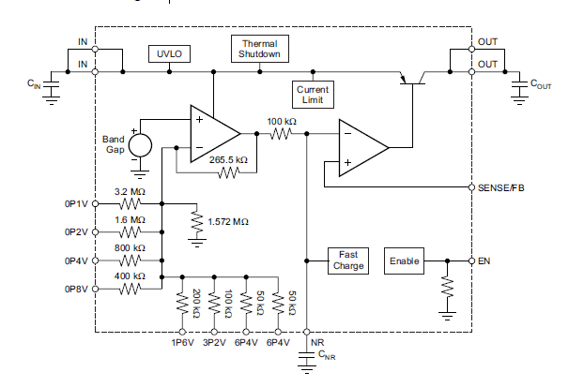**2.5 Functional Block Diagram**

**2.6 Why These Options?**

* Excellent regulation: Both meet stringent load/line regulation specs <0.6%.
* High current: Capable of handling 2A (continuous or with heat sinking).
* Industry standard, widely available.

**2.7 FEATURE**

TPS7A47 – Key Features

* Works with input voltage from 3 V to 36 V
* Very low output noise: 4 microvolts
* Excellent filtering of power supply ripple (up to 82 dB)
* Two output modes:
  + Fixed mode (set by PCB layout): 1.4 V to 20.5 V
  + Adjustable mode (TPS7A4701 only, with resistors): 1.4 V to 34 V
* Can supply up to 1 A of current
* Low dropout: needs only 0.3 V more than output to work at 1 A
* Has an enable pin to turn it on/off
* Built-in overcurrent protection and overheat shutdown
* Small package: 5 mm × 5 mm
* Works in temperatures from –40°C to +125°C

**2.8 APPLICATIONS OF TPS7A47**

* Voltage-Controlled Oscillators (VCOs)
* Frequency Synthesizers
* Test and Measurement Equipment
* Instrumentation, Medical, and Audio Devices
* RX (Receiver), TX (Transmitter), and PA (Power Amplifier) Circuits
* Supply Rails for:
  + Operational Amplifiers
  + DACs (Digital-to-Analog Converters)
  + ADCs (Analog-to-Digital Converters)
  + Other High-Precision Analog Circuits
* Post DC-DC Converter Regulation and Ripple Filtering
* Base Stations and Telecom Infrastructure
* +12 V and +24 V Industrial Bus Systems

**2.9 Alternative with Full 2A Capability:**TPS7A47**or**TPS7A3301**(Texas Instruments)**

* TPS7A47: 3.3V/2A, ultra-low noise, <0.01% line regulation, <0.05% load regulation.

**3. ADDITIONAL COMPONENTS REQUIRED**

**3.1 For Motor Driver**:

* Flyback diodes (Schottky type) if not integrated — VNH5019 already has internal freewheeling diodes.
* Decoupling capacitors: 100 nF (ceramic) + 470 µF (electrolytic) on supply pins.
* Heatsink or PCB copper pour for thermal dissipation under high load.

**3.2 For Voltage Regulator**:

* Input/output capacitors as per datasheet (typically 10 µF low ESR ceramic).
* Adequate heatsinking if operating close to 2 A.

**4. SOMETHING SPECIAL ABOUT MY SOLUTION**

I chose parts that can handle much more than the required specs so they’ll last longer and work reliably, even in tough conditions. Both parts already have built-in protection like over-current and overheating shutdown, which makes the circuit safer and easier to build. I also suggested backup options, so if the main part isn’t available, we can still move forward without delays.