**NAME: PULLETIGURTHI DINESH**

**EMAIL:** [**pulletigurthidinesh@gmail.com**](mailto:pulletigurthidinesh@gmail.com)

**SPECIFICATION:**

**BOARD: Aritx-7 AC701**

**Question 1: Design a digital system which accepts parallel data packets and transmits them serially over a UART-like interface. The digital logic design of the system shall include the RTL development of the following modules.**

**a) Design VHDL/Verilog RTL code for the modules.**

module uart_packetizer_top (

input wire clk,

input wire rst,

input wire wr_clk,

input wire rd_clk,

input wire [7:0] data_in,

input wire data_valid,

output wire serial_out,

output wire fifo_full,

output wire tx_busy

);

wire [7:0] fifo_data;

wire fifo_empty, fifo_rd_en, tx_start, tx_ready;

wire [9:0] tx_packet;

async_fifo fifo_inst (

.wr_clk(wr_clk),

.rd_clk(rd_clk),

.rst(rst),

.wr_en(data_valid),

.rd_en(fifo_rd_en),

.din(data_in),a

.dout(fifo_data),

.fifo_full(fifo_full),

.fifo_empty(fifo_empty),

.data_out_valid()

);

packetizer_fsm fsm_inst (

.clk(clk),

.rst(rst),

.tx_ready(tx_ready),

.fifo_empty(fifo_empty),

.fifo_data(fifo_data),

.fifo_rd_en(fifo_rd_en),

.tx_start(tx_start),

.tx_packet(tx_packet),

.tx_busy(tx_busy)

);

uart_serializer uart_inst (

.clk(clk),

.rst(rst),

.tx_start(tx_start),

.tx_packet(tx_packet),

.serial_out(serial_out),

.tx_ready(tx_ready)

);

endmodule

module uart_serializer (

input wire clk,

input wire rst,

input wire tx_start,

input wire [9:0] tx_packet,

output reg serial_out,

output reg tx_ready

);

reg [3:0] bit_count;

reg [9:0] shift_reg;

reg sending;

always @(posedge clk or posedge rst) begin

if (rst) begin

serial_out <= 1;

tx_ready <= 1;

bit_count <= 0;

shift_reg <= 0;

sending <= 0;

end else begin

if (tx_start && ~sending) begin

sending <= 1;

tx_ready <= 0;

shift_reg <= tx_packet;

bit_count <= 0;

end else if (sending) begin

serial_out <= shift_reg[0];

shift_reg <= shift_reg >> 1;

bit_count <= bit_count + 1;

if (bit_count == 9) begin

sending <= 0;

tx_ready <= 1;

serial_out <= 1;

end

end

end

end

endmodule

module packetizer_fsm (

input wire clk,

input wire rst,

input wire tx_ready,

input wire fifo_empty,

input wire [7:0] fifo_data,

output reg fifo_rd_en,

output reg tx_start,

output reg [9:0] tx_packet,

output reg tx_busy

);

reg [1:0] state;

parameter IDLE = 2'b00,

READ_FIFO = 2'b01,

LOAD_PACKET = 2'b10,

TRANSMIT = 2'b11;

always @(posedge clk) begin

if (rst) begin

state <= IDLE;

fifo_rd_en <= 0;

tx_start <= 0;

tx_packet <= 10'b0;

tx_busy <= 0;

end else begin

fifo_rd_en <= 0;

tx_start <= 0;

case (state)

IDLE: begin

tx_busy <= 0;

if (~fifo_empty && tx_ready)

state <= READ_FIFO;

end

READ_FIFO: begin

fifo_rd_en <= 1;

state <= LOAD_PACKET;

end

LOAD_PACKET: begin

tx_packet <= {1'b1, fifo_data, 1'b0};

tx_start <= 1;

tx_busy <= 1;

state <= TRANSMIT;

end

TRANSMIT: begin

tx_busy <= 1;

if (~tx_ready)

state <= IDLE;

end

endcase

end

end

endmodule

module async_fifo (

input wire wr_clk,

input wire rd_clk,

input wire rst,

input wire wr_en,

input wire rd_en,

input wire [7:0] din,

output reg [7:0] dout,

output wire fifo_full,

output wire fifo_empty,

output wire data_out_valid

);

reg [7:0] mem [15:0];

reg [3:0] wr_ptr = 0;

reg [3:0] rd_ptr = 0;

reg [4:0] count = 0;

assign fifo_full = (count == 16);

assign fifo_empty = (count == 0);

assign data_out_valid = ~fifo_empty;

always @(posedge wr_clk) begin

if (rst) begin

wr_ptr <= 0;

count <= 0;

end else if (wr_en && ~fifo_full) begin

mem[wr_ptr] <= din;

wr_ptr <= wr_ptr + 1;

count <= count + 1;

end

end

always @(posedge rd_clk) begin

if (rst) begin

rd_ptr <= 0;

end else if (rd_en && ~fifo_empty) begin

dout <= mem[rd_ptr];

rd_ptr <= rd_ptr + 1;

count <= count - 1;

end

end

endmodule

**b) Develop a simulation testbench and provide the following results.**

**1. FIFO write and read.**

**2. Serial output waveform along with fifo_full and tx_busy**

**signals.**

**3. At least 2 valid packets with proper framing.**

**4. FSM state transitions.**

`timescale 1ns / 1ps

module tb_uart_packetizer;

reg clk;

reg wr_clk;

reg rd_clk;

reg rst;

reg [7:0] data_in;

reg data_valid;

wire serial_out;

wire fifo_full;

wire tx_busy;

uart_packetizer_top uut (

.clk(clk),

.rst(rst),

.wr_clk(wr_clk),

.rd_clk(rd_clk),

.data_in(data_in),

.data_valid(data_valid),

.serial_out(serial_out),

.fifo_full(fifo_full),

.tx_busy(tx_busy)

);

always #10 clk = ~clk;

always #15 wr_clk = ~wr_clk;

always #20 rd_clk = ~rd_clk;

initial begin

clk = 0;

wr_clk = 0;

rd_clk = 0;

rst = 1;

data_in = 8'b00000000;

data_valid = 0;

#50;

rst = 0;

#50;

send_data(8'hA5);

#200;

send_data(8'h3C);

#1000;

$finish;

end

task send_data(input [7:0] byte);

begin

@(posedge wr_clk);

data_in = byte;

data_valid = 1;

@(posedge wr_clk);

data_valid = 0;

end

endtask

endmodule

**c) Generate documentation with following details**

**1. FSM state diagram along with state transitions.**

**2. FIFO usage explanation.**

**3. Rational for synchronous/asynchronous FIFO**

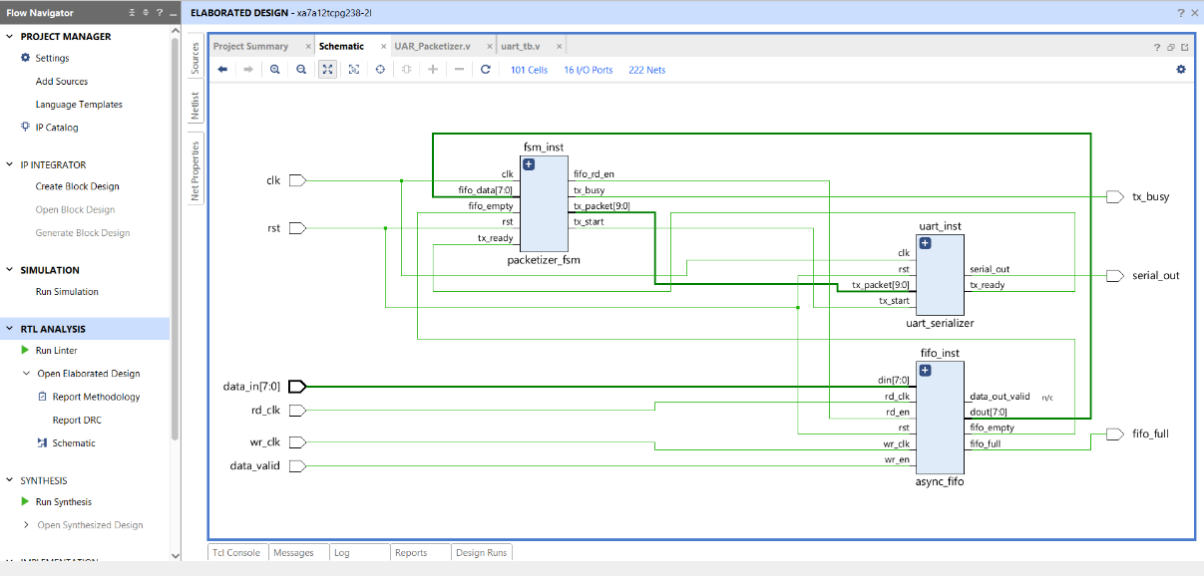FIFO stands for first in first out whenever any element or data store in a array or Queue which element is first in it goes first just like the order wise when it comes to the RTL code with the help of FSM RTL code is designed with the help of the HDL language like Verilog by understanding the UART protocol and FSM design process final schematic is generated.

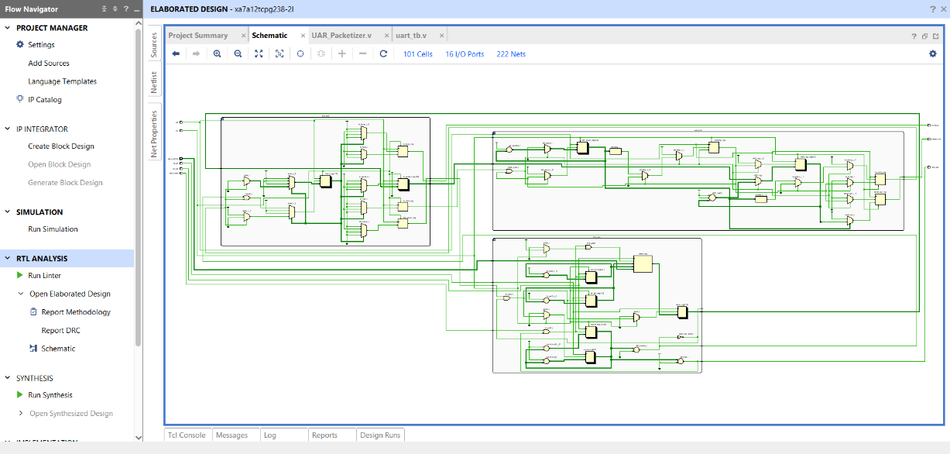

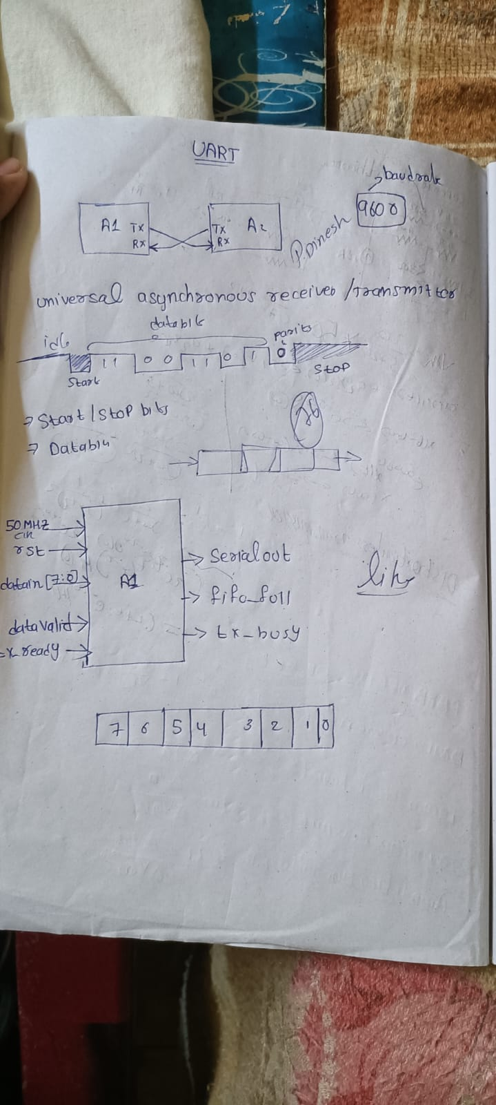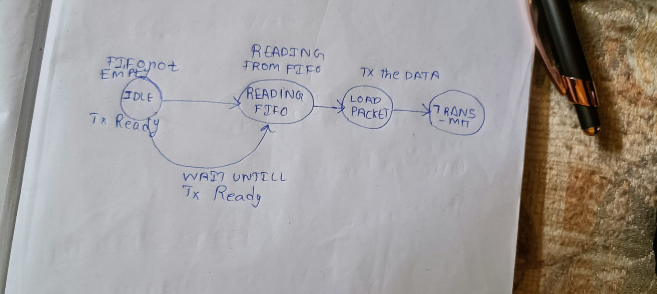

**Question 2**

**a) Carry out synthesis, place and route on AMD-Xillinx Vivado tool with a target FPGAfrom chosen from Kintex/Virtex family of FPGAs?**

**b) Provide the synthesis and timing reports generated by AMD-Xillinx Vivado tool.**

**c) Report the resource utilization and achieved maximum operating clock frequencyat Synthesis level and post-place and route level?**

**d) Describe the encoding technique is used in the FSM implementation. Provide a tool generated report indicating the type of encoding technique used for FSM implementation.**

