Atomix: An AI-Assisted, Quantity-Aware Virtual Chemistry Laboratory for VR and Desktop Learning
Kushal D. Soni  Dept. of Computer Engineering  K. J. Somaiya Institute of Technology  Mumbai, India  kushal.soni@somaiya.edu | Dhir M. Thakar  Dept. of Computer Engineering  K. J. Somaiya Institute of Technology  Mumbai, India  dhir.thakar@somaiya.edu | Kartik R. Verma  Dept. of Computer Engineering  K. J. Somaiya Institute of Technology  Mumbai, India  kartik.verma@somaiya.edu | Dr. Madhura Phadke  Dept. of Computer Engineering  K. J. Somaiya Institute of Technology  Mumbai, India  madhura.phadke@somaiya.edu

Abstract—Students learn chemistry by linking what they see in a laboratory to molecular events and symbolic equations, yet they get little safe, repeatable practice and rarely receive specific explanations of their mistakes. Virtual laboratories, immersive VR, game-based learning and AI chatbots each address part of this problem but are usually used in isolation, judge experiments as fixed click sequences, and offer help that is unaware of the learner's actions. We present Atomix, a Unity 6 virtual chemistry laboratory that runs on Meta Quest/OpenXR headsets and, through a run-time-injected keyboard-and-mouse mode, on ordinary Windows PCs. A data-driven free-hand reaction engine judges eight inorganic experiments by order of addition, instant overdose, underdose after a 1.5 s settling period and heating procedure, with per-reaction tolerances of 5-15 % scaled by three difficulty levels, and rates each success with a minimum-reagent accuracy score and stars. Live 3D molecular animations, a context-aware AI assistant with a grounded offline fallback, a 300-attempt history, thermodynamic graphs and a randomized 18-task assessment with a coin economy complete the learning cycle. The prototype comprises 110 C# scripts (39,601 lines), compiles without errors and passed 111/111, 167/167, 226/226 and 22/22 automated checks executed on the shipped logic.
Keywords—virtual chemistry laboratory, virtual reality, conversational AI, game-based learning, Unity, educational technology
I. Introduction
Chemistry is understood at three linked levels: the macroscopic change seen in the test tube, the sub-microscopic world of atoms and bonds, and the symbolic level of formulas and equations [9]. Learners find the transitions between these levels difficult because the molecular level is never directly observed [10]. Practical laboratory time is also constrained by reagent cost, apparatus, supervision and safety: reactions such as sodium or potassium with water cannot be practised freely by students.
Technology-enhanced learning has approached the problem from several directions. Virtual laboratories allow repetition and preparation [1], [12]; puzzle games and gamified activities raise motivation [2], [3], [11]; VR and immersive visualization make processes and molecules tangible [4], [5], [13]; and AI chatbots answer learners' questions in natural language [7], [14]. A randomized pilot study warns, however, that immersion must be judged by its effect on outcomes rather than assumed to help [6], and reviews of educational games stress structured evaluation [8].
Three gaps motivate this work. First, the strands above are rarely combined in one learning flow. Second, simulations typically trigger a reaction when the right objects touch, so they cannot judge how much reagent was used, in which order, or for how long a sample was heated, and therefore cannot explain realistic mistakes. Third, chatbots do not know what the learner has just done and become unavailable without internet access.
This paper presents Atomix, a virtual chemistry laboratory that integrates quantity-aware free-hand experimentation, molecular visualization, a context-aware AI assistant with an offline fallback, attempt history, thermodynamic analysis and randomized assessment, available both in VR and on a desktop. Our contributions are: (i) a reusable, data-driven reaction-evaluation engine with tolerance-based overdose, underdose, order and procedure checks and a settling rule; (ii) a minimum-reagent accuracy model for fair star ratings across difficulty levels; (iii) a dual-path assistant whose offline brain answers from live measurements; and (iv) an implementation verified by compilation and automated checks.
II. Related Work
Ramos et al. [1] argued that virtual laboratories are most valuable as complements that prepare students for hands-on work, and Ali and Ullah [12] found wide variation among virtual chemistry laboratories in realism, feedback and assessment. Agarwal and Saha [2] taught molecule formation through a puzzle game, Sanchez-Lopez et al. [3] gamified laboratory teaching, and Byusa et al. [11] concluded from a systematic review that game-based learning improves motivation and understanding when mechanics are tied to learning goals. Bell and Fogler [4] applied VR to chemical-engineering education, Luo et al. [5] built an immersive multi-projection molecular viewer, and Alvarez Ramirez and Bueno [13] applied VR to organic chemistry. Xie et al. [6] reported a randomized controlled pilot of immersive VR for science learning. Sandu and Gide [7] and Atmosukarto et al. [14] studied AI chatbots in higher education and in an online chemistry course. Gilbert and Treagust [9] and Wu et al. [10] ground the need for molecular visualization. None of these systems combines quantity-aware judging, molecular views, live-context AI and assessment across VR and desktop, which is the space Atomix occupies (Table VI).
III. System Design
A. Architecture
Atomix is built in Unity 6000.3.7f1 with the Built-in Render Pipeline and is organised into four scenes (main menu, practice laboratory, testing laboratory and assistant scene) and five layers (Fig. 1). The input layer uses the XR Interaction Toolkit on a headset; without one, DesktopBootstrap uses a run-time initialisation hook to inject a first-person controller, crosshair and ray-based grabbing into the same scenes, so no scene is duplicated. A typed-input gate lets learners type questions without the keyboard moving the player. The presentation layer holds the world-space Reaction Book, the learning panel and HUD; the simulation core holds eight reaction scripts and the shared engine; the intelligence layer holds the assistant, scoring and graphs; and the persistence layer stores history, coins and reports.
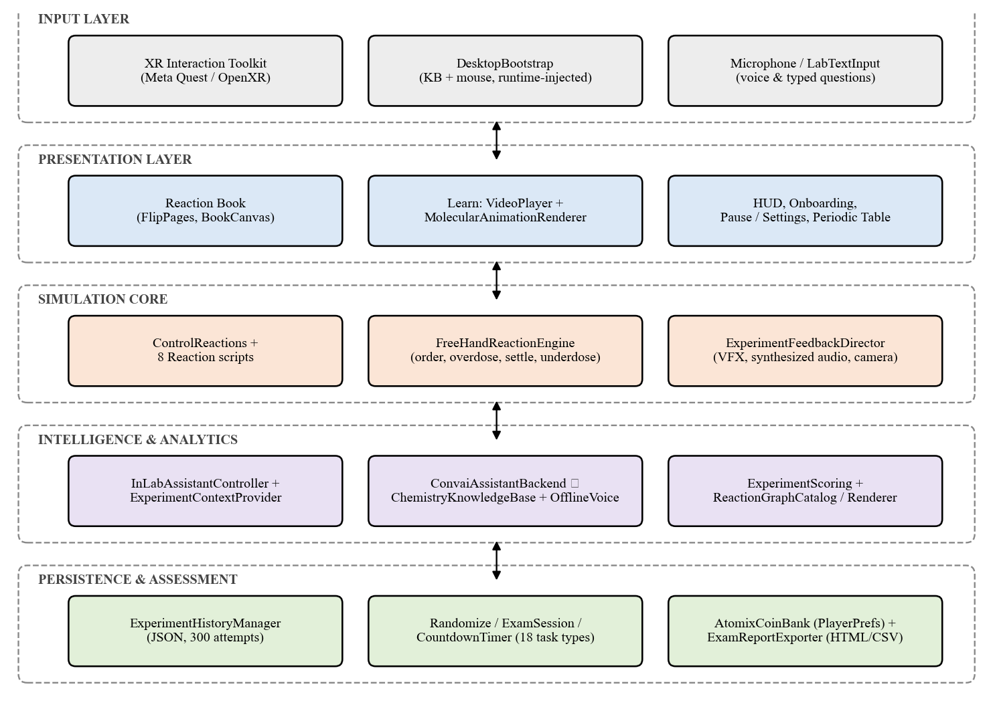
Fig. 1. Layered architecture of Atomix.
Fig. 2 shows the level-1 data flow. Input handling feeds reaction selection and the evaluation engine; the engine streams live context to the assistant and verdicts to history and scoring; the assessment process issues tasks to the same engine and stores coins and settings in PlayerPrefs, while attempts and assistant exchanges are written to a JSON history file.
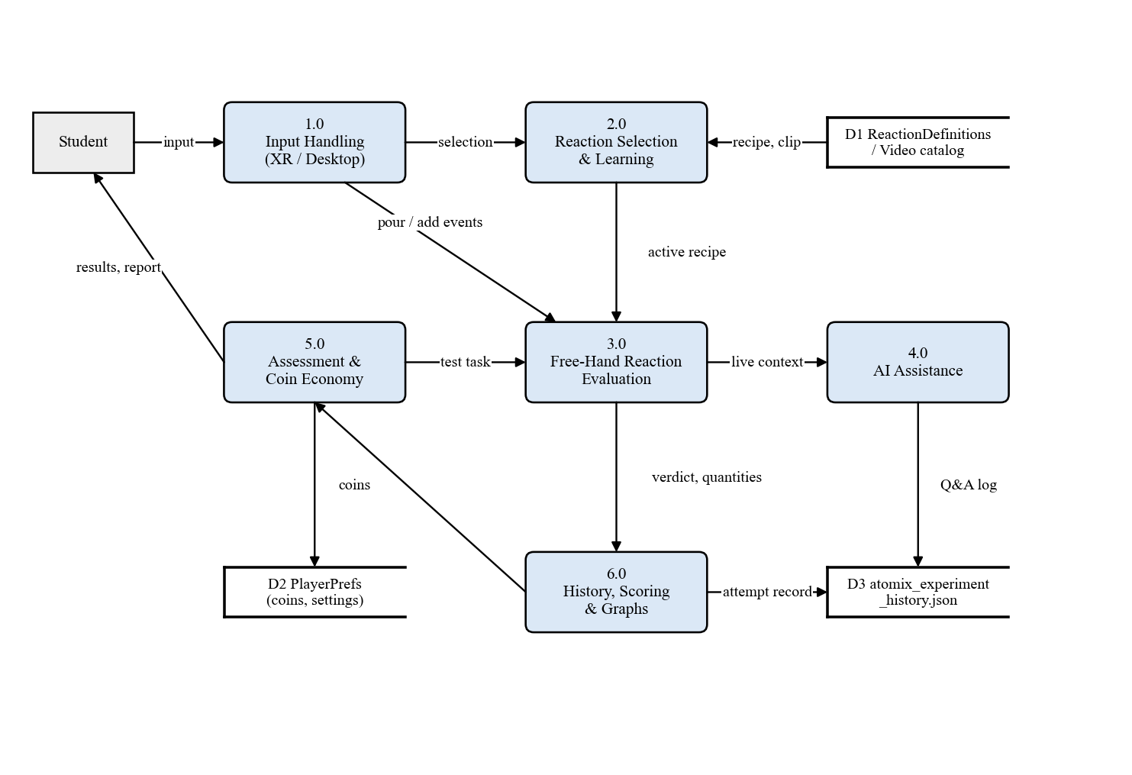
Fig. 2. Level-1 data-flow diagram of Atomix.
B. Learning Flow
As Fig. 3 summarises, a learner opens the Reaction Book, selects one of eight reactions and a difficulty level, and chooses LEARN or PERFORM. LEARN plays a recorded molecular video or a live 3D ball-and-stick animation authored in code for all eight reactions, in which a thinning red bond is breaking, a thickening green bond is forming and a moving yellow dot is an electron being transferred; only the redox reactions show electron transfer. PERFORM enables the apparatus of that reaction only (Fig. 4). The learner pours liquids by tilting vessels, adds solids and heats with a Bunsen burner while a tooltip shows live amounts. A success shows the balanced equation, accuracy and stars and unlocks graphs; a failure shows a chemistry-specific reason and can be retried with F5.
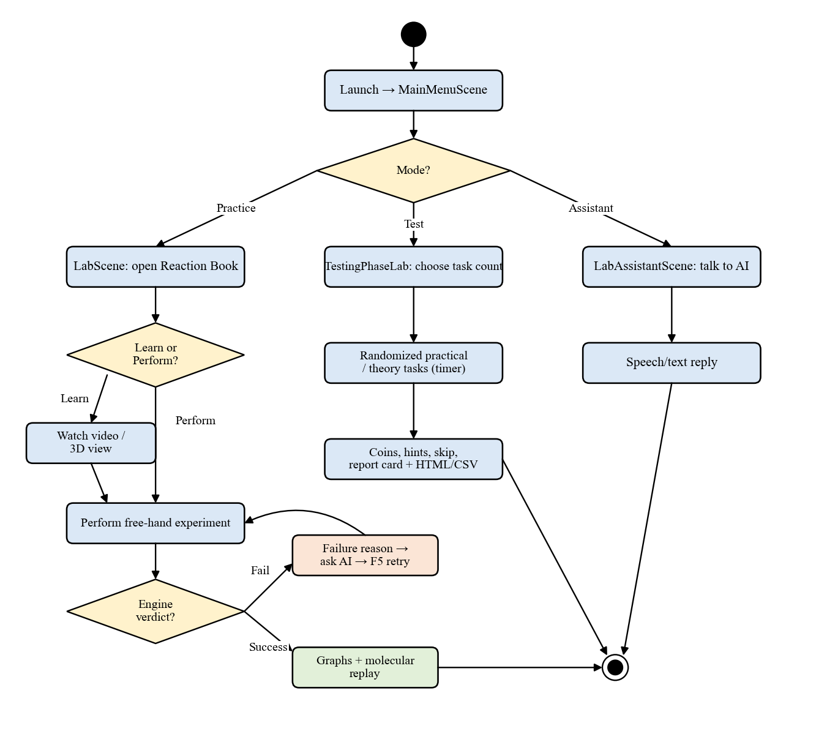
Fig. 3. Activity diagram of the practice, test and assistant journeys.
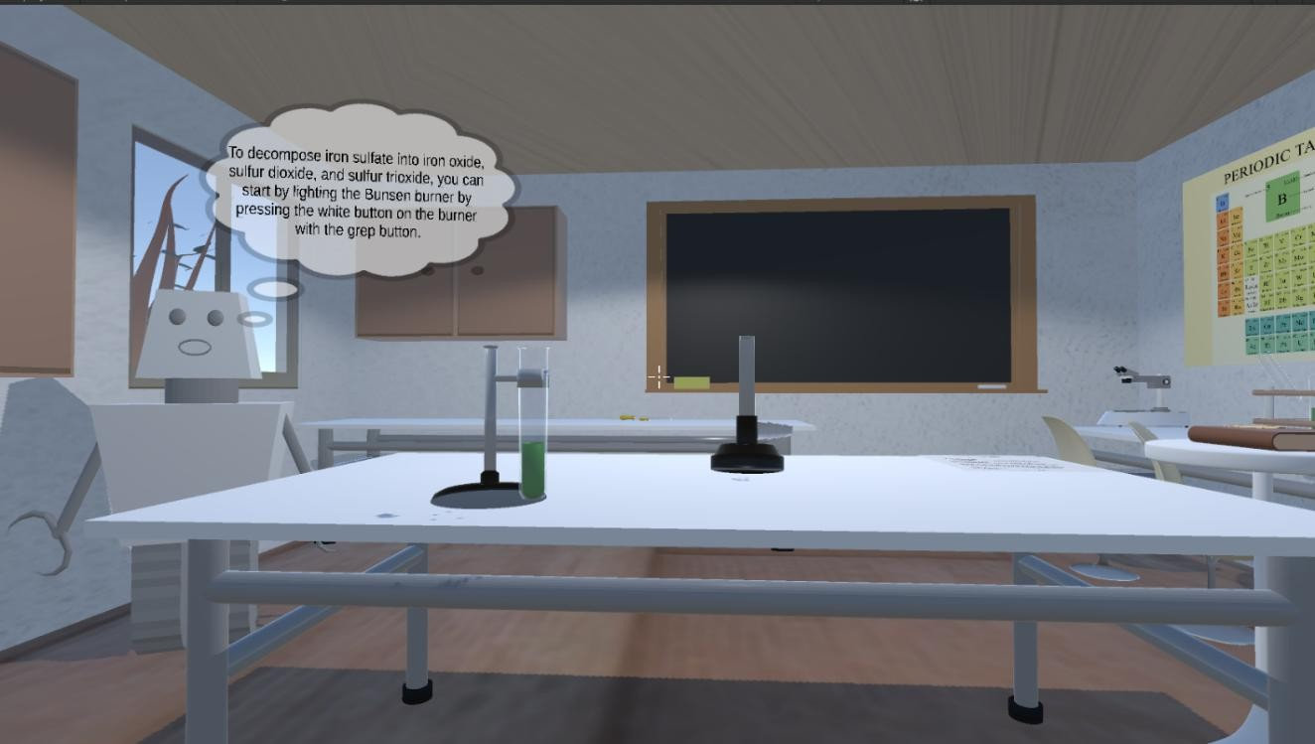
Fig. 4. The Atomix laboratory with the FeSO₄ decomposition set up; the assistant explains how to light the burner.
Fig. 5 shows the live molecular view. Atoms carry their element symbols in CPK colours, heating stages shake the molecule and warm the background, and a step counter and progress bar show the position in the sequence. The view is available before an experiment (learn-before-perform) and is replayed automatically after a success, so the macroscopic result is immediately tied to its sub-microscopic cause.
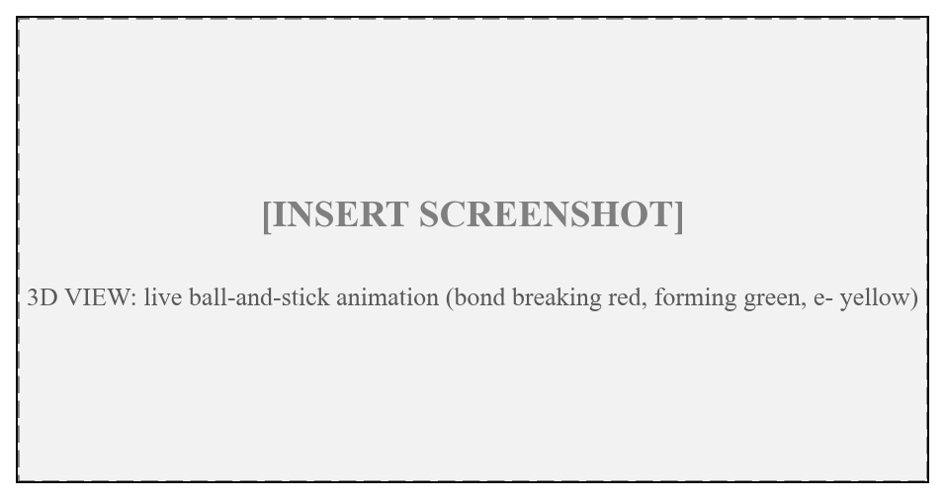
Fig. 5. Live 3D molecular animation for reaction 1 [INSERT SCREENSHOT from final build].
C. Implementation
Table I lists the principal modules. Reaction logic dominates the code base (Fig. 6) because each reaction has a laboratory script, a test-scene variant and pouring helpers. All interface and handling sounds are synthesised at run time from one D-major palette, so no audio assets are imported; grab sounds are pitched by object size and failure uses gentle falling tones because failure is the expected path while practising. Walking head-bob is off by default to avoid motion sickness, and held objects follow targets with the frame-rate-independent filter x ← x + (x_{t} − x)(1 − e^{−kΔt}), which replaced a Lerp that behaved differently at 60 Hz and 144 Hz. Scene changes load asynchronously, and reports fall back from the Desktop to Documents to the application data path.
TABLE I
Principal Modules
Module | Responsibility
ControlReactions, 8 reaction scripts | Selection, apparatus, effects
FreeHandReactionEngine (1,264 lines) | Order, overdose, settle, underdose
ReactionDefinition (8 assets) | Data-driven recipes
ExperimentScoring | Accuracy, stars, difficulty scale
InLabAssistantController, ContextProvider | Questions with live context
ConvaiAssistantBackend / ChemistryKnowledgeBase | Online / offline answers
MolecularSceneCatalog / Renderer | Live 3D molecular stages
ExperimentHistoryManager | JSON history (300 attempts)
ReactionGraphCatalog / Renderer | ΔH, E_{a}, ΔS, ΔG graphs
ExamSession, AtomixCoinBank, ReportExporter | Assessment, coins, HTML/CSV
DesktopBootstrap, FirstPersonController | Run-time desktop mode

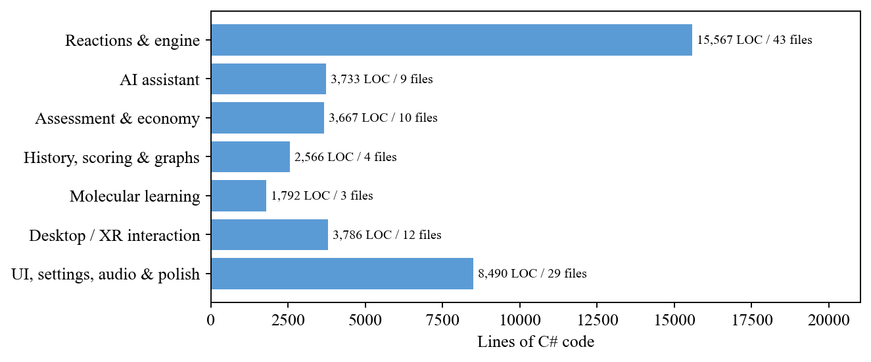
Fig. 6. Distribution of the 39,601 lines of C# across subsystems.
IV. Methodology
A. Data-Driven Recipes
Each reaction is described by a ScriptableObject recipe holding reagents, targets, units, a tolerance and an order rule (Table II). Tolerances are tight for the violent alkali-metal reactions and loose for hand-timed heating.
TABLE II
Shipped Reaction Recipes
# | Reaction | Targets (ordered) | τ
1 | 2Na+2H₂O→2NaOH+H₂ | H₂O 50 ml; Na 5 g | 5%
2 | H₂SO₄+CuO→CuSO₄+H₂O | H₂SO₄ 20 ml; CuO 8 g | 8%
3 | HCl+NaHCO₃→NaCl+H₂O+CO₂ | HCl 15 ml; NaHCO₃ 12 g | 10%
4 | 2K+2H₂O→2KOH+H₂ | H₂O 50 ml; K 3 g | 5%
5 | 2Al+3I₂→2AlI₃ | Al 5 g; I₂ 15 g; H₂O 2 ml | 10%
6 | CaO+H₂O→Ca(OH)₂ | H₂O 30 ml; CaO 15 g | 8%
7 | CaCO₃→CaO+CO₂ | Heat 10 s (balloon first) | 15%
8 | 2FeSO₄→Fe₂O₃+SO₂+SO₃ | Heat 10 s | 15%

B. Free-Hand Evaluation Engine
For reagent i with target T_{i}, tolerance τ_{i} and difficulty scale s (1.5 Guided, 1.0 Standard, 0.6 Expert) the accepted range is
q_{i} ∈ [ T_{i}(1 − sτ_{i}/100), T_{i}(1 + sτ_{i}/100) ] (1)
Liquid quantity is integrated from a tilt-dependent pour rate, solids increase in discrete additions and heating accumulates time over the flame. Every frame, the engine (i) fails with WrongOrder if a reagent precedes an earlier one; (ii) fails with Overdose the instant any q_{i} exceeds its upper bound, even mid-pour; (iii) returns InProgress while pouring or while any reagent is missing; (iv) otherwise accumulates a settle timer
t_{s} ← (t_{s} + Δt)·[A(t) ∧ ¬P(t)] (2)
where A is true when all reagents are present and P while any pour is active; (v) once t_{s} ≥ 1.5 s it fails with Underdose if any q_{i} is below range; (vi) checks procedure rules such as fitting the balloon before heating CaCO₃; and (vii) returns Success. Judging underdose only after settling prevents a learner who pauses between reagents from being failed unfairly. Fig. 7 shows the resulting state machine. The engine depends on Unity only through the frame time, so the same code judges the practice and the test scenes.
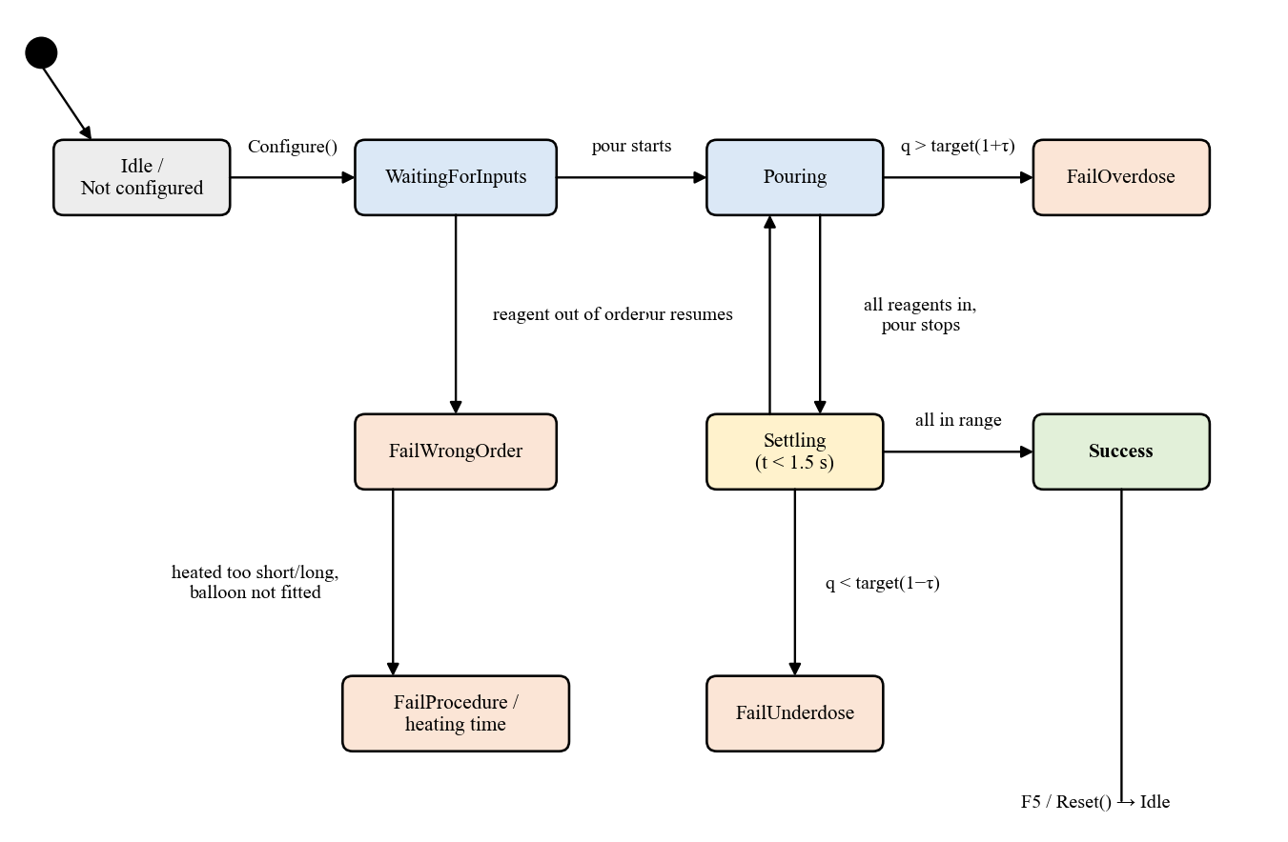
Fig. 7. State machine of the free-hand reaction engine.
Fig. 8 plots the resulting accepted deviation for every reagent at the three levels: the Guided level widens each window by half for a first attempt, and the Expert level, unlocked by passing Standard, narrows it to 60 % and hides the targets.
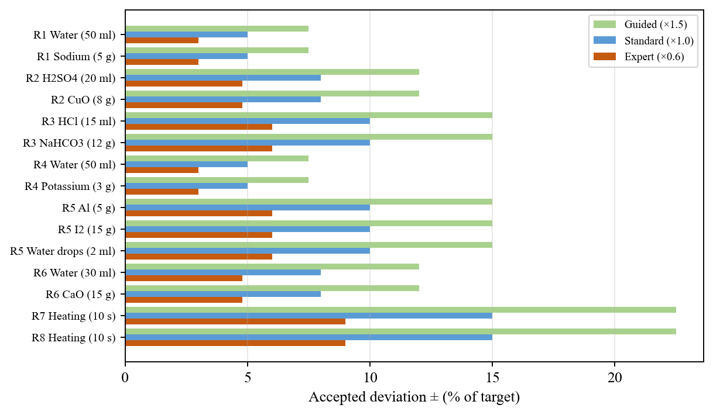
Fig. 8. Accepted deviation per reagent at Guided, Standard and Expert levels.
C. Accuracy and Star Model
Each reagent's accuracy falls linearly from 1 on target to 0 at the edge of its Standard range, and the attempt scores its worst reagent:
a_{i} = clamp(1 − |q_{i} − T_{i}| / (T_{i}τ_{i}/100), 0, 1), A = 100·min_{i} a_{i} (3)
Three stars require A ≥ 60, two require A ≥ 25, and any success earns at least one. The minimum, rather than the mean, prevents a careful measurement from hiding a careless one and prevents fixed-mass solids from inflating the score; using the Standard range on every level keeps stars comparable (Fig. 9).
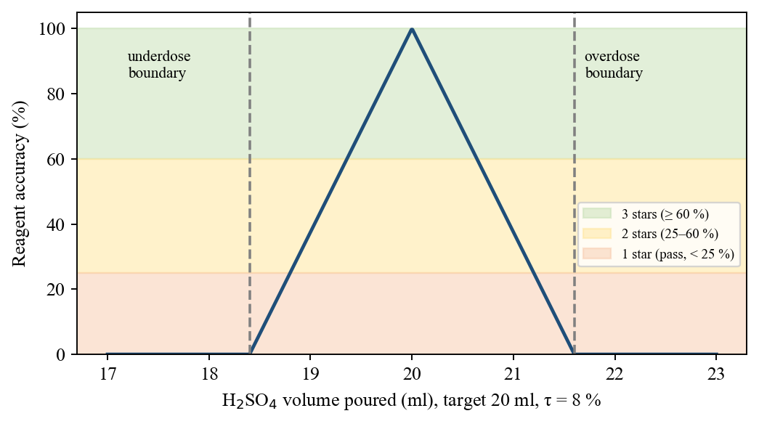
Fig. 9. Accuracy function and star bands for H₂SO₄ in reaction 2 (accepted 18.4-21.6 ml).
D. Context-Aware Assistant with Offline Fallback
Questions arrive by push-to-talk, typing, a one-key "why did it fail" shortcut, or Ask-AI buttons on graphs and animations. Each is sent with the current reaction, quantities, targets, verdict and attempt counts (Fig. 10). When credentials and network are available, the Convai character endpoint returns text and speech [18]. Otherwise a grounded knowledge base classifies the question by keyword scores S_{k}(q),
k* = argmax_{k} S_{k}(q) (Overview if all S_{k} = 0) (4)
over intents such as WhyFailed, Quantities, Procedure, Molecular, Graphs, Calculation, Safety and Progress, and answers from game data, e.g., "you poured 27.4 ml where the equation needs 20.0, a 37 % overdose", spoken by the Windows synthesiser. Every exchange is logged with the attempt.
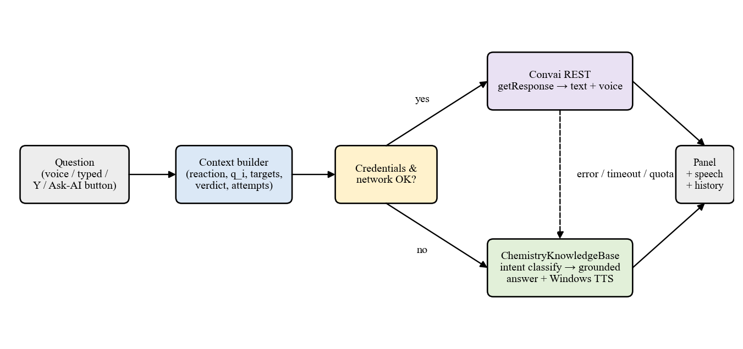
Fig. 10. Dual-path routing of assistant questions.
E. Thermodynamics, History and Assessment
A catalog stores ΔH, E_{a} and ΔS for each reaction and derives ΔG(T) = ΔH − TΔS/1000, crossover temperature T* = 1000ΔH/ΔS and reverse barrier E_{a} − ΔH for the energy-profile, enthalpy and entropy graphs. Attempts (quantities, steps, outcome, accuracy, AI log) are stored as JSON, capped at 300. The test scene draws 3-18 tasks from 8 practical and 10 theory items; practical tasks use the same engine with hidden targets. Coins (5-100 per task by time left, with streak and first-clear bonuses) persist across sessions, buy hints (procedure only), extra time or skips, and determine ranks at 0/500/1500/3500/7000 lifetime coins; each run exports an HTML and CSV report.
The balance and rank follow B = max(0, L − S) and rank = max{r : L ≥ θ_{r}}, where L and S are lifetime coins earned and spent; Table III lists the parameters. Hints deliberately reveal the procedure but never the quantity, because the amount is precisely what the test measures.
TABLE III
Assessment Economy Parameters
Parameter | Value
Task pool | 8 practical + 10 theory (3, 5, 8, 10 or all)
Earning | 5-100 coins per task by time left
Bonuses | First clear +25; streak 3 +30, 5 +60; unaided run +50
Purchases | Hint 40; +30 s 60; skip 100
Ranks (lifetime) | 0 / 500 / 1500 / 3500 / 7000

V. Results and Discussion
A. Implementation and Verification
The prototype contains 110 C# scripts with 39,601 lines of code, the largest share (15,567 lines in 43 files) in reaction logic. It compiles against the real Unity 6000.3.7f1 assemblies with zero errors and no new warnings. Engine-independent logic was extracted verbatim and executed with a time shim; Table IV and Fig. 11 summarise the suites. The outcome matrix drove every test-scene experiment through correct amounts, overdose, underdose, reversed order and a mid-procedure pause, and confirmed that targets are never revealed in the test.
TABLE IV
Verification Results
Suite | Checks passed
Compilation (Unity 6000.3.7f1) | 0 errors, 0 new warnings
Engine outcome matrix (8 test tasks) | 111 / 111
Regression: molecular + offline AI | 167 / 167
Regression: coins + exam report | 226 / 226
Synthesised audio | 22 / 22

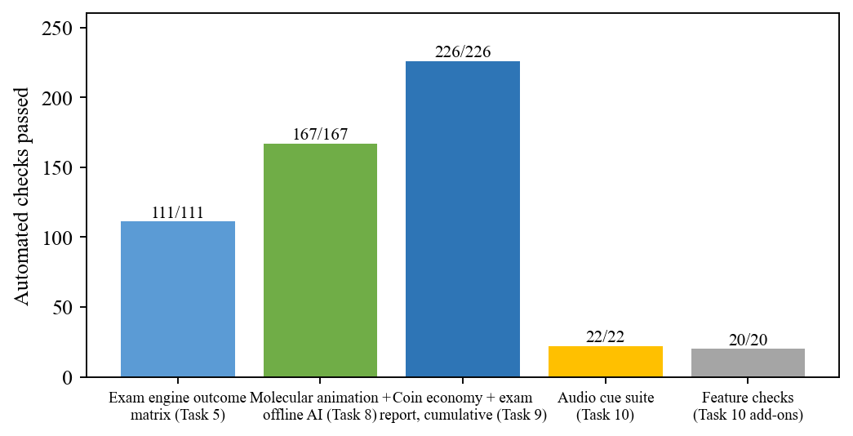
Fig. 11. Automated checks passed per verification suite.
B. Content Coverage
Atomix delivers 8 quantity-aware experiments, 10 theory questions (18 task types), live 3D animations for 8/8 reactions plus 7 recorded clips, 6 reaction categories, 13 achievements and a 118-element interactive periodic table. Tolerance windows range from ±3 % (Expert, alkali metals) to ±22.5 % (Guided, heating).
C. Scientific Consistency
Table V lists the thermodynamic data and ΔG at 298.15 K computed from it (Figs. 12 and 13). Only the two thermal decompositions have positive ΔG at room temperature, which is exactly why they are the experiments requiring the burner; their crossover temperatures are about 1110 K and 901 K. Reaction 3 is endothermic yet spontaneous through its entropy gain, a ready classroom example, and the alkali-metal reactions combine very small barriers with large exothermicity, matching their violence on contact with water.
TABLE V
Thermodynamic Data and Derived Gibbs Energy
# | ΔH | E_{a} | ΔS | ΔG₂₉₈
1 | −368.6 | 10 | −15.5 | −364.0
2 | −63.7 | 48 | −43.0 | −50.9
3 | +31.4 | 45 | +241.0 | −40.5
4 | −393.2 | 6 | +44.7 | −406.5
5 | −627.6 | 85 | −86.9 | −601.7
6 | −65.2 | 46 | −26.3 | −57.4
7 | +178.3 | 185 | +160.7 | +130.4
8 | +340.1 | 365 | +377.4 | +227.6

ΔH, E_{a}, ΔG in kJ/mol; ΔS in J/mol·K.
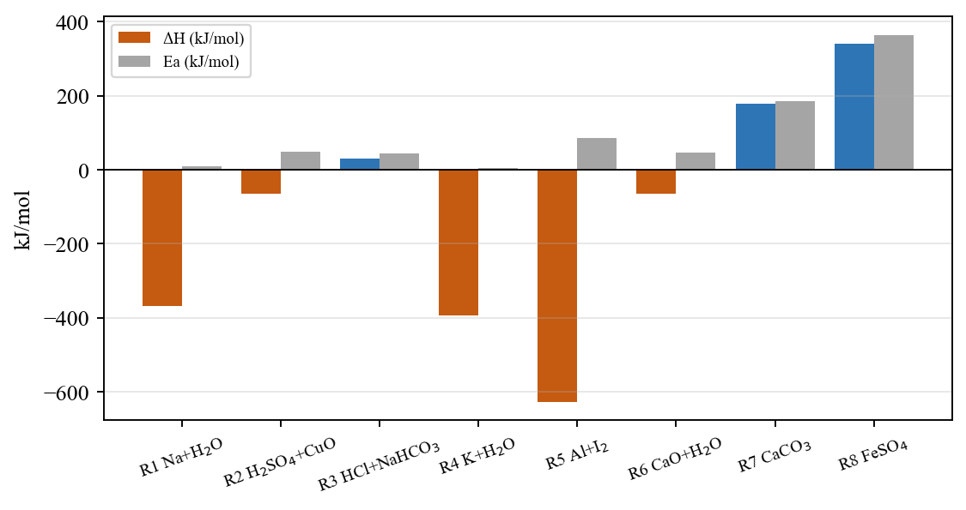
Fig. 12. Enthalpy change and activation energy of the eight reactions.
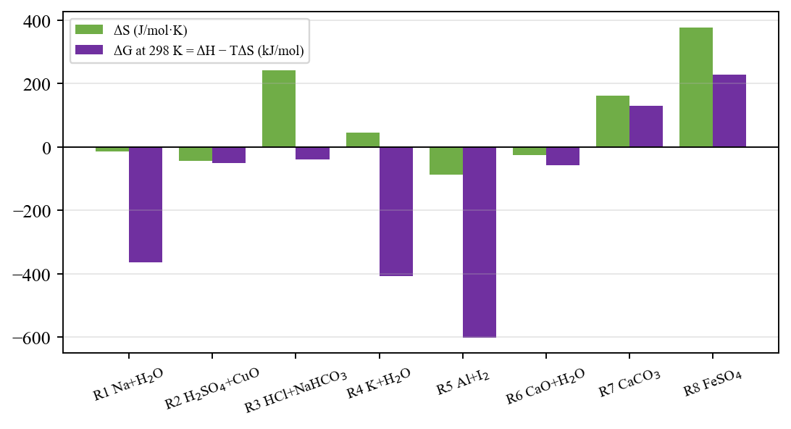
Fig. 13. Entropy change and Gibbs free energy at 298 K for the eight reactions.
D. Comparison with Existing Systems
Table VI compares Atomix functionally with representative systems from Section II; numerical learning results of those studies are not directly comparable because they used different populations and measures.
TABLE VI
Functional Comparison
Feature | [1],[12] | [4],[13] | [5] | [7],[14] | Atomix
VR + desktop | Desktop | VR | CAVE | Web | Both
Quantity judging | No | No | No | No | Yes
Molecular view | Static | Partial | Yes | No | 8/8 live
AI help | No | No | No | Generic | Live context
Offline help | - | - | - | No | Yes
History + assessment | Partial | No | No | No | Yes

E. Discussion
Three design choices proved important. First, judging underdose only after a settling period separates unfinished from wrong: without it, any learner who paused between reagents was failed, which the outcome matrix now guards against. Second, scoring the worst reagent rather than the average aligns the star rating with laboratory practice, where one careless measurement spoils a preparation regardless of how precise the others were. Third, the offline knowledge base is not merely a fallback; for questions about the bench it is more precise than a general model because it reads the engine's measurements directly, and it keeps all four help features (why it failed, what happened, explain this graph, explain this animation) available with no network, microphone or service quota.
From a pedagogical perspective, Atomix operationalises the macro-micro-symbolic link [9]: the same reaction is seen as an experiment, as an animation of bonds and electrons, as a balanced equation and as an energy diagram, and the assistant can be asked about any of these views in the context of the learner's own attempt. Whether this integration yields measurable learning gains is the central question for the planned evaluation [6], [8].
F. Limitations
The results establish technical and functional viability, not learning gain: no controlled user study, usability survey or on-device frame-rate measurement has yet been performed. Offline answers cover only the eight reactions, offline speech is Windows-only, and coins are stored per machine.
VI. Conclusion and Future Work
Atomix unifies free-hand, quantity-aware experimentation, molecular visualization, a live-context AI assistant that works offline, attempt history, thermodynamic graphs and randomized assessment in one application for VR and desktop. Its engine judges order, overdose, underdose and procedure against data-driven recipes and scores attempts fairly across difficulty levels, and the implementation passed every automated check run on its shipped logic. Future work will measure learning outcomes through a pre-test/post-test study with usability questionnaires, add titration, organic and electrochemistry experiments as new recipe assets, provide a teacher dashboard with accounts, and embed an on-device language model grounded on the knowledge base.
References
[1] S. Ramos, E. P. Pimentel, M. das G. B. Marietto, and W. T. Botelho, "Hands-on and virtual laboratories to undergraduate chemistry education: Toward a pedagogical integration," in Proc. IEEE FIE, 2016, pp. 1-8.
[2] M. Agarwal and S. Saha, "Learning chemistry through puzzle based game: Atoms to molecule," in Proc. IEEE ICETA, 2011, pp. 189-193.
[3] A. L. Sanchez-Lopez et al., "Enhancing chemistry laboratory teaching through gamification: The IQ-Mobile Race," in Proc. IEEE TALE, 2023, pp. 1-4.
[4] J. T. Bell and H. S. Fogler, "The application of virtual reality to (chemical engineering) education," in Proc. IEEE VR, 2004, pp. 217-218.
[5] Y. Luo, P. Guo, S. Hasegawa, and M. Sato, "An interactive molecular visualization system for education in immersive multi-projection virtual environment," in Proc. ICIG, 2004, pp. 485-488.
[6] T. Xie, Y. Li, and Y. Tang, "Effects of using immersive virtual reality for science education on learning outcomes: A randomized controlled pilot study," IEEE Trans. Learn. Technol., vol. 16, no. 6, pp. 1045-1056, 2023.
[7] N. Sandu and E. Gide, "Adoption of AI-chatbots to enhance student learning experience in higher education in India," in Proc. ITHET, 2019, pp. 1-5.
[8] M. P. Kurniawan, M. Suyanto, E. Utami, and Kusrini, "Educational game learning quality evaluation tool: A systematic literature review," in Proc. ICICoS, 2024.
[9] J. K. Gilbert and D. F. Treagust, Eds., Multiple Representations in Chemical Education. Dordrecht: Springer, 2009.
[10] H.-K. Wu, J. S. Krajcik, and E. Soloway, "Using technology to support the development of conceptual understanding of chemical representations," 2000.
[11] E. Byusa, E. Kampire, and A. R. Mwesigye, "Game-based learning approach on students' motivation and understanding of chemistry concepts: A systematic review of literature," Heliyon, vol. 8, e09541, 2022.
[12] N. Ali and S. Ullah, "Review to analyze and compare virtual chemistry laboratories for their use in education," J. Chem. Educ., vol. 97, no. 10, pp. 3563-3574, 2020.
[13] J. Alvarez Ramirez and A. Bueno, "Learning organic chemistry with virtual reality," in Proc. IEEE ICEV, 2020.
[14] I. Atmosukarto, W. S. Cheow, P. Iyer, N. Tong, and K. Yu, "Enhancing adaptive online chemistry course with AI-chatbot," in Proc. IEEE TALE, 2021.
[15] Unity Technologies, "Unity 6 User Manual," 2025. [Online]. Available: https://docs.unity3d.com/Manual/
[16] The Khronos Group, "The OpenXR Specification." [Online]. Available: https://registry.khronos.org/OpenXR/
[17] Unity Technologies, "XR Interaction Toolkit documentation." [Online]. Available: https://docs.unity3d.com/Packages/com.unity.xr.interaction.toolkit@latest
[18] Convai, "Convai documentation - Character API." [Online]. Available: https://docs.convai.com/

