
Atomix: Your Personal Lab with AI
LY Innovation-Based Major Project-B Report
Submitted in partial fulfilment of the requirements of the Degree of
Bachelor of Technology in Computer Engineering
by
Kushal D. Soni (Roll No. [INSERT])
Kartik R. Verma (Roll No. [INSERT])
Dhir M. Thakar (Roll No. [INSERT])
Supervisor
Dr. Madhura Phadke

Department of Computer Engineering
K. J. Somaiya Institute of Technology
An Autonomous Institute permanently affiliated to University of Mumbai
Ayurvihar, Sion, Mumbai-400022
2026-27

CERTIFICATE
This is to certify that the project entitled "Atomix: Your Personal Lab with AI" is a bonafide work of Kushal D. Soni, Kartik R. Verma, Dhir M. Thakar submitted to the University of Mumbai in partial fulfilment of the requirement in Major Project, for the award of the degree of "Bachelor of Technology" in "Computer Engineering".
______________________________
Dr. Madhura Phadke
Project Guide
Department of Computer Engineering

______________________________  Dr. Sarita Ambadekar  Head, Department of Computer Engineering | ______________________________  Dr. Vivek Sunnapwar  Principal, KJSIT
Place: Sion, Mumbai-400022
Date:
PROJECT APPROVAL FOR L. Y.
This project report entitled "Atomix: Your Personal Lab with AI" by
Kushal D. Soni (Roll No. [INSERT])
Kartik R. Verma (Roll No. [INSERT])
Dhir M. Thakar (Roll No. [INSERT])
is an approved Last Year Innovation-Based Major Project in Computer Engineering.
Examiners:
1. ______________________________
Name and Signature
External Examiner
2. ______________________________
Name and Signature
Internal Examiner
Place: Sion, Mumbai-400022
Date:
DECLARATION
We declare that this written submission represents our ideas in our own words and where others' ideas or words have been included, we have adequately cited and referenced the original sources. We also declare that we have adhered to all principles of academic honesty and integrity and have not misrepresented or fabricated or falsified any idea/data/fact/source in our submission. We understand that any violation of the above will be cause for disciplinary action by the Institute and can also evoke penal action from the sources which have thus not been properly cited or from whom proper permission has not been taken when needed.
Kushal D. Soni (Roll No. [INSERT])
Kartik R. Verma (Roll No. [INSERT])
Dhir M. Thakar (Roll No. [INSERT])
Date:
ACKNOWLEDGEMENT
Before presenting our LY Major Project work entitled "Atomix: Your Personal Lab with AI", we would like to convey our sincere thanks to the people who guided us throughout the course of this project work.
First, we would like to express our immense gratitude towards our Project Guide Dr. Madhura Phadke for the constant encouragement, support, guidance and mentoring at all stages of the project and report.
We would like to express our sincere thanks to our H.O.D. Dr. Sarita Ambadekar for the encouragement, co-operation and suggestions during the progressing stages of the report.
We would like to express our sincere thanks to our beloved Principal Dr. Vivek Sunnapwar for providing various facilities to carry out this project.
Finally, we would like to thank all the teaching and non-teaching staff of the college, and our friends, for their moral support during the course of this work and for their direct and indirect involvement in the completion of this report, which made our endeavour fruitful.
Place: Sion, Mumbai-400022
Date:
ABSTRACT
Chemistry is learnt by linking what is seen in a laboratory to what happens at the molecular level and to the symbolic equation, yet students get little safe, repeatable practice and rarely receive specific explanations of their mistakes. Virtual laboratories, immersive Virtual Reality (VR), game-based learning and AI chatbots each address part of this problem, but they are usually studied in isolation, judge experiments only as fixed sequences, and offer help that is unaware of what the learner has just done. This project presents Atomix: Your Personal Lab with AI, a Unity 6 virtual chemistry laboratory that runs on Meta Quest / OpenXR headsets and, through a run-time-injected keyboard-and-mouse mode, on ordinary Windows computers. Atomix offers eight inorganic experiments selected from an in-world Reaction Book. A data-driven free-hand reaction engine judges each experiment by the order of addition, instant overdose detection, underdose after a settling period and heating procedure, using per-reaction tolerances scaled by Guided, Standard and Expert difficulty levels, and rates every success with an accuracy score and stars.
Before and after each experiment the learner can watch recorded molecular videos or a live 3D animation that shows bonds breaking and forming and electrons being transferred. A context-aware AI Lab Assistant receives the live measurements, verdict and attempt history; it answers by voice and text through the Convai service and falls back to a grounded offline knowledge base with local speech, so help remains available without internet or a microphone. A persistent experiment history, enthalpy, activation-energy, entropy and Gibbs-energy graphs, and a randomized assessment scene with eighteen task types, a coin economy and HTML/CSV reports complete the learning cycle. The implementation comprises 110 C# scripts (39,601 lines), compiles without errors and passed all automated checks executed on the shipped logic (111/111, 167/167, 226/226 and 22/22). A controlled study of learning outcomes is identified as the next step.
Keywords: virtual chemistry laboratory, virtual reality, conversational AI, game-based learning, Unity, free-hand experimentation.
CONTENTS
LIST OF FIGURES x
LIST OF TABLES xii
LIST OF ABBREVIATIONS xiii
CHAPTER 1: INTRODUCTION 1
1.1 Introduction 1
1.2 Problem Definition 2
1.3 Aim and Objectives 3
1.4 Organization of the Report 4
CHAPTER 2: REVIEW OF LITERATURE 5
2.1 Literature Survey 5
2.1.1 Chemical representations and the need for visualization 5
2.1.2 Virtual laboratories 5
2.1.3 Game-based learning and gamification 6
2.1.4 Virtual Reality and immersive visualization 6
2.1.5 AI-assisted learning 6
2.2 Research Gaps 8
CHAPTER 3: REQUIREMENT SPECIFICATION 10
3.1 Introduction 10
3.2 Hardware Requirements 10
3.3 Software Requirements 11
3.4 Feasibility Study 11
3.4.1 Technical Feasibility 11
3.4.2 Economic Feasibility 12
3.4.3 Operational Feasibility 12
3.5 Cost Estimation 12
3.6 Functional Requirements 13
3.7 Non-Functional Requirements 14
3.8 Project Schedule 15
CHAPTER 4: PROJECT ANALYSIS & DESIGN 16
4.1 Introduction 16
4.2 UML Diagrams 16
4.2.1 Use-Case Diagram 16
4.2.2 Sequence Diagrams 18
4.2.3 State Diagram 19
4.2.4 Data Flow Diagrams 20
4.2.5 Class Diagram 22
4.2.6 Activity Diagram 23
4.3 Scene Architecture 24
4.4 Design Decisions 25
CHAPTER 5: METHODOLOGY 26
5.1 Introduction 26
5.2 Development Methodology 26
5.3 System Block Diagram 26
5.4 Reaction Recipes 28
5.5 Free-Hand Reaction Evaluation Algorithm 28
5.6 Accuracy and Star Rating Model 30
5.7 AI Assistant: Context Building, Routing and Intent Classification 31
5.8 Molecular Animation Model 33
5.9 Thermodynamic Model for Scientific Graphs 33
5.10 Assessment and Coin Economy 34
5.11 Frame-Rate-Independent Interaction Smoothing 35
5.12 Data Persistence 35
CHAPTER 6: IMPLEMENTATION DETAILS 36
6.1 Introduction 36
6.2 System Implementation 36
6.2.1 Laboratory Environment and Main Menu 36
6.2.2 Reaction Book and Learn-Before-Perform 37
6.2.3 Free-Hand Experimentation and Feedback 38
6.2.4 Experiment History and Scientific Graphs 39
6.2.5 In-Laboratory AI Assistant 40
6.2.6 Testing Scene, Coin Economy and Reports 41
6.2.7 Periodic Table, Settings and Presentation 42
6.3 Desktop Mode Implementation 43
6.4 Key Scripts 43
6.5 VR Implementation 44
CHAPTER 7: RESULT ANALYSIS 45
7.1 Introduction 45
7.2 Performance Measures 45
7.2.1 Build and Verification Results 45
7.2.2 Content and Coverage Metrics 46
7.2.3 Scientific Data Used by the System 47
7.2.4 Requirement Traceability 49
7.2.5 Measurements to be Added 49
7.3 Screenshots 49
7.4 Comparative Analysis 50
7.5 Limitations 51
CHAPTER 8: CONCLUSION & FUTURE SCOPE 52
8.1 Conclusion 52
8.2 Future Scope 52
REFERENCES 54
PUBLISHED PAPERS 56
CERTIFICATES 57
PLAGIARISM REPORT 58

LIST OF FIGURES
Figure 1.1: The Atomix learning cycle - choose, learn, experiment, receive feedback, ask the AI, review, analyse and try again 2
Figure 4.1: Use-case diagram of Atomix 17
Figure 4.2: Sequence diagram - performing a free-hand experiment 18
Figure 4.3: Sequence diagram - asking the context-aware AI assistant 19
Figure 4.4: State diagram of the free-hand reaction engine 20
Figure 4.5: Level 0 DFD (context diagram) 20
Figure 4.6: Level 1 DFD 21
Figure 4.7: Level 2 DFD of the reaction-evaluation process 22
Figure 4.8: Class diagram of the core subsystems 23
Figure 4.9: Activity diagram of the user journey 24
Figure 5.1: Phase-wise development methodology 26
Figure 5.2: System block diagram of Atomix 27
Figure 5.3: Accepted deviation per reagent at the three difficulty levels 30
Figure 5.4: Reagent accuracy function and star bands for H2SO4 in reaction 2 31
Figure 5.5: Dual-path routing of AI questions 32
Figure 5.6: Energy profiles generated from catalog data for reactions 1 and 7 34
Figure 6.1: Distribution of the 39,601 lines of C# code across subsystems 36
Figure 6.2: The Atomix virtual laboratory with the FeSO4 experiment set up and assistant guidance 37
Figure 6.3: Main menu 37
Figure 6.4: Reaction Book with LEARN / PERFORM and difficulty selection 38
Figure 6.5: Learning panel playing a recorded molecular video 38
Figure 6.6: Live 3D molecular animation (bond breaking, forming and electron transfer) 38
Figure 6.7: Free-hand pouring with live measurement tooltip and tracker 39
Figure 6.8: Chemistry-specific failure card 39
Figure 6.9: Experiment History panel 40
Figure 6.10: Scientific graphs panel 40
Figure 6.11: In-lab AI assistant answering a typed question 41
Figure 6.12: Testing scene setup and coin HUD 41
Figure 6.13: Report card and exported HTML test report 42
Figure 6.14: Interactive periodic table 42
Figure 6.15: Pause menu with settings, achievements and controls 43
Figure 7.1: Automated verification checks passed per suite 46
Figure 7.2: Content inventory of the Atomix prototype 47
Figure 7.3: Enthalpy change and activation energy of the eight reactions 48
Figure 7.4: Entropy change and Gibbs free energy at 298 K 48

LIST OF TABLES
Table 2.1: Summary of the literature survey 7
Table 2.2: Capability coverage of surveyed work versus the proposed system 8
Table 3.1: Hardware requirements 10
Table 3.2: Software requirements 11
Table 3.3: Cost estimation 13
Table 3.4: Functional requirements 13
Table 3.5: Non-functional requirements 14
Table 3.6: Project schedule 15
Table 4.1: Key use-case descriptions 17
Table 4.2: Scene architecture 24
Table 5.1: Reaction recipes used by the free-hand engine 28
Table 5.2: Engine verdicts and feedback 30
Table 5.3: Offline assistant intents and answer sources 32
Table 5.4: Coin-economy parameters 35
Table 6.1: Desktop controls 43
Table 6.2: Key scripts and responsibilities 44
Table 7.1: Build and verification summary 45
Table 7.2: Content and coverage metrics 46
Table 7.3: Thermodynamic data per reaction and derived Gibbs energy 47
Table 7.4: Requirement traceability 49
Table 7.5: Comparison with existing systems 50

LIST OF ABBREVIATIONS
Sr. No. | Abbreviation | Description
1 | AI | Artificial Intelligence
2 | API | Application Programming Interface
3 | CAVE | Cave Automatic Virtual Environment
4 | CPK | Corey-Pauling-Koltun (atom colouring convention)
5 | CSV | Comma-Separated Values
6 | DFD | Data Flow Diagram
7 | FR | Functional Requirement
8 | GBL | Game-Based Learning
9 | GPU | Graphics Processing Unit
10 | HMD | Head-Mounted Display
11 | HTML | HyperText Markup Language
12 | HUD | Heads-Up Display
13 | INR | Indian Rupee
14 | JSON | JavaScript Object Notation
15 | KB | Keyboard (in figures: KB + mouse) / Knowledge Base (Offline KB)
16 | LOC | Lines of Code
17 | MP4 | MPEG-4 Part 14 video format
18 | RAM | Random Access Memory
19 | RCT | Randomized Controlled Trial
20 | REST | Representational State Transfer
21 | SDK | Software Development Kit
22 | SO | ScriptableObject (Unity data asset)
23 | SoC | System on Chip
24 | SUS | System Usability Scale
25 | TTS | Text-to-Speech
26 | UI | User Interface
27 | UML | Unified Modelling Language
28 | VFX | Visual Effects
29 | VR | Virtual Reality
30 | XR | Extended Reality

CHAPTER 1: INTRODUCTION

1.1 Introduction
Chemistry is learnt at three linked levels: the macroscopic level of what can be seen in a test tube, the sub-microscopic level of atoms, ions and bonds, and the symbolic level of formulas and equations [9]. Laboratory work is where the first level is experienced, yet the second level remains invisible and the third level is usually met only on paper, which is why learners often find it hard to connect an observation such as fizzing or a colour change to the reaction that causes it [10]. At the same time, practical laboratory time is limited by the cost of reagents, by safety rules that forbid reactive metals or toxic gases in a classroom, and by the availability of apparatus and supervision. Educational technology has responded with virtual laboratories [1], [12], game-based learning [2], [3], [11], immersive Virtual Reality (VR) [4]-[6], [13] and Artificial Intelligence (AI) tutors and chatbots [7], [14]. This project, Atomix: Your Personal Lab with AI, belongs to this domain of technology-enhanced chemistry education. Atomix is a Unity 6 virtual chemistry laboratory that runs on Meta Quest / OpenXR headsets and, without a headset, on a Windows desktop with keyboard and mouse. Inside one application the learner chooses one of eight inorganic reactions, watches a molecular-level explanation, performs the experiment free-hand with measured quantities, receives a chemistry-specific verdict, asks a context-aware AI Lab Assistant why the result occurred, reviews a persistent history of attempts, studies the thermodynamics of the reaction through scientific graphs, and finally takes a randomized, timed assessment. Figure 1.1 summarises this learning cycle, which is the organising idea of the whole system.
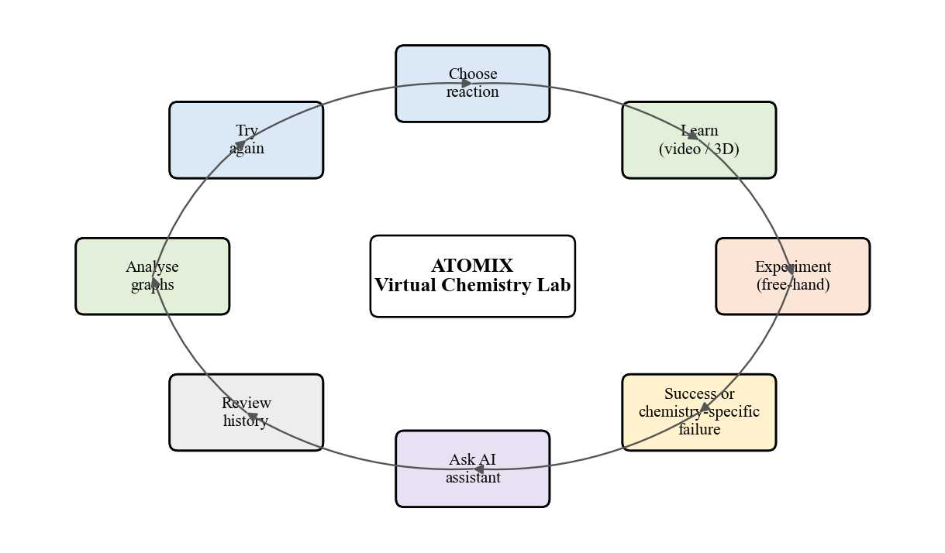
Figure 1.1: The Atomix learning cycle - choose, learn, experiment, receive feedback, ask the AI, review, analyse and try again
The cycle in Figure 1.1 deliberately treats failure as a normal and informative step. A student who pours too much sulfuric acid onto copper(II) oxide is not simply told "wrong"; the laboratory explains which reagent was out of range, by how much, and why that matters chemically, and the AI assistant can then be asked about the specific attempt. The rest of this report describes how this behaviour was specified, designed, implemented and verified.

1.2 Problem Definition
Secondary-school and first-year undergraduate chemistry students rarely get enough unsupervised, repeatable practice with real reactions, and when they do practise, they seldom receive immediate, specific explanations of their mistakes. Existing digital alternatives address the problem only partially. Virtual laboratories reproduce procedures but are usually desktop-only and judge experiments as a fixed sequence of clicks [1], [12]; VR applications offer immersion and molecular visualization but rarely assess the quantities a learner actually used [4], [5], [13]; game-based tools improve motivation but focus on a narrow concept [2], [3]; and AI chatbots answer questions without knowing what the student has just done in the laboratory [7], [14]. Moreover, most cloud-AI tutors stop working entirely when there is no internet connection, no microphone, or an expired service quota.
The problem addressed by this project is therefore: to design and implement a single, accessible virtual chemistry laboratory in which learners can perform quantity-aware experiments in VR or on a desktop, see the molecular explanation of each reaction, receive chemistry-specific feedback on their own mistakes from an AI assistant that is aware of the live experiment and still works offline, track and review their attempts, and be assessed through randomized practical and theoretical tasks.

1.3 Aim and Objectives
Aim. To build Atomix, an AI-assisted virtual chemistry laboratory that unifies hands-on experimentation, molecular-level visualization, context-aware conversational help, progress tracking and assessment in one Unity application that runs both in VR and on a desktop computer.
Objectives. The project objectives were defined as follows:
- To model an interactive 3D chemistry laboratory with grabbable glassware, reagents, a Bunsen burner and a world-space Reaction Book offering eight inorganic reactions across decomposition, displacement, neutralization, redox, precipitation and combustion categories.
- To support two input modalities from one code base: XR interaction on Meta Quest / OpenXR and a runtime-injected keyboard-and-mouse desktop mode.
- To replace fixed-sequence triggers with a reusable free-hand reaction engine that validates reagent order, overdose, underdose (after the mixture settles) and heating duration against data-driven recipes with configurable tolerances and difficulty levels.
- To provide a learn-before-perform workflow with recorded molecular videos and a live, code-authored 3D ball-and-stick animation for all eight reactions showing bond breaking, bond forming and electron transfer.
- To integrate an in-laboratory AI assistant that receives the live experiment context, answers by voice and text through the Convai service, and falls back to an offline, grounded chemistry knowledge base with Windows speech synthesis.
- To persist a detailed experiment history, compute an accuracy score and star rating for every attempt, and present energy-profile, enthalpy and entropy graphs with Gibbs free-energy reasoning for each reaction.
- To build a randomized assessment scene with eight practical and ten theory tasks, a persistent coin economy, and an exportable HTML/CSV test report.
- To verify the implementation through compilation against the real Unity assemblies and automated checks that execute the shipped logic.

1.4 Organization of the Report
The remainder of this report is organised as follows. Chapter 2 reviews the literature on virtual laboratories, game-based learning, immersive VR, molecular visualization and AI-assisted learning, summarises it in a comparative table and identifies the research gaps that motivate Atomix. Chapter 3 specifies the hardware and software requirements, the functional and non-functional requirements, the feasibility study and the cost estimate. Chapter 4 presents the analysis and design of the system through use-case, sequence, state, data-flow, class and activity diagrams. Chapter 5 explains the methodology: the layered system architecture, the free-hand reaction-evaluation algorithm with its mathematical formulation, the scoring model, the AI routing logic, the thermodynamic model behind the scientific graphs and the assessment economy. Chapter 6 describes the implementation module by module with screenshots. Chapter 7 analyses the results, including verification statistics, the scientific data used by the system and a comparison with the systems surveyed in Chapter 2. Chapter 8 concludes the report and outlines future work. References, published papers, certificates and the plagiarism report follow.

CHAPTER 2: REVIEW OF LITERATURE

2.1 Literature Survey
Search strategy. We searched IEEE Xplore, ScienceDirect, the Journal of Chemical Education and Google Scholar for the period 2000-2024 using combinations of the keywords "virtual chemistry laboratory", "virtual reality chemistry education", "immersive molecular visualization", "game-based learning chemistry", "gamification laboratory", "AI chatbot education" and "educational game evaluation". Titles and abstracts were screened for relevance to (i) laboratory simulation, (ii) immersive or game-based chemistry learning, (iii) visualization of chemical representations, or (iv) conversational AI support for learners. Fourteen works were retained: eight peer-reviewed conference papers, three journal articles, one systematic literature review on evaluation, one edited book on multiple representations and one technology-support study. They are discussed thematically below and summarised in Table 2.1.

2.1.1 Chemical representations and the need for visualization
Gilbert and Treagust [9] consolidate research showing that chemistry understanding depends on moving between the macroscopic, sub-microscopic and symbolic levels, and that learners struggle precisely at the transitions between them. Wu, Krajcik and Soloway [10] studied a computer-based visualization tool that let students build and convert between molecular representations and reported that technology can scaffold the development of representational competence. Both works motivate the inclusion of molecular-level explanation alongside the macroscopic experiment, which in Atomix takes the form of molecular videos and a live 3D ball-and-stick animation tied to each reaction.

2.1.2 Virtual laboratories
Ramos et al. [1] examined how hands-on and virtual laboratories can be integrated pedagogically in undergraduate chemistry and argued that virtual laboratories are most valuable as a complement that allows repetition and preparation rather than as a replacement. Ali and Ullah [12] reviewed and compared existing virtual chemistry laboratories with respect to their features, interactivity and educational use, finding wide variation in realism, feedback and assessment support. Together they show that a virtual laboratory should allow repeated, safe experimentation and should give meaningful feedback, a requirement that Atomix addresses with its free-hand engine and failure explanations.

2.1.3 Game-based learning and gamification
Agarwal and Saha [2] designed a puzzle-based game, "Atoms to Molecule", in which learners assemble molecules from atoms, and reported that the game format supported engagement with bonding concepts. Sanchez-Lopez et al. [3] gamified chemistry laboratory teaching through the IQ-Mobile Race activity and observed improved motivation, communication and collaboration. Byusa, Kampire and Mwesigye [11] systematically reviewed game-based learning in chemistry and concluded that it generally improves motivation and conceptual understanding, while stressing that the effect depends on the game mechanics and on clear learning goals. Kurniawan et al. [8] reviewed tools for evaluating educational-game quality and emphasised that games must be assessed for usability and educational value, not only as software. These works informed the assessment scene, the coin economy and the decision to make the mechanics themselves chemical (measuring, ordering, heating) rather than external rewards.

2.1.4 Virtual Reality and immersive visualization
Bell and Fogler [4] were among the first to apply VR to chemical-engineering education, using virtual laboratory and plant environments to visualise processes that cannot easily be shown in a classroom. Luo et al. [5] built an interactive molecular-visualization system for a multi-projection immersive environment and showed that immersive 3D presentation helps learners understand molecular structure. Alvarez Ramirez and Bueno [13] developed a VR application for learning organic chemistry. Xie, Li and Tang [6] carried out a randomized controlled pilot study of immersive VR for science education and cautioned that immersion should be judged by its measured effect on learning outcomes rather than assumed to be beneficial. These studies justify VR as the primary modality while also warning against relying on immersion alone, which is why Atomix couples immersion with feedback, explanation and assessment and keeps a desktop path for learners without headsets.

2.1.5 AI-assisted learning
Sandu and Gide [7] investigated the adoption of AI chatbots for enhancing the student learning experience in Indian higher education and found positive attitudes towards chatbot support. Atmosukarto et al. [14] added an AI chatbot to an adaptive online chemistry course so that students could obtain answers outside class hours. Neither system, however, has access to what the student is doing in a practical activity at that moment. Atomix extends this line of work by injecting live experiment context (reaction, measured quantities, targets, verdict and attempt history) into every question and by providing an offline fallback so that help is never entirely unavailable.
Table 2.1 consolidates the surveyed works. Because several of the references are design papers or reviews rather than controlled experiments, the "Dataset / Participants" column records the kind of evidence each work rests on.
Table 2.1: Summary of the literature survey
Ref. | Author / Year | Method | Dataset / Participants | Results | Limitations
[1] | Ramos et al., 2016 | Pedagogical integration of hands-on and virtual labs | Undergraduate chemistry course context | Virtual labs best used to complement and prepare for hands-on work | Desktop simulation; no immersive or AI support
[2] | Agarwal & Saha, 2011 | Puzzle-based game (Atoms to Molecule) | Learners playing the game | Game format supported engagement with bonding concepts | Single concept; no laboratory procedure
[3] | Sanchez-Lopez et al., 2023 | Gamified lab activity (IQ-Mobile Race) | Chemistry laboratory class | Improved motivation, communication, collaboration | Physical activity; not a simulation
[4] | Bell & Fogler, 2004 | VR modules for chemical-engineering education | Engineering students / VR modules | VR visualises processes not feasible in class | Early hardware; no quantity-level assessment
[5] | Luo et al., 2004 | Immersive multi-projection molecular visualization | System demonstration | 3D immersion aids understanding of molecular structure | Expensive projection setup; structure only
[6] | Xie, Li & Tang, 2023 | Randomized controlled pilot study of immersive VR | Science learners (pilot RCT) | Immersion must be judged by learning outcomes | Pilot scale; VR content only
[7] | Sandu & Gide, 2019 | Survey of AI-chatbot adoption | Indian higher-education students | Positive perception of chatbot support | Generic chatbot; no task context
[8] | Kurniawan et al., 2024 | Systematic review of game-evaluation tools | Published evaluation studies | Need for structured usability and educational evaluation | Review only; no system
[9] | Gilbert & Treagust, 2009 | Edited synthesis on multiple representations | Body of chemistry-education research | Macro / sub-micro / symbolic levels must be linked | Theoretical; no tool
[10] | Wu, Krajcik & Soloway, 2000 | Computer-based visualization tool for representations | High-school chemistry classroom | Technology scaffolds representational understanding | 2D desktop tool; no experimentation
[11] | Byusa et al., 2022 | Systematic review of game-based learning in chemistry | Published GBL studies | GBL improves motivation and understanding | Effects depend on mechanics; heterogeneous studies
[12] | Ali & Ullah, 2020 | Review and comparison of virtual chemistry labs | Existing virtual-lab products | Large variation in realism, feedback, assessment | Comparative review; no new system
[13] | Alvarez Ramirez & Bueno, 2020 | VR application for organic chemistry | Prototype application | VR feasible for chemistry learning | Organic topics; no AI or assessment
[14] | Atmosukarto et al., 2021 | AI chatbot in adaptive online chemistry course | Online course students | Chatbot extends support beyond class hours | Course-level; unaware of lab activity; online only

2.2 Research Gaps
The survey reveals that each strand of work solves one part of the problem in isolation. Table 2.2 maps the surveyed systems onto the capabilities that a complete practice laboratory needs; it is derived from the descriptions in the cited works.
Table 2.2: Capability coverage of surveyed work versus the proposed system
Capability | [1],[12] | [2],[3] | [4],[5],[13] | [6] | [7],[14] | Atomix
3D virtual laboratory procedure | Yes | - | Partial | Partial | - | Yes
Immersive VR | - | - | Yes | Yes | - | Yes
Desktop access without headset | Yes | Yes | - | - | Yes | Yes
Quantity / order-aware validation | - | - | - | - | - | Yes
Molecular-level visualization | - | Partial | Yes | - | - | Yes
Conversational AI help | - | - | - | - | Yes | Yes
AI aware of live experiment state | - | - | - | - | - | Yes
Works offline | Yes | Yes | Yes | Yes | - | Yes
Assessment and attempt history | Partial | Partial | - | Yes | - | Yes

From Table 2.2 the following research gaps are identified:
- Fragmentation. Virtual laboratories, immersive VR, molecular visualization, game mechanics and AI tutors are studied separately; no surveyed system combines them in one learning flow.
- Shallow validation. Simulations usually trigger a reaction when the right objects touch. They do not judge how much reagent was used, in which order, or for how long a sample was heated, and therefore cannot explain realistic mistakes.
- Context-blind AI. Chatbots answer general questions but do not know the learner's current reaction, the amounts poured or why the last attempt failed, and they become unavailable without internet access.
- Access barrier. Immersive systems depend on headsets or projection rooms, excluding learners who only have a laptop.
- Weak link between practice and theory. Few systems connect a successful experiment to its energetics (enthalpy, activation energy, entropy, Gibbs free energy) or keep a reviewable history of attempts.
- Evaluation. As [6] and [8] note, the educational effect of such systems must be measured; this remains an open item for Atomix as well and is listed as future work.
Atomix is designed to close gaps 1 to 5 within a single Unity application, and the evaluation gap (6) is addressed in this report at the level of functional verification, with a learning-outcome study planned as future work.

CHAPTER 3: REQUIREMENT SPECIFICATION

3.1 Introduction
This chapter specifies what Atomix must provide and what it needs in order to run. Requirements were derived from the problem definition in Section 1.2, from the gaps in Section 2.2 and from repeated play-testing during development. They are grouped into hardware requirements, software requirements, functional requirements and non-functional requirements, followed by a feasibility study, a cost estimate and the project schedule. Where a value is an estimate rather than a measured fact it is marked [ASSUMED].

3.2 Hardware Requirements
Atomix has two run-time targets and one development target. Table 3.1 lists the hardware for each. The desktop target is intentionally modest so that the laboratory remains usable on typical college laptops, while the VR target requires a standalone or PC-tethered OpenXR headset.
Table 3.1: Hardware requirements
Component | Development workstation | Desktop run-time (Windows) | VR run-time
Processor | Quad-core x64, 3.0 GHz or better [ASSUMED] | x64 dual/quad-core [ASSUMED] | Meta Quest on-board SoC, or PC as left
Memory | 16 GB RAM [ASSUMED] | 8 GB RAM [ASSUMED] | Headset built-in
Graphics | DirectX 11/12 GPU, VR-capable [ASSUMED] | DirectX 11 GPU | Headset built-in
Storage | 50 GB free (project, Library, builds) [ASSUMED] | 2-3 GB free [ASSUMED] | 2-3 GB free [ASSUMED]
Display / HMD | Monitor + Meta Quest for testing | Monitor (any resolution) | Meta Quest / OpenXR headset
Input | Keyboard, mouse, Quest controllers | Keyboard and mouse | Quest controllers / hands
Audio | Speakers/headset, microphone | Speakers; microphone optional | Headset audio and microphone
Network | Internet for packages and Convai | Optional (cloud AI only) | Optional (cloud AI only)

A microphone is optional because questions can be typed, and the network is optional because the assistant falls back to its offline knowledge base. This was a deliberate requirement: the original assistant failed completely without internet or a microphone.

3.3 Software Requirements
Table 3.2 lists the software stack. All tools used during development are free for academic or personal use.
Table 3.2: Software requirements
Software | Version / detail | Purpose
Unity Editor | 6000.3.7f1 (Unity 6), Built-in Render Pipeline | Game engine, scene authoring, builds [15]
C# / .NET (Unity scripting) | Unity-bundled | All run-time logic (110 scripts)
OpenXR plug-in, Oculus XR | Unity packages | Headset runtime abstraction [16]
XR Interaction Toolkit | Unity package | Grabbing, sockets, locomotion, world-space UI [17]
Unity Input System | Unity package | Unified keyboard, mouse and controller input
TextMeshPro | Unity package | World-space and HUD text
Unity VideoPlayer | Built in | Recorded molecular videos (MP4)
Convai REST API | character/getResponse endpoint | Cloud conversational AI and voice [18]
Windows speech synthesis | Windows 10/11 | Offline spoken replies
Android Build Support / Meta Quest | Unity module | Quest (Android) builds
Visual Studio / VS Code | Any recent | Script editing and debugging
Git and GitHub | Any recent | Version control and team collaboration
Operating system | Windows 10/11 (64-bit) | Development and desktop run-time

3.4 Feasibility Study

3.4.1 Technical Feasibility
Atomix is technically feasible because every capability it needs is provided by mature, documented components. Unity 6 supplies rendering, physics, audio, video playback and cross-platform builds; OpenXR and the XR Interaction Toolkit provide device-independent headset support; and the Convai REST endpoint exposes conversational AI and speech through a single HTTP request, which avoided the heavier SDK used in the first prototype. The team had prior experience with C# and Unity. The riskiest technical element, liquid pouring, was handled without a fluid simulation: pour volume is integrated from tilt angle and time, which is cheap enough for a standalone headset. Feasibility was confirmed in practice: the final code base compiles against the real Unity 6000.3.7f1 assemblies with zero errors.

3.4.2 Economic Feasibility
The software cost of the project is effectively zero: Unity Personal, the XR packages, Visual Studio Community, Git and the Convai free tier are free for this use, and the 3D laboratory assets were obtained from free sources. The only significant expense is hardware, chiefly one VR headset for testing, and the desktop mode means that deployment to students does not require headsets at all. The cost estimate in Section 3.5 shows that the project is within the means of a student team and a college department. Compared with recurring reagent, glassware and waste-disposal costs of physical practice sessions, a virtual laboratory that can be reused indefinitely is economical.

3.4.3 Operational Feasibility
Students already use games and laptops, so the interaction model (walk with W/A/S/D, look with the mouse, click to grab) needs little training, and a first-run onboarding card and a live objective line explain what to do. Teachers can use Atomix for pre-laboratory preparation, for remedial practice and for quick formative tests whose results are exported as HTML and CSV. Safety-critical reactions such as sodium or potassium with water, which cannot be performed freely by students in a real laboratory, can be practised without risk. Accessibility settings (motion-sickness-safe camera defaults, audio buses, typed questions) widen the range of users who can operate the system comfortably.

3.5 Cost Estimation
Table 3.3 gives an indicative cost estimate. Prices are approximate Indian market prices at the time of writing and must be verified before inclusion in any budget; they are marked [ASSUMED].
Table 3.3: Cost estimation
Item | Quantity | Approx. cost (INR) | Remarks
Development laptops / PCs | 3 | 0 | Students' existing machines
Meta Quest 3S headset (VR testing) | 1 | 30,000 [ASSUMED] | Optional for deployment; desktop mode needs none
Unity 6 Personal | 3 seats | 0 | Free licence under revenue threshold
Visual Studio Community / VS Code | 3 | 0 | Free
Convai API (free tier) | 1 account | 0 | Offline fallback when quota expires
3D models, textures, sounds | - | 0 | Free assets; audio cues synthesized in code
GitHub repository | 1 | 0 | Free
Internet and miscellaneous | - | 2,000 [ASSUMED] | Package downloads, cloud AI use
Total (indicative) |  | 32,000 [ASSUMED] | Dominated by the optional headset

3.6 Functional Requirements
The functional requirements are listed in Table 3.4. Each is traced to its implementation and verification in Chapter 7 (Table 7.4).
Table 3.4: Functional requirements
ID | Requirement
FR1 | The system shall present a 3D chemistry laboratory with grabbable glassware, reagents and a Bunsen burner.
FR2 | The user shall select one of eight reactions from a world-space Reaction Book or with keys 1-8.
FR3 | The system shall offer LEARN (recorded video or live 3D molecular view) and PERFORM for each reaction.
FR4 | The system shall measure poured volumes, solid additions and heating time live and display them.
FR5 | The system shall judge each experiment for wrong order, overdose, underdose and procedure errors against a recipe and tolerance.
FR6 | The system shall display a chemistry-specific explanation of every failure and allow a bench reset (F5).
FR7 | The AI assistant shall accept voice (push-to-talk) and typed questions and reply in voice and text.
FR8 | The AI assistant shall receive the live experiment context and shall answer offline when the cloud is unavailable.
FR9 | The system shall record every attempt (quantities, steps, outcome, AI Q&A) and persist up to 300 attempts.
FR10 | The system shall score each successful attempt (accuracy %, 1-3 stars) and offer Guided, Standard and Expert levels.
FR11 | The system shall show energy-profile, enthalpy and entropy graphs and let the user ask the AI to explain them.
FR12 | The testing scene shall generate randomized practical and theory tasks with a timer and a chosen task count.
FR13 | The testing scene shall maintain a persistent coin wallet with hints, extra time and skip purchases and ranks.
FR14 | The system shall export a test report in HTML and CSV.
FR15 | The application shall run in VR and, without a headset, with keyboard and mouse.

3.7 Non-Functional Requirements
Table 3.5 lists the non-functional requirements, which constrain how the functional requirements are delivered, particularly on a standalone headset and on machines without internet access.
Table 3.5: Non-functional requirements
Category | Requirement
Performance | Interactive frame rates on a standalone headset; no fluid simulation; asynchronous scene loading behind a loading screen.
Availability | Core learning features must work without internet, microphone or AI credentials.
Usability | Desktop controls discoverable via help overlay and onboarding; panels open at a readable distance; typed input gated so letters do not move the player.
Comfort / accessibility | Walking camera motion off by default (motion sickness); camera shake scalable to zero; separate audio buses; room tone off by default.
Maintainability | Reaction recipes as data (ScriptableObject assets); single shared engine for all eight reactions; frame-rate-independent smoothing.
Portability | Same scenes for Meta Quest/OpenXR and Windows; desktop mode injected at run time without editing scenes.
Data integrity | History stored as JSON with a 300-attempt cap; coins and settings in PlayerPrefs; reports written to Desktop, then Documents, then persistentDataPath.
Security | API credentials kept in a settings asset outside code; must be rotated and kept out of version control.

3.8 Project Schedule
The project was developed between April and October 2026, as reflected in the repository history (first commits in early April 2026, final commit on 1 October 2026). Table 3.6 shows the phases; the month boundaries of individual phases are approximate [ASSUMED].
Table 3.6: Project schedule
Phase | Period (2026) | Main outcomes
Requirement analysis and literature survey | April | Problem definition, reaction list, survey, research paper draft
Laboratory modelling and VR interaction | April - May | 3D lab, eight reaction scripts, XR rig, Reaction Book
Desktop mode and AI assistant | May - June | DesktopBootstrap, first-person controller, lab assistant
Free-hand engine and history | July - August | Quantity-aware engine, history UI, scientific graphs
Molecular animation and offline AI | September | Live 3D molecular view, ChemistryKnowledgeBase, typed input
Assessment economy, polish and verification | September - October | Coins, reports, audio, post-processing, automated checks
Report and paper preparation | October | This report, IEEE paper

CHAPTER 4: PROJECT ANALYSIS & DESIGN

4.1 Introduction
This chapter analyses the system from the perspectives of its users, its run-time behaviour and its data. The Unified Modelling Language (UML) is used for the use-case, sequence, state, class and activity views, and Data Flow Diagrams (DFDs) at levels 0, 1 and 2 describe how information moves between processes and stores. All diagrams were drawn from the implemented code, so the class and method names in them correspond to real scripts in the project.

4.2 UML Diagrams

4.2.1 Use-Case Diagram
Figure 4.1 shows the use-case diagram. The primary actor is the Student, who uses all eleven use cases: selecting a reaction, learning through a video or the 3D view, performing the free-hand experiment, receiving feedback, asking the AI assistant, reviewing history, viewing graphs, taking a randomized test, spending coins, downloading a test report and configuring settings and difficulty. Two secondary actors appear. The Convai cloud / offline knowledge base actor answers assistant questions; it is drawn as an external actor because the cloud service is outside the system boundary, and the offline knowledge base is its substitute. The Instructor consumes the exported test reports and may review a student's history on the same machine.
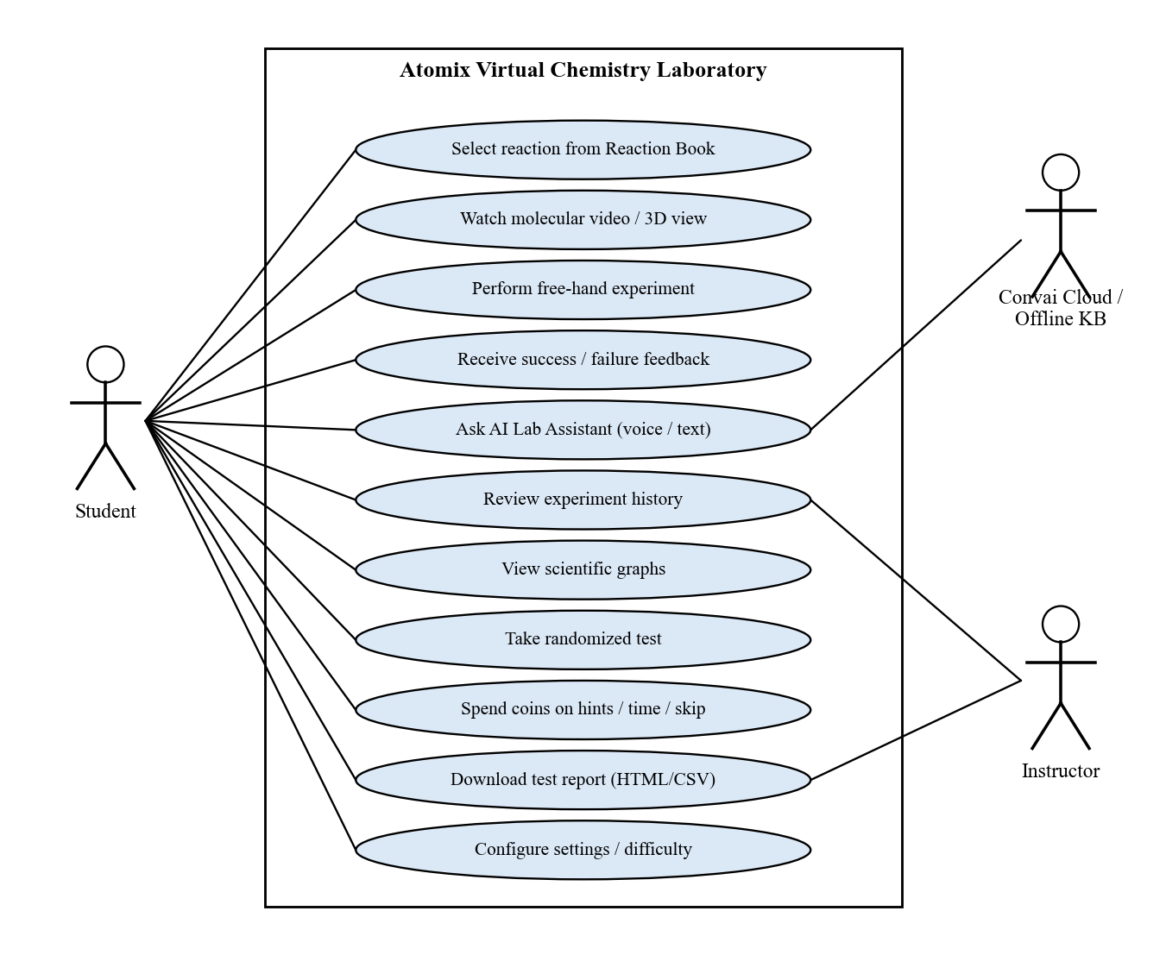
Figure 4.1: Use-case diagram of Atomix
Table 4.1 describes the three most important use cases in more detail, including their preconditions and alternative flows.
Table 4.1: Key use-case descriptions
Use case | Precondition | Main flow | Alternative flow
Perform free-hand experiment | Reaction selected in the book | Grab vessel, tilt to pour or add solid, heat if required; engine shows live quantities; mixture settles; Success | Wrong order, overdose, underdose or procedure error ends in a failure card; F5 resets the bench
Ask AI Lab Assistant | In LabScene or LabAssistantScene | Hold V or press Enter, ask; context attached; reply spoken and shown; Q&A logged | No network or credentials: offline knowledge base answers with Windows speech
Take randomized test | TestingPhaseLab loaded | Choose task count (3/5/8/10/all); timer starts; complete tasks; coins awarded; report card | Buy hint, extra time or skip with coins; time-out records the task as missed

4.2.2 Sequence Diagrams
Figure 4.2 shows the sequence of messages when a student performs an experiment. Selecting a page in the Reaction Book calls ControlReactions.SelectReaction(n), which activates only the apparatus for reaction n and configures the shared FreeHandReactionEngine from the reaction's ReactionDefinition asset. Each pour or solid addition is reported to the engine through AddQuantity. The engine's Evaluate method runs every frame; it returns InProgress until it reaches a verdict, after which the reaction script plays the corresponding visual effect, sound and equation (or the failure reason) and the attempt is written to the history manager, which serialises it to JSON.
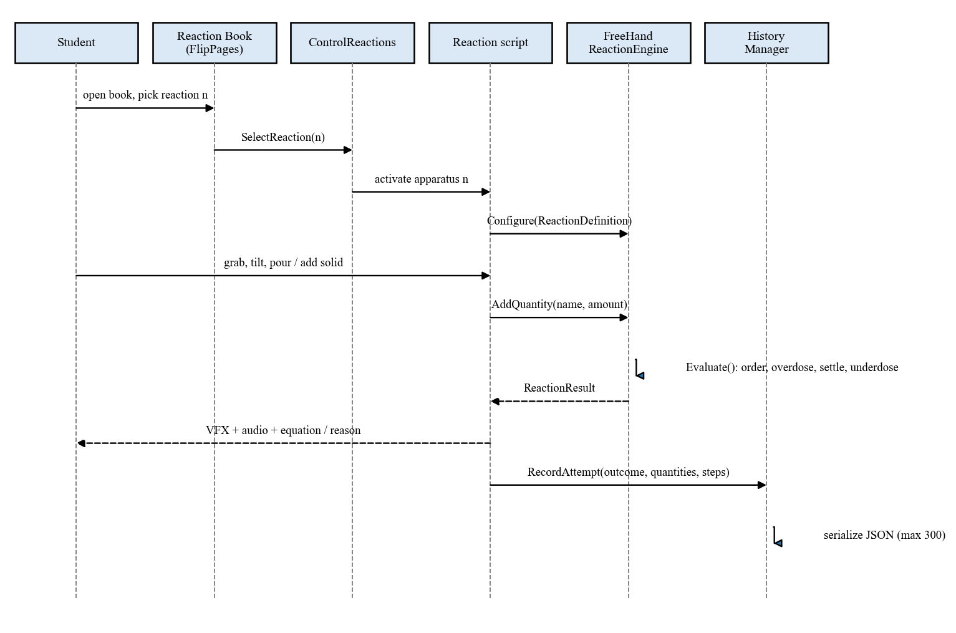
Figure 4.2: Sequence diagram - performing a free-hand experiment
Figure 4.3 shows the sequence for an AI question. The InLabAssistantController first asks the ExperimentContextProvider for the current reaction, quantities, targets, verdict and attempt counts, and sends the question together with this context to the Convai backend. If the request succeeds the reply text and audio are returned; if credentials are missing, the network fails or the quota is exhausted, the same question is answered by the ChemistryKnowledgeBase from the game's own data. In both cases the answer is spoken, shown in the assistant panel and recorded in the attempt history.
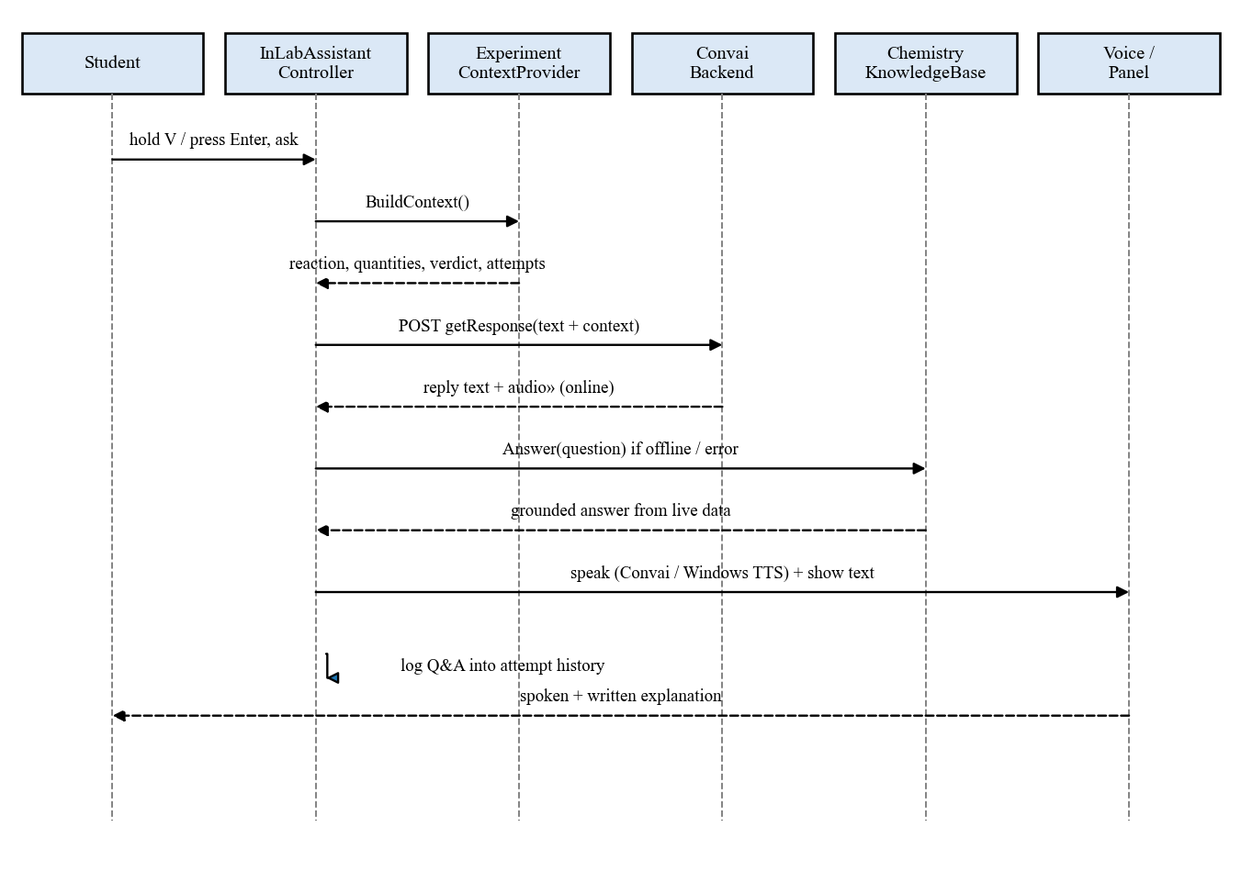
Figure 4.3: Sequence diagram - asking the context-aware AI assistant

4.2.3 State Diagram
The behaviour of the free-hand reaction engine is best described as a state machine (Figure 4.4). After Configure the engine waits for inputs. As soon as a pour starts it enters Pouring; overdose is checked on every frame, so pouring past the upper limit fails immediately even mid-pour. When all reagents are present and pouring has stopped the engine enters Settling and accumulates a settle timer; resuming a pour resets the timer and returns to Pouring. Only after 1.5 seconds of settling is underdose judged, which prevents a student who pauses between reagents from being failed unfairly. Adding a reagent out of order produces FailWrongOrder, and the heating reactions add procedure checks such as heating time and, for calcium carbonate, fitting the balloon before heating. Every terminal state can be reset with F5.
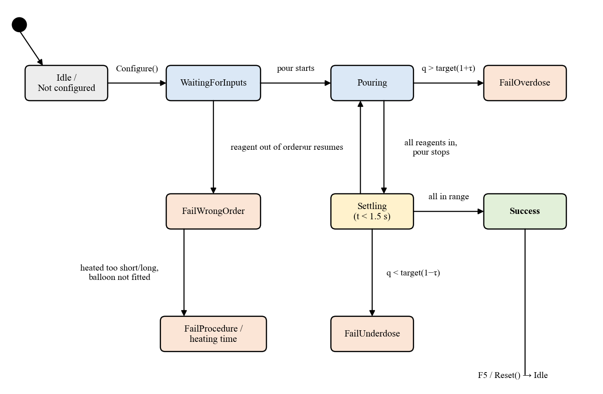
Figure 4.4: State diagram of the free-hand reaction engine

4.2.4 Data Flow Diagrams
Figure 4.5 is the context-level (level 0) DFD. Atomix exchanges data with three external entities: the student, who provides VR or keyboard-and-mouse input, voice and typed questions and receives the 3D scene, feedback, speech, graphs and scores; the Convai cloud service, which receives a question with its context and returns reply text and audio; and the local file system, which stores the experiment history and exported reports.
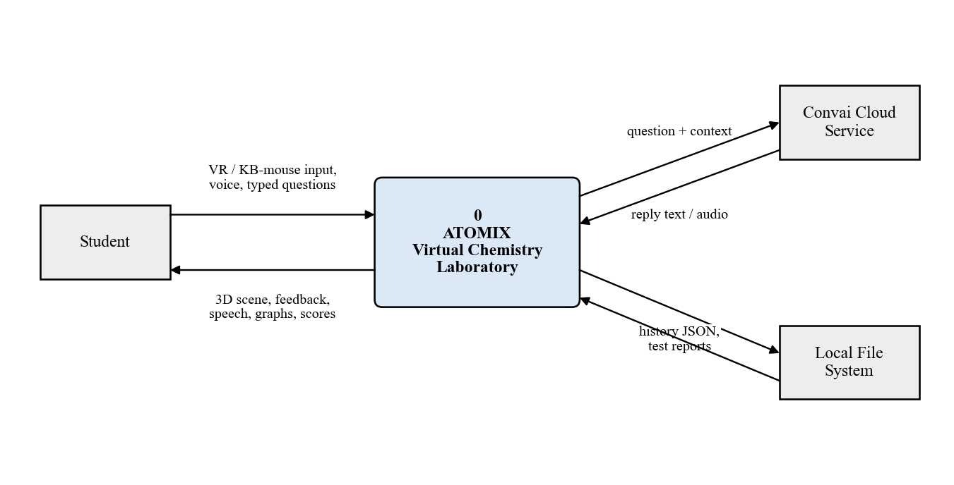
Figure 4.5: Level 0 DFD (context diagram)
Figure 4.6 decomposes the system into six processes. Input handling (1.0) unifies XR and desktop input. Reaction selection and learning (2.0) reads recipes and video clips from data store D1. Free-hand reaction evaluation (3.0) receives pour and add events, produces verdicts, and feeds live context to AI assistance (4.0). Assessment and coin economy (5.0) issues test tasks to the evaluation process and stores coins and settings in PlayerPrefs (D2). History, scoring and graphs (6.0) records attempts and AI exchanges in the history file (D3).
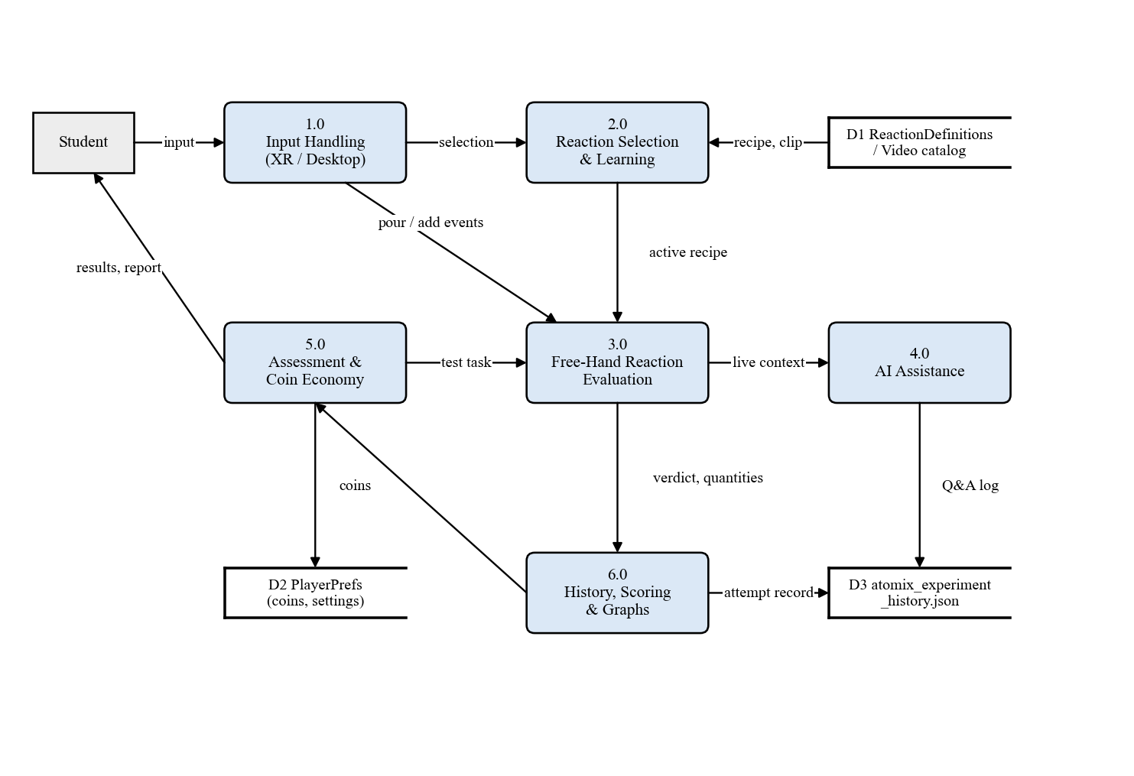
Figure 4.6: Level 1 DFD
Figure 4.7 refines process 3.0 to level 2. Reagents are registered with target, unit and tolerance (3.1); quantities are accumulated live (3.2); order and overdose are checked every frame (3.3); a settle timer runs once everything has been added (3.4); underdose and procedure rules are then checked (3.5). A successful result is scored for accuracy and stars (3.6), and every verdict is turned into visual, audio and text feedback by the feedback director (3.7) before being passed to history and to the AI context.
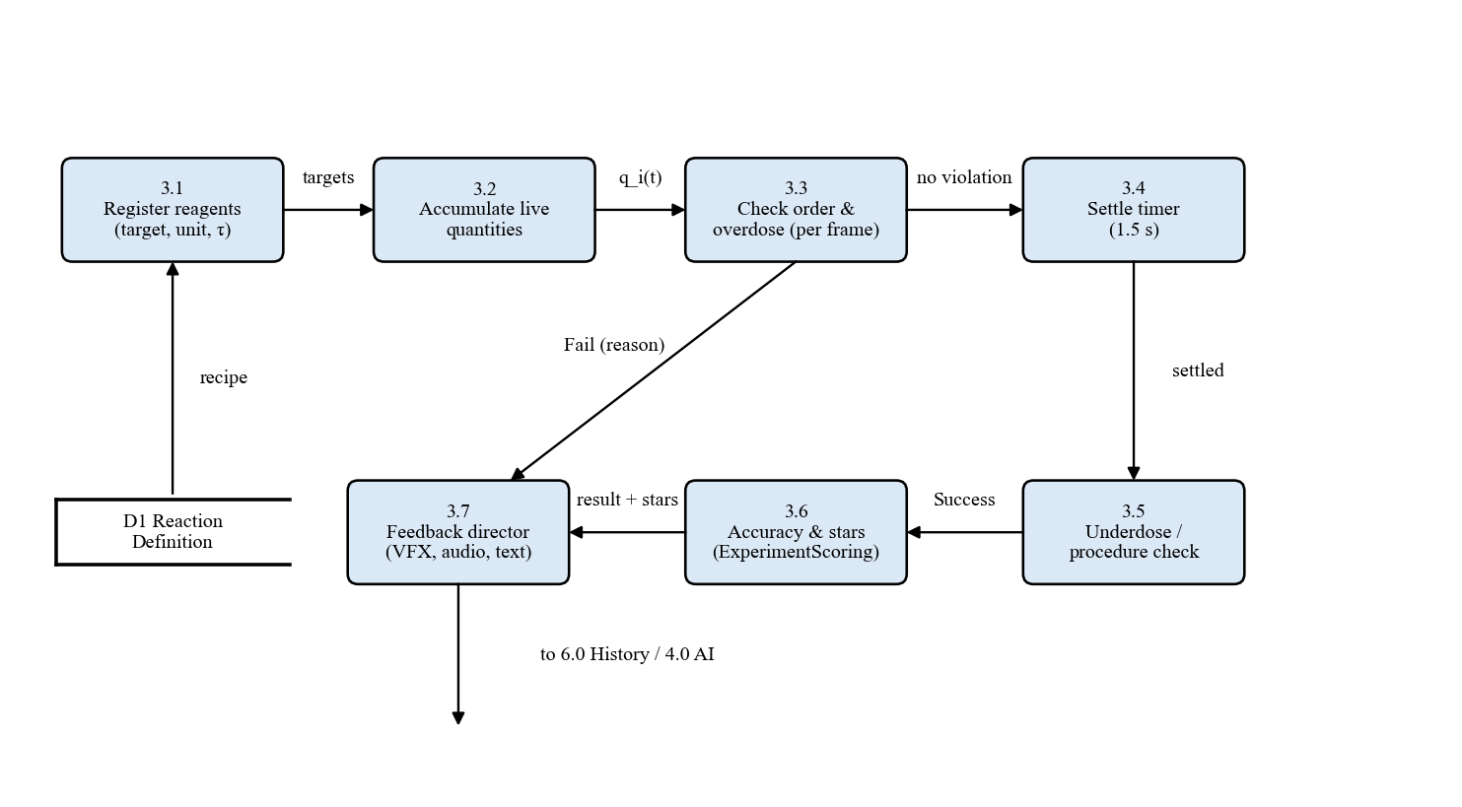
Figure 4.7: Level 2 DFD of the reaction-evaluation process

4.2.5 Class Diagram
Figure 4.8 shows the principal classes. ControlReactions owns the eight reaction objects and selects one at a time. A ReactionDefinition ScriptableObject holds the display name, tolerance, order rule and reagent list, and configures the FreeHandReactionEngine, a plain C# class whose only Unity dependency is the frame time. Each of the eight reaction scripts uses the engine, notifies the in-lab assistant, and is scored by the static ExperimentScoring class. Attempts are recorded by the ExperimentHistoryManager. The InLabAssistantController uses the Convai backend and falls back to the static ChemistryKnowledgeBase. AtomixCoinBank encapsulates prices, bonuses and rank thresholds for the testing scene.
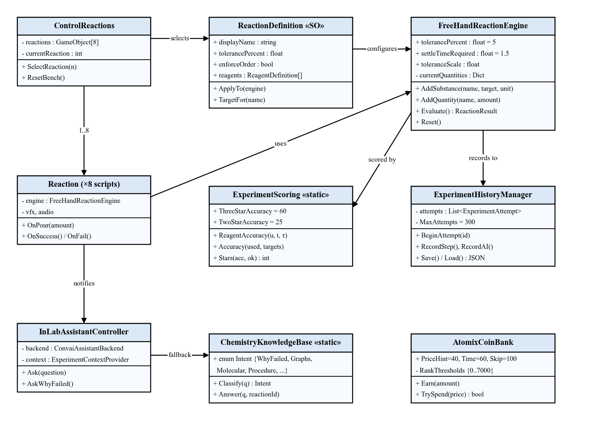
Figure 4.8: Class diagram of the core subsystems

4.2.6 Activity Diagram
Figure 4.9 shows the overall activity flow. From the main menu the user chooses one of three modes. In practice mode the Reaction Book leads to a learn-or-perform decision; performing ends either in success, which unlocks the scientific graphs and a molecular replay, or in failure, which shows the reason, invites a question to the AI and allows a retry. In test mode the user chooses the number of tasks, completes randomized practical and theory tasks under a timer, and receives coins, a report card and the exported report. In assistant mode the user converses with the AI character directly.
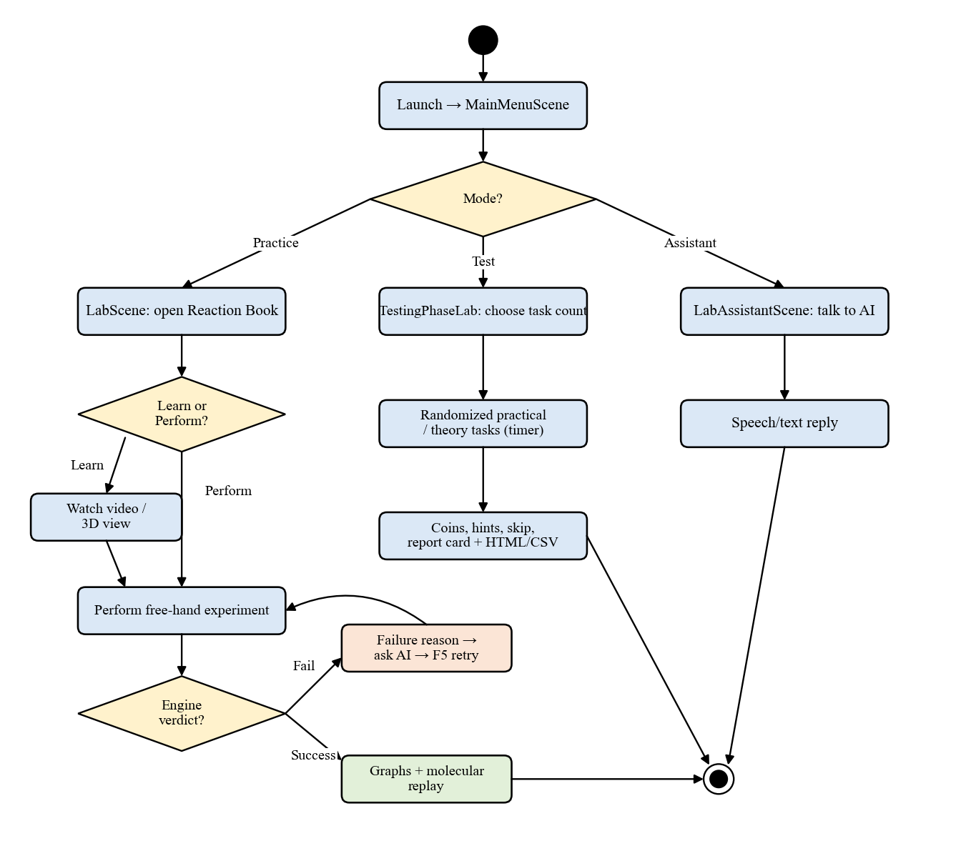
Figure 4.9: Activity diagram of the user journey

4.3 Scene Architecture
Atomix is organised into four Unity scenes. Separating the scenes keeps memory use low on a standalone headset and lets each scene own only the systems it needs. Table 4.2 lists the scenes and their responsibilities.
Table 4.2: Scene architecture
Scene | Responsibility | Key systems
MainMenuScene | Entry point; mode selection; settings | MainMenu, world-space canvas, async loader
LabScene | Practice laboratory | Reaction Book, ControlReactions, eight reactions, FreeHandReactionEngine, history, graphs, in-lab AI, periodic table
TestingPhaseLab | Assessment | Randomize, TheoreticalTasksManager, CountdownTimer, ExamSession, AtomixCoinBank, ExamReportExporter
LabAssistantScene | Dedicated AI tutor with avatar | LabAssistantCharacter, InLabAssistantController, avatar animator

4.4 Design Decisions
Several design decisions shaped the system. First, reaction rules are data, not code: targets, units, tolerances and order are stored in eight ReactionDefinition assets, so a teacher-facing change such as widening a tolerance needs no programming. Second, one engine judges every reaction, in both the practice laboratory and the testing scene, so behaviour is consistent and can be verified once. Third, the desktop mode is injected at run time by DesktopBootstrap using a RuntimeInitializeOnLoadMethod hook, so the VR scenes did not have to be duplicated. Fourth, the AI has two brains: a cloud model for open conversation and a grounded offline knowledge base that is, for this bench, more precise because it reads the live measurements. Fifth, failure is a first-class outcome: every failure path has a chemistry-specific message and a sound designed not to punish, because a learner is expected to fail many times while practising.

CHAPTER 5: METHODOLOGY

5.1 Introduction
This chapter explains how Atomix works internally. It first presents the development methodology and the layered system architecture, then details the algorithms that make the laboratory quantity-aware, the scoring model, the AI routing and intent classification, the molecular animation, the thermodynamic model behind the graphs and the assessment economy. Mathematical formulations are given where the behaviour is numerical.

5.2 Development Methodology
Atomix was developed with an incremental, phase-wise process (Figure 5.1). An initial pass through requirement analysis, laboratory design, 3D modelling, interaction design, reaction-engine development, AI integration, assessment and verification produced a working prototype. The prototype was then extended through ten feature-and-fix iterations (internally called Tasks 1 to 10), each of which began with an analysis of the existing code, implemented a focused set of changes, compiled them against the real Unity assemblies and executed automated checks against the shipped logic before being merged. Play-testing feedback from each iteration (for example, glassware that could not be grabbed in the testing scene, or the room tone sounding like a running tap) fed the next iteration.
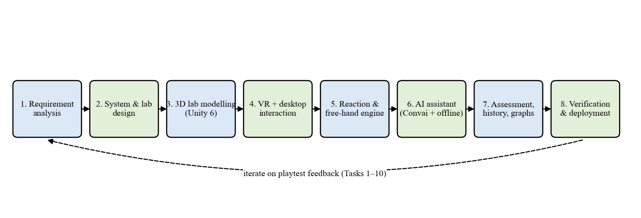
Figure 5.1: Phase-wise development methodology

5.3 System Block Diagram
Figure 5.2 shows the layered architecture of Atomix. It is presented here, before the algorithms, because each algorithm in this chapter lives in one of these layers.
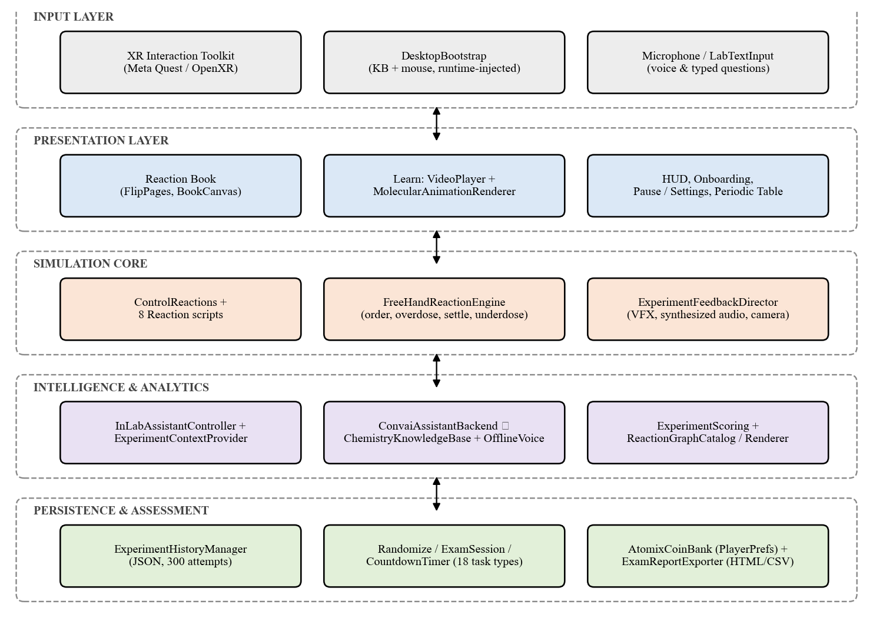
Figure 5.2: System block diagram of Atomix
Input layer. On a headset, the XR Interaction Toolkit provides grab, socket and locomotion interactions. Without a headset, DesktopBootstrap injects a first-person controller, a centre-screen crosshair, ray-based object interaction and keyboard bindings. Questions arrive from the microphone (push-to-talk) or from LabTextInput, which captures typed text and globally gates the keyboard so that typing a question does not move the player.
Presentation layer. The Reaction Book (FlipPages, BookCanvasManager) lists the reactions by category. The learning panel plays recorded MP4 clips through Unity's VideoPlayer or renders a live molecular animation to a RenderTexture. HUD elements include the objective line, onboarding card, measurement tooltip and tracker, the pause and settings menu and an interactive 118-element periodic table.
Simulation core. ControlReactions activates the chosen reaction; each of the eight reaction scripts translates object interactions into quantities for the FreeHandReactionEngine, and the ExperimentFeedbackDirector turns verdicts into effects, synthesized sounds and camera feedback.
Intelligence and analytics. The InLabAssistantController builds context through ExperimentContextProvider and routes questions to the Convai backend or the offline ChemistryKnowledgeBase. ExperimentScoring rates attempts and the ReactionGraphCatalog and Renderer draw the scientific graphs.
Persistence and assessment. ExperimentHistoryManager stores attempts as JSON; Randomize, ExamSession and CountdownTimer run the test; AtomixCoinBank persists the wallet in PlayerPrefs; ExamReportExporter writes the HTML and CSV report.

5.4 Reaction Recipes
Every experiment is described by a recipe stored in a ReactionDefinition asset. Table 5.1 lists the recipes exactly as shipped. Liquids are measured in millilitres, solids in grams and heating in seconds, and every recipe enforces the order of addition. Tolerances are tighter for the violent alkali-metal reactions (5 %) and looser for the heating reactions (15 %), where timing by hand is inherently less precise.
Table 5.1: Reaction recipes used by the free-hand engine
# | Reaction | Reagents and targets (in order) | Tolerance τ
1 | 2Na + 2H₂O → 2NaOH + H₂ | Water 50 ml; Sodium 5 g | ± 5 %
2 | H₂SO₄ + CuO → CuSO₄ + H₂O | H₂SO₄ 20 ml; CuO 8 g | ± 8 %
3 | HCl + NaHCO₃ → NaCl + H₂O + CO₂ | HCl 15 ml; NaHCO₃ 12 g | ± 10 %
4 | 2K + 2H₂O → 2KOH + H₂ | Water 50 ml; Potassium 3 g | ± 5 %
5 | 2Al + 3I₂ → 2AlI₃ | Aluminium 5 g; Iodine 15 g; Water drops 2 ml | ± 10 %
6 | CaO + H₂O → Ca(OH)₂ | Water 30 ml; CaO 15 g | ± 8 %
7 | CaCO₃ → CaO + CO₂ (heat) | Heating 10 s (balloon fitted first) | ± 15 %
8 | 2FeSO₄ → Fe₂O₃ + SO₂ + SO₃ (heat) | Heating 10 s | ± 15 %

5.5 Free-Hand Reaction Evaluation Algorithm
The FreeHandReactionEngine replaces the original fixed-sequence triggers. Let reagent i have target T_{i}, tolerance τ_{i} (per cent) and live quantity q_{i}(t). A difficulty level multiplies every tolerance by a scale factor s, so the accepted range of each reagent is given by Equations (5.1) and (5.2).
q_{i}^{min} = T_{i} (1 − s·τ_{i} / 100) (5.1)
q_{i}^{max} = T_{i} (1 + s·τ_{i} / 100) (5.2)
where the scale factor s is 1.5 for the Guided level, 1.0 for Standard and 0.6 for Expert.
For a liquid, q_{i} is integrated from the pour rate, which depends on how far the vessel is tilted: dq_{i}/dt = r(θ) while θ exceeds the pour threshold. For a solid, q_{i} increases in discrete additions, and for a heating step q_{i} is the accumulated time spent over the lit burner. The engine evaluates the following algorithm on every frame:
- If the engine is not configured or has already produced a verdict, return the stored state.
- Order check. If order is enforced and a reagent has been added while an earlier reagent in the recipe is still absent, return FailWrongOrder with the recipe's order message.
- Overdose check. For each reagent, if q_{i}(t) > q_{i}^{max}, return FailOverdose immediately, with the reagent-specific overdose message (overdose is detected mid-pour).
- If any vessel is still pouring, reset the settle timer, set the state to Pouring and return InProgress.
- If no reagent, or not every reagent, has been added, reset the settle timer, set the state to WaitingForInputs and return InProgress.
- Settling. Otherwise add the frame time Δt to the settle timer t_{s}; while t_{s} < 1.5 s return InProgress (state Settling).
- Underdose check. For each reagent, if q_{i} < q_{i}^{min}, return FailUnderdose with the reagent-specific message.
- Procedure check. For heating reactions, verify heating duration and procedure preconditions (for CaCO₃, the balloon must be fitted before heating); otherwise return the procedure failure.
- Return Success; compute accuracy and stars (Section 5.6); record the attempt.
The settling rule can be written formally as Equation (5.3), where P(t) is true while any pour is in progress and A(t) is true when every reagent has a non-zero quantity:
t_{s} ← (t_{s} + Δt) · [A(t) ∧ ¬P(t)] (5.3)
Here [·] is 1 when the condition holds and 0 otherwise, so the timer restarts whenever pouring resumes; underdose is judged only once t_{s} ≥ 1.5 s.
Figure 5.3 visualises the accepted windows for every reagent at the three difficulty levels. The Guided level widens each window by half for a first attempt, while the Expert level, unlocked by passing Standard, narrows it to 60 % and hides the targets.
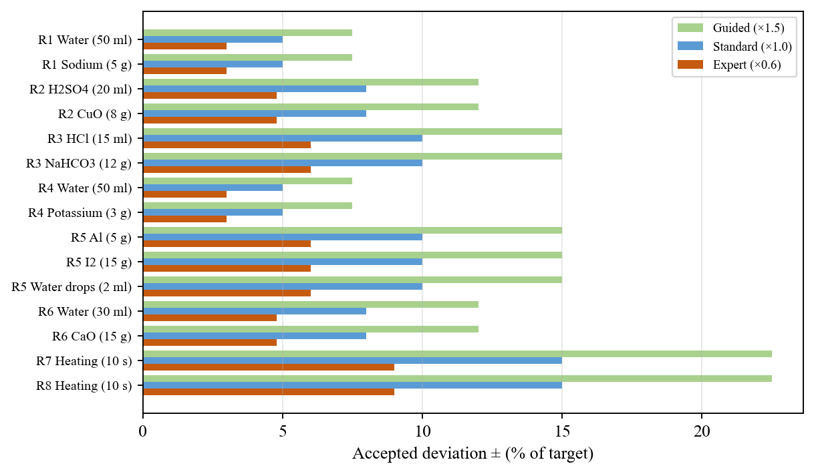
Figure 5.3: Accepted deviation per reagent at the three difficulty levels
Table 5.2 lists the verdicts the engine can return and the feedback associated with each.
Table 5.2: Engine verdicts and feedback
Verdict | Trigger | Feedback to the learner
Success | All quantities within range after settling; procedure correct | Reaction effect, sound, balanced equation, accuracy and stars, graphs unlocked
FailOverdose | Any q_{i} > q_{i}^{max} (checked every frame) | Reagent-specific chemistry reason, e.g. excess reagent pushes mixture away from the balanced equation
FailUnderdose | Any q_{i} < q_{i}^{min} after 1.5 s settling | Which reagent was short and its chemical consequence
FailWrongOrder | Reagent added before an earlier one | Why the order of addition matters for this reaction
Procedure failure | Heating too short/long; balloon not fitted (CaCO₃) | e.g. CO₂ escaped into the room instead of being collected

5.6 Accuracy and Star Rating Model
Before scoring existed, a titration that landed exactly on the mark and one that scraped in at the edge of the tolerance produced the same result. ExperimentScoring now converts every successful attempt into an accuracy percentage. Each reagent scores 1 when exactly on target, falling linearly to 0 at the edge of its accepted range (Equation 5.4); the experiment scores its least accurate reagent (Equation 5.5).
a_{i} = clamp( 1 − |q_{i} − T_{i}| / (T_{i} · τ_{i} / 100), 0, 1 ) (5.4)
A = 100 · min_{i} a_{i} (5.5)
The minimum rather than the mean is used so that one careful measurement cannot compensate for a careless one, and so that a reagent added as a fixed lump (such as the sodium block, which is always exact) cannot inflate the score. Scoring always uses the recipe's Standard tolerance, so three stars mean the same precision on every difficulty level. Stars are then assigned by Equation (5.6).
stars = 3 if A ≥ 60; 2 if 25 ≤ A < 60; 1 otherwise (5.6)
A failed attempt always receives zero stars, and a successful attempt always receives at least one.
Figure 5.4 plots Equation (5.4) for reaction 2 (H₂SO₄, target 20 ml, τ = 8 %). The accepted window is 18.4-21.6 ml; three stars require every reagent within 40 % of the allowed deviation, i.e. within ±0.64 ml of the target.
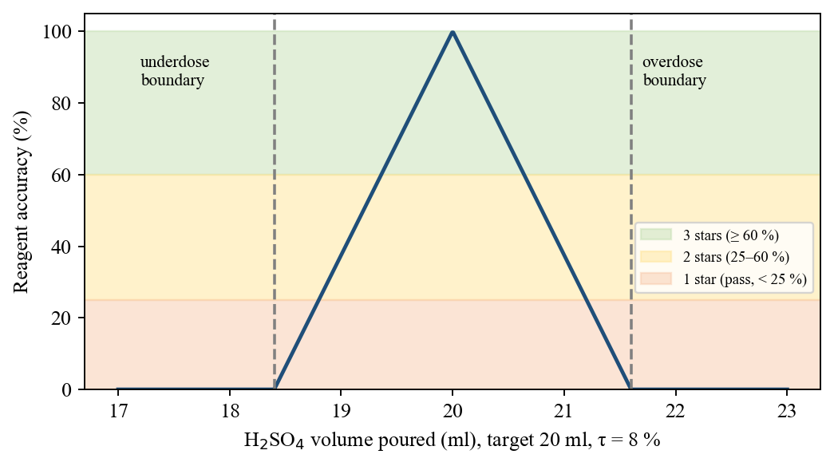
Figure 5.4: Reagent accuracy function and star bands for H2SO4 in reaction 2

5.7 AI Assistant: Context Building, Routing and Intent Classification
Figure 5.5 shows how a question is processed. Questions can come from push-to-talk (V), typed input (Enter), the "why did it fail" shortcut (Y), or the "Ask AI" buttons on the graph and molecular panels. The context builder serialises the current reaction, the measured quantities, the targets and accepted ranges, the verdict and failure reason, and the number of previous and successful attempts. If credentials and network are available, the question and context are posted to the Convai character endpoint, which returns text and synthesized speech. On missing credentials, network error, time-out or exhausted quota, the question is routed to the offline ChemistryKnowledgeBase.
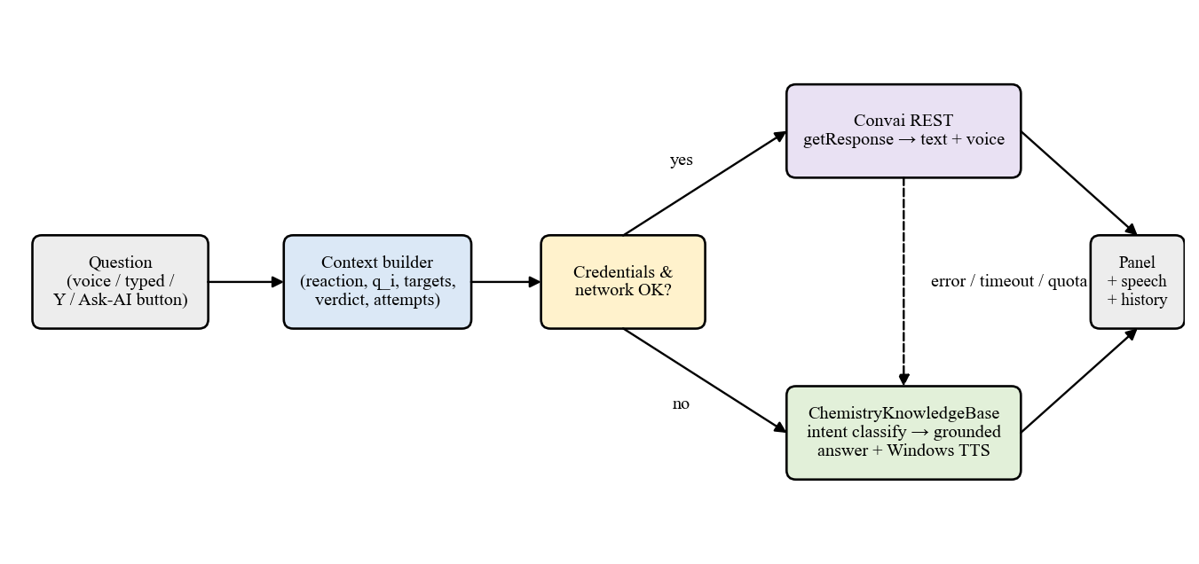
Figure 5.5: Dual-path routing of AI questions
The offline knowledge base is a grounded lookup rather than a language model. It classifies the question into an intent by keyword scoring and answers from the game's own data. If S_{k}(q) is the number of keyword matches of question q for intent k, the chosen intent is given by Equation (5.7):
k* = argmax_{k} S_{k}(q); k* = Overview if max_{k} S_{k}(q) = 0 (5.7)
Table 5.3 lists the intents together with an example question and the data each answer is drawn from.
Table 5.3: Offline assistant intents and answer sources
Intent | Example question | Answer source
WhyFailed | Why did my experiment fail? | Engine verdict, offending reagent, used vs. target
Quantities | How much water do I need? | ReactionDefinition targets and ranges
Procedure | What do I do next? | Recipe order and procedure steps
WhatHappened | What happened in the beaker? | Reaction facts and products
Molecular | What is the yellow dot? | Molecular scene stage captions
Graphs | Explain the energy graph | ReactionGraphCatalog values (ΔH, Ea, ΔS, ΔG)
Calculation | Is this reaction spontaneous? | Derived Gibbs energy and crossover temperature
Safety | Is this dangerous? | Per-reaction safety facts
Progress | How am I doing? | Experiment history counts
Overview | (no keyword matched) | Reaction summary

Because it reads live measurements, the offline path can give precise, personal answers such as "you poured 27.4 ml where the equation needs 20.0, a 37 % overdose", which a generic cloud model cannot do without the context. Offline replies are spoken through the Windows speech synthesiser; on other platforms they are shown as text.

5.8 Molecular Animation Model
The live 3D view is authored entirely in code: MolecularSceneCatalog defines, for each of the eight reactions, a sequence of stages containing atoms (element, position, CPK colour) and bonds, and MolecularAnimationRenderer interpolates between stages and renders the result into a RenderTexture shown on the learning panel. Three visual encodings make the chemistry explicit: a bond that thins and turns red is breaking, a bond that thickens in green is forming, and a travelling yellow dot is an electron being transferred. Electron transfer is shown only for the redox reactions (1, 4, 5 and 8); the non-redox reactions such as 2, 3 and 6 deliberately show none, and the caption of reaction 2 says so. Heating stages shake the molecule and warm the background, and a step counter and progress bar show the position in the sequence. The automated checks for this module verify atom conservation between stages and bond lengths.

5.9 Thermodynamic Model for Scientific Graphs
After a successful experiment the learner can open three graphs: an energy profile, an exothermic/endothermic diagram and an entropy comparison. Each reaction has one entry in the ReactionGraphCatalog holding its enthalpy change ΔH, activation energy E_{a} and entropy change ΔS. ΔH and ΔS were derived from standard thermodynamic data for the equations used; activation energies are literature-plausible values exposed as editable fields. The catalog derives further quantities, given by Equations (5.8) to (5.10).
ΔG(T) = ΔH − T·ΔS / 1000 (5.8)
T* = 1000 · ΔH / ΔS (5.9)
E_{a,rev} = E_{a} − ΔH (5.10)
In these equations ΔH, ΔG and E_{a} are in kJ/mol and ΔS in J/mol·K (hence the factor 1000); T* is the crossover temperature at which ΔG changes sign, meaningful only when ΔH and ΔS have the same sign; and E_{a,rev} is the activation energy of the reverse reaction.
Figure 5.6 shows energy profiles drawn from these values for an exothermic reaction (sodium and water) and an endothermic one (calcium carbonate decomposition). The contrast between a 10 kJ/mol barrier and a 185 kJ/mol barrier explains, at a glance, why the first reaction starts on contact while the second needs a burner.
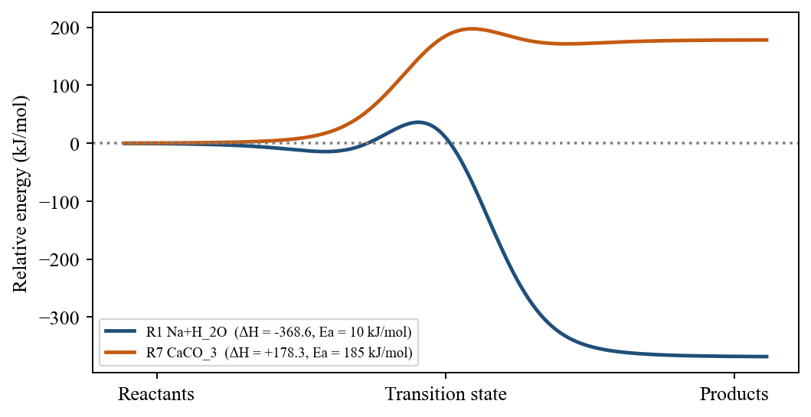
Figure 5.6: Energy profiles generated from catalog data for reactions 1 and 7

5.10 Assessment and Coin Economy
The testing scene draws tasks from eight practical tasks and ten theory questions (eighteen task types). A setup screen asks for the run length (3, 5, 8, 10 or all), clamped to what the selected mix contains: 10 for theory only, 8 for practical only and 18 for both. The countdown is held until a choice is made. Practical tasks are judged by the same free-hand engine as the laboratory, with targets hidden. Coins are earned per task, between 5 and 100 according to the time remaining, with bonuses for a first-ever clear, streaks and an unaided run, and can be spent on help. The lifetime total L and spent total S persist in PlayerPrefs; the balance and rank are computed by Equations (5.11) and (5.12), where θ = {0, 500, 1500, 3500, 7000} are the rank thresholds. Table 5.4 lists all parameters of the economy.
B = max(0, L − S) (5.11)
rank = max{ r : L ≥ θ_{r} }, progress = (L − θ_{r}) / (θ_{r+1} − θ_{r}) (5.12)
Table 5.4: Coin-economy parameters
Parameter | Value
Earning per task | 5-100 coins, scaled by time left
Bonuses | First-ever clear +25; 3-streak +30; 5-streak +60; perfect unaided run +50
Purchases | Hint 40 (F2); +30 seconds 60 (F3); skip task 100 (F4)
Ranks | Apprentice (0), Lab Technician (500), Chemist (1500), Senior Chemist (3500), Lab Master (7000)
Hint content | Procedure only, never the quantity - the amount is what the test measures

5.11 Frame-Rate-Independent Interaction Smoothing
Held objects and UI panels follow their targets smoothly. An early implementation used x ← Lerp(x, target, k·Δt), which is frame-rate dependent: a beaker followed the crosshair visibly harder at 144 Hz than at 60 Hz and overshot below 1/k frames per second. It was replaced by the exponential form in Equation (5.13), which gives the same motion at any frame rate.
x ← x + (x_{target} − x) · (1 − e^{−k·Δt}) (5.13)

5.12 Data Persistence
Each attempt is stored as an ExperimentAttempt record containing a unique identifier, reaction identifier and name, timestamp, duration, outcome, quantities used, target quantities, the ordered list of steps with their correctness, accuracy, stars and the AI questions and answers. The list is serialised to atomix_experiment_history.json in Unity's persistentDataPath and capped at 300 attempts, discarding the oldest. Coins, settings and achievements are stored in PlayerPrefs. Test reports are written to the Desktop, falling back to Documents and then to persistentDataPath if the Desktop is not writable.

CHAPTER 6: IMPLEMENTATION DETAILS

6.1 Introduction
Atomix was implemented in C# on Unity 6000.3.7f1 with the Built-in Render Pipeline. The project contains 110 C# scripts totalling 39,601 lines, four scenes, eight ReactionDefinition assets, seven recorded molecular MP4 clips and a set of free 3D laboratory models. This chapter describes the implementation of each module and presents the user interface. Screenshot placeholders marked [INSERT SCREENSHOT] must be replaced with captures from the final build before submission.
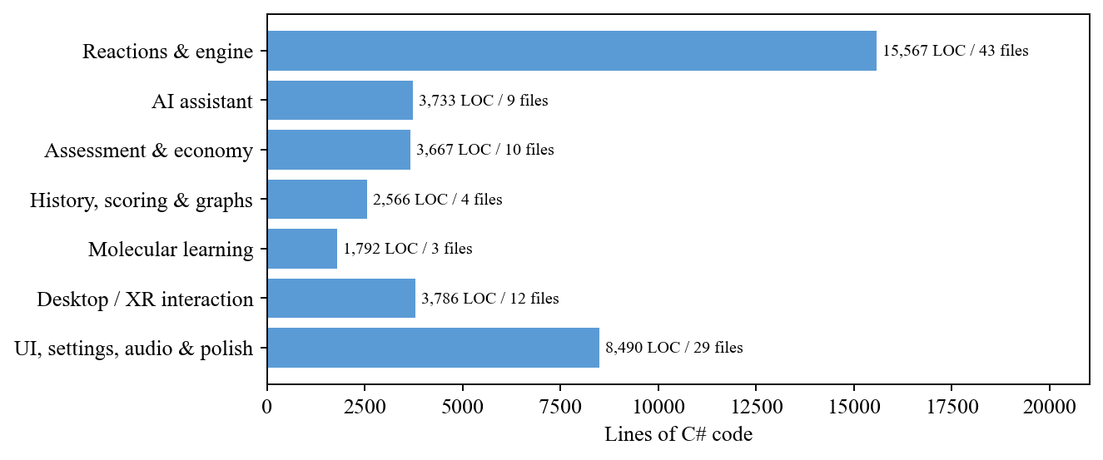
Figure 6.1: Distribution of the 39,601 lines of C# code across subsystems
Figure 6.1 shows how the code is distributed. The reaction scripts and engine form the largest group because each of the eight reactions has a laboratory script, a test-scene script and helpers for pouring and filling; the UI, settings, audio and presentation group is second, reflecting the effort spent on usability and comfort.

6.2 System Implementation

6.2.1 Laboratory Environment and Main Menu
The laboratory scene (Figure 6.2) was assembled from free 3D models of benches, cupboards, a blackboard, a sink, a microscope, a periodic-table poster and glassware such as Erlenmeyer flasks, Berzelius beakers, test tubes and pipettes. Lighting, ambient occlusion and a box-projected reflection probe give the glassware believable reflections of the room. The capture in Figure 6.2 shows the iron(II) sulfate experiment set up on the bench, with the assistant character's speech bubble explaining that the Bunsen burner is lit by pressing its button. The main menu (Figure 6.3) is a world-space canvas offering the practice laboratory, the testing scene, the assistant scene, settings and exit.
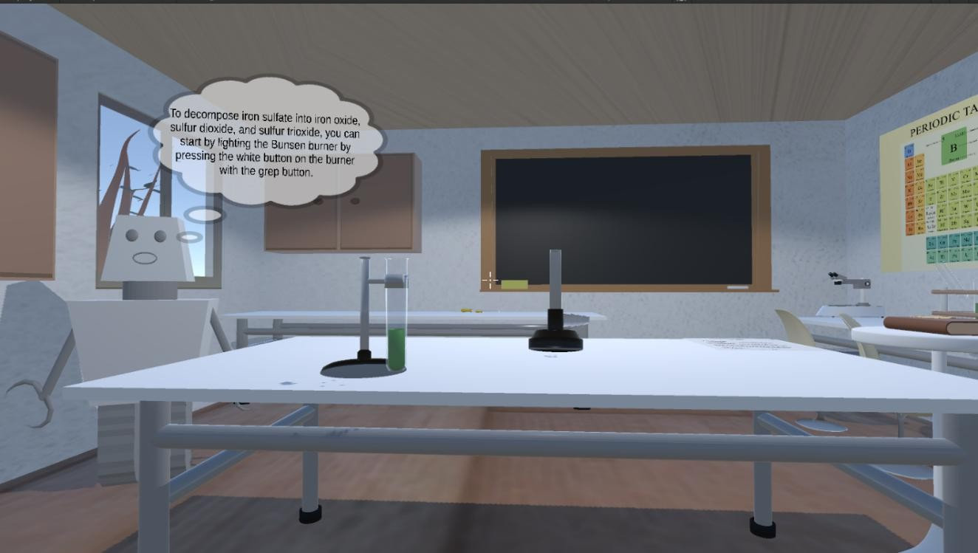
Figure 6.2: The Atomix virtual laboratory with the FeSO4 experiment set up and assistant guidance
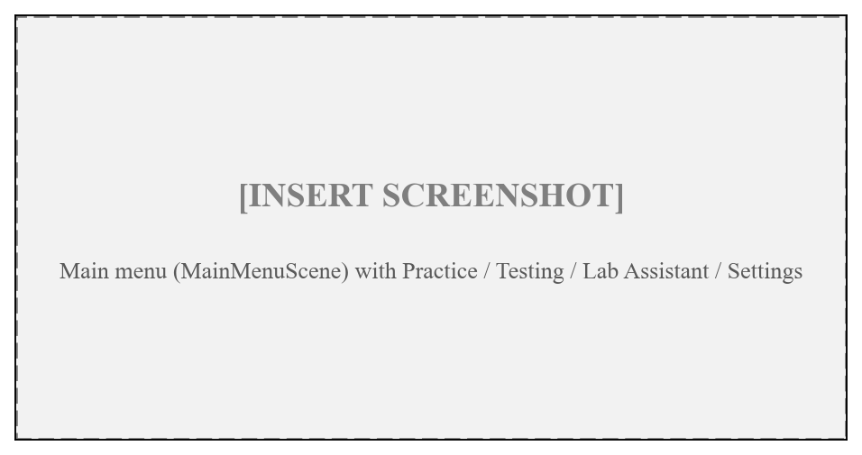
Figure 6.3: Main menu

6.2.2 Reaction Book and Learn-Before-Perform
The Reaction Book (Figure 6.4) is a world-space book whose pages are turned with the controller, the mouse or the arrow keys; keys 1-8 select a reaction directly. Each reaction page offers LEARN and PERFORM and a difficulty selector (Guided, Standard, Expert). Choosing LEARN opens the learning panel. The ReactionLearningController looks up the reaction in the ReactionLearningVideoCatalog and plays the clip (Figure 6.5); the 3D VIEW button switches to the live molecular animation (Figure 6.6). The "Ask AI" button on this panel asks the assistant about the exact stage on screen.
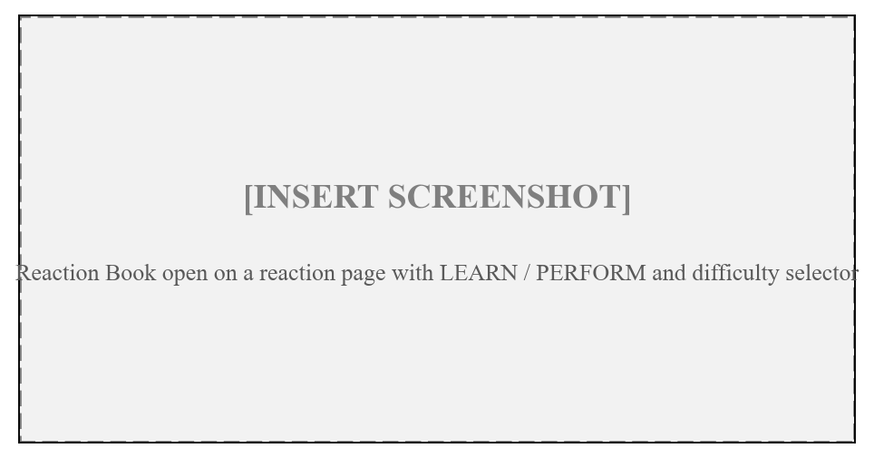
Figure 6.4: Reaction Book with LEARN / PERFORM and difficulty selection
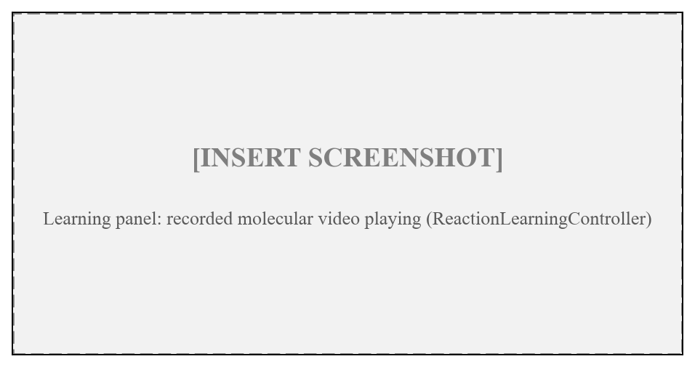
Figure 6.5: Learning panel playing a recorded molecular video
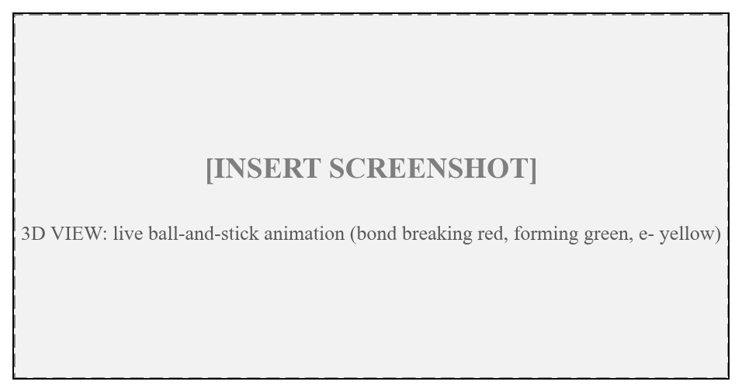
Figure 6.6: Live 3D molecular animation (bond breaking, forming and electron transfer)

6.2.3 Free-Hand Experimentation and Feedback
When PERFORM is chosen, ControlReactions enables only the apparatus of that reaction and configures the engine from its recipe. Pouring is implemented by monitoring the tilt of a held vessel; beyond a threshold angle a pour particle stream is emitted and the receiving vessel's quantity increases at a tilt-dependent rate. A floating measurement tooltip and a tracker panel (Figure 6.7) show the live amounts and, at Guided and Standard levels, the targets and ranges. The L key toggles the label between full, compact and off. When the engine reaches a verdict, the ExperimentFeedbackDirector plays the success arpeggio or the gentle failure tones, shakes the camera on violent reactions, and shows either the balanced equation with accuracy and stars or a failure card with the chemistry-specific reason (Figure 6.8). Pressing F5 reloads the bench and re-selects the same experiment.
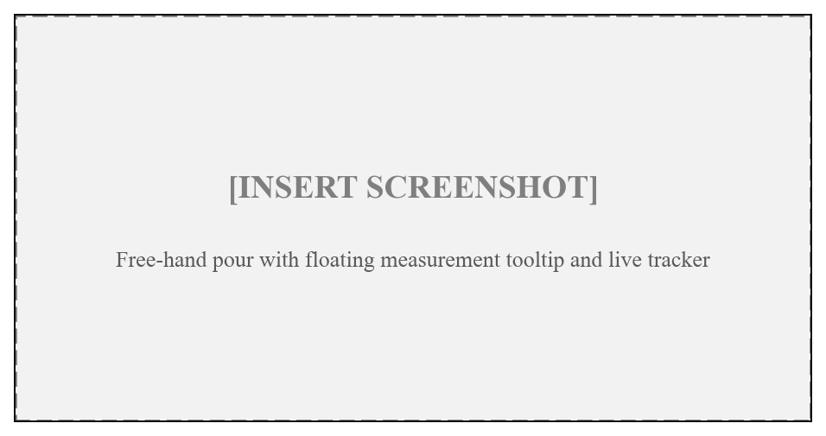
Figure 6.7: Free-hand pouring with live measurement tooltip and tracker
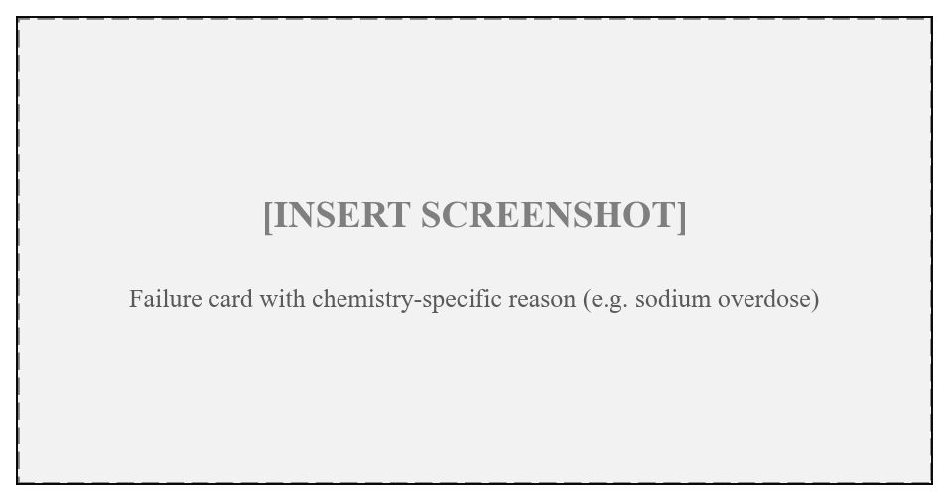
Figure 6.8: Chemistry-specific failure card

6.2.4 Experiment History and Scientific Graphs
The Tab key opens the Experiment History panel (Figure 6.9), which lists attempts newest first with colour coding for success, failure and abandoned attempts, a reaction filter, and expandable details showing used versus target quantities, every step and the AI exchanges. The F key opens the scientific graphs (Figure 6.10), drawn by ReactionGraphRenderer from the catalog: the energy profile with E_{a}, ΔH and the transition state; the enthalpy diagram with the direction of heat flow; and the entropy chart comparing all eight reactions on a common axis. Each graph has an "Ask AI to Explain" action that sends the graph's values to the assistant.
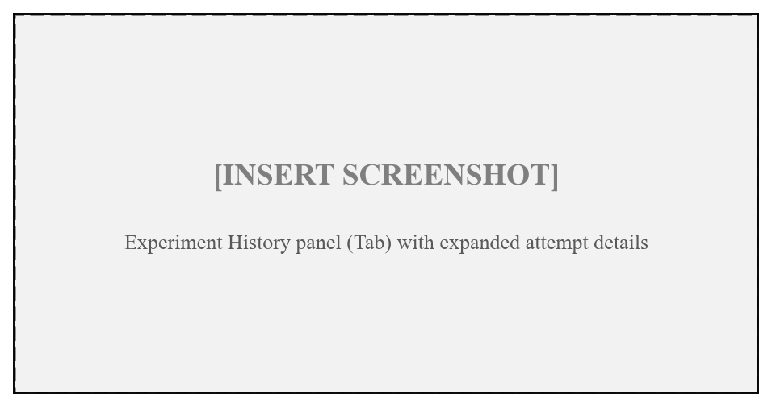
Figure 6.9: Experiment History panel
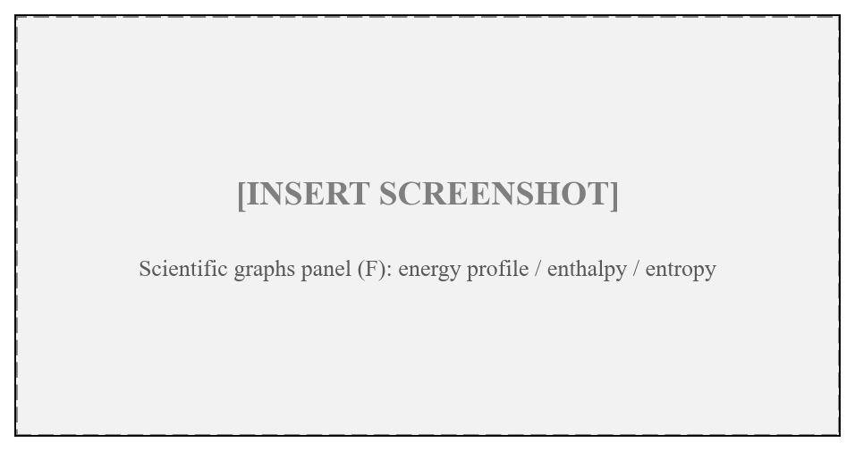
Figure 6.10: Scientific graphs panel

6.2.5 In-Laboratory AI Assistant
The assistant panel sits at the right edge of the view so that it does not obstruct the bench (Figure 6.11). Holding V records from the microphone; pressing Enter opens a text field managed by LabTextInput, which takes over the keyboard while open and is refused mid-pour so that a tipped beaker is never frozen. Y asks why the last experiment failed and M minimises the panel. ConvaiAssistantBackend posts the text and context to the Convai character endpoint using UnityWebRequest; the reply text is shown and the returned audio is played. The OfflineVoice class drives the Windows speech synthesiser for offline answers.
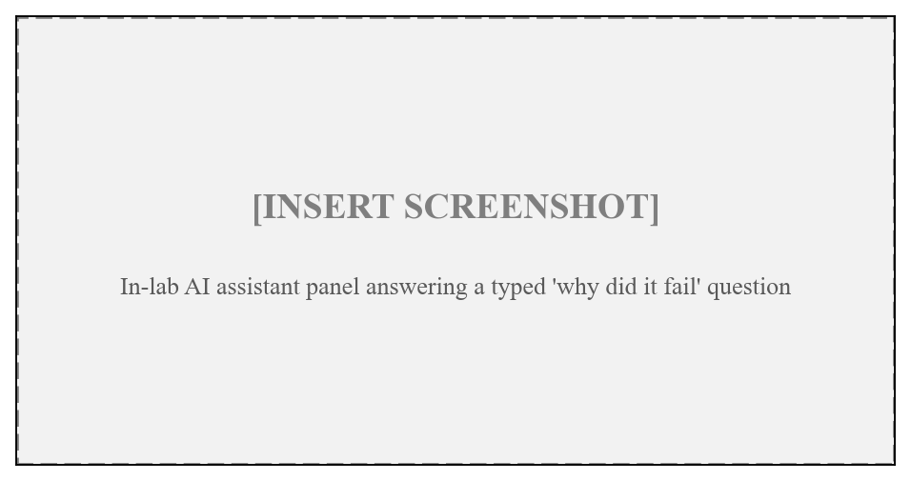
Figure 6.11: In-lab AI assistant answering a typed question

6.2.6 Testing Scene, Coin Economy and Reports
On entering TestingPhaseLab the ExamSetupUI asks for the number of tasks (Figure 6.12). Randomize selects practical reactions and TheoreticalTasksManager presents multiple-choice questions such as the colour of phenolphthalein in a basic solution or the gas produced by sodium bicarbonate and hydrochloric acid. ExamCoinHud shows the wallet and the F2/F3/F4 shop. ExamSession records every task, including skipped and timed-out ones, and at the end TestResultsUI shows a report card with grade, passed/total, coins and time. "Download this test report" writes a self-contained HTML file and a CSV file (Figure 6.13); "Retake the test" reloads the scene.
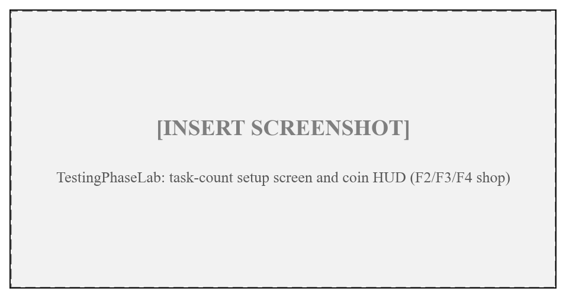
Figure 6.12: Testing scene setup and coin HUD
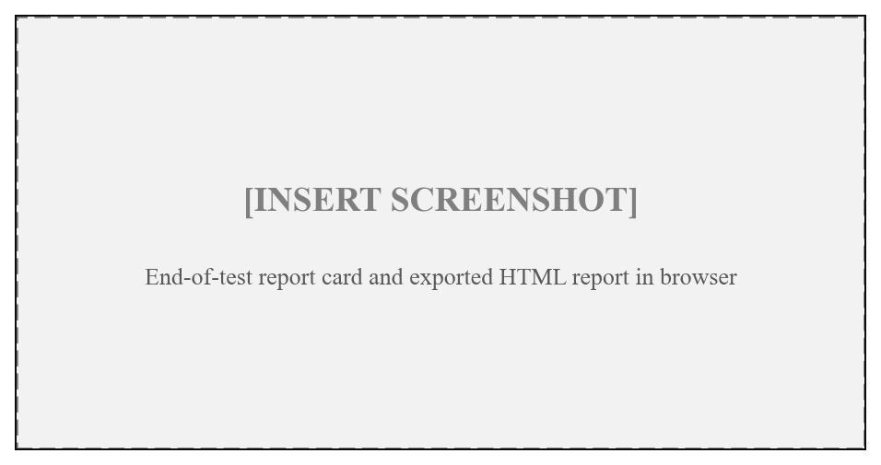
Figure 6.13: Report card and exported HTML test report

6.2.7 Periodic Table, Settings and Presentation
The P key opens an interactive periodic table of all 118 elements with an element card (Figure 6.14). F1 opens the pause menu (Figure 6.15) with settings, 13 achievements derived from the history, and a controls reference. Settings cover master volume and three audio buses, camera shake, walking motion (off by default to avoid motion sickness), post-processing, quality, full-screen mode and a frame-rate cap. All interface and handling sounds are synthesised at run time from a single D-major pitch palette, so no audio files had to be imported; grab sounds are pitched by object size. Scene changes load asynchronously behind a fade with a chemistry tip, replacing a blocking load that froze the window.
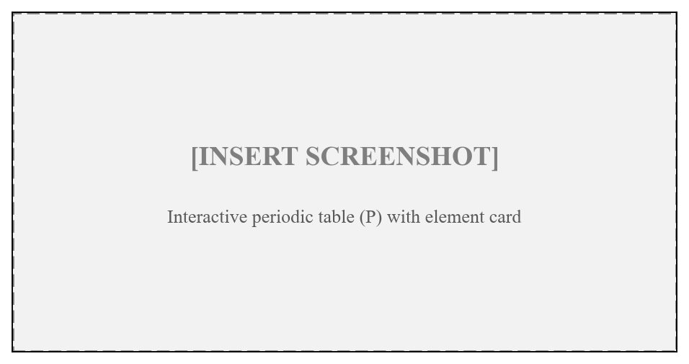
Figure 6.14: Interactive periodic table
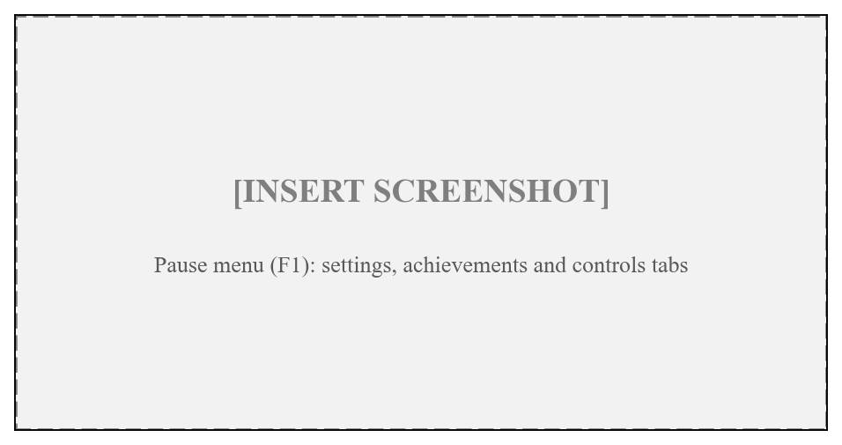
Figure 6.15: Pause menu with settings, achievements and controls

6.3 Desktop Mode Implementation
DesktopBootstrap uses Unity's RuntimeInitializeOnLoadMethod attribute so that, when no XR device is active, it runs after each scene loads and adds the desktop components: a FirstPersonController with walking, sprint and fly, a crosshair, an ObjectInteraction ray that grabs DesktopInteractable and ObjectGrabbable objects, a LabBoundary clamp that keeps the player inside the room, and a DesktopObjectSettler that lowers glassware authored slightly above the bench onto the surface below it. Table 6.1 lists the desktop controls.
Table 6.1: Desktop controls
Input | Action | Input | Action
W A S D / Mouse | Move / look | Tab | Experiment history
Left Shift | Sprint | F | Scientific graphs
Space / Ctrl | Fly up / down | P | Periodic table
Left click | Grab / release / interact | L | Measurement label mode
Q / E, Z / X, C | Rotate, tilt, roll held object | F1 | Pause menu
T / R | Reset pose / release | V (hold) | Push-to-talk
B, Arrow keys | Book, flip pages | Enter | Type a question
1 - 8 | Quick-select reaction | Y / M | Why failed / minimise AI
F5 | Reset bench and retry | F2 / F3 / F4 | Hint / +30 s / skip (test)

6.4 Key Scripts
Table 6.2 lists the most important of the 110 scripts and their responsibilities.
Table 6.2: Key scripts and responsibilities
Script | Responsibility
ControlReactions.cs | Reaction selection and laboratory set-up
FreeHandReactionEngine.cs (1,264 lines) | Shared quantity, order, overdose, underdose and settle logic
ReactionDefinition.cs | Data-driven recipe asset; configures the engine
Reaction*.cs, KOHReaction.cs, CaCO3Reaction.cs, Feso4Reaction.cs | Per-reaction interaction, effects and engine feeding
ExperimentScoring.cs | Accuracy percentage, stars and difficulty scales
ExperimentHistoryManager.cs / ExperimentHistoryUI.cs | Attempt persistence and browsing
InLabAssistantController.cs / ExperimentContextProvider.cs | In-lab AI and context building
ConvaiAssistantBackend.cs | REST calls to the Convai character endpoint
ChemistryKnowledgeBase.cs / OfflineVoice.cs | Offline intent-based answers and Windows speech
MolecularSceneCatalog.cs / MolecularAnimationRenderer.cs | Code-authored molecular stages and live rendering
ReactionGraphCatalog.cs / ReactionGraphRenderer.cs / ReactionGraphUI.cs | Thermodynamic data and graphs
Randomize.cs / ExamSession.cs / CountdownTimer.cs | Randomized timed assessment
AtomixCoinBank.cs / ExamCoinHud.cs / ExamReportExporter.cs | Wallet, shop, HTML/CSV report
DesktopBootstrap.cs / FirstPersonController.cs / LabTextInput.cs | Desktop mode and typed-input gate
AtomixAudio.cs / CameraJuice.cs / AtomixPostFx.cs | Synthesised audio, camera feedback, post-processing

6.5 VR Implementation
For the headset the scenes use an XR Origin with the XR Interaction Toolkit. Glassware carries grab interactables so that it can be picked up with either controller (or tracked hands with the Oculus hand models), world-space canvases receive ray interaction, and continuous or teleport locomotion moves the user. Because quantities are derived from vessel tilt and time, the same reaction scripts serve both the controller grab and the desktop grab without modification. The Quest build targets Android through the Oculus/OpenXR loader.

CHAPTER 7: RESULT ANALYSIS

7.1 Introduction
This chapter presents the results that can be stated with evidence. Atomix is a functional academic prototype; it has been verified by compilation and by automated checks that execute the shipped code, and its scientific content is quantified below. A controlled study of learning outcomes, usability scores or on-device frame rates has not yet been carried out, so no such figures are reported; placeholders are provided where the team is expected to add measured data.

7.2 Performance Measures

7.2.1 Build and Verification Results
Every development iteration was compiled against the real Unity 6000.3.7f1 assemblies, and the logic that does not depend on the engine (the reaction engine, scoring, molecular geometry, knowledge base, coin bank and audio synthesis) was extracted verbatim and executed outside Unity with a minimal time shim. Table 7.1 and Figure 7.1 summarise the results.
Table 7.1: Build and verification summary
Verification item | Result
Compilation against Unity 6000.3.7f1 assemblies | 0 errors; 68 pre-existing warnings (CS0649/CS0414 in original scripts); 0 new warnings
Reaction-engine outcome matrix (8 test-scene experiments) | 111 / 111 checks passed
Regression suite after molecular animation and offline AI | 167 / 167 checks passed
Regression suite after coin economy and exam report | 226 / 226 checks passed
Synthesised-audio suite | 22 / 22 checks passed
Full Play-mode regression on headset and desktop | [INSERT: results of final Play-mode pass]

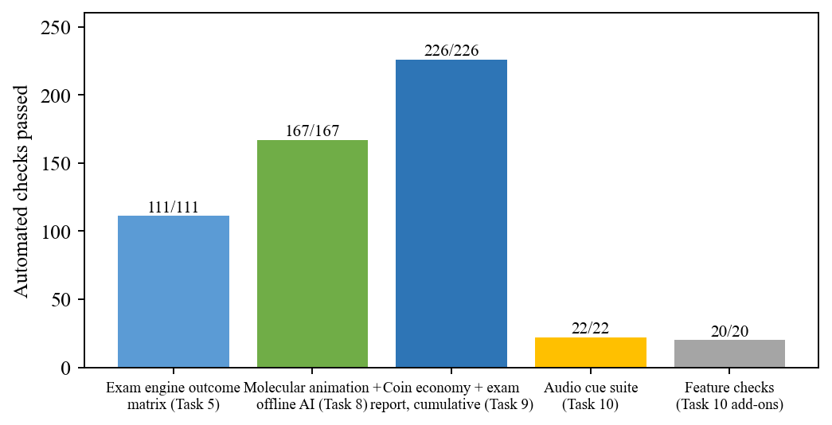
Figure 7.1: Automated verification checks passed per suite
The outcome matrix in Table 7.1 drove each test-scene experiment through correct amounts, overdose, underdose, reversed order and a pause mid-procedure, and confirmed that pausing never fails the learner and that the test scene never reveals target values. The molecular suite checked atom conservation and bond lengths across stages. All suites passed in full.

7.2.2 Content and Coverage Metrics
Table 7.2 and Figure 7.2 quantify the learning content delivered by the prototype.
Table 7.2: Content and coverage metrics
Metric | Value
Practical experiments (all quantity-aware) | 8
Theory questions | 10
Assessment task types | 18
Reactions with live 3D molecular animation | 8 of 8
Recorded molecular MP4 clips in project | 7
Reaction categories in the book | 6
Unity scenes | 4
Achievements | 13
Periodic-table elements | 118
C# scripts / lines of code | 110 / 39,601
Maximum stored attempts | 300

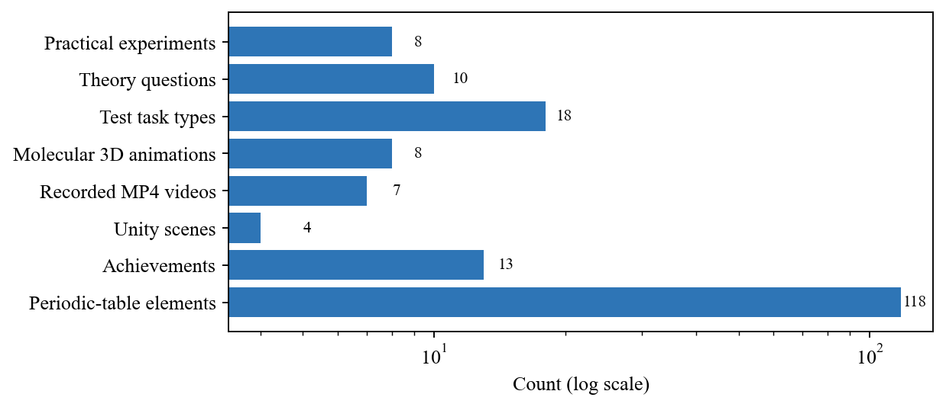
Figure 7.2: Content inventory of the Atomix prototype

7.2.3 Scientific Data Used by the System
Table 7.3 lists the thermodynamic values used by the graphs, together with the Gibbs free energy at 298.15 K computed with Equation (5.8). Figures 7.3 and 7.4 plot these values.
Table 7.3: Thermodynamic data per reaction and derived Gibbs energy
# | Type | ΔH (kJ/mol) | E_{a} (kJ/mol) | ΔS (J/mol·K) | ΔG₂₉₈ (kJ/mol) | Spontaneous at 298 K
1 | Exothermic | −368.6 | 10 | −15.5 | −364.0 | Yes
2 | Exothermic | −63.7 | 48 | −43.0 | −50.9 | Yes
3 | Endothermic | +31.4 | 45 | +241.0 | −40.5 | Yes (entropy-driven)
4 | Exothermic | −393.2 | 6 | +44.7 | −406.5 | Yes
5 | Exothermic | −627.6 | 85 | −86.9 | −601.7 | Yes
6 | Exothermic | −65.2 | 46 | −26.3 | −57.4 | Yes
7 | Endothermic | +178.3 | 185 | +160.7 | +130.4 | No (needs heating)
8 | Endothermic | +340.1 | 365 | +377.4 | +227.6 | No (needs heating)

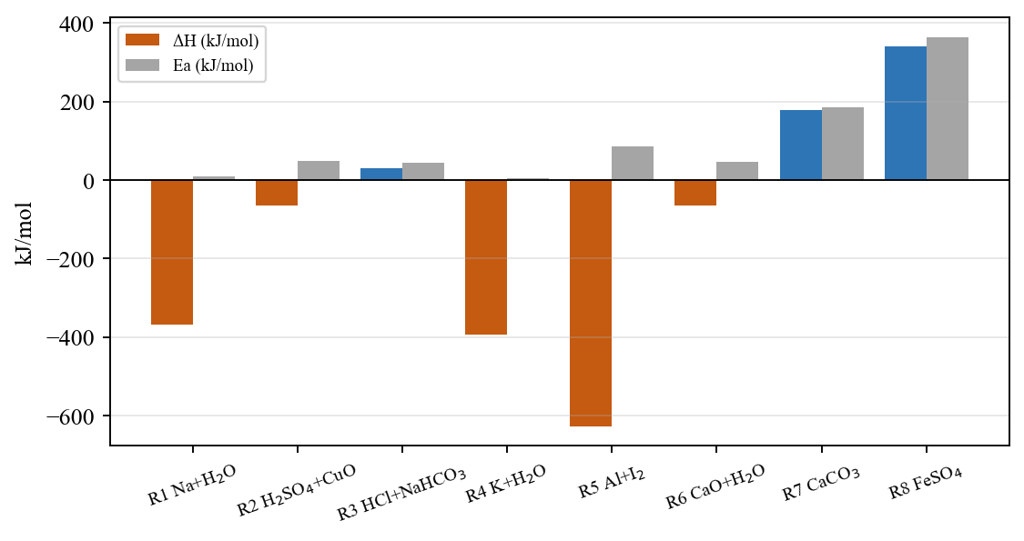
Figure 7.3: Enthalpy change and activation energy of the eight reactions
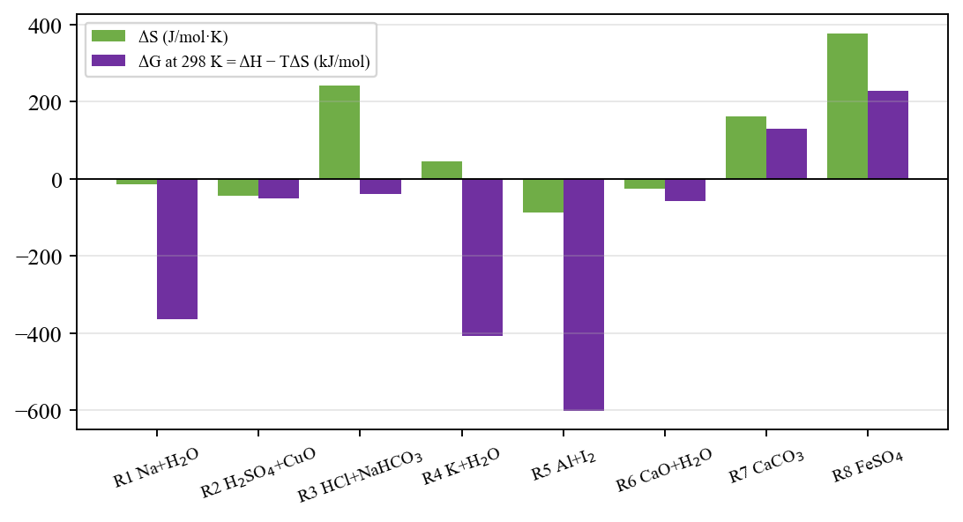
Figure 7.4: Entropy change and Gibbs free energy at 298 K
The data in Table 7.3 is consistent with what the learner observes in the laboratory. The two thermal decompositions (7 and 8) are the only reactions with positive ΔG at room temperature, which is exactly why they are the two experiments that require the Bunsen burner; Equation (5.9) gives crossover temperatures of about 1,110 K and 901 K respectively. Reaction 3 is endothermic yet spontaneous because of its large entropy gain from releasing CO₂ gas, which gives the teacher a concrete example of entropy-driven spontaneity. The alkali-metal reactions (1 and 4) combine very low activation energies with large negative ΔH, matching their violent behaviour on contact with water.

7.2.4 Requirement Traceability
Table 7.4 traces each functional requirement of Table 3.4 to its implementation and verification evidence.
Table 7.4: Requirement traceability
ID | Implemented by | Status / evidence
FR1 | LabScene, 3D models, grab interactables | Implemented; Figure 6.2
FR2 | FlipPages, BookCanvasManager, keys 1-8 | Implemented
FR3 | ReactionLearningController, MolecularAnimationRenderer | Implemented; 8/8 animations, 167/167 suite
FR4, FR5 | FreeHandReactionEngine, ReactionDefinition | Implemented; 111/111 outcome matrix
FR6 | ExperimentFeedbackDirector, LabRetryController (F5) | Implemented
FR7, FR8 | InLabAssistantController, ConvaiAssistantBackend, ChemistryKnowledgeBase | Implemented; offline path verified in 167/167 suite
FR9, FR10 | ExperimentHistoryManager, ExperimentScoring | Implemented
FR11 | ReactionGraphCatalog / Renderer / UI | Implemented
FR12-FR14 | Randomize, ExamSession, AtomixCoinBank, ExamReportExporter | Implemented; 226/226 suite
FR15 | XR rig + DesktopBootstrap | Implemented; headset Play-mode pass [INSERT]

7.2.5 Measurements to be Added
The following measures are recommended for the final submission and the planned user study; they are left as placeholders because they have not yet been measured: [INSERT: average frame rate on Meta Quest and on the desktop test machine], [INSERT: scene load times], [INSERT: Convai average response latency versus offline response latency], and [INSERT: System Usability Scale scores and pre-test / post-test knowledge scores from a student study].

7.3 Screenshots
The principal screens of the system were presented in Section 6.2 (Figures 6.2 to 6.15). The laboratory capture in Figure 6.2 is taken from the running build; the remaining figures are placeholders to be replaced with captures from the final build.

7.4 Comparative Analysis
Table 7.5 compares Atomix with the representative systems from the literature survey on the dimensions identified in Section 2.2. The comparison is functional, based on the capabilities described in each work, because the surveyed systems were evaluated on different populations and metrics and their numerical results are not directly comparable.
Table 7.5: Comparison with existing systems
Feature | Virtual labs [1],[12] | VR systems [4],[13] | Molecular VR [5] | AI chatbots [7],[14] | Atomix
Platform | Desktop / web | VR | Projection CAVE | Web / messaging | Meta Quest + Windows desktop
Experiment judging | Step sequence | Scripted | None | None | Order, overdose, underdose, heating, with tolerance
Difficulty levels | Rare | No | No | No | Guided / Standard / Expert
Molecular view | Static images | Partial | Yes | No | Video + live animation for 8/8 reactions
AI help | No | No | No | Yes, generic | Context-aware, voice + text, offline fallback
Progress record | Scores | No | No | Chat log | 300-attempt history with steps, accuracy, AI log
Thermodynamics | No | No | No | No | ΔH, E_{a}, ΔS, ΔG graphs with AI explanation
Assessment | Quizzes | No | No | No | 18 task types, coins, HTML/CSV report

The comparison shows that Atomix is, to the best of our survey, the only system among those reviewed that combines quantity-aware experiment judging, molecular visualization, a context-aware AI assistant that works offline, attempt history, thermodynamic analysis and assessment in one application available both in VR and on a desktop. Its main weakness relative to the literature is evaluation: unlike [6], Atomix has not yet been tested in a controlled study, so its effect on learning remains to be measured.

7.5 Limitations
The current prototype has the following known limitations: the application still identifies itself with the legacy product and company name of the original template, which is kept deliberately because renaming would reset players' saved data unless a migration is written; cloud AI requires valid credentials and internet, and offline answers cover only the eight reactions; offline speech is Windows-only; some visual substance state may remain after re-selecting an experiment; coins are stored per machine with no accounts or leaderboard; and the AI service key was committed to the repository history during development and must be rotated before the repository is shared.

CHAPTER 8: CONCLUSION & FUTURE SCOPE

8.1 Conclusion
This project designed and implemented Atomix, an AI-assisted virtual chemistry laboratory built in Unity 6 that runs on Meta Quest / OpenXR headsets and, through a run-time-injected keyboard-and-mouse mode, on ordinary Windows computers. Atomix integrates, in one application, eight quantity-aware inorganic experiments, a learn-before-perform workflow with recorded videos and live 3D molecular animations for all eight reactions, an in-laboratory AI assistant that knows the learner's live measurements and keeps working offline, a persistent experiment history with accuracy scores and star ratings, scientific graphs that connect each experiment to its enthalpy, activation energy, entropy and Gibbs free energy, and a randomized assessment scene with a persistent coin economy and exportable reports.
The central technical contribution is the data-driven free-hand reaction engine, which judges experiments by order of addition, overdose (instantly), underdose (after a settling period) and procedure, using per-reaction tolerances scaled by difficulty level, and which is shared by the practice laboratory and the test scene. The second contribution is the dual-path assistant whose offline brain gives grounded, personal explanations from the engine's own measurements. The implementation comprises 110 scripts and 39,601 lines of C#, compiles without errors, and passed every automated check that was run against the shipped logic (111/111, 167/167, 226/226 and 22/22). All functional requirements listed in Chapter 3 were implemented. As the literature warns, however, functional completeness is not the same as proven learning benefit; Atomix demonstrates technical and functional viability, and its educational effect must now be measured.

8.2 Future Scope
- Learning-outcome study. Conduct a controlled study with pre-tests and post-tests and usability questionnaires, comparing Atomix with conventional preparation, as recommended in [6] and [8].
- Larger reaction library. Add organic, titration and electrochemistry experiments; because recipes are data, many additions require only new ReactionDefinition assets and effects.
- Teacher dashboard and accounts. Synchronise history and test reports to a server so instructors can monitor classes and assign experiments; replace per-machine coins with accounts and leaderboards.
- Richer offline AI. Embed a small on-device language model grounded on the knowledge base, and extend offline speech beyond Windows.
- Multiplayer laboratory. Allow partners or a teacher to share the same bench in VR.
- Performance and platform work. Profile and optimise for standalone headsets, add mixed-reality passthrough mode, and support Android tablets and WebGL.
- Accessibility and localisation. Add Hindi and Marathi language support, subtitles for all narration and colour-blind-safe highlight schemes.

REFERENCES
[1] S. Ramos, E. P. Pimentel, M. das G. B. Marietto, and W. T. Botelho, "Hands-on and virtual laboratories to undergraduate chemistry education: Toward a pedagogical integration," in Proc. 2016 IEEE Frontiers in Education Conf. (FIE), 2016, pp. 1-8, doi: 10.1109/FIE.2016.7757580.
[2] M. Agarwal and S. Saha, "Learning chemistry through puzzle based game: Atoms to molecule," in Proc. 2011 9th IEEE Int. Conf. Emerging eLearning Technologies and Applications (ICETA), 2011, pp. 189-193, doi: 10.1109/ICETA.2011.6112613.
[3] A. L. Sanchez-Lopez, O. R. Camacho-Ornelas, L. M. Lozano-Sanchez, M. F. Rivas-Gastelum, A. Parra-Cordova, and Y. P. Avalos, "Enhancing chemistry laboratory teaching through gamification: The IQ-Mobile Race," in Proc. 2023 IEEE Int. Conf. Teaching, Assessment and Learning for Engineering (TALE), 2023, pp. 1-4, doi: 10.1109/TALE56641.2023.10398328.
[4] J. T. Bell and H. S. Fogler, "The application of virtual reality to (chemical engineering) education," in Proc. IEEE Virtual Reality Conf. (VR 2004), 2004, pp. 217-218, doi: 10.1109/VR.2004.1310077.
[5] Y. Luo, P. Guo, S. Hasegawa, and M. Sato, "An interactive molecular visualization system for education in immersive multi-projection virtual environment," in Proc. 3rd Int. Conf. Image and Graphics (ICIG), 2004, pp. 485-488, doi: 10.1109/ICIG.2004.36.
[6] T. Xie, Y. Li, and Y. Tang, "Effects of using immersive virtual reality for science education on learning outcomes: A randomized controlled pilot study," IEEE Trans. Learning Technologies, vol. 16, no. 6, pp. 1045-1056, 2023, doi: 10.1109/TLT.2023.3263587.
[7] N. Sandu and E. Gide, "Adoption of AI-chatbots to enhance student learning experience in higher education in India," in Proc. 2019 18th Int. Conf. Information Technology Based Higher Education and Training (ITHET), 2019, pp. 1-5, doi: 10.1109/ITHET46829.2019.8937382.
[8] M. P. Kurniawan, M. Suyanto, E. Utami, and Kusrini, "Educational game learning quality evaluation tool: A systematic literature review," in Proc. 2024 7th Int. Conf. Informatics and Computational Sciences (ICICoS), 2024, doi: 10.1109/ICICoS62600.2024.10636925.
[9] J. K. Gilbert and D. F. Treagust, Eds., Multiple Representations in Chemical Education. Dordrecht, Netherlands: Springer, 2009, doi: 10.1007/978-1-4020-8872-8.
[10] H.-K. Wu, J. S. Krajcik, and E. Soloway, "Using technology to support the development of conceptual understanding of chemical representations," 2000. [VERIFY: venue and pages]
[11] E. Byusa, E. Kampire, and A. R. Mwesigye, "Game-based learning approach on students' motivation and understanding of chemistry concepts: A systematic review of literature," Heliyon, vol. 8, no. 5, e09541, 2022, doi: 10.1016/j.heliyon.2022.e09541.
[12] N. Ali and S. Ullah, "Review to analyze and compare virtual chemistry laboratories for their use in education," J. Chemical Education, vol. 97, no. 10, pp. 3563-3574, 2020, doi: 10.1021/acs.jchemed.0c00185.
[13] J. Alvarez Ramirez and A. Bueno, "Learning organic chemistry with virtual reality," in Proc. 2020 IEEE Int. Conf. Engineering Veracruz (ICEV), 2020, doi: 10.1109/ICEV50249.2020.9289672.
[14] I. Atmosukarto, W. S. Cheow, P. Iyer, N. Tong, and K. Yu, "Enhancing adaptive online chemistry course with AI-chatbot," in Proc. 2021 IEEE Int. Conf. Engineering, Technology & Education (TALE), 2021, doi: 10.1109/TALE52509.2021.9678528.
[15] Unity Technologies, "Unity 6 User Manual," 2025. [Online]. Available: https://docs.unity3d.com/Manual/index.html
[16] The Khronos Group, "The OpenXR Specification," [Online]. Available: https://registry.khronos.org/OpenXR/
[17] Unity Technologies, "XR Interaction Toolkit," package documentation. [Online]. Available: https://docs.unity3d.com/Packages/com.unity.xr.interaction.toolkit@latest
[18] Convai, "Convai Documentation - Character API," [Online]. Available: https://docs.convai.com/

PUBLISHED PAPERS
[INSERT: Published / communicated paper "Atomix - Your Personal Lab with A.I." by K. D. Soni, D. M. Thakar, K. R. Verma and M. Phadke]
[INSERT: Conference / journal name, date, ISSN/ISBN, DOI or acceptance letter]

CERTIFICATES
[INSERT: Paper publication certificates]
[INSERT: Conference attendance / presentation certificates]
[INSERT: Competition participation certificates, if any]

PLAGIARISM REPORT
[INSERT: First few pages of the plagiarism report (e.g., Turnitin / Drillbit) with similarity index]

