
Atomix: Your Personal Lab with AI
LY Innovation-Based Major Project-B Report
Submitted in partial fulfilment of the requirements of the Degree of
Bachelor of Technology in Computer Engineering
by
Kushal D. Soni (Roll No. [INSERT])
Kartik R. Verma (Roll No. [INSERT])
Dhir M. Thakar (Roll No. [INSERT])
Supervisor
Dr. Madhura Phadke

Department of Computer Engineering
K. J. Somaiya Institute of Technology
An Autonomous Institute permanently affiliated to University of Mumbai
Ayurvihar, Sion, Mumbai-400022
2026-27

CERTIFICATE
This is to certify that the project entitled "Atomix: Your Personal Lab with AI" is a bonafide work of Kushal D. Soni, Kartik R. Verma, Dhir M. Thakar submitted to the University of Mumbai in partial fulfilment of the requirement in Major Project, for the award of the degree of "Bachelor of Technology" in "Computer Engineering".
______________________________
Dr. Madhura Phadke
Project Guide
Department of Computer Engineering

______________________________  Dr. Sarita Ambadekar  Head, Department of Computer Engineering | ______________________________  Dr. Vivek Sunnapwar  Principal, KJSIT
Place: Sion, Mumbai-400022
Date:
PROJECT APPROVAL FOR L. Y.
This project report entitled "Atomix: Your Personal Lab with AI" by
Kushal D. Soni (Roll No. [INSERT])
Kartik R. Verma (Roll No. [INSERT])
Dhir M. Thakar (Roll No. [INSERT])
is an approved Last Year Innovation-Based Major Project in Computer Engineering.
Examiners:
1. ______________________________
Name and Signature
External Examiner
2. ______________________________
Name and Signature
Internal Examiner
Place: Sion, Mumbai-400022
Date:
DECLARATION
We declare that this written submission represents our ideas in our own words and where others' ideas or words have been included, we have adequately cited and referenced the original sources. We also declare that we have adhered to all principles of academic honesty and integrity and have not misrepresented or fabricated or falsified any idea/data/fact/source in our submission. We understand that any violation of the above will be cause for disciplinary action by the Institute and can also evoke penal action from the sources which have thus not been properly cited or from whom proper permission has not been taken when needed.
Kushal D. Soni (Roll No. [INSERT])
Kartik R. Verma (Roll No. [INSERT])
Dhir M. Thakar (Roll No. [INSERT])
Date:
ACKNOWLEDGEMENT
Before presenting our LY Major Project work entitled "Atomix: Your Personal Lab with AI", we would like to convey our sincere thanks to the people who guided us throughout the course of this project work.
First, we would like to express our immense gratitude towards our Project Guide Dr. Madhura Phadke for the constant encouragement, support, guidance and mentoring at all stages of the project and report.
We would like to express our sincere thanks to our H.O.D. Dr. Sarita Ambadekar for the encouragement, co-operation and suggestions during the progressing stages of the report.
We would like to express our sincere thanks to our beloved Principal Dr. Vivek Sunnapwar for providing various facilities to carry out this project.
Finally, we would like to thank all the teaching and non-teaching staff of the college, and our friends, for their moral support during the course of this work and for their direct and indirect involvement in the completion of this report, which made our endeavour fruitful.
Place: Sion, Mumbai-400022
Date:
ABSTRACT
Chemistry is learnt by linking what is seen in a laboratory to what happens at the molecular level and to the symbolic equation, yet students get little safe, repeatable practice and rarely receive specific explanations of their mistakes. Virtual laboratories, immersive Virtual Reality (VR), game-based learning and AI chatbots each address part of this problem, but they are usually studied in isolation, judge experiments only as fixed sequences, and offer help that is unaware of what the learner has just done. This project presents Atomix: Your Personal Lab with AI, a Unity 6 virtual chemistry laboratory that runs on Meta Quest / OpenXR headsets and, through a run-time-injected keyboard-and-mouse mode, on ordinary Windows computers. Atomix offers eight inorganic experiments selected from an in-world Reaction Book. A data-driven free-hand reaction engine judges each experiment by the order of addition, instant overdose detection, underdose after a settling period and heating procedure, using per-reaction tolerances scaled by Guided, Standard and Expert difficulty levels, and rates every success with an accuracy score and stars.
Before and after each experiment the learner can watch recorded molecular videos or a live 3D animation that shows bonds breaking and forming and electrons being transferred. A context-aware AI Lab Assistant receives the live measurements, verdict and attempt history; it answers by voice and text through the Convai service and falls back to a grounded offline knowledge base with local speech, so help remains available without internet or a microphone. A persistent experiment history, enthalpy, activation-energy, entropy and Gibbs-energy graphs, and a randomized assessment scene with eighteen task types, a coin economy and HTML/CSV reports complete the learning cycle. The implementation comprises 110 C# scripts (39,601 lines), compiles without errors and passed all automated checks executed on the shipped logic (111/111, 167/167, 226/226 and 22/22). A controlled study of learning outcomes is identified as the next step.
Keywords: virtual chemistry laboratory, virtual reality, conversational AI, game-based learning, Unity, free-hand experimentation.
CONTENTS
LIST OF FIGURES viii
LIST OF TABLES ix
LIST OF ABBREVIATIONS x
CHAPTER 1: INTRODUCTION 1
1.1 Introduction 1
1.2 Problem Definition 1
1.3 Aim and Objectives 2
1.4 Organization of the Report 2
CHAPTER 2: REVIEW OF LITERATURE 3
2.1 Literature Survey 3
2.2 Research Gaps 5
CHAPTER 3: REQUIREMENT SPECIFICATION 6
3.1 Introduction 6
3.2 Hardware Requirements 6
3.3 Software Requirements 6
3.4 Feasibility Study 7
3.5 Cost Estimation 7
3.6 Functional and Non-Functional Requirements 8
CHAPTER 4: PROJECT ANALYSIS & DESIGN 10
4.1 Introduction 10
4.2 UML Diagrams 10
4.3 Scene Architecture 14
CHAPTER 5: METHODOLOGY 15
5.1 Introduction 15
5.2 System Block Diagram 15
5.3 Reaction Recipes and Evaluation Algorithm 16
5.4 Accuracy and Star Model 17
5.5 Context-Aware AI with Offline Fallback 18
5.6 Molecular, Thermodynamic and Assessment Models 18
CHAPTER 6: IMPLEMENTATION DETAILS 20
6.1 Introduction 20
6.2 System Implementation 20
6.3 Desktop and VR Modes 22
CHAPTER 7: RESULT ANALYSIS 24
7.1 Introduction 24
7.2 Performance Measures 24
7.3 Screenshots 26
7.4 Comparative Analysis 27
CHAPTER 8: CONCLUSION & FUTURE SCOPE 28
8.1 Conclusion 28
8.2 Future Scope 28
REFERENCES 29
PUBLISHED PAPERS 31
CERTIFICATES 32
PLAGIARISM REPORT 33

LIST OF FIGURES
Figure 1.1: The Atomix learning cycle 1
Figure 4.1: Use-case diagram of Atomix 10
Figure 4.2: Sequence diagram - performing a free-hand experiment 11
Figure 4.3: State diagram of the free-hand reaction engine 12
Figure 4.4: Level 0 DFD (context diagram) 12
Figure 4.5: Level 1 DFD 13
Figure 4.6: Level 2 DFD of the reaction-evaluation process 13
Figure 4.7: Class diagram of the core subsystems 14
Figure 5.1: System block diagram of Atomix 15
Figure 5.2: Reagent accuracy function and star bands for H2SO4 in reaction 2 17
Figure 5.3: Dual-path routing of AI questions 18
Figure 6.1: The Atomix virtual laboratory with the FeSO4 experiment set up 20
Figure 6.2: Reaction Book with LEARN / PERFORM and difficulty selection 21
Figure 6.3: Live 3D molecular animation 21
Figure 6.4: In-lab AI assistant answering a typed question 21
Figure 6.5: Testing scene report card and exported HTML report 22
Figure 7.1: Automated verification checks passed per suite 25
Figure 7.2: Enthalpy change and activation energy of the eight reactions 26

LIST OF TABLES
Table 2.1: Summary of the literature survey 3
Table 2.2: Capability coverage of surveyed work versus Atomix 5
Table 3.1: Hardware requirements 6
Table 3.2: Software requirements 6
Table 3.3: Cost estimation 7
Table 3.4: Functional requirements 8
Table 4.1: Scene architecture 14
Table 5.1: Reaction recipes used by the free-hand engine 16
Table 5.2: Engine verdicts and feedback 17
Table 5.3: Coin-economy parameters 19
Table 6.1: Key scripts and responsibilities 22
Table 7.1: Build and verification summary 24
Table 7.2: Thermodynamic data per reaction and derived Gibbs energy 25
Table 7.3: Requirement traceability 26
Table 7.4: Comparison with existing systems 27

LIST OF ABBREVIATIONS
Sr. No. | Abbreviation | Description
1 | AI | Artificial Intelligence
2 | API | Application Programming Interface
3 | CAVE | Cave Automatic Virtual Environment
4 | CPK | Corey-Pauling-Koltun (atom colouring convention)
5 | CSV | Comma-Separated Values
6 | DFD | Data Flow Diagram
7 | FR | Functional Requirement
8 | GBL | Game-Based Learning
9 | GPU | Graphics Processing Unit
10 | HMD | Head-Mounted Display
11 | HTML | HyperText Markup Language
12 | HUD | Heads-Up Display
13 | INR | Indian Rupee
14 | JSON | JavaScript Object Notation
15 | KB | Keyboard (in figures: KB + mouse) / Knowledge Base (Offline KB)
16 | LOC | Lines of Code
17 | MP4 | MPEG-4 Part 14 video format
18 | RAM | Random Access Memory
19 | RCT | Randomized Controlled Trial
20 | REST | Representational State Transfer
21 | SDK | Software Development Kit
22 | SO | ScriptableObject (Unity data asset)
23 | SoC | System on Chip
24 | SUS | System Usability Scale
25 | TTS | Text-to-Speech
26 | UI | User Interface
27 | UML | Unified Modelling Language
28 | VFX | Visual Effects
29 | VR | Virtual Reality
30 | XR | Extended Reality

CHAPTER 1: INTRODUCTION

1.1 Introduction
Chemistry is learnt at three linked levels: the macroscopic change seen in a test tube, the sub-microscopic world of atoms and bonds, and the symbolic level of formulas and equations [9]. Learners find the transitions between these levels hard because the molecular level is never directly observed [10], while practical laboratory time is limited by reagent cost, apparatus, supervision and safety rules that forbid reactions such as sodium in water. Technology-enhanced learning has responded with virtual laboratories [1], [12], game-based learning [2], [3], [11], immersive Virtual Reality (VR) [4]-[6], [13] and AI chatbots [7], [14]. This project, Atomix: Your Personal Lab with AI, is a Unity 6 virtual chemistry laboratory that runs on Meta Quest / OpenXR headsets and, without a headset, on a Windows desktop with keyboard and mouse. Figure 1.1 shows its learning cycle.
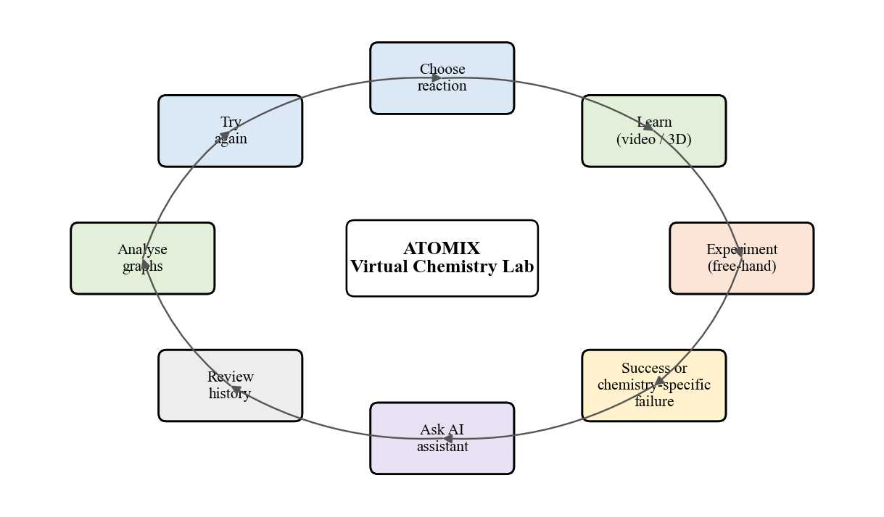
Figure 1.1: The Atomix learning cycle

1.2 Problem Definition
Students rarely get enough safe, repeatable practice with real reactions, and seldom receive immediate, specific explanations of their mistakes. Existing virtual laboratories judge experiments as fixed click sequences and are mostly desktop-only [1], [12]; VR applications offer immersion but do not assess the quantities used [4], [5], [13]; and AI chatbots answer questions without knowing what the learner has just done, and stop working offline [7], [14]. The problem addressed is therefore to build one accessible laboratory, usable in VR and on a desktop, in which learners perform quantity-aware experiments, see the molecular explanation, receive chemistry-specific feedback from an AI assistant that knows the live experiment and works offline, review their attempts and are assessed through randomized tasks.

1.3 Aim and Objectives
Aim: to build Atomix, an AI-assisted virtual chemistry laboratory that unifies experimentation, molecular visualization, context-aware help, progress tracking and assessment for VR and desktop. Objectives:
- Model an interactive 3D laboratory with eight inorganic reactions selectable from a world-space Reaction Book.
- Support XR interaction on Meta Quest / OpenXR and a run-time-injected keyboard-and-mouse mode from one code base.
- Build a data-driven free-hand engine that validates order, overdose, underdose and heating with configurable tolerances and difficulty levels.
- Provide learn-before-perform molecular videos and a live 3D animation for all eight reactions.
- Integrate a context-aware AI assistant (Convai) with an offline grounded knowledge base and speech.
- Persist attempt history with accuracy scores and stars, and present thermodynamic graphs for each reaction.
- Build a randomized 18-task assessment with a persistent coin economy and HTML/CSV reports, and verify the implementation with automated checks.

1.4 Organization of the Report
Chapter 2 reviews the literature; Chapter 3 specifies requirements; Chapter 4 presents the design; Chapter 5 the methodology; Chapter 6 the implementation; Chapter 7 the results; and Chapter 8 concludes.

CHAPTER 2: REVIEW OF LITERATURE

2.1 Literature Survey
Search strategy. IEEE Xplore, ScienceDirect, the Journal of Chemical Education and Google Scholar were searched for 2000-2024 using the keywords "virtual chemistry laboratory", "virtual reality chemistry education", "immersive molecular visualization", "game-based learning chemistry" and "AI chatbot education". Fourteen works on laboratory simulation, immersive or game-based chemistry learning, chemical representations and conversational AI were retained (Table 2.1).
Gilbert and Treagust [9] show that understanding chemistry depends on linking macroscopic, sub-microscopic and symbolic levels, and Wu et al. [10] found that visualization tools scaffold this link. Ramos et al. [1] argue that virtual laboratories are best used to complement and prepare for hands-on work, and Ali and Ullah [12] found wide variation among virtual laboratories in realism, feedback and assessment. Agarwal and Saha [2] and Sanchez-Lopez et al. [3] used puzzle games and gamified lab activities to raise engagement, and Byusa et al. [11] conclude that game-based learning improves motivation and understanding when mechanics serve learning goals; Kurniawan et al. [8] stress structured evaluation of such games. Bell and Fogler [4], Luo et al. [5] and Alvarez Ramirez and Bueno [13] applied VR and immersive visualization to chemistry, while Xie et al. [6] caution, from a randomized pilot, that immersion must be judged by measured outcomes. Sandu and Gide [7] and Atmosukarto et al. [14] report positive use of AI chatbots, but these are unaware of laboratory activity.
Table 2.1: Summary of the literature survey
Ref. | Author / Year | Method | Dataset / Participants | Results | Limitations
[1] | Ramos et al., 2016 | Pedagogical integration of hands-on and virtual labs | Undergraduate chemistry course context | Virtual labs best used to complement and prepare for hands-on work | Desktop simulation; no immersive or AI support
[2] | Agarwal & Saha, 2011 | Puzzle-based game (Atoms to Molecule) | Learners playing the game | Game format supported engagement with bonding concepts | Single concept; no laboratory procedure
[3] | Sanchez-Lopez et al., 2023 | Gamified lab activity (IQ-Mobile Race) | Chemistry laboratory class | Improved motivation, communication, collaboration | Physical activity; not a simulation
[4] | Bell & Fogler, 2004 | VR modules for chemical-engineering education | Engineering students / VR modules | VR visualises processes not feasible in class | Early hardware; no quantity-level assessment
[5] | Luo et al., 2004 | Immersive multi-projection molecular visualization | System demonstration | 3D immersion aids understanding of molecular structure | Expensive projection setup; structure only
[6] | Xie, Li & Tang, 2023 | Randomized controlled pilot study of immersive VR | Science learners (pilot RCT) | Immersion must be judged by learning outcomes | Pilot scale; VR content only
[7] | Sandu & Gide, 2019 | Survey of AI-chatbot adoption | Indian higher-education students | Positive perception of chatbot support | Generic chatbot; no task context
[8] | Kurniawan et al., 2024 | Systematic review of game-evaluation tools | Published evaluation studies | Need for structured usability and educational evaluation | Review only; no system
[9] | Gilbert & Treagust, 2009 | Edited synthesis on multiple representations | Body of chemistry-education research | Macro / sub-micro / symbolic levels must be linked | Theoretical; no tool
[10] | Wu, Krajcik & Soloway, 2000 | Computer-based visualization tool for representations | High-school chemistry classroom | Technology scaffolds representational understanding | 2D desktop tool; no experimentation
[11] | Byusa et al., 2022 | Systematic review of game-based learning in chemistry | Published GBL studies | GBL improves motivation and understanding | Effects depend on mechanics; heterogeneous studies
[12] | Ali & Ullah, 2020 | Review and comparison of virtual chemistry labs | Existing virtual-lab products | Large variation in realism, feedback, assessment | Comparative review; no new system
[13] | Alvarez Ramirez & Bueno, 2020 | VR application for organic chemistry | Prototype application | VR feasible for chemistry learning | Organic topics; no AI or assessment
[14] | Atmosukarto et al., 2021 | AI chatbot in adaptive online chemistry course | Online course students | Chatbot extends support beyond class hours | Course-level; unaware of lab activity; online only

2.2 Research Gaps
Table 2.2 maps the surveyed work onto the capabilities a complete practice laboratory needs.
Table 2.2: Capability coverage of surveyed work versus Atomix
Capability | [1],[12] | [2],[3] | [4],[5],[13] | [6] | [7],[14] | Atomix
3D virtual laboratory procedure | Yes | - | Partial | Partial | - | Yes
Immersive VR | - | - | Yes | Yes | - | Yes
Desktop access without headset | Yes | Yes | - | - | Yes | Yes
Quantity / order-aware validation | - | - | - | - | - | Yes
Molecular-level visualization | - | Partial | Yes | - | - | Yes
Conversational AI help | - | - | - | - | Yes | Yes
AI aware of live experiment state | - | - | - | - | - | Yes
Works offline | Yes | Yes | Yes | Yes | - | Yes
Assessment and attempt history | Partial | Partial | - | Yes | - | Yes

The gaps are: (1) fragmentation - no surveyed system combines virtual lab, VR, molecular views, AI and assessment; (2) shallow validation - quantities, order and heating time are not judged, so realistic mistakes cannot be explained; (3) context-blind, online-only AI; (4) headset-only access; (5) a weak link between practice and thermodynamic theory; and (6) limited evaluation of educational effect. Atomix addresses gaps 1-5; gap 6 is future work.

CHAPTER 3: REQUIREMENT SPECIFICATION

3.1 Introduction
Requirements were derived from the problem definition, the research gaps and repeated play-testing. Estimated values are marked [ASSUMED].

3.2 Hardware Requirements
Table 3.1 lists hardware for development, desktop use and VR use. A microphone and internet are optional because questions can be typed and the assistant answers offline.
Table 3.1: Hardware requirements
Component | Development workstation | Desktop run-time (Windows) | VR run-time
Processor | Quad-core x64, 3.0 GHz or better [ASSUMED] | x64 dual/quad-core [ASSUMED] | Meta Quest on-board SoC, or PC as left
Memory | 16 GB RAM [ASSUMED] | 8 GB RAM [ASSUMED] | Headset built-in
Graphics | DirectX 11/12 GPU, VR-capable [ASSUMED] | DirectX 11 GPU | Headset built-in
Storage | 50 GB free (project, Library, builds) [ASSUMED] | 2-3 GB free [ASSUMED] | 2-3 GB free [ASSUMED]
Display / HMD | Monitor + Meta Quest for testing | Monitor (any resolution) | Meta Quest / OpenXR headset
Input | Keyboard, mouse, Quest controllers | Keyboard and mouse | Quest controllers / hands
Audio | Speakers/headset, microphone | Speakers; microphone optional | Headset audio and microphone
Network | Internet for packages and Convai | Optional (cloud AI only) | Optional (cloud AI only)

3.3 Software Requirements
Table 3.2 lists the software stack; all of it is free for academic use.
Table 3.2: Software requirements
Software | Version / detail | Purpose
Unity Editor | 6000.3.7f1 (Unity 6), Built-in Render Pipeline | Game engine, scene authoring, builds [15]
C# / .NET (Unity scripting) | Unity-bundled | All run-time logic (110 scripts)
OpenXR plug-in, Oculus XR | Unity packages | Headset runtime abstraction [16]
XR Interaction Toolkit | Unity package | Grabbing, sockets, locomotion, world-space UI [17]
Unity Input System | Unity package | Unified keyboard, mouse and controller input
TextMeshPro | Unity package | World-space and HUD text
Unity VideoPlayer | Built in | Recorded molecular videos (MP4)
Convai REST API | character/getResponse endpoint | Cloud conversational AI and voice [18]
Windows speech synthesis | Windows 10/11 | Offline spoken replies
Git and GitHub | Any recent | Version control and team collaboration

3.4 Feasibility Study
Technical: Unity 6, OpenXR, the XR Interaction Toolkit and the Convai REST endpoint are mature and documented; pouring is computed from tilt and time instead of a fluid simulation, which is light enough for a standalone headset, and the final code compiles against Unity 6000.3.7f1 with zero errors. Economic: all software is free and assets were free; the only significant cost is an optional headset, since the desktop mode needs none, and a reusable virtual lab avoids recurring reagent and disposal costs. Operational: game-like controls, an onboarding card and a live objective line make the system easy to learn; teachers can use it for pre-lab preparation and quick tests with exported reports; dangerous reactions can be practised safely; and comfort settings (motion-safe camera defaults, typed questions) widen accessibility.

3.5 Cost Estimation
Table 3.3 gives an indicative cost estimate; prices are approximate and marked [ASSUMED].
Table 3.3: Cost estimation
Item | Quantity | Approx. cost (INR) | Remarks
Development laptops / PCs | 3 | 0 | Students' existing machines
Meta Quest 3S headset (VR testing) | 1 | 30,000 [ASSUMED] | Optional for deployment; desktop mode needs none
Unity 6 Personal | 3 seats | 0 | Free licence under revenue threshold
Visual Studio Community / VS Code | 3 | 0 | Free
Convai API (free tier) | 1 account | 0 | Offline fallback when quota expires
3D models, textures, sounds | - | 0 | Free assets; audio cues synthesized in code
GitHub repository | 1 | 0 | Free
Internet and miscellaneous | - | 2,000 [ASSUMED] | Package downloads, cloud AI use
Total (indicative) |  | 32,000 [ASSUMED] | Dominated by the optional headset

3.6 Functional and Non-Functional Requirements
Table 3.4 lists the functional requirements. The key non-functional requirements are: interactive frame rates on a standalone headset; core features available without internet, microphone or AI credentials; comfort defaults (walking camera motion off, shake scalable to zero, room tone off); maintainability through data-driven recipes and one shared engine; portability through run-time desktop injection; and bounded, robust persistence (300-attempt JSON history, report-folder fallbacks).
Table 3.4: Functional requirements
ID | Requirement
FR1 | The system shall present a 3D chemistry laboratory with grabbable glassware, reagents and a Bunsen burner.
FR2 | The user shall select one of eight reactions from a world-space Reaction Book or with keys 1-8.
FR3 | The system shall offer LEARN (recorded video or live 3D molecular view) and PERFORM for each reaction.
FR4 | The system shall measure poured volumes, solid additions and heating time live and display them.
FR5 | The system shall judge each experiment for wrong order, overdose, underdose and procedure errors against a recipe and tolerance.
FR6 | The system shall display a chemistry-specific explanation of every failure and allow a bench reset (F5).
FR7 | The AI assistant shall accept voice (push-to-talk) and typed questions and reply in voice and text.
FR8 | The AI assistant shall receive the live experiment context and shall answer offline when the cloud is unavailable.
FR9 | The system shall record every attempt (quantities, steps, outcome, AI Q&A) and persist up to 300 attempts.
FR10 | The system shall score each successful attempt (accuracy %, 1-3 stars) and offer Guided, Standard and Expert levels.
FR11 | The system shall show energy-profile, enthalpy and entropy graphs and let the user ask the AI to explain them.
FR12 | The testing scene shall generate randomized practical and theory tasks with a timer and a chosen task count.
FR13 | The testing scene shall maintain a persistent coin wallet with hints, extra time and skip purchases and ranks.
FR14 | The system shall export a test report in HTML and CSV.
FR15 | The application shall run in VR and, without a headset, with keyboard and mouse.

CHAPTER 4: PROJECT ANALYSIS & DESIGN

4.1 Introduction
This chapter models Atomix with UML use-case, sequence, state and class diagrams and with data-flow diagrams at levels 0, 1 and 2. All diagrams were drawn from the implemented code.

4.2 UML Diagrams
Use-case diagram. In Figure 4.1 the Student uses all eleven use cases, from selecting a reaction to downloading a test report. The Convai cloud (or its offline knowledge-base substitute) answers assistant questions, and the Instructor consumes exported reports.
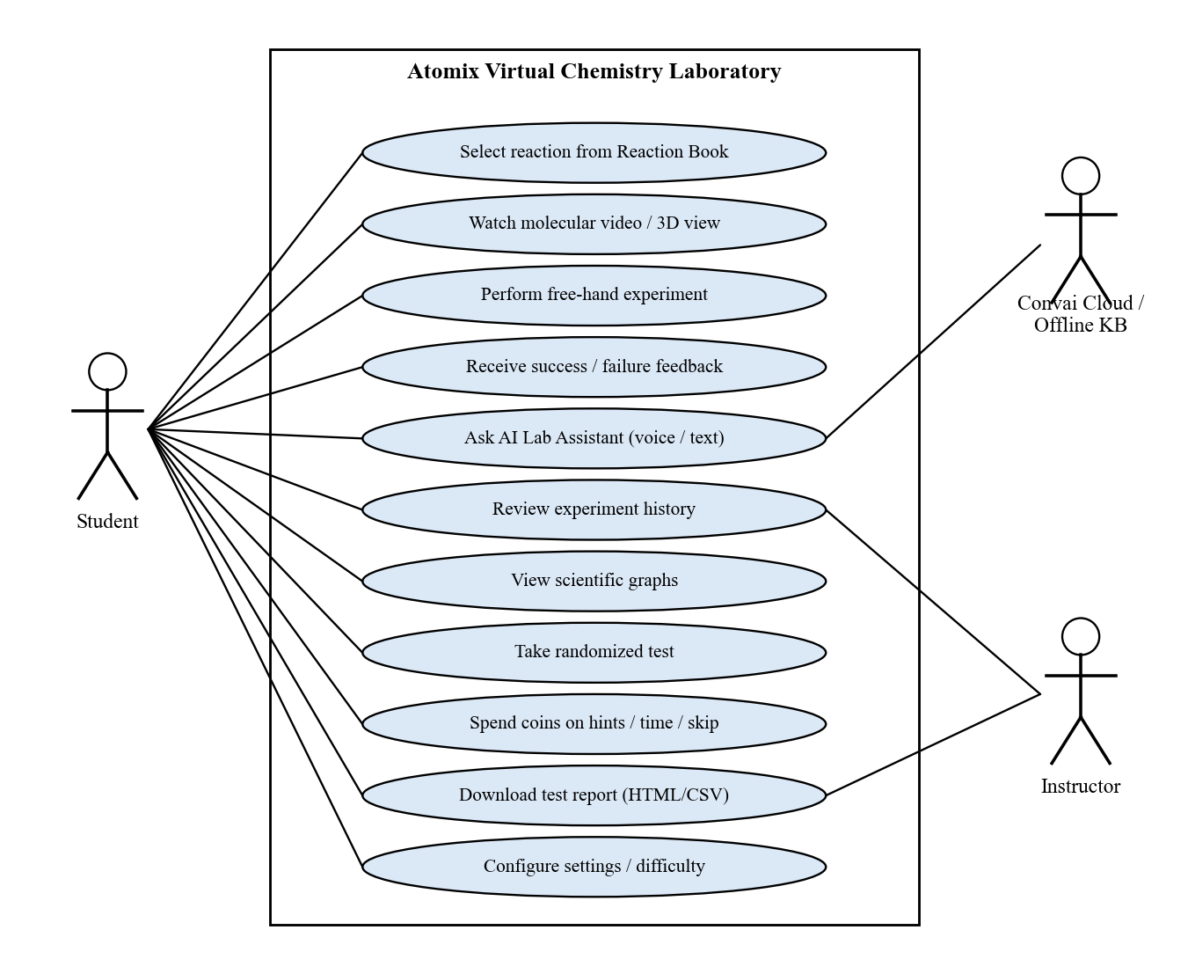
Figure 4.1: Use-case diagram of Atomix
Sequence diagram. Figure 4.2 shows an experiment: the Reaction Book calls ControlReactions.SelectReaction(n), which activates reaction n and configures the shared FreeHandReactionEngine from its ReactionDefinition. Pours and additions are reported with AddQuantity; Evaluate runs every frame until a verdict, after which effects, sound and the equation or failure reason are shown and the attempt is saved to the history manager.
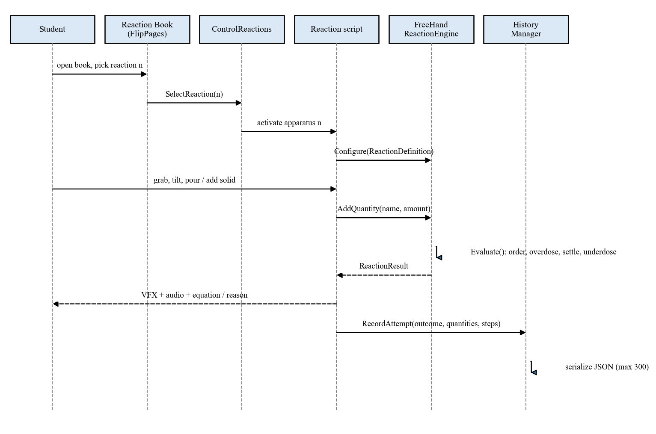
Figure 4.2: Sequence diagram - performing a free-hand experiment
State diagram. Figure 4.3 shows the engine's states. Overdose is checked every frame, so it fails immediately even mid-pour; once all reagents are in and pouring stops, a 1.5 s settle timer runs before underdose is judged, so a learner who pauses is never failed unfairly. Wrong order and heating-procedure errors are separate failures, and F5 resets every terminal state.
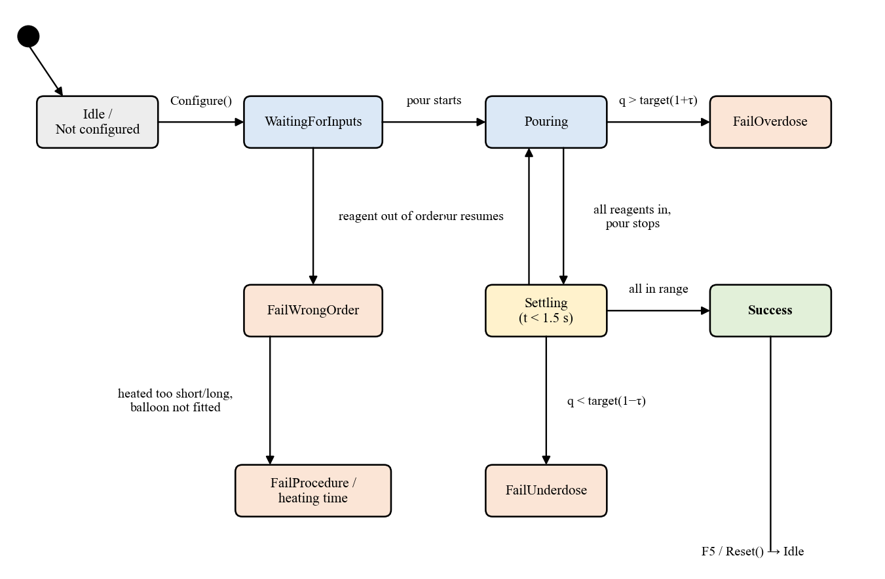
Figure 4.3: State diagram of the free-hand reaction engine
Data flow diagrams. At level 0 (Figure 4.4) Atomix exchanges input, feedback and speech with the student, questions and replies with the Convai cloud, and history and reports with the local file system. Level 1 (Figure 4.5) decomposes the system into input handling, reaction selection and learning, reaction evaluation, AI assistance, assessment and history, with recipe, PlayerPrefs and history stores. Level 2 (Figure 4.6) refines evaluation into reagent registration, quantity accumulation, order and overdose checks, settling, underdose and procedure checks, scoring and feedback.
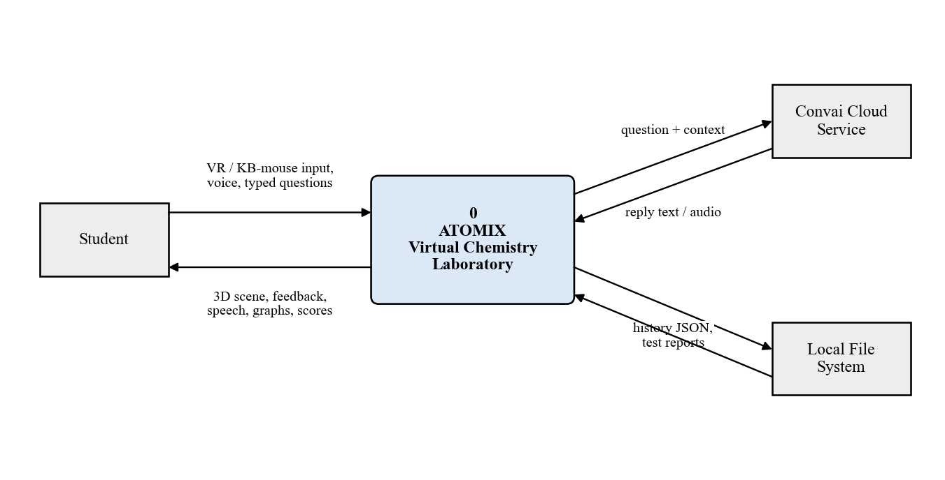
Figure 4.4: Level 0 DFD (context diagram)
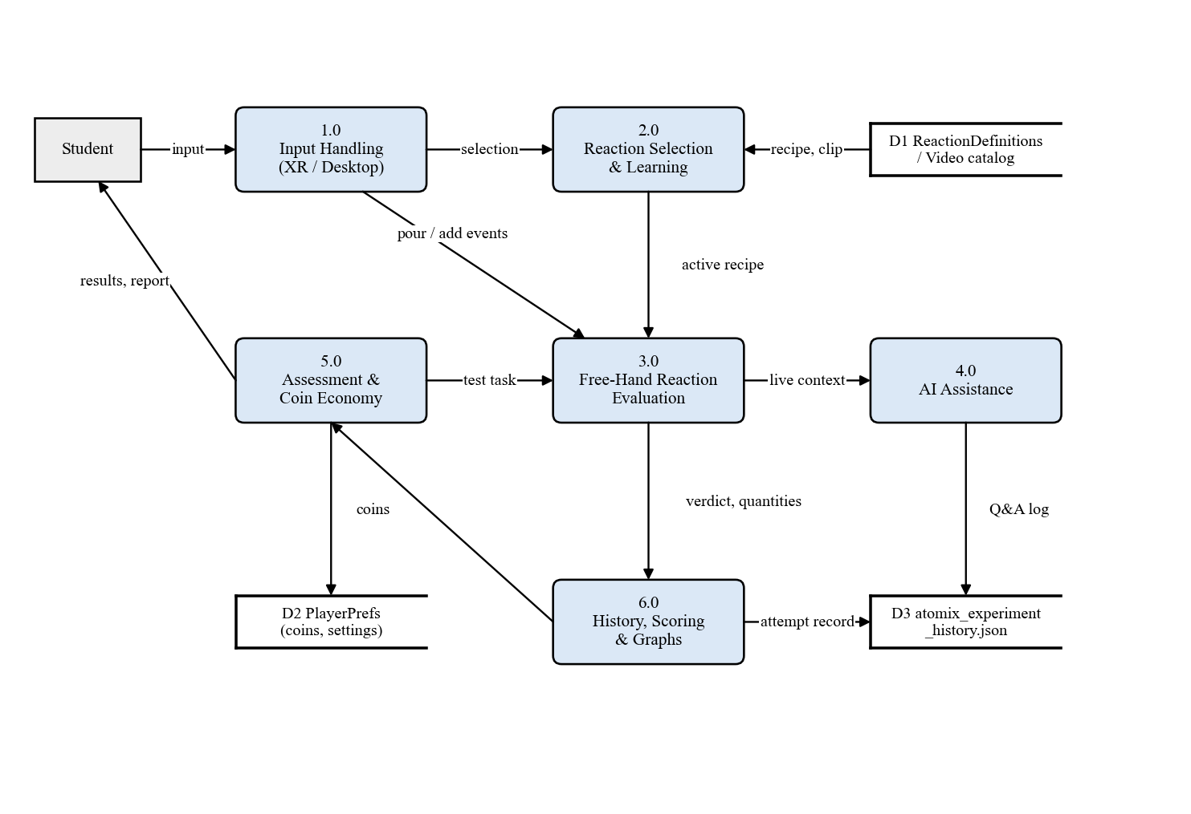
Figure 4.5: Level 1 DFD
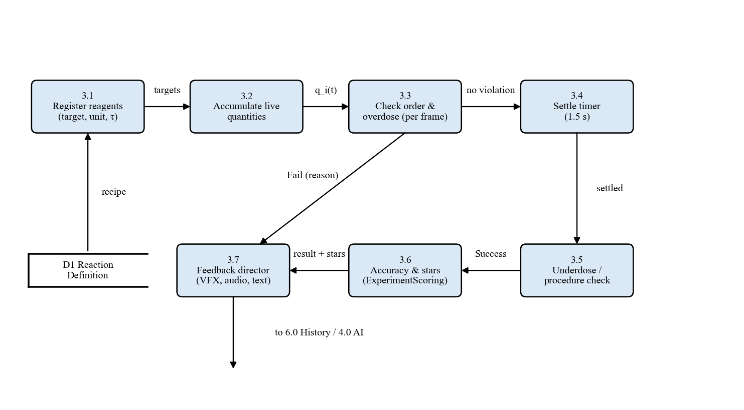
Figure 4.6: Level 2 DFD of the reaction-evaluation process
Class diagram. Figure 4.7 shows the core classes: ControlReactions selects among eight reaction scripts; a ReactionDefinition configures the engine; ExperimentScoring rates attempts; ExperimentHistoryManager persists them; the InLabAssistantController uses the Convai backend with the ChemistryKnowledgeBase as fallback; and AtomixCoinBank holds the economy.
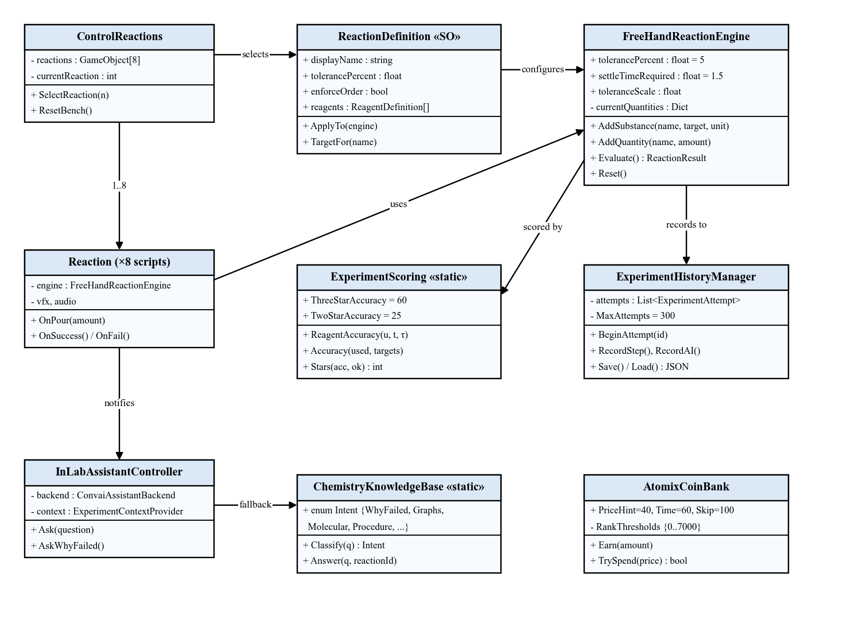
Figure 4.7: Class diagram of the core subsystems

4.3 Scene Architecture
Atomix uses four scenes (Table 4.1) so that each loads only the systems it needs.
Table 4.1: Scene architecture
Scene | Responsibility | Key systems
MainMenuScene | Entry point; mode selection; settings | MainMenu, world-space canvas, async loader
LabScene | Practice laboratory | Reaction Book, ControlReactions, eight reactions, FreeHandReactionEngine, history, graphs, in-lab AI, periodic table
TestingPhaseLab | Assessment | Randomize, TheoreticalTasksManager, CountdownTimer, ExamSession, AtomixCoinBank, ExamReportExporter
LabAssistantScene | Dedicated AI tutor with avatar | LabAssistantCharacter, InLabAssistantController, avatar animator

CHAPTER 5: METHODOLOGY

5.1 Introduction
Atomix was developed incrementally: a first prototype was extended through ten feature-and-fix iterations, each compiled against the real Unity assemblies and checked by automated tests before merging.

5.2 System Block Diagram
Figure 5.1 shows five layers. The input layer uses the XR Interaction Toolkit on a headset; otherwise DesktopBootstrap injects a first-person controller, crosshair and ray grabbing at run time, and LabTextInput captures typed questions while gating the keyboard. The presentation layer holds the Reaction Book, learning panel and HUD. The simulation core holds ControlReactions, the eight reaction scripts, the engine and the feedback director. The intelligence layer holds the assistant, scoring and graph catalog, and the persistence layer holds history, test session, coin bank and report exporter.
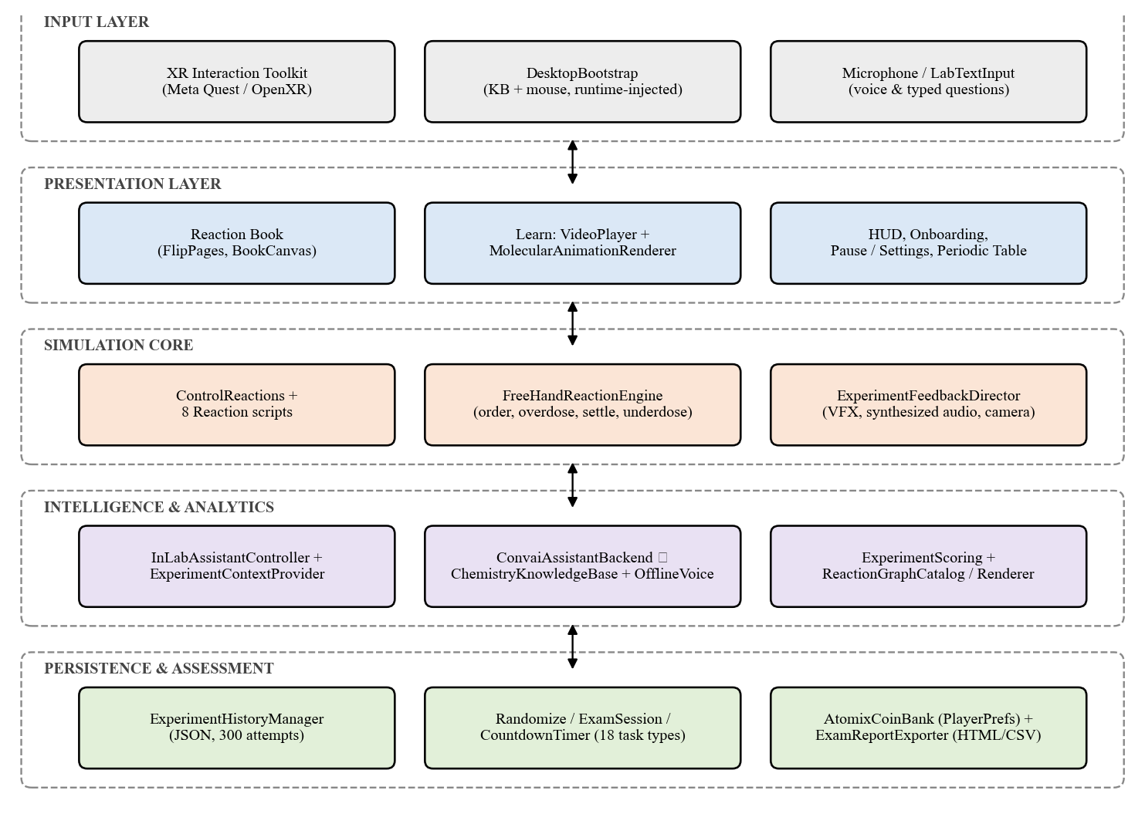
Figure 5.1: System block diagram of Atomix

5.3 Reaction Recipes and Evaluation Algorithm
Each experiment is a ReactionDefinition asset (Table 5.1). For reagent i with target T_{i}, tolerance τ_{i} and difficulty scale s (1.5 Guided, 1.0 Standard, 0.6 Expert), the accepted range is given by Equation (5.1).
Table 5.1: Reaction recipes used by the free-hand engine
# | Reaction | Reagents and targets (in order) | Tolerance τ
1 | 2Na + 2H₂O → 2NaOH + H₂ | Water 50 ml; Sodium 5 g | ± 5 %
2 | H₂SO₄ + CuO → CuSO₄ + H₂O | H₂SO₄ 20 ml; CuO 8 g | ± 8 %
3 | HCl + NaHCO₃ → NaCl + H₂O + CO₂ | HCl 15 ml; NaHCO₃ 12 g | ± 10 %
4 | 2K + 2H₂O → 2KOH + H₂ | Water 50 ml; Potassium 3 g | ± 5 %
5 | 2Al + 3I₂ → 2AlI₃ | Aluminium 5 g; Iodine 15 g; Water drops 2 ml | ± 10 %
6 | CaO + H₂O → Ca(OH)₂ | Water 30 ml; CaO 15 g | ± 8 %
7 | CaCO₃ → CaO + CO₂ (heat) | Heating 10 s (balloon fitted first) | ± 15 %
8 | 2FeSO₄ → Fe₂O₃ + SO₂ + SO₃ (heat) | Heating 10 s | ± 15 %

T_{i}(1 − s·τ_{i}/100) ≤ q_{i} ≤ T_{i}(1 + s·τ_{i}/100) (5.1)
Liquid quantity is integrated from a tilt-dependent pour rate, solids increase in discrete additions and heating accumulates time over the flame. Every frame the engine:
- Returns FailWrongOrder if a reagent is added before an earlier one.
- Returns FailOverdose immediately if any q_{i} exceeds its upper bound.
- Returns InProgress while pouring or while any reagent is missing, resetting the settle timer.
- Otherwise accumulates the settle timer t_{s} (Equation 5.2) and waits until t_{s} ≥ 1.5 s.
- Returns FailUnderdose if any q_{i} is below range, or a procedure failure for wrong heating or (for CaCO₃) heating before fitting the balloon.
- Otherwise returns Success, scores the attempt and records it.
t_{s} ← (t_{s} + Δt) · [A(t) ∧ ¬P(t)] (5.2)
where A(t) is true when all reagents are present and P(t) while any pour is active. Table 5.2 lists the verdicts and the feedback given.
Table 5.2: Engine verdicts and feedback
Verdict | Trigger | Feedback to the learner
Success | All quantities within range after settling; procedure correct | Reaction effect, sound, balanced equation, accuracy and stars, graphs unlocked
FailOverdose | Any q_{i} > q_{i}^{max} (checked every frame) | Reagent-specific chemistry reason, e.g. excess reagent pushes mixture away from the balanced equation
FailUnderdose | Any q_{i} < q_{i}^{min} after 1.5 s settling | Which reagent was short and its chemical consequence
FailWrongOrder | Reagent added before an earlier one | Why the order of addition matters for this reaction
Procedure failure | Heating too short/long; balloon not fitted (CaCO₃) | e.g. CO₂ escaped into the room instead of being collected

5.4 Accuracy and Star Model
Each reagent's accuracy falls linearly from 1 on target to 0 at the edge of its Standard range, and the attempt scores its worst reagent (Equations 5.3 and 5.4). Three stars need A ≥ 60, two need A ≥ 25, and any success earns at least one. The minimum prevents a careful measurement from hiding a careless one, and using the Standard range on every level keeps stars comparable. Figure 5.2 plots the model for H₂SO₄ in reaction 2 (accepted 18.4-21.6 ml).
a_{i} = clamp(1 − |q_{i} − T_{i}| / (T_{i}·τ_{i}/100), 0, 1) (5.3)
A = 100 · min_{i} a_{i} (5.4)
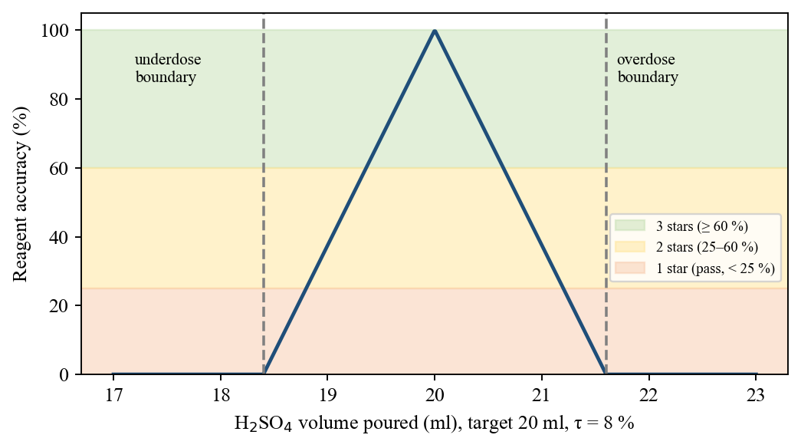
Figure 5.2: Reagent accuracy function and star bands for H2SO4 in reaction 2

5.5 Context-Aware AI with Offline Fallback
Questions arrive by push-to-talk (V), typing (Enter), a "why did it fail" key (Y) or Ask-AI buttons on graphs and animations. Each is sent with the reaction, quantities, targets, verdict and attempt counts (Figure 5.3). With credentials and network, Convai's character endpoint returns text and speech; otherwise the ChemistryKnowledgeBase classifies the question by keyword scores S_{k}(q) (Equation 5.5) into intents such as WhyFailed, Quantities, Procedure, Molecular, Graphs, Calculation, Safety and Progress, and answers from game data - e.g., "you poured 27.4 ml where the equation needs 20.0, a 37 % overdose" - using Windows speech.
k* = argmax_{k} S_{k}(q); Overview if all S_{k}(q) = 0 (5.5)
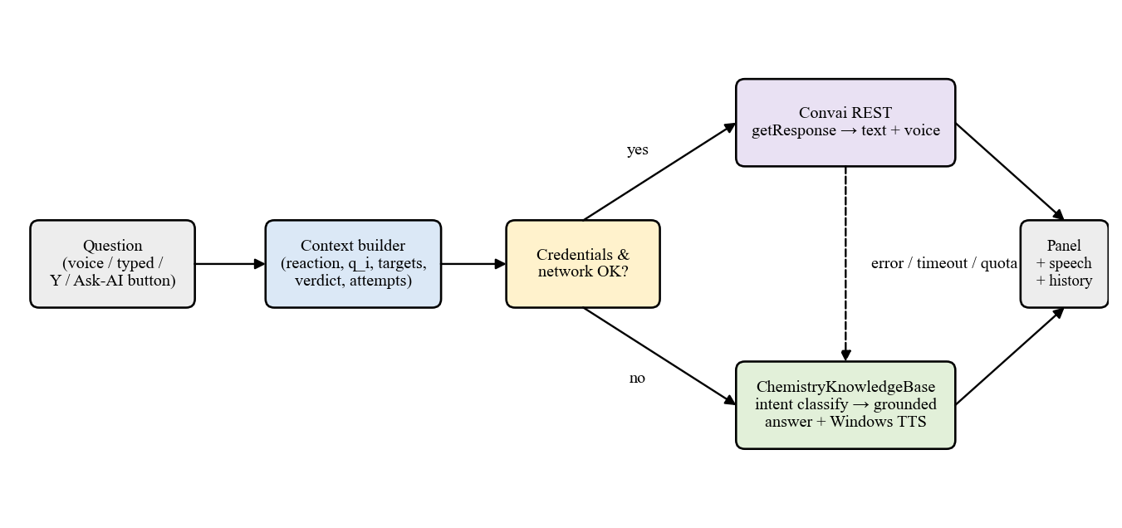
Figure 5.3: Dual-path routing of AI questions

5.6 Molecular, Thermodynamic and Assessment Models
The live 3D view is authored in MolecularSceneCatalog: a thinning red bond is breaking, a thickening green bond is forming and a yellow dot is an electron transferred, shown only for the redox reactions. The graph catalog stores ΔH, E_{a} and ΔS per reaction and derives Gibbs energy, crossover temperature and reverse barrier (Equations 5.6-5.8; ΔH, ΔG, E_{a} in kJ/mol, ΔS in J/mol·K).
ΔG(T) = ΔH − T·ΔS / 1000 (5.6)
T* = 1000 · ΔH / ΔS (5.7)
E_{a,rev} = E_{a} − ΔH (5.8)
The test scene draws 3-18 tasks from 8 practical and 10 theory items; practical tasks use the same engine with hidden targets. Coins persist across sessions; the balance is B = max(0, L − S) for lifetime earned L and spent S, and rank = max{r : L ≥ θ_{r}} with θ = {0, 500, 1500, 3500, 7000}. Table 5.3 lists the parameters.
Table 5.3: Coin-economy parameters
Parameter | Value
Earning per task | 5-100 coins, scaled by time left
Bonuses | First-ever clear +25; 3-streak +30; 5-streak +60; perfect unaided run +50
Purchases | Hint 40 (F2); +30 seconds 60 (F3); skip task 100 (F4)
Ranks | Apprentice (0), Lab Technician (500), Chemist (1500), Senior Chemist (3500), Lab Master (7000)
Hint content | Procedure only, never the quantity - the amount is what the test measures

CHAPTER 6: IMPLEMENTATION DETAILS

6.1 Introduction
Atomix is implemented in C# on Unity 6000.3.7f1 (Built-in Render Pipeline): 110 scripts totalling 39,601 lines, four scenes, eight recipe assets and seven molecular MP4 clips. Placeholders marked [INSERT SCREENSHOT] must be replaced with captures from the final build.

6.2 System Implementation
Laboratory. The lab (Figure 6.1) is built from free 3D models of benches, a sink, blackboard, periodic-table poster and glassware, with ambient occlusion and a box-projected reflection probe. The capture shows the FeSO₄ experiment set up while the assistant explains how to light the burner.
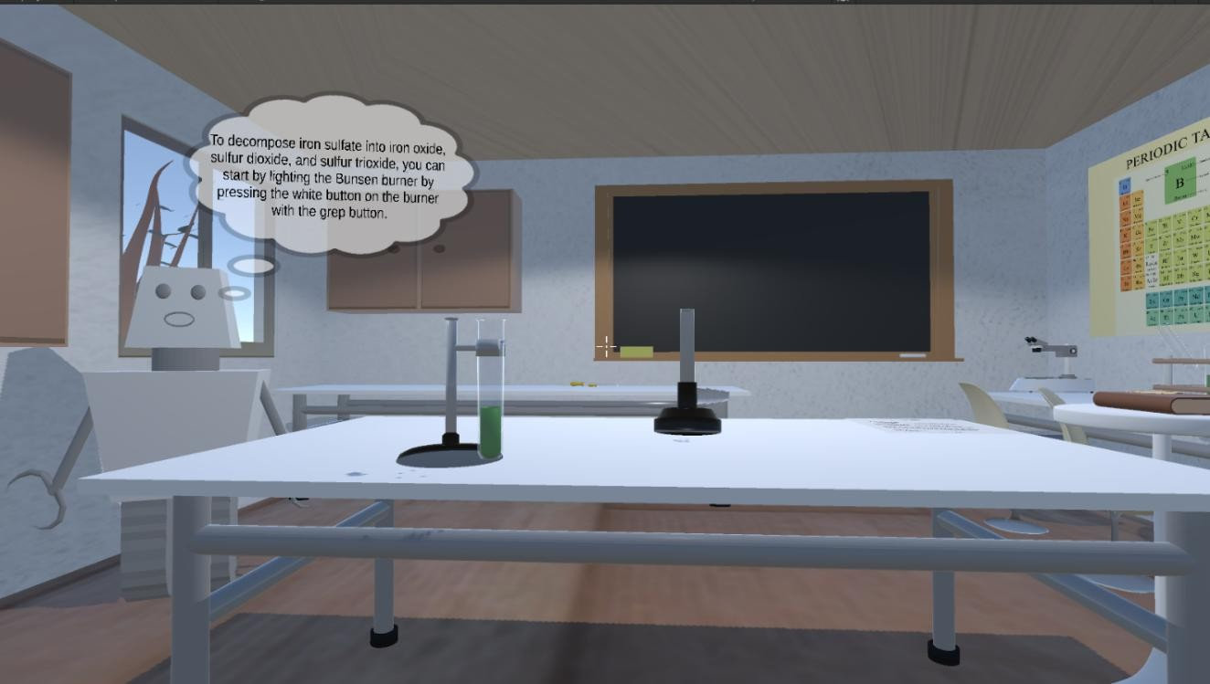
Figure 6.1: The Atomix virtual laboratory with the FeSO4 experiment set up
Reaction Book and learning. The world-space book (Figure 6.2) lists reactions by category with LEARN / PERFORM and a difficulty selector; keys 1-8 select directly. LEARN plays a video through ReactionLearningVideoCatalog or, via 3D VIEW, the live animation rendered by MolecularAnimationRenderer (Figure 6.3).
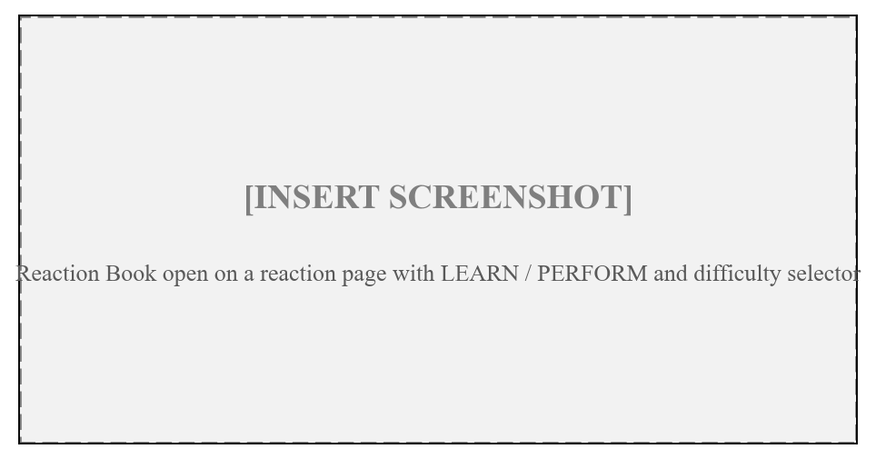
Figure 6.2: Reaction Book with LEARN / PERFORM and difficulty selection
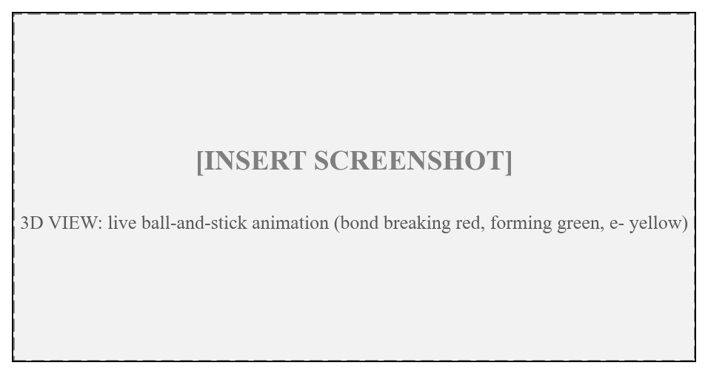
Figure 6.3: Live 3D molecular animation
Experimentation, history and graphs. PERFORM enables only that reaction's apparatus. Tilting a held vessel past a threshold emits a pour stream and raises the receiver's quantity; a tooltip and tracker show live amounts. Verdicts trigger synthesized success or gentle failure tones, camera shake and a result or failure card; F5 resets the bench. Tab opens the history (filters, expandable steps, used versus target, AI log) and F the energy-profile, enthalpy and entropy graphs with "Ask AI to Explain".
AI assistant. The panel sits at the right edge (Figure 6.4). LabTextInput takes over the keyboard while typing and is refused mid-pour; ConvaiAssistantBackend posts text and context with UnityWebRequest; OfflineVoice speaks offline answers.
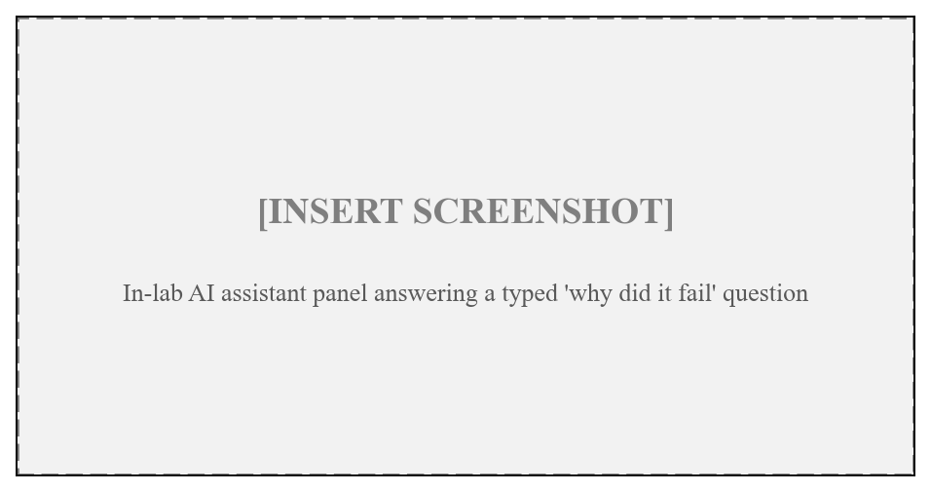
Figure 6.4: In-lab AI assistant answering a typed question
Testing scene. ExamSetupUI asks for the task count; Randomize and TheoreticalTasksManager present practical and multiple-choice tasks; ExamCoinHud shows the wallet and the F2/F3/F4 shop; ExamSession records every task; and the report card exports HTML and CSV reports (Figure 6.5).
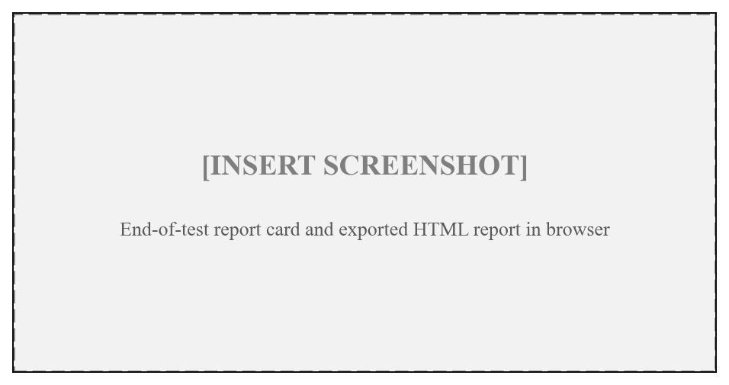
Figure 6.5: Testing scene report card and exported HTML report

6.3 Desktop and VR Modes
DesktopBootstrap uses RuntimeInitializeOnLoadMethod to add, when no XR device is active, a FirstPersonController (W/A/S/D, mouse look, sprint, fly), a crosshair, ray-based grabbing, a LabBoundary clamp and a DesktopObjectSettler that lowers floating glassware onto the bench. Held objects are rotated with Q/E, tilted with Z/X and rolled with C. In VR, an XR Origin with grab interactables, ray-interactable canvases, locomotion and Oculus hand models is used; because amounts derive from tilt and time, the same reaction scripts serve both modes. Table 6.1 lists the key scripts.
Table 6.1: Key scripts and responsibilities
Script | Responsibility
ControlReactions.cs | Reaction selection and laboratory set-up
FreeHandReactionEngine.cs (1,264 lines) | Shared quantity, order, overdose, underdose and settle logic
ReactionDefinition.cs | Data-driven recipe asset; configures the engine
ExperimentScoring.cs | Accuracy percentage, stars and difficulty scales
ExperimentHistoryManager.cs / ExperimentHistoryUI.cs | Attempt persistence and browsing
InLabAssistantController.cs / ExperimentContextProvider.cs | In-lab AI and context building
ConvaiAssistantBackend.cs | REST calls to the Convai character endpoint
ChemistryKnowledgeBase.cs / OfflineVoice.cs | Offline intent-based answers and Windows speech
MolecularSceneCatalog.cs / MolecularAnimationRenderer.cs | Code-authored molecular stages and live rendering
ReactionGraphCatalog.cs / ReactionGraphRenderer.cs / ReactionGraphUI.cs | Thermodynamic data and graphs
Randomize.cs / ExamSession.cs / CountdownTimer.cs | Randomized timed assessment
AtomixCoinBank.cs / ExamCoinHud.cs / ExamReportExporter.cs | Wallet, shop, HTML/CSV report
DesktopBootstrap.cs / FirstPersonController.cs / LabTextInput.cs | Desktop mode and typed-input gate

CHAPTER 7: RESULT ANALYSIS

7.1 Introduction
Atomix is a functional prototype verified by compilation and by automated checks that run the shipped logic. No controlled learning study, usability survey or on-device frame-rate measurement has yet been carried out, so none is reported; placeholders mark where measured data should be added.

7.2 Performance Measures
Engine-independent logic was extracted verbatim and executed with a time shim. Table 7.1 and Figure 7.1 show that every suite passed in full; the outcome matrix drove each test-scene experiment through correct amounts, overdose, underdose, reversed order and a mid-procedure pause, and confirmed that targets are never revealed in the test.
Table 7.1: Build and verification summary
Verification item | Result
Compilation against Unity 6000.3.7f1 assemblies | 0 errors; 68 pre-existing warnings (CS0649/CS0414 in original scripts); 0 new warnings
Reaction-engine outcome matrix (8 test-scene experiments) | 111 / 111 checks passed
Regression suite after molecular animation and offline AI | 167 / 167 checks passed
Regression suite after coin economy and exam report | 226 / 226 checks passed
Synthesised-audio suite | 22 / 22 checks passed
Full Play-mode regression on headset and desktop | [INSERT: results of final Play-mode pass]

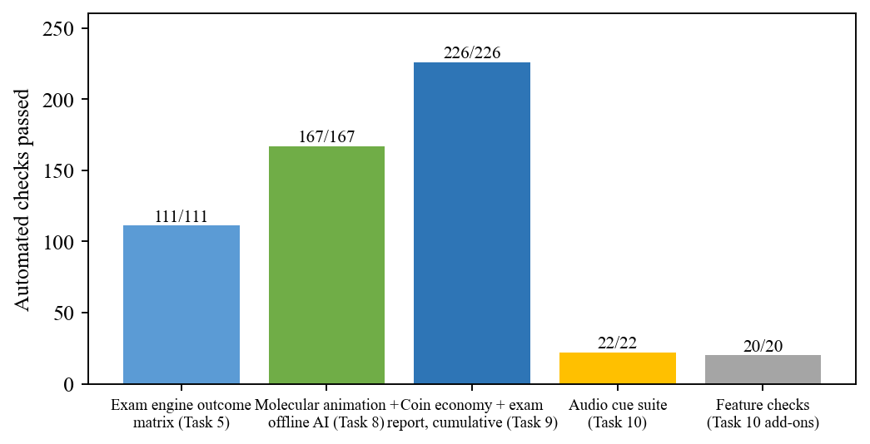
Figure 7.1: Automated verification checks passed per suite
Table 7.2 lists the thermodynamic data used by the graphs with ΔG at 298.15 K from Equation (5.6), and Figure 7.2 plots ΔH and E_{a}. Only the two thermal decompositions have positive ΔG at room temperature, which is why they are the experiments needing the burner (crossover about 1,110 K and 901 K). Reaction 3 is endothermic yet spontaneous through its entropy gain, and the alkali-metal reactions combine tiny barriers with large exothermicity, matching their violence in water. Other content metrics: 18 task types, 8/8 live animations, 13 achievements and a 118-element periodic table. [INSERT: frame rate on Quest and desktop; Convai versus offline response latency; SUS and pre/post-test scores.]
Table 7.2: Thermodynamic data per reaction and derived Gibbs energy
# | Type | ΔH (kJ/mol) | E_{a} (kJ/mol) | ΔS (J/mol·K) | ΔG₂₉₈ (kJ/mol) | Spontaneous at 298 K
1 | Exothermic | −368.6 | 10 | −15.5 | −364.0 | Yes
2 | Exothermic | −63.7 | 48 | −43.0 | −50.9 | Yes
3 | Endothermic | +31.4 | 45 | +241.0 | −40.5 | Yes (entropy-driven)
4 | Exothermic | −393.2 | 6 | +44.7 | −406.5 | Yes
5 | Exothermic | −627.6 | 85 | −86.9 | −601.7 | Yes
6 | Exothermic | −65.2 | 46 | −26.3 | −57.4 | Yes
7 | Endothermic | +178.3 | 185 | +160.7 | +130.4 | No (needs heating)
8 | Endothermic | +340.1 | 365 | +377.4 | +227.6 | No (needs heating)

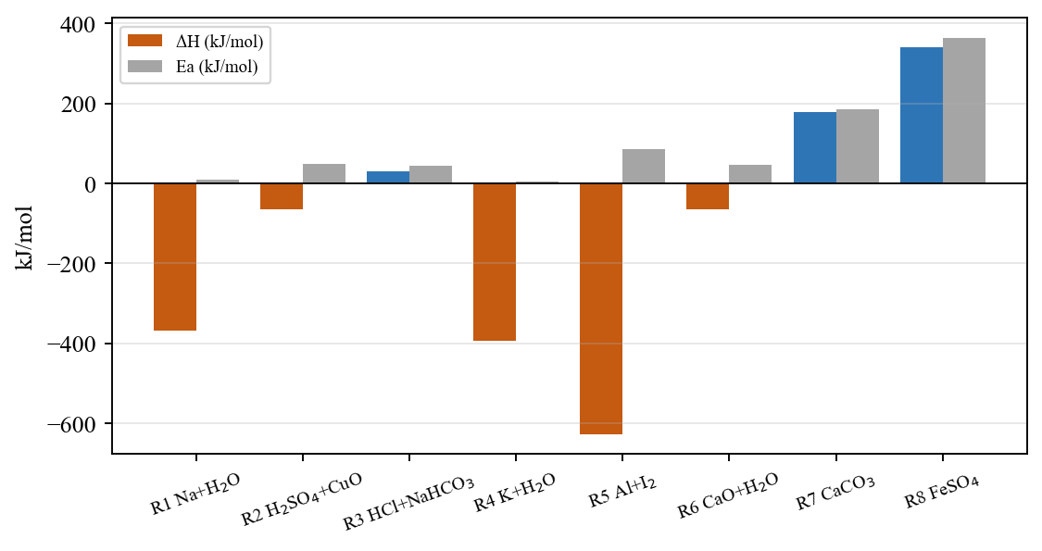
Figure 7.2: Enthalpy change and activation energy of the eight reactions
Table 7.3 traces the functional requirements of Table 3.4 to their implementation and evidence.
Table 7.3: Requirement traceability
ID | Implemented by | Status / evidence
FR1 | LabScene, 3D models, grab interactables | Implemented; Figure 6.1
FR2 | FlipPages, BookCanvasManager, keys 1-8 | Implemented
FR3 | ReactionLearningController, MolecularAnimationRenderer | Implemented; 8/8 animations, 167/167 suite
FR4, FR5 | FreeHandReactionEngine, ReactionDefinition | Implemented; 111/111 outcome matrix
FR6 | ExperimentFeedbackDirector, LabRetryController (F5) | Implemented
FR7, FR8 | InLabAssistantController, ConvaiAssistantBackend, ChemistryKnowledgeBase | Implemented; offline path verified in 167/167 suite
FR9, FR10 | ExperimentHistoryManager, ExperimentScoring | Implemented
FR11 | ReactionGraphCatalog / Renderer / UI | Implemented
FR12-FR14 | Randomize, ExamSession, AtomixCoinBank, ExamReportExporter | Implemented; 226/226 suite
FR15 | XR rig + DesktopBootstrap | Implemented; headset Play-mode pass [INSERT]

7.3 Screenshots
The main screens are shown in Figures 6.1 to 6.5.

7.4 Comparative Analysis
Table 7.4 compares Atomix functionally with representative systems from Chapter 2 (their numerical results used different populations and are not directly comparable). Atomix is the only reviewed system combining quantity-aware judging, molecular views, a live-context AI that works offline, attempt history, thermodynamics and assessment across VR and desktop; its main weakness is the absence, so far, of a controlled evaluation like [6]. Known limitations include online-only cloud AI, Windows-only offline speech, per-machine coins and a committed API key that must be rotated.
Table 7.4: Comparison with existing systems
Feature | Virtual labs [1],[12] | VR systems [4],[13] | Molecular VR [5] | AI chatbots [7],[14] | Atomix
Platform | Desktop / web | VR | Projection CAVE | Web / messaging | Meta Quest + Windows desktop
Experiment judging | Step sequence | Scripted | None | None | Order, overdose, underdose, heating, with tolerance
Difficulty levels | Rare | No | No | No | Guided / Standard / Expert
Molecular view | Static images | Partial | Yes | No | Video + live animation for 8/8 reactions
AI help | No | No | No | Yes, generic | Context-aware, voice + text, offline fallback
Progress record | Scores | No | No | Chat log | 300-attempt history with steps, accuracy, AI log
Thermodynamics | No | No | No | No | ΔH, E_{a}, ΔS, ΔG graphs with AI explanation
Assessment | Quizzes | No | No | No | 18 task types, coins, HTML/CSV report

CHAPTER 8: CONCLUSION & FUTURE SCOPE

8.1 Conclusion
Atomix unifies quantity-aware free-hand experimentation, molecular visualization, a context-aware AI assistant that works offline, attempt history, thermodynamic graphs and randomized assessment in one Unity 6 application for VR and desktop. Its data-driven engine judges order, overdose, underdose and procedure against per-reaction tolerances scaled by difficulty, and its minimum-reagent model rates attempts fairly. The 110-script, 39,601-line implementation compiles without errors and passed all automated checks (111/111, 167/167, 226/226, 22/22), and every functional requirement was implemented. These results show technical and functional viability; the educational effect remains to be measured.

8.2 Future Scope
- A controlled pre-test/post-test study with usability questionnaires.
- More experiments (titration, organic, electrochemistry) as new recipe assets.
- A teacher dashboard with accounts, synced history and leaderboards.
- An on-device language model grounded on the knowledge base; offline speech beyond Windows.
- Multiplayer benches, mixed-reality passthrough, WebGL/tablet builds and Hindi/Marathi localisation.

REFERENCES
[1] S. Ramos, E. P. Pimentel, M. das G. B. Marietto, and W. T. Botelho, "Hands-on and virtual laboratories to undergraduate chemistry education: Toward a pedagogical integration," in Proc. 2016 IEEE Frontiers in Education Conf. (FIE), 2016, pp. 1-8, doi: 10.1109/FIE.2016.7757580.
[2] M. Agarwal and S. Saha, "Learning chemistry through puzzle based game: Atoms to molecule," in Proc. 2011 9th IEEE Int. Conf. Emerging eLearning Technologies and Applications (ICETA), 2011, pp. 189-193, doi: 10.1109/ICETA.2011.6112613.
[3] A. L. Sanchez-Lopez, O. R. Camacho-Ornelas, L. M. Lozano-Sanchez, M. F. Rivas-Gastelum, A. Parra-Cordova, and Y. P. Avalos, "Enhancing chemistry laboratory teaching through gamification: The IQ-Mobile Race," in Proc. 2023 IEEE Int. Conf. Teaching, Assessment and Learning for Engineering (TALE), 2023, pp. 1-4, doi: 10.1109/TALE56641.2023.10398328.
[4] J. T. Bell and H. S. Fogler, "The application of virtual reality to (chemical engineering) education," in Proc. IEEE Virtual Reality Conf. (VR 2004), 2004, pp. 217-218, doi: 10.1109/VR.2004.1310077.
[5] Y. Luo, P. Guo, S. Hasegawa, and M. Sato, "An interactive molecular visualization system for education in immersive multi-projection virtual environment," in Proc. 3rd Int. Conf. Image and Graphics (ICIG), 2004, pp. 485-488, doi: 10.1109/ICIG.2004.36.
[6] T. Xie, Y. Li, and Y. Tang, "Effects of using immersive virtual reality for science education on learning outcomes: A randomized controlled pilot study," IEEE Trans. Learning Technologies, vol. 16, no. 6, pp. 1045-1056, 2023, doi: 10.1109/TLT.2023.3263587.
[7] N. Sandu and E. Gide, "Adoption of AI-chatbots to enhance student learning experience in higher education in India," in Proc. 2019 18th Int. Conf. Information Technology Based Higher Education and Training (ITHET), 2019, pp. 1-5, doi: 10.1109/ITHET46829.2019.8937382.
[8] M. P. Kurniawan, M. Suyanto, E. Utami, and Kusrini, "Educational game learning quality evaluation tool: A systematic literature review," in Proc. 2024 7th Int. Conf. Informatics and Computational Sciences (ICICoS), 2024, doi: 10.1109/ICICoS62600.2024.10636925.
[9] J. K. Gilbert and D. F. Treagust, Eds., Multiple Representations in Chemical Education. Dordrecht, Netherlands: Springer, 2009, doi: 10.1007/978-1-4020-8872-8.
[10] H.-K. Wu, J. S. Krajcik, and E. Soloway, "Using technology to support the development of conceptual understanding of chemical representations," 2000. [VERIFY: venue and pages]
[11] E. Byusa, E. Kampire, and A. R. Mwesigye, "Game-based learning approach on students' motivation and understanding of chemistry concepts: A systematic review of literature," Heliyon, vol. 8, no. 5, e09541, 2022, doi: 10.1016/j.heliyon.2022.e09541.
[12] N. Ali and S. Ullah, "Review to analyze and compare virtual chemistry laboratories for their use in education," J. Chemical Education, vol. 97, no. 10, pp. 3563-3574, 2020, doi: 10.1021/acs.jchemed.0c00185.
[13] J. Alvarez Ramirez and A. Bueno, "Learning organic chemistry with virtual reality," in Proc. 2020 IEEE Int. Conf. Engineering Veracruz (ICEV), 2020, doi: 10.1109/ICEV50249.2020.9289672.
[14] I. Atmosukarto, W. S. Cheow, P. Iyer, N. Tong, and K. Yu, "Enhancing adaptive online chemistry course with AI-chatbot," in Proc. 2021 IEEE Int. Conf. Engineering, Technology & Education (TALE), 2021, doi: 10.1109/TALE52509.2021.9678528.
[15] Unity Technologies, "Unity 6 User Manual," 2025. [Online]. Available: https://docs.unity3d.com/Manual/index.html
[16] The Khronos Group, "The OpenXR Specification," [Online]. Available: https://registry.khronos.org/OpenXR/
[17] Unity Technologies, "XR Interaction Toolkit," package documentation. [Online]. Available: https://docs.unity3d.com/Packages/com.unity.xr.interaction.toolkit@latest
[18] Convai, "Convai Documentation - Character API," [Online]. Available: https://docs.convai.com/

PUBLISHED PAPERS
[INSERT: Published / communicated paper "Atomix - Your Personal Lab with A.I." by K. D. Soni, D. M. Thakar, K. R. Verma and M. Phadke]
[INSERT: Conference / journal name, date, ISSN/ISBN, DOI or acceptance letter]

CERTIFICATES
[INSERT: Paper publication certificates]
[INSERT: Conference attendance / presentation certificates]
[INSERT: Competition participation certificates, if any]

PLAGIARISM REPORT
[INSERT: First few pages of the plagiarism report (e.g., Turnitin / Drillbit) with similarity index]

