[INSERT: University of Mumbai emblem]
Irrigation Advisory System for Sugarcane Crop using AI and Sensor-based Technology
LY Innovation-Based Major Project-B Report
Submitted in partial fulfilment of the requirements of the Degree of
Bachelor of Technology in Computer Engineering
by
[INSERT: Student Name 1] ([INSERT: Roll No.])
[INSERT: Student Name 2] ([INSERT: Roll No.])
[INSERT: Student Name 3] ([INSERT: Roll No.])

Supervisor and Guide
[INSERT: Guide Name]
[INSERT: Somaiya Vidyavihar logo]
Department of Computer Engineering
K. J. Somaiya Institute of Technology
An Autonomous Institute permanently affiliated to University of Mumbai
Ayurvihar, Sion, Mumbai-400022
University of Mumbai
2026-27

Certificate
This is to certify that the project entitled “Irrigation Advisory System for Sugarcane Crop using AI and Sensor-based Technology” is a bonafide work of
[INSERT: Student Name 1] ([INSERT: Roll No.])
[INSERT: Student Name 2] ([INSERT: Roll No.])
[INSERT: Student Name 3] ([INSERT: Roll No.])
submitted to the University of Mumbai in partial fulfilment of the requirement for the award of the degree of Bachelor of Technology in Computer Engineering. The work was carried out in the Department of Computer Engineering, K. J. Somaiya Institute of Technology, during the academic year 2026-27.
_____________________________ _____________________________
Supervisor and Guide Head of Department
[INSERT: Guide Name] Dr. Sarita Ambadekar
_____________________________
Principal
Dr. Vivek Sunnapwar
Place: Sion, Mumbai-400022
Date: [INSERT: date]

Project Approval for L.Y.
This project report entitled “Irrigation Advisory System for Sugarcane Crop using AI and Sensor-based Technology” by
[INSERT: Student Name 1] ([INSERT: Roll No.])
[INSERT: Student Name 2] ([INSERT: Roll No.])
[INSERT: Student Name 3] ([INSERT: Roll No.])
is approved for the degree of Bachelor of Technology in Computer Engineering, University of Mumbai.
_____________________________ _____________________________
External Examiner Internal Examiner
Name: [INSERT] Name: [INSERT]
Place: Sion, Mumbai-400022
Date: [INSERT: date]

Declaration
We declare that this written submission represents our ideas in our own words and, where others’ ideas or words have been included, we have adequately cited and referenced the original sources. We also declare that we have adhered to all principles of academic honesty and integrity and have not misrepresented, fabricated or falsified any idea, data, fact or source in our submission. We understand that any violation of the above will be cause for disciplinary action by the Institute and can also evoke penal action from the sources which have not been properly cited or from whom proper permission has not been taken when needed.
All experimental results reported in this document were produced by the software described in it, on the dataset supplied for use case KJS-AGR-01. No result has been added from outside that work.
[INSERT: Student Name 1] ([INSERT: Roll No.]) _____________________ (Signature)
[INSERT: Student Name 2] ([INSERT: Roll No.]) _____________________ (Signature)
[INSERT: Student Name 3] ([INSERT: Roll No.]) _____________________ (Signature)
Date: [INSERT: date]

Acknowledgement
We express our sincere gratitude to our guide, [INSERT: Guide Name], for the guidance, encouragement and critical review that shaped this project from the first dataset profile to the final report. The discussions on validation and on what the data could and could not support were especially valuable.
We are grateful to Dr. Sarita Ambadekar, Head of the Department of Computer Engineering, for providing the facilities and an environment that supports project-based learning, and to Dr. Vivek Sunnapwar, Principal, K. J. Somaiya Institute of Technology, for his constant support of innovation-based projects.
We thank the faculty owners of use case KJS-AGR-01 and the K. J. Somaiya Institute of Applied Agricultural Research (KIAAR), Sameerwadi, and Godavari Biorefineries Ltd. (GBL) for defining the problem and supplying the plot-level dataset on which this work is built.
Finally, we thank the teaching and non-teaching staff of the department, and our friends and families, for their help and patience throughout the project.
[INSERT: Student Name 1] ([INSERT: Roll No.])
[INSERT: Student Name 2] ([INSERT: Roll No.])
[INSERT: Student Name 3] ([INSERT: Roll No.])

Abstract
Sugarcane is one of the most water-intensive crops grown in Karnataka, yet most farmers in the KIAAR and Godavari Biorefineries catchment schedule irrigation from experience rather than measurement. This leads to over-irrigation, moisture stress, wasted electricity and lost yield. This project builds a plot-level irrigation advisory system for sugarcane on a dataset of 1,000 geofenced plots in six taluks of Mandya district. Each plot record carries satellite vegetation indices, weather aggregates, soil properties and a soil-moisture value. We first trained and compared four regression models for soil moisture. Gradient Boosting reached a test R² of 0.9998 on the conventional random split. A leave-one-village-out audit then showed that no model outperformed a mean predictor on unseen villages, because soil moisture in the dataset takes only 33 distinct values and six of ten villages share a single value. We therefore designed the system to treat an in-field probe reading as the primary soil-moisture input and the model estimate as a labelled fallback.
Because the dataset has no labels for irrigation dates, depths or yields, these outputs are computed with the FAO-56 soil water balance and the FAO-33 yield response method rather than trained models. The engine estimates crop water requirement, the next irrigation date, the depth, volume and pump duration, a water stress index, rainfall-adjusted postponement, yield loss from delayed irrigation and a stage-split fertigation dose. A scheduler places pumping hours into electricity supply windows at plot and feeder level. Advisories are generated in English, Kannada, Hindi and Marathi, and an optional large-language-model rewrite is rejected if any number changes. The system is delivered as a FastAPI service with a web frontend and a Streamlit dashboard, has 22 automated tests, and logs human review decisions as future training labels.
Keywords: irrigation scheduling, sugarcane, FAO-56, soil moisture, spatial cross-validation, decision support, multilingual advisory.
Contents
Certificate i
Project Approval for L.Y. ii
Declaration iii
Acknowledgement iv
Abstract v
List of Figures ix
List of Tables xi
List of Abbreviations xii
Chapter 1: Introduction 1
1.1 Introduction 1
1.2 Problem Definition 1
1.3 Aim and Objectives 2
1.4 Organization of the Report 3
Chapter 2: Review of Literature 4
2.1 Literature Survey 4
2.1.1 Crop water requirement and irrigation scheduling 4
2.1.2 Remote sensing of crops and land cover 5
2.1.3 Machine learning methods 5
2.1.4 Validating models on spatial data 6
2.1.5 Explainable AI 6
2.1.6 Weather data, software platforms and governance 6
2.2 Research Gaps 8
Chapter 3: Requirement Specification 10
3.1 Introduction 10
3.2 Hardware Requirements 10
3.3 Software Requirements 11
3.4 Feasibility Study 11
3.4.1 Technical feasibility 11
3.4.2 Economic feasibility 12
3.4.3 Operational feasibility 12
3.5 Cost Estimation 12
3.6 Functional Requirements 13
3.7 Non-Functional Requirements 14
3.8 Dataset Specification 14
3.9 Data Requirements Not Met by the Dataset 15
Chapter 4: Project Analysis and Design 17
4.1 Introduction 17
4.2 UML Diagrams 17
4.2.1 Use-case diagram 17
4.2.2 Sequence diagram 18
4.2.3 State diagram 19
4.2.4 Activity diagram 20
4.2.5 Class diagram 21
4.2.6 Data flow diagram: level 0 22
4.2.7 Data flow diagram: level 1 23
4.2.8 Data flow diagram: level 2 24
4.3 System Architecture 25
4.4 Deployment Design 26
4.5 Database Design 27
4.6 API Design 28
4.7 User Interface Design 29
Chapter 5: Methodology 30
5.1 Introduction 30
5.2 System Block Diagram 30
5.3 Data Preprocessing and Feature Engineering 31
5.4 Soil-Moisture Models and Validation 32
5.4.1 Candidate models 32
5.4.2 Random-split protocol 32
5.4.3 Spatial validation protocol 33
5.4.4 Explainability 33
5.5 FAO-56 Irrigation Decision Engine 33
5.5.1 Crop stage, crop coefficient and root depth 34
5.5.2 Reference and crop evapotranspiration 35
5.5.3 Soil water availability and depletion 35
5.5.4 Daily water balance and rainfall adjustment 35
5.5.5 Irrigation depth, volume and pump duration 36
5.5.6 Decision algorithm 36
5.6 Yield Loss from Delayed Irrigation 37
5.7 Fertigation Recommendation 37
5.8 Pump Scheduling 37
5.9 Multilingual Advisory Generation 38
5.10 Human-in-the-Loop Review 39
Chapter 6: Implementation Details 40
6.1 Introduction 40
6.2 System Implementation 40
6.2.1 Web frontend: farm dashboard 40
6.2.2 Effect of a field probe reading 42
6.2.3 Fleet map 43
6.2.4 Pump scheduling 44
6.2.5 Use-case coverage view 45
6.2.6 REST API documentation 46
6.2.7 Streamlit dashboard 47
6.3 Code Organisation 48
6.4 Backend Implementation 49
6.5 Frontend Implementation 50
6.6 Testing 50
6.7 Deployment 51
Chapter 7: Result Analysis 52
7.1 Introduction 52
7.2 Performance Measures 52
7.2.1 Exploratory analysis of the dataset 52
7.2.2 Soil-moisture models on the random split 54
7.2.3 Feature importance 55
7.2.4 Spatial validation 56
7.2.5 Decision engine results for one farm 58
7.2.6 Scenario and sensitivity analysis 60
7.2.7 Feeder scheduling 63
7.2.8 Response time 64
7.2.9 Test results 65
7.3 Screenshots 65
7.4 Comparative Analysis 66
Chapter 8: Conclusion and Future Scope 68
8.1 Conclusion 68
8.2 Future Scope 69
References 71
Published Papers 73
Certificates 74
Plagiarism Report 75

List of Figures
Figure 4.1: Use-case diagram of the irrigation advisory system 18
Figure 4.2: Sequence diagram for generating and reviewing a farm advisory 19
Figure 4.3: State diagram of a plot’s irrigation status 20
Figure 4.4: Activity diagram for producing and reviewing an advisory 21
Figure 4.5: Class and module diagram of the backend 22
Figure 4.6: Level 0 data flow diagram (context diagram) 23
Figure 4.7: Level 1 data flow diagram 24
Figure 4.8: Level 2 data flow diagram for process 3.0, Plan irrigation 25
Figure 4.9: Layered system architecture 26
Figure 4.10: Deployment diagram 27
Figure 5.1: System block diagram 31
Figure 5.2: Soil-moisture machine learning pipeline and validation 32
Figure 6.1: Web frontend: upper half of the farm dashboard (model estimate, English) 41
Figure 6.2: Web frontend: lower half of the farm dashboard 42
Figure 6.3: Farm dashboard after entering a probe reading of 0.15 m³/m³ 42
Figure 6.4: Farmer message in Kannada, human review form and model card 43
Figure 6.5: Web frontend: fleet map of all 1,000 plots by irrigation status 44
Figure 6.6: Web frontend: feeder-level pump schedule for Bheemanahalli 45
Figure 6.7: Web frontend: use-case coverage matrix 46
Figure 6.8: Interactive REST API documentation (Swagger UI) 47
Figure 6.9: Streamlit analytical dashboard 48
Figure 7.1: Distribution of soil moisture in the dataset 52
Figure 7.2: Correlation heatmap of the numeric columns 53
Figure 7.3: Rainfall versus soil moisture 53
Figure 7.4: Soil moisture of every plot by village 54
Figure 7.5: Validation RMSE of candidate models (log scale) 55
Figure 7.6: Top ten features by importance in the selected model 56
Figure 7.7: MAE under random, leave-one-village-out and leave-one-taluk-out validation (log scale) 57
Figure 7.8: Projected root-zone depletion for farm MM-MD-0110: model estimate versus probe reading 59
Figure 7.9: Crop coefficient and root depth over the sugarcane season 60
Figure 7.10: Days until irrigation versus soil-moisture reading for three soil textures 61
Figure 7.11: Pump hours per irrigation by method 62
Figure 7.12: Relative yield loss by delay and growth stage 63
Figure 7.13: Scheduled and unmet pump-hours by irrigation method and feeder cap 64
Figure 7.14: Web frontend: model validation view 65

List of Tables
Table 2.1: Summary of the literature survey 7
Table 3.1: Hardware requirements 10
Table 3.2: Software requirements and versions 11
Table 3.3: Cost estimation 13
Table 3.4: Functional requirements 13
Table 3.5: Summary statistics of the numeric columns (1,000 plots) 15
Table 3.6: Outputs requested by the use case and the data they need 15
Table 4.1: Table prediction_logs 27
Table 4.2: Table advisory_feedback 28
Table 4.3: REST API endpoints 28
Table 5.1: Agronomic parameters of the decision engine 34
Table 5.2: Soil water properties by texture (FAO-56 Table 19 mid-points) 34
Table 6.1: Project modules and responsibilities 48
Table 6.2: Automated test cases 50
Table 7.1: Validation performance of candidate models (random 70/15/15 split) 54
Table 7.2: Held-out test performance of the selected model (Gradient Boosting) 55
Table 7.3: Spatial validation results for all schemes, feature sets and models 56
Table 7.4: Leave-one-village-out error of Gradient Boosting by village 57
Table 7.5: Engine output for farm MM-MD-0110 with the model estimate and with a probe reading 58
Table 7.6: Estimated yield loss for delayed irrigation, farm MM-MD-0110 (grand growth) 60
Table 7.7: Effect of forecast rain on the irrigation due date 61
Table 7.8: Days until irrigation by soil-moisture reading and soil texture 61
Table 7.9: Water and pump time per irrigation by method (0.736 ha plot) 62
Table 7.10: Relative yield loss (%) by delay and growth stage 63
Table 7.11: Feeder scheduling results for Bheemanahalli (96 farms, 21 days) 64
Table 7.12: Measured response times 64
Table 7.13: Comparison with the approaches from the literature survey 67

List of Abbreviations
API | Application Programming Interface
ASGI | Asynchronous Server Gateway Interface
CDN | Content Delivery Network
CPU | Central Processing Unit
CSS | Cascading Style Sheets
CSV | Comma-Separated Values
CV | Cross-validation
DFD | Data Flow Diagram
DPDP | Digital Personal Data Protection (Act, 2023)
EDA | Exploratory Data Analysis
ERTS | Earth Resources Technology Satellite
ESCOM | Electricity Supply Company
ET | Evapotranspiration
ET_{a} | Actual crop evapotranspiration
ET_{c} | Crop evapotranspiration under standard conditions
ET_{o} | Reference evapotranspiration
FAO | Food and Agriculture Organization of the United Nations
GBL | Godavari Biorefineries Ltd.
GEE | Google Earth Engine
GPU | Graphics Processing Unit
HP | Horsepower
HTML | Hypertext Markup Language
HTTP | Hypertext Transfer Protocol
INR | Indian Rupee
IoT | Internet of Things
JSON | JavaScript Object Notation
K_{c} | Crop coefficient
KIAAR | K. J. Somaiya Institute of Applied Agricultural Research
K_{s} | Water stress coefficient
K_{y} | Yield response factor
LAI | Leaf Area Index
LLM | Large Language Model
LOTO | Leave-one-taluk-out (cross-validation)
LOVO | Leave-one-village-out (cross-validation)
MAE | Mean Absolute Error
MAP | Mono-ammonium phosphate (12-61-0)
ML | Machine Learning
MOP | Muriate of potash
NDVI | Normalized Difference Vegetation Index
NPK | Nitrogen, phosphorus and potassium
OOB | Out-of-bag (error estimate)
OS | Operating System
PK | Primary key
R² | Coefficient of determination
RAM | Random Access Memory
RAW | Readily available water
REST | Representational State Transfer
RMSE | Root Mean Squared Error
SDK | Software Development Kit
SHAP | SHapley Additive exPlanations
SSD | Solid-State Drive
STEPS | Somaiya Technology for Efficient Plot Survey
SVG | Scalable Vector Graphics
TAW | Total available water
UI | User Interface
UML | Unified Modeling Language
UTC | Coordinated Universal Time
vCPU | Virtual CPU
θ_{FC} | Volumetric soil water content at field capacity
θ_{WP} | Volumetric soil water content at wilting point

Chapter 1: Introduction

1.1 Introduction
Agriculture in India depends heavily on irrigation, and sugarcane is among its most water-demanding crops. A sugarcane crop stays in the field for twelve to eighteen months and passes through germination, tillering, grand growth and maturity, each with a different water demand. In the northern and southern sugar belts of Karnataka, the crop is supplied by canals and by borewell pumps that run on a rationed agricultural electricity supply. The K. J. Somaiya Institute of Applied Agricultural Research (KIAAR), Sameerwadi, and Godavari Biorefineries Ltd. (GBL) work with an estimated 18,000 to 25,000 sugarcane farmers whose plots have already been digitised and geofenced through earlier initiatives [1]. The use case KJS-AGR-01 asks how these digital assets, together with satellite data, weather forecasts, field sensors and artificial intelligence, can be turned into plot-specific irrigation advice that a farmer can act on. Irrigation science already offers a standard, physically based method for this task: the soil water balance and crop coefficient approach of the Food and Agriculture Organization (FAO) Irrigation and Drainage Paper 56 [2]. What is missing is a system that joins that method with the available data, measures honestly how far the data can be trusted, and delivers the result in the farmer's own language.
This report describes the design, implementation and evaluation of such a system. We built a soil-moisture estimation model from the supplied plot dataset, audited how well it generalises to new locations, and placed it inside a decision engine based on FAO-56 that computes when to irrigate, how much water to apply and how long to run the pump. Around this engine we built pump scheduling against electricity supply windows, fertigation advice, multilingual farmer advisories, a human review loop, a REST service, a web frontend and an analytical dashboard.

1.2 Problem Definition
Irrigation of sugarcane in the KIAAR and GBL catchment is scheduled mostly from farmers’ experience rather than from measurement or scientific recommendation [1]. Without knowledge of crop water requirement, current soil moisture, expected rainfall and the stage of the crop, a farmer either irrigates too often or too late. Over-irrigation wastes water and electricity, leaches nutrients and raises cultivation cost. Late irrigation lets the root zone dry beyond the point at which the crop can extract water freely, and the resulting moisture stress reduces cane yield. The electricity supplied for agricultural pumps is available only in fixed windows, so even a correct irrigation decision can fail if the required pumping hours do not fit the available supply. Finally, the number of farms involved makes manual agronomic supervision of each plot impossible.
The supplied dataset adds a second, technical problem. It contains 1,000 plot records from six taluks of Mandya district with satellite vegetation indices, weather aggregates, soil chemistry, plot polygons and a soil-moisture value, but it has no observation dates and no records of irrigation events, irrigation depths, water stress or yields. A naive approach would train a model to predict irrigation dates or yields from columns whose names sound suitable. Such a model would be fabricated, because the dataset contains no ground truth for those outputs. The problem addressed in this project is therefore stated as follows:
To design and build a plot-level irrigation advisory system for sugarcane that estimates soil moisture from the available data, verifies how far that estimate can be trusted on unseen locations, converts soil moisture into transparent irrigation, stress, yield-loss, fertigation and pump-scheduling decisions using established agronomic methods, and delivers those decisions to farmers and field staff in their own language with human oversight.

1.3 Aim and Objectives
The aim of the project is to deliver a working, tested prototype of the AI-enabled irrigation advisory platform described in use case KJS-AGR-01, in which every output is traceable either to a trained model, to a published agronomic equation, or to a stated assumption. The objectives are:
- To profile the supplied plot dataset and identify which prediction targets it can and cannot support.
- To train, compare and select regression models for soil moisture using a leakage-safe preprocessing pipeline, and to explain their predictions.
- To evaluate the selected model with spatially grouped cross-validation (leave-one-village-out and leave-one-taluk-out) and to design the system around the result.
- To implement an FAO-56 soil water balance engine that produces crop water requirement, the next irrigation date, irrigation depth, volume and pump duration, a water stress index and rainfall-adjusted recommendations.
- To estimate relative yield loss from delayed irrigation using the FAO-33 yield response method and to generate stage-wise fertigation advice.
- To schedule pumping hours within electricity supply windows for individual farms and for groups of farms sharing one feeder.
- To generate farmer advisories in English, Kannada, Hindi and Marathi, with an optional large language model (LLM) rewrite that cannot change any number.
- To expose all functions through a REST API, a web frontend and a dashboard, record human review decisions, and verify the system with automated tests.

1.4 Organization of the Report
Chapter 2 reviews the methods and tools on which the work builds, from FAO crop water guidelines and vegetation indices to tree-based learners, spatial cross-validation and explainable AI, and identifies the research gaps the project addresses. Chapter 3 specifies the hardware and software requirements, the feasibility of the system, a cost estimate, the functional and non-functional requirements and the dataset. Chapter 4 presents the analysis and design of the system through UML diagrams, data flow diagrams at three levels, the architecture, the database schema and the API design. Chapter 5 explains the methodology in detail: the system block diagram, preprocessing and feature engineering, the machine learning and validation procedure, and the mathematical formulation of the irrigation, stress, yield-loss, fertigation, scheduling and advisory modules. Chapter 6 describes the implementation of the backend, the web frontend and the dashboard with annotated screenshots, and the test suite. Chapter 7 analyses the results, including model performance, the spatial validation audit, decision-engine behaviour, scheduling outcomes and response times, and compares the system with the approaches surveyed in Chapter 2. Chapter 8 concludes the report and outlines future work.

Chapter 2: Review of Literature

2.1 Literature Survey
Our search began from the needs stated in the use-case document [1] and worked outward along the four building blocks of the system: crop water requirement and irrigation scheduling, remote sensing of crop and land condition, machine learning and its validation for spatial data, and the software and governance frameworks needed to deliver advice to farmers. For the agronomic block we used the FAO Irrigation and Drainage Papers, which are the accepted international references for crop water requirement and yield response. For remote sensing and machine learning we selected the original papers that introduced each method used in the project, and the papers that define best practice for validating models on spatially structured data. For the delivery layer we relied on the official documentation of the frameworks used and on Indian data-protection law. Sources were selected for direct relevance to a decision made in this project; each is summarised below and in Table 2.1. [INSERT: additional peer-reviewed studies on IoT- and ML-based irrigation scheduling from the team’s own database search, with search terms, databases and date range]

2.1.1 Crop water requirement and irrigation scheduling
Allen et al. [2] define the FAO-56 procedure that underpins modern irrigation scheduling. Reference evapotranspiration (ET_{o}) from a hypothetical grass surface is computed with the FAO Penman-Monteith equation, and the water used by a specific crop is obtained by multiplying ET_{o} by a crop coefficient K_{c} that changes through four growth stages. The paper tabulates K_{c} values, stage lengths, maximum rooting depths and allowable depletion fractions for many crops, including sugarcane, and describes a daily root-zone water balance in which irrigation becomes due when depletion reaches the readily available water. It also defines a water stress coefficient K_{s} that reduces crop transpiration once depletion passes that threshold. The method is physically grounded and widely validated, but it needs inputs such as soil water-holding capacity, crop stage and either full meteorological data or a simplified ET_{o} estimate, and it produces scheduling advice only when someone supplies those inputs plot by plot.
Doorenbos and Pruitt [3] preceded FAO-56 with FAO-24, which presented several ET_{o} methods for different levels of data availability, including a modified Blaney-Criddle method. The original Blaney-Criddle formula [4] estimates consumptive use from mean air temperature and the share of annual daylight hours, which makes it usable when only temperature and latitude are known. Its accuracy is lower than Penman-Monteith, especially in humid or windy conditions, but it is the only option when radiation, humidity and wind records are absent, which is the case for most plots in the supplied dataset.
Doorenbos and Kassam [5] related crop yield to water deficit through the yield response factor K_{y}, stating that the relative yield decrease equals K_{y} times the relative evapotranspiration deficit. They give K_{y} values by growth stage, showing that sugarcane is far more sensitive to water deficit during establishment and vegetative growth than during ripening. The relationship is linear and empirical and is meant for planning-level estimates rather than precise field prediction, but it is the standard way to express the yield cost of water stress when no local yield trials are available.

2.1.2 Remote sensing of crops and land cover
Rouse et al. [6] introduced the Normalized Difference Vegetation Index (NDVI), the normalised difference between near-infrared and red reflectance, to monitor vegetation from the ERTS-1 (Landsat-1) satellite. NDVI remains the most widely used indicator of green biomass and crop vigour and is one of the inputs in the supplied dataset. It saturates in dense canopies and is affected by soil background and atmosphere, so it describes crop condition rather than soil water directly.
Gorelick et al. [7] describe Google Earth Engine (GEE), a cloud platform that hosts petabytes of satellite imagery and runs analysis at planetary scale. The structure of the supplied dataset, with a system index column and GeoJSON geometry, is characteristic of an export from such a platform. The ESA WorldCover product [8] is a 10 m global land-cover map for 2020; the dataset’s sampling-method column indicates that plots were sampled from its cropland class. Land-cover maps of this kind confirm that a location is cropland but do not identify the crop, and their class accuracy varies by region.

2.1.3 Machine learning methods
Pedregosa et al. [9] present scikit-learn, the Python library used in this project for preprocessing pipelines, model training and evaluation. Its pipeline and column-transformer abstractions make it possible to fit imputation, scaling and encoding on training data only, which prevents information from the test set leaking into the model. Breiman [10] introduced random forests, ensembles of decision trees grown on bootstrap samples with random feature selection at each split, which reduce variance and handle mixed feature types well. Geurts et al. [11] proposed extremely randomised trees, which also randomise split thresholds and are faster to train with similar accuracy. Friedman [12] formulated gradient boosting as stage-wise fitting of weak learners to the negative gradient of a loss function; gradient-boosted trees are among the most accurate learners on tabular data. All three tree ensembles can memorise fine-grained structure in the training data, which is an advantage for interpolation and a risk for extrapolation to new conditions.

2.1.4 Validating models on spatial data
Roberts et al. [13] show that when observations are spatially, temporally or hierarchically structured, random cross-validation places near-duplicate observations in both training and test folds and therefore underestimates prediction error. They recommend blocked cross-validation, in which whole blocks such as regions, time periods or groups are held out together. Meyer et al. [14] apply this to environmental mapping and show that models using location-like predictors can reach excellent random cross-validation scores while failing on new areas; spatial cross-validation exposes this, and removing predictors that only identify location can improve true spatial performance. These two papers directly motivated the leave-one-village-out and leave-one-taluk-out audit in this project.

2.1.5 Explainable AI
Lundberg and Lee [15] unify several attribution methods under SHapley Additive exPlanations (SHAP), which assign each feature a contribution to a prediction based on Shapley values from cooperative game theory. SHAP gives consistent local and global explanations, with a fast exact algorithm for tree ensembles, but its values describe the model rather than causal effects in the field. The project uses SHAP for global importance when the library is installed and otherwise falls back to the model’s native importance, and uses a one-at-a-time baseline replacement for local explanations.

2.1.6 Weather data, software platforms and governance
Open-Meteo [16] provides a free forecast API that returns daily temperature, precipitation, precipitation probability and FAO-56 Penman-Monteith reference evapotranspiration for any coordinate without an API key, which makes it suitable for a prototype that must stay free to run. FastAPI [17] is a Python web framework that derives request validation and interactive OpenAPI documentation from type hints. Streamlit [18] turns Python scripts into interactive data applications and suits analytical dashboards. Leaflet [19] is a lightweight JavaScript map library, and OpenStreetMap [20] supplies the base map tiles. The Claude API [21] provides access to a large language model that can rewrite structured facts into natural language. The Digital Personal Data Protection Act, 2023 [22] governs the processing of personal data of Indian citizens, including farmer names, phone numbers and plot locations, and requires purpose limitation, data minimisation and consent.
Table 2.1 summarises every source cited in this report, the method or contribution it provides, the data it relies on, its main result and its limitation as it affects this project.
Table 2.1: Summary of the literature survey
Author / Year | Method or contribution | Dataset | Result | Limitation for this project
KJSIT, KIAAR, GBL [1] (2026) | Use-case definition, objectives, workflow and governance needs | 18,000–25,000 farms; supplied plot dataset | Lists 11 AI models and 10 workflow stages to build | Specifies goals, not methods or labels
Allen et al. [2] (1998) | FAO-56 crop coefficients, Penman-Monteith ET_{o}, daily water balance, K_{s} | Lysimeter and field studies worldwide | Standard procedure for crop water requirement and scheduling | Needs soil, crop-stage and weather inputs per plot
Doorenbos and Pruitt [3] (1977) | FAO-24 ET_{o} methods incl. modified Blaney-Criddle | Global climatic data | ET_{o} methods for low-data settings | Lower accuracy than Penman-Monteith
Blaney and Criddle [4] (1950) | Temperature-based consumptive-use formula | Irrigated areas of the western USA | ET from mean temperature and daylight share | Ignores humidity, wind, radiation
Doorenbos and Kassam [5] (1979) | Yield response factor K_{y} | Field experiments, many crops | Relative yield loss = K_{y} × relative ET deficit | Linear, planning-level; not locally calibrated
Rouse et al. [6] (1974) | NDVI vegetation index | ERTS-1 (Landsat-1) imagery, Great Plains | Index tracks green biomass | Saturates; indicates vigour, not soil water
Gorelick et al. [7] (2017) | Google Earth Engine cloud geospatial platform | Public satellite archives | Planetary-scale analysis for everyone | Exports are snapshots without field truth
Zanaga et al. [8] (2021) | ESA WorldCover 10 m land cover | Sentinel-1 and Sentinel-2 imagery, 2020 | Global 10 m map with 11 classes | Identifies cropland, not crop type
Pedregosa et al. [9] (2011) | scikit-learn library | Not applicable (software) | Consistent API, pipelines, model selection | General-purpose; validation design is the user’s task
Breiman [10] (2001) | Random forests | Benchmark datasets | Low-variance ensemble with OOB error | Interpolates; poor extrapolation
Geurts et al. [11] (2006) | Extremely randomised trees | Benchmark datasets | Accuracy similar to random forests, faster | Same extrapolation limits
Friedman [12] (2001) | Gradient boosting machine | Simulated and real regression data | Strong accuracy on tabular data | Can memorise group identity
Roberts et al. [13] (2017) | Blocked cross-validation for structured data | Ecological case studies | Random CV underestimates error on structured data | Gives principles, not a ready model
Meyer et al. [14] (2019) | Spatial CV and predictor selection | Environmental mapping case studies | Location-like predictors inflate random-CV scores | Requires enough spatial groups
Lundberg and Lee [15] (2017) | SHAP feature attribution | Benchmark models | Consistent local and global explanations | Explains the model, not causality
Open-Meteo [16] | Free weather forecast API with FAO ET_{o} | Numerical weather models | Daily forecast up to 16 days | Forecast skill drops with lead time
Ramírez [17] | FastAPI web framework | Not applicable (software) | Typed REST APIs with OpenAPI docs | Python only
Streamlit [18] | Data-app framework | Not applicable (software) | Rapid analytical dashboards | Limited layout control for farmers
Agafonkin et al. [19] | Leaflet map library | Not applicable (software) | Interactive web maps | Needs internet for tiles
OpenStreetMap [20] | Open base map | Volunteered geographic data | Global street and land map | Rural detail varies
Anthropic [21] | Claude LLM API | Not applicable (service) | Natural-language generation from facts | Needs network, key; may alter facts unless checked
Govt. of India [22] (2023) | DPDP Act | Not applicable (law) | Rules for consent and data minimisation | Compliance procedures still evolving

2.2 Research Gaps
The surveyed work and the use-case document reveal the following gaps, each of which this project addresses:
- Labels for irrigation decisions are missing. The use case asks for models that predict irrigation dates, durations, water stress and yield [1], but the available data contain none of these outcomes. FAO-56 and FAO-33 [2], [5] can compute them from physical relationships, yet they are rarely packaged with satellite-derived plot data into an operational system. We fill this gap by using the FAO methods as a transparent rule-based engine and labelling each output by its source.
- Random validation overstates spatial generalisation. Roberts et al. and Meyer et al. [13], [14] show that random cross-validation hides failure on new locations, but agricultural prototypes are still commonly reported with random-split scores. We audit our model with leave-one-village-out and leave-one-taluk-out validation and change the system design according to the result.
- Decisions ignore the electricity constraint. Scheduling literature computes how much to irrigate, but farmers can pump only inside rationed supply windows shared by everyone on a feeder. We add a feeder-level scheduler that shows how much of the computed demand the supply can actually meet.
- Advice does not reach farmers in usable form. Agronomic outputs such as depletion in millimetres are not actionable for a farmer. LLMs can produce fluent text [21] but may alter numbers. We generate deterministic advisories in four languages and accept an LLM rewrite only when every number is preserved.
- No feedback loop exists to create labels. Without records of what farmers actually did, no future model can learn irrigation decisions. We log every human accept, modify or reject decision as a future training label, in line with the human-in-the-loop principle of the use case.

Chapter 3: Requirement Specification

3.1 Introduction
This chapter specifies what is needed to build, run and deploy the irrigation advisory system. It lists the hardware used for development and the hardware a field deployment would add, the software stack with exact versions, the technical, economic and operational feasibility of the system, a cost estimate, and the functional and non-functional requirements. It closes with a specification of the supplied dataset, because the content of the data determined which requirements could be met with trained models and which needed agronomic rules.

3.2 Hardware Requirements
The prototype is a software system; no field hardware was built or connected during the project. Table 3.1 lists the machine on which the system was developed and measured, the minimum server configuration we assume for a pilot deployment, and the field devices that the design anticipates. The development machine has a discrete GPU, but no part of the system uses it: all models are trained on the CPU in seconds.
Table 3.1: Hardware requirements
Component | Development machine (used) | Pilot deployment (minimum)
Processor | 13th Gen Intel Core i7-13700HX, 16 cores, 24 threads | 2 vCPU [ASSUMED]
Memory | 15.7 GB RAM | 4 GB RAM [ASSUMED]
Storage | Local SSD; project with model and reports under 50 MB | 10 GB for logs and backups [ASSUMED]
GPU | NVIDIA GeForce RTX 4050 Laptop GPU (not used) | Not required
Client device | Desktop browser (Chrome) | Any smartphone or PC with a modern browser
Network | Broadband; internet needed only for maps, live forecast and optional LLM | Mobile data for field staff
Field sensor | Not connected (probe reading entered manually) | Capacitive soil-moisture probe at 30 cm and 60 cm with an IoT gateway [INSERT: device model]

3.3 Software Requirements
The system is written in Python 3.10 for the backend and in plain HTML, CSS and JavaScript for the web frontend, with no build step. Table 3.2 lists the libraries with the versions installed in the project’s virtual environment at the time of evaluation.
Table 3.2: Software requirements and versions
Software | Version | Purpose in the system
Windows 11 Home | 10.0.26300 | Development operating system (any OS with Python works)
Python | 3.10.11 | Backend language
pandas / NumPy | 2.3.3 / 2.2.6 | Data loading, cleaning and numerical computation
scikit-learn | 1.7.2 | Preprocessing pipeline, regressors, cross-validation [9]
joblib | 1.6.0 | Saving and loading the trained pipeline
FastAPI / Starlette | 0.141.1 / 1.6.0 | REST API, static frontend hosting, OpenAPI docs [17]
Uvicorn | 0.53.0 | ASGI web server
Pydantic | 2.13.5 | Request validation
Streamlit / Altair | 1.64.0 / 6.2.2 | Analytical dashboard and its charts [18]
folium / streamlit-folium | 0.20.0 / 0.26.2 | Plot maps in the dashboard
Leaflet (CDN) | 1.9.4 | Plot maps in the web frontend [19]
Matplotlib / seaborn | 3.10.9 / 0.13.2 | EDA and validation figures
PyYAML | 6.0.3 | Configuration file
SQLite | Bundled with Python | Prediction and feedback logs
pytest / httpx2 | 9.1.1 / 2.13.0 | Automated tests and API test client
anthropic (optional) | ≥ 1.0 | Optional LLM rewrite of advisories [21]
Docker (optional) | Any recent | Containerised API deployment

3.4 Feasibility Study

3.4.1 Technical feasibility
Every technical component of the system is built from mature, open-source tools that the team could install and run on a laptop. The heaviest computation, running the FAO-56 engine for all 1,000 plots, takes under five seconds and is then cached, and a single-farm advisory is returned in milliseconds (Section 7.2.7). The engine uses only arithmetic on a few dozen parameters, so it scales linearly to the 25,000 farms in scope without special hardware. The main technical risk lies in the data rather than the software: the spatial audit in Chapter 7 shows that the satellite-derived soil-moisture values cannot be extrapolated to unseen villages. The design mitigates this by accepting a probe reading as the primary input, which makes the system technically feasible on the condition that field sensing is added.

3.4.2 Economic feasibility
All development software is free and open source, the weather forecast service is free for non-commercial use [16], and the map tiles come from OpenStreetMap [20]. The optional LLM rewrite is the only component with a per-use charge, and the system works fully without it. A pilot deployment needs one small server or virtual machine. The dominant cost of a real rollout would be soil-moisture probes and their maintenance, which the use case already plans for. The potential benefit, reducing over-irrigation and the electricity it consumes across thousands of farms, is large relative to these costs, although the project did not measure savings in the field.

3.4.3 Operational feasibility
The intended users are farmers, field officers and agronomists. The web frontend works in a phone browser, shows the decision as a single headline (“Irrigate today for 65.4 hours”), and gives the farmer message in the farmer’s language, so no training in agronomy is needed to act on it. Field officers can review and override each advisory, which keeps experts in control and builds trust. Operational limits are connectivity in villages, which affects maps and live forecasts but not the core advisory, and the need for KIAAR to supply plot-specific planting dates, soil textures and the electricity timetable.

3.5 Cost Estimation
Table 3.3 estimates the cost of the prototype and of a pilot. Software costs are known to be zero; hardware and hosting prices depend on vendor quotations that were not part of this project and are left as placeholders to be filled from actual quotes.
Table 3.3: Cost estimation
Item | Quantity | Unit cost (INR) | Total (INR)
Development software (Python stack, FastAPI, Streamlit, Leaflet) | — | 0 | 0
Weather forecast API (Open-Meteo, non-commercial) | — | 0 | 0
Development laptop (existing, not purchased) | 1 | — | 0
Cloud virtual machine for pilot, 2 vCPU / 4 GB | 12 months | [INSERT: quote] | [INSERT]
Soil-moisture probe with gateway (pilot plots) | [INSERT: number of plots] | [INSERT: quote] | [INSERT]
Optional LLM API usage | [INSERT: advisories per month] | [INSERT: per-request price] | [INSERT]
Total for prototype as built |  |  | 0

3.6 Functional Requirements
Table 3.4 lists the functional requirements. They were derived from the objectives in the use-case document [1], refined after the dataset was profiled, and each is mapped to the module that implements it.
Table 3.4: Functional requirements
ID | Requirement | Implemented in
FR1 | Load and validate the plot dataset; mark out-of-range values as missing | src/data_loader.py
FR2 | Train, compare and save soil-moisture regression models with leakage-safe preprocessing | src/train.py
FR3 | Explain predictions globally and per farm | src/explainability.py
FR4 | Audit the model with leave-one-village-out and leave-one-taluk-out validation | src/validation.py
FR5 | Accept a field probe reading that overrides the model estimate | src/decision.py
FR6 | Compute crop stage, K_{c}, ET_{o}, ET_{c}, TAW, RAW and current depletion | src/agronomy.py
FR7 | Project a 14-day water balance and return the next irrigation date, depth, volume and pump hours | src/agronomy.py
FR8 | Adjust the recommendation for forecast rain and report days postponed | src/agronomy.py
FR9 | Compute the water stress index and relative yield loss for delays | src/agronomy.py
FR10 | Recommend stage-wise fertigation in fertiliser products per acre and per plot | src/agronomy.py
FR11 | Schedule pumping in electricity supply windows per farm and per feeder | src/scheduling.py
FR12 | Fetch a live 14-day forecast on request | src/weather.py
FR13 | Generate advisories in English, Kannada, Hindi and Marathi; optional LLM rewrite with number check | src/multilingual.py
FR14 | Record accept, modify or reject decisions by reviewers | src/database.py
FR15 | Expose all functions through a REST API, web frontend and dashboard | api/, frontend/, dashboard/

3.7 Non-Functional Requirements
- Transparency: every output states whether it came from a sensor, the ML model or an FAO equation, and every agronomic parameter is held in one configuration file with its source.
- Performance: a single-farm advisory must return in well under a second; a fleet view of all plots must complete within a few seconds and be cached.
- Usability: the frontend must work at phone width, in light and dark mode, and present the decision as one sentence in the user’s language.
- Reliability: the core advisory must work offline from external services; the forecast and LLM are optional and fall back silently with a stated note.
- Privacy: no farmer names or phone numbers are stored; the weather call sends only rounded plot coordinates and only on request, in line with the DPDP Act [22].
- Maintainability and testability: modules are small and independent, and an automated test suite covers the equations, scheduling, languages and every endpoint.
- Portability: the system runs on any OS with Python 3.10 and can be packaged with Docker.

3.8 Dataset Specification
The supplied file, IrrigationAdvisoryDataset.csv, contains 1,000 rows and 16 columns. Every row is one sugarcane plot in Mandya district, sampled from the ESA WorldCover Cropland class [8], with a valid GeoJSON polygon. The plots fall in six taluks, Krishnarajpet (207), Pandavpura (205), Malavalli (204), Mandya (189), Maddur (102), Shrirangapattana (93), and in 10 villages. The only missing values are 6 in NDVI. Table 3.5 summarises the numeric columns.
Table 3.5: Summary statistics of the numeric columns (1,000 plots)
Column | Mean | Std. dev. | Min | Max | Distinct
NDVI | 0.580 | 0.089 | 0.260 | 0.787 | 994
LAI | 0.602 | 0.090 | 0.400 | 0.850 | 313
Soil Moisture | 0.223 | 0.010 | 0.218 | 0.256 | 33
Soil pH | 6.373 | 0.233 | 6.000 | 7.200 | 505
Organic Carbon | 10.543 | 1.852 | 7.665 | 20.000 | 55
Rainfall mm | 629.6 | 74.6 | 498.3 | 711.3 | 38
Relative Humidity | 78.877 | 1.897 | 76.200 | 82.674 | 14
Temperature C | 23.253 | 0.578 | 22.197 | 24.174 | 14

Three properties of the data shaped the requirements. First, District and Sampling Method have a single value, and Farm Area is constant apart from floating-point noise at 0.736 ha, so none of these can be a predictor. Second, there is no observation date and every Farm ID is unique, so the data are a single snapshot and no temporal or repeated-measure modelling is possible. Third, rainfall, humidity and temperature take only 38, 14 and 14 distinct values, and soil moisture only 33, which shows that these are coarse grid values shared by many neighbouring plots rather than plot-level measurements.

3.9 Data Requirements Not Met by the Dataset
Table 3.6 lists the outputs requested by the use case together with the data each would need for a trained model, and how this project handles the gap. This table is the reason most decision outputs are produced by agronomic rules rather than by machine learning.
Table 3.6: Outputs requested by the use case and the data they need
Requested output | Labels needed for training | Approach in this project
Soil moisture | Present (Soil_Moisture column) | Trained regression model, audited spatially
Next irrigation date, duration | Logged irrigation events per plot | FAO-56 water balance
Crop water requirement | Measured evapotranspiration | K_{c} × ET_{o} (FAO-56)
Water stress probability | Observed stress or canopy temperature | FAO-56 K_{s} index
Yield loss from delay | Yield trials with controlled delays | FAO-33 K_{y} relationship
Fertigation | Nutrient trials and soil tests | Stage-split NPK placeholder doses
Pump scheduling | Feeder timetable and pump data | Heuristic scheduler with configurable windows
Disease forecasting | Disease incidence records | Not implemented
Yield prediction | Harvested yield per plot | Not implemented

Chapter 4: Project Analysis and Design

4.1 Introduction
This chapter models the system before its methodology and implementation are described. We first identify the actors and their goals, then show how requests flow through the system, how an advisory changes state over time, how the main activity proceeds, and how the code is organised into classes and modules. Data flow diagrams (DFDs) at three levels show what data moves between processes and stores. The chapter ends with the layered architecture, the deployment view, the database schema, the API design and the user-interface design.

4.2 UML Diagrams

4.2.1 Use-case diagram
Figure 4.1 shows the four human actors and two external systems. The farmer views the advisory, chooses the language and may enter a probe reading. The field officer does the same for many farmers and additionally fetches the weather forecast, inspects the fleet map, builds feeder schedules and records review decisions. The agronomist reviews advisories and may request an LLM rewrite of the farmer message. The researcher or administrator trains and validates the model, runs the spatial audit, edits the agronomic parameters and views the coverage matrix and review log. Open-Meteo is used by the forecast use case and the Claude API by the rewrite use case; both are optional, shown by dashed associations.
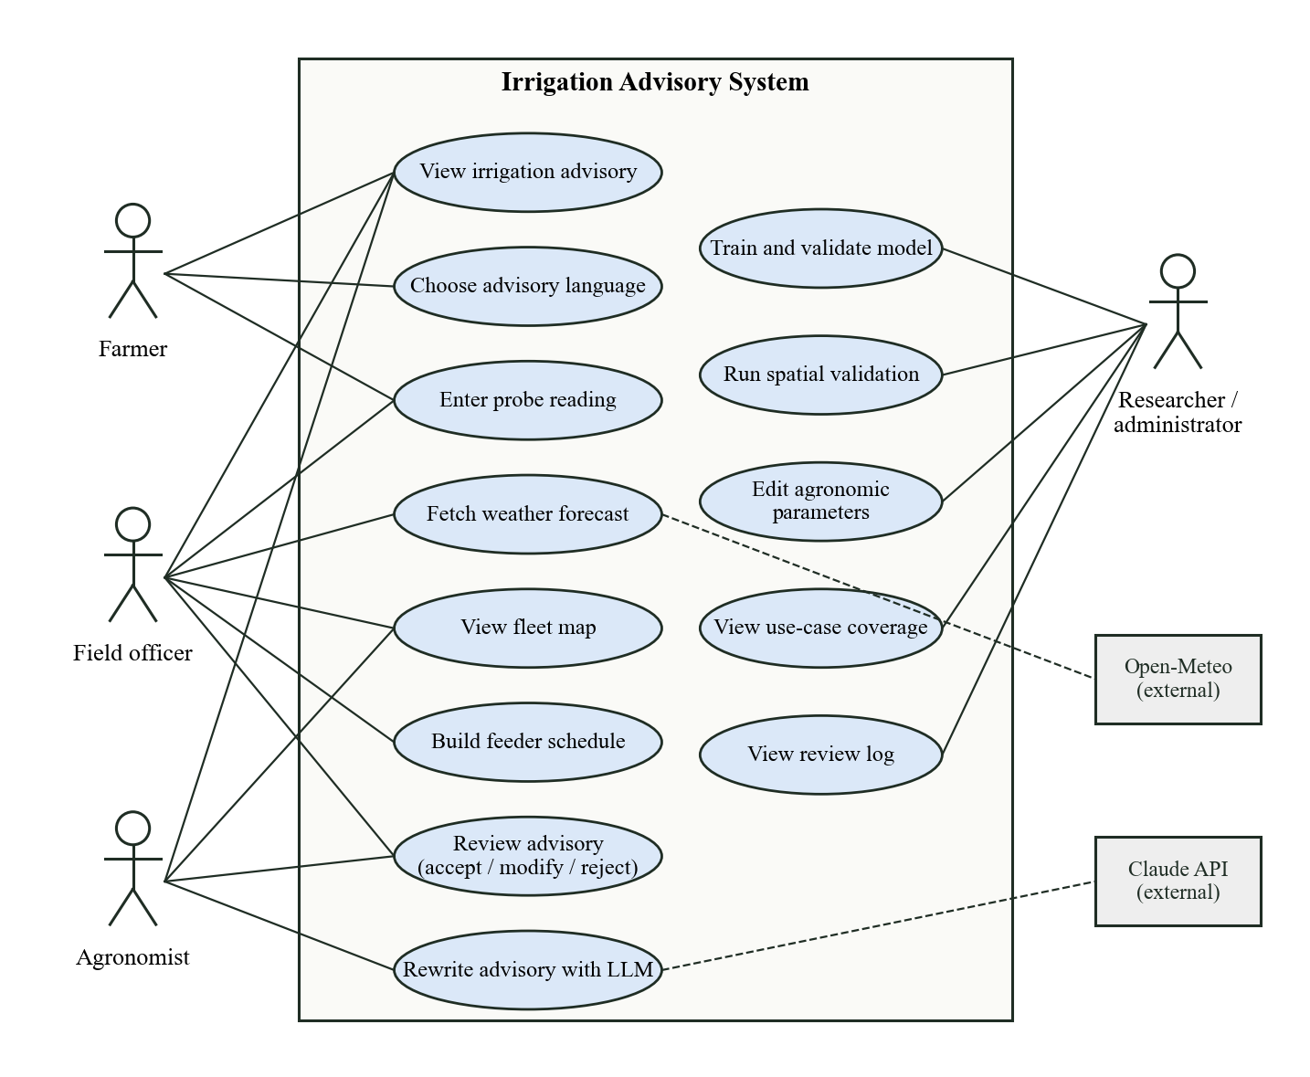
Figure 4.1: Use-case diagram of the irrigation advisory system

4.2.2 Sequence diagram
Figure 4.2 traces the most important interaction: producing an advisory for one farm in the web frontend. The frontend first requests the farm’s details, for which the service layer runs the saved soil-moisture pipeline and its local explanation (messages 2–4). It then posts the user’s settings to the plan endpoint (message 5). If a live forecast is requested, the API fetches it from Open-Meteo (messages 6–7). The decision engine computes the water balance, stress, fertigation and pump sessions and returns the plan bundle with advisory text (messages 8–10), which the frontend renders as cards, charts and a map (messages 11–12). When the reviewer records a decision, it is posted and stored in SQLite (messages 13–14).
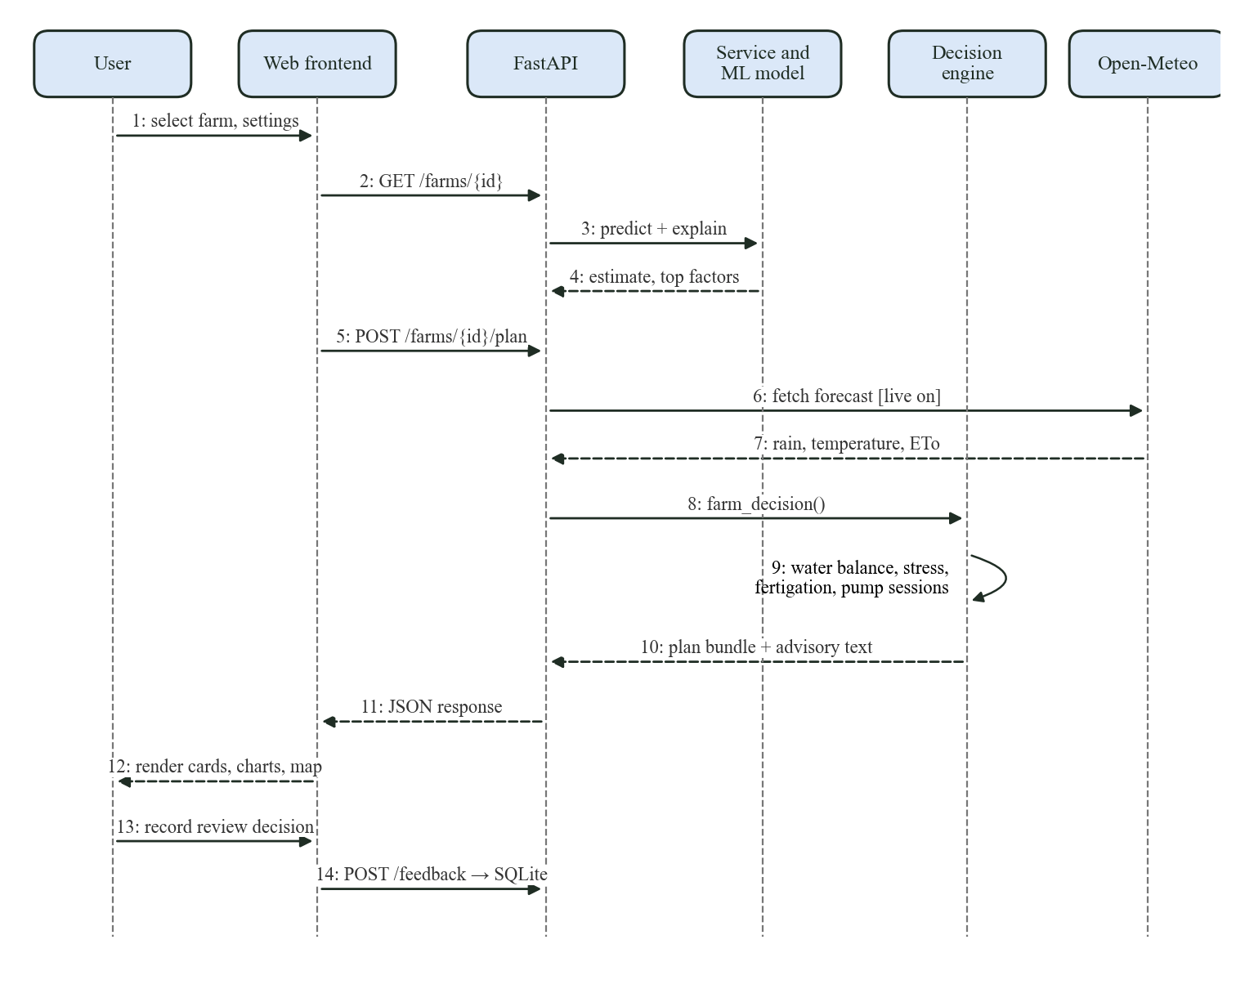
Figure 4.2: Sequence diagram for generating and reviewing a farm advisory

4.2.3 State diagram
Figure 4.3 shows the life cycle of a plot’s irrigation status. A newly created plan starts in Not required when the due date is more than three days away. Each day the crop’s evapotranspiration increases root-zone depletion and moves the plot towards Irrigate soon; forecast rain can move it back by postponing the due date. When depletion reaches the readily available water, the plot enters Irrigate now, and the stress index keeps rising for as long as irrigation is delayed. Irrigation refills the root zone, the reviewer’s decision is logged, and depletion resets to near zero, returning the plot to Not required. These three statuses are exactly the values IRRIGATE_NOW, IRRIGATE_SOON and NOT_REQUIRED returned by the engine.
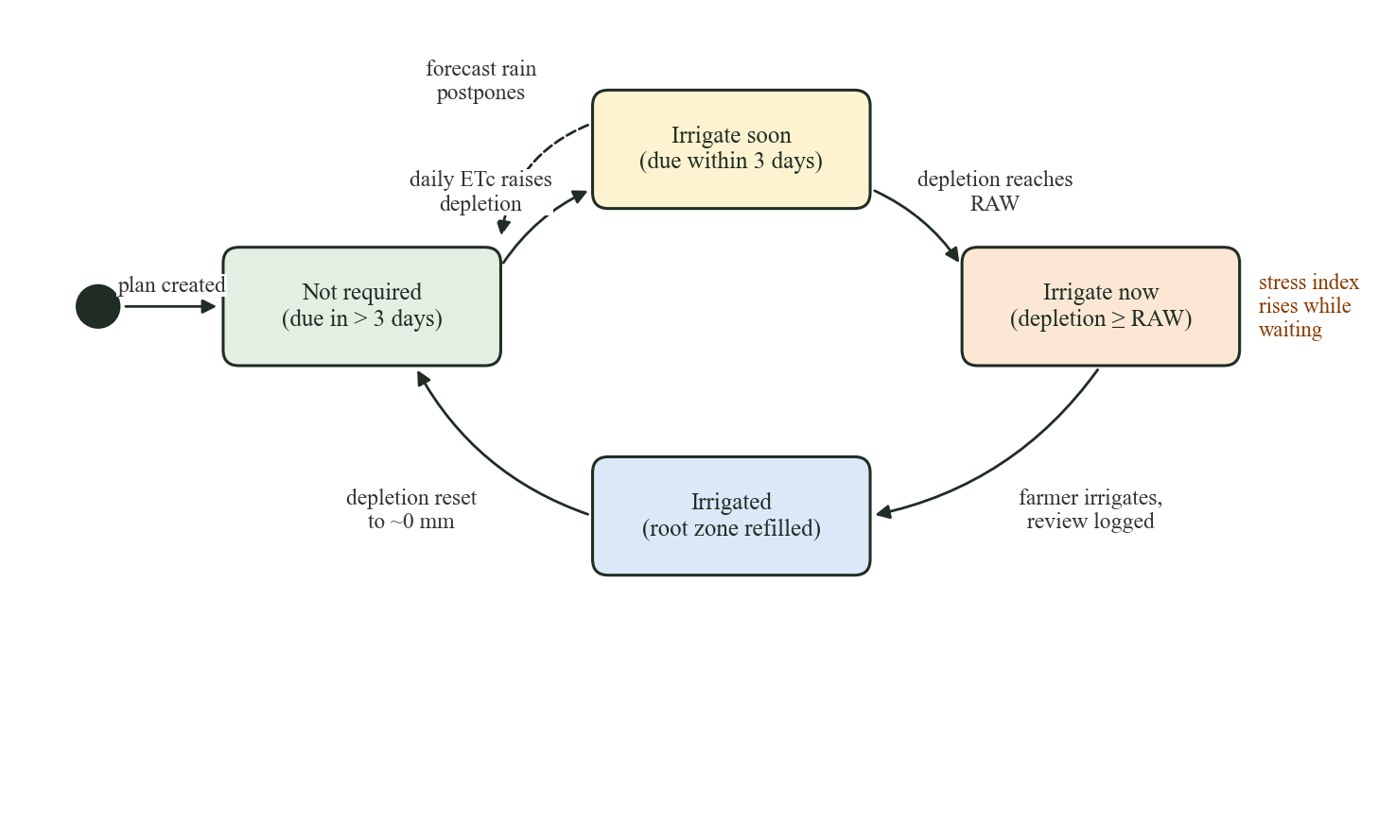
Figure 4.3: State diagram of a plot’s irrigation status

4.2.4 Activity diagram
Figure 4.4 details the decision logic for one advisory. The first decision selects the soil-moisture source, preferring a probe reading over the model estimate. The second decides whether to fetch a live forecast. The engine then computes the crop and soil parameters, projects the 14-day water balance and classifies the plot: Irrigate now if depletion already exceeds the threshold, Irrigate soon if it will within three days, and Not required otherwise. Quantities, stress, yield loss, fertigation and pump sessions are computed for every status, the advisory is rendered in the chosen language, and a human reviewer accepts, modifies or rejects it before the decision is logged.
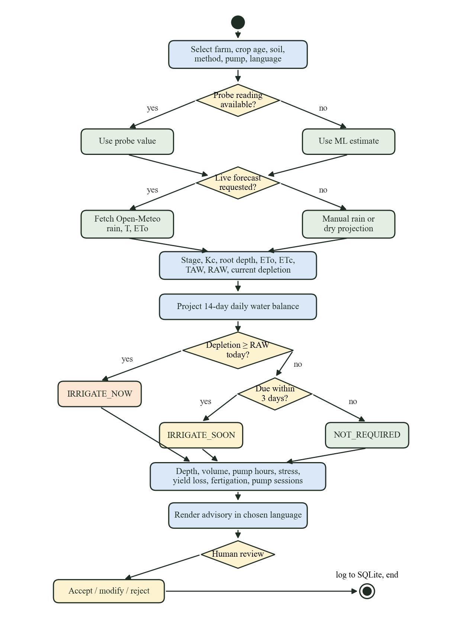
Figure 4.4: Activity diagram for producing and reviewing an advisory

4.2.5 Class diagram
The backend is organised into small Python modules rather than deep class hierarchies, because most of the logic is a sequence of pure functions. Figure 4.5 shows the main units. FarmConditions is a data class carrying one plot’s inputs into the agronomy module, which provides the crop stage, ET_{o}, stress, plan, yield-loss and fertigation functions. The decision module orchestrates a farm’s full advisory by calling agronomy, scheduling and multilingual. The scheduling module uses the Window data class for supply windows. FarmFeatureEngineer is a scikit-learn transformer that forms the first step of the ML pipeline, and the service module caches the farm table and fleet status for the API.
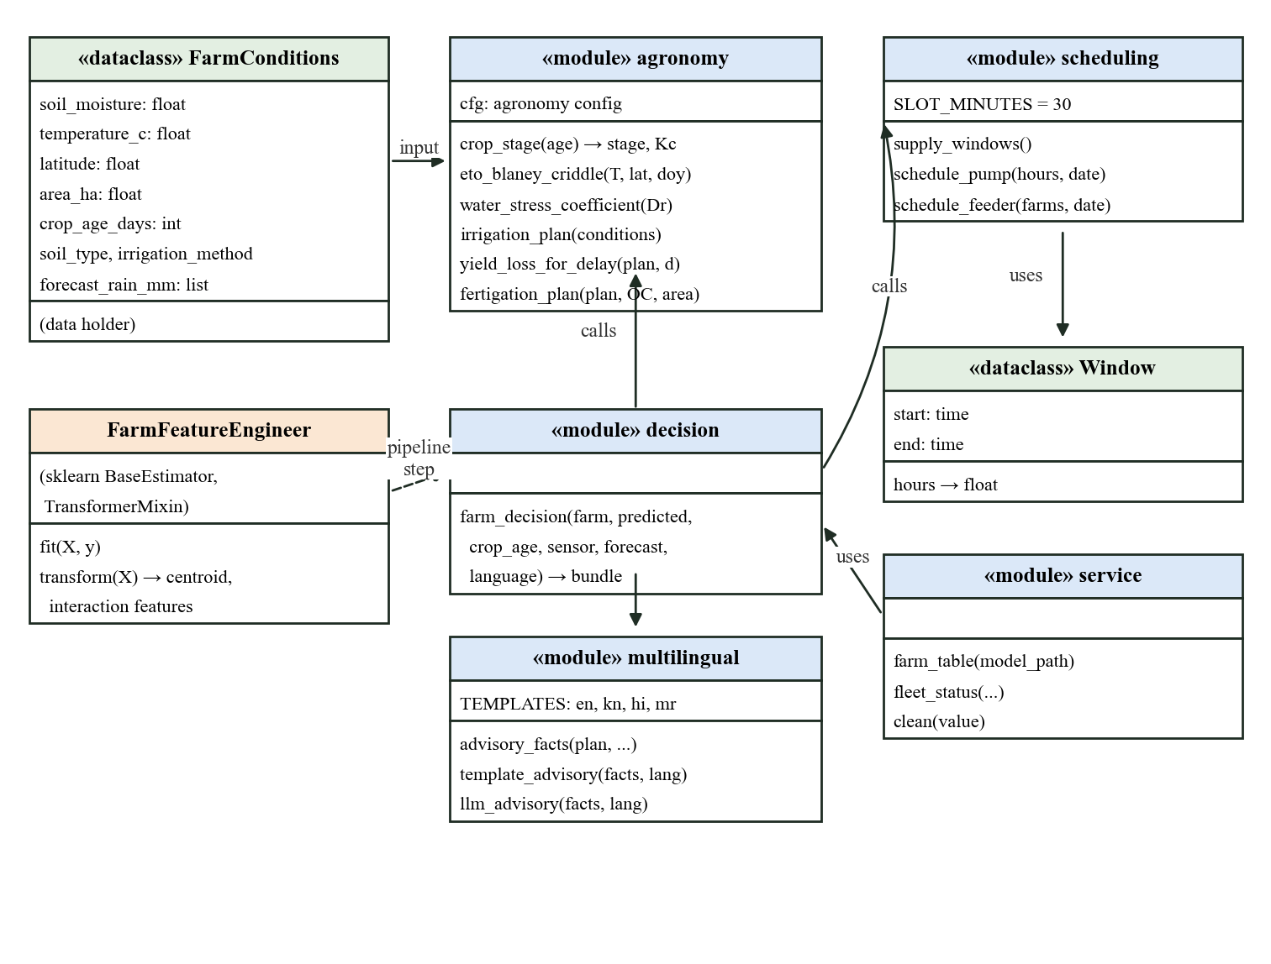
Figure 4.5: Class and module diagram of the backend

4.2.6 Data flow diagram: level 0
The context diagram in Figure 4.6 treats the whole system as one process. Farmers and field officers send farm selections, crop age, probe readings, language and review decisions, and receive advisories, schedules and maps. Agronomists and researchers send parameters and retraining requests and receive validation reports and the coverage matrix. The plot dataset supplies plot records, and Open-Meteo supplies forecast rain and reference evapotranspiration.
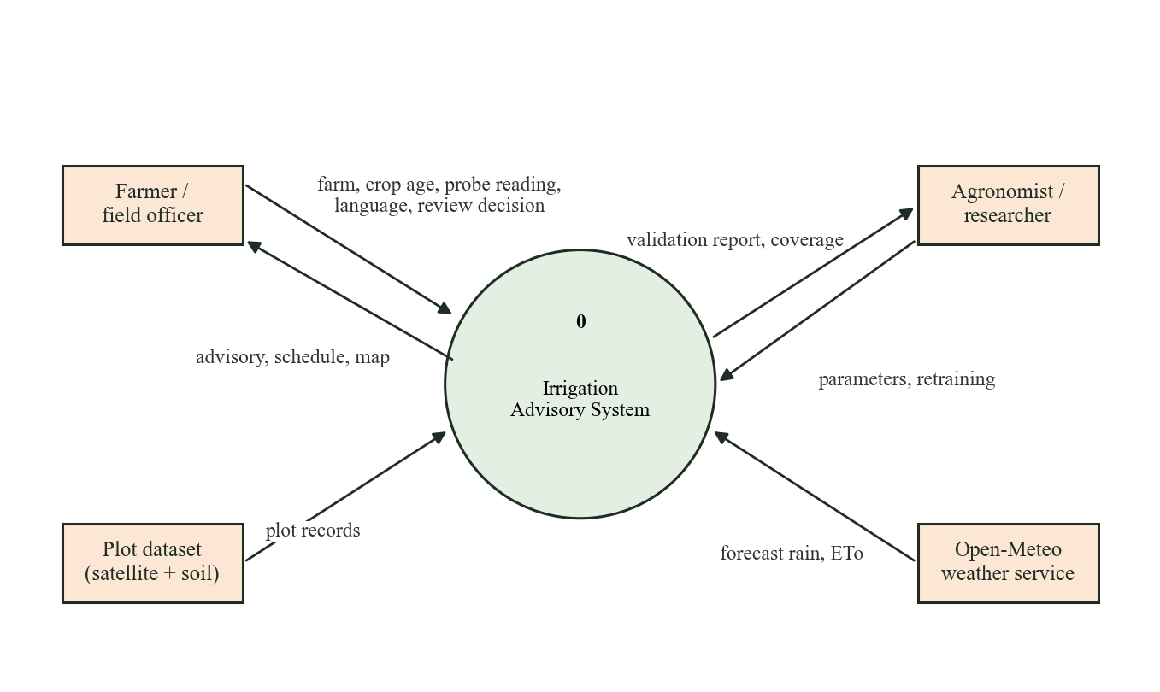
Figure 4.6: Level 0 data flow diagram (context diagram)

4.2.7 Data flow diagram: level 1
Figure 4.7 decomposes the system into six processes. Process 1.0 loads and validates the CSV records. Process 2.0 estimates soil moisture using the saved model artifact (store D1). Process 3.0 plans irrigation from the soil-moisture value, the user’s inputs, forecast data and the FAO parameters in the configuration file (D2). Process 4.0 schedules pumps using the supply windows and feeder cap from D2. Process 5.0 turns the plan facts and pump sessions into an advisory in the chosen language, and process 6.0 stores the reviewer’s decision in the SQLite logs (D3).
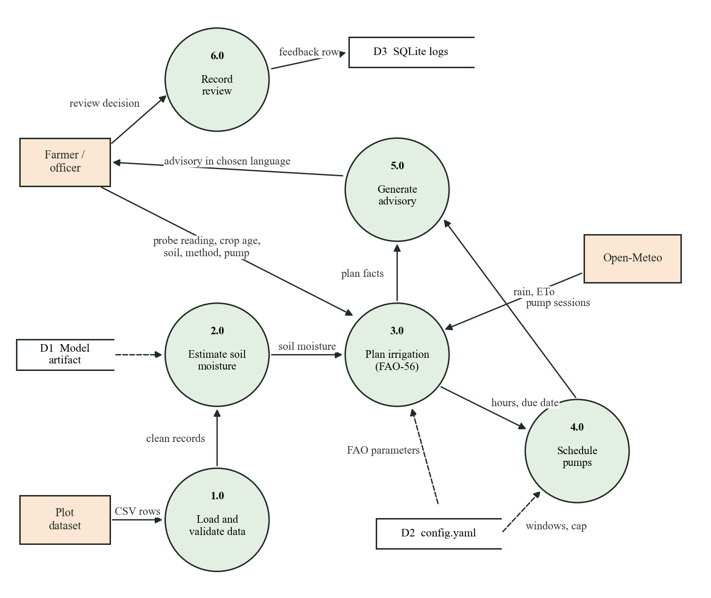
Figure 4.7: Level 1 data flow diagram

4.2.8 Data flow diagram: level 2
Figure 4.8 decomposes process 3.0, the core of the system. Process 3.1 derives the growth stage, K_{c} and root depth from crop age. Process 3.2 computes ET_{o} by Blaney-Criddle or takes it from the forecast. Process 3.3 computes total and readily available water and the current depletion from the soil-moisture value and the soil’s field capacity and wilting point. Process 3.4 runs the daily water balance, and process 3.5 converts the depletion on the due day into depth, volume and pump hours. Processes 3.6 and 3.7 compute the stress index, yield loss and fertigation dose. All parameters are read from the configuration store.
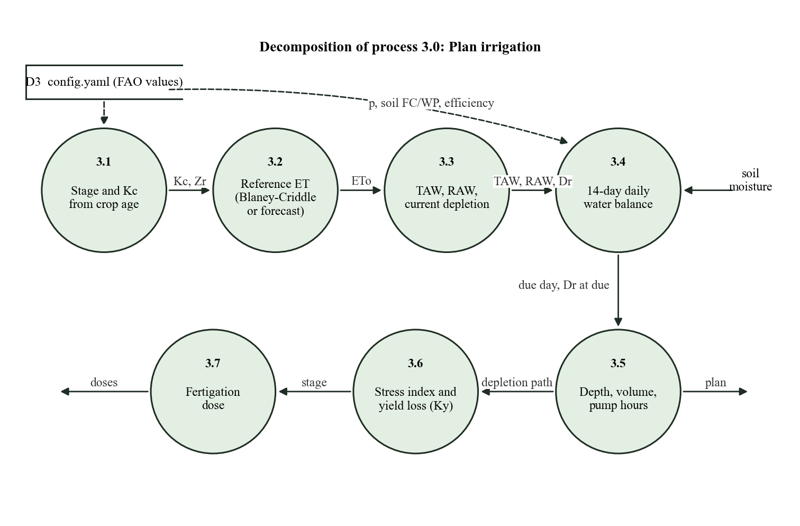
Figure 4.8: Level 2 data flow diagram for process 3.0, Plan irrigation

4.3 System Architecture
Figure 4.9 shows the four-layer architecture. The presentation layer has three interfaces: the web frontend for farmers and field staff, the Streamlit dashboard for analysts, and the Swagger UI for developers. The service layer is a FastAPI application with 17 routes and Pydantic validation, and a SQLite database for logs. The processing and AI layer contains the five core modules: the ML pipeline, the spatial validation audit, the FAO-56 engine, the pump scheduler and the multilingual advisory generator. The data layer holds the plot dataset, the optional probe readings and forecast, and the configuration file and model artifact. Each layer depends only on the one beneath it, so, for example, a new mobile app could replace the web frontend without any change to the engine.
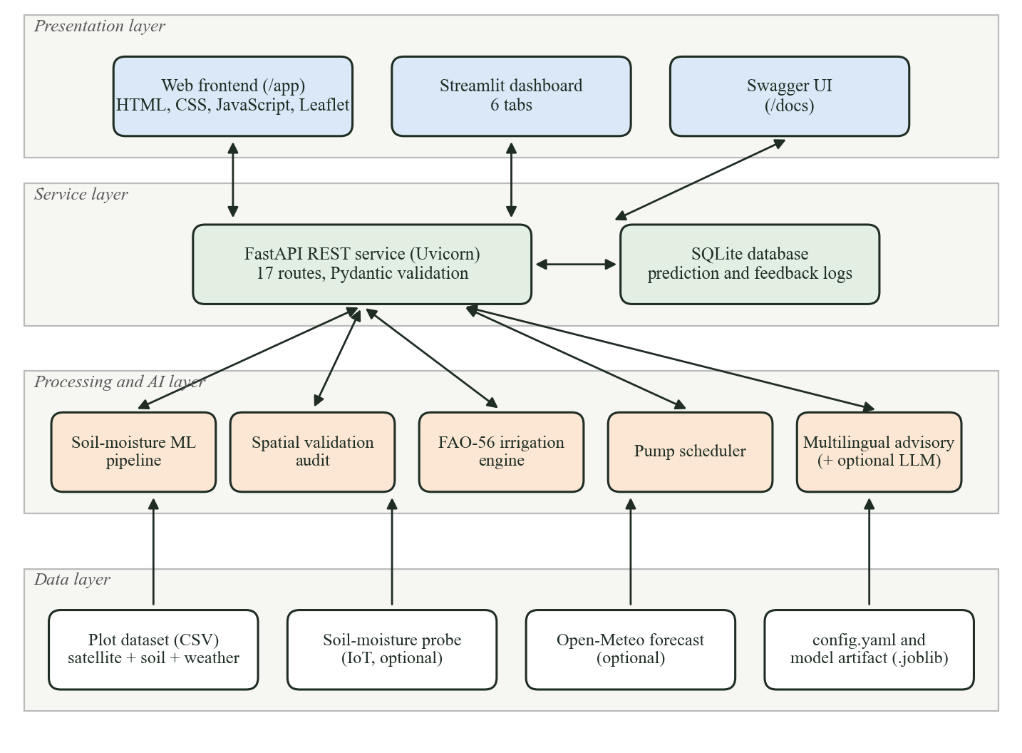
Figure 4.9: Layered system architecture

4.4 Deployment Design
Figure 4.10 shows the deployment view. A single Python host or Docker container runs Uvicorn with the FastAPI application, which serves the REST routes, the static web frontend at /app and the report figures, and holds the model artifact and the SQLite file. The Streamlit dashboard runs as a second process on the same host. Clients reach the system over HTTP from a desktop or phone browser. The host calls Open-Meteo, and optionally the Anthropic API, over HTTPS.
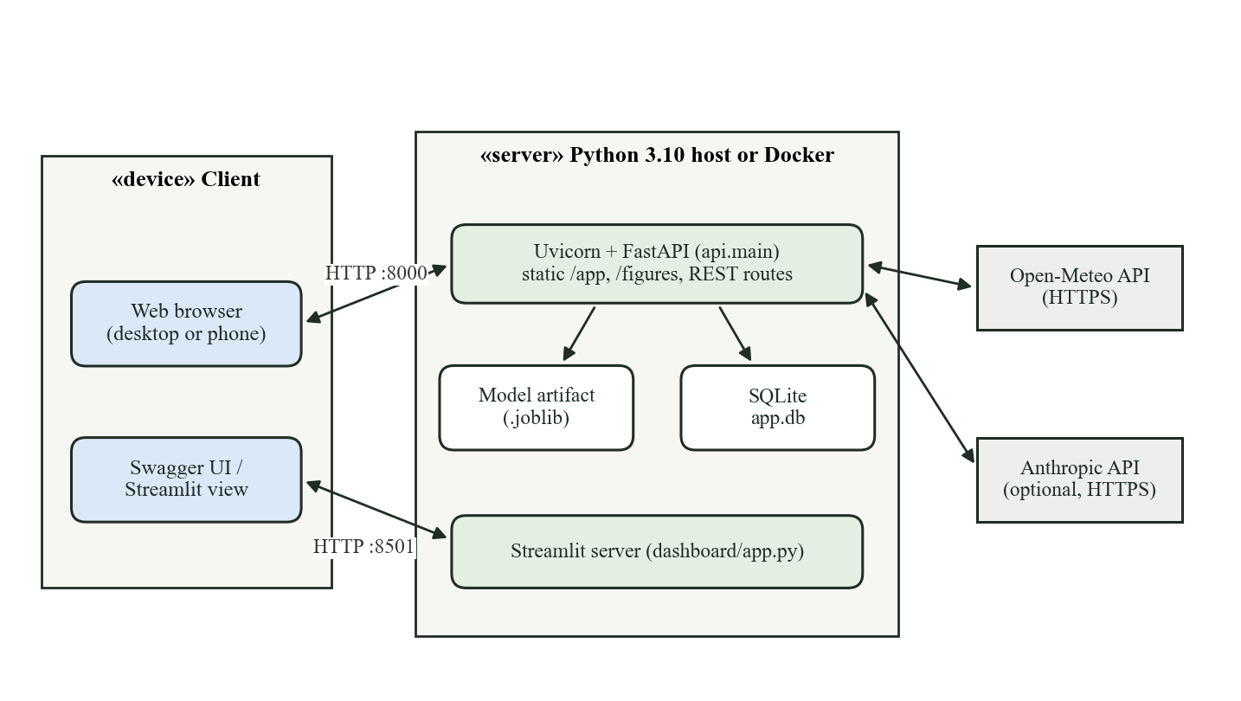
Figure 4.10: Deployment diagram

4.5 Database Design
The prototype uses SQLite with two tables, shown in Table 4.1 and Table 4.2. The first logs every prediction and what-if simulation made through the API. The second stores human review decisions; its CHECK constraint restricts decisions to the three allowed values, and the stored soil-moisture source lets future analysis separate decisions made on probe readings from those made on model estimates. Neither table stores farmer names or phone numbers.
Table 4.1: Table prediction_logs
Column | Type | Description
id | INTEGER PK | Auto-increment identifier
farm_id | TEXT | Plot identifier
timestamp | TEXT | UTC time of the prediction
input_features | TEXT (JSON) | Inputs sent to the model
prediction | REAL | Predicted soil moisture (m³/m³)
risk_level | TEXT | Prototype risk level
advisory | TEXT (JSON) | Full advisory returned
model_version | TEXT | Selected model name
event_type | TEXT | prediction or what_if

Table 4.2: Table advisory_feedback
Column | Type | Description
id | INTEGER PK | Auto-increment identifier
farm_id | TEXT | Plot identifier
timestamp | TEXT | UTC time of the decision
reviewer_role | TEXT | farmer, field_officer or agronomist
decision | TEXT CHECK | accepted, modified or rejected
recommended_date | TEXT | Irrigation date advised by the engine
recommended_hours | REAL | Pump hours advised
override_date / override_hours | TEXT / REAL | Reviewer’s replacement values when modified
comment | TEXT | Free-text note (max. 1,000 characters)
soil_moisture_source | TEXT | sensor or ml_model

4.6 API Design
Table 4.3 lists the REST endpoints. The first four existed in the initial prototype; the remaining thirteen were added in this project, five for planning, scheduling, advisories and feedback and eight to serve the web frontend. All request bodies are validated by Pydantic models, which return HTTP 422 for invalid input, and an unknown farm returns HTTP 404.
Table 4.3: REST API endpoints
Method | Path | Purpose
GET | /health | Service status and whether a model is available
POST | /predict | Soil-moisture prediction, risk level and explanation for given features
POST | /what-if | Prediction before and after changing selected inputs
GET | /model-info | Model name, features, test metrics and split strategy
POST | /irrigation-plan | Full plan for arbitrary inputs, with optional probe reading and rain
POST | /feeder-schedule | Pump-slot allocation for farms sharing a feeder
POST | /advisory | Render advisory facts in a language, optionally via LLM
POST | /feedback | Record an accept, modify or reject decision
GET | /feedback | List recent review decisions
GET | /options | Soils, methods, languages, supply windows and defaults for forms
GET | /farms | List of all plots with location and model estimate
GET | /farms/geojson | Plot polygons, optionally filtered by taluk or village
GET | /farms/{farm_id} | One plot’s fields, model estimate and top factors
POST | /farms/{farm_id}/plan | Full advisory bundle for a plot, optionally with live forecast
GET | /fleet | Irrigation status of every plot under shared settings
GET | /validation | Spatial validation summary and results
GET | /coverage | Use-case coverage matrix

4.7 User Interface Design
The web frontend follows the software output sample in the use-case document [1]: a filter bar across the top, then cards for the plot map, the irrigation advisory, the weather outlook and alerts, followed by soil, crop, water-balance, fertigation, yield-risk, pump and water-summary cards, and finally the farmer message, the review form and the model explanation. Five further views cover the fleet map, pump scheduling, model validation, use-case coverage and the review log. Status is always shown with a text label as well as a colour, so it remains readable for colour-blind users and in print. The layout collapses to a single column at phone width, and a toggle switches between light and dark themes.

Chapter 5: Methodology

5.1 Introduction
This chapter explains how the system turns plot data into an irrigation decision. We begin with the system block diagram, then describe data preprocessing and feature engineering, the soil-moisture models and their validation, and the mathematical formulation of the FAO-56 decision engine. The yield-loss, fertigation, pump-scheduling and advisory-generation modules follow, each with its algorithm. All parameter values quoted here are those held in the project’s configuration file at the time of evaluation.

5.2 System Block Diagram
Figure 5.1 shows the data path from inputs to outputs. Four inputs enter on the left: the plot dataset, an optional field probe reading, an optional weather forecast and the farmer’s own inputs (crop age, soil texture, irrigation method and pump discharge). The plot dataset passes through preprocessing and feature engineering into the soil-moisture regression model. The soil-moisture source selector is the key design decision of the project: it passes a probe reading to the engine when one exists and falls back to the model estimate otherwise, recording which source was used. The FAO-56 water-balance block combines soil moisture with crop and weather inputs to produce the decision outputs, which feed the pump scheduler, the fertigation schedule and the advisory generator. The advisory reaches users through the web frontend, dashboard and API, a human reviewer accepts, modifies or rejects it, and the review is logged as a future training label (dashed arrow).
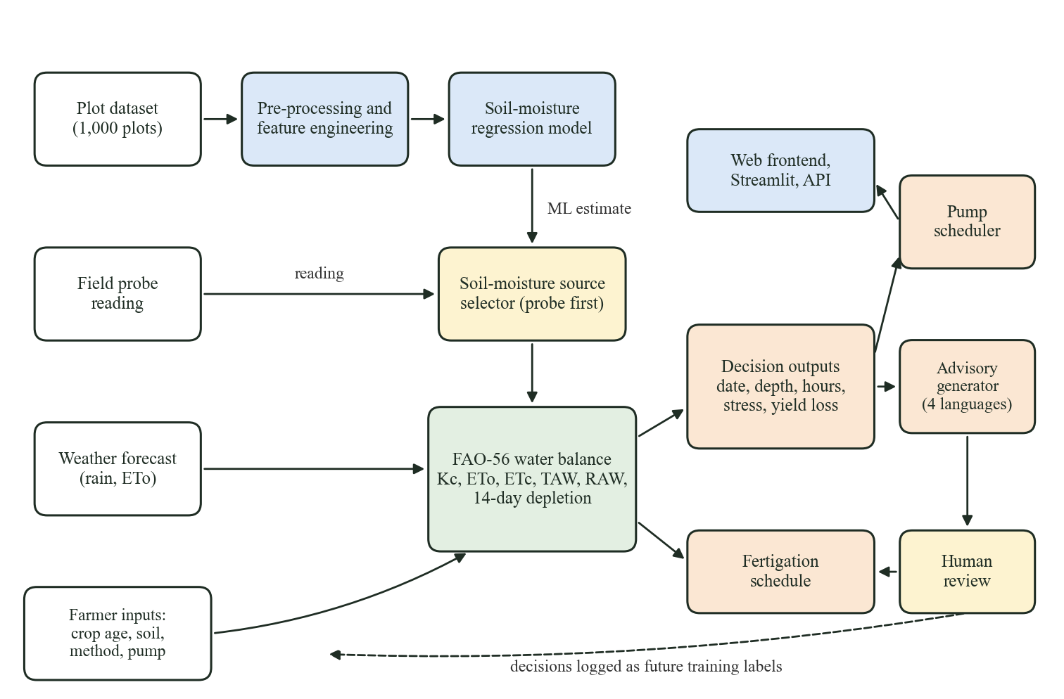
Figure 5.1: System block diagram

5.3 Data Preprocessing and Feature Engineering
Figure 5.2 shows the machine learning pipeline. All preprocessing is placed inside a single scikit-learn Pipeline [9], so that imputation statistics, scaling parameters and category vocabularies are learnt from training rows only and the saved artifact applies exactly the same transformation at prediction time. The steps are:
- Loading and validation. The CSV is read and each numeric column is checked against a physical range (for example NDVI in [−1, 1], relative humidity in [0, 100] and soil moisture in [0, 1]). Out-of-range values are converted to missing rather than silently dropped. Exact duplicate rows and rows without a target are removed before training; there were none in the supplied data.
- Column selection. The model receives LAI, NDVI, organic carbon, rainfall, relative humidity, soil pH, temperature, taluk, village and the GeoJSON polygon. The row index, Farm ID, District, Sampling Method and Farm Area are excluded because they are identifiers or constant (Section 3.8).
- Feature engineering. A custom transformer, FarmFeatureEngineer, computes the bounding-box centre of each polygon as longitude and latitude, and two interaction terms, rainfall × temperature and relative humidity × temperature. Invalid geometry yields missing coordinates instead of invented ones.
- Numeric preprocessing. Eleven numeric features are imputed with the training median and standardised to zero mean and unit variance.
- Categorical preprocessing. Taluk and village are imputed with the most frequent value and one-hot encoded; unseen categories are ignored at prediction time.
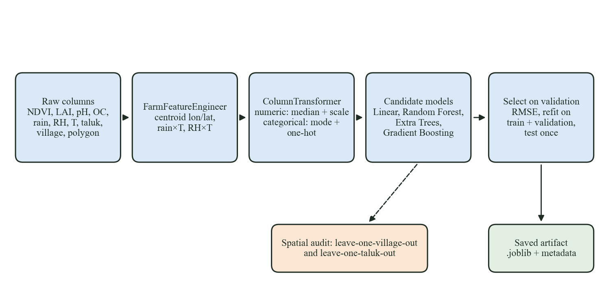
Figure 5.2: Soil-moisture machine learning pipeline and validation

5.4 Soil-Moisture Models and Validation

5.4.1 Candidate models
Four regressors were trained inside the pipeline: ordinary least-squares Linear Regression as a baseline; a Random Forest [10] and Extra Trees [11], each with 250 trees and a minimum of two samples per leaf; and Gradient Boosting [12] with 200 stages. All use a fixed random state of 42 for reproducibility. XGBoost is added automatically when installed; it was not installed for the reported run.

5.4.2 Random-split protocol
Because the data have no timestamp and no repeated Farm IDs, the original training script used a random 70/15/15 split. Each model is fitted on the 70% training part and compared on the 15% validation part; the model with the lowest validation RMSE is refitted on training plus validation data (850 rows) and evaluated once on the 150-row test set. The metrics are the mean absolute error, root mean squared error and coefficient of determination:
MAE = (1/n) Σ |y_{i} − ŷ_{i}| (5.1)
RMSE = √[ (1/n) Σ (y_{i} − ŷ_{i})² ] (5.2)
R² = 1 − Σ (y_{i} − ŷ_{i})² / Σ (y_{i} − ȳ)² (5.3)
where y_{i} is the observed soil moisture, ŷ_{i} the prediction and ȳ the mean of the observations. In Equation (5.3), R² below zero means the model is worse than predicting the mean.

5.4.3 Spatial validation protocol
Following Roberts et al. and Meyer et al. [13], [14], we repeated the evaluation with grouped cross-validation. In leave-one-village-out (LOVO) validation, each of the ten villages is held out in turn, the model is trained on the other nine, and predictions for the held-out village are collected; the ten folds together give one out-of-sample prediction per plot. Leave-one-taluk-out (LOTO) does the same with the six taluks. A random 5-fold split is run alongside for comparison, and a mean predictor serves as the baseline that any useful model must beat. Each scheme is run with all features and with an environment-only feature set that excludes taluk, village and coordinates, to test whether the location features are what the model relies on.

5.4.4 Explainability
Global importance is computed with SHAP [15] when the library is installed and otherwise with the model’s native impurity-based importance; the reported run used the native importance. A local explanation for a farm replaces one raw feature at a time with a reference value (the training median or mode) and records the change in prediction. This gives a model-agnostic sensitivity ranking, which we present as sensitivity rather than as a causal effect.

5.5 FAO-56 Irrigation Decision Engine
The engine implements the single crop coefficient procedure of FAO-56 [2] for sugarcane. Its inputs are soil moisture θ (m³/m³), mean temperature T (°C), latitude φ, plot area A (ha), crop age in days, soil texture, irrigation method, pump discharge Q (m³/h) and, optionally, daily forecast rain and ET_{o}. Table 5.1 lists the parameters.
Table 5.1: Agronomic parameters of the decision engine
Parameter | Value | Source
K_{c} initial / mid / end | 0.4 / 1.25 / 0.75 | FAO-56 Table 12, sugarcane
Stage lengths (days) | 35 / 60 / 190 / 120 | FAO-56 Table 11, sugarcane
Depletion fraction p (table) | 0.65 | FAO-56 Table 22, sugarcane
Root depth Z_{r} min / max (m) | 0.3 / 1.2 | FAO-56 Table 22 [ASSUMED range]
Application efficiency E_{a} | drip 0.9, sprinkler 0.75, furrow 0.6, flood 0.5 | Typical design values [ASSUMED]
Pump discharge Q (default) | 18 m³/h | About 5 L/s, common 5 HP pump [ASSUMED]
Effective rain | 0.8 × P if P ≥ 5 mm, else 0 | Prototype rule [ASSUMED]
K_{y} by stage | 0.75 / 0.75 / 0.5 / 0.1 | FAO-33, sugarcane
Forecast horizon | 14 days | Design choice

Soil water-holding properties are taken from FAO-56 Table 19 for four textures; Table 5.2 shows them with the total available water they give at full rooting depth. The red soils of Mandya are mostly sandy loam to loam, so sandy loam is the default.
Table 5.2: Soil water properties by texture (FAO-56 Table 19 mid-points)
Soil texture | θ_{FC} (m³/m³) | θ_{WP} (m³/m³) | TAW at Z_{r} = 1.2 m (mm)
sandy loam | 0.23 | 0.11 | 144
loam | 0.25 | 0.12 | 156
silt loam | 0.29 | 0.15 | 168
clay | 0.36 | 0.22 | 168

5.5.1 Crop stage, crop coefficient and root depth
Crop age determines the stage. With stage lengths L_{ini}, L_{dev}, L_{mid} and L_{late}, the crop coefficient is constant during the initial and mid-season stages and is linearly interpolated during development and late season:
K_{c} = K_{c,ini} + [(t − L_{ini}) / L_{dev}] (K_{c,mid} − K_{c,ini}) for L_{ini} ≤ t < L_{ini} + L_{dev} (5.4)
and analogously from K_{c,mid} to K_{c,end} in the late stage, where t is crop age in days. Root depth grows linearly from Z_{r,min} at planting to Z_{r,max} at the start of mid-season:
Z_{r} = Z_{r,min} + min(1, t / (L_{ini} + L_{dev})) (Z_{r,max} − Z_{r,min}) (5.5)

5.5.2 Reference and crop evapotranspiration
When a forecast with Penman-Monteith ET_{o} is available, it is used directly. Otherwise ET_{o} is estimated with the Blaney-Criddle method [4], [3], which needs only mean temperature and latitude:
ET_{o} = p_{d} (0.46 T + 8.13), p_{d} = 100 N / (365 × 12) (5.6)
where p_{d} is the day’s percentage of annual daytime hours and N the maximum daylight hours, from FAO-56 equations 24, 25 and 34:
δ = 0.409 sin(2πJ/365 − 1.39), ω_{s} = arccos(−tan φ tan δ), N = (24/π) ω_{s} (5.7)
with J the day of the year. Crop evapotranspiration under standard conditions is then
ET_{c} = K_{c} × ET_{o} (5.8)

5.5.3 Soil water availability and depletion
Total available water in the root zone, the readily available part, and the current depletion are
TAW = 1000 (θ_{FC} − θ_{WP}) Z_{r} (5.9)
RAW = p × TAW, p = clip(p_{table} + 0.04 (5 − ET_{c}), 0.1, 0.8) (5.10)
D_{r} = clip(1000 (θ_{FC} − θ) Z_{r}, 0, TAW) (5.11)
The adjustment of p in Equation (5.10) follows the footnote of FAO-56 Table 22: on days of high demand the crop starts to suffer earlier, so the readily available fraction shrinks. Once depletion exceeds RAW, transpiration is reduced by the water stress coefficient (FAO-56 equation 84):
K_{s} = (TAW − D_{r}) / ((1 − p) TAW) if D_{r} > RAW, otherwise K_{s} = 1 (5.12)
The system reports a water stress index of 1 − K_{s} and a category: none (K_{s} = 1), mild (K_{s} ≥ 0.8), moderate (K_{s} ≥ 0.5) or severe.

5.5.4 Daily water balance and rainfall adjustment
Starting from today’s depletion, the engine projects the root-zone balance day by day for 14 days. For day i, with forecast rain P_{i},
P_{e,i} = 0.8 P_{i} if P_{i} ≥ 5 mm, otherwise 0 (5.13)
D_{r,i+1} = clip(D_{r,i} + K_{s,i} ET_{c,i} − P_{e,i}, 0, TAW) (5.14)
Irrigation is due on the first day on which D_{r} reaches RAW. The projection is run twice, with and without forecast rain, and the difference between the two due days is reported as the number of days the rain postpones irrigation. If the threshold is not reached within the horizon, the due day is extrapolated using today’s ET_{c}.

5.5.5 Irrigation depth, volume and pump duration
The net depth refills the root zone on the due day. The gross depth allows for losses of the irrigation method, and volume and pump time follow from plot area and pump discharge:
d_{net} = D_{r}(due), d_{gross} = d_{net} / E_{a} (5.15)
V = 10 × d_{gross} × A (m³), t_{pump} = V / Q (h) (5.16)
The factor 10 in Equation (5.16) converts a depth of 1 mm over 1 ha to 10 m³.

5.5.6 Decision algorithm
The complete decision for one plot is computed by the following algorithm:
- Read soil moisture θ from the probe if a reading is given; otherwise use the model estimate. Record the source.
- Compute the stage, K_{c} and Z_{r} from crop age using Equation (5.4) and Equation (5.5).
- Look up θ_{FC} and θ_{WP} for the soil texture and compute TAW and D_{r} using Equation (5.9) and Equation (5.11).
- Obtain today’s ET_{o} from the forecast or from Equation (5.6); compute ET_{c}, p and RAW using Equation (5.8) and Equation (5.10).
- Compute today’s K_{s} with Equation (5.12) and the stress category.
- Project the balance for 14 days with and without forecast rain using Equation (5.13) and Equation (5.14); find both due days.
- Set the status to IRRIGATE_NOW if D_{r} ≥ RAW today, to IRRIGATE_SOON if the due day is within 3 days, and to NOT_REQUIRED otherwise.
- Compute depth, volume and pump hours with Equation (5.15) and Equation (5.16).
- Compute the yield-loss table (Section 5.6), the fertigation dose (Section 5.7) and pump sessions (Section 5.8), then render the advisory (Section 5.9).

5.6 Yield Loss from Delayed Irrigation
Doorenbos and Kassam [5] relate relative yield loss to relative evapotranspiration deficit through the yield response factor:
1 − Y_{a}/Y_{m} = K_{y} (1 − ET_{a}/ET_{m}) (5.17)
To estimate the cost of delaying irrigation by d days past the due date, the engine starts at D_{r} = RAW and steps forward d days. Each day the crop uses only K_{s} × ET_{c}, and the shortfall ET_{c}(1 − K_{s}) is added to the deficit. The deficit is divided by the crop’s demand over the current stage, ET_{c} × L_{stage}, and multiplied by the stage K_{y}. Because K_{y} is 0.75 during establishment and tillering but only 0.10 during ripening, the same delay costs much more early in the season. The result is a relative loss, not a prediction of absolute yield.

5.7 Fertigation Recommendation
A seasonal NPK dose of 250 kg N, 75 kg P₂O₅ and 190 kg K₂O per hectare is split across the four growth stages. These values are placeholders until KIAAR supplies its soil-test-based recommendation. The nitrogen share is scaled by an organic-carbon rating (low below 5 g/kg: ×1.25; high above 7.5 g/kg: ×0.75), assuming the dataset reports organic carbon in g/kg. The stage dose is divided into applications every 15 days, n = ceil(L_{stage} / 15), and each application is converted into water-soluble products:
MAP = P₂O₅ / 0.61, Urea = (N − 0.12 MAP) / 0.46, MOP = K₂O / 0.60 (5.18)
using the nutrient contents of mono-ammonium phosphate (12-61-0), urea (46% N) and muriate of potash (60% K₂O). Doses are reported per hectare, per acre and for the plot, and the application is timed with the next irrigation.

5.8 Pump Scheduling
Agricultural feeders supply electricity only in fixed windows. The prototype uses three windows, 05:00–08:00, 14:00–17:00, 20:00–23:00, which are placeholders for the actual feeder timetable. For a single farm, the required pump hours are placed into consecutive windows from the due date, morning window first, because pumping in the cool morning reduces evaporation losses. For a feeder shared by many farms, at most C pumps may run at once (default 25). The feeder scheduler uses the following greedy algorithm:
- Divide every supply window in the planning horizon into 30-minute slots and set each slot’s usage to zero.
- Sort farms by due day (earliest first), then by stress index (highest first), then by Farm ID.
- For each farm, compute the slots needed as its pump hours × 2.
- Scan slots in time order from the farm’s due date and take every slot whose usage is below C, until enough slots are taken or the horizon ends.
- Increase the usage of each slot taken. If the farm received fewer slots than needed, record it with its scheduled and unmet hours.
- Merge adjacent slots of a farm into continuous pumping sessions and report demand, unmet hours, peak concurrent pumps and feeder utilisation.
The heuristic is simple and transparent; it serves the most urgent farms first but is not proven optimal.

5.9 Multilingual Advisory Generation
The engine output is first reduced to a small set of facts: status, due date, pump hours, gross depth, stress category, forecast rain, days postponed, the first pump slot and the urea and MOP doses per acre. A deterministic template for each language turns the facts into four to six short sentences ending with a request to confirm with the field officer. Templates exist for English, Kannada, Hindi and Marathi, so the core advisory always works offline. An optional rewrite sends only the facts to a large language model through the Claude API [21] with instructions to use every number exactly and add nothing. The algorithm guards the result:
- If the client library or credentials are unavailable, or the API returns an error or a refusal, return the template text with a note.
- Otherwise extract all numbers from the generated text with a regular expression.
- Compare them with the pump hours, depth and fertiliser numbers in the facts; if any is missing, discard the generated text and return the template with a note naming the missing numbers.
- Otherwise return the generated text, marked as LLM-generated and number-verified.

5.10 Human-in-the-Loop Review
Every advisory carries a review form in which a farmer, field officer or agronomist records whether the advice was accepted, modified (with override hours or date) or rejected, with an optional comment. The record stores the recommended values and the soil-moisture source alongside the decision. This implements the use case’s requirement for manual override and advisory acceptance [1], and over time it creates the labelled data on irrigation decisions that the supplied dataset lacks.

Chapter 6: Implementation Details

6.1 Introduction
This chapter describes how the design of Chapter 4 and the methodology of Chapter 5 were implemented. We first present the running system through annotated screenshots of the web frontend, the API documentation and the Streamlit dashboard. We then describe the code organisation, the backend and frontend implementation, the configuration and data handling, the automated test suite and the deployment procedure. All screenshots were captured from the running system on 30 September 2026 for farm MM-MD-0110 in Bheemanahalli village, Malavalli taluk, with a planting date of 4 March 2026 (crop age 180 days), sandy loam soil, furrow irrigation and an 18 m³/h pump.

6.2 System Implementation

6.2.1 Web frontend: farm dashboard
Figure 6.1 shows the upper half of the farm dashboard, the main screen for farmers and field officers. The filter bar at the top selects taluk, village and farm and sets the planting date (from which crop age is computed), soil texture, irrigation method, pump discharge and an optional probe reading; the Live forecast box fetches a 14-day forecast. The plot view card shows all 96 plots of the village on an OpenStreetMap base map [20] with the selected plot in orange; clicking another polygon opens that plot. The irrigation advisory card gives the decision as one headline, here “No irrigation needed until 12 Oct”, followed by the soil-moisture value and its source and four tiles: next irrigation date, pump duration, water to apply and water stress. The weather outlook shows the next five days, and the alerts card lists what needs attention: here that crop water is adequate, that a 5-day delay past the due date would cost about 0.3% of yield, and that the advisory uses the model estimate and should be confirmed with a probe reading. The second row shows soil and sensor status, crop status with a growth-stage track, and the 14-day root-zone water balance chart, in which the blue line of daily depletion crosses the red dashed irrigation threshold of 85 mm on 12 October.
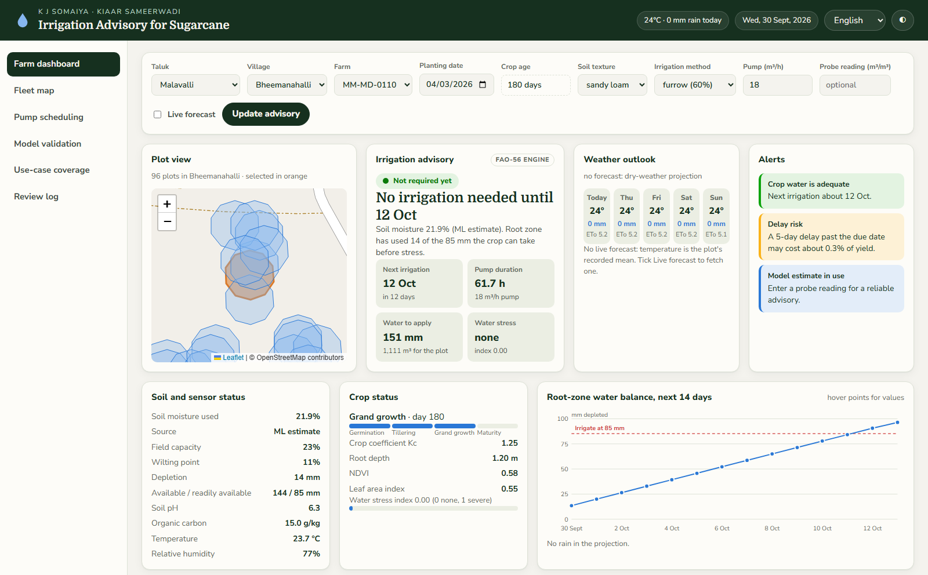
Figure 6.1: Web frontend: upper half of the farm dashboard (model estimate, English)
Figure 6.2 shows the lower half of the same screen. The fertigation card gives the next application date and the dose of urea, MAP and MOP per acre and for the plot, marked as placeholder doses. The yield risk chart shows relative yield loss for delays of 0 to 15 days. The pump schedule lists sessions in the supply windows, morning first, and the water summary gives ET_{o}, ET_{c}, daily plot demand, 14-day demand, net and gross depth, method efficiency and the ET_{o} source. The bottom row holds the farmer message with Copy and Rewrite with Claude buttons, the human review form, and the soil-moisture model card with the model estimate, the prototype risk level and the local effects of each feature, with a reminder that the model is not reliable for unseen villages.
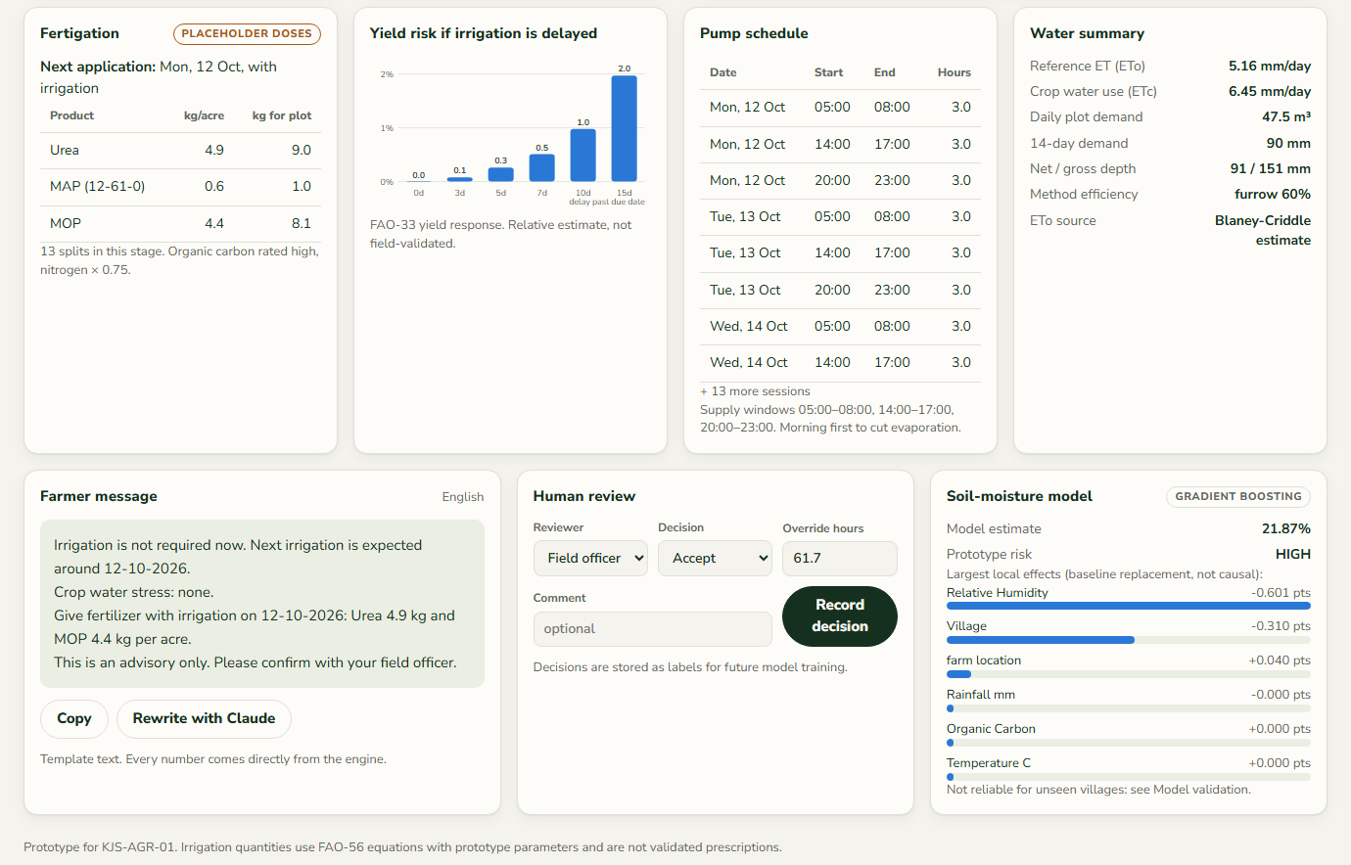
Figure 6.2: Web frontend: lower half of the farm dashboard

6.2.2 Effect of a field probe reading
Figure 6.3 shows the same farm after a field officer enters a probe reading of 0.15 m³/m³ and switches the language to Kannada. Soil moisture is now reported as 15.0% from the field probe, the root zone has used 96 mm against a threshold of 85 mm, and the decision changes to “Irrigate today for 65.4 hours” with 160 mm of water (1177 m³). The status pill turns red and reads Irrigate now, and the alerts report mild water stress (index 0.18) and confirm that the advisory uses the field measurement. This screen demonstrates the soil-moisture source selector of Figure 5.1.
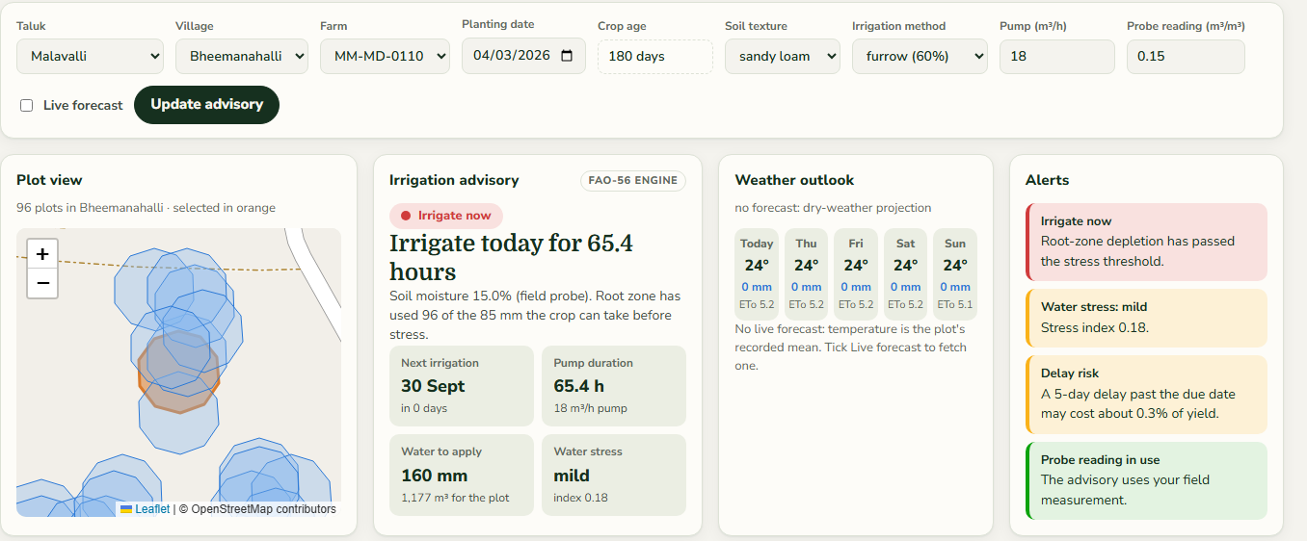
Figure 6.3: Farm dashboard after entering a probe reading of 0.15 m³/m³
Figure 6.4 shows the bottom row of the same screen. The farmer message is rendered in Kannada with every number unchanged: run the pump for 65.4 hours (about 160 mm of water), mild crop water stress, best pump time 05:00–08:00 on 30-09-2026, and urea 4.9 kg and MOP 4.4 kg per acre with the irrigation. The review form is pre-filled with the advised 65.38 hours so that a reviewer who modifies the advice only needs to change the number.
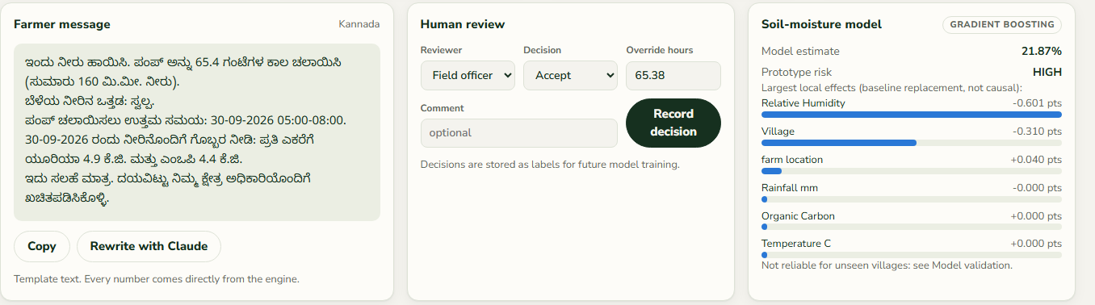
Figure 6.4: Farmer message in Kannada, human review form and model card

6.2.3 Fleet map
Figure 6.5 shows the fleet map, which runs the decision engine for all 1,000 plots under the dashboard’s crop and equipment settings. Summary tiles count plots by status and the water due in the next seven days. The map shows every plot polygon coloured by status on the district base map, and the table lists the plots due soonest; selecting a plot or a row opens it on the dashboard. Under the settings shown, with sandy loam soil and the model’s soil-moisture estimates, every plot is Not required yet. Section 7.2.6 discusses why and how this changes with soil texture.
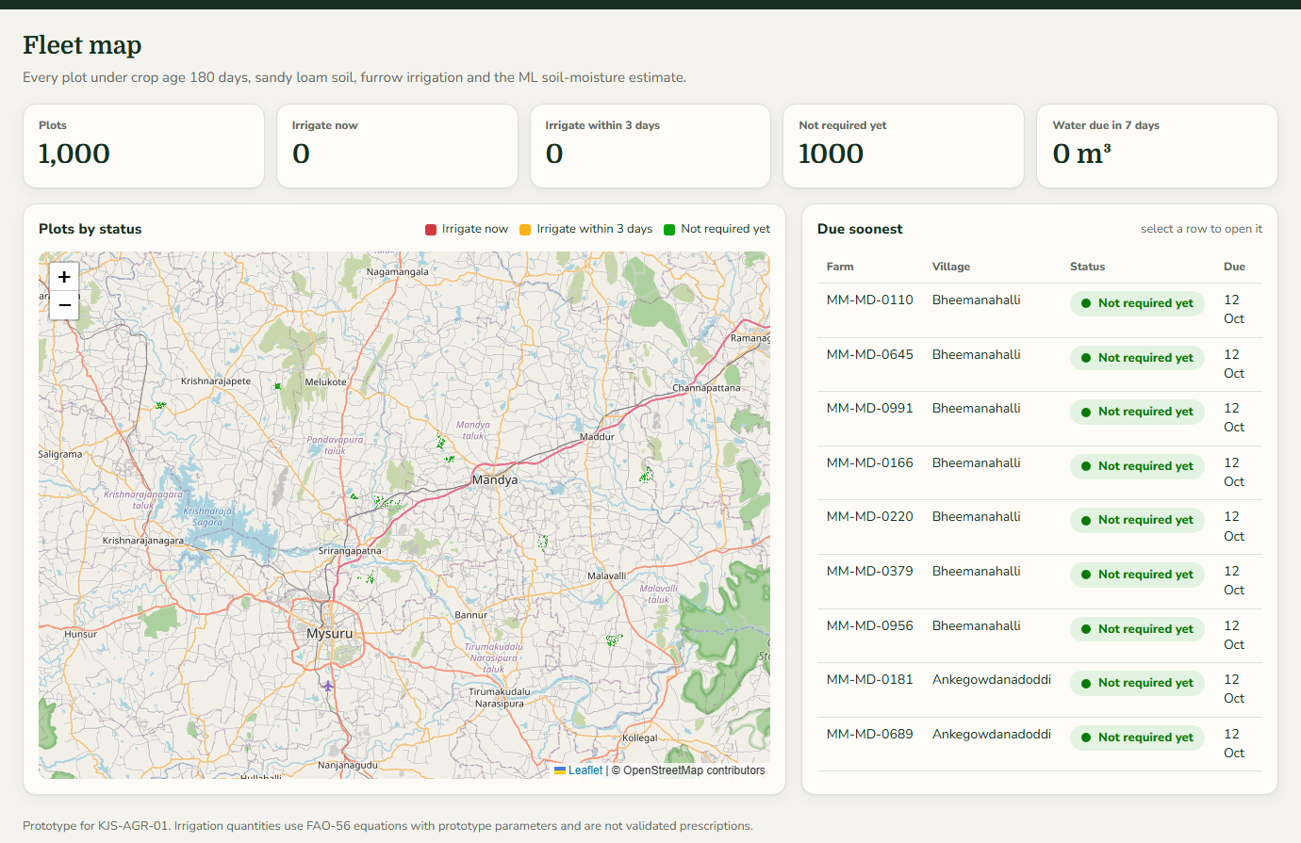
Figure 6.5: Web frontend: fleet map of all 1,000 plots by irrigation status

6.2.4 Pump scheduling
Figure 6.6 shows the pump scheduling view for the Bheemanahalli feeder with a cap of 25 pumps and a 21-day horizon. The tiles show 96 farms due within the horizon, of which 25 can be fully scheduled, with 3,834 of 5,858 pump-hours unmet, a peak of 25 concurrent pumps and 43% feeder utilisation. The Gantt chart draws each farm’s pumping sessions in the three daily supply windows; the first 25 farms by priority fill the feeder from 12 October, the next group starts once slots free up, and the table at the bottom lists farms that cannot finish in the horizon with their needed, scheduled and unmet hours.
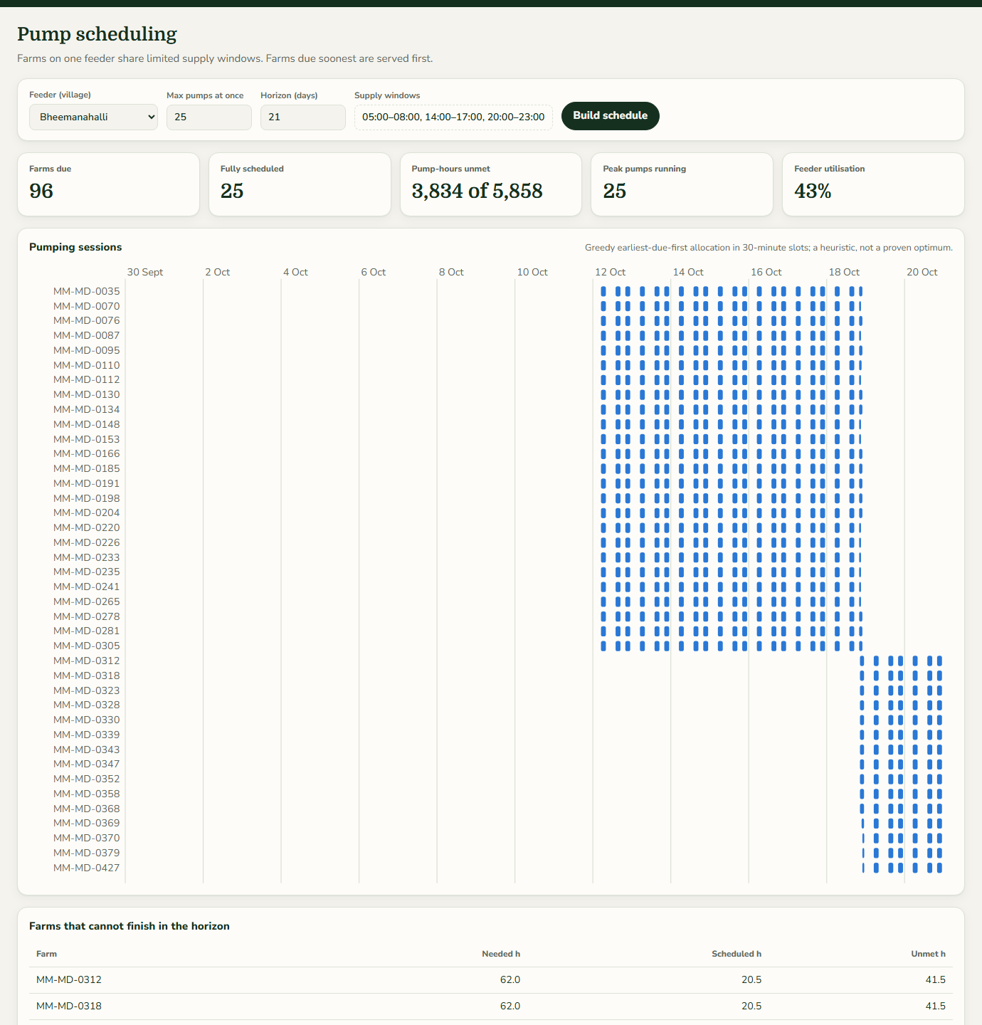
Figure 6.6: Web frontend: feeder-level pump schedule for Bheemanahalli

6.2.5 Use-case coverage view
Figure 6.7 shows the use-case coverage view, which lists each AI model requested in KJS-AGR-01 with its status (ML model, rule-based, partial, blocked or implemented), how it is built and its limitation, followed by the ten workflow stages and what the prototype provides for each. It makes the traceability between the use-case document and the code visible to reviewers inside the application itself. The model validation view, which presents the spatial audit, is shown with the results in Chapter 7.
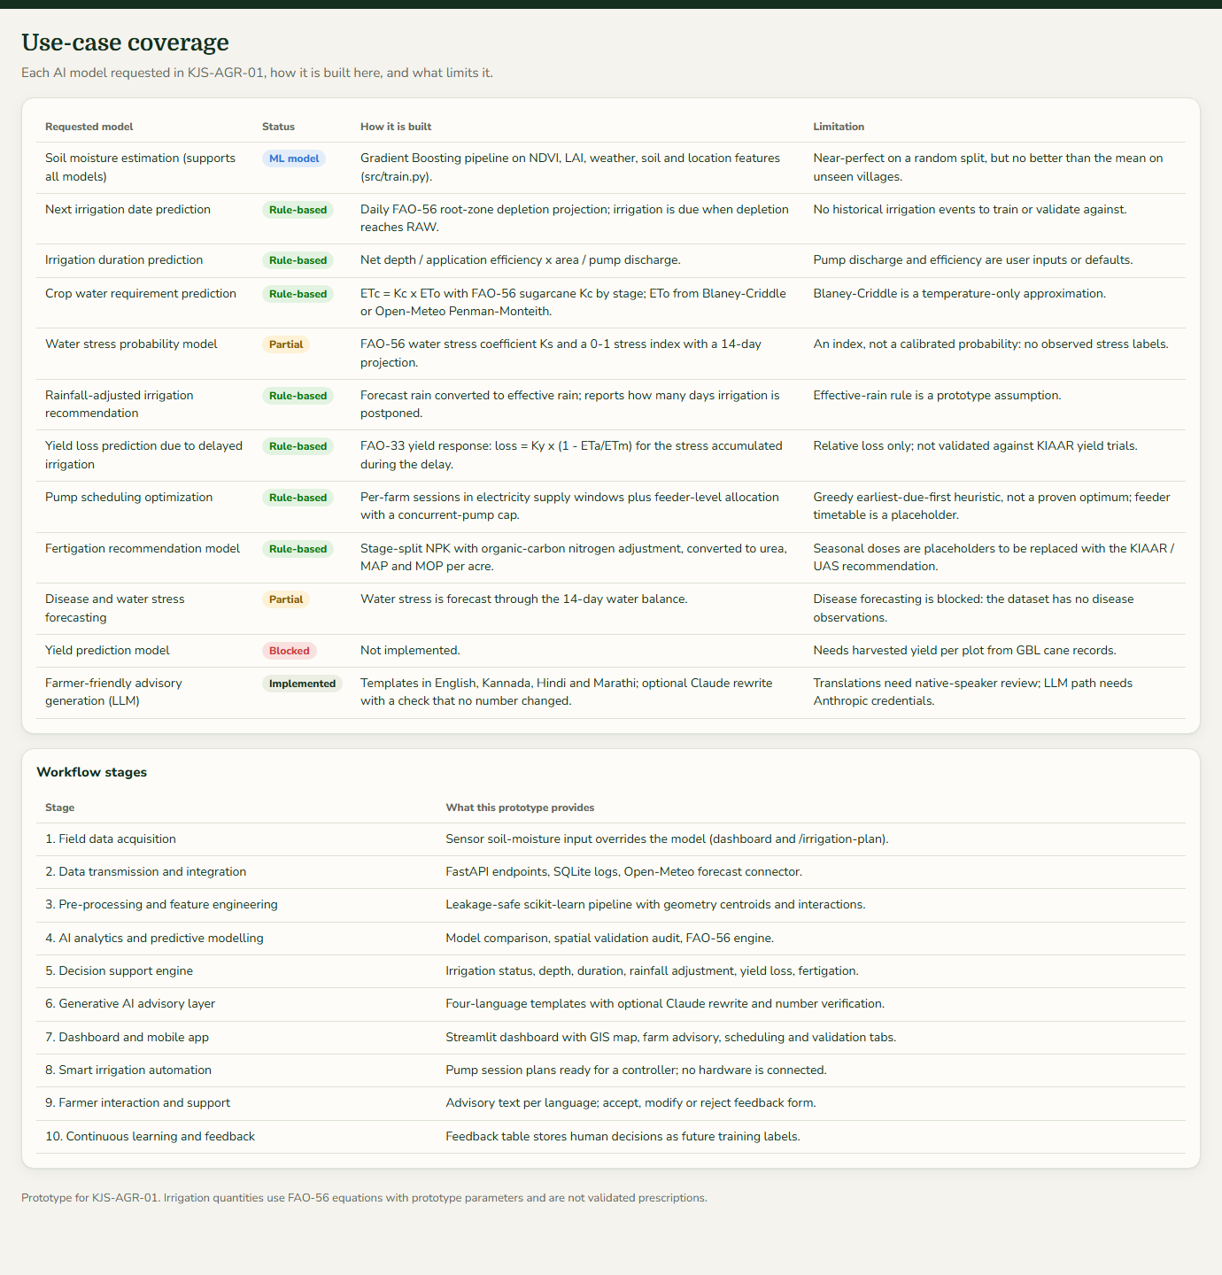
Figure 6.7: Web frontend: use-case coverage matrix

6.2.6 REST API documentation
Figure 6.8 shows the interactive API documentation generated by FastAPI [17] at /docs. All 17 routes of Table 4.3 are listed with their HTTP methods, and the request schemas (AdvisoryRequest, FarmPlanRequest, FeedbackRequest and others) can be expanded and tried from the browser. This page is the main tool for integrating the service with other platforms such as the STEPS plot survey system.
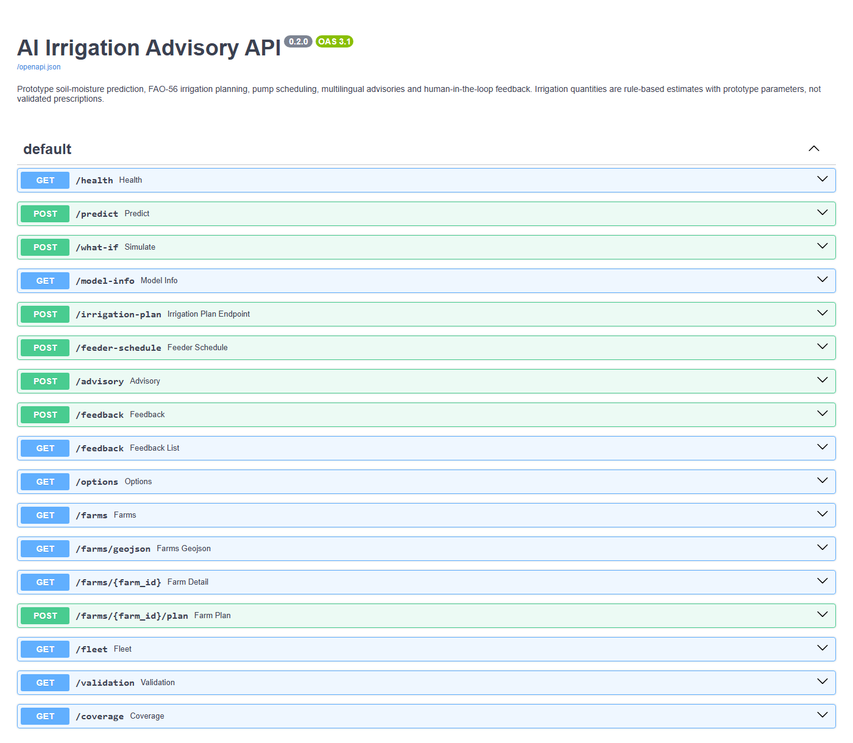
Figure 6.8: Interactive REST API documentation (Swagger UI)

6.2.7 Streamlit dashboard
Figure 6.9 shows the analytical dashboard built with Streamlit [18]. It offers the same farm advisory as the web frontend, with the farm, crop, equipment, sensor and language settings in a sidebar, and six tabs: farm advisory, fleet map, pump scheduling, soil-moisture model (with the what-if simulator), model validation and use-case coverage. It is intended for analysts and researchers, while the web frontend is designed for field use.
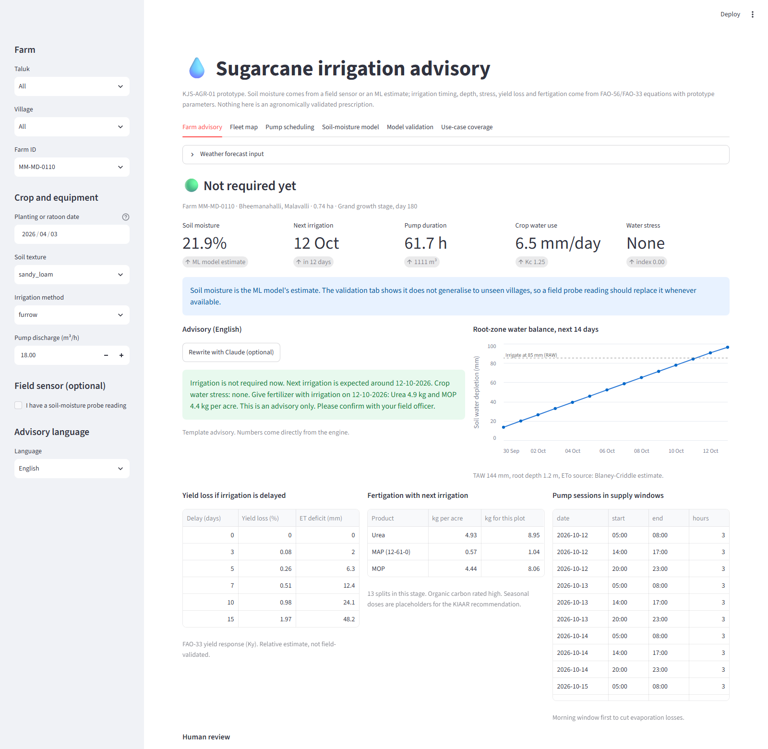
Figure 6.9: Streamlit analytical dashboard

6.3 Code Organisation
Table 6.1 lists the modules of the system. The backend modules are independent: the agronomy, scheduling and multilingual modules do not import the ML code, so the engine can be reused with any soil-moisture source.
Table 6.1: Project modules and responsibilities
Module | Responsibility
src/data_loader.py | Load CSV, enforce physical ranges, produce the dataset profile
src/features.py | Parse GeoJSON, compute polygon centres and interaction features
src/preprocessing.py | Build the leakage-safe scikit-learn pipeline
src/train.py | Train and compare candidates, select, test and save the artifact
src/explainability.py | Global importance (SHAP or native) and local perturbation explanations
src/predict.py | Load the artifact, predict, explain and run what-if simulations
src/validation.py | Random, leave-one-village-out and leave-one-taluk-out audit
src/agronomy.py | FAO-56 water balance, stress, FAO-33 yield loss, fertigation
src/scheduling.py | Single-farm pump sessions and feeder allocation
src/multilingual.py | Four-language templates and verified LLM rewrite
src/weather.py | Optional Open-Meteo forecast connector
src/decision.py | Per-farm orchestration: source selector, engine, schedule, advisory
src/service.py | Cached farm table and fleet status for the API
src/database.py | SQLite prediction and feedback logs
src/coverage.py | Use-case traceability matrix
api/main.py | FastAPI application, 17 routes, static frontend mount
frontend/ (index.html, styles.css, app.js) | Single-page web frontend, no build step
dashboard/app.py | Streamlit dashboard
config.yaml | All thresholds, FAO parameters, supply windows and LLM settings
tests/ (7 files) | 22 automated tests

6.4 Backend Implementation
The backend is a FastAPI application served by Uvicorn. On start-up it initialises the two SQLite tables. The trained pipeline is loaded once and cached, and the farm table, which holds every plot with its model estimate and polygon centre, is computed once per model path and cached in memory. Fleet results are cached per combination of crop age, soil, method, pump discharge and date, so repeated views are served in milliseconds. Requests are validated by Pydantic models: crop age must lie between 0 and 500 days, a probe reading between 0 and 0.6 m³/m³, the language must be one of four codes and a review decision one of three values; invalid input returns HTTP 422 with a description.
The plan endpoint for a farm builds the forecast input from manual rain values or, when requested, from Open-Meteo. The weather connector sends only the plot centre rounded to three decimal places (about 100 m) and converts the daily maximum and minimum temperature, precipitation, precipitation probability and FAO ET_{o} into the engine’s format. Any network failure is caught, and the plan falls back to the manual or dry projection with a note explaining what happened. The decision module then calls the engine, fertigation, yield-loss and scheduling functions and renders the advisory text in the requested language, returning one JSON bundle that contains everything the frontend displays.
The optional LLM rewrite uses the official Anthropic Python SDK [21] with the model named in the configuration file at low effort. The prompt sends only the verified facts and instructs the model to use every number exactly and add nothing. Missing packages, absent credentials, connection errors, API errors and refusals are each handled and return the template text, and generated text is accepted only after the number check of Section 5.9.

6.5 Frontend Implementation
The web frontend is a single page of about 230 lines of HTML, 400 lines of CSS and 850 lines of JavaScript, with no framework and no build step; FastAPI serves it as static files at /app. A hash-based router switches between the six views. Settings and the selected farm are stored in the browser’s local storage so that a field officer returns to the same farm. Charts are drawn as inline SVG generated in JavaScript, so they need no charting library and carry hover tooltips with exact values. Maps use Leaflet [19]; the fleet map uses its canvas renderer to draw 1,000 polygons smoothly. Colours are defined as CSS variables with separate light and dark values, and the layout uses CSS grid with breakpoints at 1,400, 1,100 and 760 pixels, collapsing to one column on phones. If the map library cannot load, a message replaces the map and every other card continues to work.

6.6 Testing
The project has 22 automated tests written with pytest, listed in Table 6.2. A session fixture trains a fresh model into a temporary folder, so the tests do not depend on the saved artifact, and API tests use a temporary database. All 22 tests passed on the final code.
Table 6.2: Automated test cases
Test file | What is verified | Result
test_preprocessing.py | Dataset loads with 1,000 rows, 16 columns and 6 missing NDVI; missing values are imputed inside the pipeline | 2 passed
test_model.py | Saved model predicts in (0, 1) with explanation; what-if uses the saved model | 2 passed
test_advisory.py | Prototype risk thresholds and advisory fields | 1 passed
test_agronomy.py | FAO-56 K_{c} by stage; plausible daylight and ET_{o}; K_{s} matches equation 84; dry soil triggers immediate irrigation with consistent volume and hours; wetter soil delays irrigation; rain postpones irrigation and light rain does not; drip needs less water than flood; yield loss grows with delay; fertiliser conversion returns the nutrient dose | 9 passed
test_scheduling.py | Single pump prefers morning and covers all hours; feeder respects capacity and due dates; farms that do not fit are reported with scheduled and unmet hours | 3 passed
test_multilingual.py | Templates in all four languages contain the engine’s numbers; LLM path falls back to the template when the SDK is missing | 2 passed
test_api.py | Original endpoints; plan, advisory, feeder and feedback endpoints, including probe override and invalid decision (422); frontend endpoints, unknown farm (404), static app and root redirect | 3 passed
Total |  | 22 passed

In addition to the automated tests, every view of the web frontend was rendered in headless Chrome in light and dark mode at desktop width and at a 390-pixel phone width, and the live weather connector was exercised against the real Open-Meteo service.

6.7 Deployment
The system is installed with a Python virtual environment and the requirements file. Three commands prepare it: training the model, running the spatial validation and running the tests. One command, uvicorn api.main:app, then starts the API, the web frontend at the server root and the documentation at /docs, and a second command starts the Streamlit dashboard. A Dockerfile packages the API for container deployment. The source code is kept in a Git repository [INSERT: repository URL if it may be disclosed].

Chapter 7: Result Analysis

7.1 Introduction
This chapter presents the results of the system and interprets them. All numbers were produced by the project code on the supplied dataset; decision-engine results use a fixed start date of 30 September 2026 so that they can be reproduced. We first examine the dataset, then the soil-moisture models under random and spatial validation, then the behaviour of the decision engine for one farm and across scenarios, the feeder scheduling results and the response times of the service. The chapter ends with screenshots of the validation and advisory outputs and a comparison with the approaches surveyed in Chapter 2.

7.2 Performance Measures

7.2.1 Exploratory analysis of the dataset
Figure 7.1 shows the distribution of soil moisture across the 1,000 plots. Most values lie between 0.217 and 0.226 m³/m³, with a separate group near 0.25 to 0.26. The histogram is made of a few tall bars rather than a smooth curve, which is the first sign that the variable takes few distinct values.
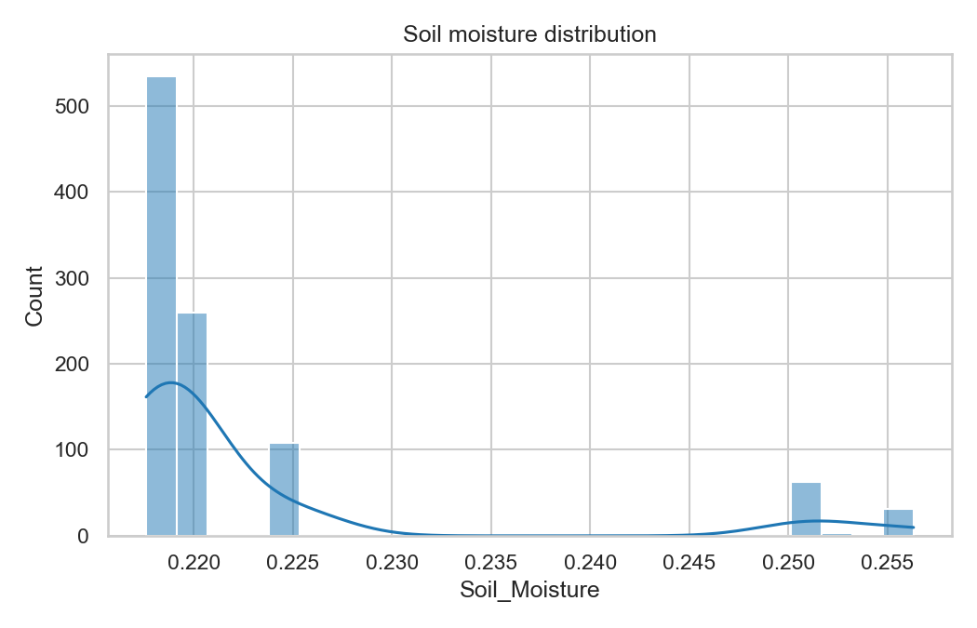
Figure 7.1: Distribution of soil moisture in the dataset
Figure 7.2 shows the correlation matrix of the numeric columns. Soil moisture correlates positively with relative humidity and rainfall and negatively with temperature, while NDVI, LAI, organic carbon and pH show almost no correlation with it. Rainfall, humidity and temperature are also strongly correlated with each other, because they are coarse climate values that vary together from one area to another. Figure 7.3 confirms this: soil moisture against rainfall forms a few horizontal clusters, one per climate grid value, rather than a continuous trend.
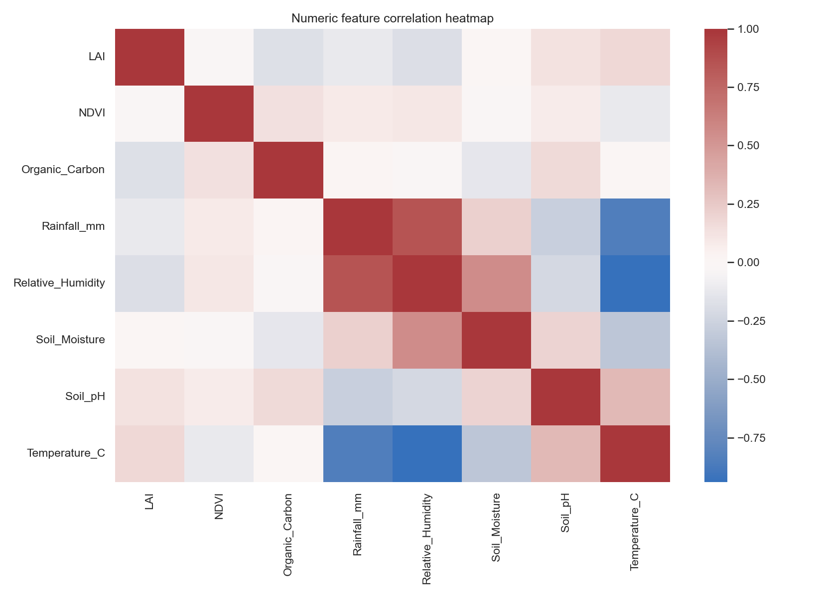
Figure 7.2: Correlation heatmap of the numeric columns
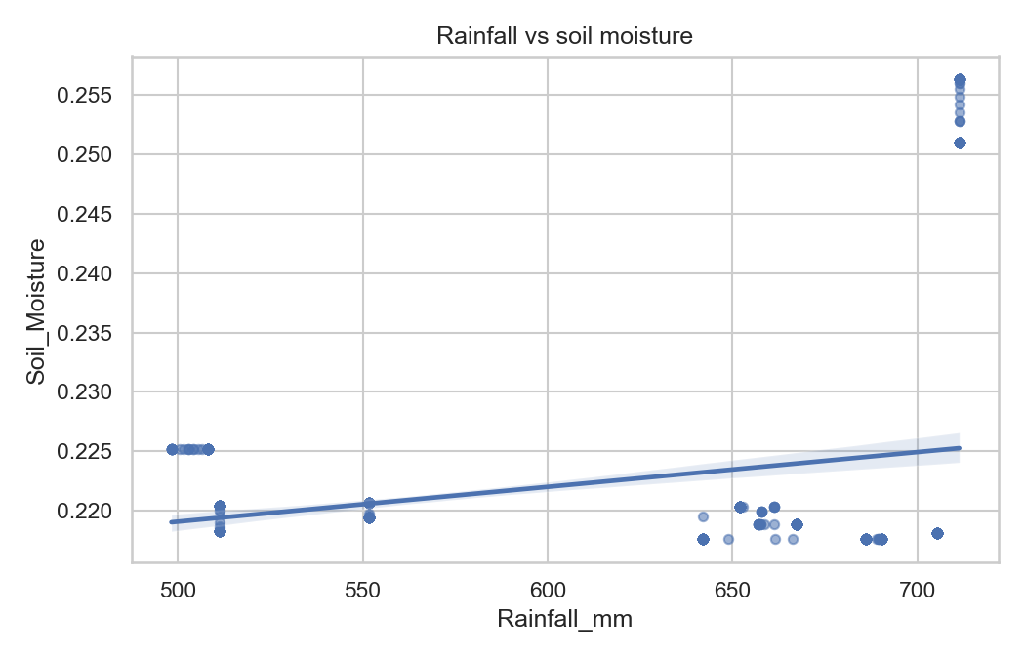
Figure 7.3: Rainfall versus soil moisture
Figure 7.4 makes the structure explicit by plotting every plot’s soil moisture by village, with the number of distinct values printed above each column. Six of the ten villages have exactly one soil-moisture value shared by all of their plots, and the others have between three and twelve. Laxmipura sits apart at about 0.25 m³/m³. Soil moisture in this dataset is therefore essentially a property of the village, not of the plot.
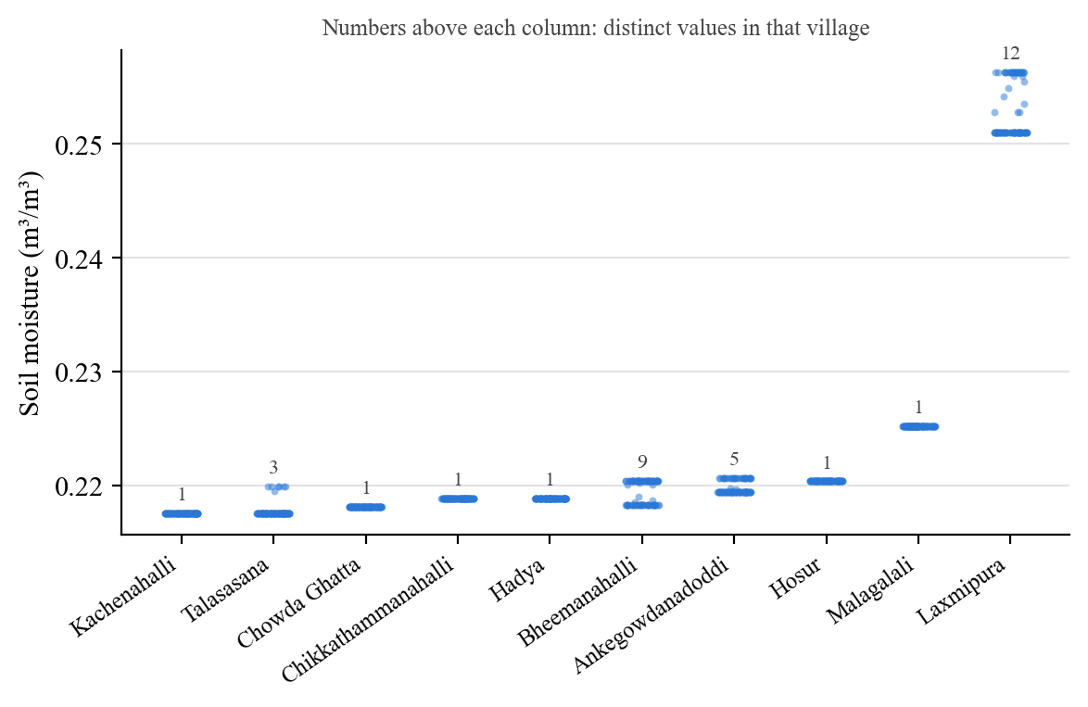
Figure 7.4: Soil moisture of every plot by village

7.2.2 Soil-moisture models on the random split
Table 7.1 reports the validation performance of the four candidate models on the random split, and Figure 7.5 plots their RMSE on a logarithmic scale. Gradient Boosting has the lowest validation RMSE and was selected. Refitted on training and validation data and evaluated once on the 150-row test set, it achieved the test metrics in Table 7.2.
Table 7.1: Validation performance of candidate models (random 70/15/15 split)
Model | MAE | RMSE | R²
Gradient Boosting | 1.05 × 10⁻⁵ | 5.41 × 10⁻⁵ | 0.999973
Random Forest | 2.15 × 10⁻⁵ | 7.66 × 10⁻⁵ | 0.999946
Extra Trees | 5.62 × 10⁻⁵ | 1.83 × 10⁻⁴ | 0.999691
Linear Regression | 4.92 × 10⁻⁴ | 9.05 × 10⁻⁴ | 0.992460

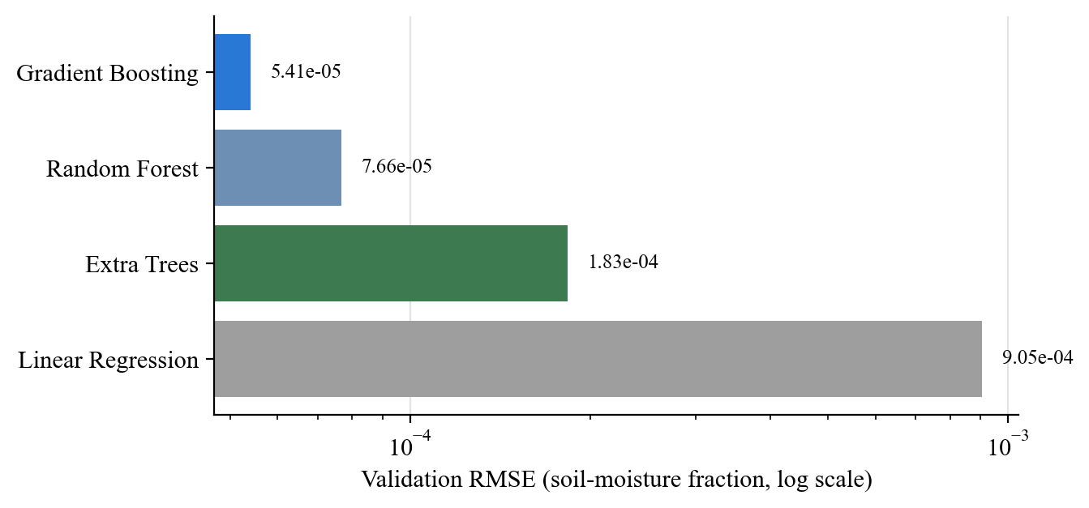
Figure 7.5: Validation RMSE of candidate models (log scale)
Table 7.2: Held-out test performance of the selected model (Gradient Boosting)
MAE | RMSE | R²
1.53 × 10⁻⁵ | 1.57 × 10⁻⁴ | 0.9998

On this protocol the model appears almost perfect: its test error is about 1.5 × 10⁻⁵ m³/m³, a tiny fraction of the target’s standard deviation of 0.0102. Such a result is too good to be taken at face value. Because plots of the same village share a soil-moisture value (Section 7.2.1), a random split places plots from every village in both the training and the test sets, and the model only has to recognise the village. The next two sections test this explanation.

7.2.3 Feature importance
Figure 7.6 shows the ten most important features of the selected model, using its native impurity-based importance because SHAP was not installed. Rainfall (0.321), the Laxmipura village indicator (0.301) and longitude (0.187) together account for about 81% of the importance. Rainfall itself takes only 38 values and acts as a location code. NDVI, LAI, pH and organic carbon do not appear in the top ten. The model has therefore learnt where a plot is, not how its vegetation or soil relates to moisture.
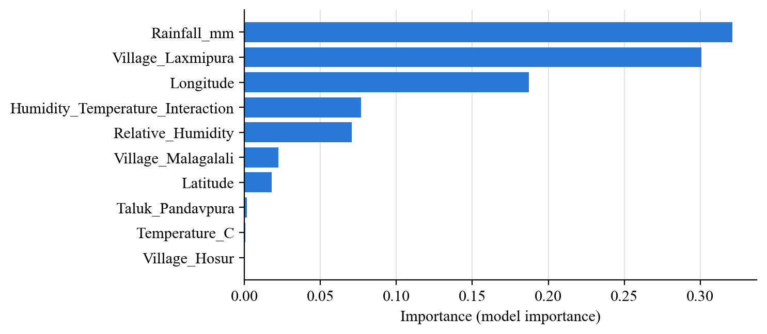
Figure 7.6: Top ten features by importance in the selected model

7.2.4 Spatial validation
Table 7.3 reports all results of the spatial audit described in Section 5.4.3, and Figure 7.7 plots the all-features results. On the random 5-fold split, Random Forest and Gradient Boosting reach R² of 1.000. On leave-one-village-out validation every model has negative R². The best, Random Forest, has an MAE of 0.00713, against 0.00714 for simply predicting the training mean, so it adds no useful information about an unseen village. Linear Regression is far worse than the mean on unseen groups (R² of −13.8 and −106.8), because it extrapolates the village and taluk effects linearly. Removing the location features (environment only) does not rescue the models: they remain at or below the mean baseline. On leave-one-taluk-out validation the tree models come closest to the baseline but still have negative R².
Table 7.3: Spatial validation results for all schemes, feature sets and models
Scheme | Features | Model | MAE | RMSE | R²
Random 5-fold | all features | Mean baseline | 0.00644 | 0.01019 | -0.004
Random 5-fold | all features | Linear Regression | 0.00048 | 0.00081 | 0.994
Random 5-fold | all features | Random Forest | 0.00001 | 0.00009 | 1.000
Random 5-fold | all features | Gradient Boosting | 0.00001 | 0.00009 | 1.000
Random 5-fold | environment only | Linear Regression | 0.00351 | 0.00453 | 0.801
Random 5-fold | environment only | Random Forest | 0.00022 | 0.00062 | 0.996
Random 5-fold | environment only | Gradient Boosting | 0.00029 | 0.00065 | 0.996
Leave-one-village-out | all features | Mean baseline | 0.00714 | 0.01128 | -0.231
Leave-one-village-out | all features | Linear Regression | 0.02928 | 0.03918 | -13.845
Leave-one-village-out | all features | Random Forest | 0.00713 | 0.01247 | -0.504
Leave-one-village-out | all features | Gradient Boosting | 0.00725 | 0.01284 | -0.595
Leave-one-village-out | environment only | Linear Regression | 0.00768 | 0.01177 | -0.339
Leave-one-village-out | environment only | Random Forest | 0.00820 | 0.01374 | -0.826
Leave-one-village-out | environment only | Gradient Boosting | 0.00840 | 0.01426 | -0.966
Leave-one-taluk-out | all features | Mean baseline | 0.00691 | 0.01121 | -0.215
Leave-one-taluk-out | all features | Linear Regression | 0.06771 | 0.10558 | -106.801
Leave-one-taluk-out | all features | Random Forest | 0.00543 | 0.01103 | -0.176
Leave-one-taluk-out | all features | Gradient Boosting | 0.00512 | 0.01063 | -0.092
Leave-one-taluk-out | environment only | Linear Regression | 0.00983 | 0.01281 | -0.588
Leave-one-taluk-out | environment only | Random Forest | 0.00539 | 0.01084 | -0.137
Leave-one-taluk-out | environment only | Gradient Boosting | 0.00520 | 0.01063 | -0.093

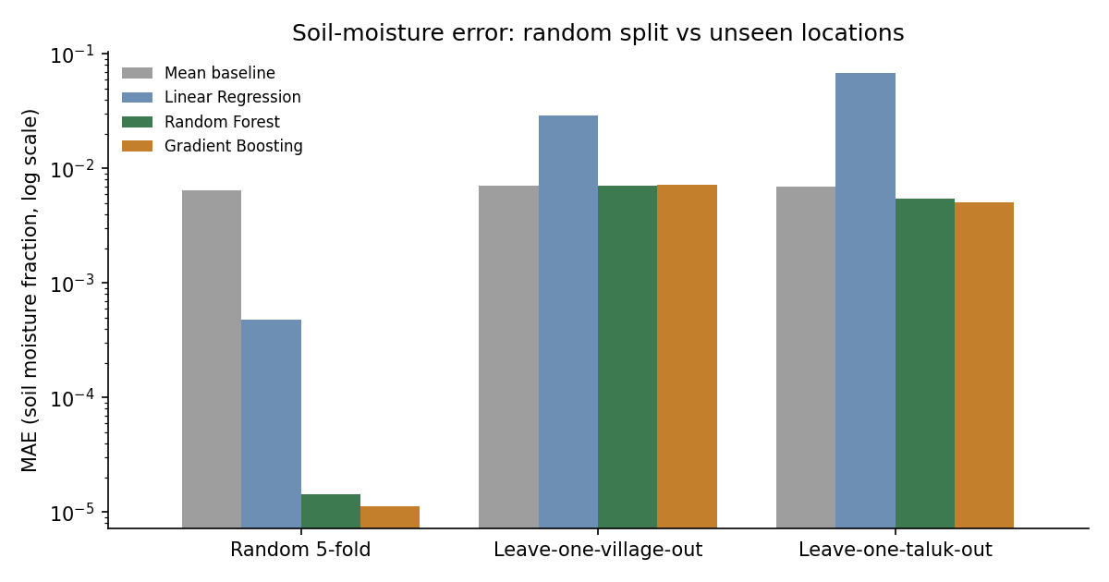
Figure 7.7: MAE under random, leave-one-village-out and leave-one-taluk-out validation (log scale)
Table 7.4 breaks the leave-one-village-out error of Gradient Boosting down by village. Villages whose value is close to the common level of about 0.218 to 0.220 are predicted well by chance, for example Hadya and Chikkathammanahalli. Laxmipura, the village with high soil moisture, has the largest error, 0.0331: no other village shows such values, so the model cannot predict them when Laxmipura is held out. Chowda Ghatta also has a large error, 0.0213, despite an ordinary value, because its climate inputs resemble those of a wetter village. These results agree with the findings of Roberts et al. and Meyer et al. [13], [14] that random cross-validation hides failure on new locations.
Table 7.4: Leave-one-village-out error of Gradient Boosting by village
Held-out village | Plots | Distinct values | Mean soil moisture | MAE
Ankegowdanadoddi | 102 | 5 | 0.2198 | 0.00144
Bheemanahalli | 96 | 9 | 0.2195 | 0.00518
Chikkathammanahalli | 94 | 1 | 0.2188 | 0.00009
Chowda Ghatta | 108 | 1 | 0.2181 | 0.02127
Hadya | 95 | 1 | 0.2188 | 0.00001
Hosur | 93 | 1 | 0.2204 | 0.00058
Kachenahalli | 99 | 1 | 0.2176 | 0.00322
Laxmipura | 99 | 12 | 0.2528 | 0.03315
Malagalali | 108 | 1 | 0.2252 | 0.00500
Talasasana | 106 | 3 | 0.2177 | 0.00097

Consequence for the design. The model can describe the surveyed villages but cannot estimate soil moisture for a new village, and the dataset cannot support plot-level soil-moisture prediction at all. This is why the system treats a probe reading as the primary soil-moisture input, labels every model-based advisory as an estimate, and warns the user in the alerts and model cards. The finding is also the strongest argument for the IoT sensor network proposed in the use case [1].

7.2.5 Decision engine results for one farm
Table 7.5 shows the full engine output for farm MM-MD-0110 (0.736 ha, crop age 180 days, sandy loam, furrow irrigation, 18 m³/h pump, no rain) in two cases: using the model estimate of 0.2187 m³/m³ and using a probe reading of 0.150 m³/m³. Both share the crop and climate quantities: grand-growth stage with K_{c} = 1.25, root depth 1.2 m, ET_{o} = 5.16 mm/day by Blaney-Criddle and ET_{c} = 6.45 mm/day. The adjusted depletion fraction is 0.592, giving RAW = 85.2 mm of the 144 mm TAW.
Table 7.5: Engine output for farm MM-MD-0110 with the model estimate and with a probe reading
Output | Model estimate | Probe reading
Soil moisture used (m³/m³) | 0.2187 | 0.150
Current depletion D_{r} (mm) | 13.5 | 96.0
Water stress coefficient K_{s} / category | 1.00 / none | 0.817 / mild
Status | NOT_REQUIRED | IRRIGATE_NOW
Next irrigation | 2026-10-12 (in 12 days) | 2026-09-30 (today)
Net / gross depth (mm) | 90.6 / 151.0 | 96.0 / 160.0
Volume (m³) | 1110.6 | 1176.8
Pump duration (h) | 61.7 | 65.4
Pump sessions / first session | 21 / 2026-10-12 05:00 | 22 / 2026-09-30 05:00
Fertigation per acre (urea / MAP / MOP, kg) | 4.93 / 0.57 / 4.44 | 4.93 / 0.57 / 4.44

Figure 7.8 plots the two 14-day depletion paths. With the model estimate, depletion starts at 13.5 mm and rises by roughly 6.5 mm a day until it crosses RAW on day 12. With the probe reading the root zone is already past RAW, so irrigation is due immediately; the curve then flattens because K_{s} falls below 1 and the stressed crop transpires less, the effect that FAO-56 equation 84 is designed to capture. A probe reading only 0.069 m³/m³ lower than the model estimate moves the decision from “in 12 days” to “today”, which shows how much the advisory depends on soil-moisture accuracy.
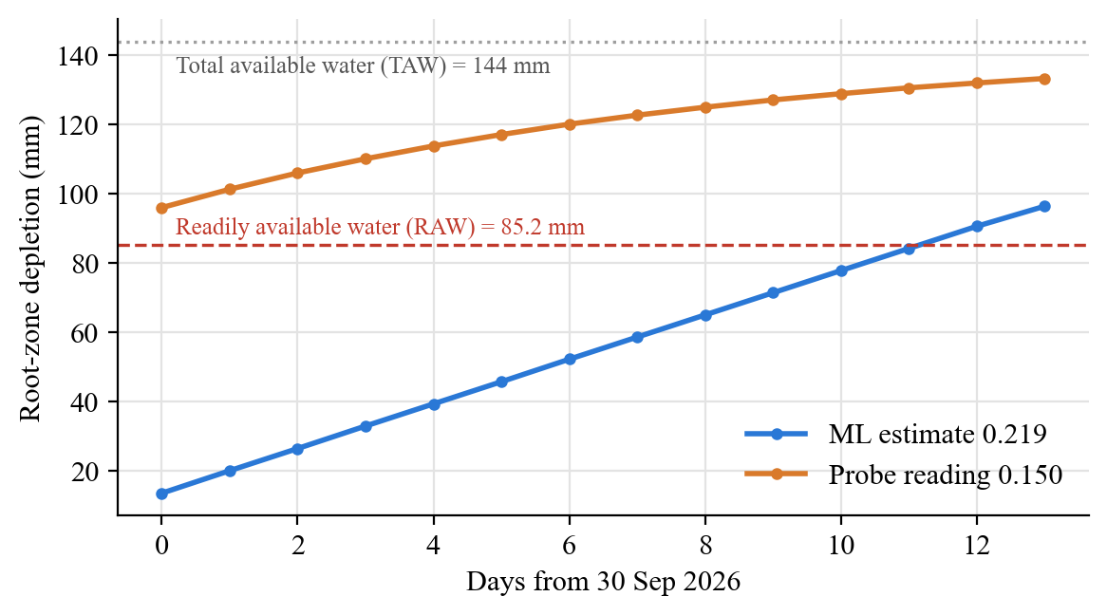
Figure 7.8: Projected root-zone depletion for farm MM-MD-0110: model estimate versus probe reading
Figure 7.9 shows how the crop coefficient and root depth used by the engine change over the 405-day season defined by the FAO-56 stage lengths. K_{c} rises from 0.40 to 1.25 during development and falls to 0.75 in the late stage, while roots deepen until the start of mid-season. Crop water use and the size of the root-zone reservoir therefore both depend strongly on crop age, which is why the planting date is a required input.
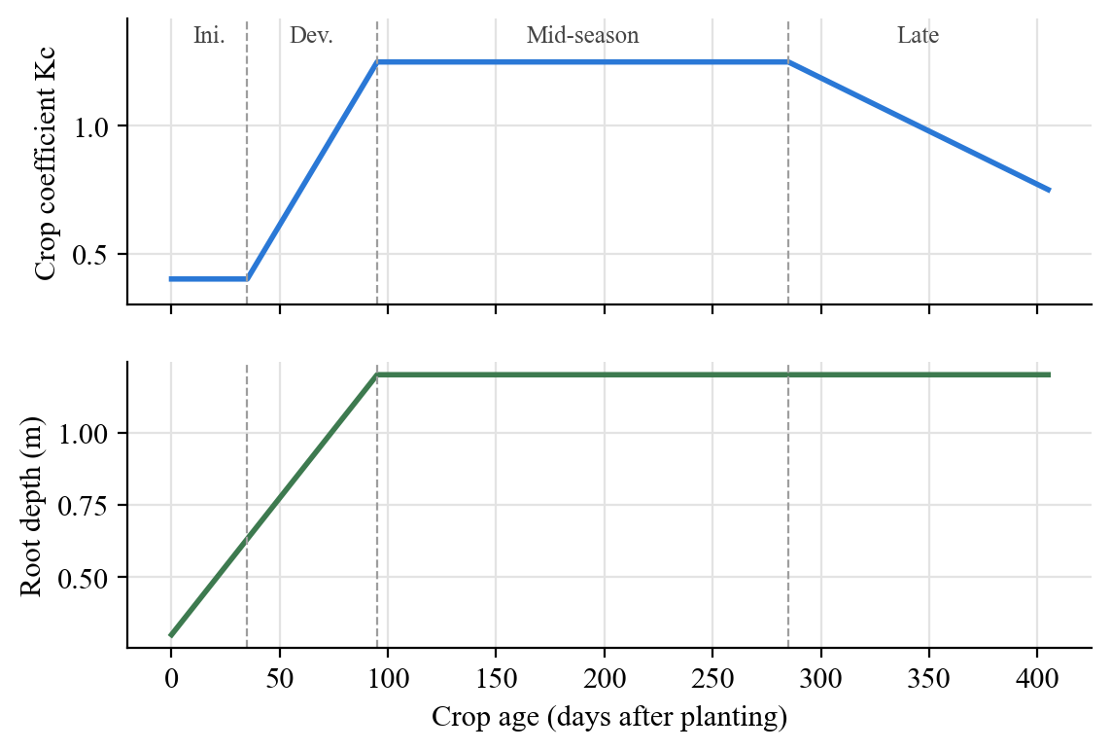
Figure 7.9: Crop coefficient and root depth over the sugarcane season
Table 7.6 lists the yield-loss estimate for the same farm. Delaying irrigation by 5 days past the due date costs an estimated 0.26% of yield, and 15 days about 2%, because the grand-growth stage has K_{y} = 0.5 and a long stage over which the deficit is spread.
Table 7.6: Estimated yield loss for delayed irrigation, farm MM-MD-0110 (grand growth)
Delay (days) | ET deficit (mm) | K_{s} at end of delay | Relative yield loss (%)
0 | 0.0 | 1.00 | 0.00
3 | 2.0 | 0.71 | 0.08
5 | 6.3 | 0.56 | 0.26
7 | 12.4 | 0.44 | 0.51
10 | 24.1 | 0.31 | 0.98
15 | 48.2 | 0.17 | 1.97

7.2.6 Scenario and sensitivity analysis
Rainfall adjustment. Table 7.7 shows the effect of forecast rain on a plot at 0.218 m³/m³ that would be due in 12 days without rain. A single 10 mm shower postpones irrigation by one day, 45 mm over two days by six days, and 60 mm or more by seven days. The postponement saturates because the root zone cannot hold more than field capacity: once depletion reaches zero, additional rain is treated as lost.
Table 7.7: Effect of forecast rain on the irrigation due date
Daily rain from today (mm) | Total (mm) | Due day without rain | Due day with rain | Days postponed
none | 0 | 12 | 12 | 0
0, 0, 10 | 10 | 12 | 13 | 1
0, 0, 25, 20 | 45 | 12 | 18 | 6
15, 15, 15, 15 | 60 | 12 | 19 | 7
0, 40, 30, 20 | 90 | 12 | 19 | 7

Sensitivity to soil moisture and soil texture. Figure 7.10 and Table 7.8 show the number of days until irrigation is due as a function of the soil-moisture reading for three soil textures. The relationship is steep: on sandy loam, a change of 0.03 m³/m³ moves the due date by four to five days. Texture matters as much as the reading, because the same moisture is close to field capacity in a sandy loam and well below it in a silt loam. On silt loam a reading of 0.20 m³/m³ already calls for irrigation today, while on sandy loam it allows eight more days. Soil texture for each plot must therefore come from KIAAR soil records rather than a default.
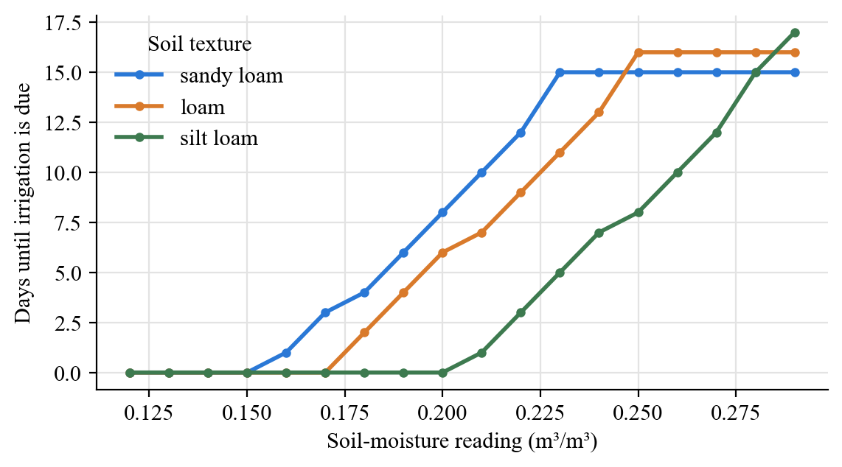
Figure 7.10: Days until irrigation versus soil-moisture reading for three soil textures
Table 7.8: Days until irrigation by soil-moisture reading and soil texture
Reading (m³/m³) | Sandy loam | Loam | Silt loam
0.14 | 0 | 0 | 0
0.17 | 3 | 0 | 0
0.20 | 8 | 6 | 0
0.22 | 12 | 9 | 3
0.24 | 15 | 13 | 7
0.27 | 15 | 16 | 12

The same effect appears across the whole fleet. With sandy loam and the model estimates, all 1000 plots are Not required yet, with due dates 12 to 15 days away. With silt loam, 793 plots become Irrigate within 3 days and 207 remain Not required. The fleet view is therefore only as reliable as the soil and crop inputs behind it.
Irrigation method. Table 7.9 and Figure 7.11 compare the four irrigation methods for the same plot and soil moisture. Because the net depth is the same, the gross water and pump time scale inversely with application efficiency: drip needs 41.5 pump hours where furrow needs 62.2 and flood 74.7, a saving of a third relative to furrow.
Table 7.9: Water and pump time per irrigation by method (0.736 ha plot)
Method | Efficiency | Gross depth (mm) | Volume (m³) | Pump hours
drip | 0.90 | 101.6 | 747 | 41.5
sprinkler | 0.75 | 121.9 | 896 | 49.8
furrow | 0.60 | 152.3 | 1120 | 62.3
flood | 0.50 | 182.8 | 1345 | 74.7

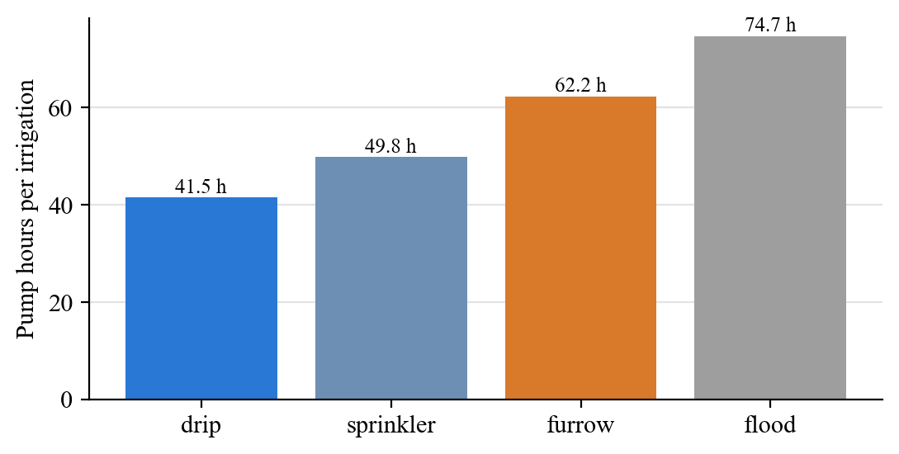
Figure 7.11: Pump hours per irrigation by method
Yield loss by growth stage. Figure 7.12 and Table 7.10 compare the yield cost of the same delays at four crop ages. A 10-day delay costs about 10% of yield at germination and 5% at tillering, but under 1% in grand growth and 0.3% at maturity. Advisories should therefore be most insistent in the first three months after planting or ratooning, which matches the K_{y} values of FAO-33 [5].
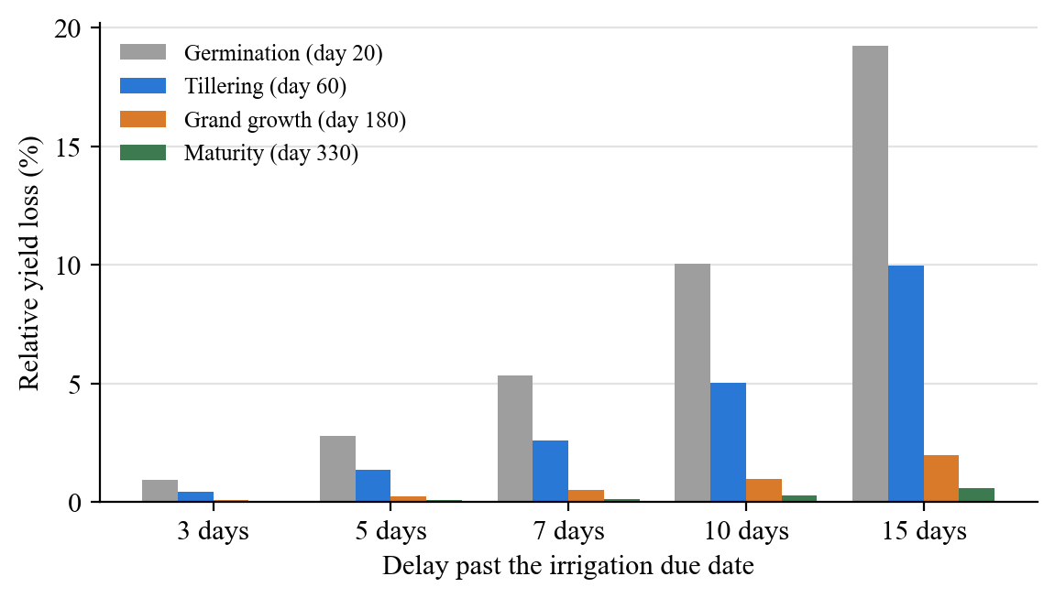
Figure 7.12: Relative yield loss by delay and growth stage
Table 7.10: Relative yield loss (%) by delay and growth stage
Growth stage (crop age) | 3 d | 5 d | 7 d | 10 d | 15 d
Germination (day 20) | 0.93 | 2.80 | 5.35 | 10.05 | 19.25
Tillering (day 60) | 0.44 | 1.35 | 2.62 | 5.04 | 9.96
Grand growth (day 180) | 0.08 | 0.26 | 0.51 | 0.98 | 1.97
Maturity (day 330) | 0.02 | 0.08 | 0.15 | 0.30 | 0.60

7.2.7 Feeder scheduling
Table 7.11 and Figure 7.13 show the feeder scheduler applied to the 96 plots of Bheemanahalli due within a 21-day horizon, for two irrigation methods and three feeder caps. With furrow irrigation and 25 pumps allowed at once, only 25 farms can complete their irrigation and about two-thirds of the 5,858 pump-hours needed cannot be supplied. Doubling the cap to 50 still leaves 1,888 hours unmet, and only a cap of 100 serves every farm. With drip irrigation, total demand falls to 3,906 hours; at a cap of 50, 71 farms are fully served and only 24 hours remain unmet. Utilisation stays below 45% because farms become due at the same time in this scenario, so the early windows are saturated while later windows sit idle. The result shows quantitatively why the use case lists electricity availability as an operational constraint [1], and that staggering planting dates or adopting drip would relieve it more than adding supply hours.
Table 7.11: Feeder scheduling results for Bheemanahalli (96 farms, 21 days)
Method | Pump cap | Farms due | Fully scheduled | Demand (h) | Unmet (h) | Utilisation
furrow | 25 | 96 | 25 | 5858 | 3834 | 43%
furrow | 50 | 96 | 50 | 5858 | 1888 | 42%
furrow | 100 | 96 | 96 | 5858 | 0 | 31%
drip | 25 | 96 | 33 | 3906 | 1878 | 43%
drip | 50 | 96 | 71 | 3906 | 24 | 41%
drip | 100 | 96 | 96 | 3906 | 0 | 21%

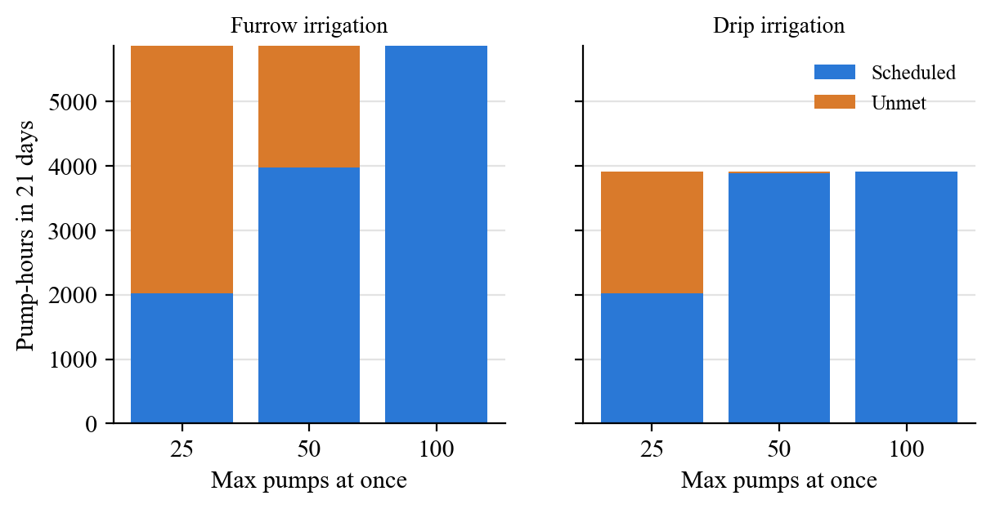
Figure 7.13: Scheduled and unmet pump-hours by irrigation method and feeder cap

7.2.8 Response time
Table 7.12 lists response times measured on the development machine of Table 3.1 through the API test client. A farm advisory is computed in about 8 ms and the engine alone takes about 4.6 ms per plan, so the full fleet of 1,000 plots takes under 5 seconds on first request and about 9 ms once cached. The slower farm-detail and prediction calls are dominated by the local explanation, which re-runs the model once per feature. All interactive requests are well within the one-second requirement of Section 3.7.
Table 7.12: Measured response times
Operation | Runs | Time
FAO-56 engine, one plan (in-process) | 1,000 | 4.6 ms each
POST /farms/{id}/plan (full advisory bundle) | 20 | 8.2 ms median
GET /farms/{id} (model estimate and explanation) | 20 | 50.6 ms median
POST /predict | 10 | 55.3 ms median
POST /feeder-schedule (100 farms, 21 days) | 5 | 18.8 ms median
GET /fleet, first request (1,000 plots) | 1 | 4,772 ms
GET /fleet, cached | 1 | 9.3 ms

7.2.9 Test results
All 22 automated tests listed in Table 6.2 passed on the final code, covering data loading, the ML pipeline, every agronomic equation family, scheduling, all four language templates, the LLM fallback and every API endpoint.

7.3 Screenshots
Figure 7.14 shows the model validation view of the web frontend, which presents the spatial audit of Section 7.2.4 to users of the application: the finding in plain language, tiles for the number of distinct soil-moisture values, the number of single-value villages and the best and baseline unseen-village errors, followed by the chart and the full results table.
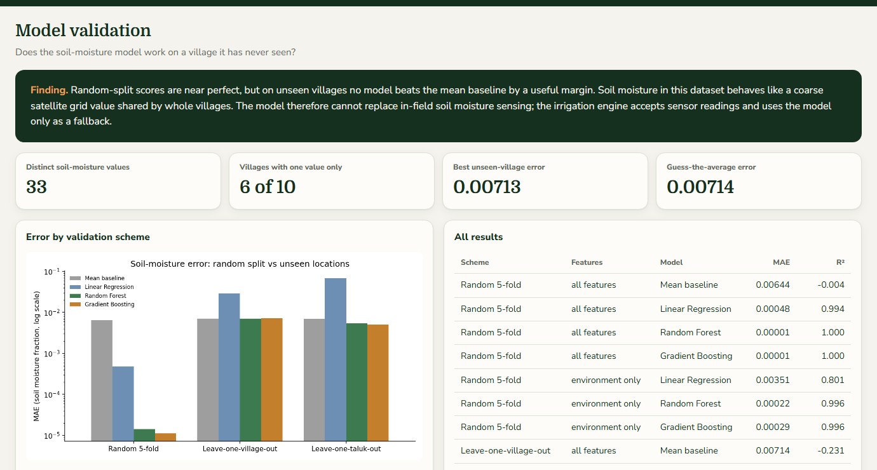
Figure 7.14: Web frontend: model validation view
The advisories generated for farm MM-MD-0110 with the probe reading of 0.15 m³/m³ are reproduced below in all four languages, exactly as produced by the template engine. Each contains the same numbers: 65.4 pump hours, about 160 mm of water, mild stress, the 05:00–08:00 slot on 30-09-2026, and 4.9 kg urea and 4.4 kg MOP per acre.
English:
Irrigate today. Run the pump for 65.4 hours (about 160 mm of water). Crop water stress: mild. Best pump time: 30-09-2026 05:00-08:00. Give fertilizer with irrigation on 30-09-2026: Urea 4.9 kg and MOP 4.4 kg per acre. This is an advisory only. Please confirm with your field officer.
Kannada:
ಇಂದು ನೀರು ಹಾಯಿಸಿ. ಪಂಪ್ ಅನ್ನು 65.4 ಗಂಟೆಗಳ ಕಾಲ ಚಲಾಯಿಸಿ (ಸುಮಾರು 160 ಮಿ.ಮೀ. ನೀರು). ಬೆಳೆಯ ನೀರಿನ ಒತ್ತಡ: ಸ್ವಲ್ಪ. ಪಂಪ್ ಚಲಾಯಿಸಲು ಉತ್ತಮ ಸಮಯ: 30-09-2026 05:00-08:00. 30-09-2026 ರಂದು ನೀರಿನೊಂದಿಗೆ ಗೊಬ್ಬರ ನೀಡಿ: ಪ್ರತಿ ಎಕರೆಗೆ ಯೂರಿಯಾ 4.9 ಕೆ.ಜಿ. ಮತ್ತು ಎಂಒಪಿ 4.4 ಕೆ.ಜಿ. ಇದು ಸಲಹೆ ಮಾತ್ರ. ದಯವಿಟ್ಟು ನಿಮ್ಮ ಕ್ಷೇತ್ರ ಅಧಿಕಾರಿಯೊಂದಿಗೆ ಖಚಿತಪಡಿಸಿಕೊಳ್ಳಿ.
Hindi:
आज सिंचाई करें। पंप को 65.4 घंटे चलाएँ (लगभग 160 मि.मी. पानी)। फसल में जल तनाव: हल्का। पंप चलाने का सबसे अच्छा समय: 30-09-2026 05:00-08:00। 30-09-2026 को सिंचाई के साथ खाद दें: प्रति एकड़ यूरिया 4.9 कि.ग्रा. और एमओपी 4.4 कि.ग्रा.। यह केवल एक सलाह है। कृपया अपने क्षेत्र अधिकारी से पुष्टि करें।
Marathi:
आज पाणी द्या. पंप 65.4 तास चालवा (सुमारे 160 मि.मी. पाणी). पिकावरील पाण्याचा ताण: सौम्य. पंप चालवण्याची सर्वोत्तम वेळ: 30-09-2026 05:00-08:00. 30-09-2026 रोजी पाण्यासोबत खत द्या: प्रति एकर युरिया 4.9 किलो आणि एमओपी 4.4 किलो. हा फक्त सल्ला आहे. कृपया आपल्या क्षेत्र अधिकाऱ्याकडून खात्री करा.

7.4 Comparative Analysis
Published irrigation-advisory systems report different metrics on different data, so a direct numerical comparison with them would not be meaningful. We instead compare the capabilities of this system with the approaches identified in the literature survey and the use-case document: experience-based scheduling as practised today [1], manual FAO-56 scheduling [2], an ML model validated only by a random split (the initial prototype from which this project started), and the sample dashboard in the use-case document. Table 7.13 summarises the comparison.
Table 7.13: Comparison with the approaches from the literature survey
Capability | Experience-based | Manual FAO-56 | Random-split ML prototype | Use-case sample UI | This system
Plot-specific irrigation date and duration | No | Yes | No | Shown | Yes
Uses physical crop water balance | No | Yes | No | Not stated | Yes
Accepts field sensor readings | No | Yes | No | Yes | Yes
Rainfall-adjusted advice | Informal | Manual | No | Shown | Yes, automatic
Water stress and yield-loss estimate | No | Manual | No | Shown | Yes
Fertigation advice | Experience | No | No | Shown | Yes (placeholder doses)
Electricity-window pump schedule | Informal | No | No | Shown | Yes, farm and feeder
Spatially validated soil-moisture model | — | — | No (R² 0.9998 random only) | Not stated | Yes (LOVO, LOTO)
Explains predictions | — | Equations visible | Yes | Not stated | Yes
Advice in local languages | Spoken | No | No | Planned | 4 languages
Human review and override logged | — | — | No | Planned | Yes
Scales to thousands of plots | No | No | Yes | Yes | Yes (1,000 in < 5 s)

The comparison with the initial prototype is the most instructive. That prototype mapped its soil-moisture prediction to a risk level with fixed thresholds of 0.220 and 0.230 m³/m³, so farm MM-MD-0110, with an estimate of 0.2187, was labelled HIGH risk. The FAO-56 engine, given the same value, finds that the root zone has used only 13.5 of 85 mm of readily available water and that irrigation is due in 12 days. Thresholds on soil moisture alone ignore soil texture, root depth and crop demand, and can produce opposite advice to a water-balance calculation. The prototype’s headline R² of 0.9998 also hid the fact that the model does not transfer to new villages. This system replaces both with a transparent, physically based decision and an honest statement of where the data can and cannot be trusted.

Chapter 8: Conclusion and Future Scope

8.1 Conclusion
We set out to build the irrigation advisory platform of use case KJS-AGR-01 in a way that never claims more than the data can support. The project delivers a working, tested system that takes a sugarcane plot, a soil-moisture value and a few farmer inputs, and returns when to irrigate, how much water to apply, how long to run the pump and in which electricity windows, how stressed the crop is, what a delay would cost in yield and what fertiliser to apply, in English, Kannada, Hindi or Marathi.
The first conclusion concerns the data. A Gradient Boosting model reached a test R² of 0.9998 for soil moisture on a random split, but leave-one-village-out validation showed that it is no better than predicting the mean for an unseen village. The dataset’s soil moisture takes only 33 values, six of ten villages share a single value, and the model’s most important features identify location rather than crop or soil condition. Satellite-derived soil moisture at this resolution therefore cannot drive plot-level irrigation decisions on its own. We designed the system around this finding: a field probe reading is the primary input, the model estimate is a labelled fallback, and the limitation is shown to users inside the application.
The second conclusion concerns the decision outputs. Because no labels exist for irrigation dates, durations, stress or yield, we computed them with the FAO-56 water balance and the FAO-33 yield response method instead of fabricating trained models. The resulting engine is transparent, fast (about 5 ms per plot) and sensitive in the right ways: it postpones irrigation for forecast rain, needs a third less pumping with drip than with furrow, and shows that delays early in the season cost five to ten times more yield than delays in grand growth. Its sensitivity to soil texture and to the soil-moisture reading also shows exactly which data KIAAR must supply for reliable advice.
The third conclusion concerns operations. The feeder scheduler shows that under a 25-pump cap and furrow irrigation, about two-thirds of the pumping a village needs cannot be supplied in three weeks when farms fall due together. The electricity constraint named in the use case is therefore binding, and drip irrigation or staggered schedules relieve it more effectively than additional supply hours. Finally, the multilingual advisories with number-verified LLM rewriting, the human review log and the explicit labelling of every output’s source address the responsible-AI, generative-AI and human-in-the-loop requirements of the use case. The system meets the functional requirements of Section 3.6 at prototype level, with 22 passing automated tests.

8.2 Future Scope
- Field sensing. Install soil-moisture probes at 30 cm and 60 cm on sample plots across several villages, stream readings through an IoT gateway to the existing probe input, and use them both to drive advisories and to recalibrate the satellite-based estimate.
- Plot data from STEPS. Read planting or ratoon dates, soil texture and irrigation method for each plot from the STEPS platform instead of shared defaults, so that fleet views reflect real conditions.
- Learning from feedback. Use the logged review decisions, actual irrigation events and harvested yields from GBL cane records to validate the FAO-56 outputs, calibrate the crop coefficients and K_{y} for local varieties, and train data-driven models for irrigation dates and yield with temporal and spatial hold-outs.
- Local parameters. Replace placeholder values with KIAAR’s soil-test-based fertiliser recommendations, the ESCOM feeder timetables and measured pump discharges.
- Better weather and ET~o~. Use Penman-Monteith ET_{o} from a forecast service or local weather stations by default, and add forecast uncertainty to the rainfall adjustment.
- Optimised scheduling. Replace the greedy feeder heuristic with an integer-programming or constraint-programming scheduler that staggers farms to raise utilisation and minimise stress.
- Disease and yield modules. Add disease forecasting and yield prediction once incidence and yield records become available.
- Farmer channels. Deliver advisories by SMS, WhatsApp and voice in the farmer’s language, have native speakers and the KIAAR extension team review the translations, and package the frontend as an installable mobile app with offline support.
- Production hardening. Add authentication and role-based access, consent management in line with the DPDP Act [22], audit logs, model versioning and monitoring before deployment to the 18,000 to 25,000 farms in scope.

References
[1] K. J. Somaiya Institute of Technology, K. J. Somaiya Institute of Applied Agricultural Research and Godavari Biorefineries Ltd., “AI use case integration in teaching-learning: KJS-AGR-01, Irrigation advisory system for sugarcane crop using AI and sensor-based technology,” internal use-case document, Mumbai, India, 2026.
[2] R. G. Allen, L. S. Pereira, D. Raes, and M. Smith, “Crop evapotranspiration: Guidelines for computing crop water requirements,” FAO Irrigation and Drainage Paper 56, Food and Agriculture Organization of the United Nations, Rome, Italy, 1998.
[3] J. Doorenbos and W. O. Pruitt, “Guidelines for predicting crop water requirements,” FAO Irrigation and Drainage Paper 24, Food and Agriculture Organization of the United Nations, Rome, Italy, 1977.
[4] H. F. Blaney and W. D. Criddle, “Determining water requirements in irrigated areas from climatological and irrigation data,” U.S. Department of Agriculture, Soil Conservation Service, Technical Paper 96, Washington, DC, USA, 1950.
[5] J. Doorenbos and A. H. Kassam, “Yield response to water,” FAO Irrigation and Drainage Paper 33, Food and Agriculture Organization of the United Nations, Rome, Italy, 1979.
[6] J. W. Rouse, R. H. Haas, J. A. Schell, and D. W. Deering, “Monitoring vegetation systems in the Great Plains with ERTS,” in Proc. 3rd Earth Resources Technology Satellite-1 Symposium, NASA SP-351, Washington, DC, USA, 1974, pp. 309–317.
[7] N. Gorelick, M. Hancher, M. Dixon, S. Ilyushchenko, D. Thau, and R. Moore, “Google Earth Engine: Planetary-scale geospatial analysis for everyone,” Remote Sensing of Environment, vol. 202, pp. 18–27, 2017.
[8] D. Zanaga et al., “ESA WorldCover 10 m 2020 v100,” Zenodo, 2021, doi: 10.5281/zenodo.5571936.
[9] F. Pedregosa et al., “Scikit-learn: Machine learning in Python,” Journal of Machine Learning Research, vol. 12, pp. 2825–2830, 2011.
[10] L. Breiman, “Random forests,” Machine Learning, vol. 45, no. 1, pp. 5–32, 2001.
[11] P. Geurts, D. Ernst, and L. Wehenkel, “Extremely randomized trees,” Machine Learning, vol. 63, no. 1, pp. 3–42, 2006.
[12] J. H. Friedman, “Greedy function approximation: A gradient boosting machine,” The Annals of Statistics, vol. 29, no. 5, pp. 1189–1232, 2001.
[13] D. R. Roberts et al., “Cross-validation strategies for data with temporal, spatial, hierarchical, or phylogenetic structure,” Ecography, vol. 40, no. 8, pp. 913–929, 2017.
[14] H. Meyer, C. Reudenbach, S. Wöllauer, and T. Nauss, “Importance of spatial predictor variable selection in machine learning applications – Moving from data reproduction to spatial prediction,” Ecological Modelling, vol. 411, Art. no. 108815, 2019.
[15] S. M. Lundberg and S.-I. Lee, “A unified approach to interpreting model predictions,” in Advances in Neural Information Processing Systems 30 (NIPS 2017), Long Beach, CA, USA, 2017, pp. 4765–4774.
[16] Open-Meteo, “Free open-source weather API,” [Online]. Available: https://open-meteo.com/. [Accessed: 30-Sep-2026].
[17] S. Ramírez, “FastAPI documentation,” [Online]. Available: https://fastapi.tiangolo.com/. [Accessed: 30-Sep-2026].
[18] Streamlit, “Streamlit documentation,” [Online]. Available: https://docs.streamlit.io/. [Accessed: 30-Sep-2026].
[19] V. Agafonkin et al., “Leaflet: An open-source JavaScript library for mobile-friendly interactive maps,” [Online]. Available: https://leafletjs.com/. [Accessed: 30-Sep-2026].
[20] OpenStreetMap contributors, “OpenStreetMap,” [Online]. Available: https://www.openstreetmap.org/. [Accessed: 30-Sep-2026].
[21] Anthropic, “Claude API documentation,” [Online]. Available: https://docs.anthropic.com/. [Accessed: 30-Sep-2026].
[22] Government of India, “The Digital Personal Data Protection Act, 2023 (No. 22 of 2023),” Ministry of Law and Justice, New Delhi, India, 2023.

Published Papers

[INSERT: copy of the paper published or submitted from this project, with conference or journal details]

Certificates

[INSERT: participation and publication certificates]

Plagiarism Report

[INSERT: plagiarism report generated by the institute’s approved tool, with similarity percentage]

