This document provides a detailed description of the database schema and its entities. The schema is designed to provide a powerful and scalable database for a high traffic fintech platform.

**Entities and Attributes:**

1. **User**

* User_ID (INT, PRIMARY KEY)
* Name (VARCHAR(255), NOT NULL)
* Email (VARCHAR(255), UNIQUE, NOT NULL)
* Phone (VARCHAR(20), UNIQUE, NOT NULL)
* KYC_status (BOOLEAN, NOT NULL)
* Account_type (VARCHAR(50), CHECK)

1. **Investment**

* Investment_ID (INT, PRIMARY KEY)
* User_ID (INT, FOREIGN KEY)
* Asset_Type (VARCHAR(100), NOT NULL)
* Amount (DECIMAL(15,2), CHECK > 0, NOT NULL)
* Risk_level (VARCHAR(50), CHECK)

1. **Stakeholders**

* Stakeholder_ID (INT, PRIMARY KEY)
* Name (VARCHAR(255), NOT NULL)
* Type (VARCHAR(100), NOT NULL)
* Contact_Details (VARCHAR(255), NOT NULL)

1. **Audits**

* Audit_ID (INT, PRIMARY KEY)
* Stakeholder_ID (INT, FOREIGN KEY, ON DELETE SET NULL)
* User_ID (INT, FOREIGN KEY, ON DELETE CASCADE)
* Audit_data (TEXT, NOT NULL)

1. **Vendor**

* Vendor_ID (INT, PRIMARY KEY)
* Name (VARCHAR(255), NOT NULL)
* Service_Type (VARCHAR(100), NOT NULL)
* Contract_Details (TEXT, NOT NULL)
* Total_Revenue (DECIMAL(15,2), CHECK >= 0, DEFAULT 0)
* Success_Rate (DECIMAL(5,2), CHECK 0-100)

1. **Payment_Gateway**

* Gateway_ID (INT, PRIMARY KEY)
* Name (VARCHAR(255), NOT NULL)
* API_Details (TEXT, NOT NULL)
* Supported_Currencies (TEXT, NOT NULL)
* Vendor_ID (INT, FOREIGN KEY, ON DELETE SET NULL)

1. **Transaction**

* Transaction_ID (INT, PRIMARY KEY)
* User_ID (INT, FOREIGN KEY, ON DELETE CASCADE)
* Timestamp (TIMESTAMP, DEFAULT CURRENT_TIMESTAMP)
* Transaction_Status (VARCHAR(50), CHECK)
* Payment_Type (VARCHAR(50), NOT NULL
* Gateway_ID (INT, FOREIGN KEY, ON DELETE SET NULL)
* Transaction_Fee (DECIMAL(10,2), CHECK >= 0)
* Discount (DECIMAL(10,2), CHECK >= 0)

1. **Market_Data**

* Marketdata_ID (INT, PRIMARY KEY)
* Vendor_ID (INT, FOREIGN KEY, ON DELETE CASCADE)
* Asset_Type (VARCHAR(100), NOT NULL)
* Price (DECIMAL(15,2), CHECK >= 0, NOT NULL)

1. **Compliance_Security**

* Compliance_ID (INT, PRIMARY KEY)
* User_ID (INT, FOREIGN KEY, ON DELETE CASCADE)
* KYC_Status (BOOLEAN, NOT NULL)
* Fraud_Risk_Score (INT, CHECK 0-100)
* Regulation_Compliance (VARCHAR(255), NOT NULL)

**Relationship between each entity:**

1. User and transaction have one to many relations.
2. User and investment have one to many relations.
3. User and audits have many to many relations.
4. Audits and stakeholders have many to one relation.
5. User and compliance security have one to one relation.
6. Transaction and payment gateway have many to one relation.
7. Payment and vendor have many to one relation.
8. Vendor and market data have one to many relation.

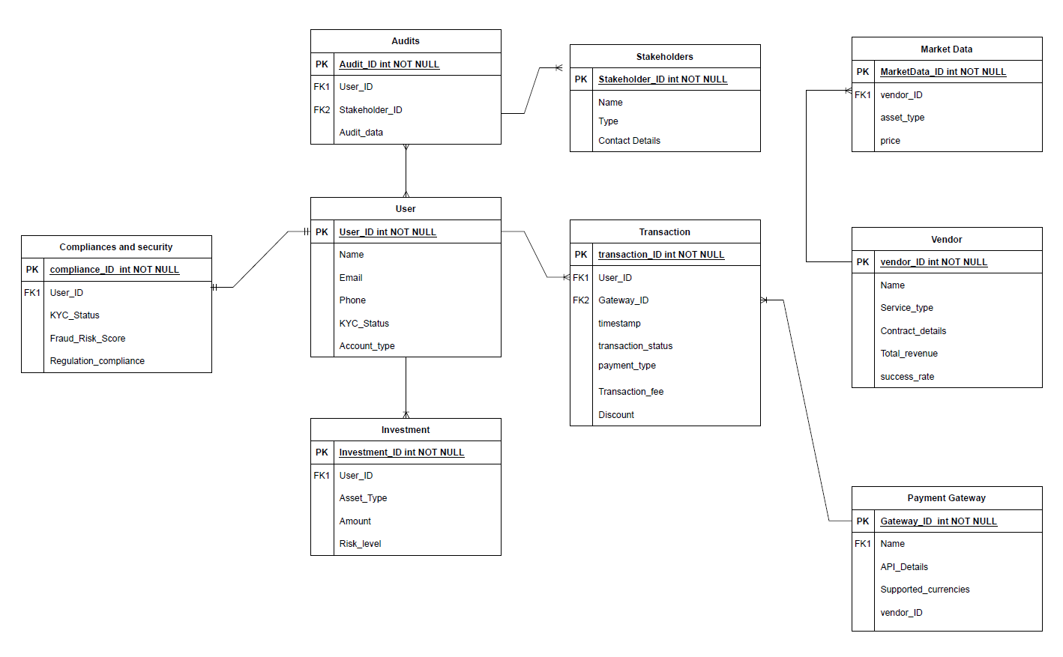

ER Diagram