**—Submission—**

**\*\*\*\*Capstone-Project Reference Links and Screenshots\*\*\*\***

## **## Links:**

**Github URL:** [**https://github.com/Dhiraj-Shivade/devops-build.git**](https://github.com/Dhiraj-Shivade/devops-build.git)

**DockerHub URL:** [**https://hub.docker.com/repositories/dhirajshivade**](https://hub.docker.com/repositories/dhirajshivade)

**React-app URL:** [**http://3.108.95.24:80**](http://3.108.95.24:80)

**##Screenshots:**

**#Docker Images:**

Dev Repo - **dhirajshivade/dev:my-react-app-v1 (container ID-33ada7f559d6)**

Prod Repo - **dhirajshivade/prod:my-react-app-v1 (container ID-e0ff855121f2)**

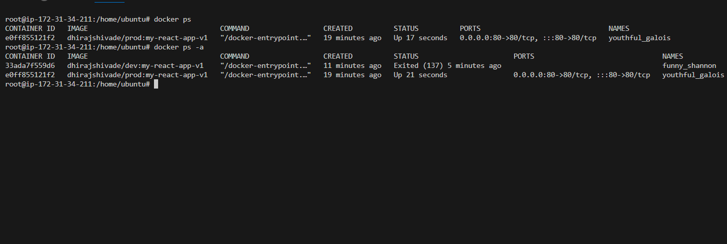

**#Dockerhub repo:**

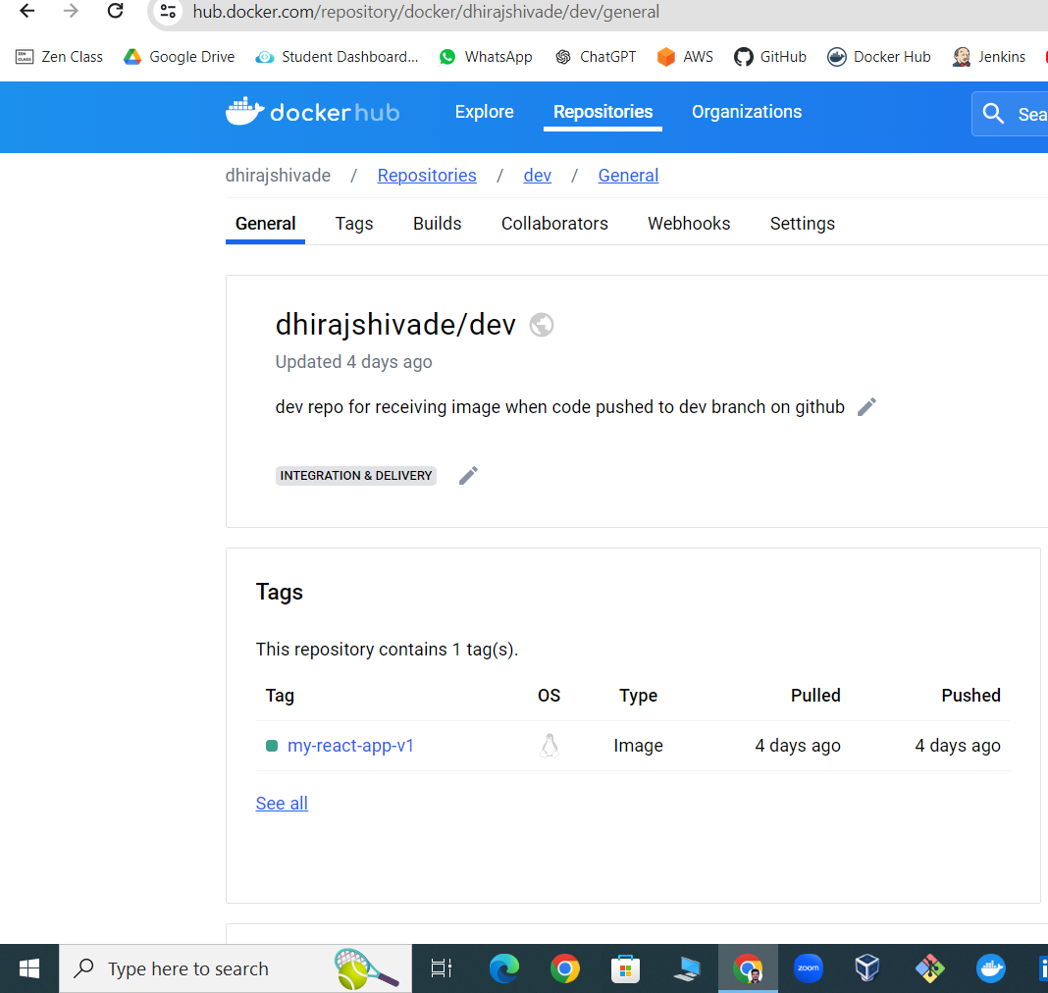

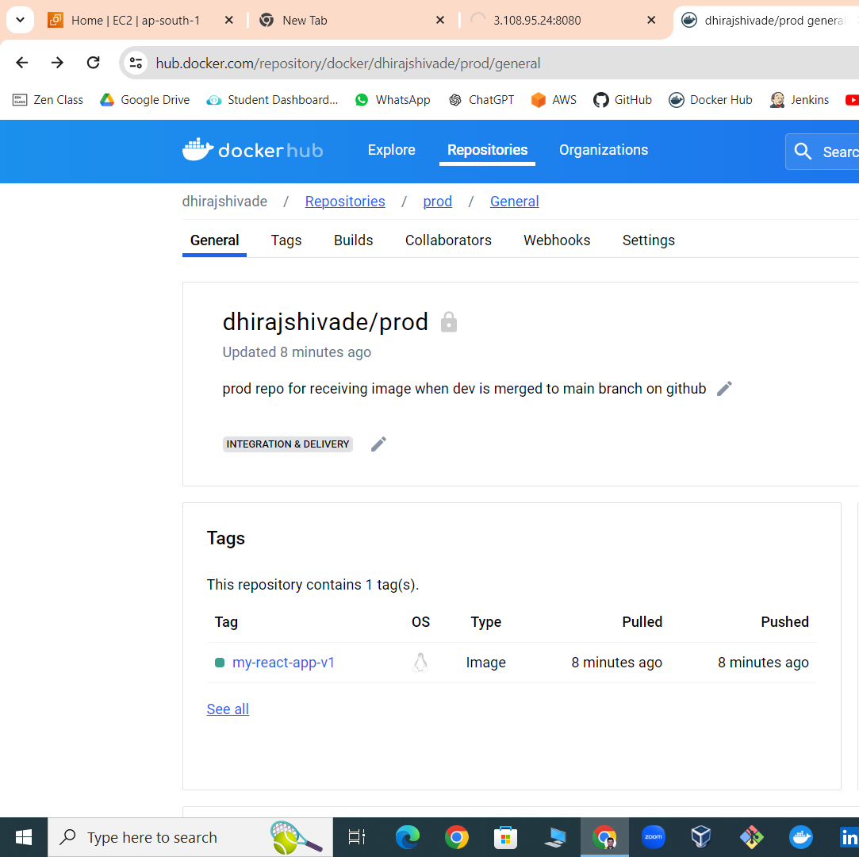

**# Github Webhook Integration -**

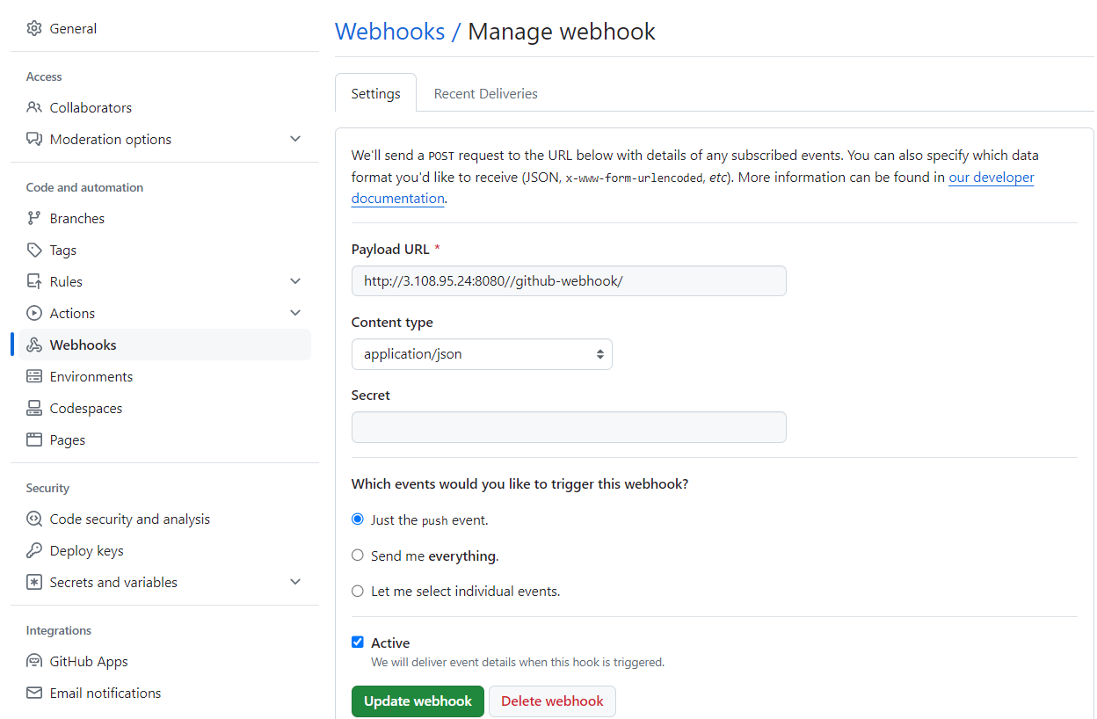

**#Jenkins (Port 8080)**

1. **Login page-**

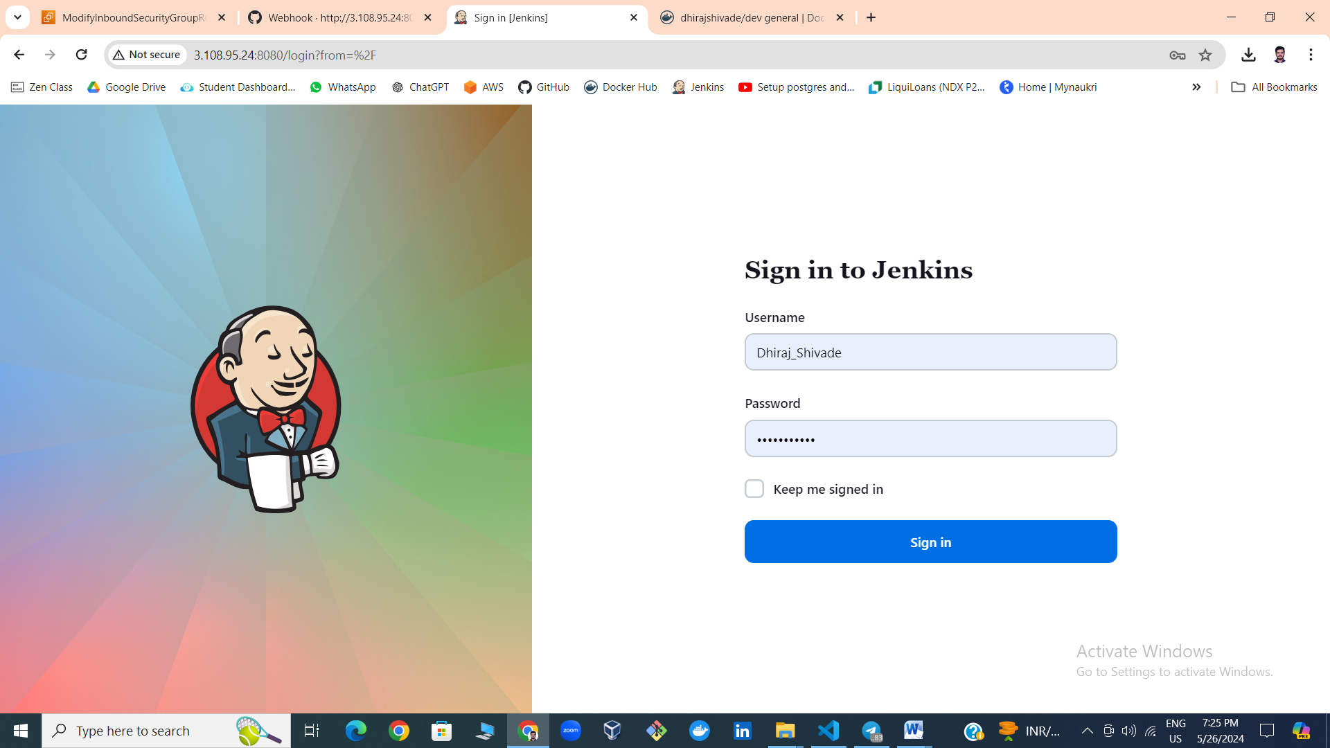

1. **Jenkins Credentials passed as secret text and defined as Env. Variables-**

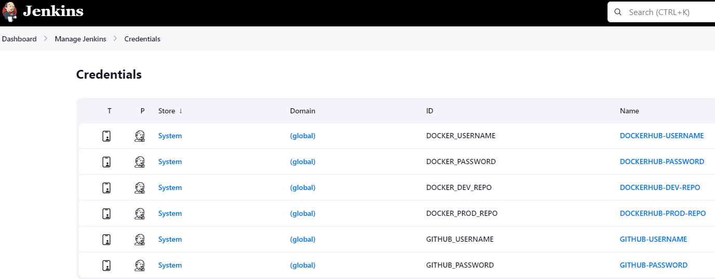

**3) Pre-Build script for build.sh in job configure-**

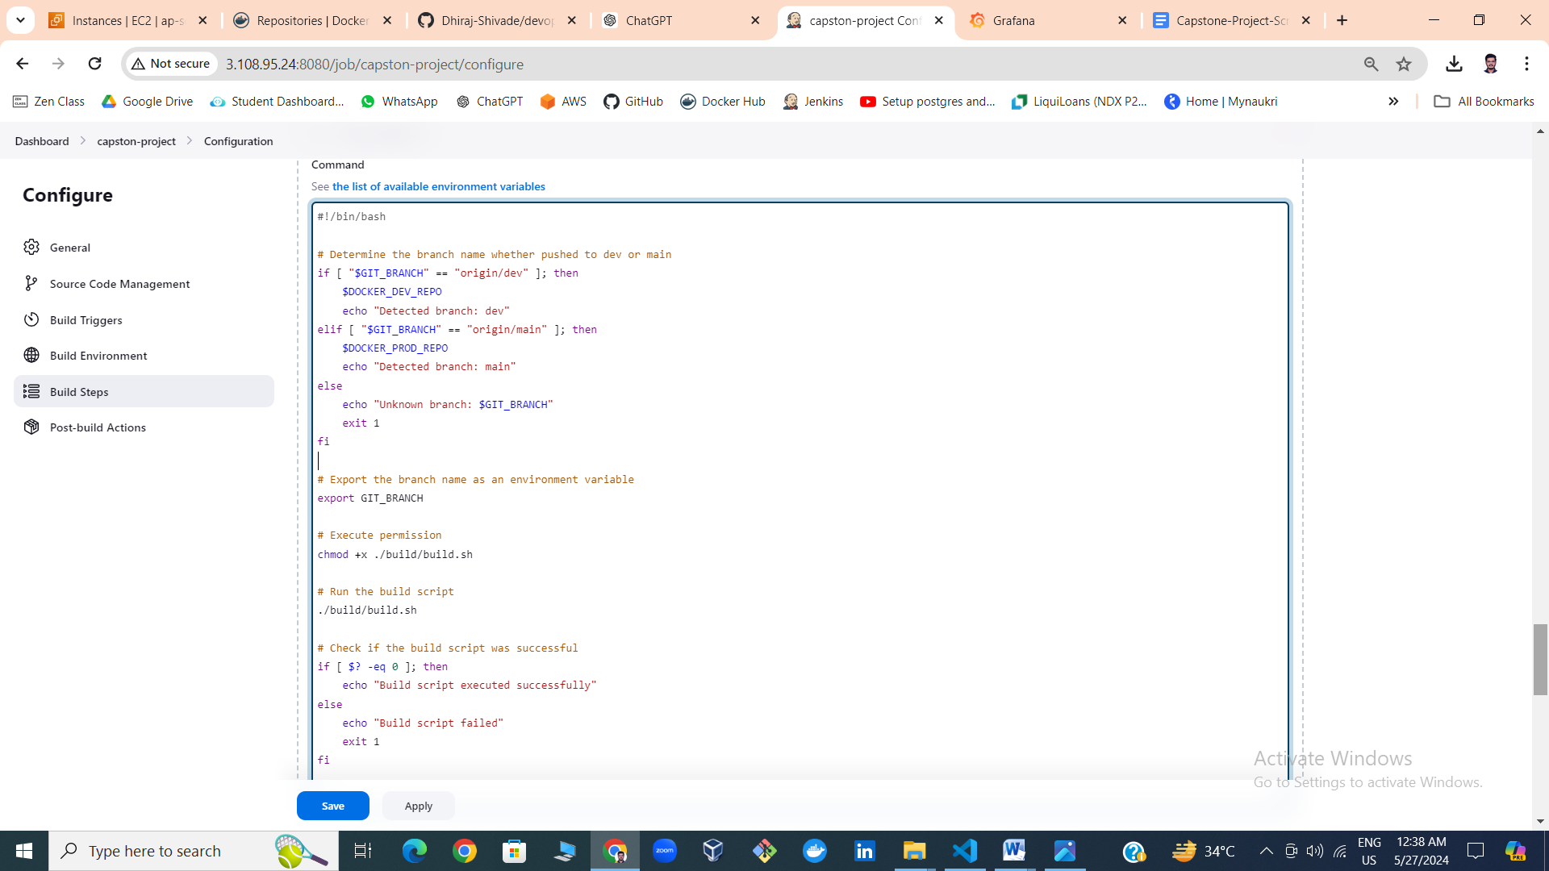

1. **build.sh -**

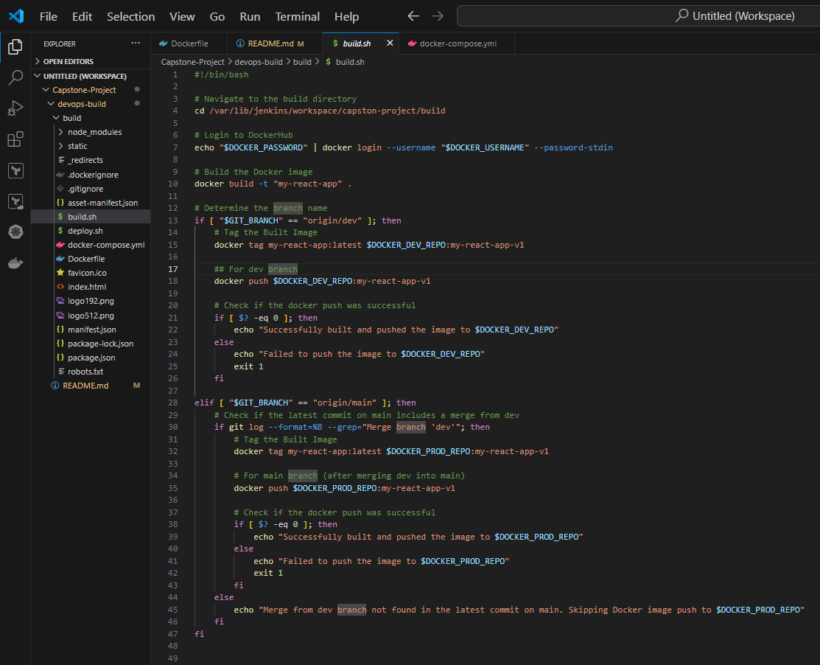

1. **Pre-build step for deploy.sh in job configure-**

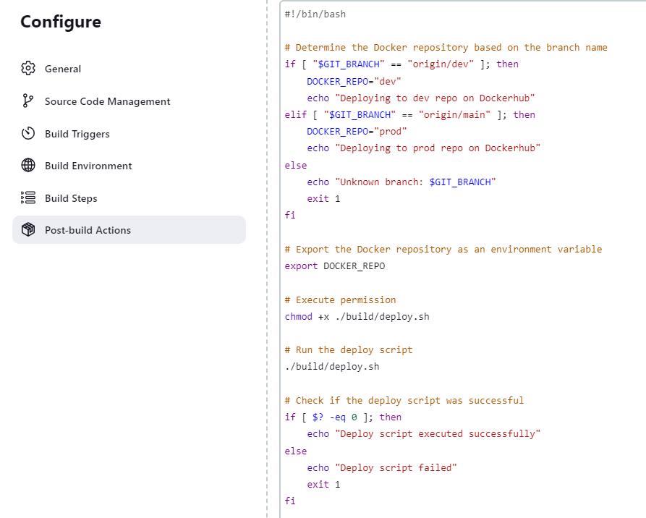

1. **deploy.sh -**

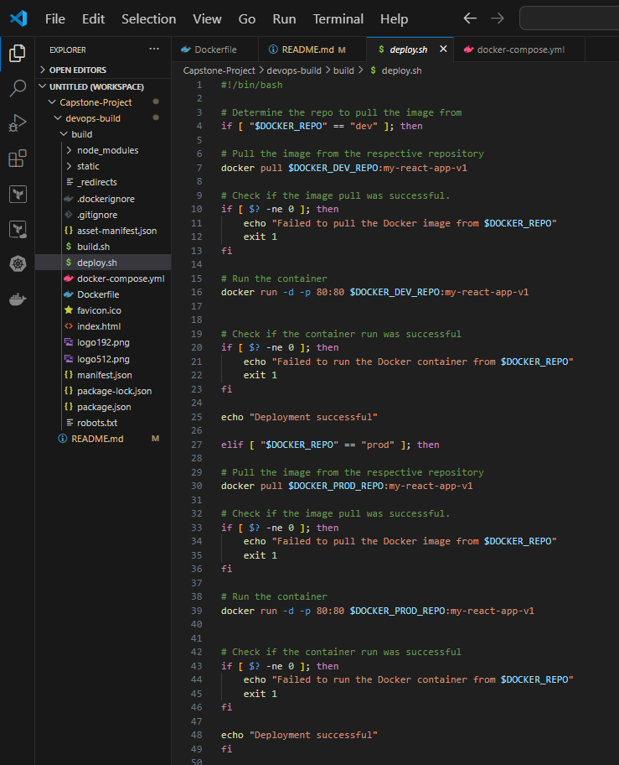

**6) Jenkins Project (Home) -**

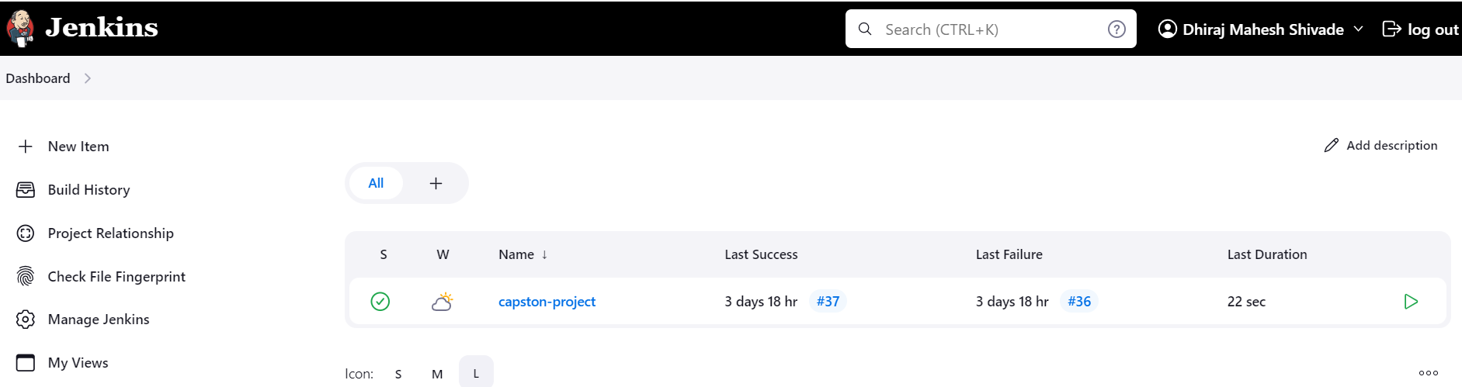

**7) GitSCM polling config and Github server config -**

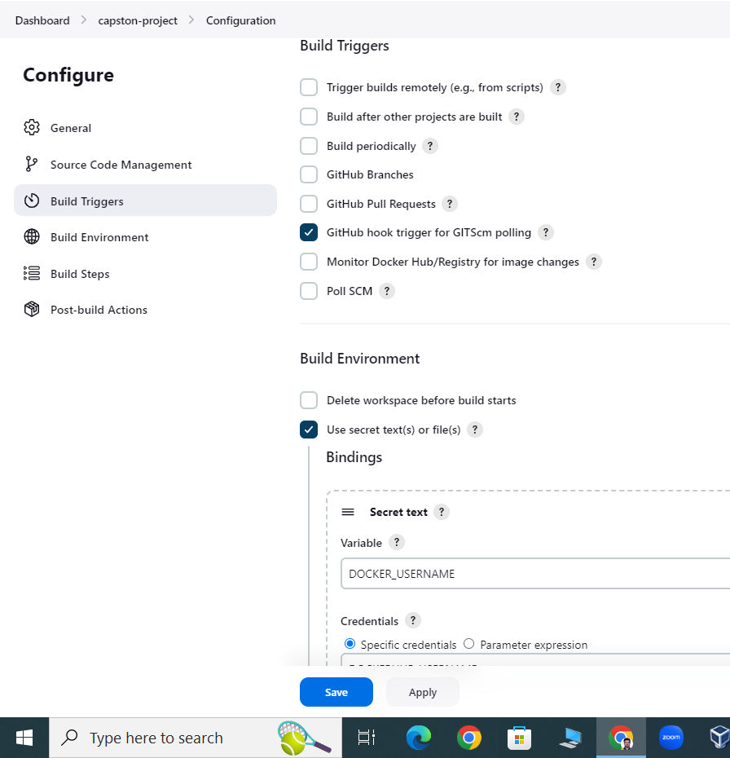

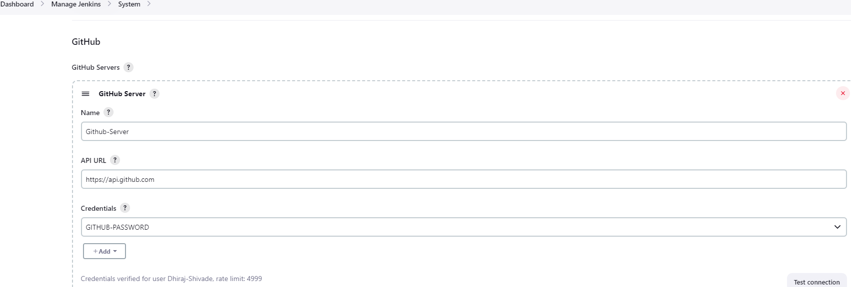

**#AWS:**

1. **EC2 Instance-**

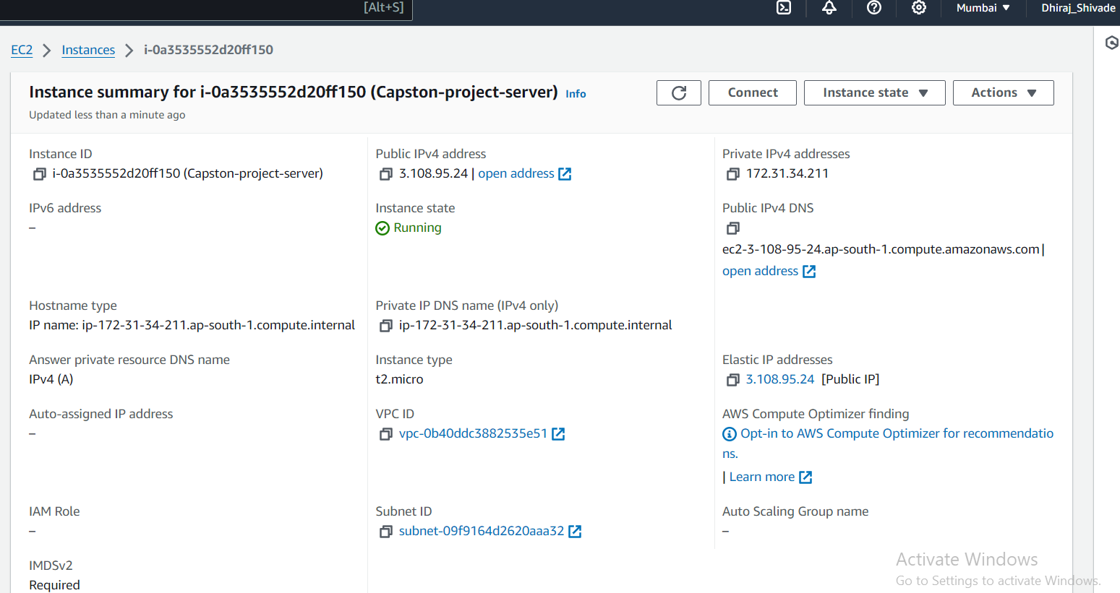

1. **Security Group -**

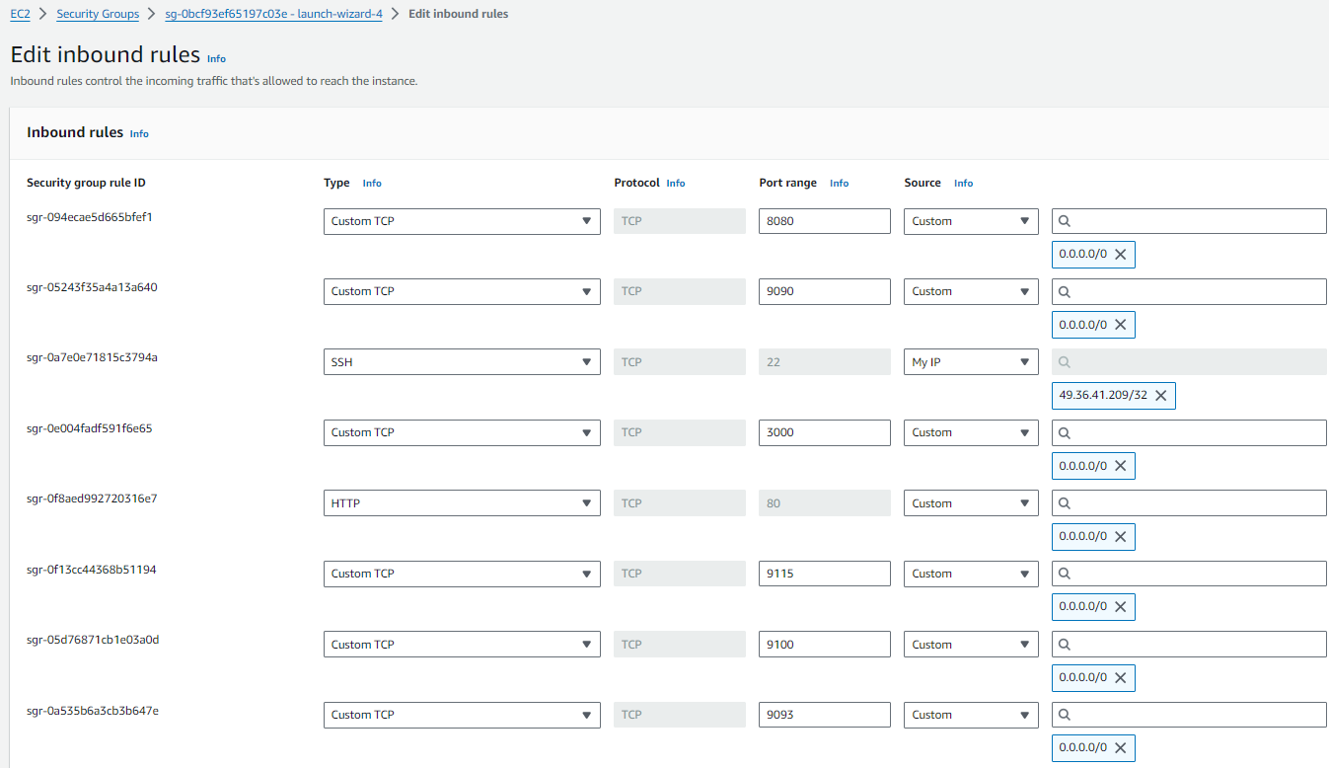

**# Deployed Application running in docker container on ec2 (Port 80)**

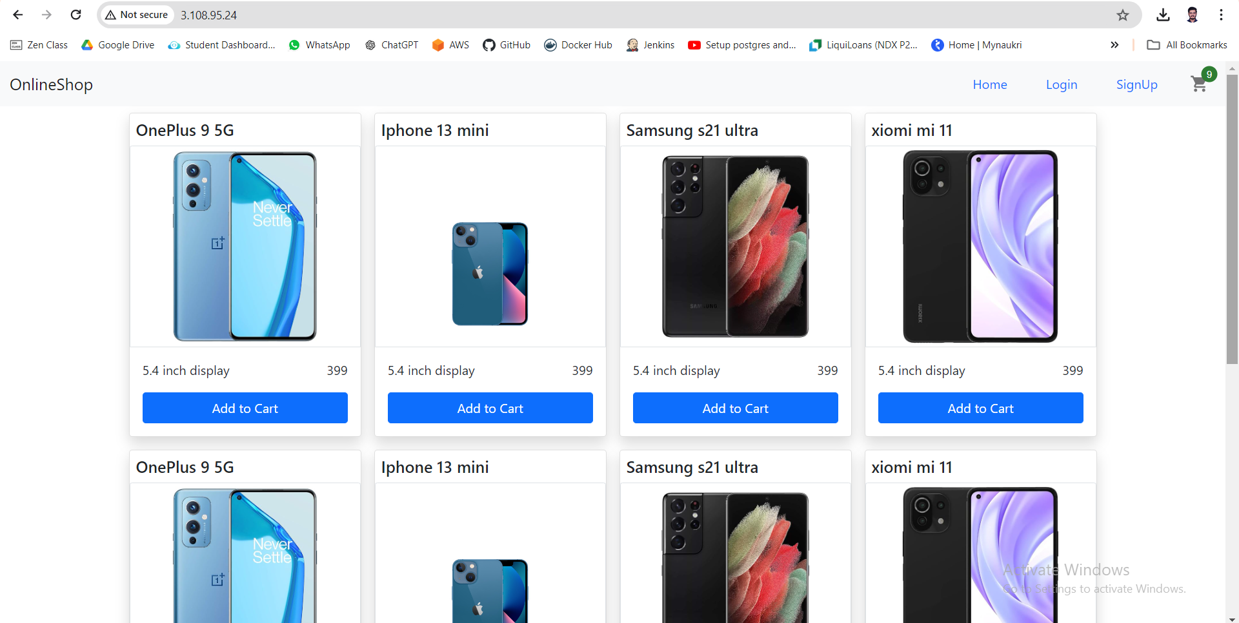

**# Monitoring :**

**Prometheus with targets to scrape metrics from instance and react-app (Port - 9090)**

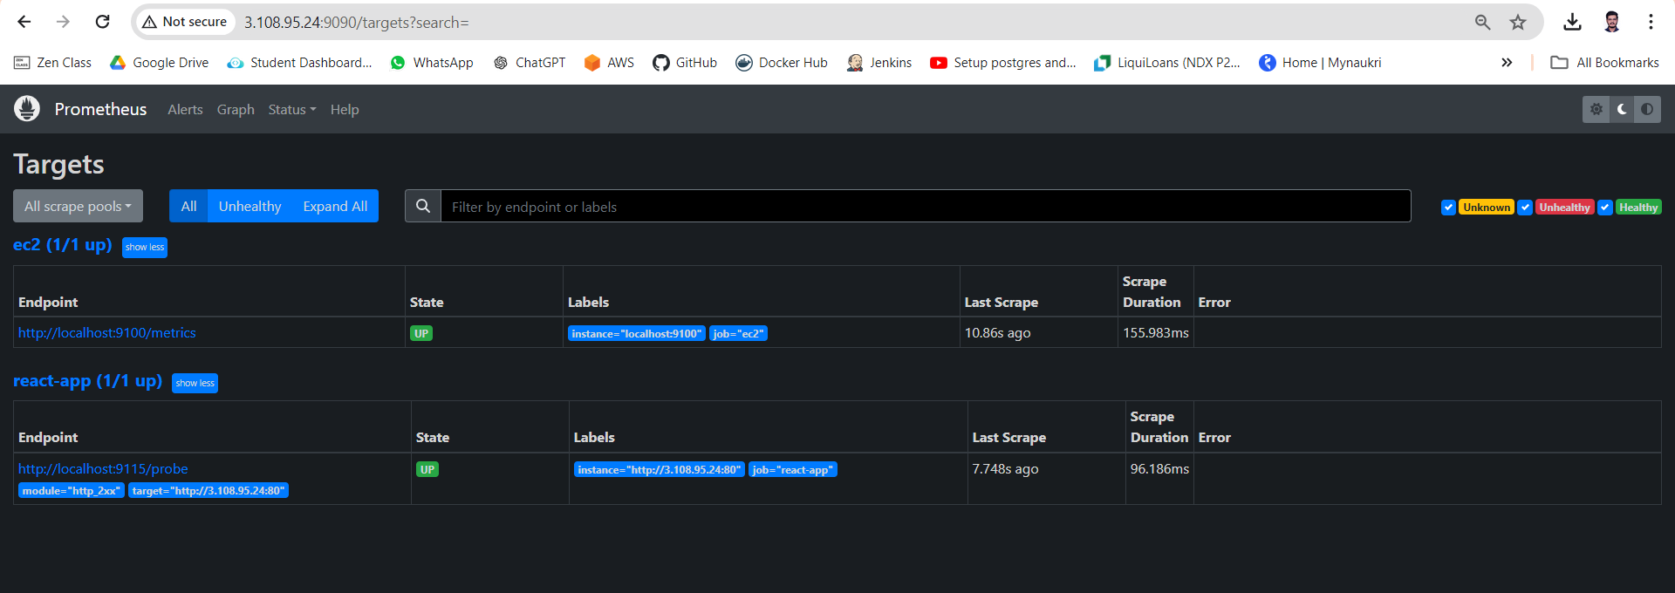

**# Blackbox_Exporter (Port- 9115) collects metrics for running app with the help of http status codes**

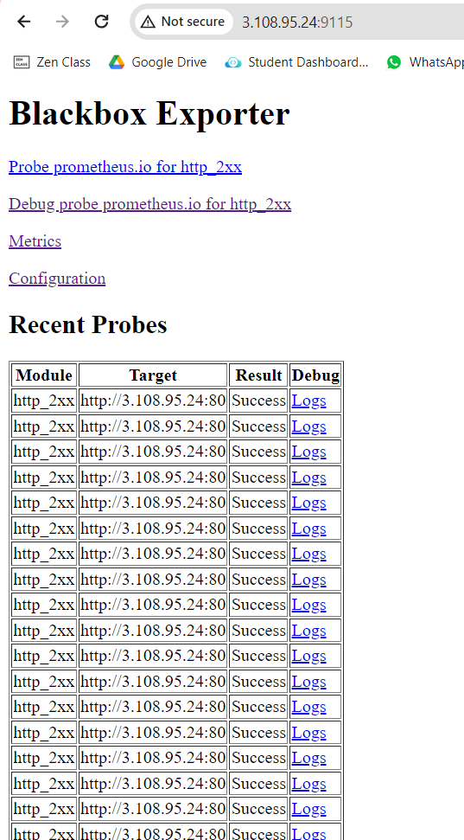

**# Node_Exporter (Port- 9100) collects metrics for running instance(node) with the health status -**

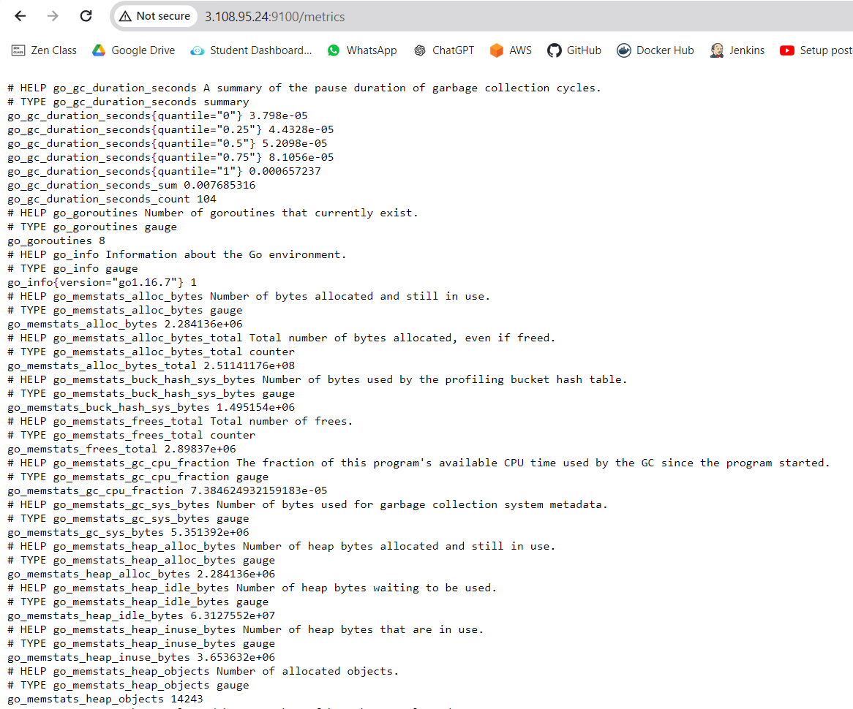

**# Alertmanager (Port 9093) showing alert when i stopped container -**

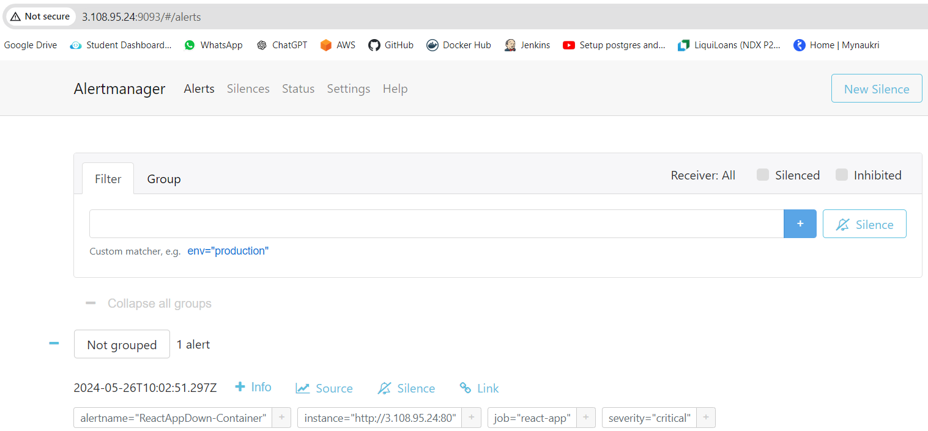

**# Alert email (SNS Notification) for App goes Down (when Container stopped- blackbox_exporter)**

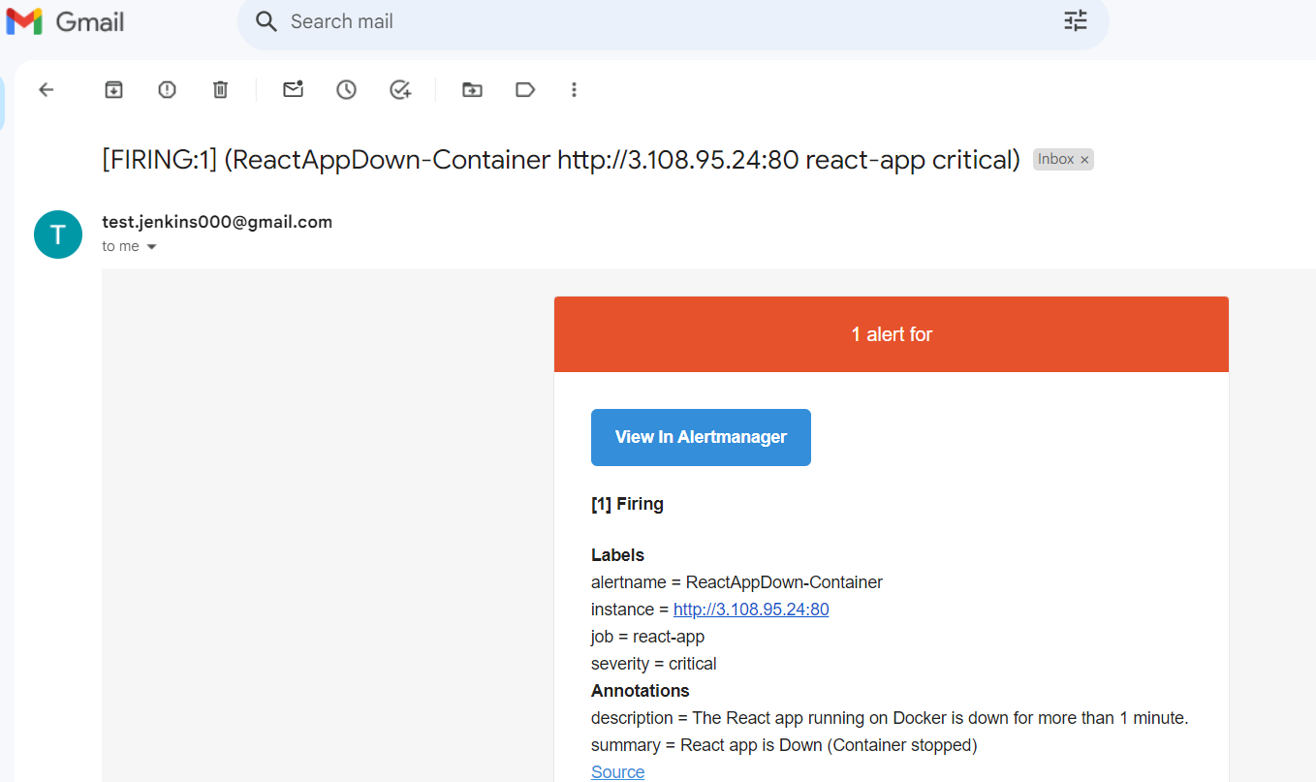

**## Alert email (SNS Notification) for App goes Down (when ec2 stopped- node_exporter)**

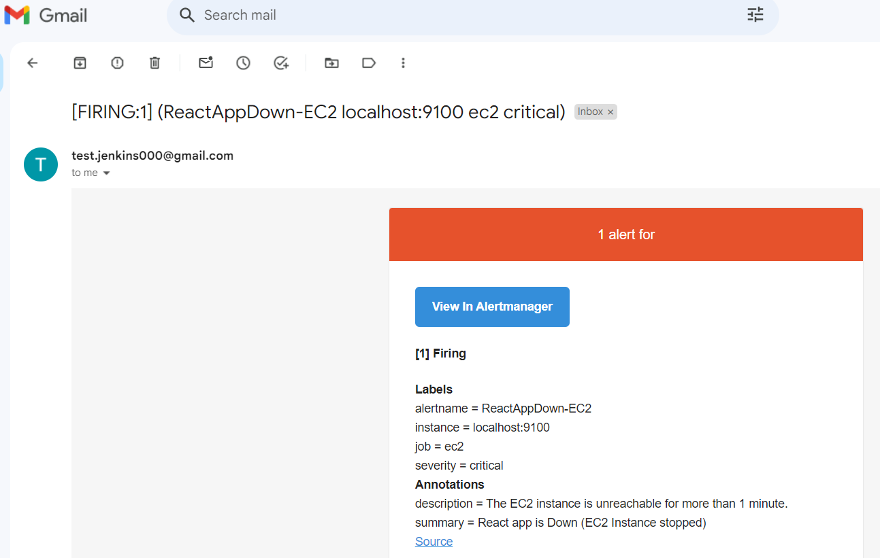

**# Grafana ( Metrics Visualization and Monitoring) (Port - 3000) -**

