Electronic Journal

(Front-end step by step development guide)

Preface

“Write few sentence about the project”. This project has been developed in Angular 6 with Angular-Material (CSS framework). Angular is JavaScript framework that makes application development quicker and easier to maintain than if you did everything by hand. In this project we have used NVD3 for showing graph visualization. This document helps to understand how the project has been developed with step by step guide.

Prerequisites:

* Nodejs version 8.0 and above should be installed on the system.
* npm.
* Angular-CLI should be installed on the system.
* Visual Studio (Not mandatory but very helpful)
* Basic knowledge of HTML, CSS and Typescript.

Create Electronic Journal project

|  |
| --- |
| ng new electronic-journal |

The above command will create a skeleton of angular application.

Here’s what the app structure looks like:

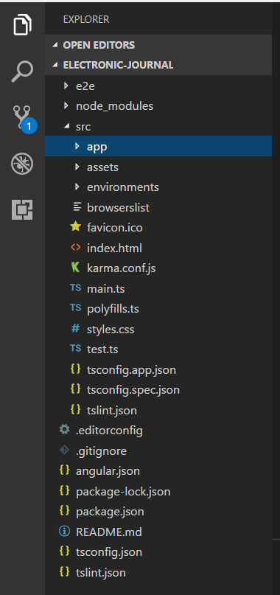

We would need NVD3 and d3 dependencies to for graph Visualization. We will open the terminal and run following commands to add the dependencies:

|  |
| --- |
| npm install [d3@3.5.7](mailto:d3@3.5.7) --save |

|  |
| --- |
| npm install nvd3 –save |

Install Angular Material:

|  |
| --- |
| npm install --save @angular/material @angular/cdk @angular/animations |

To run the application we will run the below command:

|  |
| --- |
| ng serve |

The app will run on <http://localhost:4200/>.

All is well☺!

ng serve command launches the server, watches your files, and rebuilds the app as you make change to those files.

To make project maintainable we have separated the pages, reusable components, services, pipes, routing and etc in separate folder. Snippet attached below:

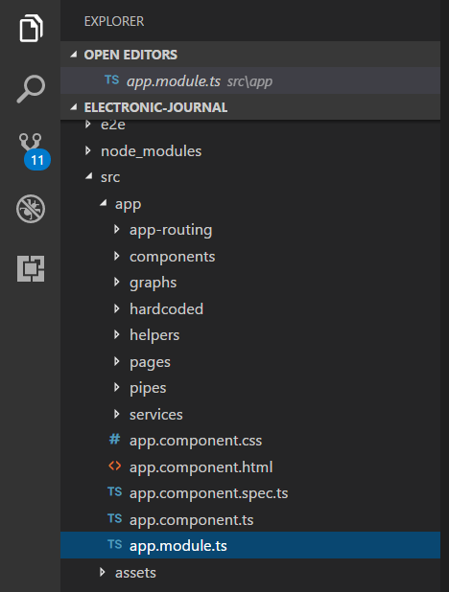

In our project we have several reusable components, such as navbar which is elaborated below.

Navbar Component:

**navbar.component.html**

|  |
| --- |
| <mat-toolbar id="main-navbar" fxLayout="row" fxLayoutAlign="space-between center">  <span class="site-title">Electronic Journal</span>  <mat-icon>search</mat-icon>  </mat-toolbar> |

<mat-toolbar> is an Angular material component which is provided to create the Header of the application.

The snippet of our header is attached below.



Note: In order to use each component of Angular Material we have to include its module dependency in our app module. Snippet attached below for reference.

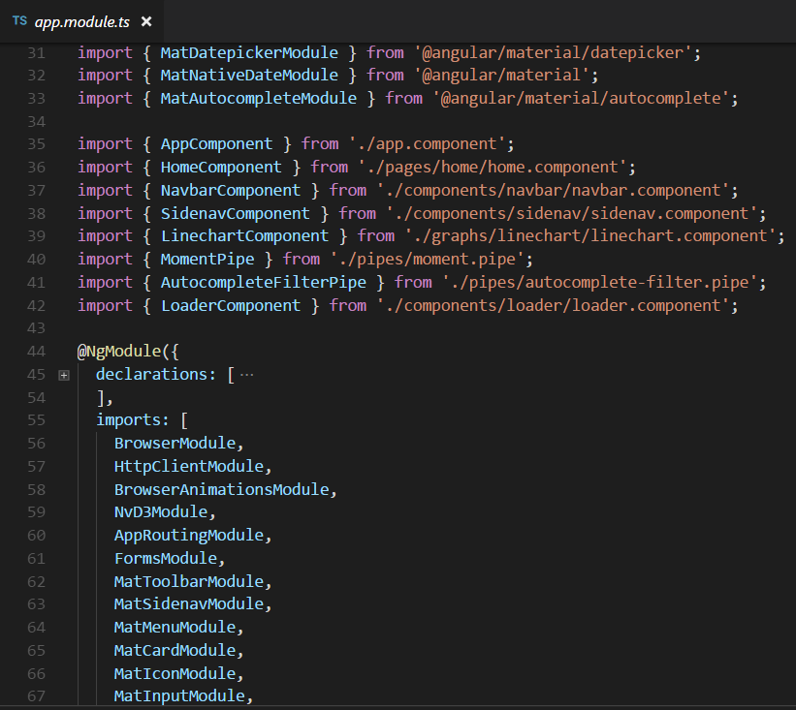

Crate a graph using nvd3

Nvd3 is an open source project, which provides reusable charts based on the D3 data visualization library.

Few good points about NVD3:

* Responsive – Charts created using NVD3 will be rendered differently depending on size of the screen and orientation.
* Dynamic – Charts can be refreshed easily when data changes.

In our home component we have created a line graph using nvd3.

**home.component.ts**

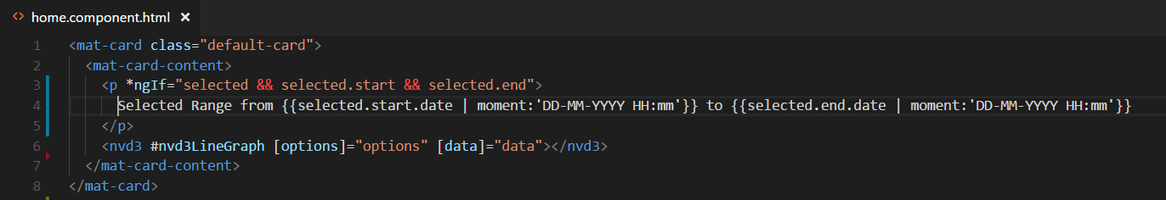

<nvd3> tag is nvd3 component which takes two input properties options and data. In option we passes all the configuration related to graph and in data input property, we assign the data for which graph will be drawn.

In option properties, there are few important configuration such as:

* type: This is one of the most vital property. Here we assign what graph should be render on the data.
* x and y: This property needs to be configured based on our input data.
* Height: It sets the height of the graph irrespective of parent’s height.
* xAxis: This is an object inside which there are so many property such as:
  + axisLabel which is text shown on the x axis.
  + rotateLabels: Here we assign angle on which text needs to be rotated.

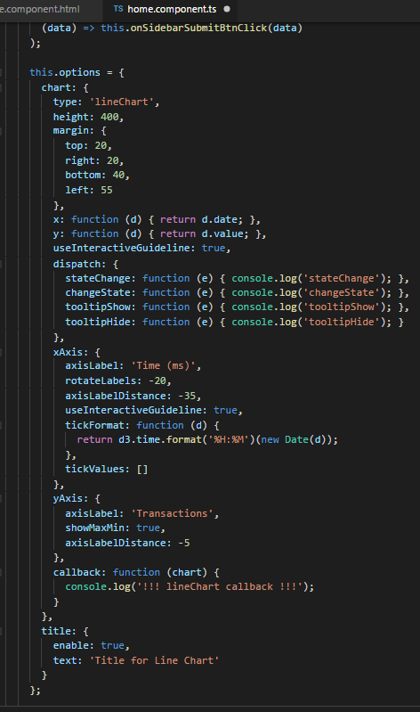

The data set:

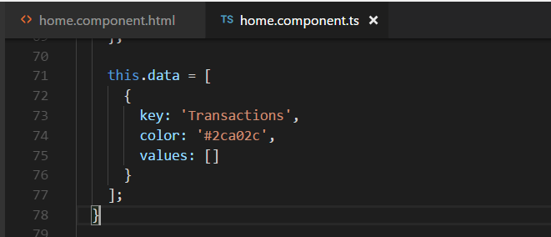

In data we assign key, color and values. Key is the text which will be shown on the line graph when mouse hovers. Color property is being used to set the color of the line. In “Values” we assign our data which consist x and y coordinate to draw the line.

After configuring option and data our graph will be render screenshot attached below:

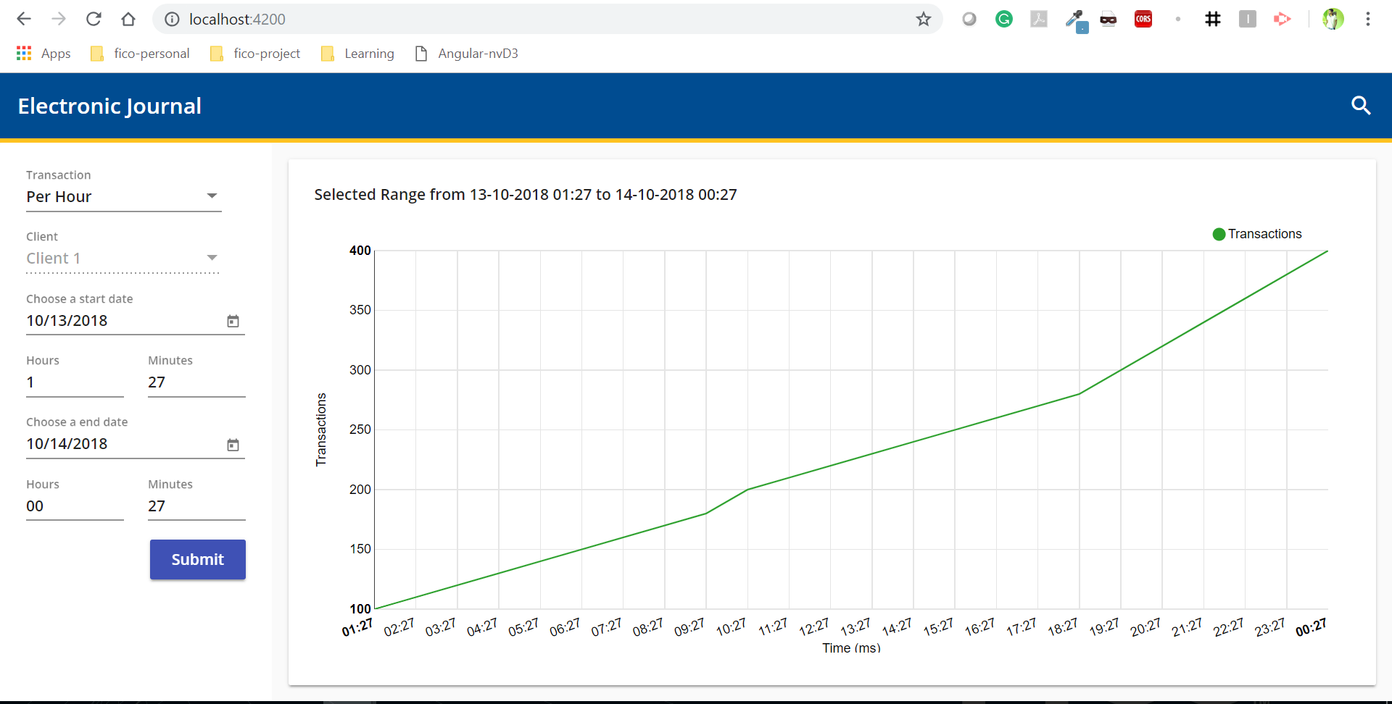

Thank you!