

**Project Title: HealthcareManagement_System**

**Team Members:**

- Dhiraj. N [Leader]

- Muthulakshmi.  J [Back end]

- Haridharshana. M. U [Front end]

-Geetha. A[Data scientist]

-Abinaya. P[Data scientist]

**Abstract:**

The healthcare system is a critical component of any society, playing a pivotal role in the well-being of its citizens. In recent years, the global healthcare landscape has witnessed significant changes, driven by advances in technology, shifting demographics, and the evolving needs of patients.Enhancing Healthcare with AI-Driven Disease Segmentation. Healthcare providers, like Apollo Hospitals Enterprise Limited, are leveraging machine learning operations (MLOps) to segment patients based on their disease conditions and illness severity. Business users can upload diverse training data, select features via a user interface, preview test data, and benefit from AI-driven explanations for model outcomes. Visual data analysis simplifies result interpretation. This initiative enhances patient care, resource allocation, and healthcare efficiency, bridging the gap between data science and operations.

**Project Overview:**

The project focuses on leveraging machine learning for disease segmentation in healthcare. It aims to enable healthcare providers to understand patients' disease conditions, track disease progression, and enhance patient care. The project will develop a machine learning model that can be trained and tested with diverse datasets. Business users will have a user-friendly interface for uploading data, selecting features, and accessing explanatory AI functionality. Visual data analysis will simplify the interpretation of model outcomes. The project's core objectives are to improve patient care and streamline healthcare operations.

**Technologies Used:**

• Programming Language: Python

• Machine Learning Libraries: Scikit-Learn, mlxtend, missingno

**Data Collection and Preprocessing:**

The dataset (diabetes_df) is collected from opensource. The initial exploration involves checking the dataset's structure, information, and summary statistics. Missing values in columns like Glucose, BloodPressure, SkinThickness, Insulin, and BMI are replaced with NaN. The data is visualized using histograms and a correlation heatmap. Standard scaling is applied to certain features. The dataset is split into features (X) and the target variable (y), and a train-test split is performed.

**Model Architecture:**

The model architecture includes the use of RandomForestClassifier and DecisionTreeClassifier from Scikit-Learn for the prediction task. RandomForest is an ensemble model that combines multiple decision trees. The code utilizes mlxtend for plotting decision regions. The data is preprocessed using StandardScale.

**Training Process:**

• RandomForestClassifier:

• Number of estimators: 200

• Training data is fit to the model using rfc.fit(X_train, y_train)

• DecisionTreeClassifier:

• The model is initialized with dtree = DecisionTreeClassifier()

• Training data is fit to the model using dtree.fit(X_train, y_train)

**Evaluation Metrics:**

• RandomForestClassifier:

• Training set accuracy is evaluated using metrics.accuracy_score(y_train, rfc_train)

• Test set accuracy is evaluated using metrics.accuracy_score(y_test, predictions)

• DecisionTreeClassifier:

• Test set accuracy is evaluated using metrics.accuracy_score(y_test, predictions)

• Additional evaluation metrics include confusion matrix and classification report.

**Results and Discussion:**

The healthcare management app allows the user give input based on their symptoms of illness and the AI model predicts and says whether the person have disease or not and it will also help doctors to analyse the progress of the patients health conditions.

**Deployment:**

We deploy the app using flask and streamlit.

Deepsphere.AI

**Instructions for Running the Project:**

1. Installing required packages such as numpy, pandas, scikit learn.
2. Obtain the needed dataset.
3. By using random forest and decision tree algorithm train the dataset.
4. Then test the dataset to know the accuracy of the model.
5. Develop the UI part the app and connect it with the backend using flask.

**Code Snippets:**

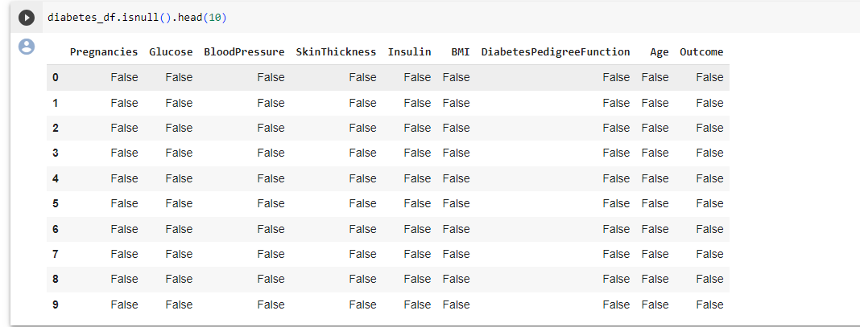

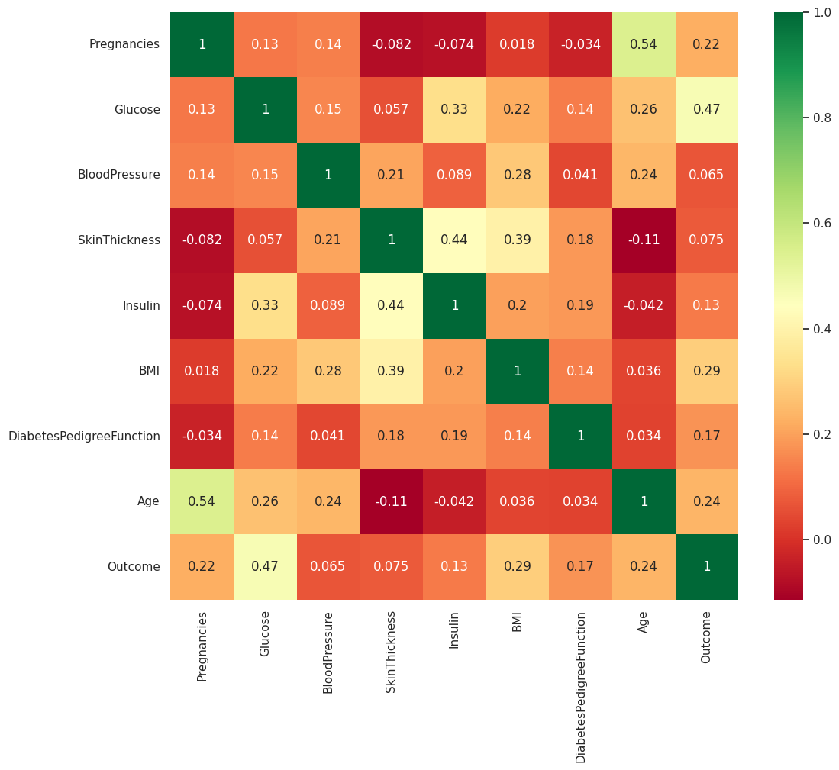

**Conclusion:**

The project is poised to revolutionize the way healthcare organizations use AI and machine learning to improve patient care and streamline operations, ultimately leading to better patient outcomes and more efficient healthcare management. It serves as a bridge between healthcare professionals and advanced technology, offering a comprehensive solution to address the ever-evolving challenges in the healthcare industry.

**References:**

W3 Schools,Kaggle

https://bmcmedinformdecismak.biomedcentral.com/articles/10.1186/s12911-021-01488-9

© DeepSphere.AI | Confidential and Proprietary | Not for Distribution 2