Shenyang Aerospace University

Project Design Report

Project Category：Java Programming Language
Project Title：The Title of your project

College: College of Computer Science
Major: Computer Science and Technology
Class: 1751520107
Student ID: 175152010702
Student Name: 丁荣
Supervisor: Yiping Teng(滕一平)
Date:

Contents
Problem Specification 1
Program Design 1
Sample Execution 3
Analysis and Conclusions 5
References 5
Feedback 5
Appendix A: Source Code 6

Problem Specification
Write a course selection information management program for your class. The information includes student ID, Student name, Course ID, Course name. The program has the following capabilities:
- Login the system with username and password.
- Add a new course selection information.
- Delete someone’s course selection information.
- Modify someone’s course selection information.
- Display course selection information.
- Search a specified student information using student name or ID as the keyword.

Program Design
Design requirements
- Implement the project with Object Oriented Programming.
- Design a friendly GUI for information management.
- Check the data validity when entering student’s information.
Write the project report in accordance with the specification of course design report
(1) Class listing
List the class name and purpose of all the classes designed in the program.
For example,
Design Document: StudentInfoManagement
NO. | Class | Purpose
1 | Javaproject | The top-level control object manages other objects in the program. The class is the program running entry. It creates the DisplayFrame object
2 | Loginframe | User logins the system with username and password
3 | Login 1 | Manages the username and password
4 | Displayframe | Contains the main features of the program.
5 | AddFrame | Implement the function of adding a new student’s information
6 | Subject | Selection of course
(2) Class Diagram
A class diagram shows class structure, contents, and the static relationships among the classes used to model a system. These relationships are known as associations and are drawn as lines connecting the related graph nodes. Each node in a class diagram is labeled with its class name. The class node may also contain lists of data attributes and method prototypes(optional).
For example,
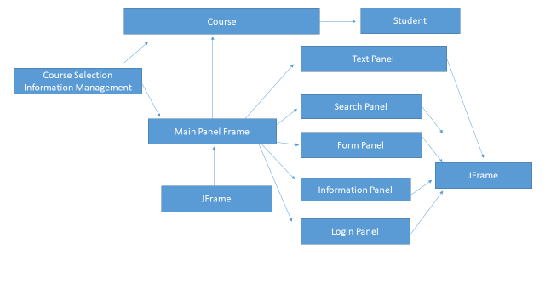
Figure 1 The Sample of Class Diagram
There are two simple relationships in our class diagram: dependency relationship and inheritance relationship.

a. Dependency relationship
Dependency relationship is creation or usage relationship between classes. we draw a dashed edge to illustrate the dependency relationship between classes. For example, StudentInfoMain class creates an object of CourseSelection. So there is a dashed edge between two classes with the arrowhead pointing to CourseSelection.

b. Inheritance relationship
Inheritance relationships are indicated using an open triangle to point to the appropriate super class. For example, JFrame class is the super class of MainFrame class. So there is a directed edge between them using an open triangle to point to the JFrame class
(3)The design documents of each class in the program
For example, the design documents of the CourseSelection Class include the data member listing and the method listing shown as follows:

Table 1 The data member listing of the CourseSelection class
Data member | Visibility | Purpose
Course ID | private | Store the course id
CourseName | private | Store the course name
LocalDate | private | Get the local date

Table 2 The method listing of the CourseSelection class
Method | Visibility | Purpose
getcourseid | public | Return the value of course id
getCourseName | public | Return the coursename
getlocaldate | public | Return the localdate
delete | public | Delete the index element in the studentList.
getstudentid | public | Return the value of studentid

Sample Execution
(1)Application Login Window
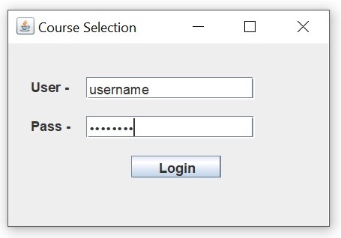
Figure 2 Login Window
(2) Application Main Interface
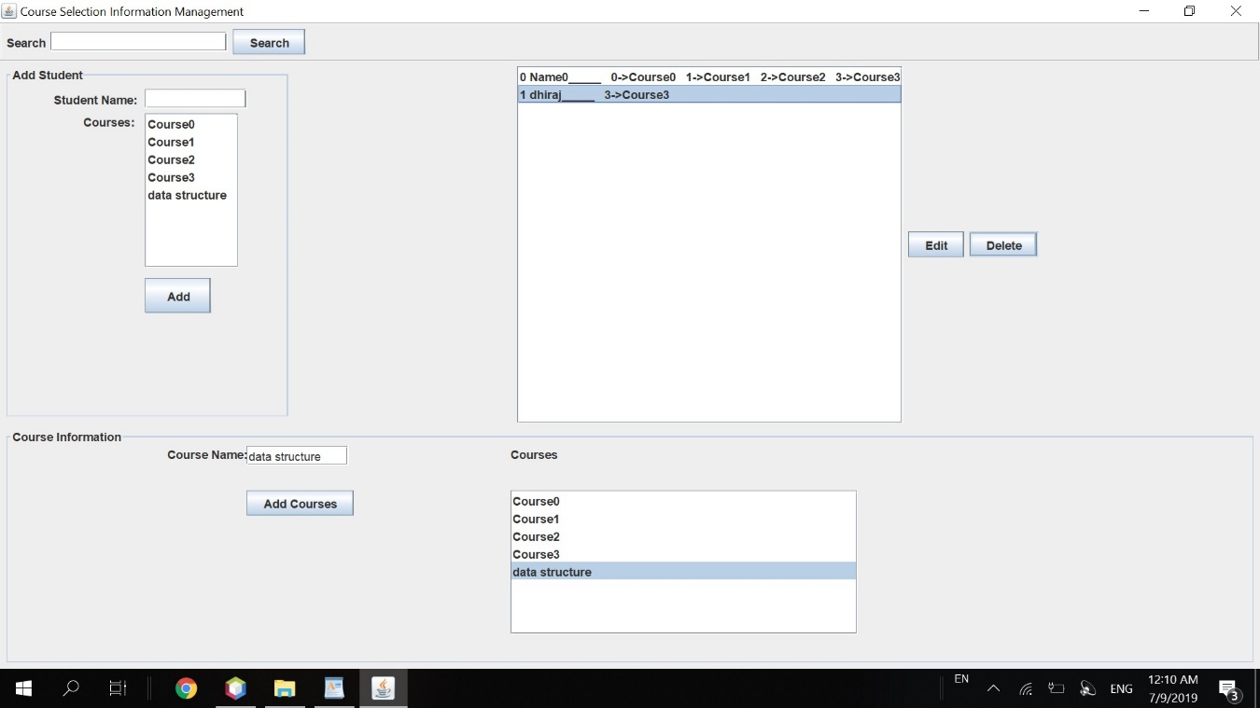

Figure 3 Application Main Window

Analysis and Conclusions
• What were the goals or objectives of the project?
The goals of the project were to create a course management system that allows the
User to login to the system, add a course, delete a course, modify a course and display all the courses.

• Did you achieve these goals? Give specifics on how each was accomplished.
Yes the goals were achieved. The goal of logging in was done by putting the username and password in the code and making sure that the system can only be accessed by the saved data. The goal of adding a course was accomplished by creating a class (Subject) that allows the user to enter the information and ensure
that it is stored. The goal of delete goal was to remove an unwanted course from the system.

• Looking back on the project what would you do differently in the design phase and in the coding and testing phases?
In the design phase, I would have added a “Create User” feature to allow multiple users to access the system. In the coding, I would have incorporated switch case feature where there were multiple if-else in a single module or part of a feature.

• What additions would you suggest to improve the working of your program?
I would add a database to store the data of the courses so that the next time the system is used, the data does not have to be re-entered.

References
1- Google search engine
2- Effective Java book
[4] https://www.youtube.com/channel/UCS3W5vFugqi6QcsoAIHcMpw/videos 1Bestcsharp blog

Feedback
- Was it too difficult, or too easy?
- It was a bit difficult
- Was the assignment fun or challenging?
- It was both fun and challenging.
- Was there something that was unclear?
- Everything was clear
- Was the project too long for the given amount of time?
- I hardly made it through the given timeline, it was challenging for me to get it done in three weeks.

Appendix A: Source Code
Course :
public class Course {
private int courseId;
private String courseName;

public int getCourseId() {
return courseId;
}

public String getCourseName() {
return courseName;
}

public Course(int courseId, String courseName) {
this.courseId = courseId;
this.courseName = courseName;
}

@Override
public String toString() {
return courseName + "\n";
}
}

Course Selection Information Management:
import javax.swing.*;

public class CourseSelectionInfromationManagement {

public static void main(String[] args){
SwingUtilities.invokeLater(new Runnable() {
@Override
public void run() {
new Login();
}
});
}
}
Delete Listner:
public interface DeleteListner {
void onDeleteClicked(int index);
}

EditListener:
public interface EditListener {
void onEditClicked(int index);
}

FormPanel:
import javax.swing.*;
import javax.swing.border.Border;
import java.awt.*;
import java.awt.event.ActionEvent;
import java.awt.event.ActionListener;
import java.util.ArrayList;
import java.util.List;

public class FormPanel extends JPanel {

private static final String FORM_TITLE = "Add Student";

private JLabel studentNameLabel;
private JTextField studentNameField;
private JButton addStudentButton;
private JButton editStudentButton;
private JList<Course> courseJList;
private JLabel coursesLabel;
private List<Course> courses;
private List<Student> students;
private DefaultListModel<Course> courseDefaultListModel;
private StudentListener studentListener;
private int editIndex;

public FormPanel(List<Student> students, List<Course> courses) {
Dimension dim = getPreferredSize();
dim.width = 300;
setPreferredSize(dim);

studentNameLabel = new JLabel("Student Name:");
coursesLabel = new JLabel("Courses: ");
studentNameField = new JTextField(10);
addStudentButton = new JButton("Add");
editStudentButton = new JButton("Edit");
editStudentButton.setVisible(false);

courseJList = new JList<>();
courseJList.setSelectionMode(ListSelectionModel.MULTIPLE_INTERVAL_SELECTION);
this.courses = courses;
this.students = students;

addStudentButton.addActionListener(actionEvent -> {
if (!(studentNameField.getText().isEmpty() || courseJList.getSelectedValuesList().isEmpty())) {
String studentName = studentNameField.getText();
List<Course> courseList = courseJList.getSelectedValuesList();
Student student = new Student(students.size(), studentName, courseList);
studentListener.onStudentAdd(student);
setAddPanel();
}
else{
JOptionPane.showMessageDialog(this, "Empty Field");
}
});

editStudentButton.addActionListener(actionEvent -> {
if (!(studentNameField.getText().isEmpty() || courseJList.getSelectedValuesList().isEmpty())) {
String studentName = studentNameField.getText();
List<Course> courseList = courseJList.getSelectedValuesList();
Student student = new Student(editIndex, studentName, courseList);
studentListener.onStudentEdit(editIndex, student);
setAddPanel();
}
else {
JOptionPane.showMessageDialog(this, "Empty Field");
}
});

// Set up jList.
courseDefaultListModel = new DefaultListModel<>();
courseDefaultListModel.addAll(courses);
courseJList.setModel(courseDefaultListModel);

setLayout(new GridBagLayout());
setGrid();

Border innerBorder = BorderFactory.createTitledBorder(FORM_TITLE);
Border outerBorder = BorderFactory.createEmptyBorder(5, 5, 5, 5);

setBorder(BorderFactory.createCompoundBorder(outerBorder, innerBorder));

}

public void setStudentListener(StudentListener studentListener) {
this.studentListener = studentListener;
}

private void setGrid() {

GridBagConstraints gc = new GridBagConstraints();

//////// First Row /////////
gc.weightx = 1;
gc.weighty = 0.1;

gc.gridx = 0;
gc.gridy = 0;
gc.insets = new Insets(0, 8, 0, 0);
gc.anchor = GridBagConstraints.LINE_END;
gc.fill = GridBagConstraints.NONE;
add(studentNameLabel, gc);

gc.gridx = 1;
gc.gridy = 0;
gc.anchor = GridBagConstraints.LINE_START;
add(studentNameField, gc);

//////// Next Row /////////
gc.gridx = 0;
gc.gridy = 1;
gc.insets = new Insets(0, 8, 0, 0);
gc.anchor = GridBagConstraints.FIRST_LINE_END;
add(coursesLabel, gc);

gc.gridx = 1;
gc.gridy = 1;
gc.anchor = GridBagConstraints.FIRST_LINE_START;
gc.ipadx = 10;
gc.ipady = 10;
add(new JScrollPane(courseJList), gc);

//////// Next Row /////////
gc.gridy = 2;
gc.weightx = 0;
gc.weighty = 1.0;
add(addStudentButton, gc);

gc.gridy = 2;
gc.weightx = 0;
gc.weighty = 1.0;
add(editStudentButton, gc);
}

public void courseChanged(Course course) {
this.courses.add(course);
courseDefaultListModel.addElement(course);
}

public void setEditPanel(int index) {
studentNameField.setText(students.get(index).getStudentName());
List<Integer> selectedIndices = new ArrayList<>();
for (Course course : students.get(index).getCourses()) {
selectedIndices.add(course.getCourseId());
}
int[] selected = new int[selectedIndices.size()];
for (int i=0; i < selected.length; i++)
{
selected[i] = selectedIndices.get(i);
}
courseJList.setSelectedIndices(selected);
editIndex = index;
addStudentButton.setVisible(false);
editStudentButton.setVisible(true);
}

public void setAddPanel() {
studentNameField.setText("");
courseJList.clearSelection();
editStudentButton.setVisible(false);
addStudentButton.setVisible(true);
}
}

InformationListener:
import java.util.List;

public interface InformationListener {
void setInformationChangedListener(Course course);
}

Information Panel:
import javax.swing.*;
import javax.swing.border.Border;
import java.awt.*;
import java.awt.event.ActionEvent;
import java.awt.event.ActionListener;
import java.util.ArrayList;
import java.util.List;

public class InformationPanel extends JPanel {

private static final String INFORMATION_TITLE = "Course Information";
private static final String INFORMATION_TABLE_TITLE = "Courses";

private JLabel courseNameLabel, courseTableLabel;
private JTextField courseNameField;
private JButton addCourseButton;
private JList<Course> courseJList;
private List<Course> courses;
private DefaultListModel<Course> courseDefaultListModel;
private InformationListener informationListener;

public InformationPanel(List<Course> courses){
Dimension dimension = getPreferredSize();
dimension.height = 250;
setPreferredSize(dimension);

courseNameField = new JTextField(10);
courseNameLabel = new JLabel("Course Name:");
addCourseButton = new JButton("Add Courses");
this.courses = courses;

courseTableLabel = new JLabel(INFORMATION_TABLE_TITLE);
courseJList = new JList<>();
courseJList.setFixedCellWidth(350);

courseDefaultListModel= new DefaultListModel<>();
courseDefaultListModel.addAll(courses);
courseJList.setModel(courseDefaultListModel);

addCourseButton.addActionListener(actionEvent -> {
if(!courseNameField.getText().isEmpty()){
Course course = new Course(courses.size(), courseNameField.getText());
addCourse(course);
informationListener.setInformationChangedListener(course);
}
});

Border innerBorder = BorderFactory.createTitledBorder(INFORMATION_TITLE);
Border outerBorder = BorderFactory.createEmptyBorder(5, 5, 5, 5);

setLayout(new GridBagLayout());

setGrid();

setBorder(BorderFactory.createCompoundBorder(outerBorder, innerBorder));
}

private void addCourse(Course course) {
courseDefaultListModel.addElement(course);
}

public void setInformationListener(InformationListener informationListener){
this.informationListener = informationListener;
}

private void setGrid() {
GridBagConstraints gc = new GridBagConstraints();

//////// First Row /////////
gc.weightx = 0.4;
gc.weighty = 1;
gc.gridx = 0;
gc.gridy = 0;
gc.anchor = GridBagConstraints.FIRST_LINE_END;
add(courseNameLabel, gc);

gc.gridx = 1;
gc.gridy = 0;
gc.anchor = GridBagConstraints.FIRST_LINE_START;
add(courseNameField, gc);

//////// Next Row /////////
gc.gridx = 1;
gc.gridy = 1;
gc.anchor = GridBagConstraints.FIRST_LINE_START;
add(addCourseButton, gc);

//////// Right column //////
gc.weightx = 1;
gc.weighty = 1;
gc.gridx = 2;
gc.gridy = 0;
add(courseTableLabel, gc);

gc.gridx = 2;
gc.gridy = 1;
gc.anchor = GridBagConstraints.FIRST_LINE_START;
add(new JScrollPane(courseJList), gc);
}
}

Main Frame:
import javax.swing.*;
import java.awt.*;
import java.util.ArrayList;
import java.util.List;

public class MainFrame extends JFrame {

private TextPanel textPanel;
private SearchPanel searchPanel;
private FormPanel formPanel;
private InformationPanel informationPanel;
private List<Course> courses;
private List<Student> students;

public MainFrame() {
super("Course Selection Information Management");

setLayout(new BorderLayout());

courses = new ArrayList<>();
courses.add(new Course(0, "Course0"));
courses.add(new Course(1, "Course1"));
courses.add(new Course(2, "Course2"));
courses.add(new Course(3, "Course3"));

students = new ArrayList<>();
List<Course> temp_course = new ArrayList<>();
temp_course.addAll(courses);
students.add(new Student(0, "Name0", temp_course));

textPanel = new TextPanel(students);
searchPanel = new SearchPanel();
formPanel = new FormPanel(students, courses);
informationPanel = new InformationPanel(courses);

add(formPanel, BorderLayout.WEST);
add(textPanel, BorderLayout.CENTER);
add(searchPanel, BorderLayout.NORTH);
add(informationPanel, BorderLayout.SOUTH);

informationPanel.setInformationListener(course -> {
formPanel.courseChanged(course);
});

formPanel.setStudentListener(new StudentListener() {
@Override
public void onStudentAdd(Student student) {
students.add(student);
textPanel.displayStudents(student);
}

@Override
public void onStudentEdit(int index, Student student) {
students.remove(index);
students.add(index, student);
textPanel.refreshList(students);
}
});

textPanel.setEditListener(index -> formPanel.setEditPanel(index));

textPanel.setDeleteListner(index -> {
students.remove(index);
textPanel.refreshList(students);
formPanel.setAddPanel();
});

searchPanel.setSearchListener(text -> {
int resultIndex = 0;
for(Student student: students){
if(student.getStudentName().equals(text) ||
((text.matches("\\d") && student.getStudentID() == Integer.parseInt(text)))){
textPanel.showResult(resultIndex);
break;
}
resultIndex ++;
}

});

setSize(1000, 700);
setLocation(50, 50);
setDefaultCloseOperation(JFrame.EXIT_ON_CLOSE);
setVisible(true);

}
}

Search Listener:
public interface SearchListener {
void onSearchClicked(String text);
}

Search Panel:
import javax.swing.*;
import javax.swing.border.Border;
import java.awt.*;
import java.awt.event.ActionEvent;
import java.awt.event.ActionListener;

public class SearchPanel extends JPanel {

private JTextField searchField;
private JLabel searchLabel;
private JButton searchButton;
private SearchListener searchListener;

public SearchPanel() {

Dimension dim = getPreferredSize();
dim.height = 40;
setPreferredSize(dim);
setBorder(BorderFactory.createEtchedBorder());

searchButton = new JButton("Search");
searchField = new JTextField();
Dimension textAreaDimension = searchField.getPreferredSize();
textAreaDimension.width = 180;
searchField.setPreferredSize(textAreaDimension);

searchButton.addActionListener(actionEvent -> {
if(!(searchField.getText().isEmpty())){
searchListener.onSearchClicked(searchField.getText());
}
});

searchLabel = new JLabel("Search");

add(searchLabel);
add(searchField);
add(searchButton);
setLayout(new FlowLayout(FlowLayout.LEFT));
}

public void setSearchListener(SearchListener searchListener) {
this.searchListener = searchListener;
}
}

Student:
import java.util.List;

public class Student {
private int studentID;
private String studentName;
private List<Course> courses;

public Student(int studentID, String studentName, List<Course> courses) {
this.studentID = studentID;
this.studentName = studentName;
this.courses = courses;
}

public String getStudentName() {
return studentName;
}

public int getStudentID() {
return studentID;
}

public List<Course> getCourses() {
return courses;
}

@Override
public String toString() {

StringBuilder stringBuilder = new StringBuilder();
stringBuilder.append(studentID);
stringBuilder.append(" ");
stringBuilder.append(studentName);
stringBuilder.append("_____");
for (Course course : courses) {
stringBuilder.append(" ");
stringBuilder.append(course.getCourseId());
stringBuilder.append("->");
stringBuilder.append(course.getCourseName());
}

return stringBuilder.toString();
}
}

StudentListener:
public interface StudentListener {
void onStudentAdd(Student student);

void onStudentEdit(int index, Student student);
}

Text Panel:
import javax.swing.*;
import java.awt.*;
import java.awt.event.ActionEvent;
import java.awt.event.ActionListener;
import java.util.List;

public class TextPanel extends JPanel {

private JButton editButton, deleteButton;
private List<Student> students;
private JList<Student> studentJList;
private DefaultListModel<Student> defaultListModel;

private EditListener editListener;
private DeleteListner deleteListner;

public TextPanel(List<Student> students) {

editButton = new JButton("Edit");
deleteButton = new JButton("Delete");

editButton.addActionListener(actionEvent -> {
if(!(studentJList.getSelectedValue() == null)){
editListener.onEditClicked(studentJList.getSelectedIndex());
}
});

deleteButton.addActionListener(actionEvent -> {
if(!(studentJList.getSelectedValue() == null)){
deleteListner.onDeleteClicked(studentJList.getSelectedIndex());
}
});

this.students = students;
studentJList = new JList<>();
defaultListModel = new DefaultListModel<>();
defaultListModel.addAll(students);
studentJList.setModel(defaultListModel);

studentJList.setVisibleRowCount(20);

setLayout(new FlowLayout(FlowLayout.CENTER));
add(new JScrollPane(studentJList));
add(editButton);
add(deleteButton);

}

public void setDeleteListner(DeleteListner deleteListner) {
this.deleteListner = deleteListner;
}

public void setEditListener(EditListener editListener) {
this.editListener = editListener;
}

public void displayStudents(Student student) {
defaultListModel.addElement(student);
}

public void refreshList(List<Student> students){
defaultListModel.removeAllElements();
this.students = students;
defaultListModel.addAll(this.students);
}

public void showResult(int result) {
studentJList.setSelectedIndex(result);
}
}

