Experiment No – 2
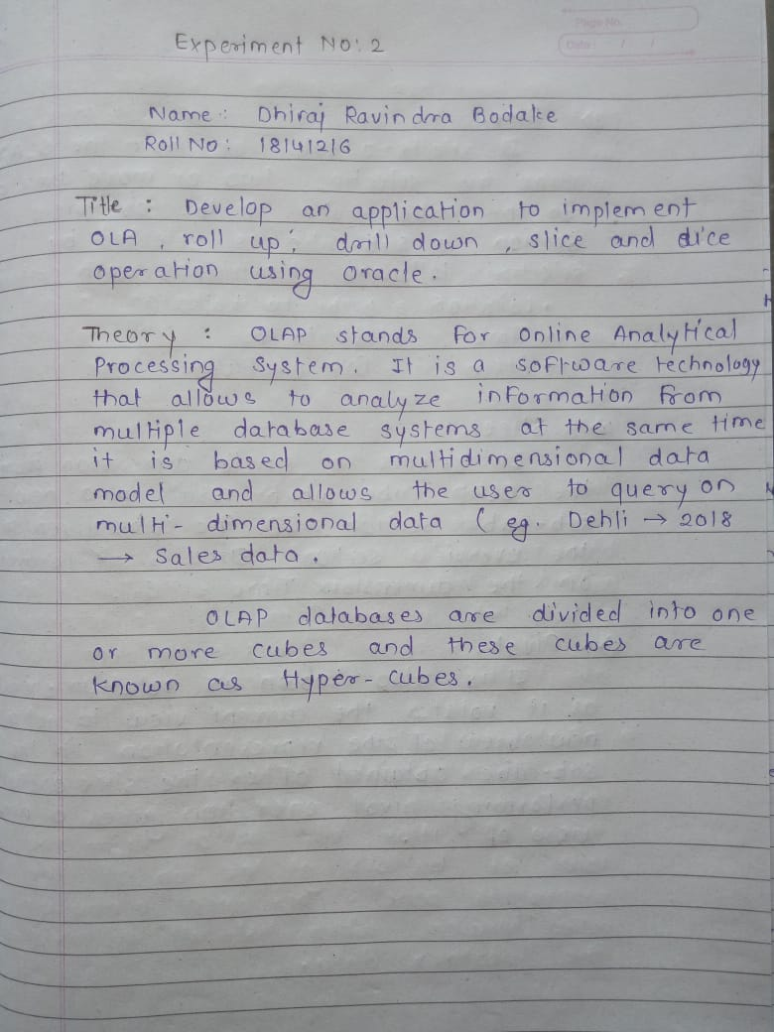


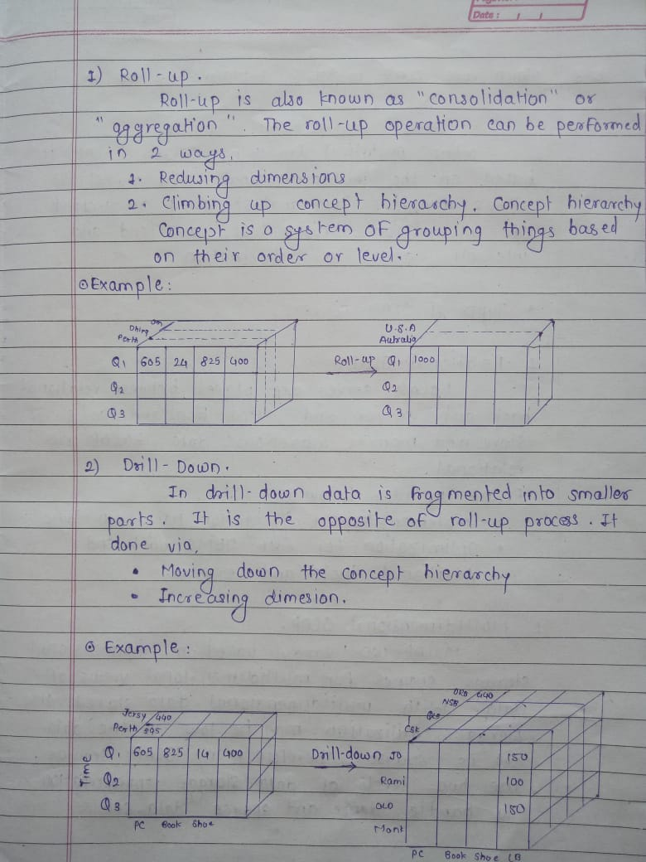

Drill down -
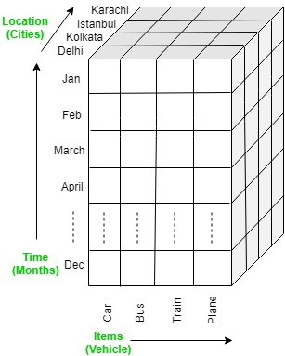

Drill down –

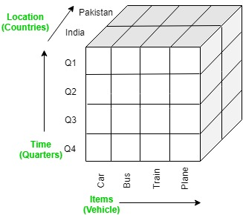


Dice –

Slice –


Pivot –


Practical –

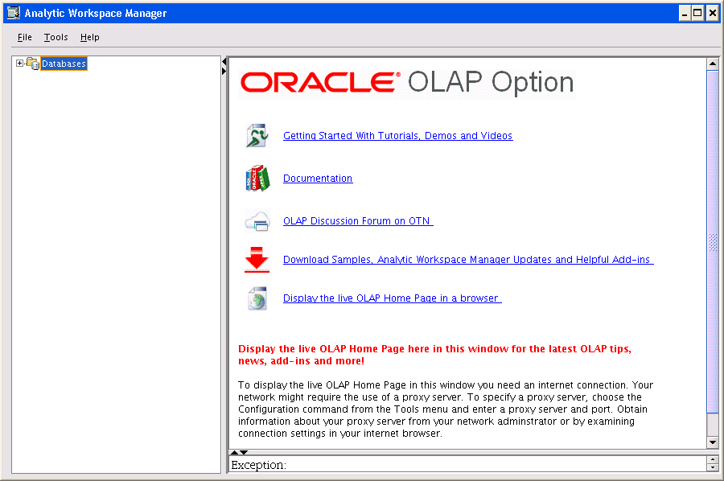

Defining a Database Connection:
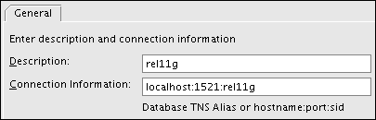

Opening a Database Connection
To connect to a database:
- Click the plus icon (+) next to a database connection in the navigation tree.
- Supply your database user name and password in the Connect to Database dialog box.

Installing Plugins
Plugins extend the functionality of Analytic Workspace Manager. Plugins are distributed as JAR files. Any Java developer can create a plugin. The developer should provide information about what the plugin does and how to use it.
If you have one or more plugins, then you must identify their location to Analytic Workspace Manager.
To use plugins:
- Create a local directory for storing the plugins.
- Copy the JAR files to that directory.
- Open Analytic Workspace Manager.
- Choose Configuration from the Tools menu.
The Configuration dialog box opens.
- Select Enable Plugins and identify the plugin directory. Click OK.
- Close and reopen Analytic Workspace Manager.
The functionality provided by the plugins is available in the navigator.

Conclusion:
Thus we successfully installed and performed OLPA operations on oracle.

