Experiment No 3

Title: Develop an Application to construct a multidimensional data using Oracle.
Theory:
For constructing multidimensional model steps are to import the DDL for the SH schema, examine the relational and physical model, reverse engineer to create a logical model, create a new multidimensional model, engineer from the physical model to create the multidimensional diagram and examine the results.

Importing the DDL for the SH (Sales History) Sample Schema
Perform the following steps:
1 . | Open Oracle SQL Developer Data Modeler. If you performed the previous tutorial, and did not exit Oracle SQL Developer Data Modeling, select File > Close to close the model you previously worked on.
2 . | Select File > Import > DDL File.  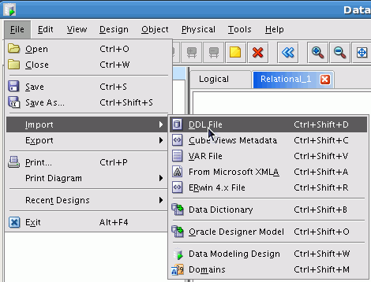
3 . | You can add multiple DDL files to be imported at the same time. Click the '+' icon to add a DDL file.  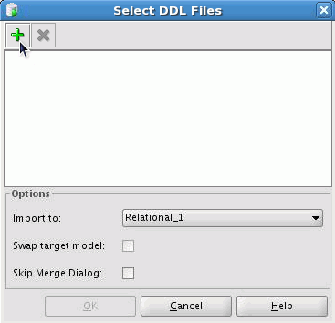
4 . | Select sh_cre_all.sql from the directory where you unzipped the files from the Prerequisites and click Open.  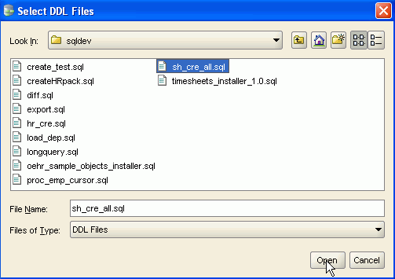
5 . | 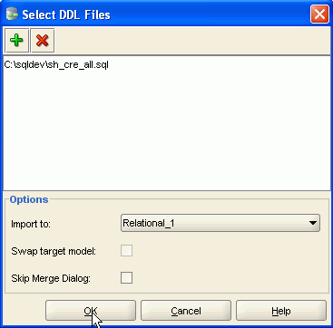  Click OK.
6 . | Select Oracle Database 11g and click OK.  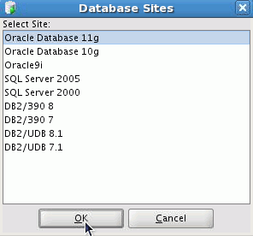
7 . | The Compare Model window appears. You can view the changes that will occur when the DDL file is imported. Expand Tables under sh_cre_all. You see that the list of tables that will be created. Click Merge.  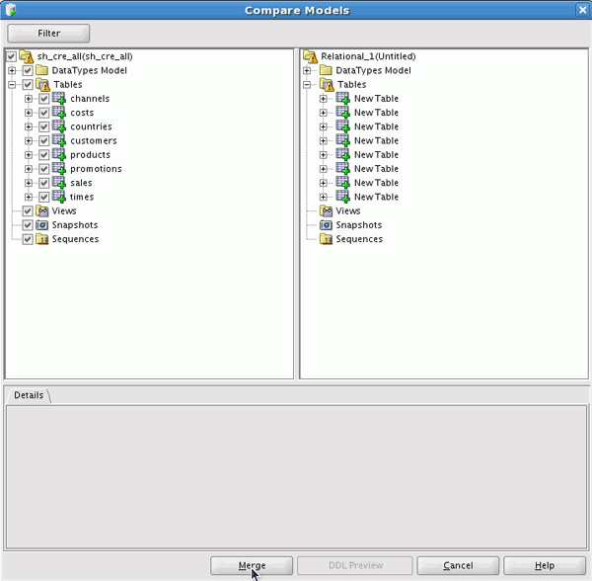
8 . | The relational diagram is displayed. To view the entire diagram, click the Fit Screen icon.  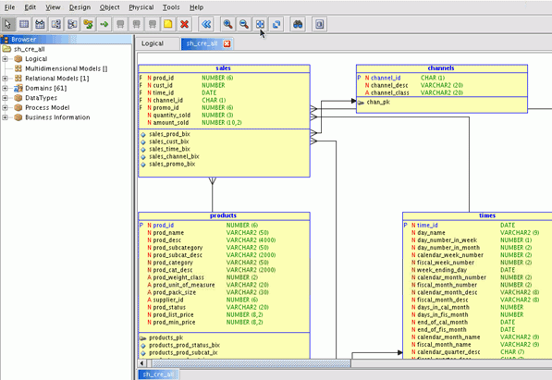
9 . | You can now see more of the diagram. In the next section, you review the relational and physical model objects in the navigator.  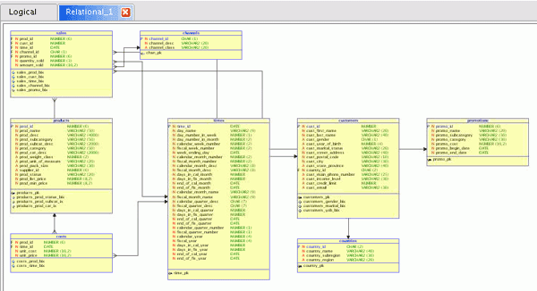

Reviewing the Relational and Physical Model
Perform the following steps:
1 . | In the left navigator, expand Relational Model. Right-click Relational_1 and select Properties.  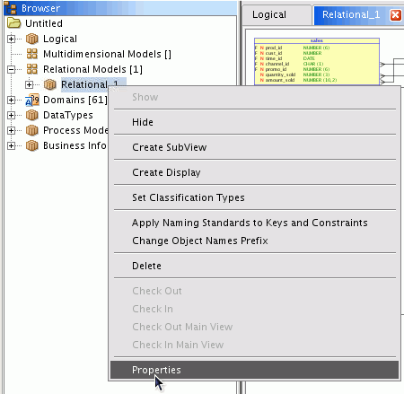
2 . | Change the Name to SH_Schema and click OK.  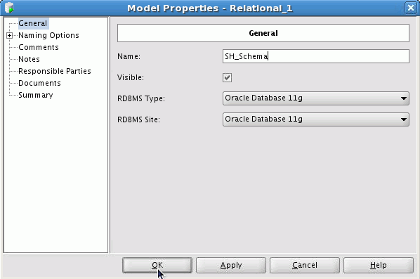
3 . | Expand SH_Schema> Physical Models > Oracle Database 11g > Dimensions >times_dim> Levels. Notice that there are 5 Dimensions in this model. Each dimension contains various levels and hierarchies. Double-click the day level for the times dimension.  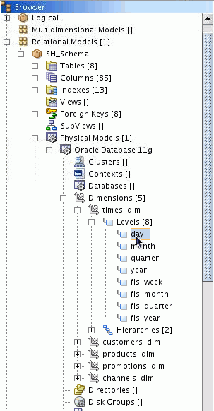
4 . | Click the Level Attributes tab to view the columns defined for this level.  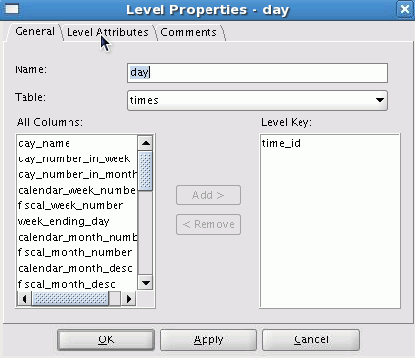
5 . | The columns are displayed. Click OK.  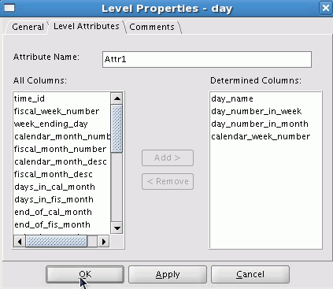
6 . | Expand Hierarchies. Double-click cal_rollup.  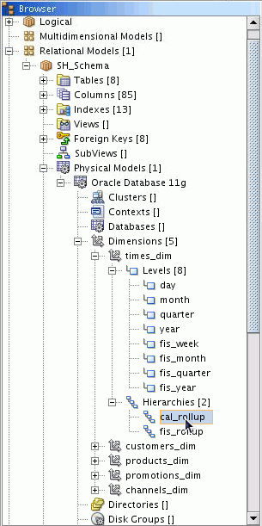
7 . | Review the list of levels included in this hierarchy. Click OK. In the next section, you engineer the relational model to a logical model so that you can then create the multidimensional model.  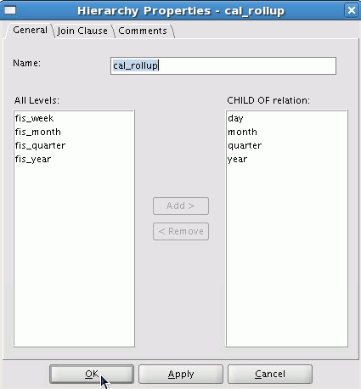

Generating a Multidimensional Model
In this section, you engineer the relational model to a logical model and then generate the multidimensional model. Perform the following steps:
1 . | Click the Engineer to Logical Model icon.  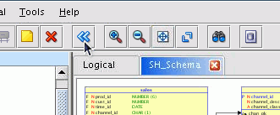
2 . | Expand Tables to see the objects that will be added to the Logical Model. Click Engineer.  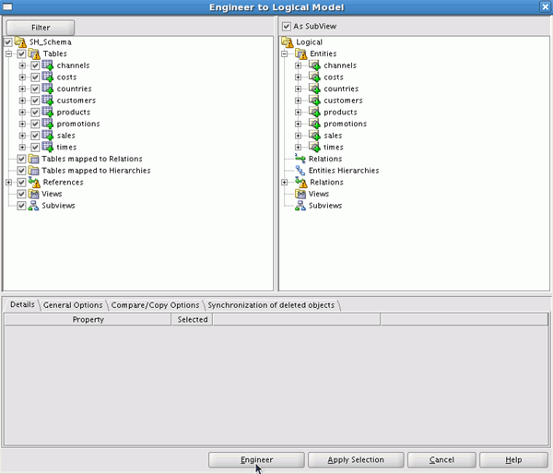
3 . | The Logical Model is displayed.  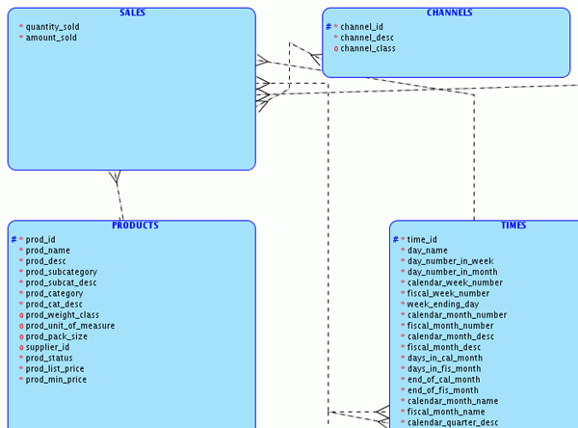
4 . | Now you can create a multidimensional model. In the left navigator, right-click Multidimensional Models and select New Multidimensional Model.  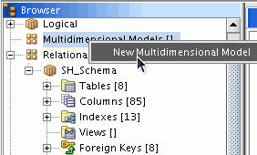
5 . | Once your multidimensional model is created, you can change the name. Expand Multidimensional Models and right-click Multidimensional_1, then select Properties.  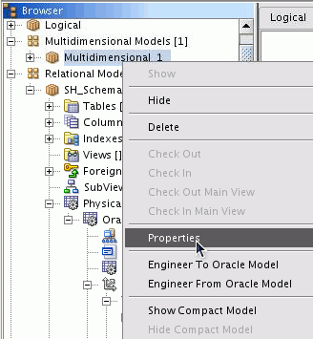
6 . | Change the Name from Multidimensional_1 to SH_Multidimensional and click OK.  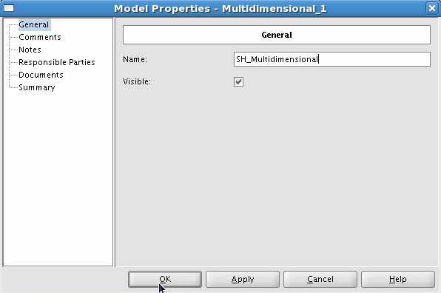
7 . | Now you can create the multidimensional model. Right-click SH_Multidimensional and select Engineer From Oracle Model.  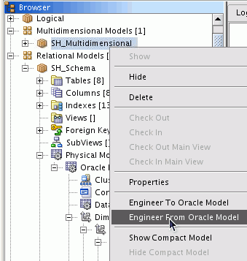
8 . | Click OK.  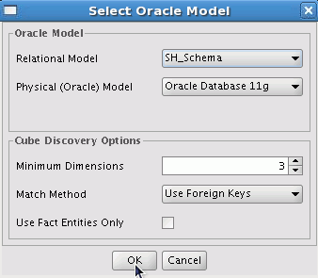
9 . | The multidimensional model was created successfully. In the next section, you review the times_dim object in the multidimensional model.  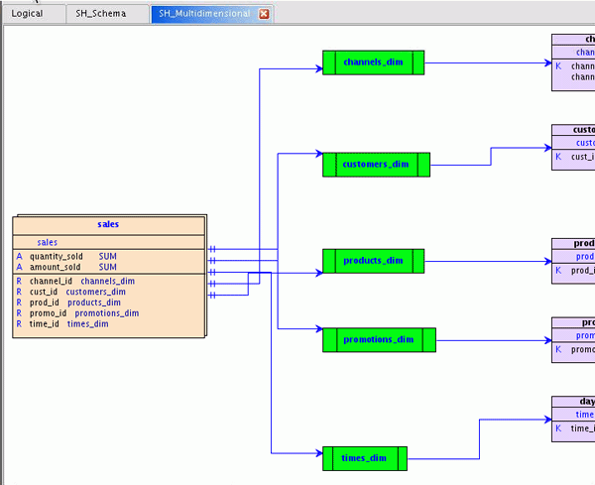

Reviewing the Multidimensional Model
Perform the following steps:
1 . | Double-click the times_dim object in the diagram.  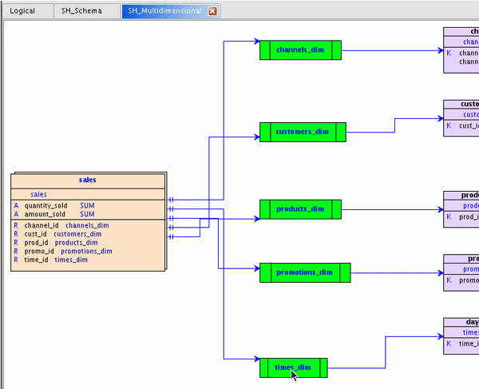
2 . | In the left navigator, click Levels.  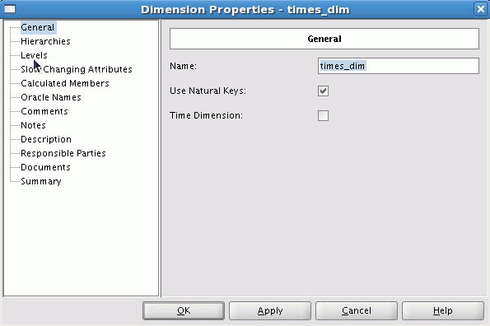
3 . | The levels are displayed. You can drill down into the levels. Double-click the day level.  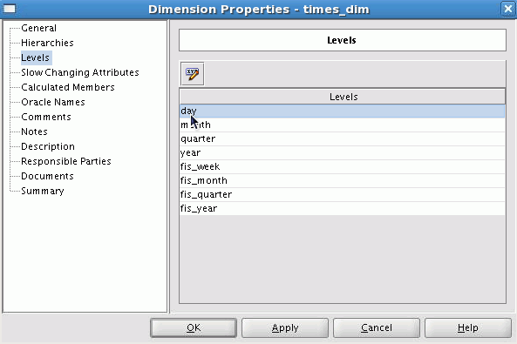
4 . | In the left navigator, click Descriptive Attributes.  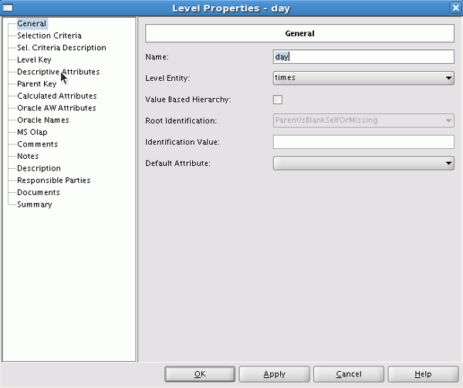
5 . | Review the attributes shown. Click OK twice to return to the diagram.  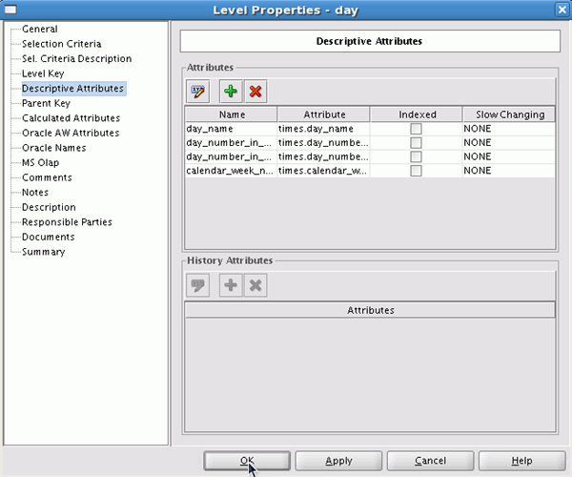

Conclusion:
Thus, we studied how to develop an application to construct a multidimensional data using Oracle.

