Experiment 1

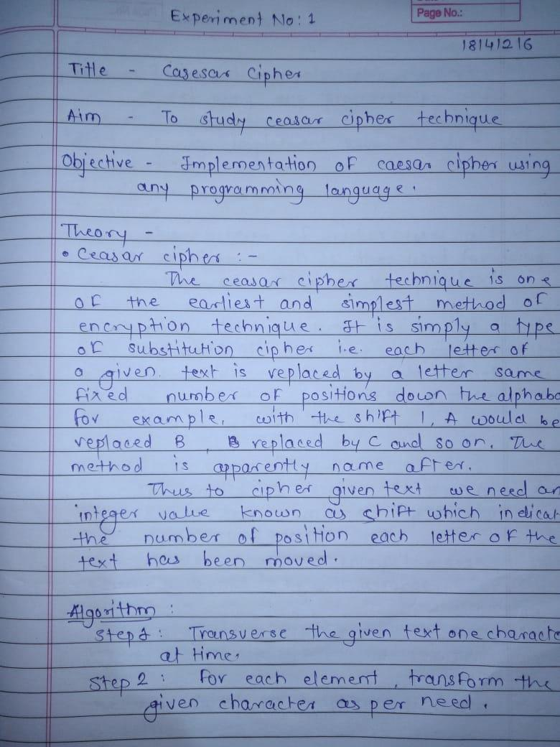
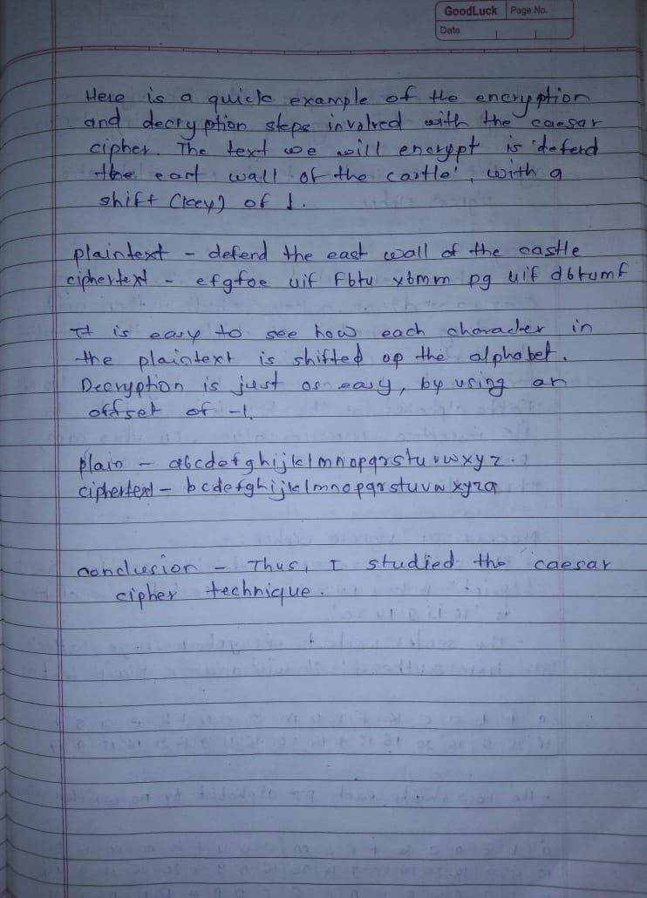

Program –

#include<bits/stdc++.h>
using namespace std;
int main(){
int x;string s;string s1;
while(1){
cout<<"1 : encryption"<<endl;
cout<<"2 : decryption"<<endl;
cout<<"3 : exit"<<endl<<endl;
cin>>x;
switch(x)
{
case 1:
cout<<"enter Plaintext : ";
cin>>s;
int key;
cout<<"enter key : ";
cin>>key;
for(int i=0;i<s.length();i++){
if(s[i]>64&&s[i]<91){
s[i]=('A'+(s[i]-'A'+key)%26);
}
if(s[i]>96&&s[i]<123){
s[i]=('a'+(s[i]-'a'+key)%26);
}
}
cout<<"Ciphertext is : ";
cout<<s<<endl<<endl;
break;
case 2:
cout<<"enter Ciphertext : " ;
cin>>s1;
int key2;
cout<<"enter key : ";
cin>>key2;
key2=-key2;
for(int i=0;i<s1.length();i++){
if(s1[i]>64&&s1[i]<91){
s1[i]=('Z'-('Z'-s1[i]-key2)%26);
}
if(s1[i]>96&&s1[i]<123){
s1[i]=('z'-('z'-s1[i]-key2)%26);
}
}
cout<<"Plaintext is : ";
cout<<s1<<endl<<endl;
break;
case 3:
exit(1);
}
}
}
Output –

