Experiment 2

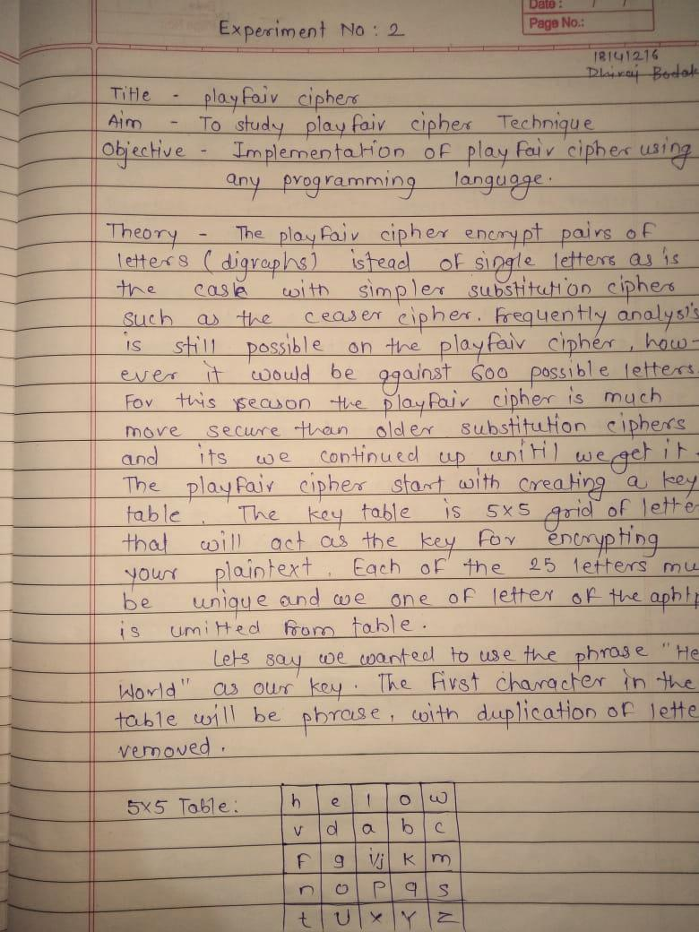
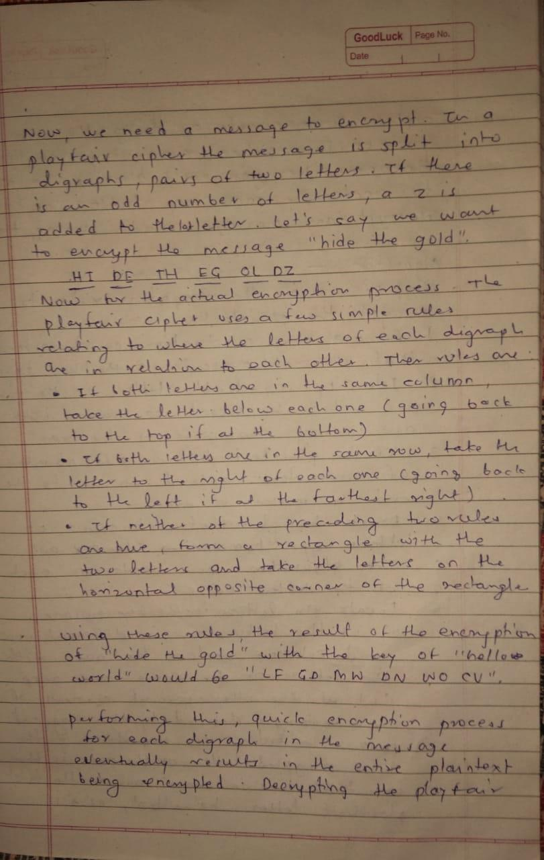
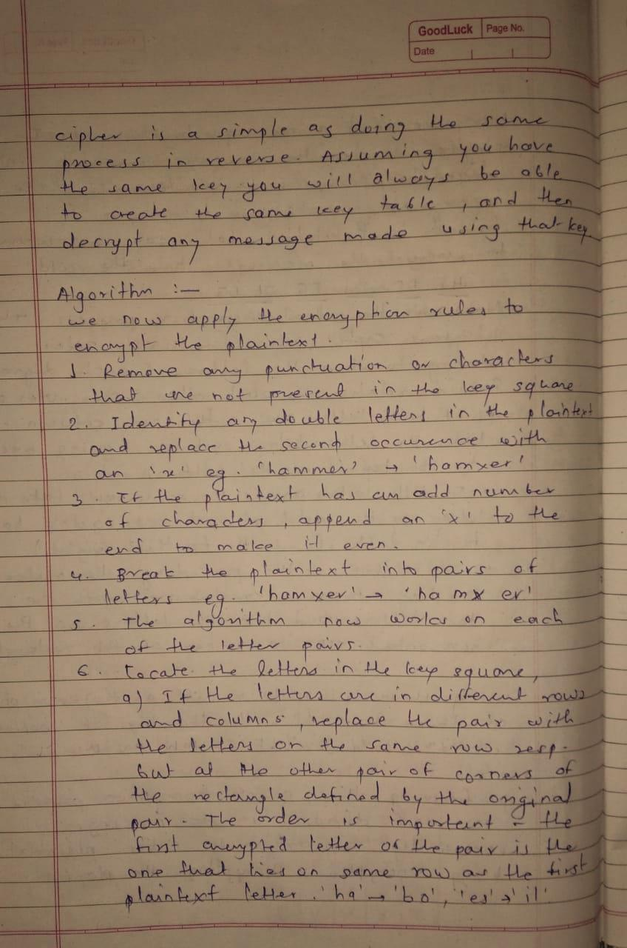

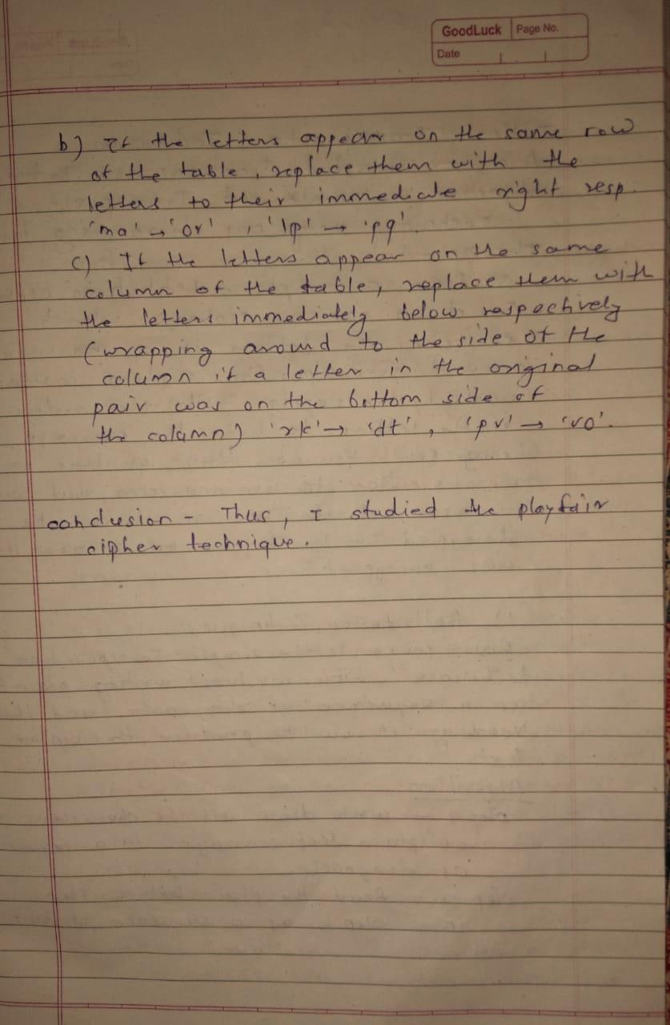

Program –

#include<stdio.h>
#include<conio.h>
#include<string.h>
#include<bits/stdc++.h>
#include<ctype.h>
#define MX 5
using namespace std;
void playfair(char ch1, char ch2, char key[MX][MX]) {
int i, j, w, x, y, z;
FILE * out;
if ((out = fopen("cipher.txt", "a+")) == NULL) {
printf("File Currupted.");
}
for (i = 0; i < MX; i++) {
for (j = 0; j < MX; j++) {
if (ch1 == key[i][j]) {
w = i;
x = j;
} else if (ch2 == key[i][j]) {
y = i;
z = j;
}
}
}
//printf("%d%d %d%d",w,x,y,z);
if (w == y) {
x = (x + 1) % 5;
z = (z + 1) % 5;
printf("%c%c", key[w][x], key[y][z]);
fprintf(out, "%c%c", key[w][x], key[y][z]);
} else if (x == z) {
w = (w + 1) % 5;
y = (y + 1) % 5;
printf("%c%c", key[w][x], key[y][z]);
fprintf(out, "%c%c", key[w][x], key[y][z]);
} else {
printf("%c%c", key[w][z], key[y][x]);
fprintf(out, "%c%c", key[w][z], key[y][x]);
}
fclose(out);
}
int main() {
int i, j, k = 0, l, m = 0, n;
char key[MX][MX], keyminus[25], str[25] = {
0
};
string keystr;
char alpa[26] = {
'A',
'B',
'C',
'D',
'E',
'F',
'G',
'H',
'I',
'J',
'K',
'L',
'M',
'N',
'O',
'P',
'Q',
'R',
'S',
'T',
'U',
'V',
'W',
'X',
'Y',
'Z'
};
printf("\nEnter the key - ");
cin>>keystr;
printf("\nEnter Plaintext - ");
cin>>str;
n = keystr.length();
unordered_map<char,int> m1;
string temp;
for(int i=0;i<n;i++)
{
if(m1.find(keystr[i])==m1.end())
{
temp+=keystr[i];
m1[keystr[i]]++;
}
}
keystr=temp;
//convert the characters to uppertext
for (i = 0; i < n; i++) {
if (keystr[i] == 'j') keystr[i] = 'i';
else if (keystr[i] == 'J') keystr[i] = 'I';
keystr[i] = toupper(keystr[i]);
}
//convert all the characters of plaintext to uppertext
for (i = 0; i < strlen(str); i++) {
if (str[i] == 'j') str[i] = 'i';
else if (str[i] == 'J') str[i] = 'I';
str[i] = toupper(str[i]);
}
// store all characters except key
j = 0;
for (i = 0; i < 26; i++) {
for (k = 0; k < n; k++) {
if (keystr[k] == alpa[i]) break;
else if (alpa[i] == 'J') break;
}
if (k == n) {
keyminus[j] = alpa[i];
j++;
}
}
//construct key keymatrix
k = 0;
for (i = 0; i < MX; i++) {
for (j = 0; j < MX; j++) {
if (k < temp.length()) {
key[i][j] = keystr[k];
k++;
} else {
key[i][j] = keyminus[m];
m++;
}
printf("%c ", key[i][j]);
}
printf("\n");
}
// construct diagram and convert to cipher text
printf("\nCipher Text - ");
for (i = 0; i < strlen(str); i++) {
if (str[i] == 'J') str[i] = 'I';
if (str[i + 1] == '\0') playfair(str[i], 'X', key);
else {
if (str[i + 1] == 'J') str[i + 1] = 'I';
if (str[i] == str[i + 1]) playfair(str[i], 'X', key);
else {
playfair(str[i], str[i + 1], key);
i++;
}
}
}
getch();
}

Output –
