Experiment 4

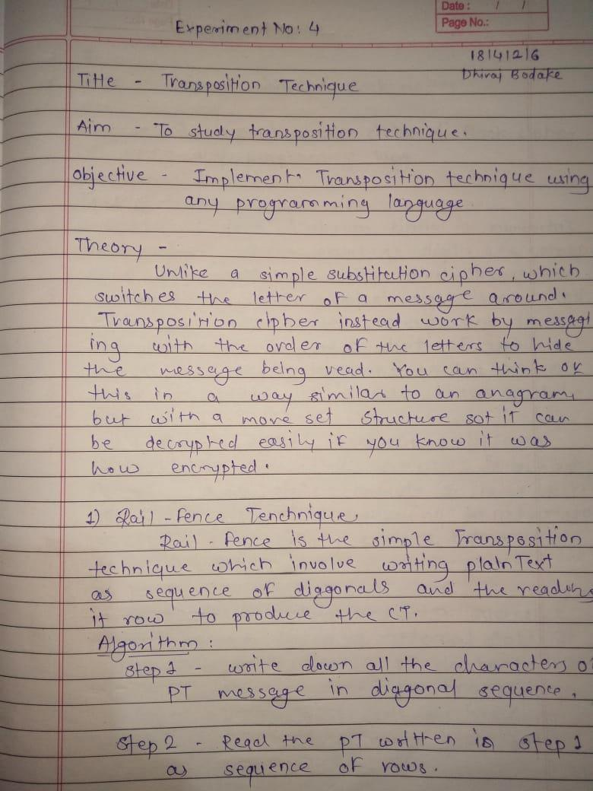

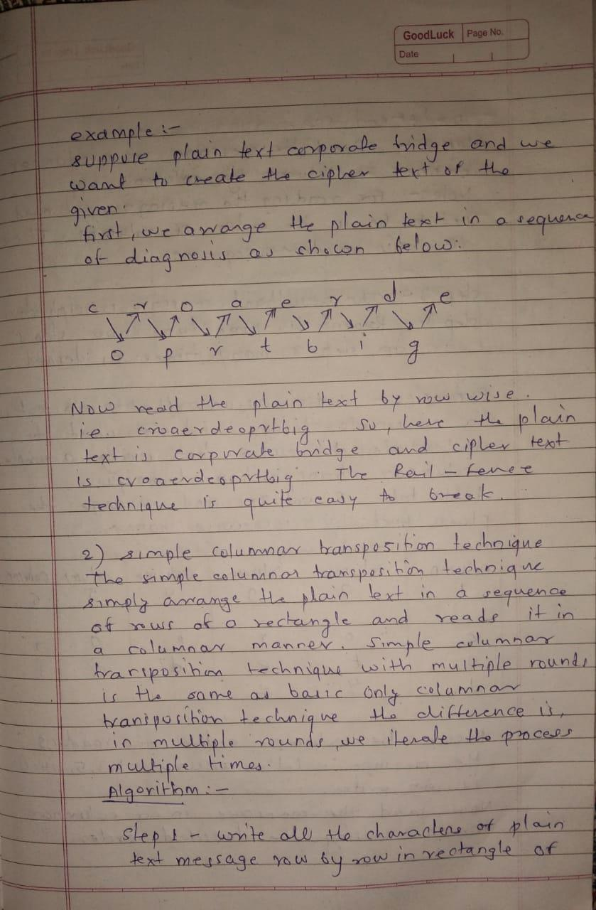
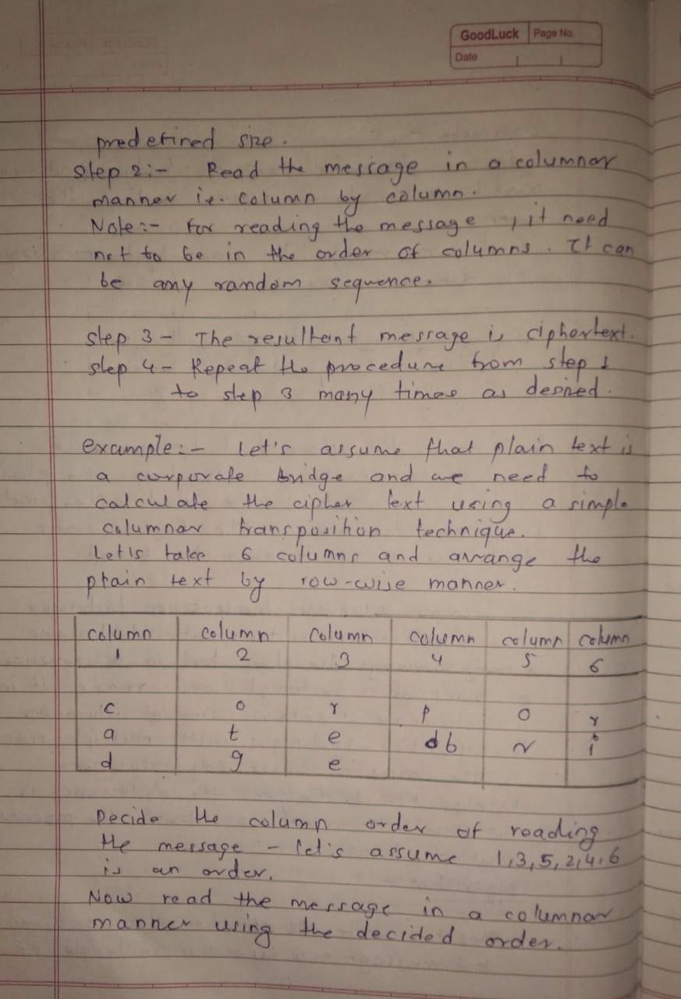

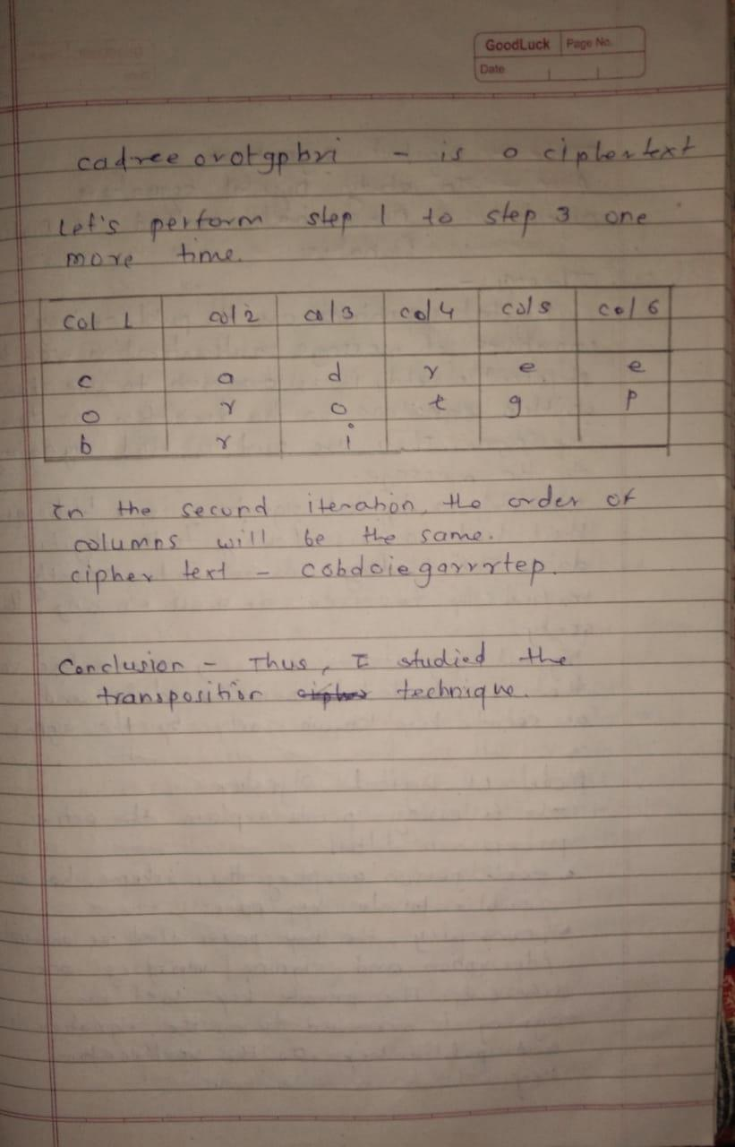

Program –

#include<bits/stdc++.h>
using namespace std;
map<int,int> keyMap;
string key;
void setPermutationOrder(string key)
{
for(int i=0; i < key.length(); i++)
{
keyMap[key[i]] = i;
}
}
string encryptMessage(string msg)
{
int row,col,j;
string cipher = "";
col = key.length();
row = msg.length()/col;

if (msg.length() % col)
row += 1;

char matrix[row][col];

for (int i=0,k=0; i < row; i++)
{
for (int j=0; j<col; )
{
if( isalpha(msg[k]))
{
matrix[i][j] = msg[k];
j++;
}
k++;
}
}
cout<<endl;
for(int z=0;z<col;z++){
cout<<key[z]<<" ";
}
cout<<endl;
for (int i=0,k=0; i < row; i++)
{
for (int j=0; j<col; j++ )
{
cout << matrix[i][j] << " ";
}
cout<<endl;
}
for (map<int,int>::iterator ii = keyMap.begin(); ii!=keyMap.end(); ++ii)
{
j=ii->second;
for (int i=0; i<row; i++)
{
if( isalpha(matrix[i][j]) || matrix[i][j]==' ' || matrix[i][j]=='_')
cipher += matrix[i][j];
}
}
return cipher;
}

string decryptMessage(string cipher,string key)
{
int col = key.length();
int row = cipher.length()/col;
char cipherMat[row][col];
for (int j=0,k=0; j<col; j++)
for (int i=0; i<row; i++)
cipherMat[i][j] = cipher[k++];

char decCipher[row][col];
map<int,int>::iterator ii=keyMap.begin();
int k = 0;
for (int l=0,j;l< key.length();l++)
{
j = key[l]-'0'-1;
for (int i=0; i<row; i++)
{
decCipher[i][k]=cipherMat[i][j];
}
k++;
}

string msg = "";
for (int i=0; i<row; i++)
{
for(int j=0; j<col; j++)
{
if(decCipher[i][j] != '_')
msg += decCipher[i][j];
}
}
return msg;
}

int main(void)
{
string msg;
cout << "Enter plain text: ";
getline(cin,msg);
cout<<"Enter key : ";
cin >> key;
setPermutationOrder(key);

string cipher = encryptMessage(msg);
cout << "Encrypted Message: " << cipher << endl;

cout << "Decrypted Message: " << decryptMessage(cipher,key) << endl;

return 0;
}

Output –

