Experiment 5

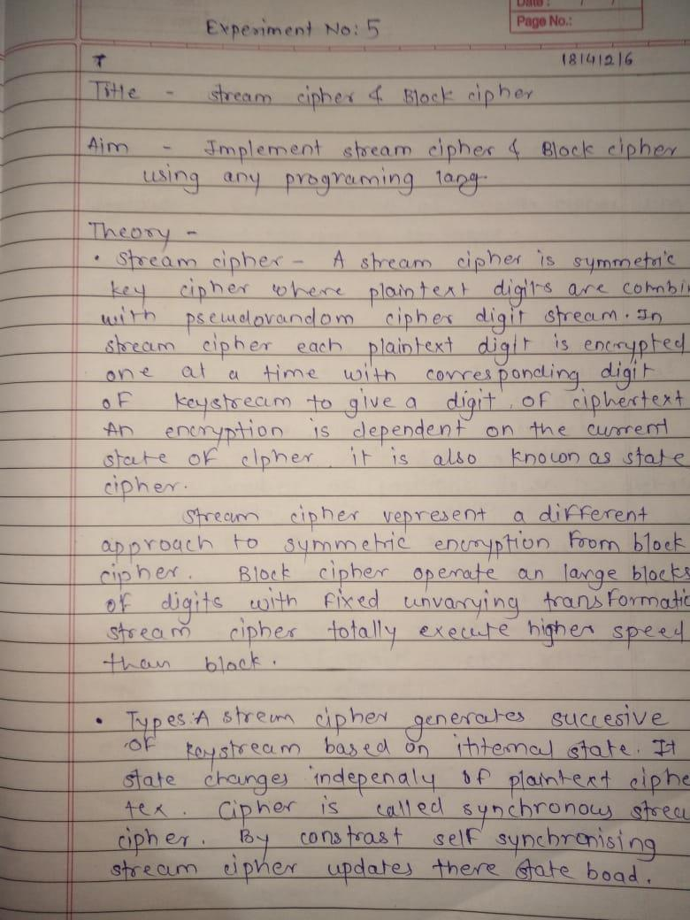
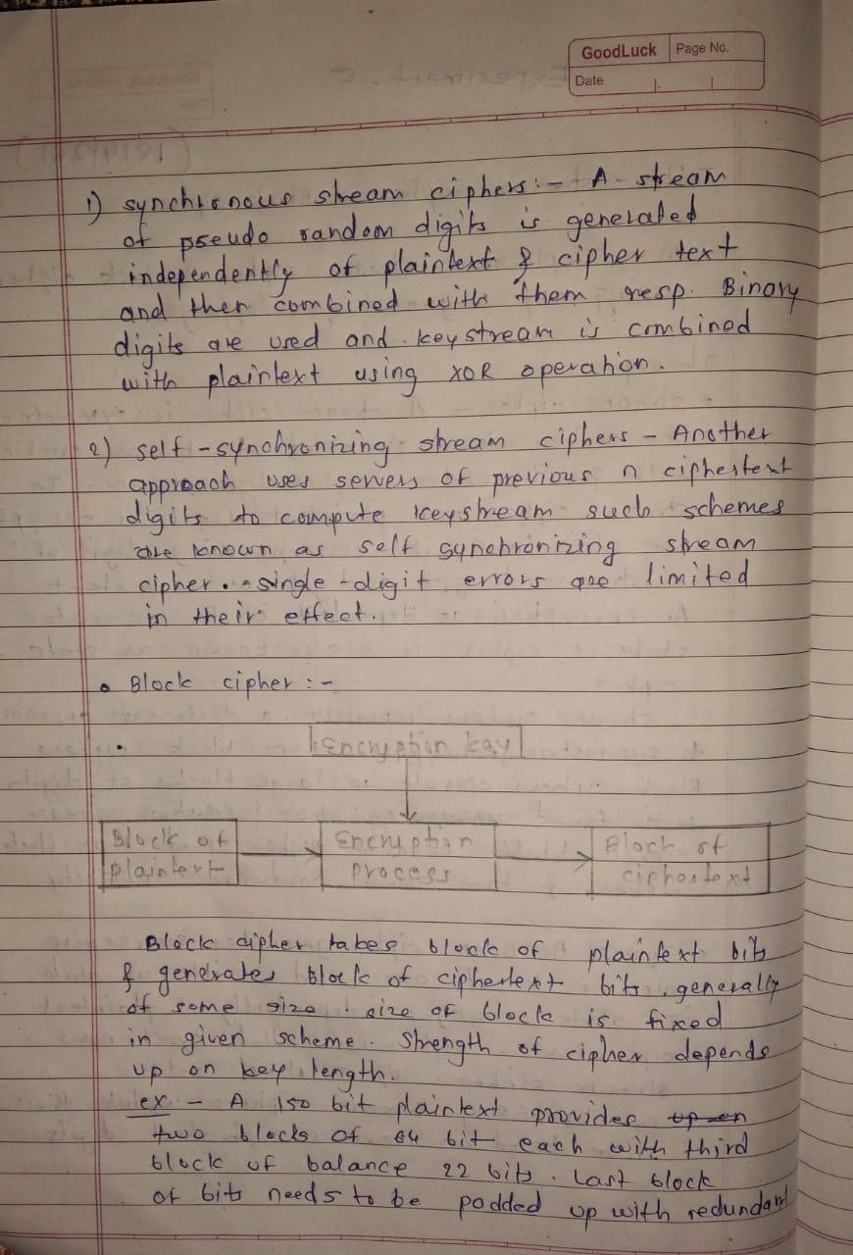

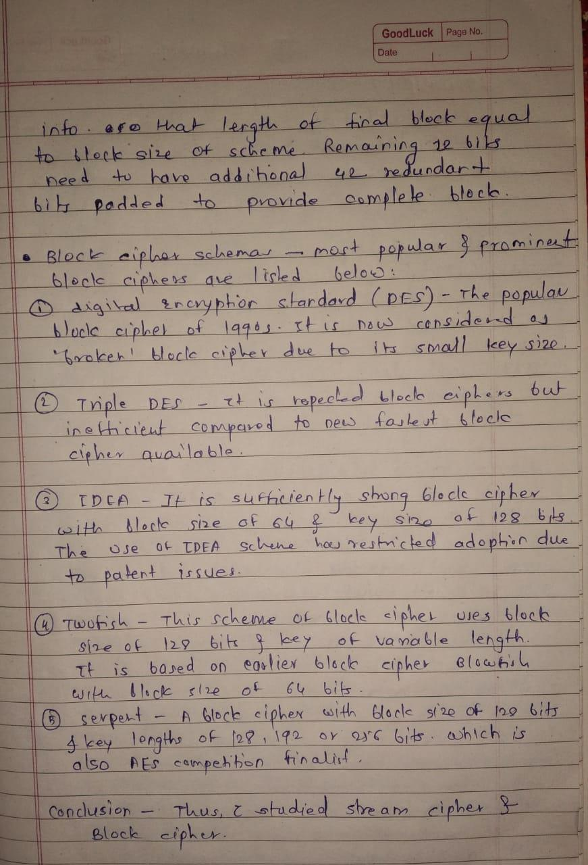
Program – Stream Cipher

import pyaes

plaintext = input("Enter the Plain Text: ")
key = "sonbm#sssd0192837465r1t26yu89i51"
aes = pyaes.AESModeOfOperationCTR(str.encode(key))
e = aes.encrypt(plaintext)
print("The Encrypted text (in bytes): ",e)
aes = pyaes.AESModeOfOperationCTR(str.encode(key))
d = aes.decrypt(e)
print("The Decrypted text (in bytes): ",d)

Output –
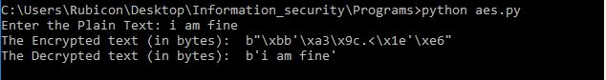

Program – Block Cipher

import pyDes
import os
plaintext = input("Enter plaintext : ")
def padded_text(s):
while len(s)%8 !=0 :
s+=' '
return s

p = padded_text(plaintext)

k_ecb = pyDes.des("DESCRYPT",pyDes.ECB, "\0\0\0\0\0\0\0\0",pad=None,padmode=None)

e_ecb = k_ecb.encrypt(str.encode(p))

print("The Encrypted string (in bytes) : ",e_ecb)

d_ecb = k_ecb.decrypt(e_ecb)

print("The Decrypted string (in bytes) : ",d_ecb)

Output –
