Experiment 6

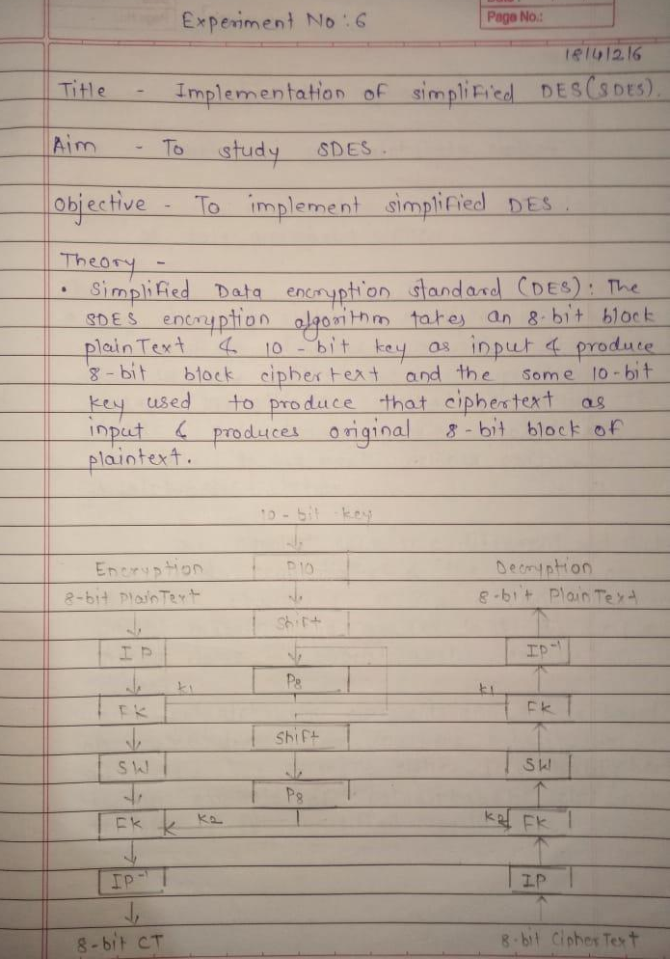
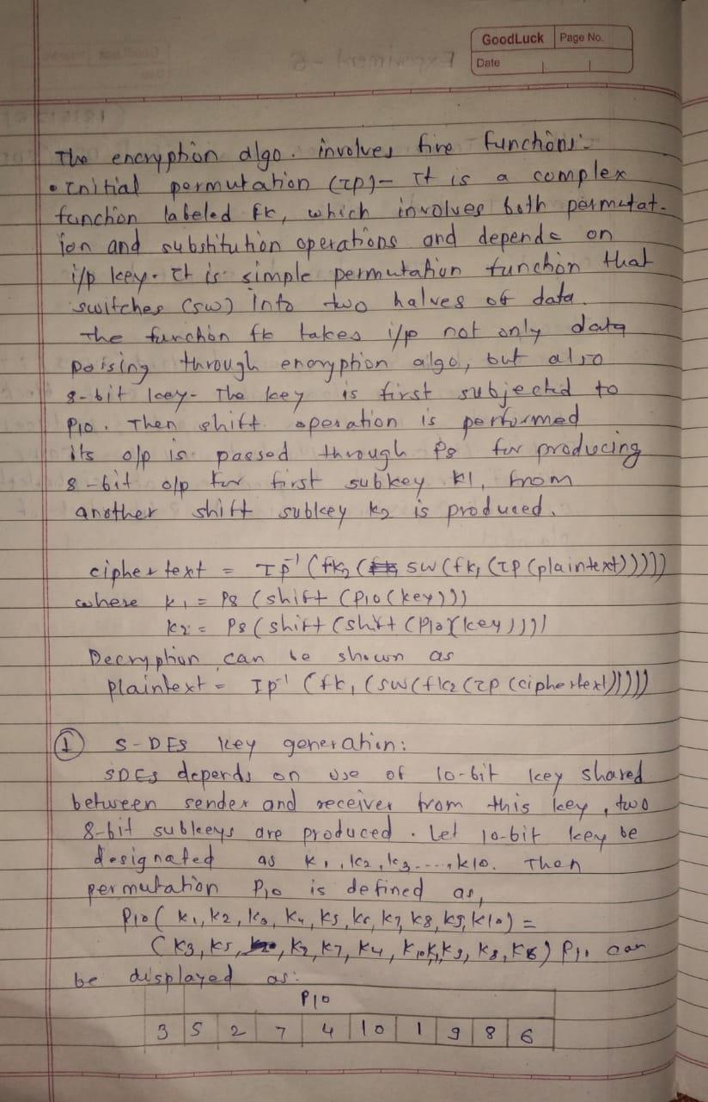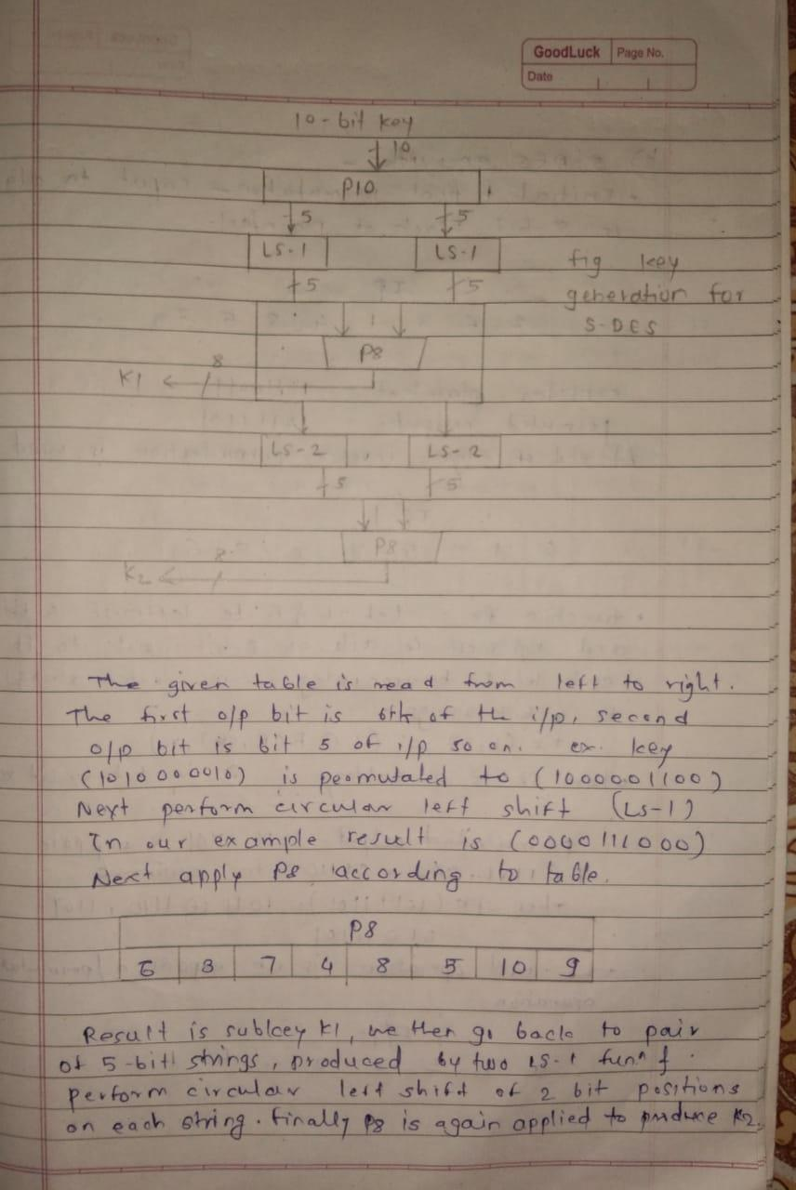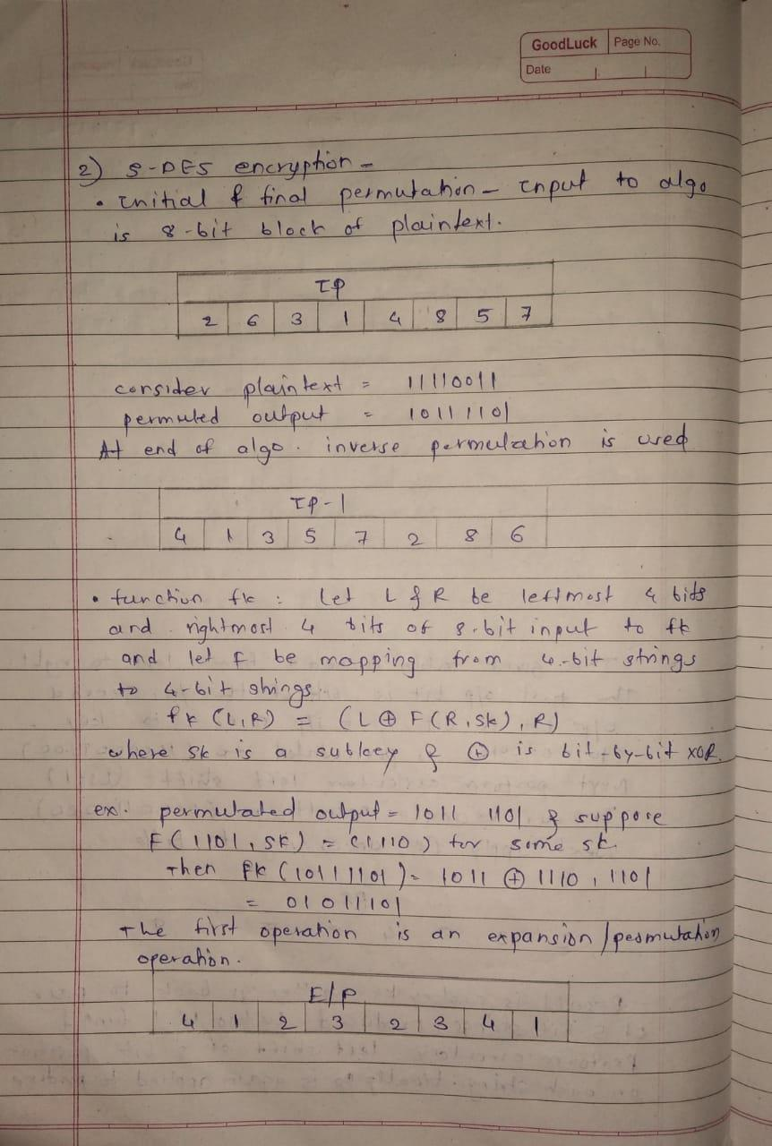
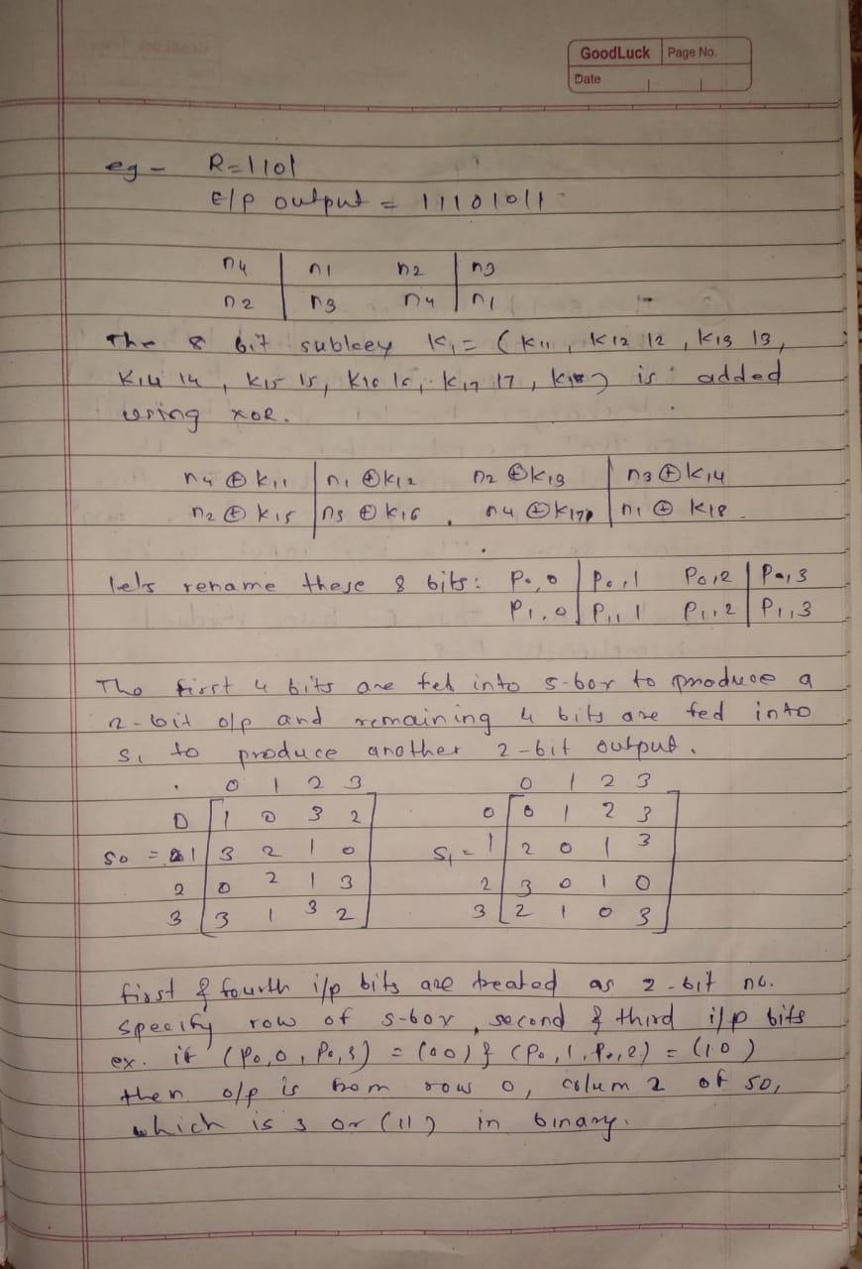

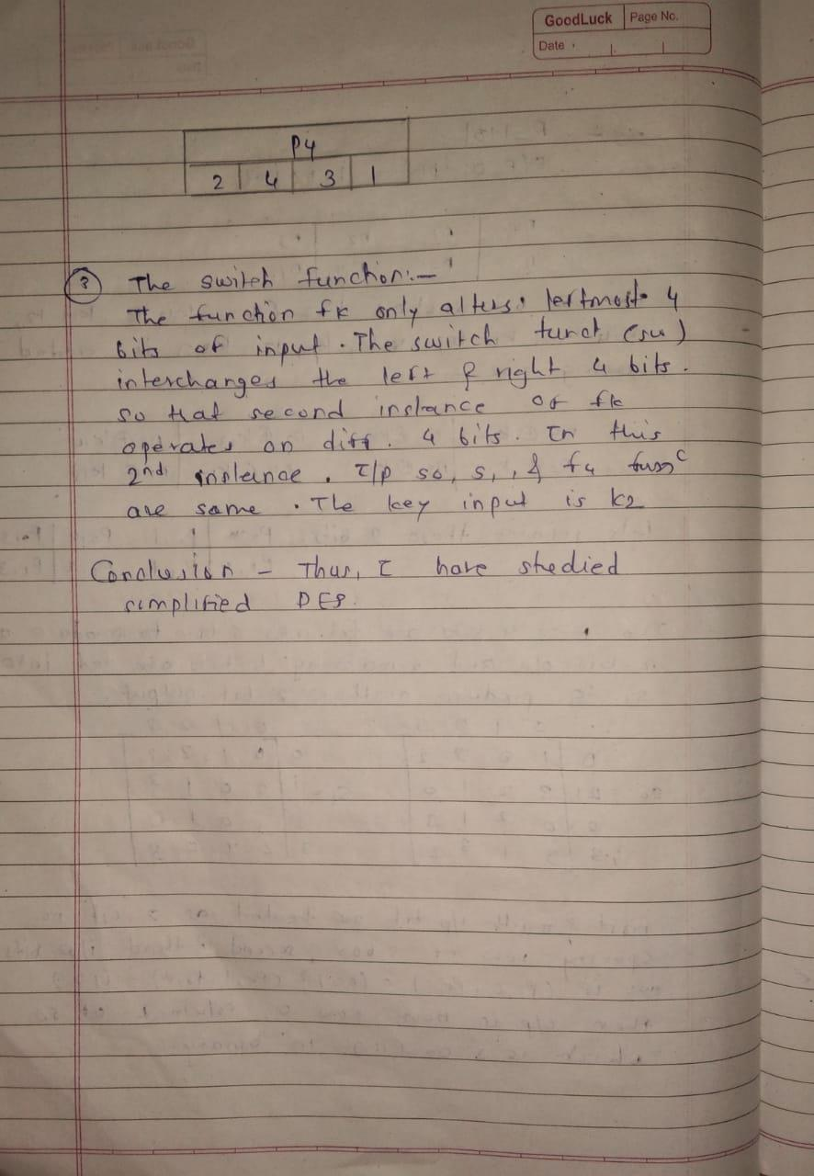

Program –

#include<stdio.h>
int main()
{
int i, cnt=0, p8[8]={6,7,8,9,1,2,3,4};
int p10[10]={6,7,8,9,10,1,2,3,4,5};

char input[11], k1[10], k2[10], temp[11];
char LS1[5], LS2[5];
//k1, k2 are for storing interim keys
//p8 and p10 are for storing permutation key

//Read 10 bits from user...
printf("Enter 10 bits input:");
scanf("%s",input);
input[10]='\0';

//Applying p10...
for(i=0; i<10; i++)
{
cnt = p10[i];
temp[i] = input[cnt-1];
}
temp[i]='\0';
printf("\nYour p10 key is :");
for(i=0; i<10; i++)
{ printf("%d,",p10[i]); }

printf("\nBits after p10 :");
puts(temp);
//Performing LS-1 on first half of temp
for(i=0; i<5; i++)
{
if(i==4)
temp[i]=temp[0];
else
temp[i]=temp[i+1];
}
//Performing LS-1 on second half of temp
for(i=5; i<10; i++)
{
if(i==9)
temp[i]=temp[5];
else

temp[i]=temp[i+1];
}
printf("Output after LS-1 :");
puts(temp);
printf("\nYour p8 key is :");
for(i=0; i<8; i++)
{ printf("%d,",p8[i]); }
//Applying p8...
for(i=0; i<8; i++)
{
cnt = p8[i];
k1[i] = temp[cnt-1];
}
printf("\nYour key k1 is :");
puts(k1);
//This program can be extended to generate k2 as per DES algorithm.
}

Output –

