Experiment 7
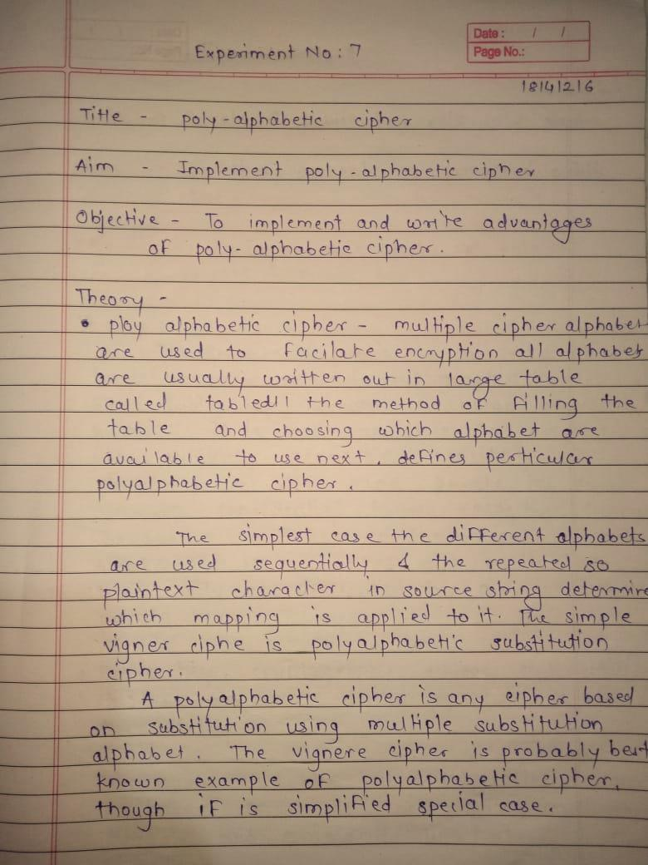
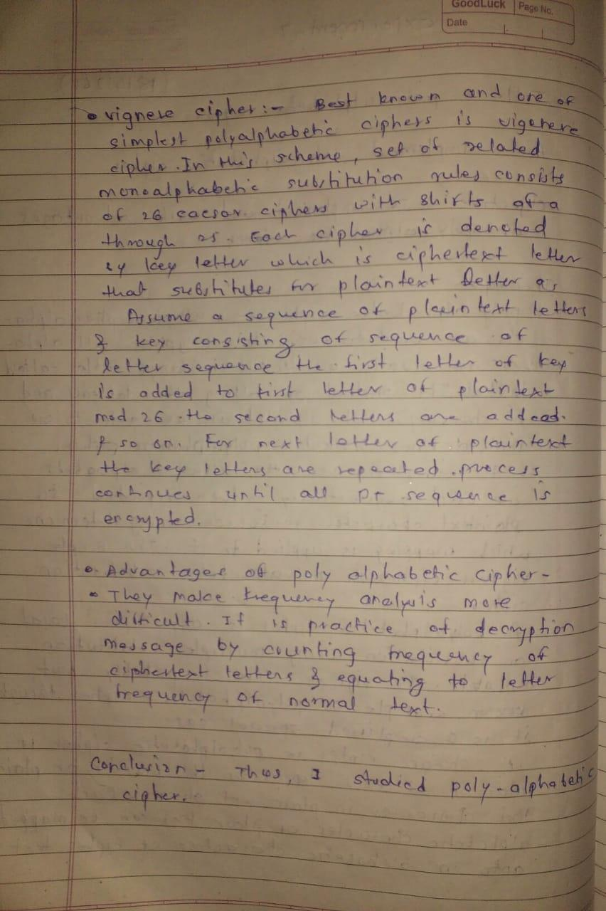
Program –

import string
ALPHABET = string.ascii_lowercase
CHARACTERS_THAT_MUST_REMAIN_THE_SAME = string.digits + string.punctuation + string.whitespace
def cycle_get(lst,index):
new_index = index % len(lst)
return(lst[new_index])
def cycle_increment_index(index,lst):
if index == len(lst) - 1:
index = 0
else:
index += 1
return(index)
def shift(letter,value):
current_letter_value = ALPHABET.find(letter)
end_value = current_letter_value + value
return(cycle_get(ALPHABET,end_value))
def convert_key_to_numbers(key):
return([ALPHABET.find(i) for i in key])
def encrypt(text,key,reverse_operation=False):
text = text.lower()
key = convert_key_to_numbers(key)
index_of_key = 0
result = ""
for char in text:
if char in CHARACTERS_THAT_MUST_REMAIN_THE_SAME:
result += char
else:
if not reverse_operation:
result += shift(char,key[index_of_key])
else:
result += shift(char,- key[index_of_key])
index_of_key = cycle_increment_index(index_of_key,key)
return(result)
def decrypt(text,key):
return(encrypt(text,key,reverse_operation=True))
def main():
text=input("Enter the plaintext :")
key=input("Enter the key :")
x=encrypt(text,key)
print("Encrypt :"+x)
y=decrypt(x,key)
print("Decrypt :"+y)

main()

Output –

