INTRODUCTION

At the heart of every shelter resides a story – a story of resilience, vulnerability, and unwavering hope. Shelter Care Management recognizes the human dimension of shelter life, prioritizing both operational efficiency and individual well-being.

Our system incorporates features designed to nurture emotional and social connections, foster a sense of community, and offer a platform for residents to actively participate in their own care pathways.

From facilitating peer support groups to connecting individuals with relevant social services, Shelter Care Management champions not just a safe haven, but a space for empowerment and individual growth.

Witness the difference when technology meets empathy, and experience the transformative impact of Shelter Care Management on the lives of those seeking refuge.

PROBLEM DEFINITION

The current shelter care management system suffers from the following problems:

1. Inefficient resource allocation: Beds, supplies, and services are distributed unevenly, potentially leaving some in need without essential support.

2. Fragmented data and communication: Disjointed systems across shelters, social services, and other stakeholders lead to duplicated efforts, missed opportunities, and delays in accessing crucial support.

To address these issues, we have implemented the following:

1.Centralized database: All shelter data, resident information, and service records are stored in a single, secure platform accessible by authorized personnel across departments.

2.Real-time occupancy and resource availability dashboards: These dashboards provide live data on available beds, supplies, and services, allowing staff to make informed decisions and optimize resource utilization.

ER DIAGRAM

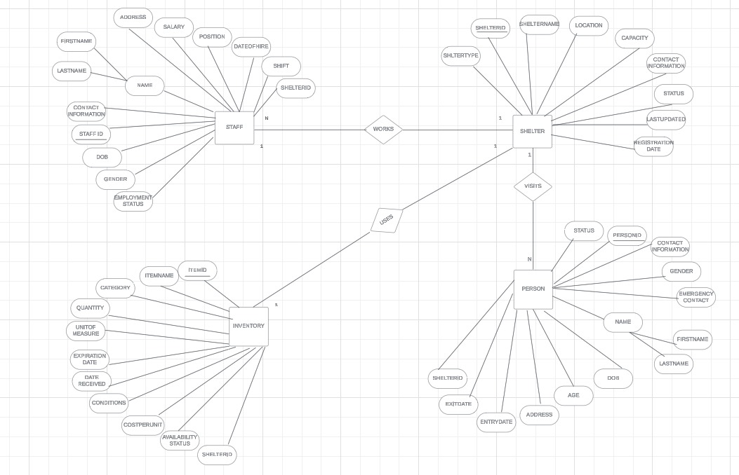

BLOCK DIAGRAM

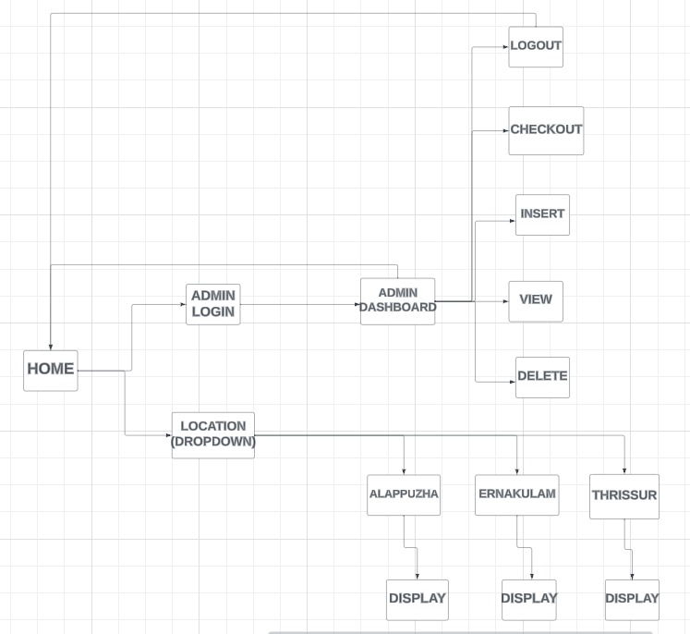

FUNCTIONALITY ACHIEVED

1. Admin Authentication: Ensuring secure access to the website's administrative panel through robust authentication mechanisms, safeguarding sensitive data and functionalities from unauthorized users.

2. Dynamic Content Display in Table View Format: Implementing a user-friendly interface that dynamically presents data in a tabular format, enhancing readability and providing a streamlined experience for users interacting with various information on the website.

3. Responsive Design: Employing responsive web design techniques to ensure a seamless user experience across a diverse range of devices, from desktop computers to tablets and smartphones, optimizing accessibility and usability.

4. Data Management Operations (Insertion, Deletion, and Updation): Enabling efficient handling of data through a comprehensive set of operations, including the insertion of new records, secure deletion of outdated information, and seamless updating of existing data to maintain accuracy and relevance.

5. Admin Operations - User Registration and Checkout: Facilitating user registration and checkout processes, streamlining the user journey on the website and providing a personalized experience while ensuring the security and integrity of user data.

6. Admin Operations - Staff Registration and Deletion: Empowering administrators with the ability to manage staff accounts by enabling secure registration and, when necessary, deletion of staff members, ensuring optimal personnel management.

7. Admin Operations - Inventory Addition and Deletion: Granting administrators the capability to efficiently manage inventory by seamlessly adding new items and removing obsolete or discontinued products, contributing to effective inventory control and resource optimization.

8. Admin Operations - Shelter Registration: Supporting administrators in the management of shelters by providing a user-friendly interface for shelter registration, enhancing the website's capability to address the needs of diverse entities

9. Dynamic Age Calculation: Applied during person registration, dynamically computes and assigns the age of an individual based on their date of birth and the current date. Enhances data accuracy and representation within the system.

10. Salary Assignment Logic: Implemented before staff registration, automatically allocates default salary values based on the staff member's designated position. Streamlines salary management, reducing data entry errors and ensuring consistency.

11. Status Update Logic: Integrated into registration and exit date modification processes, dynamically adjusts the status of an individual based on the presence or absence of an exit date. Contributes to accurate status tracking within the system.

12. Inventory Condition Classification: Triggered during inventory insertion, automatically categorizes items as 'New,' 'Used,' or 'Expired' based on their date of receipt and expiration. Enhances inventory management with real-time condition classification

13. Total Persons Update: Deployed after person insertion or exit date modification, automatically updates the total count of persons in the corresponding shelter. Ensures accurate and real-time tracking of shelter occupancy for resource allocation.

14. Shelter Status Update on Exit: Executed after updating a person's exit date, dynamically adjusts the shelter status based on occupancy percentage. Ensures real-time updates, assisting administrators in managing shelter capacities effectively.

FRONT END SPECIFICATION

***HTML, or Hypertext Markup Language***, is a fundamental coding language for creating web pages. It utilizes tags to define elements, encapsulating content between opening (<tag>) and closing (</tag>) tags. Attributes within tags provide additional information and functionality to elements. HTML structures the layout and presentation of text, images, and other multimedia on the internet.

***CSS, or Cascading Style Sheets***, is a styling language integral to web development. It complements HTML by controlling the presentation and layout of web pages. Selectors target HTML elements, and properties define their appearance, including aspects like colour, size, and layout. CSS enables consistent styling across multiple pages and enhances the visual aesthetics of websites.

***JavaScript*** is a versatile scripting language for web development. It enhances interactivity on web pages by enabling dynamic behaviour. JavaScript can manipulate HTML and CSS, responding to user actions and modifying content in real-time. It's a client-side language executed in browsers, facilitating the creation of responsive and engaging web applications.

BACK END SPEICIFICATION

***MySQL*** is a popular relational database management system (RDBMS) crucial for web applications. It organizes data into tables with defined relationships. SQL (Structured Query Language) is used to interact with MySQL, allowing users to perform operations such as querying, inserting, updating, and deleting data. MySQL provides a robust and scalable backend solution for storing and managing structured information in various web applications.

***Flask*** is a lightweight web framework for Python, designed to build web applications efficiently. It follows the WSGI standard and provides tools for routing, templating, and handling HTTP requests and responses. Flask's simplicity and extensibility make it an excellent choice for developing scalable and modular web applications using Python.

***SQLAlchemy*** is a powerful SQL toolkit and Object-Relational Mapping (ORM) library in Python, facilitating interaction with databases. It integrates seamlessly with Flask for web development and supports various database systems, including MySQL.

CONCLUSION

In conclusion, the Shelter Care Management Database Management System (DBMS) project has successfully addressed critical issues plaguing shelter management, ushering in a new era of efficiency and compassion.

The introduction of a centralized database, auditable logs, and real-time dashboards has not only optimized resource allocation but also fostered transparency and accountability across the system. Through dynamic content display, responsive design, and streamlined administrative operations, the DBMS not only ensures operational fluidity but also creates a platform for residents to actively participate in their care pathways, promoting individual growth and empowerment.

Moving forward, the project serves as a beacon for continued progress, offering a scalable and adaptable foundation that redefines shelter management by placing human connection and well-being at its core.