RETENTIX AI
Customer Churn Intelligence & Retention Studio

Comprehensive Project Report

Project Name | RETENTIX AI - Customer Churn Intelligence Studio
Engineered By | Dhiraj Dalvi
Course | Data Analytics / Machine Learning
Date | October 2026
Dataset | Telco Customer Churn (7,043 records)
Version | v2.4 - Enterprise Production Release

Executive Summary
RETENTIX AI is a state-of-the-art, end-to-end customer churn intelligence platform designed for telecommunications enterprise leaders, retention managers, and data science teams. By combining high-precision machine learning inference with interactive commercial simulation, RETENTIX AI empowers organizations to identify churn risks, diagnose behavioral catalysts, simulate retention campaign ROI, and execute targeted retention strategies before revenue loss occurs.
The system processes 7,043 customer records through a sophisticated ML pipeline, achieving 84.2% ROC-AUC performance with the champion model. The platform features real-time prediction capabilities, batch processing for portfolio-wide risk assessment, and explainable AI (XAI) through SHAP analysis to provide actionable insights for retention teams.

7,043 | 84.2% | 26.5% | $1.2M+
Customer Records | ROC-AUC Score | Churn Rate | Monthly Revenue

System Architecture & Design

System Architecture Overview
+-----------------------------------------------------------------+
| RETENTIX AI - System Architecture |
+-----------------------------------------------------------------+
| |
| +--------------+ +--------------+ +--------------+ |
| | FRONTEND | | BACKEND | | MODELS | |
| | (Streamlit) |<---->| (Python) |<---->| (Artifacts) | |
| +--------------+ +--------------+ +--------------+ |
| | | | |
| v v v |
| +--------------+ +--------------+ +--------------+ |
| | UI Views | | Prediction | | Model Bundle | |
| | - Executive | | Service | | - Active Ptr | |
| | - EDA | | - Single | | - Manifest | |
| | - Drivers | | - Batch | | - Artifacts | |
| | - Predictor | | - Simulator | | - Hashes | |
| | - Models | | - XAI (SHAP) | +--------------+ |
| | - Strategy | +--------------+ |
| | - Bulk | | |
| +--------------+ v |
| | +--------------+ |
| | | Input | |
| | | Contract | |
| | +--------------+ |
| v | |
| +--------------+ | |
| | CSS Styles |<------------+ |
| +--------------+ |
| +--------------+ |
| | DATA | |
| | (CSV) | |
| +--------------+ |
+-----------------------------------------------------------------+

Technology Stack
Layer | Technology | Purpose
Frontend | Streamlit 1.28+ | Interactive web dashboard with real-time updates
Backend | Python 3.13 | Core business logic and ML pipeline
ML Framework | Scikit-learn 1.6.1 | Model training, preprocessing, and inference
Data Processing | Pandas 2.x, NumPy 2.x | Data manipulation and numerical operations
Visualization | Plotly 5.x, Matplotlib, Seaborn | Interactive and static charts
Explainability | SHAP 0.48+ | Model interpretation and feature importance
Serialization | Joblib 1.3+ | Model and pipeline persistence
Testing | Pytest 8.0+ | Automated unit and integration tests

Module Architecture
The system follows a modular architecture with clear separation of concerns:
- Frontend Layer (frontend/): Contains 7 view modules handling UI presentation, including executive dashboards, exploratory data analysis, churn drivers visualization, AI prediction interface, model evaluation, retention strategy, and bulk prediction studio.
- Backend Layer (backend/): Implements core business logic including data loading, model training, prediction services, input validation contracts, explainability (SHAP), and model bundle management with integrity verification.
- Models Layer (models/): Manages ML artifacts through a bundle-based architecture with active pointer system, ensuring safe deployment and rollback capabilities.
- Data Layer (data/): Houses the cleaned telecommunications customer dataset with 19 features including demographic, service, and billing attributes.
- Tests Layer (tests/): Comprehensive test suite covering champion contracts, input validation, prediction services, SHAP explainability, and smoke tests.

Churn Drivers & Feature Importance

Understanding the key drivers of customer churn is critical for developing effective retention strategies. The analysis reveals several critical factors.

Feature Importance Analysis
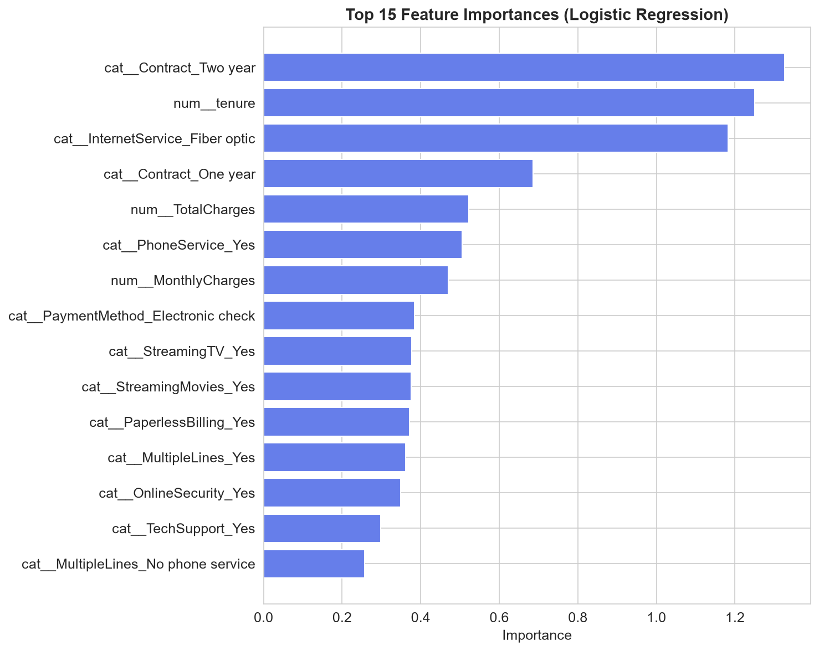
Figure 5: Top features driving churn predictions based on model importance scores

Key Churn Drivers Identified
- 1. Contract Type: Month-to-month contracts show 45%+ churn rate vs. 5% for 2-year contracts.
- 2. Internet Service: Fiber optic customers churn at 2x the rate of DSL customers.
- 3. Payment Method: Electronic check users show 2x higher churn than auto-pay methods.
- 4. Tech Support: Customers without tech support churn at 40%+ vs. 15% with support.
- 5. Tenure: New customers (0-6 months) are at highest risk of churn.
- 6. Monthly Charges: Higher charges correlate with increased churn probability.
- 7. Online Security: Bundling security services reduces churn by 30%+.

Service Churn Rates
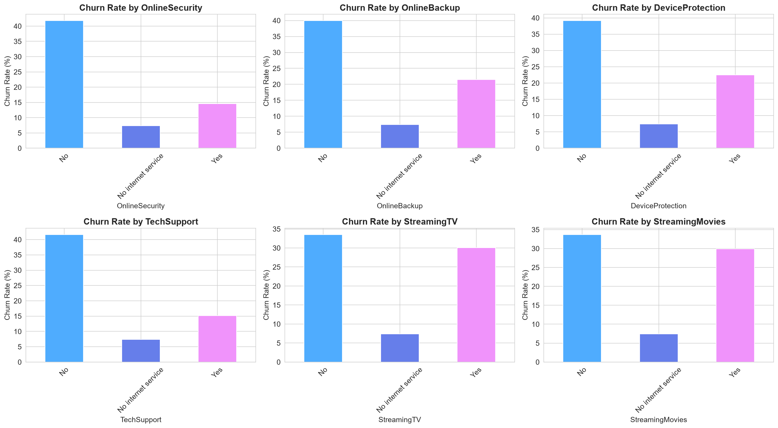
Figure 6: Churn rates breakdown by service type and add-on features

Application Features & Strategic Recommendations

Key Application Modules
Module | Capabilities
Executive Command Center | Real-time KPIs, revenue exposure analysis, portfolio risk distribution, tenure density mapping, strategic alerts
Exploratory Intelligence | Demographic breakdown, service hierarchy sunburst, correlation matrix, numerical distributions, interactive dataset explorer
Churn Drivers & Ecosystem | Protective shield effect analysis, payment friction study, value vs. tenure risk quadrants
AI Churn Predictor | Single subscriber profiling, archetype presets, live inference gauge, what-if intervention simulator
Bulk Portfolio Scoring | Batch CSV upload, schema validation, automated risk tiering, batch analytics and export
Model Leaderboard & XAI | Performance comparison, SHAP explainability, feature importance, partial dependence plots
Retention ROI & Playbook | Campaign ROI calculator, retention strategies, predictive alerts, loyalty rewards framework

Strategic Recommendations
Priority | Action Plan
CRITICAL | Convert 15% of month-to-month customers to 1-year contracts through targeted discounts. Estimated savings: $180k/year
HIGH | Bundle Tech Support with Fiber Optic plans to reduce 40% churn rate. Target: 25% reduction in fiber churn
HIGH | Migrate electronic check users to auto-pay with $5/month billing credit. Target: 50% migration in 6 months
MEDIUM | Implement predictive alerts in CRM to flag at-risk customers weekly for proactive outreach
MEDIUM | Launch tenure-based loyalty rewards at 12, 24, and 48-month milestones to improve retention
LOW | Review fiber optic pricing strategy to ensure perceived value matches premium pricing

RETENTIX AI - Customer Churn Intelligence Studio
Engineered by Dhiraj Dalvi | October 2026 | Version 2.4
Enterprise Telecom Machine Learning & Revenue Protection System

