#bucketing in hive.

1.createnormal table for storing data:create table products_no_buckets(

id int,

name string,

cost double ,

category string)

row format delimited fields terminated by ',';

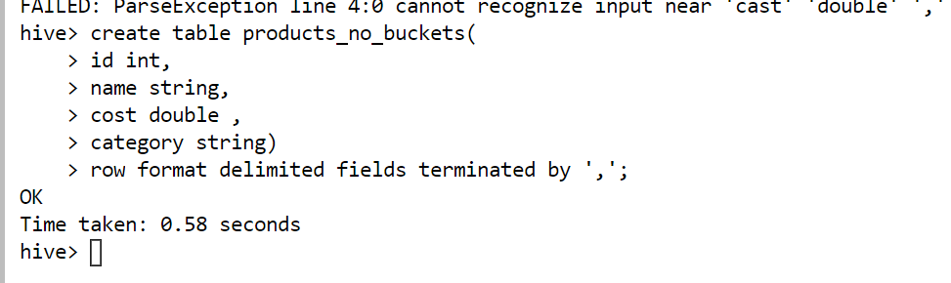

2..load data from local file in normal table

load data local inpath 'newproducts.csv' into table products_no_buckets

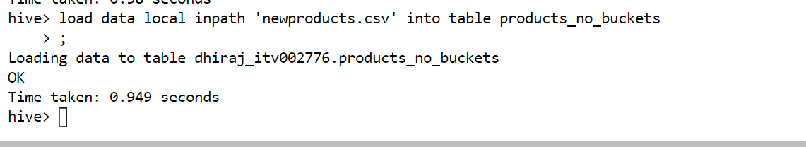

Records after inserting:

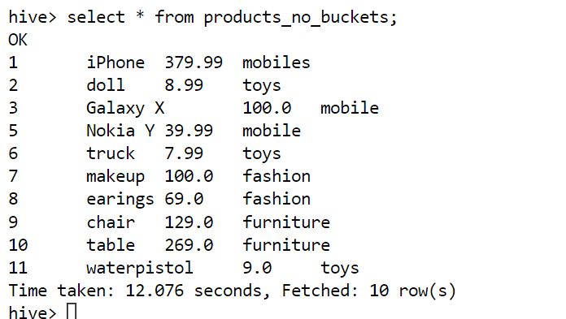

See path in hdfs:

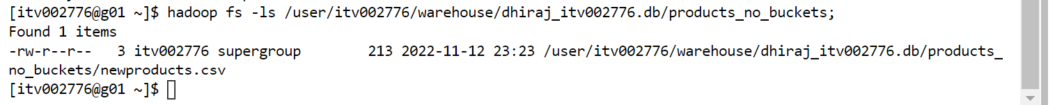

3.set bucketing to true:set hive.enforce.bucketing=true;

4.create bucketed table on column:

create table products_w_buckets(

id int,

name string,

cost double ,

category string)

clustered by (id) into 4 Buckets;

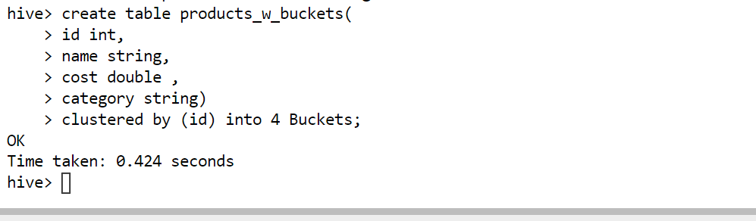

See table in hadoop:

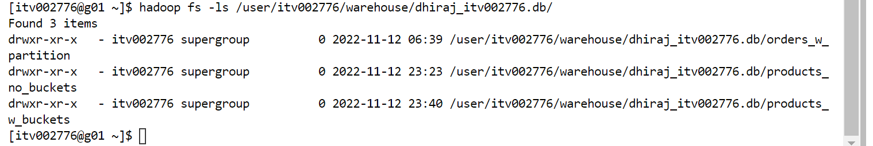

5.load data from non-bucketed to bucketed table:

from products_no_buckets insert into products_w_buckets select id,name,cost,category;

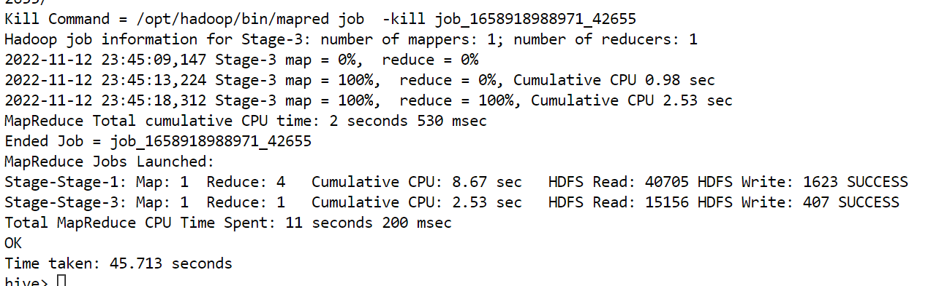

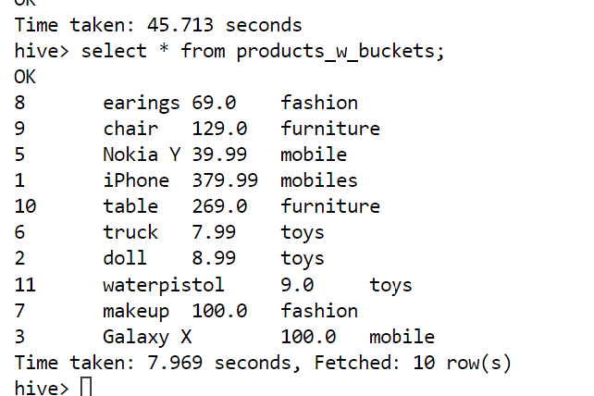

See file structure in hadoop:

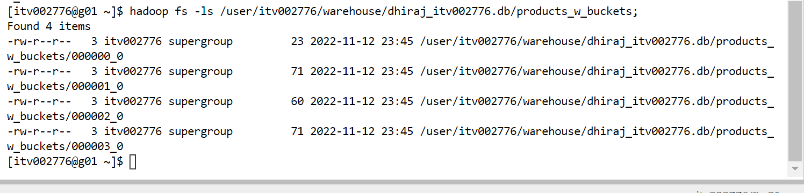

6.To see content bucket wise :

select * from products_w_buckets tablesample(bucket 1 out of 4);

