**Assignments 6**

1. Declare a single-dimensional array of 5 integers inside the main method. Traverse the array to print the default values. Then accept records from the user and print the updated values of the array.

**package** com.assignment6.name;

**import** java.util.Scanner;

**public** **class** ArrayProgram1 {

**static** Scanner *sc* = **new** Scanner(System.***in***);

**public** **static** **void** main(String[] args) {

**int**[] arr = **new** **int**[5];

System.***out***.println("Default values for Array");

**for**(**int** i=0; i< arr.length; ++i) {

System.***out***.print(arr[i]+ " ");

}

System.***out***.println("\nAccept Array Elements");

**for**(**int** index=0; index< arr.length; ++index) {

System.***out***.println("Enter value of arr["+ index +"] : ");

arr[index] = *sc*.nextInt();

}

System.***out***.println("Array : ");

**for**(**int** i=0; i< arr.length; ++i) {

System.***out***.print(arr[i]+ " ");

}

*sc*.close();

}

}

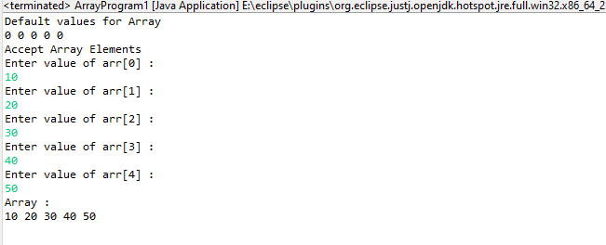

1. Declare a single-dimensional array of 5 integers inside the main method. Define a method named acceptRecord to get input from the terminal into the array and another method named printRecord to print the state of the array to the terminal.

**package** com.assignment6.name;

**import** java.util.Scanner;

**class** Array{

**private** **int**[] arr;

**public** Array() {

**this**(5);

}

**public** Array(**int** size) {

**this**.arr = **new** **int**[size];

}

Scanner sc = **new** Scanner(System.***in***);

**public** **void** acceptArray() {

**for**(**int** i=0; i< **this**.arr.length; ++i) {

System.***out***.println("Enter value of arr["+i+"] : ");

**this**.arr[i] = sc.nextInt();

}

}

**public** **void** printArray() {

System.***out***.println("\nArray elements : ");

**for**(**int** i=0; i<**this**.arr.length; ++i) {

System.***out***.println(**this**.arr[i]);

}

}

}

**public** **class** ArrayProgram2 {

**public** **static** **void** main(String[] args) {

Array a1 = **new** Array();

a1.acceptArray();

a1.printArray();

}

}

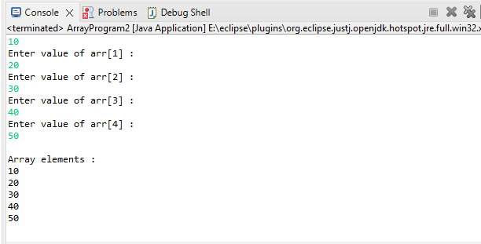

1. Write a program to find the maximum and minimum values in a single-dimensional array of integers.

**package** com.assignment6.name;

**import** java.util.Scanner;

**public** **class** ArrayMinMaxProgram {

**static** Scanner *sc* = **new** Scanner(System.***in***);

**public** **static** **void** main(String[] args) {

**int**[] arr = **new** **int**[5];

**for**(**int** i=0; i<arr.length; i++) {

System.***out***.println("Enter value of arr["+i+"]");

arr[i] = *sc*.nextInt();

}

// Max value from the array

**int** max = 0;

**for**(**int** i=0; i<arr.length; ++i) {

**if**(arr[i] > max) {

max = arr[i];

}

}

System.***out***.println("Max value from the array : "+max);

// Min value from the array

**int** min=0;

**for**(**int** i=0; i<arr.length; ++i) {

min = arr[0];

**if**(arr[i] < min) {

min = arr[i];

}

}

System.***out***.println("Min value from the array : "+min);

}

}

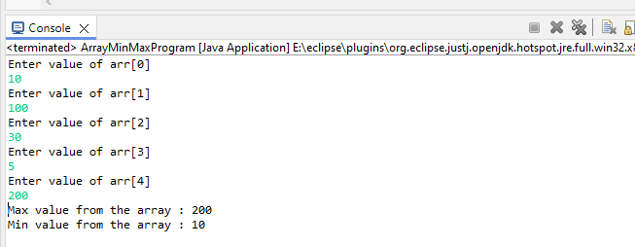

1. Write a program to remove duplicate elements from a single-dimensional array of integers.

**package** com.assignment6.name;

**import** java.util.Scanner;

**public** **class** ArrayRemoveDuplicateProgram {

**static** Scanner *sc* = **new** Scanner(System.***in***);

**public** **static** **void** main(String[] args) {

**int**[] arr = **new** **int**[6];

System.***out***.println("Enter 10 elements in array");

**for**(**int** i=0; i<arr.length; i++) {

System.***out***.println("Enter value of arr["+i+"] : ");

arr[i] = *sc*.nextInt();

}

**for**(**int** i=0; i<arr.length; i++) {

System.***out***.print(arr[i] + " ");

}

// remove duplicates

**int**[] arr1 = **new** **int**[arr.length];

**int** k = 0;

**for**(**int** i=0; i<arr.length; i++) {

**boolean** isduplicate = **false**;

**for**(**int** j=0; j<arr.length; j++) {

**if**(arr[i] == arr1[j]) {

isduplicate = **true**;

**break**;

}

}

// add array element to new array arr1

**if**(!isduplicate ) {

arr1[k++] = arr[i];

}

}

System.***out***.println("\nArray after removing duplicate values : \n");

**for**(**int** i=0; i<arr1.length; i++) {

System.***out***.print(+arr1[i] + " ");

}

}

}

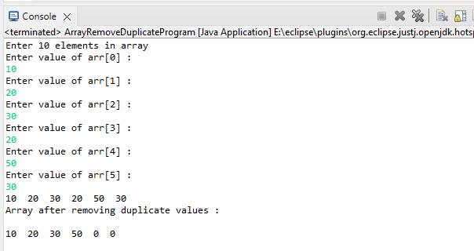

1. Write a program to find the intersection of two single-dimensional arrays.

**package** com.assignment6.name;

**import** java.util.Scanner;

**public** **class** ArrayIntersectionProgram {

**static** Scanner *sc* = **new** Scanner(System.***in***);

**public** **static** **void** main(String[] args) {

System.***out***.println("Enter elements for First Array : ");

**int**[] arr1 = **new** **int**[5];

**for**(**int** i=0; i< arr1.length; i++) {

arr1[i] = *sc*.nextInt();

}

System.***out***.println("Enter elements for Second Array : ");

**int**[] arr2 = **new** **int**[5];

**for**(**int** i=0; i< arr2.length; i++) {

arr2[i] = *sc*.nextInt();

}

**int**[] intersection = **new** **int**[arr1.length];

**int** k= 0;

**for**(**int** i=0; i<arr1.length; i++) {

**for**(**int** j=0; j<arr2.length; j++) {

**if**(arr1[i] == arr2[j]) {

intersection[k++] = arr1[i];

**break**;

}

}

}

System.***out***.println("Intersection of Arrays :");

**for**(**int** i=0; i<intersection.length; i++) {

System.***out***.print(intersection[i] + " ");

}

}

}

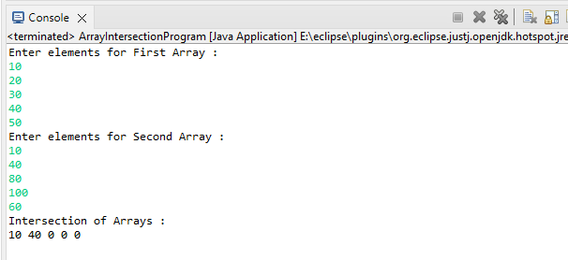

1. Write a program to find the missing number in an array of integers ranging from 1 to N.

**package** com.assignment6.name;

**import** java.util.Scanner;

**public** **class** ArrayMissingNoPropgram {

**static** Scanner *sc* = **new** Scanner(System.***in***);

**public** **static** **void** main(String[] args) {

System.***out***.println("Enter numbers from 1 to N in an array with any of missing number");

System.***out***.println("How many number you want to add");

**int** size = *sc*.nextInt();

**int** n = size + 1;

**int**[] arr = **new** **int**[size];

System.***out***.println("Enter array elements :");

**int** sum = 0;

**for**(**int** i=0; i< arr.length; i++) {

arr[i] = *sc*.nextInt();

sum = sum + arr[i];

}

**int** sumofN = n * (n+1) / 2;

**int** missingNumber = sumofN - sum;

System.***out***.println("Missing number : "+missingNumber);

}

}

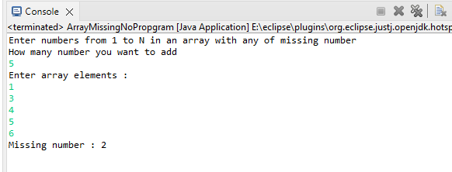

1. Declare a single-dimensional array as a field inside a class and instantiate it inside the class constructor. Define methods named acceptRecord and printRecord within the class and test their functionality.

**package** com.assignment6.name;

**import** java.util.Scanner;

**class** ArrayInit{

**private** **int**[] arr;

Scanner sc = **new** Scanner(System.***in***);

**public** ArrayInit(**int** size) {

**this**.arr = **new** **int**[size];

}

**public** **void** acceptRecord() {

System.***out***.println("Enter 5 elements of array");

**for**(**int** i=0; i<arr.length; i++) {

arr[i] = sc.nextInt();

}

}

**public** **void** printRecord() {

System.***out***.println("Array created : ");

**for**(**int** i=0; i<arr.length; i++) {

System.***out***.print(arr[i] + " ");

}

}

}

**public** **class** ArrayInitProgram {

**public** **static** **void** main(String[] args) {

ArrayInit a1 = **new** ArrayInit(5);

a1.acceptRecord();

a1.printRecord();

}

}

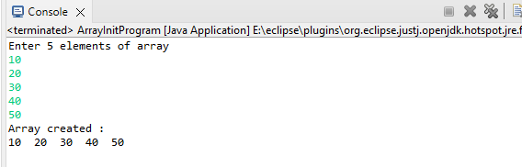

1. Modify the previous assignment to use getter and setter methods instead of acceptRecord and printRecord.

**package** com.assignment6.name;

**import** java.util.Scanner;

**class** ArrayGetterSetters {

**private** **int**[] arr;

**public** ArrayGetterSetters() {

**this**(5);

}

**public** ArrayGetterSetters(**int** size) {

arr = **new** **int**[size];

}

**private** **static** Scanner *sc* = **new** Scanner(System.***in***);

**public** **int**[] getElements() {

**return** arr;

}

**public** **void** setElement(**int** i, **int** value) {

arr[i] = value;

}

**public** **void** acceptElement() {

**for**(**int** i=0; i<arr.length; i++) {

System.***out***.print("enter value for arr["+i+"] : ");

**int** value = *sc*.nextInt();

**this**.setElement(i, value);

}

}

**public** **void** printRecord() {

**int**[] elements = **this**.getElements();

**for**(**int** element : elements ) {

System.***out***.println(element);

}

}

}

**public** **class** ArrayGetterSettersProgram {

**public** **static** **void** main(String[] args) {

ArrayGetterSetters a1 = **new** ArrayGetterSetters();

a1.acceptElement();

a1.printRecord();

}

}

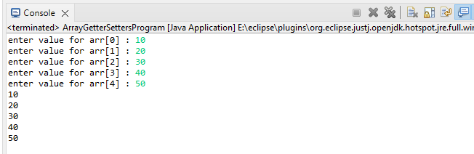

1. You need to implement a system to manage airplane seat assignments. The airplane has seats arranged in rows and columns. Implement functionalities to:

* Initialize the seating arrangement with a given number of rows and columns.
* Book a seat to mark it as occupied.
* Cancel a booking to mark a seat as available.
* Check seat availability to determine if a specific seat is available.
* Display the current seating chart.

**package** com.assignment6.name;

**import** java.util.Scanner;

**class** ArrayAirplaneSeats{

**private** String[][] seat;

**private** **int** row;

**private** **int** col;

ArrayAirplaneSeats(**int** row, **int** col){

**this**.row = row;

**this**.col = col;

seat = **new** String[row][col];

}

// 1st showing total seats are available

**public** **void** seats() {

**for**(**int** i = 0; i< row; ++i) {

**for**(**int** j=0; j<col; ++j) {

seat[i][j]= "Available";

}

}

}

**private** **static** Scanner *sc* = **new** Scanner(System.***in***);

// Book a seat to mark it as Occupied

**public** **void** bookSeat() {

System.***out***.println("Enter a row to book a seat");

**int** brow = *sc*.nextInt();

System.***out***.println("Enter a column to book a seat");

**int** bcol = *sc*.nextInt();

**if**(seat[brow][bcol] == "Available") {

seat[brow][bcol] = "Occupied";

System.***out***.println("Seat is confirmed successfully !");

}

**else** {

System.***out***.println("Oops! Seat is already Occupied !");

}

}

**public** **void** cancelSeat() {

System.***out***.println("Enter a row to cancel a seat");

**int** crow = *sc*.nextInt();

System.***out***.println("Enter a column to cancel a seat");

**int** ccol = *sc*.nextInt();

**if**(seat[crow][ccol] == "Occupied") {

seat[crow][ccol] = "Available";

System.***out***.println("Seat is cancelled successfully !");

}

**else** {

System.***out***.println("Seat is already Available to book ");

}

}

// Check seat availability

**public** **void** checkSeatAvailability() {

System.***out***.println("Enter a row to check a seat");

**int** chrow = *sc*.nextInt();

System.***out***.println("Enter a column to check a seat");

**int** chcol = *sc*.nextInt();

**if**(seat[chrow][chcol] == "Available") {

System.***out***.println("Continue Booking, Seat is avaiable.");

}

**else** {

System.***out***.println("Oops! Seat is already occupied!");

}

}

**public** **void** printSeats() {

**for**(**int** i = 0; i< row; ++i) {

**for**(**int** j=0; j<col; ++j) {

System.***out***.print( seat[i][j] +" ");

}

System.***out***.println();

}

}

**public** **static** **int** menuList() {

System.***out***.println("\n 0. Exit");

System.***out***.println("1. Display Chairs");

System.***out***.println("2. Book Seat ");

System.***out***.println("3. Cancel Booking ");

System.***out***.println("4. Check Seat Avaialability ");

System.***out***.println("Enter Choise : ");

**return** *sc*.nextInt();

}

**public** **static** **void** releaseResource() {

*sc*.close();

}

}

**public** **class** ArrayAirplaneSeatsProgram {

**public** **static** **void** main(String args[]) {

ArrayAirplaneSeats air = **new** ArrayAirplaneSeats(2, 2);

air.seats();

air.printSeats();

**int** choise;

**while**((choise = air.*menuList*()) != 0) {

**switch**(choise) {

**case** 1:

air.printSeats();

**break**;

**case** 2:

air.bookSeat();

**break**;

**case** 3:

air.cancelSeat();

**break**;

**case** 4:

air.checkSeatAvailability();

**break**;

}

}

ArrayAirplaneSeats.*releaseResource*();

}

}

